NAME-AMRUTA BISHWAS

1. Please make a BRD which can be presented to the client along with complete development and resource plan.
Business Requirement Document (BRD)

1. Document Revisions

Version | Date | Author | Changes Made | Reviewed By | Approval
1 | 25-11-2024 | John Doe | Initial Draft: Define objectives, scope, and requirements. | Jane Smith | Yes
1.1 | 28-11-2024 | Jane Smith | Updated requirements for Inventory and Delivery Optimization System" | John Doe | Yes
1.2 | 01-12-2024 | Michael Lee | Added data flow diagrams and use cases. | Sarah Williams | Pending

2. Approvals-

Role Name | Title | Signature | Date
Project Sponsor | CEO | MK | 24-09-2024
Business Owner | ABC | AC | 27-09-2024
Project Manager | RENU.K | RK | 28-09-2024
System Architect | JAY | JY | 30/09/024
Development Lead | KEN | KN | 15-10-2024
User Experience Lead | RTV | RV | 30-10-2024
Quality Lead | NAMA | NM | 15-11-2024
Content Lead | SAGAR | SB | 28-11-2024

3. RACI Chart for This Document:

Activity | Project Manager | Business Analyst | Developers | QA Team | Client / Stakeholders | Operations / Logistics
Requirement Gathering | A | R | C |  | C | C
BRD & SRS Documentation | A | R | C |  | C | I
UI/UX Design | A | C | C |  | I | I
Inventory System Development | A | C | R | C | I | I
Delivery Routing System Development | A | C | R | C | I | C
API Integrations (Plants & Warehouses) | A | C | R | C | I | C
Testing (Unit, Integration, UAT) | A | C | C | R | C | I
Deployment & Go-Live | A | C | R | R | I | I
Training for Ops Team & Client Users | A | R | C |  | I | C
Post-Go-Live Support & Maintenance | A | I | R | R | I | C
Reporting & Analytics Setup | A | C | R | C | C | R

Introduction
Business Goal
The primary goal of the company is to develop a comprehensive software solution that effectively manages inventory across its manufacturing plants and warehouses, while simultaneously optimizing delivery processes to ensure the swift and efficient delivery of ice cream and milk products to customers nationwide.​
Business Objectives
To achieve this overarching goal, the company aims to accomplish the following specific, measurable, and time-bound objectives:
- Inventory Management Optimization:
  - Objective: Implement a real-time inventory tracking system that monitors stock levels of raw materials and finished goods across all locations.
  - SMART Goal: Achieve a 98% accuracy rate in inventory records within the first quarter post-implementation.​
- Automated Stock Replenishment:
  - Objective: Develop an automated system that triggers procurement orders when stock levels fall below predefined thresholds.
  - SMART Goal: Reduce stockouts by 30% within six months of system deployment.​
- Delivery Route Optimization:
  - Objective: Integrate a GPS-based route planning tool to determine the most efficient delivery paths.
  - SMART Goal: Decrease average delivery time by 15% within the first quarter of operation.​
- Real-Time Delivery Tracking:
  - Objective: Provide customers with real-time updates on their delivery status through SMS or mobile notifications.
  - SMART Goal: Achieve a customer satisfaction rate of 90% regarding delivery tracking within six months.​
- Mobile Application for Delivery Personnel:
  - Objective: Develop a mobile application that enables delivery staff to receive optimized routes and update delivery statuses in real-time.
  - SMART Goal: Ensure 100% adoption of the mobile app by delivery personnel within two months of rollout.​

4.3 Business Rules
1. Organization Policies
- Inventory Management Policy: All raw materials and finished goods must be stored in compliance with food safety standards, ensuring proper temperature control and hygiene practices.​
- Delivery Policy: Products must be delivered within 24 hours of order confirmation to maintain product quality and customer satisfaction.​
- Data Security Policy: All customer and business data must be encrypted and stored securely, adhering to applicable data protection regulations.​
2. Rules and Regulations
- Food Safety Regulations: Adhere to local and international food safety standards, including proper labelling, storage, and transportation of dairy products.​
- Transportation Regulations: Comply with road safety and environmental regulations during product delivery, including vehicle maintenance and driver qualifications.​
- Labor Laws: Ensure all warehouse and delivery personnel are employed in accordance with national labor laws, including working hours and compensation.​
3. Business Rules
- Inventory Replenishment Rule: When stock levels fall below the predefined reorder point, an automatic purchase order is generated to replenish inventory.​
- Economic Order Quantity (EOQ) Rule: Utilize the EOQ model to determine the optimal order quantity that minimizes total inventory costs, balancing ordering and holding costs.
- Delivery Scheduling Rule: Orders are prioritized based on customer location and product availability, with deliveries scheduled to minimize transportation costs and time.​
- Cross-Docking Rule: Implement cross-docking practices to expedite order fulfilment by directly transferring products from inbound to outbound transportation, reducing storage time.
4. Background
The company operates multiple manufacturing plants and warehouses across the country, producing perishable products like ice cream and milk. Efficient inventory management and timely delivery are critical to maintaining product quality and customer satisfaction. The proposed software solution aims to automate inventory tracking, optimize delivery routes, and ensure compliance with food safety and transportation regulations. By integrating these business rules into the system, the company seeks to enhance operational efficiency, reduce costs, and improve service levels.

4.4 Project Objective
Objective: Develop and implement an integrated software solution to optimize inventory management and streamline delivery processes across multiple manufacturing plants and warehouses, ensuring timely and efficient delivery of ice cream and milk products to customers nationwide.​

4.5 Project Scope
In-Scope Functionality
The following functionalities are included within the project scope:​
- Inventory Management System:
  - Real-time tracking of stock levels across all locations.
  - Automated alerts for low stock and expiry dates.
  - Integration with procurement systems for seamless restocking.​
- Delivery Management System:
  - Route optimization for delivery vehicles.
  - Real-time tracking of deliveries.
  - Customer notification system for delivery updates.​
- Mobile Application for Delivery Personnel:
  - Access to optimized delivery routes.
  - Real-time updates on delivery status.
  - Ability to capture customer signatures and feedback.​
- Reporting and Analytics:
  - Dashboards for monitoring inventory levels and delivery performance.
  - Reports on stock turnover, delivery times, and customer satisfaction.​
- Integration with Existing Systems:
  - Seamless data exchange with current ERP and CRM systems.
  - API integrations for third-party logistics services.​
Out-of-Scope Functionality
The following functionalities are excluded from the project scope:​
- Customer-Facing Mobile Application:
  - Development of a mobile app for customers to place orders or track deliveries.​
- Post-Delivery Support:
  - Customer support services post-delivery, including returns and complaints management.​
- Advanced Predictive Analytics:
  - Implementation of AI-driven demand forecasting and predictive maintenance.​
- Hardware Procurement:
  - Acquisition of devices for barcode scanning or GPS tracking.​

4.6 Assumptions
The following assumptions have been made during the planning of this project:​
- All manufacturing plants and warehouses have reliable internet connectivity to support real-time data synchronization.​
- Existing ERP and CRM systems are compatible with the new software solution and can be integrated without significant modifications.​
- Delivery personnel possess basic mobile device proficiency to utilize the mobile application effectively.​
- Key stakeholders will be available for regular feedback and decision-making throughout the project lifecycle.
- Suppliers will deliver raw materials on time, ensuring uninterrupted production schedules.​

4.7 Constraints
The following constraints may impact the execution of the project:​
- Budgetary Limitations:
  - The project must be completed within the allocated budget, restricting the scope of certain features and functionalities.​
- Timeline Restrictions:
  - The software solution must be deployed within six months to align with the company's strategic objectives.​
- Resource Availability:
  - Limited availability of internal IT resources may affect the speed of development and integration efforts.
- Regulatory Compliance:
  - The solution must adhere to food safety and data protection regulations, which may impose additional requirements and limitations.​
- Geographical Limitations:
  - Certain remote locations may have limited GPS accuracy, affecting route optimization and delivery tracking functionalities.

7. Risks
Identifying and mitigating potential risks is crucial for the success of the software development project. Below are the categorized risks:
7.1 Technological Risks
- Technology Obsolescence: Adoption of technologies that may become outdated, leading to increased costs and delays.
- Integration Complexity: Challenges in integrating new software with existing legacy systems, potentially causing delays. ​
- Security Vulnerabilities: Potential for data breaches or cyberattacks if security measures are inadequate.
7.2 Skills Risks
- Inadequate Technical Skills: Lack of expertise in required technologies, leading to suboptimal implementation.
- Knowledge Gaps: Team members may lack domain-specific knowledge, affecting the quality of the solution.​
7.3 Political Risks
- Regulatory Changes: New laws or regulations could impact project scope or timelines. ​
- Political Instability: Changes in government policies or instability may disrupt project execution.​
7.4 Business Risks
- Market Changes: Shifts in market demand or customer preferences could affect project relevance. ​
- Financial Constraints: Budget cuts or financial instability may lead to resource shortages.​
7.5 Requirements Risks
- Unclear Requirements: Ambiguous or changing requirements can lead to scope creep and project delays. ​
- Stakeholder Misalignment: Divergent expectations among stakeholders may cause conflicts and delays.​
7.6 Other Risks
- Supply Chain Disruptions: Delays in hardware or software deliveries can impact project timelines. ​
- Natural Disasters: Unforeseen events like floods or earthquakes may halt project activities.​

8. Business Process Overview
8.1 Legacy System (AS-IS)
The current system relies on manual inventory tracking and delivery scheduling, leading to inefficiencies and errors. Data is siloed across departments, making real-time decision-making challenging.​
[Manufacturing Plant]
|
(Manual update via Excel / Email)
|
[Warehouse]
|
(Manual inventory tracking / spreadsheets)
|
[Customer Order Received]
|
(Manual check for availability at warehouses)
|
(Manual route planning or first-come-first-serve dispatch)
|
[Delivery Dispatched]
|
(No real-time tracking / Delayed updates)
|
[Customer Receives Order (Late/Untracked)]

8.2 Proposed Recommendations (TO-BE)
Implement an integrated software solution that automates inventory management and delivery scheduling. This system will provide real-time data access, improve accuracy, and enhance decision-making capabilities.​

[Manufacturing Plant]
|
(Auto stock update via API)
|
[Central Inventory System]
|
(Real-time visibility across locations)
|
[Customer Places Order via Web/App]
|
(System checks nearest warehouse with stock)
|
[AI-powered Route Optimization Engine]
|
[Delivery Assigned & Tracked]
|
(Real-time updates sent to customer)
|
[Customer Receives Order Quickly & Tracked]
|
(System updates inventory, generates report)

9. Business Requirements
FUNCTIOANL REQUIREMNETS:

ID | MODULE | REQUIREMNET DESCRIPTION
1 | Inventory Management | Track stock levels at manufacturing plants and warehouses in real-time
2 | Order Management | Accept and process customer orders from multiple channels (website, mobile app)
3 | Delivery Optimization | Auto-assign delivery based on location, stock availability, and delivery windows
4 | Warehouse Operations | Manage inward (production) and outward (dispatch) movements

NON-FUNCTIONAL REQUIREMENT:S
- High availability and scalability
- Secure login and role-based access
- Responsive design (web + mobile)
- Cloud hosting (AWS/Azure)
- GDPR and food safety data compliance

10. Appendices
10.1 List of Acronyms
- ERP: Enterprise Resource Planning​
- GPS: Global Positioning System​
- API: Application Programming Interface​
10.2 Glossary of Terms
- Inventory Management: The process of overseeing and controlling the ordering, storage, and use of components.​
- Delivery Optimization: The process of planning and executing the most efficient delivery routes.
UX | User Experience
KPI | Key Performance Indicator
UAT | User Acceptance Testing

2. Prepare process flow diagram using your imagination.

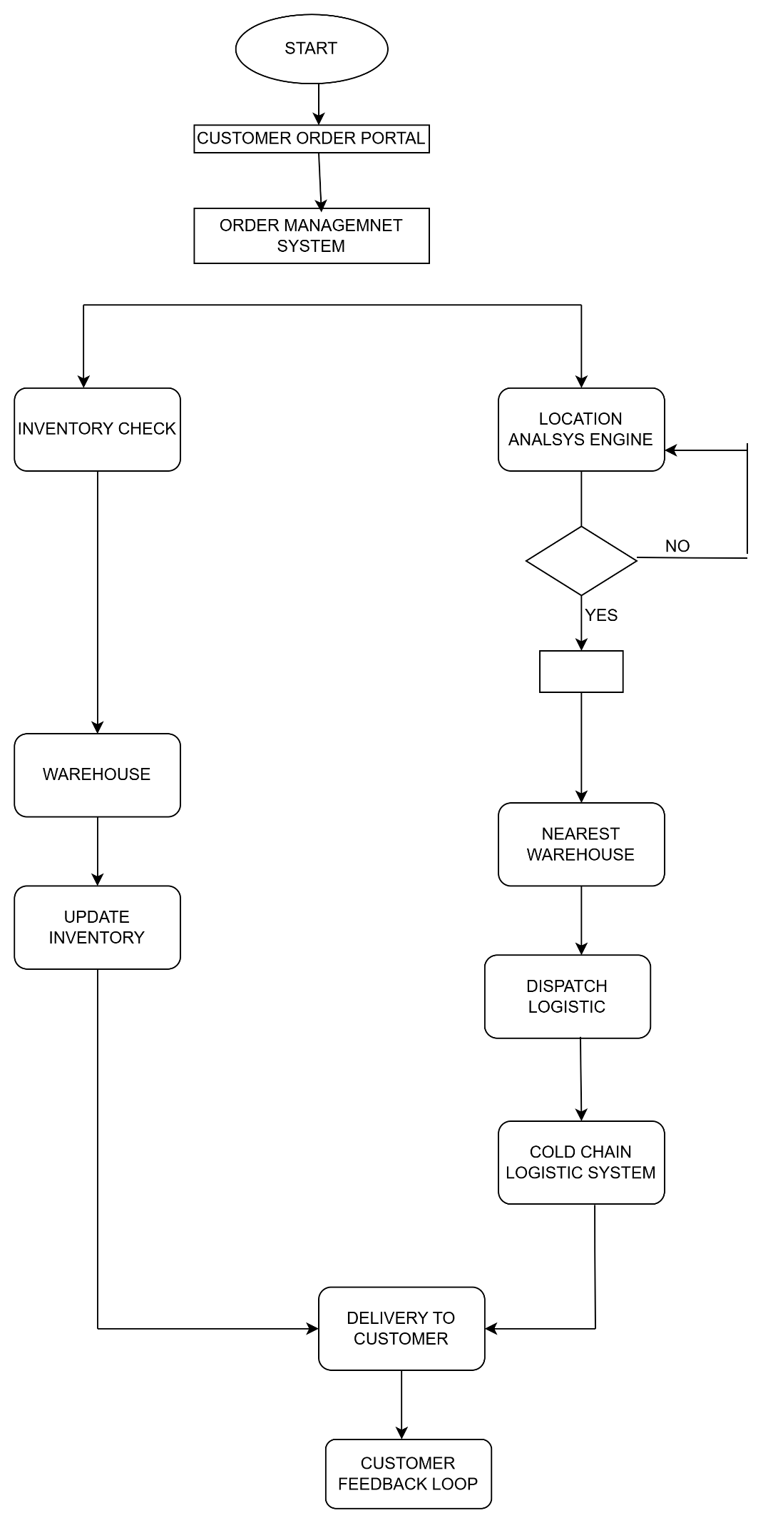

Assignment 2:
1. Write an introduction letter to a client introducing yourself as a business analyst in charge of working with the client and his team to start the business understanding process.

Subject: Introduction –Amruta Bishwas, Your Business Analyst for the upcoming web application project
Dear Stanley,
I hope this message finds you well.
My name is Amruta Bishwas, and I am the Business Analyst assigned to support you and your team throughout the initial phase of our collaboration. I’ll be working closely with you to lead the business understanding process—gathering insights into your goals, challenges, and requirements so we can set a strong foundation for a successful project.
Over the coming days, I’ll be engaging with your stakeholders to clarify needs, map out current processes, and define key objectives. My role is to ensure that we fully understand your vision and align our solutions accordingly.
I’m looking forward to partnering with you and your team. Please feel free to reach out with any questions, or if there’s anything you’d like to discuss early on.
Thank you, and I look forward to working together.
Warm regards,
Amruta Bishwas
[Wipro]
[amu@123gmail.com] | [8329920462]

2)Prepare a brief BRD and SRS for a project- Horoscope or Ticketing system or online store.
TICKITING SYSTEM:
BRD:
Business Requirements Document (BRD)
Project Name: Ticketing System
Prepared By: Amruta Bishwas
Date: 6th December 2024
Executive Summary
The objective of the Ticketing System project is to implement a comprehensive solution for managing customer support tickets effectively. The system will streamline the process of ticket creation, tracking, resolution, and closure. It will be designed to ensure seamless communication between users, support agents, and managers, improving the overall efficiency of customer support operations Additionally, the system will include advanced features for monitoring service level agreement (SLA) compliance, enhancing reporting capabilities, and integrating with a knowledge base for faster problem resolution.

1.Document Revision
Version | Date | Author | Changes Made | Reviewed By | Approval
1 | 25-11-2024 | John Doe | Initial Draft: Define objectives, scope, and requirements. | Jane Smith | Yes
1.1 | 28-11-2024 | Jane Smith | Updated requirements for Inventory and Delivery Optimization System" | John Doe | Yes
1.2 | 01-12-2024 | Michael Lee | Added data flow diagrams and use cases. | Sarah Williams | Pending

2. Approval

Role Name | Title | Signature | Date
Project Sponsor | CEO | MK | 24-09-2024
Business Owner | ABC | AC | 27-09-2024
Project Manager | RENU.K | RK | 28-09-2024
System Architect | JAY | JY | 30/09/024
Development Lead | KEN | KN | 15-10-2024
User Experience Lead | RTV | RV | 30-10-2024
Quality Lead | NAMA | NM | 15-11-2024
Content Lead | SAGAR | SB | 28-11-2024

3. RACI

Activity | Project Manager | Business Analyst | Developers | QA Team | Client / Stakeholders | Operations / Logistics
Requirement Gathering | A | R | C |  | C | C
BRD & SRS Documentation | A | R | C |  | C | I
UI/UX Design | A | C | C |  | I | I
Inventory System Development | A | C | R | C | I | I
Delivery Routing System Development | A | C | R | C | I | C
API Integrations (Plants & Warehouses) | A | C | R | C | I | C
Testing (Unit, Integration, UAT) | A | C | C | R | C | I
Deployment & Go-Live | A | C | R | R | I | I
Training for Ops Team & Client Users | A | R | C |  | I | C

4. Introduction:
4.1 Business Goals
Streamline Issue Resolution
Enable users to easily raise and track tickets while ensuring quick and efficient resolution by support teams.
Enhance Transparency
Provide users and stakeholders with real-time updates on ticket status and resolution timelines.
Improve Accountability
Introduce clear ownership of tickets through automated assignments and escalation mechanisms.
Boost Operational Efficiency
Automate routine processes such as ticket routing and SLA monitoring to reduce manual intervention and errors.
Enable Data-Driven Decisions
Generate actionable insights through reporting and analytics to identify patterns, improve service quality and optimize resources.
4.2 Business Objectives:
1. Enhanced Customer Satisfaction: By reducing resolution time and ensuring timely support through SLA compliance.
2. Optimized Support Team Performance: By providing tools for assigning tickets to the appropriate agents, managing workloads, and tracking performance.
3. Better Decision-Making: By offering detailed reports on ticket trends, SLA performance, and agent efficiency.
4. Cost Efficiency: By automating routine support processes, reducing human error, and speeding up the resolution process, leading to a reduction in operational costs.
4.3 Business Rules:
Tickets must be assigned to agents within 15 minutes of creation. Tickets cannot be closed until all required information is provided, and the issue is fully resolved. Support agents must adhere to the SLAs defined for each ticket type. A ticket must be reopened if a customer reports the issue again within 30 days of closure.
4.4 Background:
The company’s current ticketing system is inefficient, causing slow response times, missed SLAs, and manual processing. To address these issues, the company will implement a new Ticketing System that automates ticket management, tracks SLAs, integrates a knowledge base and provides detailed reporting. This system will streamline support processes, improve customer satisfaction, and ensure compliance with SLAs. The project aims to enhance efficiency, reduce costs, and provide better data insights for decision-making. Key stakeholders include customer support, IT, and business leadership. The project will be completed in 6 months, with phased rollout and ongoing support.
4.5Scope of the System
In-Scope:
User portal for raising tickets.
Support team portal for ticket management.
Automated ticket assignment and prioritization based on predefined rules.
SLA tracking and notification alerts for pending tickets.
Reports and dashboards for performance analysis.
Out-of-Scope:
Integration with third-party tools (to be planned in future phases).
Hardware procurement and setup.
5. Assumptions
All users will have access to a computer or mobile device with an internet connection.
Support teams will adhere to SLA policies as defined by the organization.
6. Constraints:
The system must be developed and implemented within a 6-month timeline.
The system should be scalable to handle up to 10,000 tickets per day without performance degradation.
It must comply with applicable data privacy regulations (e.g., GDPR).
7. Risk
1. Technical Risk:
Risk: Integration and compatibility issues with existing systems (CRM, email, chat, etc.) could lead to delays or functionality problems, causing disruptions in the ticket management process.
Mitigation: Conduct detailed technical assessments and integration testing to ensure compatibility with current systems. Allocate time for troubleshooting and ensure robust
APIs for seamless data exchange.
2. Political Risk:
Risk: Internal organizational changes, such as shifts in key personnel or management priorities, could affect the project's support or direction, cause delays or shifting project goals.
Mitigation: Maintain regular communication with key stakeholders and senior leadership to ensure alignment. Create clear documentation to keep all parties informed, regardless of organizational changes.
3. Requirement Risk:
• Risk: The requirements for the ticketing system might not be fully understood or documented, leading to misalignment between business needs and the delivered solution.
• Mitigation: Engage stakeholders early in the project to define detailed requirements. Use iterative feedback and validation (e.g., user stories and prototypes) to refine the system according to actual needs.
4. Business Risk:
Risk: The new ticketing system might not achieve the expected improvements in customer satisfaction or operational efficiency, leading to a lack of return on investment
Mitigation: Set clear, measurable business objectives before the project starts (e.g., reduced response time, SLA compliance). Regularly assess the system postimplementation and adjust processes as needed based on feedback and performance
8. Business Process Overview
System (AS-IS)
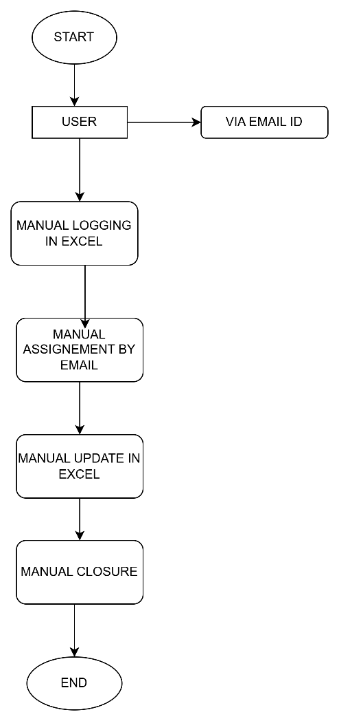

TO BE SYSTEM:
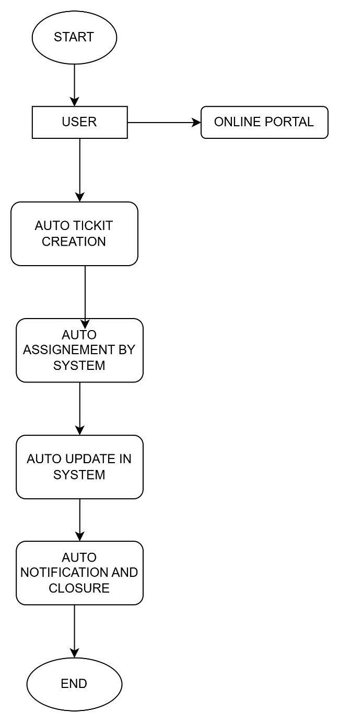

9. Business Requirements
Functional Requirements:
Type | Requirement ID | Requirement Description
Functional | FR-001 | Users can create tickets via web or email.
Functional | FR-002 | Tickets must include fields: ID, status, category, priority, description, and timestamps.
Functional | FR-003 | Agents can assign, reassign, update, and close tickets.
Functional | FR-004 | System sends automated notifications on ticket creation, update, and resolution.
Functional | FR-005 | Users can view, search, and filter tickets by various criteria.
Functional | FR-006 | Admin can create/manage users, roles, and permissions.
Functional | FR-007 | SLA timers start when ticket is submitted and track time until resolution.

NON-FUNCTIONAL REQUIREMENT:

ID | CATEGORY | REQUIREMNET DESCRIPTION
NFR-001 | Performance | The system must respond to user actions (e.g., opening a ticket) within 2 seconds.
NFR-002 | Scalability | The system must support up to 1,000 concurrent users without performance degradation.
NFR-003 | Availability | The system must have an uptime of 99.5% or higher per month.

10. Appendices
10.1 List of Acronyms
➢ AI - Artificial Intelligence
➢ GDPR - General Data Protection Regulation
➢ UAT - User Acceptance Testing
➢ D&I - Diversity and Inclusion
➢ ROI - Return on Investment
➢ AS-IS - Current State of the Process/System
➢ TO-BE - Future State of the Process/System
➢ KPI - Key Performance Indicator
➢ TAT - Turnaround Time
➢ SLA - Service Level Agreement
➢ API - Application Programming Interface
➢ UI - User Interface
➢ UX - User Experience
➢ BRD - Business Requirements Document
➢ RTM - Requirement Traceability Matrix
➢ DPA - Data Protection Act (often used with GDPR)

SRS:
1.2 Acronyms and Definitions/Acronym | Definition
UI | User Interface – The space where interactions between users and the software occur.
API | Application Programming Interface – A set of tools and protocols used to interact with the software programmatically.
SLA | Service Level Agreement – A documented agreement that defines the expected service performance and response/resolution times.
Ticket | A recorded request, issue, or query submitted by a user to be addressed by the support team.
End-user | The person submitting a ticket or using the system to request services.
Support Agent | The individual responsible for responding to and resolving tickets.
Admin | The user with the highest level of permissions, able to manage settings, users, and system configurations.

1.3 Operational Requirements
This section outlines the necessary software and hardware components required to deploy and operate Ticketing System effectively.
1.3.1 Software Requirements
The following software components are required to install and run Ticketing System 1.0:
Server-side Requirements
- Operating System: Linux (Ubuntu 20.04 LTS or later) / Windows Server 2019 or later
- Web Server: Apache 2.4+
- Application Server: Python (v3.9+) depending on implementation
- Database: MySQL
- Runtime Environment: Java
- Other Dependencies:
  - Redis (for caching and queuing)
  - Docker (optional for containerized deployment)
  - SSL certificate (for HTTPS support)
Client-side Requirements
- Web Browser:
  - Google Chrome (latest version)
  - Mozilla Firefox (latest version)
  - Microsoft Edge (Chromium-based, latest version)
- JavaScript Enabled: Required
- Internet Connection: Minimum 1 Mbps per user recommended

1.3.2 Hardware Requirements
These are the minimum and recommended hardware specifications for hosting and accessing the system.
Server Hardware Requirements
Component | Minimum | Recommended
CPU | Dual-core 2.0 GHz | Quad-core 2.5+ GHz
RAM | 4 GB | 8 GB or more
Storage | 50 GB SSD | 100 GB SSD (expandable)
Network | 1 Gbps Ethernet | 1 Gbps or higher with redundancy
Client Hardware Requirements
Component | Minimum | Recommended
CPU | Dual core | Quad-core
RAM | 2 GB | 4 GB or more
Display | 1024x768 resolution | 1920x1080 Full HD
Input Devices | Keyboard and Mouse | Keyboard, Mouse, Touchscreen (optional

1.4 References
The following documents were used as the basis for defining the scope, requirements, and design of Ticketing System
- Proposal Document
Contains the initial project proposal, including objectives, high-level features, estimated timelines, and budget considerations.
- User Requirements Document (URD)
Details the functional and non-functional requirements provided by stakeholders, including use cases, user roles, and system expectations.
1.5 Design and Implementation Constraints
This section outlines the limitations and restrictions that may impact the design and development of Ticketing System. These constraints may be due to organizational policies, technical requirements, or external dependencies.

1.5.1 Development Constraints
- Mandated Technologies:
The system must be developed using the following stack:
  - Frontend: Angular (v14+)
  - Backend: Python
  - Database: MySQL 8.0+
  - Authentication: OAuth 2.0 authentication
- Avoided Technologies:
  - Use of proprietary software libraries with restrictive licenses must be avoided.
  - No reliance on deprecated technologies such as Adobe Flash or unsupported database engines.

1.5.2 Development Standards and Conventions
- Coding Standards:
All source code must follow established industry conventions:
  - JavaScript
  - PEP8 for Python
  - Commenting and documentation required for all functions/modules
  - RESTful API design principles must be adhered to
- Version Control:
Git is the required version control system. Code must be stored and managed in a central Git repository (e.g., GitHub, GitLab, Bitbucket).
- Subcontracting Requirements:
If development is subcontracted, subcontractors must:
  - Adhere strictly to the same coding and documentation standards
  - Submit code through the same CI/CD pipeline
  - Follow project management tools and timelines defined by the project lead

1.5.3 Hardware Constraints
- Hosting Environment:
The system is required to operate on a virtualized environment or cloud-based infrastructure (e.g., AWS EC2, Azure VM) with limited scalability in the initial phase.
- Performance Limits:
  - System should support up to 500 concurrent users in the initial release
  - API response time should not exceed 2 seconds under normal load
- Memory and Storage:
  - Application must not exceed 4 GB RAM usage during runtime
  - Log and archive files must be auto-rotated and limited to a max of 30 days storage

1.5.4 Data Interchange Formats
- Standard Formats:
  - All data exchange must use JSON format for client-server communication
  - CSV and XML export formats must be supported for reporting purposes
  - API integration must support OpenAPI (Swagger) specifications for documentation

1.6 Assumed Factors That Could Affect the Requirements Stated in the SRS
This section outlines external or internal factors that are assumed during the creation of this Software Requirements Specification (SRS) and which, if changed or not fulfilled, may impact the system's design, implementation, or delivery schedule.

1.6.1 External Dependencies
- Third-party Components and Integrations:
The system relies on several external components and services that must be available and functional:
  - Email service providers (e.g., SendGrid, SMTP server) for ticket notifications
  - Authentication providers (e.g., Google OAuth, Microsoft AD) for SSO integration
  - External reporting tools or dashboards (e.g., Power BI integration)
  - APIs from other enterprise systems (e.g., CRM or ERP systems) for ticket enrichment or automation
Assumption: These services will be available, stable, and deliver required data on time and in a compatible format.

1.6.2 Parallel or Related Projects
- The system may depend on components or platforms being developed by other internal teams or third-party vendors.
  - For instance, if a centralized user authentication module is being developed separately, the project is dependent on it being delivered, tested, and documented as scheduled.
  - Delay or design changes in such modules could require adjustments in this system’s integration logic or timelines.

1.6.3 Operating Environment
- The deployment and production environment (e.g., network infrastructure, cloud provider setup, security policies) is assumed to be properly configured and maintained by the infrastructure team.
- Changes in network security settings (e.g., firewall rules, DNS policies) may disrupt external communications (e.g., email, API calls).
Assumption: The hosting environment will be provisioned on time with adequate resources and necessary configurations.

1.6.4 Licensing and Legal Constraints
- Any commercial libraries or APIs used will be properly licensed and free of legal or cost-based restrictions.
- Changes in licensing terms or API pricing models could introduce additional cost or force architectural redesign.

1.6.5 Organizational and Resource Assumptions
- Required personnel (developers, QA, infrastructure engineers) will be available as scheduled.
- Stakeholders will provide timely feedback during review cycles.
- Project scope will remain stable throughout the initial release phase.

2.0 System Overview
This section provides a high-level understanding of both the existing (if any) and the proposed systems. It outlines the limitations of the current system and explains how the proposed solution addresses those gaps.

2.1 Current System
Currently, the organization uses a manual or semi-digital process for managing support and service requests. These requests are often handled through:
- Shared email inboxes
- Phone calls or in-person communication
- Spreadsheets or informal task trackers
Limitations of the current system include:
- Lack of centralized ticket tracking
- No structured workflow or escalation path
- Limited visibility into request status for users
- No metrics or reporting capabilities for management
- High dependency on individuals for follow-up and resolution

2.2 Proposed System
The Ticketing System introduces a centralized, web-based platform for logging, managing, and resolving service tickets. The system automates key workflows, supports user role management, and integrates with existing IT infrastructure (e.g., email, user directory, external APIs).
Key features of the proposed system:
- User-friendly interface for submitting and tracking tickets
- Categorization and prioritization of tickets
- Role-based access (Admin, Support Agent, End-user)
- Automated notifications and SLA tracking
- Custom dashboards and analytics
- Integration with third-party tools (email, calendars, reporting systems)

2.3 Benefits of the Proposed System
The implementation of Ticketing System 1.0 is expected to bring the following benefits:
- Centralized Communication
All ticket-related communication is stored in one platform, improving transparency and reducing information loss.
- Improved Efficiency and Productivity
Automated workflows and task assignments reduce manual effort and ensure timely resolution.
- Enhanced User Experience
Users can easily submit, track, and receive updates on tickets through an intuitive interface.
- Real-Time Reporting and Analytics
Managers can generate reports to monitor performance, identify trends, and make data-driven decisions.
- SLA Compliance
Built-in tracking of response and resolution times ensures compliance with service level agreements.
- Scalability
The system is designed to support growth in users, ticket volume, and feature enhancements over time.
- Integration-Friendly Architecture
Supports integration with tools such as email systems, authentication services (SSO), and third-party platforms.
- Auditability and Accountability
All actions on a ticket are logged, supporting traceability and accountability.
- Reduced Operational Costs
By minimizing manual errors and improving staff efficiency, the system helps lower operational overhead.
- Customizable and Configurable
The system can be tailored to suit various departments (IT, Facilities, HR, etc.) and their workflows.

3.0 UI Requirements
This section outlines the user interface (UI) requirements for Ticketing System 1.0, including a breakdown of the key modules, screens, and the functionality each component must support. The UI must be intuitive, responsive, and accessible to users with varying roles and technical expertise.

3.1 Project Contents
The UI of the Ticketing System 1.0 will be organized into several core modules. Each module represents a key area of functionality within the system. Below is a description of each module and its expected features.

Core UI Components and Module Functionalities
A. Ticket Management Module
Description: This module allows users to submit, view, manage, and track tickets.
Functionality Includes:
- Create New Ticket (form with category, priority, description, attachment)
- View My Tickets (with filters: status, date, priority)
- Ticket Detail Page (ticket timeline, comments, status updates)
- Edit / Cancel Ticket (based on status and permissions)
- Agent View: Assign, Escalate, Close, or Reopen tickets

B. User Management Module
Description: Admins manage user roles, permissions, and profile settings.
Functionality Includes:
- Add/Edit/Delete Users
- Assign Roles (End-user, Support Agent, Admin)
- Role-based Access Control UI
- View User Activity Logs

C. Dashboard Module
Description: Displays a summary of system activity and performance metrics.
Functionality Includes:

4.0 Other Parameters
This section outlines additional considerations and conditions that influence the successful delivery and acceptance of the Ticketing System 1.0. These may include contractual deliverables, approval processes, and post-deployment criteria.

4.1 Acceptance
The client will formally review and accept the Ticketing System 1.0 based on the successful delivery of the following items. Each deliverable must meet the agreed-upon quality standards and functional requirements as outlined in the Software Requirements Specification (SRS) and project proposal.
Required Deliverables for Acceptance:
- Prototypes
Interactive UI prototypes or wireframes demonstrating core user flows, reviewed and approved during the design phase.
- Application
Fully developed, tested, and deployed Ticketing System 1.0, with all core modules functioning as specified:
  - Ticket submission and management
  - User roles and permissions
  - Reporting dashboard
  - Notification and alert mechanisms
- Documentation
  - Installation Guide: Step-by-step instructions for setting up the system on the target environment.
  - User Manual: Detailed guide for end-users and administrators, including screenshots and workflows.
  - Technical Documentation (if applicable): System architecture, database schema, and API references

3)Make an ERD of creating a support ticket/Ticketing life cycle.

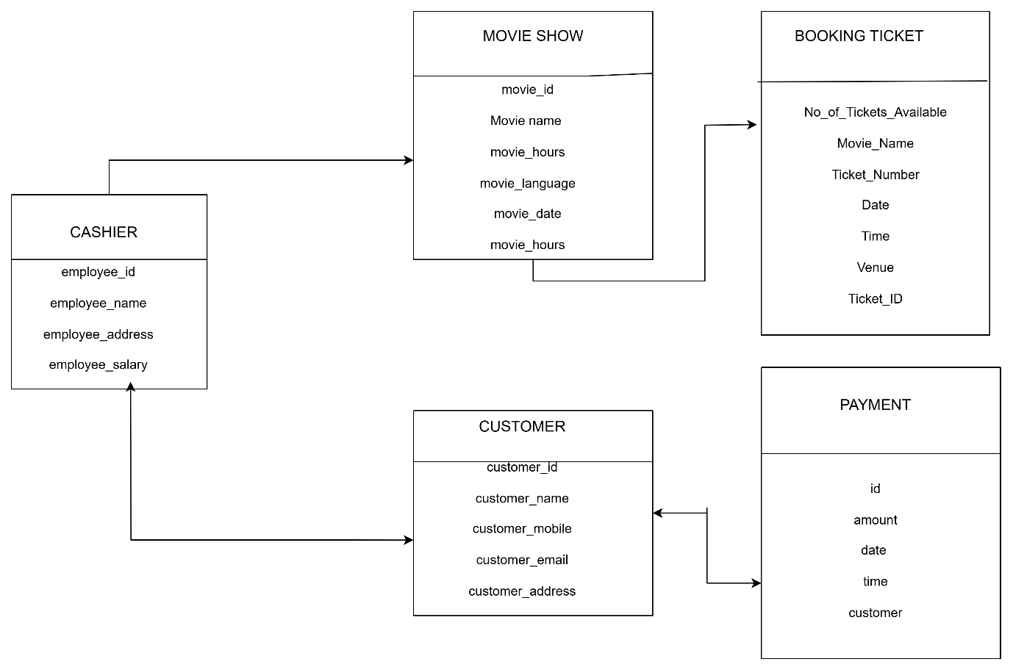

  - User story of shopping from ecommerce.

USER STORY:1 | TASKS:2 | PRIORITY:MEDIUM |  | USER STORY:2 | TASKS:2 | PRIORITY: MEDIUM
As a new user, |  |  |  | As a registered user,
I want to register an account |  |  |  | I want to log into my account
So that I can make purchases and track my orders. |  |  |  | So that I can access my personal shopping area.
BV:200 |  | CP:02 |  | BV:300 |  | CP:02
Acceptance Criteria: User can register using email and password. |  |  |  | Acceptance Criteria:
System validates input and shows errors for invalid entries. |  |  |  | Login form accepts valid credentials.
Confirmation email is sent upon registration. |  |  |  | Invalid credentials show error message.
 |  |  |  | Successful login redirects to the dashboard.

USER STORY:3 |  | TASKS:2 | PRIORITY: MEDIUM |  |  | USER STORY:4 |  | TASKS:2 | PRIORITY: MEDIUM
As a user who forgot the password, |  |  |  |  |  | As a visitor,
I want to reset my password |  |  |  |  |  | I want to browse product categories
So that I can regain access to my account. |  |  |  |  |  | So that I can explore available products.
BV:100 |  |  | CP:01 |  |  | BV:50 |  |  | CP:01
Acceptance Criteria: Forgot password link is available on login page. |  |  |  |  |  | Acceptance Criteria:
Email with reset link is sent to the user. |  |  |  |  |  | Categories are displayed on homepage and menu.
User can set a new password after clicking the link. |  |  |  |  |  | Clicking a category shows relevant products.
 |  |  |  |  |  | Subcategories are shown where applicable.
.
USER STORY:5 |  | TASKS:2 | PRIORITY: MEDIUM |  |  | USER STORY:6 |  | TASKS:2 | PRIORITY: MEDIUM
As a shopper, |  |  |  |  |  | As a shopper,
I want to search for products |  |  |  |  |  | I want to filter products by price, brand, and rating
So that I can find specific items quickly. |  |  |  |  |  | So that I can narrow down my search.
BV:300 |  |  | CP:05 |  |  | BV:400 |  |  | CP:03
Acceptance Criteria: |  |  |  |  |  | Acceptance Criteria:
Search bar accepts keywords. |  |  |  |  |  | Filters appear on category and search results pages.
Results include matching product titles, descriptions, and tags. |  |  |  |  |  | Selecting filters updates product list in real-time.
 |  |  |  |  |  | · Multiple filters can be combined.
.
USER STORY:7 |  | TASKS:2 | PRIORITY: MEDIUM |  |  | USER STORY:8 |  | TASKS:2 | PRIORITY: MEDIUM
As a user, |  |  |  |  |  | As a user,
I want to view detailed information about a product |  |  |  |  |  | I want to add items to my cart
So that I can decide whether to purchase it. |  |  |  |  |  | So that I can purchase them later.
 |  |  |  |  |  | Acceptance Criteria: Cart icon updates with item count.
Acceptance Criteria: Option to select size, colour, quantity.
BV:500 |  |  | CP:03 |  |  | BV:200 |  |  | CP:04
Acceptance Criteria: |  |  |  |  |  | Acceptance Criteria:
Cart shows list of items with quantities and prices. |  |  |  |  |  | Discount code field is present at checkout.
 |  |  |  |  |  | Valid codes apply correct discount.

USER STORY:9 |  | TASKS:2 | PRIORITY:MEDIUM |  |  | USER STORY:10 |  | TASKS:2 | PRIORITY:MEDIUM
 |  |  |  |  |  | As a user,
As a user, |  |  |  |  |  | I want to apply a discount code
I want to view my shopping cart |  |  |  |  |  | So that I can get a discount on my purchase.
So that I can review my selected items.
BV:600 |  |  | CP:06 |  |  | BV:100 |  |  | CP:02
 |  |  |  |  |  | Acceptance Criteria:
Acceptance Criteria: |  |  |  |  |  | Discount code field is present at checkout.
Cart shows list of items with quantities and prices. |  |  |  |  |  | Valid codes apply correct discount.
 |  |  |  |  |  | .
USER STORY:11 |  | TASKS:2 | PRIORITY:MEDIUM |  |  | USER STORY:12 |  | TASKS:2 | PRIORITY:MEDIUM
As a user, |  |  |  |  |  | As a visitor,
I want to complete my purchase through a checkout process |  |  |  |  |  | I want to check out without registering
So that I can place an order. |  |  |  |  |  | So that I can make a quick purchase.
BV:100 |  |  | CP:02 |  |  | BV:100 |  |  | CP:02
Acceptance Criteria: |  |  |  |  |  | Acceptance Criteria:
Checkout has steps for shipping, payment, and review. |  |  |  |  |  | Guest checkout is an option at checkout.
User must confirm shipping address. |  |  |  |  |  | Requires email and shipping address.

USER STORY:13 |  | TASKS:2 | PRIORITY:MEDIUM |  |  | USER STORY:14 |  | TASKS:2 | PRIORITY: MEDIUM
As a shopper, |  |  |  |  |  | As a customer,
I want to pay using various methods |  |  |  |  |  | I want to receive confirmation of my order via email
So that I can choose the most convenient one. |  |  |  |  |  | So that I know the order was placed.
BV:100 |  |  | CP:02 |  |  | BV:100 |  |  | CP:02
Acceptance Criteria: |  |  |  |  |  | Acceptance Criteria:
Supports credit/debit card, PayPal, etc. |  |  |  |  |  | Email is sent immediately after order.
Payment is processed securely. |  |  |  |  |  | Includes order ID, items, total price, and shipping info
USER STORY:15 |  | TASKS:2 | PRIORITY: MEDIUM |  |  | USER STORY:16 |  | TASKS:2 | PRIORITY: MEDIUM
As a customer, |  |  |  |  |  | As a customer,
I want to track my order |  |  |  |  |  | I want to cancel my order before it ships
So that I know when it will arrive. |  |  |  |  |  | So that I can stop the purchase.
BV:100 |  |  | CP:02 |  |  | BV:100 |  |  | CP:02
Acceptance Criteria: |  |  |  |  |  | Acceptance Criteria: Cancellation option available if order not shipped.
Tracking info is visible on order page. |  |  |  |  |  | Confirmation required before cancelling.
Email updates are sent when status changes. |  |  |  |  |  | Refund is initiated on cancellation.

USER STORY:17 |  | TASKS:2 | PRIORITY: MEDIUM |  |  | USER STORY:18 |  | TASKS:2 | PRIORITY: MEDIUM
As a customer, |  |  |  |  |  | As a user,
I want to read and write product reviews |  |  |  |  |  | I want to save items to a Wishlist
So that I can make informed choices. |  |  |  |  |  | So that I can buy them later.
BV:300 |  |  | CP:05 |  |  | BV:200 |  |  | CP:02
Acceptance Criteria: |  |  |  |  |  | Acceptance Criteria:
Only verified buyers can write reviews. |  |  |  |  |  | Wishlist is accessible from product page.
Reviews are moderated before publishing. |  |  |  |  |  | Items can be moved from Wishlist to cart.
Shows average rating.
USER STORY:19 |  | TASKS:2 | PRIORITY: MEDIUM |  |  | USER STORY:20 |  | TASKS:2 | PRIORITY: MEDIUM
As a user, |  |  |  |  |  | As a mobile user,
I want to see product recommendations |  |  |  |  |  | I want to shop easily on my phone
So that I can discover relevant items. |  |  |  |  |  | So that I can browse and buy products on the go.
BV:100 |  |  | CP:02 |  |  | BV:100 |  |  | CP:02
Acceptance Criteria: |  |  |  |  |  | Acceptance Criteria:
Recommendations based on browsing and purchase history. |  |  |  |  |  | All pages are responsive and load on mobile.
Displayed on homepage and product pages. |  |  |  |  |  | Menus and buttons are touch friendly.

USER STORY:21 |  | TASKS:2 | PRIORITY: MEDIUM |  |  | USER STORY:22 |  | TASKS:2 | PRIORITY: MEDIUM
As a shopper, |  |  |  |  |  | As a visitor,
I want to sort products by price or popularity |  |  |  |  |  | I want to subscribe to newsletters
So that I can view products in my preferred order. |  |  |  |  |  | So that I can receive deals and updates.
BV:400 |  |  | CP:06 |  |  | BV:500 |  |  | CP:05
Acceptance Criteria:
Sorting options include price (low to high, high to low) and popularity. |  |  |  |  |  | Acceptance Criteria:
Product list updates instantly when sort option is selected. |  |  |  |  |  | Subscription field is visible in footer or pop-up.
Default sorting is by relevance or popularity. |  |  |  |  |  | Confirmation email is sent on successful subscription.
 |  |  |  |  |  | Unsubscribe link is included in every email.
USER STORY:23 |  | TASKS:2 | PRIORITY: MEDIUM |  |  | USER STORY:24 |  | TASKS:2 | PRIORITY: MEDIUM
As a logged-in user, |  |  |  |  |  | As a returning customer,
I want to log out securely |  |  |  |  |  | I want to view my past orders
So that my account is protected. |  |  |  |  |  | So that I can track previous purchases.
BV:50 |  |  | CP:03 |  |  | BV:100 |  |  | CP:01
Acceptance Criteria: |  |  |  |  |  | Acceptance Criteria:
Logout option is available in the account menu. |  |  |  |  |  | Accessible from the user account dashboard.
User is redirected to homepage or login page after logout. |  |  |  |  |  | Shows order number, date, status, and total.

USER STORY:25 |  | TASKS:2 | PRIORITY: MEDIUM |  |  | USER STORY:26 |  | TASKS:2 | PRIORITY: MEDIUM
As a customer, |  |  |  |  |  | As a customer,
I want to download invoices for my orders |  |  |  |  |  | I want to edit my shipping address
So that I can keep a record or use it for accounting. |  |  |  |  |  | So that I can fix mistakes or change it before delivery.
BV:200 |  |  | CP:03 |  |  | BV:100 |  |  | CP:01
Acceptance Criteria: |  |  |  |  |  | Acceptance Criteria: Address can be edited before the order is shipped.
Each completed order has a “Download Invoice” button. |  |  |  |  |  | Updated address reflects on the order detail page.
Invoice is generated as a PDF with order and tax details.
USER STORY:27 |  | TASKS:2 | PRIORITY: MEDIUM |  |  | USER STORY:28 |  | TASKS:2 | PRIORITY: MEDIUM
As a global user, |  |  |  |  |  | As a global shopper,
I want to browse the site in my preferred language |  |  |  |  |  | I want to see prices in my local currency
So that I can understand the content clearly. |  |  |  |  |  | So that I can make purchase decisions easily.
 |  |  |  |  |  | Acceptance Criteria:
BV:50 |  |  | CP:02 |  |  | BV:300 |  |  | CP:02
Acceptance Criteria: · Language selector is available on the website. |  |  |  |  |  | Acceptance Criteria:
· UI and product content load in selected language. |  |  |  |  |  | Currency selector is available on the site.
. |  |  |  |  |  | Prices update according to selected currency.

USER STORY:29 |  | TASKS:2 | PRIORITY: MEDIUM |  |  | USER STORY:30 |  | TASKS:2 | PRIORITY: MEDIUM
As a shopper, |  |  |  |  |  | As a user,
I want to see if an item is in stock |  |  |  |  |  | I want to get notified when a product is back in stock
So that I don’t waste time on unavailable products. |  |  |  |  |  | So that I can buy it as soon as it's available.
BV:100 |  |  | CP:02 |  |  | BV:100 |  |  | CP:02
Acceptance Criteria: |  |  |  |  |  | Acceptance Criteria: “Notify Me" button is shown for out-of-stock items.
Each product page shows stock status ("In Stock", "Out of Stock"). |  |  |  |  |  | User can enter email or opt in with their account.
Quantity selector is disabled for out-of-stock items. |  |  |  |  |  | ·
USER STORY:31 |  | TASKS:2 | PRIORITY: MEDIUM |  |  | USER STORY:32 |  | TASKS:2 | PRIORITY: MEDIUM
. As a shopper, |  |  |  |  |  | As a customer,
I want to talk to customer support in real time |  |  |  |  |  | I want to rate the seller or vendor
So that I can get help while shopping. |  |  |  |  |  | So that I can share my experience.
BV:200 |  |  | CP:03 |  |  | BV:500 |  |  | CP:04
Acceptance Criteria: |  |  |  |  |  | Acceptance Criteria:
Chat widget appears on key pages (product, cart, checkout). |  |  |  |  |  | Rating option is available after delivery.
Chat connects to available agents or a chatbot. |  |  |  |  |  | Users can leave 1–5-star ratings with optional comments.

USER STORY:33 |  | TASKS:2 | PRIORITY: MEDIUM |  |  | USER STORY:34 |  | TASKS:2 | PRIORITY: MEDIUM
As a buyer, |  |  |  |  |  | As a customer,
I want to choose from different shipping options |  |  |  |  |  | I want to pick a delivery time slot
So that I can balance cost and delivery speed. |  |  |  |  |  | So that I can receive the package when I’m home.
BV:400 |  |  | CP:01 |  |  | BV:500 |  |  | CP:05
Acceptance Criteria: |  |  |  |  |  | Acceptance Criteria: Delivery slot selection is offered at checkout.
Available shipping methods are shown at checkout. |  |  |  |  |  | Only available time slots are shown based on zip code.
Each option shows price and estimated delivery date.
USER STORY:35 |  | TASKS:2 | PRIORITY: MEDIUM |  |  | USER STORY:36 |  | TASKS:2 | PRIORITY: MEDIUM
As a buyer, |  |  |  |  |  | As a loyal user,
I want to request gift wrapping |  |  |  |  |  | I want to refer friends
So that I can send the product as a gift. |  |  |  |  |  | So that we both can get rewards.
BV:100 |  |  | CP:03 |  |  | BV:300 |  |  | CP:03
Acceptance Criteria: Gift wrap option appears in cart or checkout. |  |  |  |  |  | Acceptance Criteria: Referral bonuses are tracked and visible.

USER STORY:37 |  | TASKS:2 | PRIORITY: MEDIUM |  |  | USER STORY:38 |  | TASKS:2 | PRIORITY: MEDIUM
As a new user, |  |  |  |  |  | As a logged-in shopper,
I want to sign up using my Google or Facebook account |  |  |  |  |  | I want to keep items in my cart
So that I can register quickly. |  |  |  |  |  | So that I can resume shopping later.
BV:100 |  |  | CP:01 |  |  | BV:300 |  |  | CP:04
Acceptance Criteria: Social login buttons are available on login and registration pages. |  |  |  |  |  | Acceptance Criteria: Cart contents are saved even after logout.
User consents to share profile information. |  |  |  |  |  | Items are restored when the user logs back in.
USER STORY:39 |  | TASKS:2 | PRIORITY: MEDIUM |  |  | USER STORY:40 |  | TASKS:2 | PRIORITY: MEDIUM
As a shopper, |  |  |  |  |  | As a visitor,
I want to share a product |  |  |  |  |  | I want to read answers to common questions
So that my friends can see what I like. |  |  |  |  |  | So that I can resolve basic doubts myself.
BV:100 |  |  | CP:02 |  |  | BV:50 |  |  | CP:03
Acceptance Criteria: Share” button available on product page. |  |  |  |  |  | Acceptance Criteria:
Options include copy link, email, WhatsApp, and social media. |  |  |  |  |  | FAQ is accessible from footer or help menu.
 |  |  |  |  |  | Questions are categorized (e.g., orders, returns, payments).
 |  |  |  |  |  | Search bar is available within the FAQ.

