Assignment 1

Q1. Please make a BRD which can be presented to the client along with complete development and resource plan

Ans.

BRD for Ice-Cream & Milk Products Company
Business Requirement Document (BRD)
Project Title: Inventory & Delivery Management System for Dairy Products
Client: Vijaya Dairy
Prepared by: Amandeep Singh
Date: 15/09/2025

1. Executive Summary:
The client operates multiple manufacturing plants and warehouses across the country. The main goals are:
- Efficient inventory management.
- Ensuring the quickest delivery to customers.
The proposed system will automate stock tracking, manage warehouse distribution, and optimize delivery logistics.

2. Objectives:
- Provide real-time visibility of inventory across plants and warehouses.
- Automate replenishment alerts.
- Optimize delivery routes and reduce turnaround time.
- Improve customer satisfaction with faster delivery.

3. Scope:
In Scope:
- Inventory tracking system.
- Order management.
- Delivery scheduling and route optimization.
- User dashboards for warehouse managers, delivery partners, and customers.
Out of Scope:
- Payment gateway integration.
- Marketing or promotional activities.

4. Stakeholders:
- Client Committee: CEO, Operations Head, Logistics Manager.
- APT IT SOLUTIONS Team: Project Manager, Business Analyst, Developers, QA, UI/UX, Delivery Head.

5. Functional Requirements:
- Maintain stock levels (milk, ice-cream SKUs).
- Auto-generate low-stock alerts.
- Integration with logistics partner APIs.
- Delivery route mapping (GPS-based).
- Reports: Inventory, Delivery performance, Stock wastage.

6. Non-Functional Requirements:
- System uptime 99.9%.
- Role-based security (admin, warehouse staff, customer support).
- Scalable to handle multiple warehouses.
- Web & Mobile compatibility.

7. Resource & Development Plan:
- Methodology: Agile (Scrum).
- Duration: 12 months.
- Budget: Approx. 1.5 Crores INR.
- Resources:
  - 1 Project Manager
  - 1 Business Analyst
  - 2 Backend Developers
  - 1 Frontend Developer
  - 1 Mobile Developer
  - 1 QA Tester
  - 1 DevOps Engineer
- Milestones:
  - Requirement Gathering – 1 Month
  - Design (UI/UX, Architecture) – 1.5 Months
  - Development – 6 Months
  - Testing – 2 Months
  - UAT & Deployment – 1.5 Months

Q2. Prepare process flow diagram using your imagination.

Process Flow Diagram (Inventory & Delivery System)
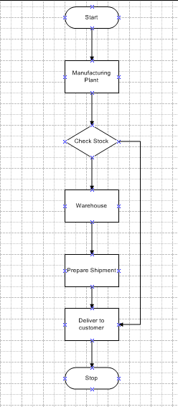

Assignment 2

Q1. Write an introduction letter to a client introducing yourself as a business analyst in charge of working with the client and his team to start the business understanding process.

Ans.

Introduction Letter
Subject: Introduction – Business Analyst for Your Project
Dear Vijaya Dairy,
I am Amandeep Singh, the assigned Business Analyst from APT IT Solutions, and I will be working with you and your team to initiate the business understanding process for your upcoming project. My primary role will be to gather requirements, document business needs, and ensure the development team delivers a solution aligned with your goals.
I look forward to collaborating closely and ensuring that your vision is successfully transformed into a working system.
Best Regards,
Amandeep Singh
Business Analyst – APT IT Solutions

Q2. Prepare a brief BRD and SRS for a project- Horoscope or Ticketing system or online store.

Ans.

Business Requirement Document (BRD) – Horoscope Application
Project Title: Online Horoscope & Astrology System
Prepared by: Amandeep Singh
Client: Divya Astrology Predictions
Date: 14/092025

1. Executive Summary
The client wants to build a digital horoscope platform where users can view their daily, weekly, and yearly horoscope predictions based on their zodiac sign or birth details. The system should also allow users to generate personalized horoscopes and consult astrologers online.

2. Objectives
- Provide daily horoscope predictions for all zodiac signs.
- Allow users to generate personalized horoscopes using birth details.
- Provide premium features such as astrologer consultation, compatibility check, and life predictions.
- Deliver the solution via mobile app and web portal.

3. Scope
In Scope:
- User registration/login.
- Horoscope prediction (daily, weekly, monthly, yearly).
- Personalized birth chart calculation.
- Compatibility check between two individuals.
- Online consultation booking.
Out of Scope:
- Payment integration with multiple currencies (phase 2).
- AI-based horoscope predictions.

4. Stakeholders
- End Users: General public, astrology enthusiasts.
- Astrologers: Provide consultation and premium content.
- Admin Team: Manage content, astrologers, and users.
- Development Team: PM, BA, Developers, QA, UI/UX.

5. Business Requirements
- BR1: Users must be able to view free horoscope predictions.
- BR2: Users should generate personalized horoscope charts.
- BR3: Users must be able to book and pay for premium astrologer consultations.
- BR4: The system should send daily notifications for horoscope updates.

6. Assumptions & Constraints
- Requires stable internet connectivity.
- Predictions provided by astrologers, system only displays them.
- Must be scalable to handle large user traffic.

Software Requirement Specification (SRS) – Horoscope Application
Project Title: Horoscope Application
Prepared by: Business Analyst
Version: 1.0

1. Introduction
This document specifies the functional and non-functional requirements for the Horoscope system. The system will provide horoscope services, birth chart generation, and online consultation.

2. Functional Requirements
- FR1: User Registration & Authentication (via email, mobile, social login).
- FR2: View Horoscope by Zodiac Sign (daily, weekly, monthly, yearly).
- FR3: Personalized Horoscope (using birth date, time, and place).
- FR4: Compatibility check between two zodiac signs/persons.
- FR5: Online consultation booking with astrologers (paid feature).
- FR6: Notification system for daily updates.
- FR7: Admin panel to manage predictions, astrologers, and users.

3. Non-Functional Requirements
- Performance: System must handle 50,000 concurrent users.
- Security: Encrypted data storage (especially user birth details).
- Availability: 99.5% uptime.
- Usability: Mobile-first design, intuitive interface.
- Scalability: Cloud-based architecture for future expansion.

4. System Interfaces
- Web Application (Responsive)
- Mobile Application (Android & iOS)
- Payment Gateway (for premium services)
- Notification Service (Push, Email, SMS)

5. Acceptance Criteria
- Users can generate and view horoscopes instantly.
- Predictions load in less than 2 seconds.
- Secure user login and data privacy maintained.
- Users receive notifications reliably.

Q3. Make an ERD of creating a support ticket/Ticketing life cycle.

ERD – Ticketing System (Support Ticket Life Cycle)

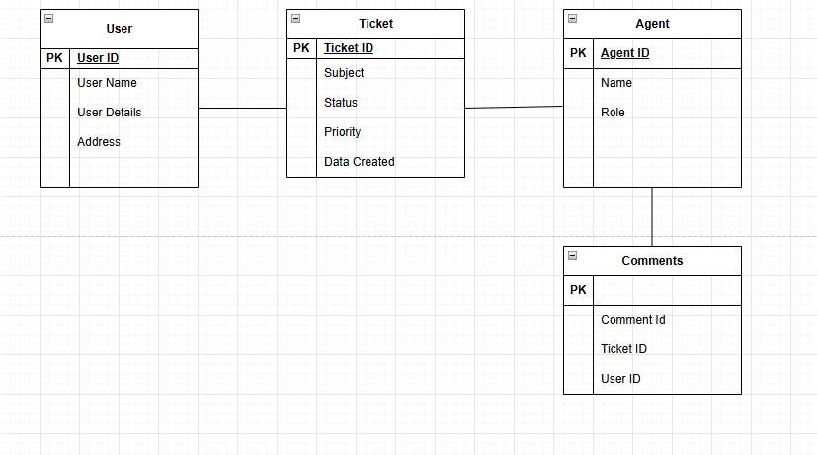

Q4. User Story of Shopping from E-commerce?

Ans.

1. Browsing Products
User Story:
As a customer,
I want to browse and search products by category, brand, and price,
So that I can easily find the items I want to purchase.
Acceptance Criteria:
- Users can search using keywords.
- Filters (price range, brand, category) are available.
- Results display product name, price, stock availability.

2. Product Details
User Story:
As a customer,
I want to view detailed product information,
So that I can make an informed purchase decision.
Acceptance Criteria:
- Product page shows name, description, price, stock status.
- High-quality product images are available.
- Customer ratings and reviews are visible.

3. Add to Cart
User Story:
As a customer,
I want to add products to my shopping cart,
So that I can purchase multiple items in a single checkout.
Acceptance Criteria:
- Cart allows adding/removing items.
- Quantity can be increased/decreased.
- Cart updates total price dynamically.

4. Checkout & Payment
User Story:
As a customer,
I want to checkout and pay securely,
So that I can complete my purchase.
Acceptance Criteria:
- Multiple payment options (Credit Card, UPI, Net Banking, Wallets).
- Billing and shipping details are required.
- Order confirmation message is displayed after payment.

5. Order Confirmation
User Story:
As a customer,
I want to receive an order confirmation email/SMS,
So that I have proof and details of my purchase.
Acceptance Criteria:
- Confirmation includes order ID, item details, price, delivery date.
- Email/SMS sent within 1 minute of order placement.

6. Order Tracking
User Story:
As a customer,
I want to track my order status online,
So that I know when to expect delivery.
Acceptance Criteria:
- Order status updates: "Processing → Shipped → Out for Delivery → Delivered".
- Tracking link provided via email/SMS.
- Real-time updates visible in user’s account.

7. Delivery
User Story:
As a customer,
I want my order delivered to my selected address,
So that I receive my products conveniently.
Acceptance Criteria:
- Delivery person contact details shared.
- Estimated delivery time displayed.
- Proof of delivery captured (OTP or signature).

8. Returns & Refunds
User Story:
As a customer,
I want to return or replace defective products,
So that I am assured of product quality.
Acceptance Criteria:
- Return request can be raised within X days.
- Refund/Replacement option provided.
- Notifications sent for return status.

