WATERFALL DELIVERABLES PART2

Document 6- Please prepare a use case diagram, activity diagram and a use case
specification document.

  - Use case Name
  - Use case Description
  - Actors Primary Actors Secondary actors
  - Basic Flow
  - ALTERNATE FLOW
  - Exceptional flows
  - Pre- Conditions
  - post-conditions
  - Assumptions
  - Constraints
  - Dependencies
  - Inputs and Outputs
  - Business Rules
  - Miscellaneous Information

USE CASE DIAGRAM
ACTIVITY DIAGRAMS

1.Submission of Application
2.Sanction of Loan by Branch Manager
3 Processing of Loan by Credit Officer
4.Loan Disbursement Process

Use Case Specification Documents:

UC01 Capture Retail Loan Application

1. Use Case Name: Capture Retail Loan Application
2. Use Case Description
Credit Officer (CO) records a new retail loan request (Home / Personal / Vehicle) in LAS by
capturing customer details, KYC, loan product selection, requested amount, collateral (if
any), income details, and uploading supporting documents. Application is saved in Draft
status.
3. Actors
Primary: Credit Officer.
Secondary: Customer (data source), LAS System UI, Document Management System (DMS)
Core Banking System (for CIF fetch), KYC/AML Service.
4. Basic Flow
- CO selects Create New Loan Application.
- CO searches for existing Customer / CIF in Core Banking; system retrieves demographics if found auto fill the details.
- If no CIF, CO initiates New Customer Onboarding mini-flow; minimal KYC captured.
- CO selects Loan Type (Home / Personal / Vehicle) and inputs requested loan amount, tenure, purpose.
- CO captures employment / income details.
- CO uploads mandatory document set; LAS stores metadata and routes files to DMS. (
- CO saves application; LAS assigns unique Application ID and sets status Draft.
- System displays confirmation and summary.
5. Alternate Flow(s)
- Customer Already Has Active Application: If search shows an active application for same loan type, system prompts CO to link or abort.
- Partial Save: CO may Save as Incomplete before all data captured; status remains Draft but flagged Incomplete for dashboard.
- Bulk Upload Mode: For mass campaigns, CO uploads spreadsheet; LAS creates multiple Draft applications; each must later be individually verified. (Dependency: Batch API)
6. Exceptional Flows
- CIF Fetch Failure: If Core Banking not reachable, allow manual capture; mark Pending-CIF-Validation.
- Duplicate CIF Mismatch: Entered KYC conflicts with retrieved CIF; system blocks save until resolved or override with Supervisor credentials.
- Mandatory Fields Missing: System validation prevents save; error list shown.
7. Pre-Conditions
- CO authenticated into LAS with create privileges.
- Branch mapping to CO defined in user profile.
- Product & parameter master for retail loans loaded.
8. Post-Conditions
- Application ID created in LAS.
- Status = Draft (or Draft-Incomplete).
- Uploaded docs reference stored in DMS.
- Audit log of creation.
9. Assumptions
- CIF master in Core Banking is authoritative source of customer identity.
- CO has scanned docs available at time of capture (or will upload later).
- Network connectivity usually available; offline capture not in scope.
10. Constraints
- Mandatory KYC per regulator must be completed before submission upstream.
- Maximum attachment size per doc (configurable).
- Data entry session timeout (security).
- CIF search limited by branch access permissions.
11. Dependencies
- Core Banking Customer API.
- KYC/AML validation service.
- DMS / File Store integration.
- Product Parameter Master.

12. Inputs and Outputs
Inputs: Customer ID/CIF, personal details, product type, loan amount, tenure, income,
collateral data, documents (KYC, income proof, property docs, vehicle quotation, etc.).
Outputs: Application ID, Draft record, error/validation messages, audit entry, DMS doc
references.

13. Business Rules (Applicable)
- Mandatory doc checklist enforced by Loan Type and Ticked Size
- Only One active application per customer per Loan Type unless over ride flagged.
14. Miscellaneous Information
- Screen should auto-populate customer fields from CIF on match.
- Configurable mandatory field matrix by Loan Type.
- Capture geolocation of branch & officer for audit.
- Consider scanner integration / mobile capture for remote branches.

UC02 Verify Documents & Compute Eligibility

1. Use Case Name: Verify Documents & Compute Eligibility
2. Use Case Description
Credit Officer validates completeness & quality of uploaded documents, runs
system-assisted eligibility (income ratios, LTV, existing liabilities), triggers credit bureau
pull, and records appraisal data where applicable. Results determine whether the
application can be forwarded to Branch Manager.
3. Actors
Primary: Credit Officer.
Secondary: LAS Eligibility Engine, Credit Bureau Interface, Valuation / Collateral Service,
DMS, Core Banking Liability Fetch Service.
4. Basic Flow
- CO opens a Draft application and selects Verify & Assess.
- System displays required doc checklist by Loan Type.
- CO marks each doc as Received / Legible / Pending.
- System fetches customer existing liabilities & delinquency from Core Banking.
- CO enters income & obligation details; system auto-calculates FOIR / DBR ratios.
- CO triggers Credit Bureau pull; score & trade lines returned.
- For secured loans (Home / Vehicle), CO captures collateral value / quotation; system computes Loan-to-Value (LTV).
- Eligibility summary generated (Pass / Conditional / Fail) with key metrics.
- CO updates remarks and saves assessment results to application record.
5. Alternate Flow(s)
- Auto Eligibility Pass: If all rules satisfied and within BM delegation, LAS may flag Fast-Track eligible.
- Conditional Eligibility: Minor doc gaps allowed if acceptable per policy; flagged for BM review.
- Manual Override: CO can propose override with justification; requires BM approval.
6. Exceptional Flows
- Credit Bureau Timeout: System retries; if still failing, mark Pending-Bureau and prevent submission upstream until resolved or override.
- Data Inconsistency: Reported income conflicts with tax statement > tolerance.
- LTV > Max Allowed: System warns; require justification or adjust loan amount.
7. Pre-Conditions
- Application exists in Draft.
- Required minimum customer data captured.
- CO has verification role.
8. Post-Conditions
- Eligibility metrics stored (FOIR, DBR, LTV, Bureau Score, etc.).
- Verification status = Verified-Complete | Verified-Conditional | Verified-Issues.
- Ready (or not) for submission to Branch Manager.
9. Assumptions
- Real-time APIs to bureau and core banking return within SLA.
- Policy parameters maintained centrally in LAS.
- Collateral valuation amounts entered by CO are validated later by approvers / external valuers.
10. Constraints
- Regulatory caps e.g., LTV for housing as per regulator (configurable).
- Data aging rules (income docs valid 60 days).
- Bureau inquiry limits per customer per day.
11. Dependencies
- Eligibility/Scoring Engine rules table.
- Credit Bureau Interface.
- Liability aggregation service.
- Collateral valuation service.
12. Inputs and Outputs
Inputs: Application ID, captured financial data, doc checklist, bureau data, liabilities data,
collateral data.
Outputs: Eligibility result, computed ratios, verification flags, exception alerts, audit log.
13. Business Rules (Applicable)
- Financial docs (salary slips, IT returns) valid 60 calendar days from issue date
- Max 3 bureau pulls per customer per 7 days (prevent score impact & cost).
14. Miscellaneous Information
- Provide visual dashboard of eligibility metrics vs policy thresholds (green/amber/red).
- Export assessment to PDF for record.
- Auto-calc EMI suggestion at different tenures.

UC03 Submit Application to Branch Manager

1. Use Case Name: Submit Application to Branch Manager
2. Use Case Description
Credit Officer formally submits a verified loan application to the Branch Manager (BM) for
credit decision within the BM’s delegation limits. Application status moves from Draft (or
verified) to Submitted-BM.
3. Actors
Primary: Credit Officer.
Secondary: Branch Manager, LAS Workflow Engine, Notification Service (Email/SMS)
4. Basic Flow
- CO selects Submit to Branch Manager from an application in Verified state.
- System runs submission validations (mandatory docs, eligibility computed, no blocking exceptions).
- CO adds covering note / comments for BM.
- LAS updates status to Submitted-BM and assigns application to mapped BM queue.
- Notification sent to BM with summary metrics.
- Audit record created (submit timestamp, user ID).
- Application locked from further edit by CO except Recall (if allowed). (BR-20)
5. Alternate Flow(s)
- Recall by CO: Until BM opens case, CO may recall to Draft for correction.
- Auto-Submit Threshold: System auto-submits after X hours once verification complete if CO has not acted.
6. Exceptional Flows
- Pending Critical Exceptions: If unresolved critical issues remain (e.g., missing KYC), system blocks submission; error list displayed.
- BM Mapping Missing: If no BM mapped to branch, escalate to admin queue; CO alerted.
7. Pre-Conditions
- Application verified (UC02) or flagged conditional with allowed gaps.
- CO role permits submission.
- BM mapping available.
8. Post-Conditions
- Status = Submitted-BM.
- BM queue updated.
- Notifications sent.
- Application locked for CO edits (subject to recall rule).
9. Assumptions
- Only one BM per branch at a time for workflow routing (else load balancing rule).
- BM has SLA dashboard.
10. Constraints
- Submission window cut-off (e.g., 8 PM local) for same-day SLA start.
- Max attachments size aggregated may not exceed threshold for routing; else compress.
11. Dependencies
- User-role & Branch hierarchy master.
- Notification gateway.
- Workflow routing rules engine.
12. Inputs and Outputs
Inputs: Verified Application, comments, attachments.
Outputs: Status change, BM notification, audit entry.
13. Business Rules (Applicable)
- BM must be notified within 5 minutes of submission (real-time or near).
- Auto-submit after 24 hrs of Verified Complete if CO inaction.
14. Miscellaneous Information
- Provide submit checklist preview before final click.
- Show SLA timer starting once BM notified.

UC04 Branch Manager Decision (Approve / Reject / Escalate)
1. Use Case Name: Branch Manager Decision (Approve / Reject / Escalate)
2. Use Case Description
Branch Manager reviews submitted retail loan application, evaluates eligibility, risk flags,
and supporting docs; decides to Approve (within delegation), Reject, Return to CO for
clarification, or Escalate to Regional Office if amount exceeds delegation or risk triggers
require higher approval.
3. Actors
Primary: Branch Manager.
Secondary: Credit Officer, LAS Workflow Engine, Risk/Score Engine, Notification Service,
DMS, Core Banking Exposure Service.
4. Basic Flow
- BM opens an item from My Approval Queue.
- System displays summary dashboard: loan details, eligibility ratios, bureau score, collateral data, doc checklist.
- BM reviews and may request additional info (comment to CO).
- BM selects decision action: Approve, Reject, Return-to-CO, or Escalate-to-RO.
- If approve within delegation: BM records sanction terms (amount, rate, tenure adjustments).
- System validates BM delegation vs sanctioned amount.
- Status updated accordingly: Approved-BM, Rejected, Returned-CO, or Escalated-RO.
- Notifications triggered to relevant parties.
- Audit logged (decision, timestamp, user, comments).
5. Alternate Flow(s)
  - Conditional Approval: BM approves subject to pending documents; flags conditions to be met before disbursement.
  - Counter Offer: BM modifies loan amount/tenure based on policy and records counter; CO must obtain customer acceptance.
  - Auto-Escalate on Delegation Breach: If sanctioned amount > BM limit, system forces Escalate path; BM cannot finalize Approve.
6. Exceptional Flows
  - Risk Score Deterioration: If new adverse data since submission (e.g., updated bureau), system warns BM; BM may override with justification.
  - Document Tampering Detected: DMS checksum mismatch; BM halts decision; escalates to Fraud Ops.
  - SLA Breach Imminent: If decision not taken within SLA threshold, escalate to BM supervisor.
7. Pre-Conditions
- Application status Submitted-BM.
- BM authenticated with approval role.
- Delegation matrix loaded.
8. Post-Conditions
- Status updated per decision.
- Sanction terms captured (if approved).
- Escalation record created (if escalated).
- Audit updated.
9. Assumptions
- BM can view supporting docs in-line (PDF viewer).
- BM has access to risk & exposure data for customer.
- Single decision per application version; re-decision requires new version.
10. Constraints
- BM delegation ceilings by product & risk grade.
- Turnaround SLA (e.g., 2 business days).
- Maker-checker segregation—BM cannot alter applicant identity fields.

11. Dependencies
- Delegation matrix master.
- Risk/Score refresh service.
- Notification engine.
- DMS viewer services.
12. Inputs and Outputs
Inputs: Submitted application, eligibility metrics, docs, risk data.
Outputs: Decision outcome, sanction terms, escalation record, notifications, audit.
13. Business Rules (Applicable)
- System validates BM sanction <= BM Delegation Limit; else force escalate.
- Decision notifications must include sanction summary / reasons.
14. Miscellaneous Information
- Provide inline policy hints when BM attempts sanction beyond range.
- Quick links to past customer relationships at branch.
- Configurable decision templates for faster sanction note drafting.

UC05 Regional Manager Decision & Sanction Recommendation

1. Use Case Name: Regional Manager Decision & Sanction Recommendation
2. Use Case Description
Regional Manager (RM) at Regional Office reviews applications escalated from branches
(due to delegation limits or risk triggers). RM can Approve (within regional delegation),
Reject, Return to Branch for additional info, or Recommend further escalation (e.g., Zonal
/ Head Office depending on bank policy—out of current scope but placeholder
maintained). Resulting status moves to Approved-RO or Rejected (or backflow states).
3. Actors
Primary: Regional Manager.
Secondary: Branch Manager, Credit Officer, LAS Workflow Engine, Risk/Score Refresh,
DMS, Higher Authority Placeholder Actor (HO), Notification Service.
4. Basic Flow
- RM opens Escalated-RO application queue.
- System displays full branch decision trail, comments, eligibility metrics, and delegation reason.
- RM reviews docs & risk; may request clarification from BM/CO via system notes.
- RM enters decision: Approve, Reject, Return-to-BM, or Escalate-Higher.
- If Approve within RM delegation, RM records sanction terms (may override BM proposal).
- LAS validates against RM delegation matrix.
- Status updated to Approved-RO (or other outcome).
- Notifications issued to BM & CO.
- Audit log updated.
5. Alternate Flow(s)
  - Co-Approval Required: Certain risk grades require joint approval by two RM signatories; LAS enforces dual authentication.
  - Policy Exception Request: RM can approve subject to Head Office ratification; flagged Pending-HO.
  - Revised Terms: RM reduces sanction amount to fall within delegation; system tracks variance from requested & BM proposal.
6. Exceptional Flows
  - Escalation Loop Detected: Application repeatedly returned between BM & RM; LAS flags to Operations Control.
  - Delegation Not Found: RM role not mapped; escalate to admin.
  - SLA Breach: RM review aging triggers escalations.
7. Pre-Conditions
- Application status Escalated-RO.
- RM authenticated & mapped to region.
- Delegation & dual-approval rules loaded.
8. Post-Conditions
- Status moved to Approved-RO | Rejected | Returned-BM | Escalated-Higher.
- Sanction terms captured.
- Audit & notification records updated.
9. Assumptions
- RM has visibility to branch comments & docs without re-upload.
- RM decisions override BM where policy permits.
- Higher authority flows may be implemented later; placeholder kept for extensibility.
10. Constraints
- RM delegation ceilings by product, collateral class, and risk grade.
- Dual authentication enforced where required.
- SLA for RM decision (e.g., 2 business days after escalation).
11. Dependencies
- Regional hierarchy & delegation master.
- Notification engine.
- Audit trail service.
- Potential HO escalation interface.
12. Inputs and Outputs
Inputs: Escalated application, BM sanction proposal, docs, risk metrics.
Outputs: RM decision, revised sanction terms, escalation/return notes, audit.
13. Business Rules (Applicable)
- RM may restructure sanction parameters; must remain within RM delegation & policy.
- Dual approval required for high-risk grades / large ticket thresholds.
14. Miscellaneous Information
- Provide side-by-side comparison: Requested vs BM Proposed vs RM Sanction.
- Ability to attach Regional Sanction Memo.

Document 7- Screens and pages
Please follow the following steps to create the mock-ups
- Kindly use Balsamiq or Axure.
- Always start with a home page of an application.
- Take a feature and follow it to the end
    - Eg: Home page of SCRUM Foods
    - Select Login- Create a login page
    - Let’s assume, you want to search a restaurant
    - Search Page- Type the restaurant name and select the dish
    - Add to cart page
    - Payment page
    - Logout Page

Balsamiq LAS Registration Page
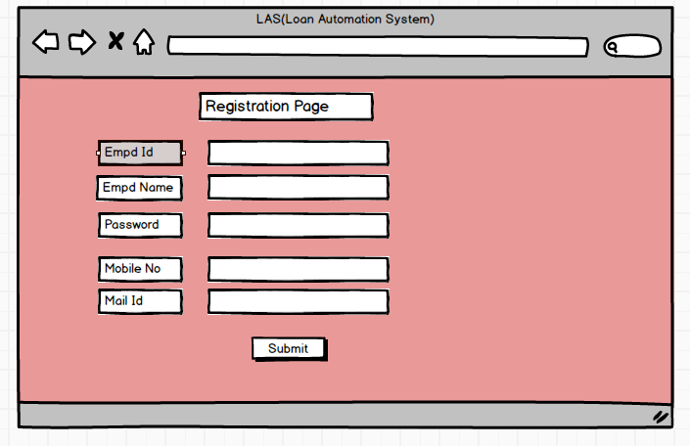

Balsamiq LAS Login Page
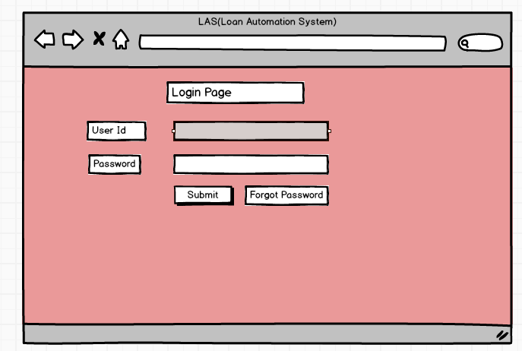
Balasmiq LAS Home Page
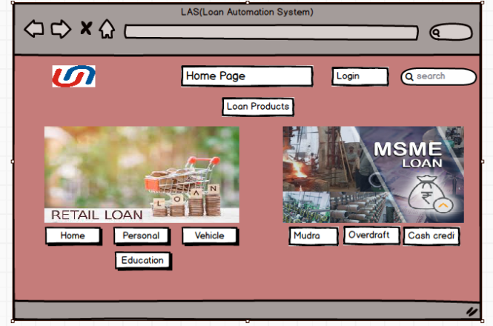

Axure Loan Sanction Page
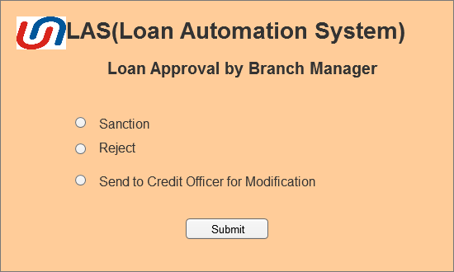

Axure Sanction Letter Generation
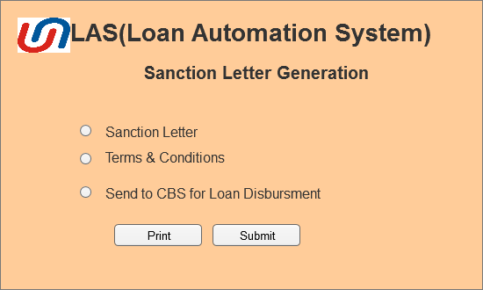

Document 8 Tools – Visio and Axure
Write a paragraph on your experience using Visio and Axure for the project.
As a Business Analyst for the Loan Automation System (LAS) project, I leveraged MS Visio and Axure to effectively visualize and streamline business processes. Using MS Visio, I created detailed process flow diagrams, use case diagrams, and activity diagrams to represent both the current (AS-IS) and proposed (TO-BE) workflows, enabling stakeholders to clearly understand system operations and process improvements.
Additionally, I utilized Axure to develop interactive wireframes and mock-ups for key LAS modules, facilitating early validation of UI/UX designs and functional requirements. These tools were instrumental in enhancing communication between stakeholders, developers, and testers, and in ensuring alignment of the LAS system with business goals and user expectations.

Document 9 – BA Experience
My Experience as BA in following Phases:
As a Business Analyst for the Loan Automation System (LAS) project, I was involved in end-to-end project execution, contributing significantly across all phases of the Software Development Life Cycle (SDLC).
1. Requirement Gathering Phase
In this phase, I employed the MOSCOW technique to prioritize and capture business requirements effectively. Due to occasional unavailability of the client, I proactively identified alternative stakeholders on their side to avoid project delays. I ensured the accuracy and completeness of requirements using the FURPS model, and removed duplicate or conflicting inputs to maintain clarity. I also used prototyping tools to visualize user requirements and improve communication between the business and technical teams.
2. Requirement Analysis Phase
I analysed and validated the gathered requirements using modelling techniques. I created UML diagrams, use case diagrams, and activity diagrams to clearly illustrate system behaviour and workflows. These visual artifacts helped stakeholders better understand the system. I conducted regular review sessions with the team to refine diagrams and incorporate feedback. Deliverables from this phase included the finalized Business Requirement Specification (BRS) and System Requirement Specification (SRS) documents.
3. Design Phase
During this phase, I collaborated with the design and QA teams to derive test cases from use case diagrams—covering both positive and negative scenarios. I ensured no test case was missed, as that could affect system quality later. I was responsible for preparing test data and maintaining the Requirement Traceability Matrix (RTM) to ensure that all requirements were addressed in design and testing. I also communicated the design solutions and documents to the client for validation and sign-off.
4. Development Phase
To support the development team, I facilitated JAD (Joint Application Development) sessions, addressing their queries and clarifying requirements. I navigated interpersonal and communication challenges by conducting one-on-one discussions with non-cooperative team members, emphasizing the impact of their contributions on project success. I conducted regular sync-up meetings with developers and clients to track progress, and when someone missed a session, I ensured they received recorded content and a follow-up discussion to keep them aligned.
5. Testing Phase
I was actively involved in the preparation and validation of test cases, ensuring coverage of all use cases. I supported high-level testing, coordinated with clients to obtain accurate test data, and updated the RTM accordingly. I worked closely with QA teams and business stakeholders to prepare for User Acceptance Testing (UAT), facilitated dry runs, and obtained formal sign-off from the client upon completion of successful testing cycles.
6. Deployment Phase
As the project transitioned to deployment, I compiled and shared the final RTM to be included in the project closure documentation. I coordinated with stakeholders to prepare end-user manuals, ensuring they were user-friendly and comprehensive. I also organized and conducted training sessions for all relevant users, taking extra measures to ensure maximum participation and readiness for the go-live environment.

