AGILE DOCUMENTS-PART-2

- Document 1:- Definition of Done
Ans.1.) In Agile development, the Definition of Done (DoD) is a shared checklist that outlines the specific criteria that must be met before a user story, feature, or other backlog item can be considered complete. It's a team-agreed upon set of conditions that ensures work is not just started but finished to a consistent level of quality, ensuring readiness for release or further development.
Example outlining DOD:-
The Definition of Done is a quality gate, a checklist that moves a task from "in progress" to "done". It's not just about finishing the code; it's about completing all necessary steps to ensure the work is usable, reliable, and ready for the next stage.

Key elements of a DOD:-

Coding standards: - Code is written according to defined standards, is peer-reviewed, and checked into the repository.

Testing: - Unit tests, integration tests, and regression tests are completed and passed.

Deployment: Code is deployed to a test environment and passes all required tests.
Acceptance: The Product Owner tests the feature and confirms it meets all acceptance criteria (e.g., can search for specific keywords, returns relevant results, etc.) and confirms the feature is working as expected
No Known Defects: The completed work is free of known, significant defects or has a plan for addressing them.
Acceptance criteria: All acceptance criteria associated with the user story or feature are met.

Q.2) Product vision?
Ans.2)

Scrum Project name: | Automation software (Smartcare 360)
Venue: | Havells India Ltd
Date: 30-7-2025 | Start time: | End time: | Duration:
Client: | Havells India Ltd
Stakeholder list: | Production Deptt | Quality Deptt | Maintenance Deptt
 | PPC | Store Deptt | Utility Deptt
Scrum Team
Scrum master: | Mr. Sumit Pandey
Product owner: | Mr. Anil | Mr. Sher Sharma
Scrum developer 1 | Jyoti chaturvedi | Neha Pandey
Scrum developer 2 | Varsh Yadav | Neeraj Shukla
Scrum developer 3 | Sudarshan | Ajay

Vision:- The vision behind developing this project is to provide a platform to all stakeholder which provide central and transparent system software where each individual can set their goals & track their progress day in day out which help them and organisation to meet KPI’s and have progressive growth as whole.
Target group  The target user are all core functional areas involved in manufacturing process. | Needs  It solves the problem related to inefficient manufacturing process having low OEE, low productivity, high energy cost etc. | Product  It is a automation software system module  The features including dashboards for each domain having all area covered makes it desirable  As it is scratch project and already available in different domains, it is feasible to develop the project | Value  It will help in organisational growth as meeting all the key indicators.  Business goal is develop an efficient and productive manufacturing environment

Q.3) Document 3:- User Stories
Ans.3)
User story no: 1 | Tasks: 1 | Priority: High
Value Statement:
As a user I want to sign up for the application

So that, I can start using application
BV: 200 | CP: 10
Acceptance criteria:
The sign up process must contain all necessary details associated with user.
It must return the result successfully sign-up when all the criteria is met
The system must send the successful sign up notification on email and registered phone no.

User story no: 2 | Tasks: 2 | Priority: High
Value Statement:
As a user, I want to login into software,

So that, I can start using the features of application
BV: 200 | CP: 10
Acceptance criteria:
The login feature must meet the defined criteria such as user name & password
Login feature must return the result ’succefully logged in’
User must be able to access all the features on domain

User story no: 3 | Tasks: 3 | Priority: Medium
Value Statement:
As a user, I want to reset my password

So that I can change my password in case I forgot my password
BV: 200 | CP: 10
Acceptance criteria:
The reset password must meet the criteria before resetting is done.
When user wants to reset password it must send link to registered email id.
Resetting of password must contain defined set of rules for password.

User story no: 4 | Tasks: 4 | Priority: High
Value Statement:
As a user, I want have access to input data

So that, I can write or input data whenever found any fault or redundancy
BV: 200 | CP: 10
Acceptance criteria:
The access to feed input data for any domain must have authorization password
It must be linked to higher hierarchy to get authorized permission to change or manipulate data

User story no: 5 | Tasks: 5 | Priority: Medium
Value Statement:
As a user, I want to export data from the application

So that, I can view the data for future references.
BV: 200 | CP: 10
Acceptance criteria:
Export data must contain excel hypertext extension link associated with it
It must be downloaded and can be saved as MS office platform.

User story no: 6 | Tasks: 6 | Priority: Low
Value Statement:
As a user, I want to register complaint or feedback for application

So that, I can generate a complaint or provide feedback in case of any bugs or issue or provide feedback on improvement of this application
BV: 200 | CP: 10
Acceptance criteria:
Registering a complaint must contain defined set of condition such as domain name, priority, description of issue
Lodging a complaint must return a result of successful logged with ticket no.

Q.4) Document 4:- Agile PO experience
Ans.4) The product owner has a vision of the product owner keeping the domain and industry experience and market need.
In Agile, product owner successfully leads cross-functional teams through iterative development cycle, translating business goals into actionable user stories and prioritizes backlogs. The product owner works closely with stakeholders to define product vision and strategy, ensuring alignment with customer needs and market trends.
The product owner experience includes facilitating sprint planning, sprint reviews, sprint retrospective within Scrum and Kanban frameworks, enabling continuous delivery of high value features. The product owner experience includes gaining knowledge on agile principles to foster collaboration, transparency and adaptability, resulting in improved team velocity, reduced time to market and enhanced product quality. Through data driven decision making and user feedback loops. The Product owner consistently delivered impactful solution that drive business growth.
From this Project, I have learned to handle sprint meetings such as
Daily scrum meeting
Sprint review meeting
Sprint retrospective meeting
Backlog refinement meeting
Also user stories creation and what things included in user stories such as
Story no
Tasks
Priority
Acceptance criteria
Business value
Complexity points

Q.5) Document 5:- Product and Sprint backlog and product owner and sprint burndown chart?
Ans)
Product Backlog:
User Story Id | User story | Tasks | Priority | BV | CP | Sprint
US_1 | As a user I want to register for application | 1 | High | 8 | 5 | Sprint 1
US_2 | As a user, I want to login for application | 2 | High | 6 | 5 | Sprint 2
US_3 | As a user, I want to reset my password | 3 | Medium | 3 | 3 | Sprint 3
US_4 | As an admin, I want to access all features of domain | 4 | High | 10 | 5 | Sprint 4
US_5 | As a user I want raise tickets for any complaint | 5 | Low | 5 | 3 | Sprint 5

Sprint Backlog:
User story Id | User story | Tasks | Owner | Status | Estimated efforts
US_1 | Registration page | 1 | Manufacturing | Done | 3
US_2 | Login page | 2 | Manufacturing | Done | 2
US_3 | Domain page | 3 | HOD | Pending | 3
US_4 | Dashboard feature | 4 | HOD/Engineers | Pending | 5

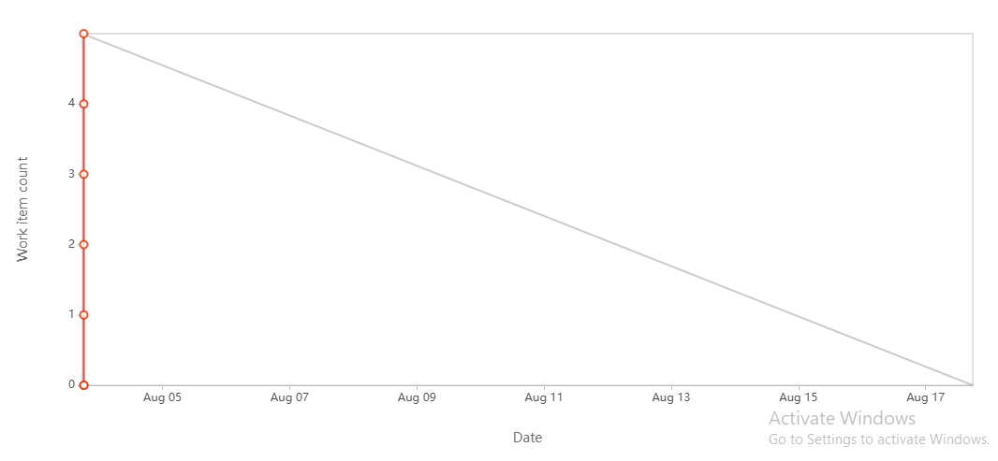

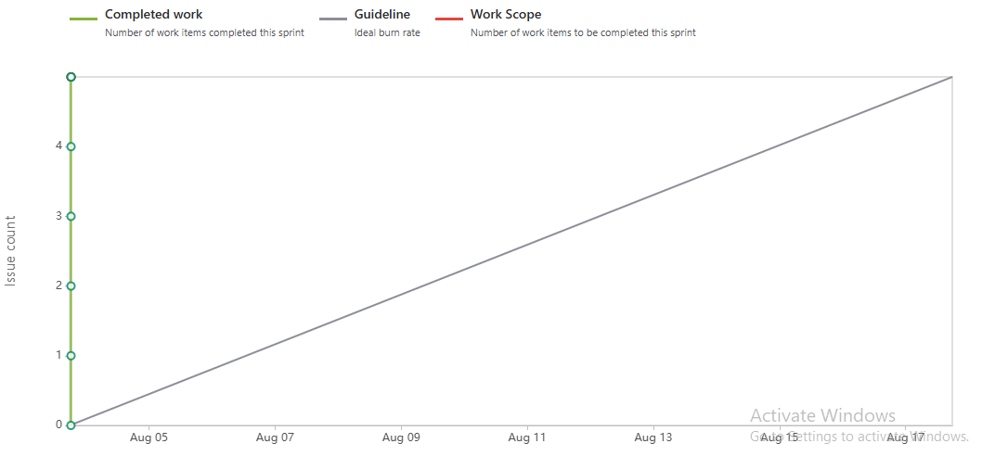

Q.6) Document 6:- Sprint meetings
Ans.6)
Meeting type 1: Sprint planning meeting
Date: | 30-07-25
Time: | 10.00 a.m.
Location: | Neemrana
Prepared by: | Sumit Pandey
Attendees: | 6 people

Agenda Topics:
Topic | Presenter | Time allotted
Refining requirements from different domain user | Mr. Vijay | 30 mins
Discussion on dashboards designs | Mr. Ajay | 30 mins

Other information:
Observer | Mr. Anil
Resources | Projector, Laptop, Internet access, Conference room
Special notes

Meeting type 2: Sprint review meeting
Date: | 31-07-25
Time: | 10.00 a.m.
Location: | Neemrana
Prepared by: | Sumit Pandey
Attendees: | 6 people

Sprint status | Things to demo | Quick updates | What’s next
Prototype designing of utility dashboard | Data allocation and design for utility domain | Designing is partially completed | Collection of critical data and automating with existing system

Meeting Type 3: Sprint retrospective meeting
Date: | 30-07-25
Time: | 10.00 a.m.
Location: | Neemrana
Prepared by: | Sumit Pandey
Attendees: | 6 people

Agenda | What went well | What didn’t go well | Question | References
Discussion on ESG dashboards and automation solution | Data collection and prototyping | Integration of New system with existing system | How older data can integrated with new system

Meeting type 4: Daily Stand-up meeting

Question | Name/role | Week ( 28-07-25 to 02-08-25)
Question | Name/role | Mon | Tue | Wed | Thur | Fri | Sat
What did you do yesterday | Developer 1 | Requirement | Requirement gathering | Refining requirements | Prepare user stories | Working on user stories | Presenting porotypes
What did you do yesterday | Developer 2 | Meeting with stakeholder | Understanding existing system | Refining requirements | Making prototypes | Working on porotypes | Working on other req.
What will you do today | Developer 1 | Meeting with stakeholders | Integration of old system with new | Integration of old system with new | Integration of old system with new | Making prototype of dashboards
What will you do today | Developer 2 | Taking up issues from stakeholders | Taking up issues from stakeholders | Taking up issues from stakeholders | Working to fix bugs | Working to fix bugs | Working to fix bugs
What is blocking your progress | Developer 1 | Change requirements | Change requirements | Change requirements | Issue in integration of old data with new | Issue in integration of old data with new | Issue in integration of old data with new
What is blocking your progress | Developer 2 | Issue in local LAN server | Issue in local LAN server | Issue in local LAN server

