Q.1. Document 1: Definition of Done
Ans. Definition of Done is a shared checklist that ensures a backlog item is complete and meets quality standards. For IDSCD, the DoD includes:
- Acceptance criteria met for each dashboard feature (e.g., compliance alerts, audit logs)
- Code developed and deployed in a test environment identical to production
- Unit tests written and passed for each module
- UX design approved for wireframes (Balsamiq)
- QA testing completed and issues resolved
- Peer code review performed
- Documentation updated (RTM, user guides)
- Product Owner sign-off after sprint review
- Refactoring completed for optimized performance
- Configuration changes documented
Q.2. Document 2- Product Vision
Ans.
Scrum Project Name: IDSCD – Integrated Drug Safety & Compliance Dashboard
Venue: Abbvie Health Virtual Lab, Hyderabad
Date: 01 August 2025 |  | Start time: 10:00 AM | End time: 12:30 PM | Duration: 2 hours 30 minutes
Client: Medline India
Stakeholder list:
PV Analysts
Regulatory Affairs Team
QA Managers
IT Support Team
Product Owner
Business Analyst
Scrum Team
Scrum Master: Mr. Ramesh Kumar
Product owner: Isha Joshi
Scrum Developer 1: Priya Sharma
Scrum Developer 2: Arjun Mehta
Scrum Developer 3: Sneha Patil
Scrum Developer 4: Rahul Deshmukh
Scrum Developer 5: Kavita Joshi
Vision: To build a centralized, real-time dashboard that enhances pharmacovigilance operations, ensures regulatory compliance and streamlines adverse event tracking for Medline India.
Target group  Pharmaceutical safety teams, regulatory officers and internal QA departments. | Needs  1. Real-time visibility into adverse event cases  2. Automated compliance alerts  3. Audit-ready documentation and logs  4. Integration with legacy PV systems |  | Product  A web-based dashboard with modular features including AE tracking, compliance alerts, audit logs and reporting tools. | Value  1. Strengthens regulatory governance  2. Reduces manual workload  3. Improves ROI through operational efficiency  4. Positions Medline India as a tech-enabled PV leader

Q.3. Document 3: User stories
Ans.
User story No: US-001 |  | Tasks: 2 (Design AE intake module, integrate with legacy PV system) | Priority: High
Value statement: As a PV analyst, I want to view real-time AE case metrics so that I can detect safety signals faster.
BV: 500 | CP: 13
Acceptance criteria:

- AE data auto-populates from intake sources
- Dashboard displays severity, country and report date
- Filters available for signal detection

User story No: US-002 |  | Tasks: 3 (View AE case metrics, filter cases by severity and country, generate signal detection reports) | Priority: High
Value statement: As a PV Analyst, I want to access real-time adverse event data so that I can detect safety signals quickly and report them efficiently.
BV: 200 | CP: 08
Acceptance criteria:

- Dashboard displays AE count, severity and country
- Filters allow sorting by date and drug name
- Exportable reports available in PDF/Excel format

User story No: US-003 |  | Tasks: 3 (Monitor compliance timelines, receive alerts for overdue submissions and access audit logs) | Priority: High
Value statement: As a Regulatory Affairs Officer, I want automated alerts for compliance deadlines so that I can ensure timely submissions and avoid penalties.
BV: 500 | CP: 13
Acceptance criteria:

- Alerts triggered 7 days before due dates
- Dashboard shows submission status
- Audit logs are timestamped and downloadable

User story No: US-004 |  | Tasks: 3 (Review dashboard modules for quality, validate data accuracy and approve release readiness) | Priority: Medium
Value statement: As a QA Manager, I want to validate dashboard functionality so that I can ensure it meets quality standards before deployment.
BV: 100 | CP: 05
Acceptance criteria:

- QA checklist completed for each module
- Bugs tracked and resolved in JIRA
- Final sign-off documented

User story No: US-005 |  | Tasks: 3 (Manage backend integration, ensure uptime and performance, provide technical support | Priority: Medium
Value statement: As an IT Support Engineer, I want to monitor system performance so that I can ensure the dashboard runs smoothly without downtime.
BV: 200 | CP: 20
Acceptance criteria:

- System uptime ≥ 99%
- API integrations tested and stable
- Support tickets resolved within SLA

User story No: US-006 |  | Tasks: 3 (Prioritize backlog items, review sprint outcomes and align features with business goals) | Priority: High
Value statement: As a Product Owner, I want to manage the product roadmap so that I can deliver high-value features aligned with stakeholder needs.
BV: 500 | CP: 08
Acceptance criteria:

- Backlog items prioritized using MoSCoW
- Sprint reviews conducted with stakeholders
- Roadmap updated after each sprint

User story No: US-007 |  | Tasks: 3 (Elicit requirements, create wireframes and RTM, facilitate sprint planning) | Priority: High
Value statement: As a Business Analyst, I want to document requirements and create wireframes so that the development team can build features accurately.
BV: 200 | CP: 08
Acceptance criteria:

- Wireframes approved by stakeholders
- RTM maps all requirements to features
- Sprint planning includes BA inputs

Q.4. Document 4: Agile PO Experience
Ans. Product Owner Responsibilities in IDSCD:
- Market Analysis: Identified need for centralized PV dashboards in pharma
- Enterprise Analysis: Compared existing tools and gaps in compliance tracking
- Product Vision: Defined modular dashboard with real-time metrics
- Roadmap: Planned 4 sprints with feature-based delivery
- Feature Management: Prioritized AE tracker, compliance alerts, audit logs
- Backlog Management: Created and refined user stories with BA
- Iteration Progress: Reviewed sprint outcomes, reprioritized based on feedback
- Sprint Meetings: Participated in planning, review, retrospective and backlog grooming
- The product owner also looks into the user stories creation and what things will be included in user stories such as story no, tasks, priority, acceptance criteria, BV & CP value.
- In Scrum, a product owner serves as the liaison between multiple areas of an organization, communicates with business stakeholders and collaborates closely with scrum teams to keep all areas of the business informed on a project's development.
- The product owner develops a vision of a product's function and operation, which in turn allows this scrum team member to define product features and break those features into product backlog items.
Q.5. Document 5: Product and sprint backlog and product and sprint burndown charts
Ans. Product backlog:
User story ID | User story | Tasks | Priority | BV | CP | Sprint
US-001 | AE Intake Module | Design UI, integrate DB | High | 200 | 08 | Sprint 1
US-002 | PV Analyst Dashboard | View AE metrics, filter cases, generate reports | High | 200 | 08 | Sprint 1
US-003 | Requirement Elicitation & Wireframes (BA) | Conduct workshops, create RTM, design wireframes | High | 200 | 08 | Sprint 1
US-004 | Compliance Alert System | Set alert rules, configure timelines, test notifications | High | 500 | 13 | Sprint 2
US-005 | Audit Log Dashboard | Create log structure, enable export, timestamp entries | Medium | 100 | 05 | Sprint 2
US-006 | Regulatory Affairs Dashboard | Monitor timelines, receive alerts, access logs | High | 500 | 13 | Sprint 2
US-007 | Role-Based Access Module | Define roles, assign permissions, test login flows | Medium | 200 | 08 | Sprint 3
US-008 | QA Validation Workflow | QA checklist, bug tracking, release approval | Medium | 100 | 05 | Sprint 3
US-009 | IT Performance Monitoring | Backend integration, uptime tracking, support ticketing | Medium | 200 | 20 | Sprint 3
US-010 | Product Roadmap Management (PO) | Prioritize backlog, review sprints, update roadmap | High | 500 | 08 | Sprint 4

Sprint backlog:
User story ID | User story | Tasks | Owner | Status | Estimated effort
US-001 | AE Intake Module | Design UI, integrate DB, test data flow | Scrum Dev 1 | Work In Progress | 8 hours
US-002 | PV Analyst Dashboard | Create filters, build metrics view, enable export | Scrum Dev 2 | Not Started | 10 hours
US-003 | Regulatory Affairs Dashboard | Build submission tracker, integrate alerts, enable audit access | Scrum Dev 2 | Not Started | 13 hours
US-004 | Compliance Alert System | Configure alert rules, test notifications, validate timelines | Scrum Dev 3 | Work In Progress | 13 hours
US-005 | QA Validation Workflow | Create QA checklist, bug tracking setup, release approval flow | Scrum Dev 3 | Not Started | 05 hours
US-006 | Audit Log Dashboard | Design log structure, enable export, timestamp entries | Scrum Dev 4 | Done | 05 hours
US-007 | IT Performance Monitoring | Backend integration, uptime tracking, support ticketing setup | Scrum Dev 4 | Work In Progress | 20 hours
US-008 | Role-Based Access Module | Define roles, assign permissions, test login flows | Scrum Dev 5 | Work In Progress | 08 hours
US-009 | Product Roadmap Management (PO) | Prioritize backlog, review sprint outcomes, update roadmap | Product Owner | Work In Progress | 08 hours

Product burndown chart:
Tracks overall progress across sprints
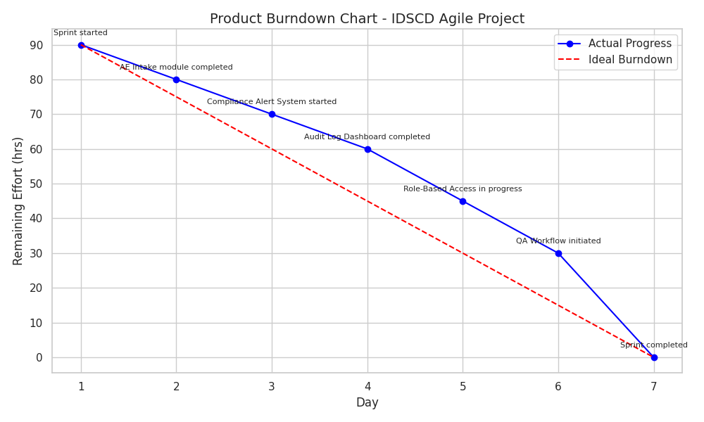

Sprint burndown chart:
Daily effort vs. remaining work visualized for each sprint
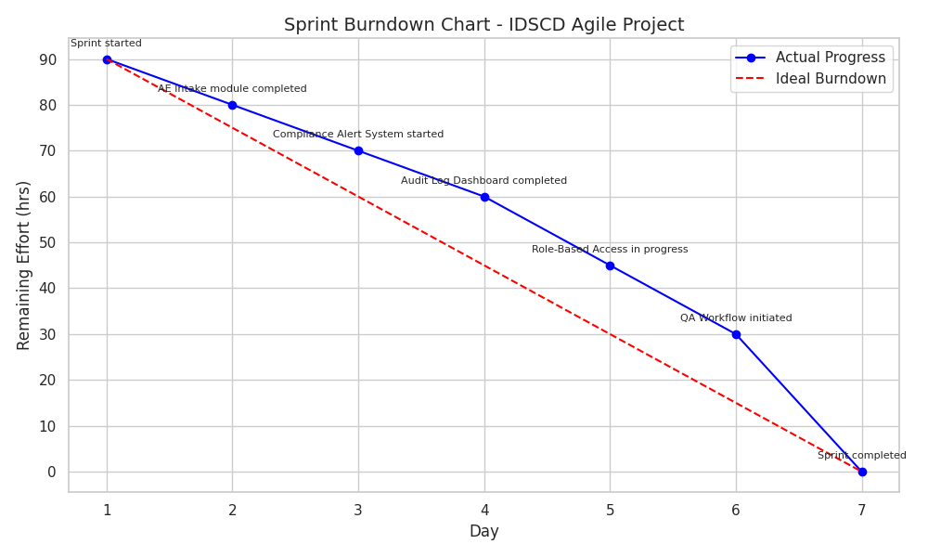
Q.6. Document 6: Sprint meetings
Ans. Meeting Type 1: Sprint Planning meeting
Date | 01-Aug-2025
Time | 10 AM
Location | Abbvie Health Virtual Lab, Hyderabad
Prepared By | Mr. Ramesh Kumar
Attendees | Scrum master, product owner, Scrum developers, Quality analyst

Agenda topics
Topic | Presenter | Time allotted
Welcome and Meeting Objectives | Scrum Master | 5 mins
Review Product Vision | Product Owner | 10 mins
Review Sprint Goal | Product Owner | 10 mins
Task Breakdown and Estimation | Scrum Developers | 20 mins
Capacity Planning | Scrum Master | 10 mins
Sprint Commitment | Entire Scrum Team | 10 mins

Other Information
Observers | QA Lead, UX Designer, Project Sponsor
Resources | JIRA (Sprint Backlog & Burndown Charts), Balsamiq (Wireframes), Visio (UML)
Special Notes | Ensure all user stories meet Definition of Done; UX and QA sign-off required

Meeting Type 2: Sprint review meeting
Date | 15-Aug-2025
Time | 11 AM
Location | Abbvie Health Virtual Lab, Hyderabad
Prepared By | Mr. Ramesh Kumar
Attendees | Product Owner, Scrum Master, Scrum Developers, QA Lead, UX Designer

Sprint status | Things to demo | Quick updates | What’s next
AE module completed | Dashboard prototype | Minor UI tweaks pending; backend validation in progress | Begin Sprint 2 (Compliance Alerts)

Meeting Type 3: Sprint retrospective meeting
Date | 26-Aug-2025
Time | 11 AM
Location | Abbvie Health Virtual Lab, Hyderabad
Prepared By | Mr. Ramesh Kumar
Attendees | Product Owner, Scrum Master, Scrum Developers, QA Lead, UX Designer

Agenda | What went well | What didn’t go well | Questions | Reference
Sprint Retrospective | Clear communication, timely delivery | Initial DB integration delays | How can we improve backend coordination? | Agile Deliverables – V2D2
Meeting Type 4: Daily Stand-up meeting
Question | Name/Role | Week “X” (from dd-mm-yyyy to dd-mm-yyyy)
Question | Name/Role | Monday | Tuesday | Wednesday | Thursday | Friday | Saturday | Sunday
What did you do yesterday? | Dev 1 | Designed AE Intake UI | Integrated AE DB | Tested AE module | Started Compliance Alert logic | Completed Compliance Alert notifications | Reviewed Audit Log structure | Finalized Audit Log export
What did you do yesterday? | Dev 2 | Created PV Dashboard filters | Built metrics | Enabled export to Excel | Started Regulatory Dashboard | Integrated alert triggers | Reviewed submission tracker | Finalized audit access module
What did you do yesterday? | Dev 3 | Set up QA checklist | Logged bugs in JIRA | Validated AE module | Started Role-Based Access module | Assigned permissions | Tested login flows | Completed QA sign-off
What will you do today? | Dev 1 | Integrate AE DB | Test AE module | Start Compliance Alert logic | Complete alert logic | Review Audit Log structure | Finalize Audit Log export | Prepare for sprint review
What will you do today? | Dev 2 | Build metrics view | Enable export | Start Regulatory Dashboard | Integrate alert triggers | Review submission tracker | Finalize audit access module | Prepare for sprint review
What will you do today? | Dev 3 | Log bugs in JIRA | Validate AE module | Start Role-Based Access module | Assign permissions | Test login flows | Complete QA sign-off | Prepare for sprint review
What (if any) is blocking your progress? | Dev 1 | None | API delay | None | Minor DB sync issue | None | None | None
What (if any) is blocking your progress? | Dev 2 | None | None | Delay in alert logic | None | None | None | None
What (if any) is blocking your progress? | Dev 3 | None | None | Waiting for access credentials | None | None | None | None

