Question 1 – Functional Requirements
Answer:
Req ID | Req Name | Req Description | Priority
FR001 | Registration | Users should be able to register with valid email and passwords | 9
FR002 | Login | Users should be able to login to the application with registered credentials. | 9
FR003 | Search for Products | Users should be able to search for their desired products | 8
FR004 | Upload their  Products | Users should be able to upload and display the available products in the application and website. | 10
FR005 | Add up desired quantity | Users should be able to add desired quantity of products | 10
FR006 | Estimated time of arrivals | Users should be able to fetch ETA for the delivery of the products according to the pin codes. | 6
FR007 | Product description and user manual | Users should be able to see product description and user manual. | 4
FR008 | Adding products to their wish list | Users should be able to add products to their wish list. | 5
FR009 | Payment Gateway | Users should be able to redirected and select their desired payment mode | 7
FR010 | Order confirmation and email | Users should be able to get pop up for order confirmation on their screen and on email. | 8
NFR001 | Usability | The application should be user friendly and easy to use. | 8
NFR002 | Performance | The application must load pages within 3 seconds | 8
NFR003 | Security | The application must have ensured security for users. | 9
NFR004 | Compatibility | The platform should be compatible with all major browsers and run on Android and iOS | 9
NFR005 | Localization | The system should support at least 3 regional Indian languages in addition to English. | 6
NFR006 | Data Integrity | The system must ensure accurate and consistent data across all transactions and modules. | 5
NFR007 | System Monitoring | The system should include real-time monitoring to detect downtime, crashes, or anomalies. | 2
NFR008 | Version Control | The platform should support controlled version upgrades without affecting existing users. | 3
NFR009 | Backup and Recovery | Daily backups should be taken and recovery time should not exceed 1 hour after failure | 2
NFR010 | Load Testing | The application must pass load testing under peak conditions before go-live. | 1

Question 2–Minimum 5 page designs
Answer: 1) Registration page
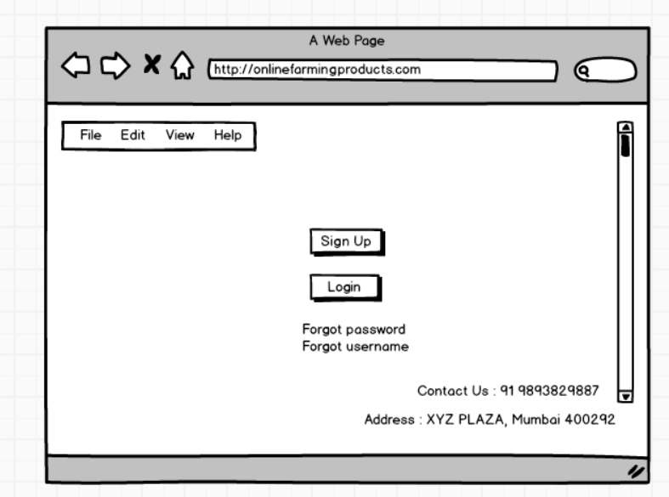
2) Product Search
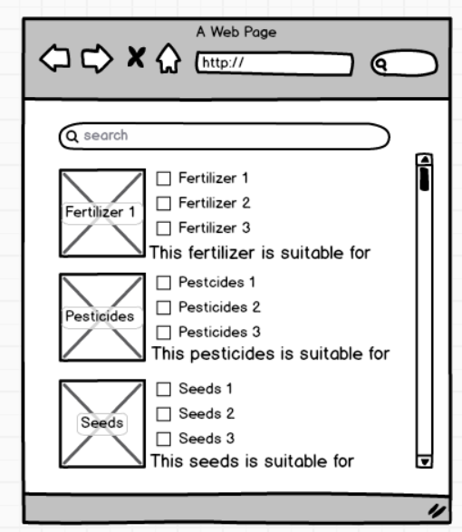
3) Product Page
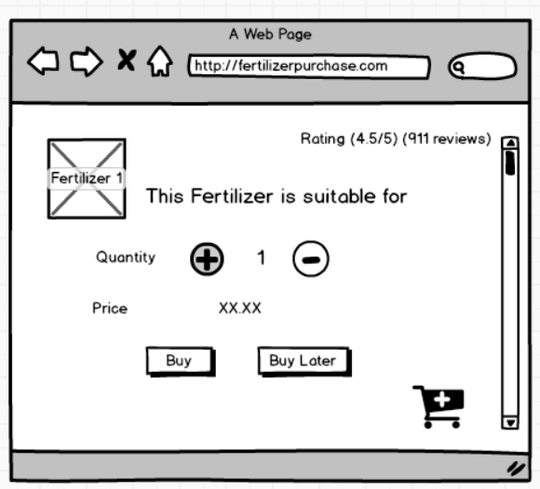
4) Payment
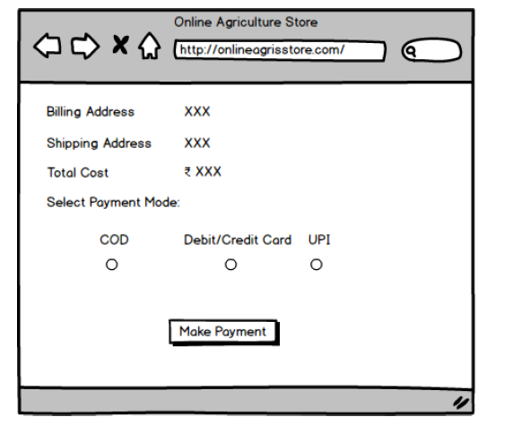

Question 3 – Tools (Visio, Balsamiq)
Answer:
Visio
Microsoft Visio is a diagramming and vector graphics application that enables users to create a wide range of professional diagrams, including flowcharts, organizational charts, and network diagrams. It offers an extensive library of templates and shapes, enabling the visualization of complex information in an understandable format.The file extension is ‘.vsd’.
Balsamiq
Balsamiq is a user interface design tool that enables users to create low-fidelity wireframes and mock-ups for web, mobile, and desktop applications. Its hand drawn style focuses on layout and structure, facilitating rapid idea visualization and iteration. The file extension is ‘.bmpr’.

Question 4 – RTM
Req ID | Req Name | Req Description | Priority | Design | D1 | T1 | D2 | T2 | UAT | Remarks
FR001 | Registration | Users should be able to register with valid email and passwords | 9 | Completed and approved | Completed | Unit Testing Completed |  |  | Pending | Integration Testing Pending
FR002 | Login | Users should be able to login to the application with registered credentials. | 9 | Completed and approved | Completed | Unit Testing Completed |  |  | Pending | Integration Testing Pending
FR003 | Search for Products | Users should be able to search for their desired products | 8 | Completed and approved | Completed | Unit Testing Completed |  |  | Pending | Integration Testing Pending
FR004 | Upload their  Products | Users should be able to upload and display the available products in the application and website. | 10 | Completed and approved | Completed | Unit Testing Completed |  |  | Pending | Integration Testing Pending
FR005 | Add up desired quantity | Users should be able to add desired quantity of products | 10 | Completed and approved | Completed | Unit Testing Completed |  |  | Pending | Integration Testing Pending
FR006 | Estimated time of arrivals | Users should be able to fetch ETA for the delivery of the products according to the pin codes. | 6 | Completed and approved | Completed | Unit Testing Completed |  |  | Pending | Integration Testing Pending
FR007 | Product description and user manual | Users should be able to see product description and user manual. | 4 | Completed and approved | Completed | Unit Testing Completed |  |  | Pending | Integration Testing Pending
FR008 | Adding products to their wish list | Users should be able to add products to their wish list. | 5 | Completed and approved | Completed | Unit Testing Completed |  |  | Pending | Integration Testing Pending
FR009 | Payment Gateway | Users should be able to redirected and select their desired payment mode | 7 | Completed and approved | Completed | Unit Testing Completed |  |  | Pending | Integration Testing Pending
FR010 | Order confirmation and email | Users should be able to get pop up for order confirmation on their screen and on email. | 8 | Completed and approved | Completed | Unit Testing Completed |  |  | Pending | Integration Testing Pending
NFR001 | Usability | The application should be user friendly and easy to use. | 8 | Completed and approved | Completed | Unit Testing Completed |  |  | Pending | Integration Testing Pending
NFR002 | Performance | The application must load pages within 3 seconds | 8 | Completed and approved | Completed | Unit Testing Completed |  |  | Pending | Integration Testing Pending
NFR003 | Security | The application must have ensured security for users. | 9 | Completed and approved | Completed | Unit Testing Completed |  |  | Pending | Integration Testing Pending
NFR004 | Compatibility | The platform should be compatible with all major browsers and run on Android and iOS | 9 | Completed and approved | Completed | Unit Testing Completed |  |  | Pending | Integration Testing Pending
NFR005 | Localization | The system should support at least 3 regional Indian languages in addition to English. | 6 | Completed and approved | Completed | Unit Testing Completed |  |  | Pending | Integration Testing Pending
NFR006 | Data Integrity | The system must ensure accurate and consistent data across all transactions and modules. | 5 | Completed and approved | Completed | Unit Testing Completed |  |  | Pending | Integration Testing Pending
NFR007 | System Monitoring | The system should include real-time monitoring to detect downtime, crashes, or anomalies. | 2 | Completed and approved | Completed | Unit Testing Completed |  |  | Pending | Integration Testing Pending
NFR008 | Version Control | The platform should support controlled version upgrades without affecting existing users. | 3 | Completed and approved | Completed | Unit Testing Completed |  |  | Pending | Integration Testing Pending
NFR009 | Backup and Recovery | Daily backups should be taken and recovery time should not exceed 1 hour after failure | 2 | Completed and approved | Completed | Unit Testing Completed |  |  | Pending | Integration Testing Pending
NFR010 | Load Testing | The application must pass load testing under peak conditions before go-live. | 1 | Completed and approved | Completed | Unit Testing Completed |  |  | Pending | Integration Testing Pending

Question 5 – 10 Test Case Documents
Answers:
Test case ID | TC505TS001 | Test case Name | Registration
Project ID | TC505 | Project Name | Online Agriculture Store
PM ID | 4654 | PM Name | Harsh Gupta
Test strategy ID | PQ505TS001 | Tester ID | FB25939
Test plan ID | PQ505TP001 | Tester Name | Mr.XYZ
Test schedule ID | PQ505TS001 | Date of Test | 08/07/2025
Scenario | Registration for webiste
Link to that page: | XXXX
Input Data | Set 1  Registration Page | Set 2  Signup Page | Set 3 | Set 4
Expected behaviour | Open page show Login or signup | Redirected to Signup page with option to enter username and password
Actual behaviour | Login Signup option displayed | Username and password entering option
Comments |  | Authorisation and security required
Result (Pass/Fail) | Pass | Pass (Security complied)

Test case ID | TC505TS002 | Test case Name | Login
Project ID | TC505 | Project Name | Online Agriculture Store
PM ID | 4654 | PM Name | Harsh Gupta
Test strategy ID | PQ505TS002 | Tester ID | FB25939
Test plan ID | PQ505TP002 | Tester Name | Mr.XYZ
Test schedule ID | PQ505TS002 | Date of Test | 08/07/2025
Scenario | Login for website
Link to that page: | XXXX
Input Data | Set 1  Login Page | Set 2  Invalid Login  credentials | Set 3 | Set 4
Expected behaviour | Verifying correct credentials entered | Display "Invalid Login username and password”
Actual behaviour | Verified user credentials | Display "Invalid credentials"
Comments | Entering Captcha require
Result (Pass/Fail) | Pass | Fail

Test case ID | TC505TS003 | Test case Name | Search for Products
Project ID | TC505 | Project Name | Online Agriculture Store
PM ID | 4654 | PM Name | Harsh Gupta
Test strategy ID | PQ505TS003 | Tester ID | FB25939
Test plan ID | PQ505TP003 | Tester Name | Mr.XYZ
Test schedule ID | PQ505TS003 | Date of Test | 08/07/2025
Scenario | Search for Products
Link to that page: | XXXX
Input Data | Set 1  Fertilizers | Set 2  Pesticides | Set 3  Seeds | Set 4  Invalid products Name
Expected behaviour | 10 options | 8 options | 37 options | Display invalid product name
Actual behaviour | Displaying 10 different varieties | Display 8 options | Display all 37 product list | Display invalid product name
Comments
Result (Pass/Fail) | Pass | Pass | Pass | Pass

Test case ID | TC505TS004 | Test case Name | Products Page
Project ID | TC505 | Project Name | Online Agriculture Store
PM ID | 4654 | PM Name | Harsh Gupta
Test strategy ID | PQ505TS004 | Tester ID | FB25939
Test plan ID | PQ505TP004 | Tester Name | Mr.XYZ
Test schedule ID | PQ505TS004 | Date of Test | 08/07/2025
Scenario | Users can click on products details to view products details and costs
Link to that page: | XXXX
Input Data | Set 1  Users clicks on products and enter products page | Set 2  Users will update the available quantity and costs | Set 3  Users will enter pin code and get estimated time of delivery |  | Set 4  User clicks Buy |  |  | Set 5  Users clicks Buy later
Expected behaviour | Redirected to the product, with detailed info - cost, offers/discounts, etc. | Inventory and stock updates will be entered and costs will be updated | Users can enter pincode and get to know the estimated time of delivery |  | Users click buy and product gets processed for payment and address selection |  |  | The product after clicking on buy later gets added to wishlist
Actual behaviour | Redirected to the product, with detailed info - cost, offers/discounts, etc. | Inventory and stock updates will be entered and costs will be updated | Users can enter pincode and get to know the estimated time of delivery |  | Users click buy and gets directed to payment and address selection page |  |  | The product after clicking on buy later gets added to wishlist
Comments
Result (Pass/Fail) | Pass | Pass | Pass |  | Pass |  |  | Pass
Test case ID | TC505TS005 | Test case Name | Payment
Project ID | TC505 | Project Name | Online Agriculture Store
PM ID | 4654 | PM Name | Harsh Gupta
Test strategy ID | PQ505TS005 | Tester ID | FB25939
Test plan ID | PQ505TP005 | Tester Name | Mr.XYZ
Test schedule ID | PQ505TS005 | Date of Test | 08/07/2025
Scenario | Payment
Link to that page: | XXXX
Input Data | Set 1  Users gets redirected payment page after clicking buy | Set 2  Users select COD | Set 3  User selects debit/ credit card | Set 4  User selects UPI
Expected behaviour | Display billing and shipping details, total bill, give payment options | Complete the payment and place order | Redirect to card service provider page for entering card details | Redirect to card UPI provider page for entering UPI details
Actual behaviour | Display billing and shipping details, total bill, give payment options | Complete the payment and place order | Redirect to card service provider page for entering card details | Redirect to card UPI provider page for entering UPI details
Comments
Result (Pass/Fail) | Pass | Pass | Pass | Pass

Test case ID | TC505TS006 | Test case Name | Order tracking system
Project ID | TC505 | Project Name | Online Agriculture Store
PM ID | 4654 | PM Name | Harsh Gupta
Test strategy ID | PQ505TS006 | Tester ID | FB25939
Test plan ID | PQ505TP006 | Tester Name | Mr XYZ
Test schedule ID | PQ505TS006 | Date of Test | 08/07/2025
Scenario | Users/customers can track the order status
Link to that page: | XXXX
Input Data | Set 1  Users can track order with their order ID through order tracking option | Set 2  Invalid order Id | Set 3 | Set 4
Expected behaviour | Users can enter their order id and get status of order, fetch logistics company name and delivery partner contact number. | Users should get popup message wrong order entered
Actual behaviour | Users can enter their order id and get status of order, fetch logistics company name and delivery partner contact number. | Users should get popup message wrong order entered
Comments
Result (Pass/Fail) | Pass | Pass | Pass | Pass

Test case ID | TC505TS007 | Test case Name | Product review
Project ID | TC505 | Project Name | Online Agriculture Store
PM ID | 4654 | PM Name | Harsh Gupta
Test strategy ID | PQ505TS007 | Tester ID | FB25939
Test plan ID | PQ505TP007 | Tester Name | Mr.XYZ
Test schedule ID | PQ505TS007 | Date of Test | 08/07/2025
Scenario | Search for Products
Link to that page: | XXXX
Input Data | Set 1  User give rating/review for a particular product | Set 2 | Set 3 | Set 4
Expected behaviour | Accept details (rating out of 5 and review details) and publish on website for other users to see
Actual behaviour | Accept details (rating out of 5 and review details) and publish on website for other users to see
Comments
Result (Pass/Fail) | Pass | Pass | Pass | Pass

Test case ID | TC505TS008 | Test case Name | Product Description
Project ID | TC505 | Project Name | Online Agriculture Store
PM ID | 4654 | PM Name | Harsh Gupta
Test strategy ID | PQ505TS008 | Tester ID | FB25939
Test plan ID | PQ505TP008 | Tester Name | Mr XYZ
Test schedule ID | PQ505TS008 | Date of Test | 08/07/2025
Scenario | Users can check detailed product description
Link to that page: | XXXX
Input Data | Set 1  Users can check product description, composition and ingredients. | Set 2 | Set 3 | Set 4
Expected behaviour | Users can check the product description and get to know manufactured date, manufacturer city.
Actual behaviour | Users can check the product description and get to know manufactured date, manufacturer city.
Comments
Result (Pass/Fail) | Pass | Pass | Pass | Pass

Test case ID | TC505TS009 | Test case Name | Support
Project ID | TC505 | Project Name | Online Agriculture Store
PM ID | 4654 | PM Name | Harsh Gupta
Test strategy ID | PQ505TS009 | Tester ID | FB25939
Test plan ID | PQ505TP009 | Tester Name | Mr XYZ
Test schedule ID | PQ505TS009 | Date of Test | 08/07/2025
Scenario | User wants customer support
Link to that page: | XXXX
Input Data | Set 1  User wants to raise a complaint for an order | Set 2 | Set 3 | Set 4
Expected behaviour | Provide options for raising a complaint by allowing them to order details and provide customer care number
Actual behaviour | Provide options for raising a complaint by allowing them to order details and provide customer care number
Comments
Result (Pass/Fail) | Pass | Pass | Pass | Pass

Test case ID | TC505TS010 | Test case Name | Search Result Sorting
Project ID | TC505 | Project Name | Online Agriculture Store
PM ID | 4654 | PM Name | Harsh Gupta
Test strategy ID | PQ505TS010 | Tester ID | FB25939
Test plan ID | PQ505TP010 | Tester Name | Mr XYZ
Test schedule ID | PQ505TS010 | Date of Test | 08/07/2025
Scenario | User after getting search results selects sorting button to sort by rating or price
Link to that page: | XXXX
Input Data | Set 1  User selects sorting button to sort by rating or price | Set 2 | Set 3 | Set 4
Expected behaviour | Display in descending/ascending order on alternate clicks of the button, by price or rating
Actual behaviour | Display in descending/ascending order on alternate clicks of the button, by price or rating
Comments
Result (Pass/Fail) | Pass | Pass | Pass | Pass

Question 6 – DB Design
Answer:

Considering the entities: User (Farmer), Order, and Agriculture Product.
Considered the various attributes (properties or traits) of the particular entity.
Mentioned the relationships between the entities.

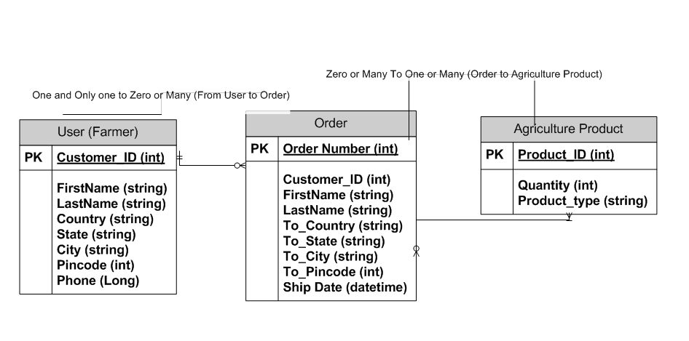

Question 7 – Data Flow Diagram

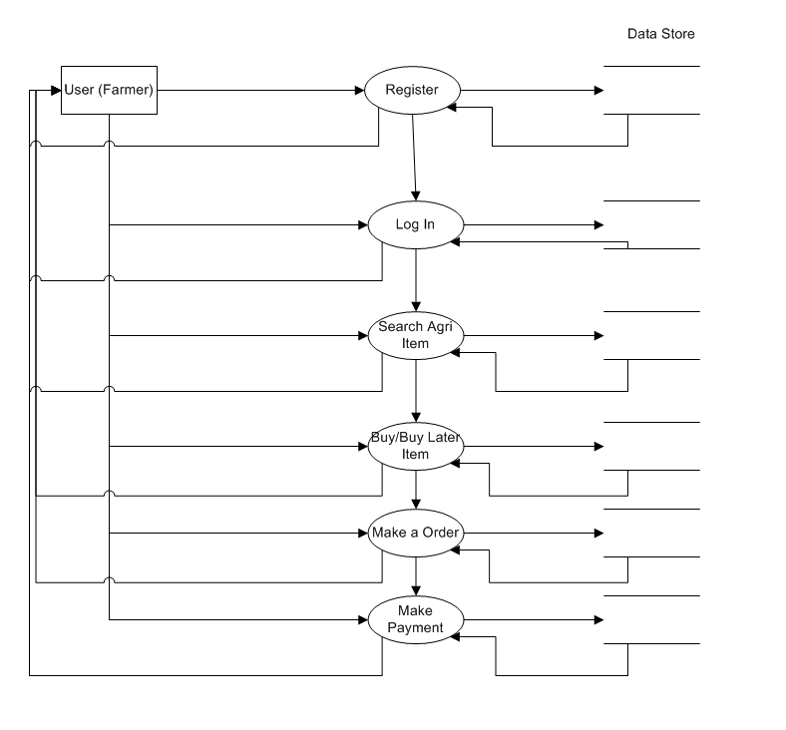

Question 8 – Change Request Vs an Enhancement

Managing change requests in the Online Agriculture Store project involves a systematic process to ensure minimal disruption and smooth implementation. Here's an approach tailored to this scenario:

- Start by understanding the change thoroughly—gather all the necessary details to grasp what’s being requested and why.

- Evaluate its impact on the project, especially in terms of time, scope, budget, and available resources.

- Communicate the findings—present the change along with an impact report to the project sponsors and key decision-makers for their input and approval.

- Once the green light is given, plan and execute the change, keeping everyone informed about what’s being updated.

- Finally, make sure all relevant project documentation reflects the newly implemented change to maintain accuracy.

In this particular instance, the change pertains to an update in government tax regulations, which directly affects the platform:

- As this is a compliance-related change, the first step is to gather precise information on the revised tax policies that must be reflected in the system.

- After that, it's important to analyse how this shift affects the current project roadmap. Since it’s a regulatory update, it's non-negotiable and has to be integrated. This means modifying the tax calculation mechanism within the platform.

- The technical changes—what goods are impacted, how the logic will shift—should be clearly shared with APT IT SOLUTIONS' development team, as well as Mr. Henry and other involved parties.

- Once approved, the team should proceed with implementation, update the concerned stakeholders, and adjust all documentation and specifications accordingly.

Question 9 – Change Request vs. an Enhancement
Answer:

In this case Mr.Ben and Mr.Kevin (friends of Mr Henry and farmers) have contacted and said that they want farmers to sell their crop yield through this application that is the online agriculture store application. They want the display the products to public and be able to sell them. Moreover, they also want to introduce auction system for crop yields.

Considering this was not a part of the project this is an enhancement. So as a BA, one should document the requirements and work with the APT IT SOLUTIONS development team to determine the feasibility of the and impact of these features. Benefits, risks, and costs should be considered with regards to the selling of crop yields enhancement before giving recommendations to the client.

Question 10 – Estimations
Answer:

Total Resources: Total 11 resources (including PM and BA)
Total Duration: 18 months (1.5 years = ~ 78 weeks)
Total Man hours available: 78*40*11 = Approx. 34,000 hours (considering one resource works 40 hours a week)

Since, the resources are trained, additional trainers are not required.
This project can be considered as a large size project considering the resources man hours available/required.
Since, project size as per man hours:
Small: Upto 500 hours
Medium: Upto 1,000 hours
Large: Upto 1,500 hours

Question 11 – UAT
Answer:
The UAT is an important phase in the Software Development Life Cycle (SDLC) and ensures that the online agriculture store application meets the business requirements and is ready for deployment. It typically involves the following steps:
- Prepare test cases from use cases or assist test manager in line with business requirements
- Perform high level testing
- Prepare Mr. Henry and his team, and also the end users (farmers) for UAT
- Provide test data to the stakeholders
- Take signoff from Mr Henry’s team through the established communication channels.

Question 12 – Project Closure Document -
S.No | Points to include | Details | Reference link
1 | Did the client signed off on the UAT Testing |  | Reference link (business case document).docx
1 | Sign off Date | 05th April 2025 | Reference link (business case document).docx
1 | Resource Name | Ms. Mary | Reference link (business case document).docx
2 | Objectives of the project
2 | User friendliness | Achieved
2 | Customer satisfaction | ROI in 12 months
2 | Availiblity of Agri Products to farmers in remote areas | Achieved
3 | Functionalities worked on
3 | Secure payment processing | Achieved
3 | Product Search | Achieved
4 | Infrastructure
4 | Software Installed | Achieved
4 | Laptops purchased | Achieved
5 | Funding |  | Reference Link(Finance breakdown).docx
5 | Amount approved | Rs.2 crore | Reference Link(Finance breakdown).docx
5 | Amount used | Rs. 1.6 croce | Reference Link(Finance breakdown).docx
6 | Overall project information
6 | Escalations | 45
6 | Customer satisfaction | High
7 | Value to the company
7 | Positive/Negative | Positive - 95%  - Mr, Henry has given the required application to his friends and other farmers in remote areas  - Increased clients for agriculture product manufacturers  - Increased revenue for farmers  - New project in pipeline

