Nurturing Process Capstone Project2 –Agile-Scrum

Question 1 – write Agile Manifesto ?
Answer - The Agile Manifesto is a declaration of 4 core values and 12 principles that guide teams to develop software in an iterative, collaborative, and customer-focused way, instead of relying on rigid plans and heavy documentation.
4 Core Values of Agile Manifesto
- Individuals and Interactions over Processes and Tools
→ Focus on people and teamwork rather than only tools.
- Working Software over Comprehensive Documentation
→ Deliver functional product instead of wasting time on too much paperwork.
- Customer Collaboration over Contract Negotiation
→ Continuous involvement of customers rather than rigid contracts.
- Responding to Change over Following a Plan
→ Adapt quickly to new requirements instead of sticking to a fixed plan.

12 Agile Principles
- Customer satisfaction through early and continuous delivery of valuable software.
Farmers and companies get features quickly instead of waiting for the full product.
- Welcome changing requirements, even late in development.
If farmers need a new payment option, we can add it anytime.
- Deliver working software frequently, from a couple of weeks to a couple of months.
First deliver login & registration, then product catalog, then payments.
- Business people and developers must work together daily.
Farmers/committee + APT IT team collaborate regularly.
- Build projects around motivated individuals.
Trust the team of BA, developers, testers, DB admins to do their job.
- Face-to-face conversation is the best way to communicate.
Direct meetings, stand-ups, or video calls instead of long emails.
- Working software is the primary measure of progress.
A running online store is better than just documents.
- Agile processes promote sustainable development.
Teams should work at a constant pace (not overworked).
- Continuous attention to technical excellence and good design.
Clean coding, secure payments, and scalable database design.
- Simplicity – maximize the amount of work not done.
Keep the app user-friendly for farmers, avoid unnecessary features.
- The best architectures, requirements, and designs emerge from self-organizing teams.
Developers + BA + Testers take decisions together.
- Regularly, the team reflects and adjusts (retrospectives).
After each sprint, check what went well and what to improve.

Question 2 – User Stories- Acceptance Criteria-BV-CP – 40 Marks Write minimum 40 User stories and their Acceptance Criteria along with their BV and CP
Answer -
User Story No. 1 | Task 2 | | Priority High
AS A USER, I WANT TO REGISTER AS A NEW CUSTOMER SO THAT I CAN COMPLETE MY ACTION.
BV : 500 | CP: 3
Acceptance Criteria:
Registration form with mandatory fields
Unique email and phone validation
Password strength validation
Submit button available
Confirmation email sent
-Account successfully created

User Story No. 2 | Task 2 | | Priority High
AS A USER, I WANT TO LOGIN TO THE SYSTEM SO THAT I CAN COMPLETE MY ACTION.
.
BV : 500 | CP: 2
Acceptance Criteria:
Username and password mandatory
- Validate credentials
- Error message for invalid login
- Redirect to homepage on success
- Remember me option available

User Story No. 3 | Task 2 | | Priority Medium
AS A USER, I WANT TO RESET PASSWORD SO THAT I CAN COMPLETE MY ACTION.

BV : 200 | CP: 2
Acceptance Criteria:
Forgot password link visible
- OTP/email verification
- New password entry with validation
- Success message displayed
- User can log in with new password

User Story No. 4 | Task 2 | | Priority Medium
AS A USER, I WANT TO UPDATE CUSTOMER PROFILE SO THAT I CAN COMPLETE MY ACTION.

BV : 200 | CP : 3
Acceptance Criteria:
- Editable profile form
- Save button enabled
- Validation for mandatory fields
- Update confirmation message
- Profile updated in database

User Story No. 5 | Task 2 | | Priority High
AS A USER, I WANT TO LOGOUT FROM THE SYSTEM SO THAT I CAN COMPLETE MY ACTION.

BV : 500 | CP : 1
Acceptance Criteria:
- Logout button visible
- Session terminated
- Redirect to login page
- Success message displayed

User Story No. 6 | Task 2 | | Priority High
AS A USER, I WANT TO SEARCH FOR A PRODUCT SO THAT I CAN COMPLETE MY ACTION

BV : 500 | CP : 3
Acceptance Criteria:
Search box available
- Keyword matching implemented
- Results displayed with product details
- No results message shown if none found

User Story No. 7 | Task 2 | | Priority High
AS A USER, I WANT TO FILTER PRODUCTS BY CATEGORY SO THAT I CAN COMPLETE MY ACTION.

BV : 500 | CP : 3
Acceptance Criteria:
- Category filter visible
- Multiple categories selectable
- Filtered products displayed correctly

User Story No. 8 | Task 2 | | Priority Medium
AS A USER, I WANT TO SORT PRODUCTS BY PRICE SO THAT I CAN COMPLETE MY ACTION.

BV : 200 | CP : 2
Acceptance Criteria:
- Sort option available
- Sort low-to-high and high-to-low
- Products arranged accordingly

User Story No. 9 | Task 2 | | Priority High
AS A USER, I WANT TO VIEW PRODUCT DETAILS SO THAT I CAN COMPLETE MY ACTION.

BV : 500 | CP : 2
Acceptance Criteria:
- Product name, description, and price visible
- Add to cart option available
- High-quality product images displayed
- Stock availability shown

User Story No. 10 | Task 2 | | Priority Low
AS A USER, I WANT TO VIEW RELATED PRODUCTS SO THAT I CAN COMPLETE MY ACTION.

BV : 100 | CP : 2
Acceptance Criteria:
- Similar products shown under details page
- Clickable product links available

User Story No. 11 | Task 2 | | Priority Medium
AS A USER, I WANT TO VIEW RELATED PRODUCTS SO THAT I CAN COMPLETE MY ACTION.

BV : 200 | CP : 3
Acceptance Criteria:
- Seasonal category available
- Products tagged as seasonal displayed

User Story No. 12 | Task 2 | | Priority Medium
AS A USER, I WANT TO VIEW BEST-SELLING PRODUCTS SO THAT I CAN COMPLETE MY ACTION.

BV : 200 | CP : 2
Acceptance Criteria:
- Best-seller tag visible
- List of top-selling products shown

User Story No. 13 | Task 2 | | Priority High
AS A USER, I WANT TO ADD PRODUCT TO CART SO THAT I CAN COMPLETE MY ACTION.

BV : 500 | CP : 3
Acceptance Criteria:
- Add to cart button visible
- Cart icon updates automatically
- Success message displayed

User Story No. 14 | Task 2 | | Priority High
AS A USER, I WANT TO VIEW CART ITEMS SO THAT I CAN COMPLETE MY ACTION.

BV : 500 | CP : 5
Acceptance Criteria:
- Cart page displays all items
- Item quantity and price shown
- Total amount calculated

User Story No. 15 | Task 2 | | Priority Medium
AS A USER, I WANT TO UPDATE CART QUANTITY SO THAT I CAN COMPLETE MY ACTION.

BV : 200 | CP : 2
Acceptance Criteria:
- Quantity change option available
- Cart total updates accordingly

User Story No. 16 | Task 2 | | Priority High
AS A USER, I WANT TO REMOVE PRODUCT FROM CART SO THAT I CAN COMPLETE MY ACTION.

BV : 500 | CP : 5
Acceptance Criteria:
- Remove button available
- Item removed successfully
- Cart total recalculated

User Story No. 17 | Task 2 | | Priority Medium
AS A USER, I WANT TO ADD PRODUCT TO WISHLIST SO THAT I CAN COMPLETE MY ACTION.

BV : 200 | CP : 2
Acceptance Criteria:
- Wishlist button visible
- Products saved in wishlist
- Wishlist accessible from account

User Story No. 18 | Task 2 | | Priority High
AS A USER, I WANT TO PROCEED TO CHECKOUT SO THAT I CAN COMPLETE MY ACTION.

BV : 500 | CP : 3
Acceptance Criteria:
- Checkout button visible
- Redirect to checkout page
- Order summary displayed

User Story No. 19 | Task 2 | | Priority High
AS A USER, I WANT TO ENTER DELIVERY ADDRESS SO THAT I CAN COMPLETE MY ACTION.

BV : 500 | CP : 2
Acceptance Criteria:
- Address form available
- Validation for mandatory fields
- Save and use for delivery option

User Story No. 20 | Task 2 | | Priority High
AS A USER, I WANT TO SELECT PAYMENT METHOD SO THAT I CAN COMPLETE MY ACTION.

BV : 500 | CP : 2
Acceptance Criteria:
- Payment options displayed
- Credit/Debit/UPI supported
- Payment gateway integration works

User Story No. 21 | Task 2 | | Priority Medium
AS A USER, I WANT TO APPLY DISCOUNT COUPON SO THAT I CAN COMPLETE MY ACTION.

BV : 200 | CP : 2
Acceptance Criteria:
- Coupon field visible
- Validate coupon code
- Discount applied successfully

User Story No. 22 | Task 2 | | Priority High
AS A USER, I WANT TO PLACE ORDER SO THAT I CAN COMPLETE MY ACTION.

BV : 500 | CP : 3
Acceptance Criteria:
- Place order button available
- Order confirmation page displayed
- Order ID generated

User Story No. 23 | Task 1 | | Priority Medium
AS A USER, I WANT TO DOWNLOAD INVOICE SO THAT I CAN COMPLETE MY ACTION.

BV : 200 | CP : 2
Acceptance Criteria:
- Invoice PDF available
- Download option provided

User Story No. 24| Task 1 | | Priority High
AS A USER, I WANT TO TRACK ORDER STATUS SO THAT I CAN COMPLETE MY ACTION.

BV : 500 | CP : 3
Acceptance Criteria:
- Order tracking option available
- Order status updates shown
- Expected delivery date displayed

User Story No. 25| Task 2 | | Priority Medium
AS A USER, I WANT TO CANCEL ORDER SO THAT I CAN COMPLETE MY ACTION.

BV : 200 | CP : 2
Acceptance Criteria:
- Cancel option available before dispatch
- Cancellation confirmation message shown

User Story No. 26| Task 2 | | Priority High
AS A USER, I WANT TO CANCEL ORDER SO THAT I CAN COMPLETE MY ACTION.

BV : 500 | CP : 3
Acceptance Criteria:
- Refund request option visible
- Reason selection required
- Refund ID generated
- Confirmation email sent

User Story No. 27| Task 2 | | Priority Medium
AS A USER, I WANT TO REQUEST PRODUCT RETURN SO THAT I CAN COMPLETE MY ACTION.

BV : 200 | CP : 3
Acceptance Criteria:
- Return request button visible
- Reason for return mandatory
- Return ID generated

User Story No. 28| Task 2 | | Priority High
AS A USER, I WANT TO CHAT WITH ADMIN SO THAT I CAN COMPLETE MY ACTION.

BV : 500 | CP : 2
Acceptance Criteria:
- Chat window available
- Send message option
- Receive response from admin

User Story No. 29| Task 2 | | Priority Medium
AS A USER, I WANT TO SUBMIT SUPPORT TICKET SO THAT I CAN COMPLETE MY ACTION.
BV : 200 | CP : 2
Acceptance Criteria:
- Support form available
- Ticket ID generated
- Track ticket status

User Story No. 30| Task 1| | Priority Medium
AS A USER, I WANT TO VIEW REFUND STATUS SO THAT I CAN COMPLETE MY ACTION.

BV : 200 | CP : 2
Acceptance Criteria:
- Refund status shown under orders
- Email updates sent to customer

User Story No. 31| Task 2| | Priority High
AS A USER, I WANT TO ADD NEW PRODUCT SO THAT I CAN COMPLETE MY ACTION.

BV : 500 | CP : 3
Acceptance Criteria:
- Product form available
- Image and details mandatory
- Product saved in database

User Story No. 32| Task 2| | Priority High
AS A USER, I WANT TO EDIT PRODUCT DETAILS SO THAT I CAN COMPLETE MY ACTION
BV : 500 | CP : 2
Acceptance Criteria:
- Editable product form
- Update confirmation shown

User Story No. 33| Task 1| | Priority Medium
AS A USER, I WANT TO REMOVE PRODUCT SO THAT I CAN COMPLETE MY ACTION.
BV : 200 | CP : 2
Acceptance Criteria:
- Remove option available
- Product deleted successfully

User Story No. 34| Task 2| | Priority Medium
AS A USER, I WANT TO VIEW SALES REPORT SO THAT I CAN COMPLETE MY ACTION.

BV : 200 | CP : 3
Acceptance Criteria:
- Report dashboard visible
- Sales data filter available
- Report export option available

User Story No. 35| Task 2| | Priority High
AS A USER, I WANT TO MANAGE CUSTOMER ORDERS SO THAT I CAN COMPLETE MY ACTION.

BV : 500 | CP : 3
Acceptance Criteria:
- Order list visible
- Update order status option available

User Story No. 36| Task 2| | Priority High
AS A USER, I WANT TO MANAGE INVENTORY STOCK SO THAT I CAN COMPLETE MY ACTION.

BV : 500 | CP : 3
Acceptance Criteria:
- Stock update form available
- Low stock alerts generated

User Story No. 37| Task 2| | Priority Medium
AS A USER, I WANT TO POST PRODUCT REVIEW SO THAT I CAN COMPLETE MY ACTION.

BV : 200 | CP : 2
Acceptance Criteria:
- Review form available
- Star rating visible
- Review displayed under product

User Story No. 38| Task 1| | Priority High
AS A USER, I WANT TO RECEIVE ORDER NOTIFICATIONS SO THAT I CAN COMPLETE MY ACTION.

BV : 500 | CP : 2
Acceptance Criteria:
- SMS/Email notifications sent
- Notification on order updates

User Story No. 39| Task 1| | Priority Medium
AS A USER, I WANT TO VIEW RECOMMENDED PRODUCTS SO THAT I CAN COMPLETE MY ACTION.

BV : 200 | CP : 2
Acceptance Criteria:
- Recommendation list visible
- AI/ML suggestion integrated

User Story No. 40| Task 2| | Priority Medium
AS A USER, I WANT TO APPLY SEASONAL DISCOUNTS SO THAT I CAN COMPLETE MY ACTION.

BV : 200 | CP : 3
Acceptance Criteria:
- Discount rules configurable
- Discount applied automatically
- Display discounted price

Question 3 – What is epic?
Write 2 epics – 5 Marks Business Value and Complexity Points

Answer - An epic is a large user story or body of work in Agile or software development that represents a significant business goal or feature. It is too complex to complete in a single sprint and is broken down into smaller user stories for easier development and tracking.
Briefs
- Business Value describes the benefit to users and the company, such as empowering farmers, reaching new markets, or adding new revenue opportunities.
- Complexity Points are estimated effort or difficulty on a typical Agile scale (1–10), indicating size, required resources, technology challenges, etc.

Question 4 –What is the difference between BV and CP – 2 Marks Product Backlog Your User stories will go into Product Back log
Answer - Business Value (BV) measures the potential benefit or impact a feature, user story, or epic will deliver to the organization or its users (e.g., increased revenue, customer satisfaction, market expansion).
Complexity Points (CP) estimate the amount of effort, technical difficulty, risk, or time required for the development team to implement a feature or user story.
- BV helps prioritize what to build first, while CP informs how difficult/large it will be to build.
- User stories are added to the Product Backlog, where the team considers both BV and CP for effective prioritization and planning.
Question 5 –Explain about Sprint– 5 Marks
Answer - A sprint in Agile (Scrum) is a fixed, time-boxed period (usually 1–4 weeks) where a development team works collaboratively to complete a set of prioritized tasks (user stories) from the product backlog. The sprint begins with a planning meeting to define the sprint goal and select work, followed by daily stand-ups to track progress, and ends with a sprint review and retrospective to demonstrate completed work and reflect on improvements. Sprints allow teams to deliver incremental value, adapt quickly to feedback, and continuously improve delivery and processes.
Every Sprint has:
- Sprint Planning – Decide what work to do.
- Daily Scrum – Small daily meeting to check progress.
- Work – Team designs, develops, and tests.
- Sprint Review – Show the work done to stakeholders.
- Sprint Retrospective – Discuss what went well, what can improve.

Question 6 – Explain Product backlog and sprint back log– 5 Marks
Answer - Product Backlog
- The Product Backlog is a prioritized list of all work items needed for the product.
- It contains features, user stories, bug fixes, enhancements, technical debt, and tasks derived from the product roadmap and stakeholder inputs.
- The Product Backlog is owned and maintained by the Product Owner and is continuously updated based on feedback and changing priorities.
- It serves as the single source of truth for all upcoming work for the development team.
- Items at the top are detailed and ready for implementation; lower items may be broader and refined later.

Sprint Backlog
- The Sprint Backlog is a subset of the Product Backlog selected for the current sprint.
- It contains the user stories and tasks the development team commits to completing in the sprint.
- Created during the sprint planning meeting, it represents the team’s short-term plan and focused workload.
- The Sprint Backlog is owned by the development team and may evolve during the sprint as tasks are broken down or new details emerge.
- It provides transparency on sprint progress and helps manage sprint scope.

Question 7 – What is impediments log? write 2 impediments – 5 Marks
Answer - An Impediments Log is a documented list used in Agile or Scrum teams to record, track, and manage obstacles or issues (impediments) that slow down or block the team’s progress in achieving sprint or project goals. It helps the team, especially the Scrum Master, to prioritize and resolve these impediments promptly to maintain workflow efficiency and project success.
Examples of Impediments
- Lack of Access to Needed Resources
The development team cannot proceed because they do not have access to the required software tools, servers, or data.
- Unclear or Changing Requirements
Ambiguous or constantly changing requirements from stakeholders cause confusion and delays in development.
Question 8 – Explain Velocity of the Team – 1 Marks Velocity – How many CP is covered in this sprint
Answer - Velocity of the Team in Agile is a metric that measures the amount of work a team can complete during a single sprint, typically measured in Complexity Points (CP) or story points.
- It helps the team understand their capacity and plan future sprints effectively.
- Velocity is calculated by summing the complexity points of all user stories fully completed in the sprint.
- For example, if the team completes user stories totaling 30 CP in a sprint, the sprint velocity is 30.
- Velocity helps in forecasting how many sprints will be needed to complete the project.

In short: Velocity = Total complexity points completed in sprint

Question 9 – Draw Sprint Burn Charts n Product Burn Down Charts– 3 Marks
Answer – Burn Chart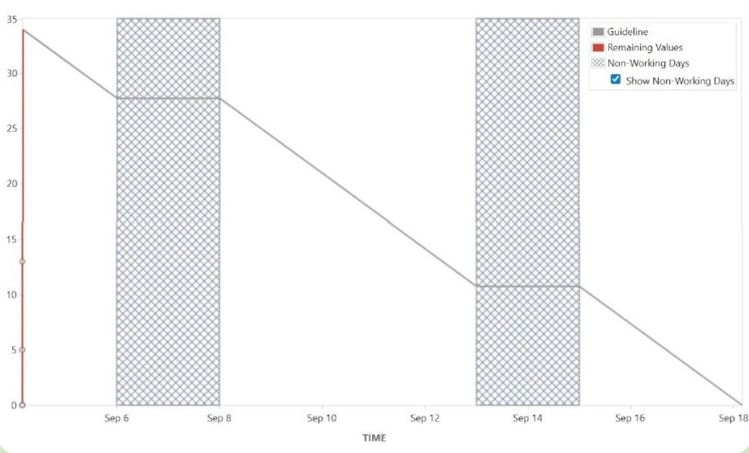
Burnup Chart
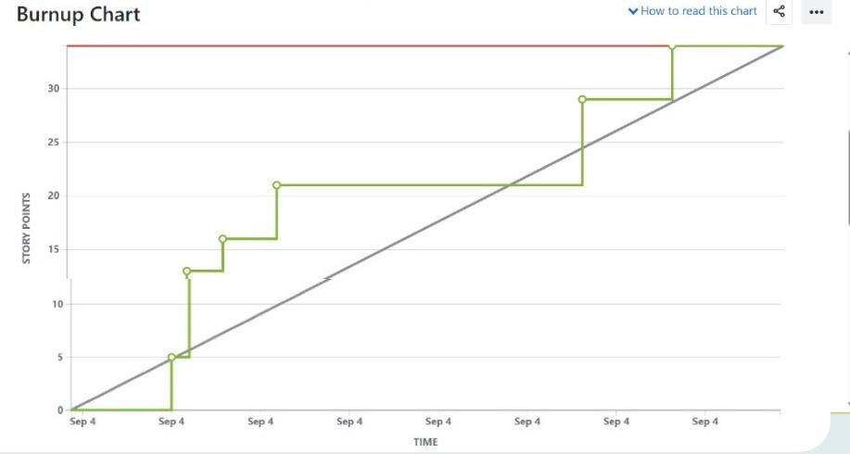
Question 10 – Explain about Product Grooming – 2 Marks
Answer - Product Grooming (also called Backlog Grooming or Backlog Refinement) is a regular Agile process where the product owner, product manager, and the development team review, update, and prioritize the items in the product backlog.

Question 11 – Explain the roles of Scrum Master and Product Owner – 3 Marks
Answer - Scrum Master
The Scrum Master is a facilitator and coach for the Scrum team.

They ensure the Scrum framework is properly followed, organize Scrum ceremonies (daily stand-ups, sprint planning, reviews, retrospectives), and help remove impediments blocking the team’s progress.

They protect the team from external distractions, promote collaboration, and foster a culture of continuous improvement.

The Scrum Master also supports the Product Owner and organization in adopting Agile practices and managing the product backlog effectively.

Product Owner
The Product Owner represents the customer/stakeholder and is responsible for defining and prioritizing the product backlog to maximize business value.

They clearly communicate the product vision, ensure user stories are well-defined and ready for development, and make decisions on feature priorities.

The Product Owner works closely with the Scrum team and stakeholders to align expectations and deliver valuable product increments.

These roles are crucial for the success of Agile projects:

The Scrum Master focuses on the process and team efficiency.
The Product Owner focuses on the product and business value.

Question 12 – Explain all Meetings Conducted in Scrum Project – 8 Marks
Answer - 1. Sprint Planning Meeting
- When: At the start of each sprint.
- Purpose: The Scrum team reviews the product backlog and decides which user stories to include in the sprint.
- The sprint goal is defined, and tasks are broken down and assigned.
- The Product Owner clarifies requirements; the team estimates effort and commits to the sprint backlog.

2. Daily Scrum (Daily Stand-up)
- When: Every day during the sprint, usually 15 minutes.
- Purpose: Team members share what they did yesterday, what they will do today, and any impediments.
- Helps the team stay synchronized and quickly address blockers.

3. Sprint Review Meeting
- When: At the end of the sprint.
- Purpose: The team demonstrates completed work to stakeholders and the Product Owner.
- Feedback is gathered, and the product backlog may be updated based on new insights.

4. Sprint Retrospective Meeting
- When: After the sprint review and before the next sprint planning.
- Purpose: The Scrum team reflects on the sprint to discuss what went well, what didn’t, and how to improve processes for the next sprint.
- Focuses on continuous improvement without blaming individuals.

5. Backlog Grooming (Backlog Refinement)
- When: Often held between sprints or during the sprint cycle.
- Purpose: The Product Owner and team review and prioritize the product backlog, clarify requirements, break down large stories, and estimate effort.
- Ensures the backlog is ready for future sprint planning.

Question 13 – Explain Sprint Size and Scrum Size– 2 Marks
Answer - Sprint Size
- Sprint size refers to the duration or length of a sprint in Scrum, typically between 1 to 4 weeks.
- It defines the fixed time box in which the team works to complete a set of user stories or tasks.
- Common practice is to start with a 2-week sprint as it balances focus, feedback frequency, and predictability.
- The sprint size should enable the team to deliver a potentially releasable product increment consistently.

Scrum Size
- Scrum size generally refers to the size or capacity of the Scrum team involved in completing the sprint work.
- Ideally, a Scrum team consists of 5 to 9 members including developers, Scrum Master, and Product Owner.
- The size ensures effective communication, collaboration, and productivity without becoming unwieldy.

In short:
- Sprint Size = Length of a sprint (time frame)
- Scrum Size = Number of team members in Scrum team

Question 14 – Explain DOR and DOD – 2 Marks
Answer - Definition of Ready (DoR)
- The Definition of Ready is a checklist or set of criteria that a user story or product backlog item must meet before the development team can start working on it.
- It ensures the story is clear, well-defined, feasible, and has enough detail (e.g., acceptance criteria, estimates) to begin development.
- DoR helps the team avoid ambiguity and ensures smoother sprint planning and execution.

Definition of Done (DoD)
- The Definition of Done is a shared understanding of all the criteria that must be met for a product backlog item or increment to be considered complete.
- It includes aspects like coding complete, peer-reviewed, tested, documented, integrated, and potentially shippable.
- DoD ensures quality and consistency in delivering usable and releasable product increments.

Summary:
- DoR governs when work is ready to start.
- DoD governs when work is officially complete.
This clear distinction helps maintain quality and predictability in Agile projects.

Question 15 – Explain Prioritization Techniques and MVP – 3 Marks
Answer - Prioritization techniques are methods used by a Business Analyst or Product Owner to decide which requirements or features should be implemented first in a project. These techniques help balance business value, customer needs, cost, effort, and time, ensuring that the most important and valuable features are delivered early.
Example as per my project:
In the Online Agriculture Product Store, prioritization techniques will decide whether Login & Product Catalog (high value, must-have) should be built first, before features like Multiple Language Support (low value, nice-to-have).
MVP (Minimum Viable Product)
- MVP is the smallest working version of the product with just enough features to satisfy early users and gather feedback.
- For your Online Agriculture Store Project, MVP can include:
  - User Registration/Login
  - Product Catalog (Seeds, Fertilizers, Pesticides)
  - Search option
  - Simple Checkout & Payment
This ensures farmers can start using the platform quickly, while advanced features (delivery tracker, COD, etc.) can be added later.

Question 16 – Difference between Business Analyst n Product Owner – 3 Marks
Answer - Difference between Business Analyst (BA) and Product Owner (PO)
- Role Focus
- BA: Focuses on gathering, analyzing, and documenting requirements. Acts as a bridge between stakeholders and the development team.
- PO: Focuses on defining the product vision, maintaining the product backlog, and ensuring the team delivers maximum value.
- Responsibilities
- BA: Requirement elicitation, process modeling, preparing BRD/FRD, stakeholder analysis.
- PO: Prioritization of backlog, writing user stories, approving/rejecting work, aligning development with business goals.
- Decision Making
- BA: Suggests solutions but doesn’t own the final decision.
- PO: Owns the final decision on what gets built and in what order.

Example for your project:
- The BA (You) documents requirements like "Farmers should be able to search products."
- The PO decides if this feature should be delivered in the first sprint or later.

Question 17 – Prepare a sample Resume of 3yrs exp Product Owner – 3 Marks
Answer - 