A customer can make a payment either by Card or by Wallet or by Cash or by Net banking
Q1. Draw a Use Case Diagram
Q2. Derive Boundary Classes, Controller classes, Entity Classes
Entity Classes (represent business/domain objects – data and logic)
Class Name | Responsibility
Customer | Holds customer details (e.g., name, ID)
Payment | Represents payment (amount, date, status)
Card | Stores card info (card number, expiry, CVV)
Wallet | Stores wallet info (wallet ID, balance)
Cash | Represents cash payment (confirmation status)
Net Banking | Stores bank account info (bank name, account ID)

2. Boundary Classes (handle interaction with the external world – UI, system interfaces)
Class Name | Responsibility
Payment Boundary | Interface for selecting and entering payment method details
Card Payment Boundary | UI for card input (card number, etc.)
Wallet Payment Boundary | UI for wallet login/ID entry
Cash Payment Boundary | UI to confirm cash payment
Net Banking Boundary | UI for bank login/account input

3. Controller Classes (manage flow between boundary and entity classes – use case logic)
Class Name | Responsibility
Payment Controller | Coordinates the payment process
Card Payment Controller | Handles card-specific payment logic
Wallet Controller | Handles wallet payment logic
Cash Payment Controller | Handles cash confirmation and update
Net Banking Controller | Handles net banking authentication and transaction

Q3. Place these classes on a three tier Architecture
It splits an application into three layers:
- Presentation Layer (User Interface)
- Business Logic Layer (Processing & Logic)
- Data Layer (Data storage and management)
Layer | Classes | Role
1. Presentation Layer | Boundary Classes: Payment UI, Card Payment Form, Wallet Payment Form, Cash Payment Confirmation, Net Banking Form | Handle user interaction (screens/forms)
2. Business Logic Layer | Controller Classes: Payment Controller, Card Payment Controller, Wallet Controller, Cash Payment Controller, Net Banking Controller | Process payment flow, coordinate tasks
3. Data Layer | Entity Classes: Customer, Payment, Card, Wallet, Cash, Net Banking | Represent and manage data in database

Q4. Explain Domain Model for Customer making payment through Net Banking
Domain Model:
A Domain Model is a visual or conceptual representation of the important real-world objects (entities) and their relationships within a specific system or process
Domain Model for Customer making Payment through Net Banking
Key Entities (Classes) in the Domain:
- Customer
  - Attributes: customerID, name, email, etc
  - Represents the person making the payment
- Payment
  - Attributes: paymentID, amount, date, status (success/failure)
  - Represents the actual payment transaction.
- NetBanking
  - Attributes: bankName, accountNumber, IFSCCode, authenticationStatus
  - Represents the net banking details used for payment
- Bank (optional but useful)
  - Attributes: bankName, branch, contactInfo
  - Represents the bank involved in the transaction
Relationships:
- A Customer initiates a Payment
- A Payment is done through NetBanking
- NetBanking is associated with a Bank
Explanation:
- The Customer wants to make a payment
- The Payment records details like amount and date
- The NetBanking entity holds the bank account information and verifies authentication
- The Bank entity holds details about the bank where the account is held
This model helps to organize and understand the data and behavior involved in net banking payments
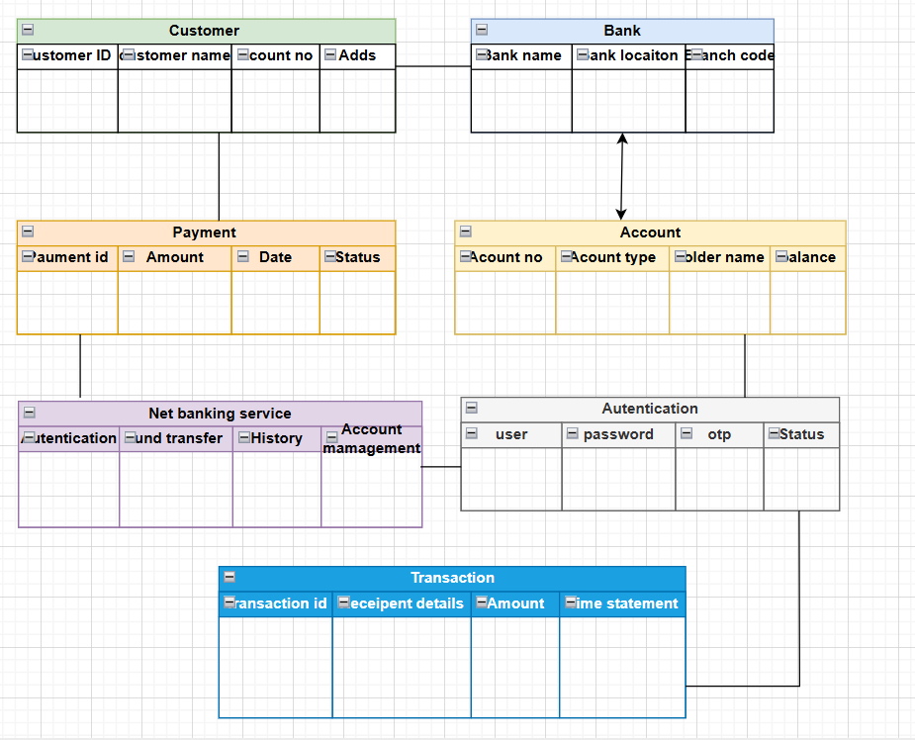
Q5. Draw a sequence diagram for payment done by Customer Net Banking
Q6. Explain Conceptual Model for this Case
A Conceptual Model is a high-level design that shows the important real-world concepts (entities) involved in a system and how they are related to each other
It does not include technical details like database tables or code — just the core concepts and relationships understood by business users and designers
Concept | Description
Customer | A person who wants to make a payment.
Payment | Represents a transaction that includes amount, date, and status.
NetBanking | A method the customer selects to make a payment through a bank.
Bank | Represents the bank where the customer's account exists.

Q7. What is MVC architecture? Explain MVC rules to derive classes from use case diagram and guidelines to place classes in 3-tier architecture
MVC Architecture
MVC stands for Model-View-Controller, a software design pattern used to separate application logic into three interconnected components
1. Model
- Handles data and business logic
- Communicates with the database
- Example: Customer, Order, Payment classes
2. View
- Represents the user interface (UI)
- Displays data from the model
- Example: HTML pages, UI screens, forms
3. Controller
- Handles user input and decides what to do
- Acts as a bridge between View and Model
- Example: PaymentController, OrderController
MVC Rules to Derive Classes from Use Case Diagram
To move from a Use Case Diagram to classes, follow these simple rules:
Rule 1: Nouns → Model Classes
- Identify all nouns in the use case descriptions.
Example: “Customer makes a payment” → Customer, Payment
Rule 2: Verbs → Methods or Controller Classes
- Identify actions (verbs) from the use case.
Example: “Make Payment” → Method in PaymentController
Rule 3: Actors → Controllers
- Actors become Controllers or trigger controller methods
Example: Customer interacts via CustomerController
Guidelines to Place Classes in 3-Tier Architecture
3-tier architecture separates classes into:
1. Presentation Tier (UI Layer)
- Responsible for interacting with users
- Contains Views (screens, forms)
- Example: PaymentPage, OrderForm
2. Business Logic Tier (Application Layer)
- Contains Controllers and Business Logic
- Implements logic described in use cases
- Example: PaymentController, OrderManager
3. Data Access Tier (Database Layer)
- Handles data storage/retrieval
- Contains Model classes and DB access
- Example: Customer, Order, Payment, PaymentDAO
Q8. Explain BA contributions in project (Waterfall Model – all Stages)
In the Waterfall model, the software development process is divided into linear, sequential stages, and each stage must be completed before moving to the next.
A Business Analyst (BA) plays a key role in every stage of the Waterfall model:
1. Requirement Gathering & Analysis Stage
BA Role: Most Critical
- Interacts with stakeholders to elicit requirements
- Gathers business, functional, and non-functional requirements
- Prepares key documents:
  - BRD (Business Requirement Document)
  - FRD (Functional Requirement Document)
  - Use Case Documents
- Gets sign-off from stakeholders on the requirements
Contribution: Ensures clarity, completeness, and no ambiguity in requirements
2. System Design Stage
BA Role: Supports Architecture & Design Team
- Clarifies functional flows and use cases to designers
- Assists in translating requirements into system architecture
- Participates in review meetings to ensure design aligns with requirements
Contribution: Bridges the gap between business goals and system design
3. Implementation / Development Stage
BA Role: On-call Support
- Supports developers by clarifying requirements
- Provides detailed functional scenarios
- Manages requirement traceability to ensure all features are implemented
Contribution: Reduces rework by minimizing requirement misunderstanding
4. Testing Stage
BA Role: Testing Support & UAT Coordination
- Reviews test cases to ensure they cover all requirements
- Helps QA understand business flows
- Coordinates and conducts User Acceptance Testing (UAT)
- Logs and tracks defects/bugs raised in UAT
Contribution: Validates that the product meets business needs
5. Deployment Stage
BA Role: Transition & Communication
- Assists in preparing Go-Live documentation
- Conducts training sessions for end users
- Coordinates with stakeholders for smooth transition
Contribution: Ensures business readiness for system launch
6. Maintenance Stage
BA Role: Change Requests & Enhancements
- Gathers feedback from users
- Documents and manages change requests
- Helps plan for future enhancements or fixes
Contribution: Supports continuous improvement of the system
Q9. What is conflict management? Explain using Thomas – Kilmann technique
Conflict Management is the process of identifying and handling conflicts fairly and efficiently. It involves resolving disagreements or differences between team members, departments, or stakeholders to maintain productivity and healthy working relationships.
As a Business Analyst or Project Manager, effective conflict management is crucial to ensure the project runs smoothly and all parties are aligned.
Thomas–Kilmann Conflict Management Model (TKI)
The Thomas–Kilmann model identifies 5 conflict-handling styles based on two dimensions:
- Assertiveness – how much you try to satisfy your own needs
- Cooperativeness – how much you try to satisfy the other person’s needs
The 5 Conflict Management Styles
Style | Description | When to Use
1. Competing (High Assertive, Low Cooperative) | My way or the highway | In emergencies or when quick, decisive action is needed
2. Collaborating (High Assertive, High Cooperative) | Win-win" – work together for a solution | When both sides’ concerns are important, long-term solution
3. Compromising (Medium Assertive, Medium Cooperative) | Split the difference | When both parties give up something to reach a middle ground
4. Avoiding (Low Assertive, Low Cooperative) | Ignore the conflict | When the issue is minor or emotions are high (cool-down time)
5. Accommodating (Low Assertive, High Cooperative) | You win, I lose | When the issue matters more to the other person, or to maintain harmony

Q10. List down the reasons for project failure
Projects can fail for various reasons, but the most common ones include:
1. Unclear Requirements
- Requirements are incomplete, ambiguous, or keep changing
- Leads to confusion and scope creep
2. Lack of Stakeholder Involvement
- Key stakeholders are not engaged or available for feedback
- Decisions get delayed or misaligned
3. Poor Planning
- Inadequate estimation of time, budget, or resources
- No risk management or contingency plans
4. Ineffective Communication
- Miscommunication between team members or with stakeholders
- Leads to misunderstandings and rework
5. Scope Creep
- Continuous addition of new features without approval or resource updates
- Project becomes unmanageable
6. Weak Project Management
- Lack of leadership or poor coordination
- No proper monitoring or progress tracking
7. Inadequate Testing
- Bugs discovered late due to insufficient or delayed testing
- Affects quality and delivery timelines
8. Technical Failures
- Use of outdated or unsuitable technologies
- Poor architecture or integration issues
9. Team Issues
- Lack of skilled team members or high team turnover
- Conflicts and poor collaboration
10. Unrealistic Deadlines
- Overpromising or tight schedules
- Leads to rushed work, low quality, and team burnout
11. Budget Overruns
- Costs not tracked properly or underestimated
- Project gets stopped due to funding issues
12. Lack of User Acceptance
- Final product doesn’t meet user expectations or needs
- Caused by poor requirement gathering or limited user involvement
Q11. List the Challenges faced in projects for BA
A Business Analyst plays a crucial role in bridging business needs and technical solutions. However, several challenges can arise during a project:
1. Unclear or Incomplete Requirements
- Stakeholders are unsure about what they want
- Requirements may be vague, conflicting, or ever-changing
2. Managing Changing Requirements (Scope Creep)
- Frequent requirement changes without formal change control
- Impacts timelines, cost, and effort
3. Lack of Stakeholder Engagement
- Stakeholders may be unavailable, disinterested, or uncooperative
- Causes delays and misunderstandings
4. Communication Gaps
- Miscommunication between business and technical teams
- BA must act as an effective translator between both sides
5. Time Constraints
- Tight deadlines for gathering and analyzing requirements
- Pressure to complete documentation quickly
6. Conflicting Stakeholder Interests
- Different stakeholders may have conflicting priorities
- BA needs to balance and negotiate requirements
7. Inadequate Domain Knowledge
- If the BA is new to a domain, it may delay understanding requirements
- Requires quick learning and adaptability
8. Poorly Defined Processes
- Lack of standardized BA processes or tools in the organization
- Leads to inefficiencies and inconsistencies
9. Resistance to Change
- End users or stakeholders may be resistant to new systems or changes
- BA must manage expectations and help with change management
10. Limited Access to End Users
- Sometimes BAs can't directly interact with actual users
- Leads to assumptions and gaps in understanding user needs
11. Technical Limitations
- Business needs may not align with system capabilities
- BA must work with developers to find feasible solutions
12. Ambiguous Acceptance Criteria
- Without clear acceptance criteria, developers/testers may build/test the wrong functionality
- Leads to rework and defects
Q12. Write about Document Naming Standards
Document Naming Standards are predefined rules for naming project documents in a consistent, organized, and easily searchable way across a project or organization.
They ensure that any stakeholder can quickly identify:
- The type of document
- The project name or ID
- The version number
- The date of creation or modification
- The author or department (optional)
Why Naming Standards Are Important
- Avoids confusion and duplication
- Helps with document retrieval and tracking
- Supports version control
- Improves team collaboration and auditability
Q13. What are the Do’s and Don’ts of a Business analyst
A Business Analyst plays a vital role in bridging the gap between business needs and technical solutions. To be effective, BAs must follow certain best practices (Do’s) and avoid common mistakes (Don’ts)
Do’s of a Business Analyst
- Understand the Business Goals
Always align requirements with the organization's strategic objectives.
- Listen Actively
Pay close attention to stakeholders, understand their pain points, and ask clarifying questions.
- Document Requirements Clearly
Use BRD, FRD, User Stories, Use Case Diagrams, etc., to communicate requirements precisely.
- Involve Stakeholders Early and Often
Keep stakeholders engaged throughout the project to avoid surprises later.
- Validate and Verify Requirements
Confirm that requirements are correct, complete, and testable.
- Facilitate Effective Communication
Act as a strong link between the business and technical teams.
- Use Visual Aids
Use diagrams (UML, BPMN, Wireframes) to simplify complex processes.
- Adapt to Change
Be flexible with changing requirements or project direction.
- Support Testing and UAT
Help QA teams understand the business flows and assist in preparing test cases.
- Maintain Traceability
Ensure every requirement is linked from origin to implementation (using RTM).
Don’ts of a Business Analyst
- Don’t Assume – Always Confirm
Never make assumptions about business needs or technical solutions.
- Don’t Use Technical Jargon with Non-Technical Stakeholders
Use simple, business-friendly language.
- Don’t Rush Requirement Gathering
Incomplete or vague requirements lead to rework and project failure.
- Don’t Ignore Stakeholder Conflicts
Address conflicts early through facilitation and negotiation.
- Don’t Be Biased
Stay neutral and represent all stakeholder needs fairly.
- Don’t Overpromise
Be realistic about what is achievable within the project constraints.
- Don’t Skip Reviews
Always review documents and requirements with stakeholders before sign-off.
- Don’t Forget the End Users
Keep user needs and usability in focus throughout the project.
- Don’t Neglect Documentation
Avoid relying only on verbal communication or informal notes.
- Don’t Resist Feedback
Be open to suggestions and ready to improve based on feedback.
Q14. Write the difference between packages and sub-systems
Both Packages and Subsystems are used in UML (Unified Modeling Language) to organize and manage large systems, but they serve different purposes
Feature | Package | Subsystem
Definition | A Package is a grouping of related UML elements (like classes, use cases) | A Subsystem is a self-contained part of a system that performs a specific function
Purpose | Organize and manage related models | Represent a logical module of the system with defined interfaces
Visibility | Mostly internal grouping (helps in organizing diagrams) | Has defined inputs/outputs and communicates with other subsystems
Used In | Class diagrams, use case diagrams, etc. | High-level system architecture diagrams
Encapsulation | Does not enforce encapsulation | Encapsulates its internal structure and provides an interface
Reusability | Not reusable by itself | Can be reused in other systems or projects
Example | Package: UserManagement, PaymentModule | Subsystem: Inventory Management, Billing System

Q15. What is camel-casing and explain where it will be used
Camel Casing is a naming convention where:
- The first word starts in lowercase
- Each subsequent word starts with an uppercase letter
- There are no spaces or underscores
It’s called “camel case” because the capital letters in the middle of the word look like the humps of a camel.
Where Is Camel Case Used
Camel casing is commonly used in programming, especially for naming:
Usage Area | Example
Variable names | orderTotal, userEmail
Function/method names | calculateTax(), getCustomerDetails()
Object names | productList, paymentHistory
JSON keys / API fields | { "userId": 123, "userName": "John" }

Q16. Illustrate Development server and what are the accesses does business analyst has?
A Development Server is an environment where developers and testers build, integrate, and test new features or enhancements before they are released to production.
It's part of the Software Development Life Cycle (SDLC) and is typically one of several environments:
Purpose of Development Server:
- To deploy code written by developers for early testing
- To integrate components before QA or UAT
- To allow collaboration between developers, testers, and sometimes BAs

What Access Does a Business Analyst Have on the Development Server
A Business Analyst usually has limited but important access, such as:
1. Read-Only Access (most common)
- To view the UI or application functionality as it is being developed
- To verify requirements early, before formal testing
- To identify gaps or misinterpretations in features
2. Access to Logs or Reports (if applicable)
- For reviewing error logs or system behavior
- Sometimes useful during defect analysis or requirement clarifications
3. Access to Test Data or Mock Inputs
- To help developers/testers with test scenarios or data setup
- BA might verify business rules with sample data
Q17. What is Data Mapping
Data Mapping is the process of matching data fields from one source to related fields in a target system.
It ensures that data is accurately transferred, transformed, or integrated between two systems — for example, during data migration, integration, or ETL (Extract, Transform, Load) processes.
Why Is Data Mapping Important?
- Ensures data accuracy and consistency
- Supports data migration and system integration
- Helps BAs and Developers understand how data should flow
- Aids in error reduction during transformation
BA’s Role in Data Mapping:
- Work with stakeholders to understand source and target fields
- Document mappings in a Data Mapping Sheet
- Clarify business rules (e.g., converting date formats, currency, etc.)
- Coordinate with technical teams for data transformation logic

