Document 1:
Definition of Done
The Definition of Done (DoD): The Definition of Done is a shared understanding of the criteria that must be met before a backlog item (user story, sprint, or release) is considered complete.
It ensures that deliverables are well-defined, unambiguous, measurable, and agreed upon by all stakeholders, reflecting both acceptance criteria (customer needs) and quality criteria (technical standards).
Levels of DoD in Agile
User Story DoD – Completion criteria for individual backlog items.
Sprint DoD – Criteria for sprint deliverables.
Release DoD – Criteria for product release readiness.
This DoD applies to:
- All User Stories in the backlog
- All Features planned in releases
- Any Product Increment delivered during a Sprint
Checklist for Definition of Done
A User Story, Feature, or Increment is considered Done only if all the following criteria are met:
1.Produced code for presumed functionalities. (Functional Completion)
- Code is written for all presumed functionalities
- All assumptions defined in the User Story are met
- Feature behaves as expected in supported browsers/devices
- Feature aligns with UX specifications and is approved by the UX designer
2. Requirements & Assumptions
- User Story is well-defined and understood
- Feature tested against defined Acceptance Criteria.
- Assumptions documented and validated.
3.Code Quality:
- Produced code for presumed functionalities.
- Refactoring completed to improve maintainability.
- Peer Code Review performed and approved.
4.Project builds without errors
- Build process is automated
- Project was deployed successfully in a test environment identical to the production platform.
- Any configuration or build changes are documented.
- Build arti facts are versioned and tagged.
5.Testing
- Unit tests written and passing.
- QA performed and all issues resolved.
- Tests on devices/browsers listed in the project assumptions passed.
6. Feature is tested against acceptance criteria QA performed & issues resolved
- Acceptance criteria are clear and met.
- Comprehensive testing, including functional, performance, and security testing.
- All identified issues or any deviations are documented and addressed
7.Validation & Approvals
- Feature ok-ed by UX Designer.
- Feature approved by Product Owner.
8.Documentation
- End-user documentation updated (if applicable).
- Technical documentation updated with relevant details.
9.Responsibility
- Developers: Code, unit tests, refactoring, documentation.
- QA/Testers: Verification against acceptance criteria, device/browser tests.
- UX Designer: UI/UX validation.
- Product Owner: Final approval before release.
- Scrum Master: Ensure adherence to DoD across the team.
Review & Continuous Improvement
This DoD will be reviewed at the end of each Release or when significant process changes occur. Continuous improvement practices will be applied to refine and enhance the DoD.
Sprint Level:
- All committed stories meet their DoD
- No open critical bugs
- Sprint retrospective completed
- Sprint demo conducted
Release Level:
- Regression testing completed
- Performance/load testing (if applicable) passed
- Release notes written and shared
- Deployment checklist reviewed and approved
Acceptance Criteria Met:
- Operator can input queue name, country name, and value dates
- Search results display Number of Total payments, Outstanding payments and Urgent Payment.
- Filters as expected.
- Approved by Product Owner after demo
Quality Criteria Met:
- Code reviewed and merged
- Unit tests written (90% coverage)
- Works on all target browsers/devices
- Load time < 3 seconds for 95% of requests
- No critical defects from QA
- Documentation updated
- Deployed to test environment identical to production.

Document 2- Product Vision
Scrum Project Details
- Name: Lite Automation Tool – Phase 1 (MVP)
- Venue: Conference Room B2, Company HQ / MS Teams
- Date: 22nd Aug 2025
- Start Time: 10:00 AM
- End Time: 12:30 PM
- Duration: 2 Hours 30 Minutes
- Clients: HSBC France.
- Stakeholder List: Client Sponsor: Mr. Arjun Pandey; Product Owner: Ms. Sowjanya Kapoor; Technical Lead: Mr. Asit Roy; QA Manager: Mr. Hetal Das; BA: Piyali Chaudhuri
Scrum Team
Scrum project name | Lite Automation Tool
Venue | Bangalore
Date | Start time  24/08/2024 | End time  27/04/2025 | Duration  8 months
Client | HSBC France
Stakeholder list | Project stakeholders  Project manager,  Development team,  Testing team,  UI designer | Business stakeholders  Project manager,  Business owner,  Project sponsor,  Subject matter expert | 3rd party stakeholders  Auditors  Vendor  Manufacturer  Legal team
Scrum master | Abhi
Scrum developer1 | Mr. Pinaki Desai
Scrum Developer 2 | Ms. Tanya Roy
Scrum Developer 3 | Mr. Ankush Pandey
Scrum Developer 4 | Ms. Alok Pandey
UI designer | Kiran
Tester | Chaitanya
Business analyst | Piyali Chaudhuri

Vision
Vision: To automate the payment release system
Target group  To attract more clients from different geographical region. | NEED  Problem:  Manual entry is time-consuming and delays processing.  Benefit:  Automation improves accuracy, reduces manual effort, and ensures compliance. | Product  Payment Release management for the European client. | Value  Company Benefit:  Faster processing, reduced compliance risks, stronger client trust.  Business Goals:  Reduce manual work by 60–70%, improve operational efficiency.  Business Model:  Better client satisfaction → stronger contracts → reduced operational cost.

Document 3: User stories
User story No: 01 | Tasks: 03 | Priority: Highest
User Story:
As an operator,
I want to search for outstanding payment options
so that I can choose the urgent payment for release.
BV: 500 | CP: 03
Acceptance criteria:
- Operator can input queue name, country, value dates
- Work Summery options load from API
- Number of total payments for processing are displayed
- Sorting by queue, value date

User story No: 02 | Tasks: 02 | Priority: High
User Story:
As an operator,
I want to view old cases, urgent cases
so that I can prioritize the cases.
BV: 500 | CP: 03
Acceptance criteria:
- Operator can see outstanding payment and value date
- Filters (queue, value date)

User story No: 03 | Tasks: 03 | Priority: Medium
User Story:
As an operator,
I want to check duplicate or failed payment if any
so, I can take immediate appropriate action
BV: 200 | CP: 03
Acceptance criteria:
- List of payments based on delicacy
- Operator can take action them

User story No: 04 | Tasks: 01 | Priority: High
User Story:
As a new tool user,
I want to sign up
so I can save credentials
BV: 500 | CP: 02
Acceptance criteria:
- Sign-up with employee id.
- Registration history is stored.

User story No: 05 | Tasks: 02 | Priority: Medium
User Story:
As a user,
I want to receive RM’S response alerts for urgent payment
So, I can take immediate action
BV: 200 | CP: 03
Acceptance criteria:
- Notifications are sent via email
- RM absent or unavailable is clearly pop-up.

User story No: 06 | Tasks: 03 | Priority: Medium
User Story:
As an operator,
I want to view my Work Summery
so I can prioritize my queue as per Cut off Currency
BV: 200 | CP: 05
Acceptance criteria:
- Operators can add queues, country.
- Option to edit, remove, and filter queues,country,value date

User story No: 07 | Tasks: 02 | Priority: High
User Story:
As a user,
I want to receive a confirmation email after the successful release of payment
so I can be sure the payment is completed.
BV: 500 | CP: 02
Acceptance criteria:
- Confirmation sent via email after payment is delivered.
- Payment includes date, Rm name

User story No: 08 | Tasks: 03 | Priority: High
User Story:
As a user,
I want to securely release payment through the automation tool
so I don't have to use multiple platforms.
BV: 500 | CP: 05
Acceptance criteria:
- Supports only Desktop
- Payment is processed securely.
- Delivery confirmation shown post-release.

User Story: 09 | Tasks: Create status dashboard - Add progress bar - Refresh updates |  | Priority:  Medium
As a Stakeholder, I want status tracking of Tool so that I can monitor deployment progress.

BV: 50 |  | CP: 3
Acceptance Criteria:
Status dashboard available
Real-time updates shown
Completed status marked clearly

User Story: 10 | Tasks: Build error handler - Show message UI - Add retry option |  | Priority:  Medium
As a an User, I want real-time error messages if Tool fails so that I can correct the issue quickly.

BV: 100 |  | CP: 5
Acceptance Criteria:
Error displayed immediately
Clear explanation provided
Retry option available

User Story: 11 | Tasks: I want to select two regions and compare their case trend on a single Work Summery page. So that I can evaluate volume trend one region vs another region. |  | Priority:  Medium
BV: 50 |  | CP: 3
Acceptance Criteria:
A ‘Compare ‘mode exists where Operator can select 2 regions.
2 chart displays 2 trend lines with different colors.
Data tables or both regions are shown below the chart

Document 4: Agile PO Experience
Role of the Product Owner:
The PO plays a central role in Agile projects by maintaining the vision of the product, leveraging domain/industry knowledge, and ensuring that the solution aligns with market needs. The PO acts as a bridge between stakeholders and the Scrum Team to maximize product value and ROI.
Following are the responsibilities of PO in a project
Market Analysis -Market analysis is a detailed assessment of business’s target market and the competitive landscape within a specific industry. This analysis lets project the success you can expect when you introduce your brand and its products to consumers within the market.
Enterprise Analysis -Enterprise Analysis is the identification of business opportunities, development and maintenance of business architecture, and the determination of optimum project investment. The most significant result that can come from effective enterprise analysis would be a business meeting its strategic goals.
Product Vision and Roadmap -
“Product Vision specifies the What and Why of the product, while Product Strategy elaborates how to realize the vision with a specific approach, and provides a roadmap showing a timeline for executing the strategy.
Managing Product Features.
Aligns and manages stakeholder expectations.
Prioritizes epics, features, and stories based on criticality and ROI
Managing Product Backlog
Review the backlog before the iteration planning meeting to ensure that the prioritization of tasks is correct and that the previous feedback has been implemented.
When the backlog gets larger, you must categorize the backlog items into short-term/ near-term and long-term.
Delete items that aren’t required and keep the ones that aren’t ready to be the backlog.
Do not add tasks unless planned. Make prioritization of the backlog tasks a priority!
Prioritized epics and user stories, such as:
Epic 1: Work summery view queue wise
▪ Epic 2: Priority or SLA case
▪ Epic 3: Stakeholder communication and information sharing
Managing Product Backlog
• Created and refined the product backlog with clearly defined user stories
. • Conducted backlog grooming sessions with the development team to ensure proper understanding.
• Prioritized backlog items based on market demand, business needs, and technical complexity.
• Regularly re-evaluated and adjusted priorities based on stakeholder feedback.
Managing Overall Iteration Progress
• Reviewed sprint progress regularly to ensure the team was on track.
• Reprioritized sprint backlogs, when necessary, based on changing business needs.
• Conducted sprint retrospectives with the Business Analyst and Scrum Master to identify areas for improvement.
Agile Ceremonies Learned & Facilitated:
From this project, I have gained hands-on experience in facilitating and participating in Agile ceremonies:
1. Handling Sprint Meetings
• Sprint Planning Meeting: Learned how to effectively plan sprints by breaking down epics into user stories and tasks and assigning priorities.
• Daily Scrum Meeting: Gained experience in facilitating daily stand-ups to track progress and identify blockers.
• Sprint Review Meeting: Conducted sprint reviews to demonstrate completed work to stakeholders and gather feedback.
• Sprint Retrospective Meeting: Facilitated retrospectives to reflect on what went well, what didn’t, and how to improve in the next sprint.
• Backlog Refinement Meeting: Learned how to refine the backlog by breaking down user stories and ensuring they were ready for upcoming sprints.
2. User Stories Creation
• Gained hands-on experience in creating user stories with clear acceptance criteria, business value (BV), and complexity points (CP).
3. Stakeholder Communication
• Acted as the liaison between business stakeholders and the Scrum team.
• Ensured that all stakeholders were informed about the project’s progress and any changes in priorities.
• Conducted regular meetings with stakeholders to gather feedback and ensure the product was aligned with business goals.
4. Product Vision and Feature Definition
• Developed a clear vision for the product and communicated it effectively to the team
. • Learned how to break down the vision into actionable features and user stories
. • Ensured that the product backlog reflected the product vision and roadmap.
5.Priority
- Indicates the importance or urgency of the user story in the context of the overall project. Priorities are usually categorized as high, medium, or low.
- For example:
- High priority: Critical for the next release
- Medium priority: Important but can wait for the next iteration
- Low priority: Nice to have, can be considered later
6.. Acceptance Criteria
- A set of conditions or criteria that must be met for the user story to be considered complete. These criteria help ensure that the implemented feature meets the user's expectations.
- For example:
- User receives a password reset email Clicking the reset link takes the user to a secure page User can successfully set a new password
7.Business Value
- Describes the value that the user story brings to the business or end-user. It helps prioritize features based on their impact.
- For example:
- High business value: Increases user engagement and satisfaction
- Medium business value: Adds a useful feature but not critical
- Low business value: Nice-to-have, minimal impact on users
8.Complexity Points
- An estimation of the complexity or difficulty of implementing the user story. Complexity points are often used in Agile methodologies or capacity planning and sprint commitments
- For example:
- 1-3 points: Low complexity, straightforward implementation5-8 points: Medium complexity, may require some effort13+ points: High complexity, may involve significant challenges
- In Scrum, a product owner serves as the liaison between multiple areas of an organization. This person communicates with business stakeholders and collaborates closely with Scrum teams to keep all areas of the business informed on a project's development.
- The product owner develops a vision of a product's function and operation, which in turn allows this Scrum team member to define product features and break those features into product backlog items
Document 5: Product and sprint backlog and product and sprint burn down charts
Answer: Product Backlog: A product backlog is a list of the new features, changes to existing features, bug fixes, infrastructure changes, or other activities that a team may deliver in order to achieve a specific outcome.
It should be cheap and fast to add a product backlog item to the product backlog, and it should be equally as easy to remove a product backlog item that does not result in direct progress to achieving the desired outcome or enable progress toward the outcome.
Product backlog items take a variety of formats, with user stories being the most common. The team using the product backlog determines the format they chose to use and looks to the backlog items as reminders of the aspects of a solution they may work on.

User Story ID | User Story Description | Tasks | Priority | BV | CP | Sprint
01 | Operator Login | Design UI, implement authentication, DB integration, testing | High | 500 | 4 | Sprint – 1
02 | Queue Search | Build Work Summery search bar, filters | High | 500 | 3 | Sprint – 1
03 | Search client | I want to search client by their last name, so that I can find their profile faster | Medium | 200 | 4 | Sprint – 2
04 | RM Profile Management | Build notifications if wrong RM or absent RM | Medium | 200 | 5 | Sprint – 2
05 | Profile Management | Edit operator details, change password | Medium | 200 | 5 | Sprint – 2
06 | Queue Details Page | Add Queue name, Value date | High | 500 | 2 | Sprint – 3
07 | Payment Release Tracking | Build payment release status updates & notifications | High | 500 | 5 | Sprint – 3
08 | Wishlist | Save payment later for Future value date | Medium | 200 | 4 | Sprint – 3
09 | Notifications | Trigger events for payment failed | Medium | 200 | 2 | Sprint – 4
 | Admin Dashboard | Manage Total Payment release reports | High | 500 | 5 | Sprint – 5

Sprint Backlog (Sprint 1)
User Story ID | User Story | Tasks | Owner | Status | Estimated Effort (hrs)
01 | User Login | UI design | Dev 1 | In Progress | 06
01 | User Login | Authentication logic | Dev 2 | To Do | 10
01 | User Login | DB integration | Dev 3 | To Do | 08
01 | User Login | Testing | QA | To Do | 06
02 | Product Search | UI search bar | Dev 2 | In Progress | 05
02 | Product Search | Backend query | Dev 4 | To Do | 09
02 | Product Search | Testing | QA | To Do | 06
Sprint 1 Estimated Total Effort = 50 hrs
Product Burndown Chart:
- Y-axis: Remaining Story Points (BV or CP)
- X-axis: Sprint Numbers (Sprint 1 → Sprint 5)
- Initial scope = 60 CP
- After each sprint, CP reduces as stories are completed
- By Sprint 5, total CP should reach 0
- This shows project-wide progress across multiple sprints.

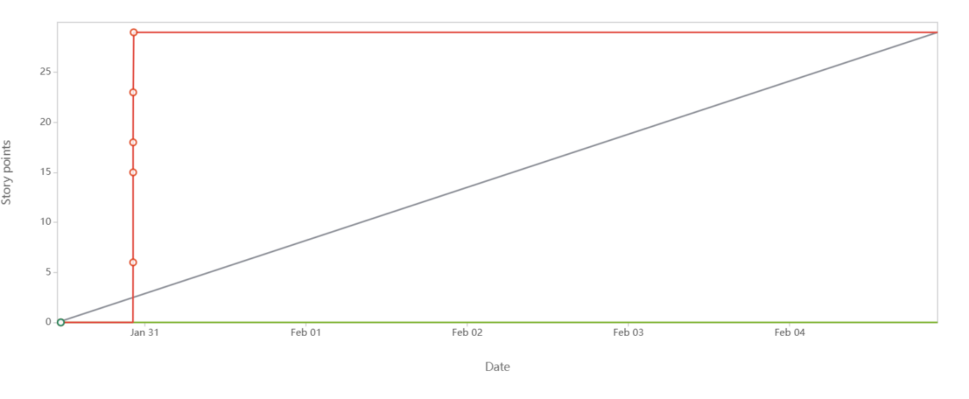
Sprint backlog:The Sprint Backlog is composed of the Sprint Goal (why), the set of Product Backlog items selected for the Sprint (what), as well as an actionable plan for delivering the Increment(how).
The Sprint Backlog is a plan by and for the Developers. It is a highly visible, real-time picture of the work that the Developers plan to accomplish during the Sprint in order to achieve the Sprint Goal. Consequently, the Sprint Backlog is updated throughout the Sprint as more is learned. It should have enough detail that they can inspect their progress in the Daily Scrum
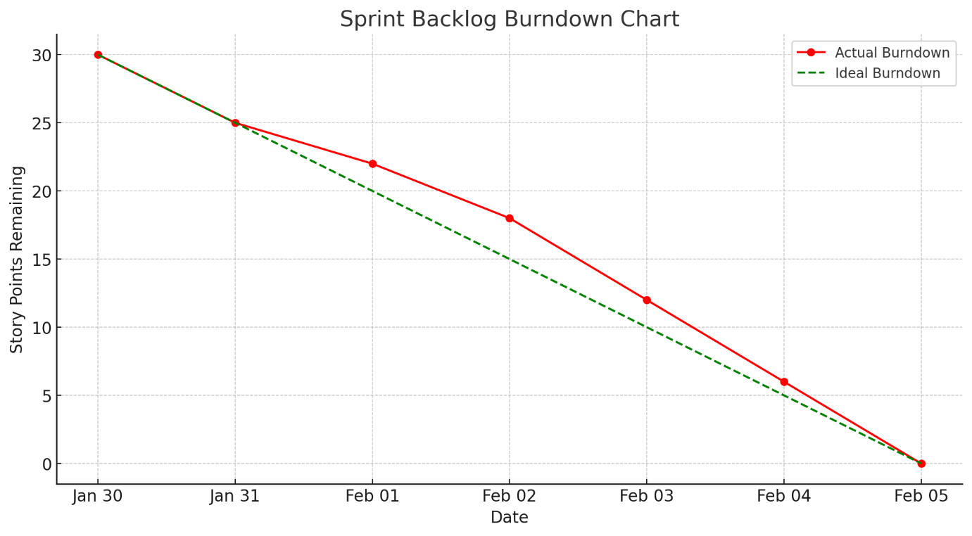
Sprint Burndown Chart (for Sprint 1)
- Y-axis: Remaining Effort (hours)
- X-axis: Days of Sprint (Day 1 → Day 10)
- Start of Sprint 1 = 50 hours
- Each day, completed tasks reduce hours
- By Day 10, total effort should reach 0
- This shows daily progress within the sprint.

Document 6: Sprint meetings
Meeting Type 1: Sprint Planning meeting
Date | 2nd September 2025
Time | 10:00 AM – 12:00 PM
Location | Conference Room B2 / Microsoft Teams
Prepared By | Piyali Chaudhuri, Business Analyst
Attendees | Scrum Master, Product Owner, Scrum Developers (1–5), Business Analyst

Agenda Topics
Topic | Presenter | Time allotted
Review of Product Backlog | Product Owner | 20 min
Identify Sprint Goal | Scrum Master | 10min
Select Items for Sprint Backlog | Scrum Master | 30min
Break User Stories into Tasks | Scrum Developers | 40min
Final Q&A + Sprint Plan Confirmation | Scrum Master / Team | 20min

Other Information
Observers | QA Lead, UI/UX Designer
Resources | JIRA Board, Product Backlog, Sprint Planning Template, Estimation Poker Cards
Special Notes | Sprint 1 planned for 2 weeks (3rd Sept to 16th Sept). Goal: Flight Search & Booking MVP

Meeting Type 2: Sprint review meeting
Date | 16th September 2025
Time | 4:00 PM – 5:00 PM
Location | Conference Room B2 / Microsoft Teams
Prepared By | Piyali Chaudhuri, Business Analyst
Attendees | Scrum Team, Product Owner, Stakeholders

Sprint status | Completed all committed backlog items for Sprint 1
Things to demo | - Search with filters  - Search Results UI integration
Quick updates | - Two minor bugs found and resolved  - Code integrated with QA pipeline
What’s next | - Begin Sprint 2 (Search + Booking feature)  - Refractor flight results for mobile responsiveness

Meeting Type 3: Sprint retrospective meeting
Date | 17th September 2025
Time | 11:00 AM – 12:00 PM
Location | Microsoft Teams
Prepared By | Piyali Chaudhuri, Business Analyst
Attendees | Scrum Master, Product Owner, Scrum Developers, BA

Agenda | - Review team performance  - Discuss blockers and improvements  - Plan action items for next sprint
What went well | - Great collaboration between developers and QA  - Backlog was well-groomed; sprint planning was smooth  - Daily stand-ups kept everyone aligned
What didn’t go well | - Slight delay due to API integration.  - Incomplete testing on lower-end devices
Questions | - Should we include end-to-end automated tests in Sprint 2?  - Can design team give mockups earlier?
Reference | - Sprint 1 Retrospective Board (Miro)  - Sprint Burn-down Chart (JIRA)

Meeting Type 4: Daily Stand-up meeting
Week 1: (03-09-2025 to 09-09-2025)
Question | Name / Role | Monday | Tuesday | Wednesday | Thursday | Friday
What did you do yesterday? | Dev 1 – Saurav | Set up API layer | Integrated search | Worked on filters | Bug fixes | Final testing
What will you do today? | Dev 1 – Saurav | Work on UI | Fix API response | UI integration | Resolve UI bugs | Push to QA
Any blockers? | Dev 1 – Saurav | None | API delay | None | Minor merge issues | None
What did you do yesterday? | Dev 2 – Tanya | UI wireframes | Component design | Page layout | Integrated filters | UX feedback fix
What will you do today? | Dev 2 – Tanya | Create layout | Refactor code | Mobile view | Resolve feedback | Review with UX
Any blockers? | Dev 2 – Tanya | None | Missing icon sets | None | Late mockup input | None
What did you do yesterday? | Dev 3 – Rajeev | Wrote unit tests | API test cases | DB integration | Code review | Final commit
What will you do today? | Dev 3 – Rajeev | DB model design | Write more tests | Optimize queries | Test deployment | Update documents
Any blockers? | Dev 3 – Rajeev | Test data issue | None | Local DB error | None | None
Note:
- Weekends are Holiday so didn’t mentioned in this chart
- Developers 4 and 5 can be included in Week 2 log.

