Capstone Prep 1 - Part 3
Question 1: Functional Requirements
Identify minimum 20 functional requirements
Answer: Functional Requirements: Functional requirements define the specific behaviors, functions or operations of a system. They describe what the system should do, outlining the necessary tasks, actions or activities it must perform to achieve its objectives.
Req ID | Req Name | Req Description | Priority
FR0001 | User Registration | The new users (farmers and manufacturers) should be able to register by providing their email ID and creating a secure password | 10
FR0002 | User Login | The registered users should be able to log in using their credentials | 10
FR0003 | Manufacturer Product Upload | Manufacturers should be able to upload product details (name, category, description, price, stock quantity, images) | 9
FR0004 | Product Catalog Display | The system should display all available products in categorized views (Fertilizers, Seeds, Pesticides) | 9
FR0005 | Search for the Products | The system should provide search functionality to find products by name, category, or manufacturer | 8
FR0006 | Adding products to the cart | Farmers should be able to add selected products to a shopping cart | 8
FR0007 | Place Order | Farmers should be able to place orders for items in their cart and confirm order details before submission | 7
FR0008 | Payment with different modes | The system should provide payment options including Credit/Debit Card, UPI, and Cash on Delivery (COD) | 7
FR0009 | Inventory Management | The system should update product stock quantities automatically when orders are placed | 7
FR0010 | Track delivery | The system should display order status updates and a delivery tracker showing shipment progress | 6
FR0011 | Generate Downloadable Invoice/Receipt | The system should generate and allow users to download/print a detailed invoice or receipt for every completed order (including order ID, itemized list, prices, taxes, payment method, and delivery address). | 6
FR0012 | User Profile Management | User should be able to view and update personal information (name, address, contact number, delivery location) | 5
FR0013 | Feedback & Ratings | Farmers should be able to submit ratings and reviews for purchased products | 5
FR0014 | Order Confirmation Email | The system should send an order confirmation email to the farmer after a successful order placement | 4
FR0015 | Customer Support | User should be able to raise a query to the customer support team | 4
FR0016 | Order History | Farmers should be able to view past orders with details (items, payment method, and delivery status). | 3
FR0017 | Notifications | The system should send notifications (email/SMS/in-app) for order confirmation, dispatch, delivery, and low-stock alerts to manufacturers | 3
FR0018 | Adding products to the wishlist/ Buy Later | Farmers should be able to add the products to the 'Wishlist' or 'Buy Later' | 2
FR0019 | Admin Dashboard | The system should provide an admin interface to manage users, products, orders, and view transaction reports | 2
FR0020 | Buy Again | User should be able to view past orders and then place order for same products again | 1

Non-functional requirements:
Non-functional requirements will describe the qualities and attributes of a system, focusing on how the system performs rather than specific behaviors or functions.
Req ID | Req Name | Req Description
NFR001 | Usability | Application should be self-explanatory and user friendly
NFR002 | Performance | The application must load pages within 3 seconds
NFR003 | Security | Application must ensure secure user authentication
NFR004 | Compatibility | Application should be compatible with Chrome, Safari, Edge and Firefox browsers
NFR005 | Response Time | The application must respond to user inputs within 2 seconds
-------------------------------------------------------------------------------------------------------------------------------
Question 2: Minimum 5 page designs
Make wireframe and prototypes
Answer:
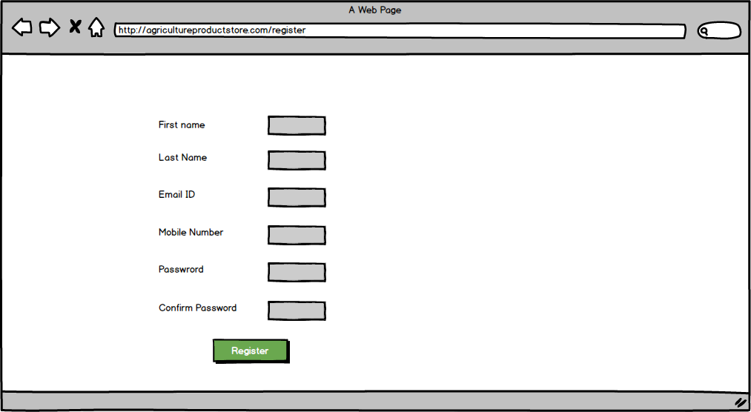
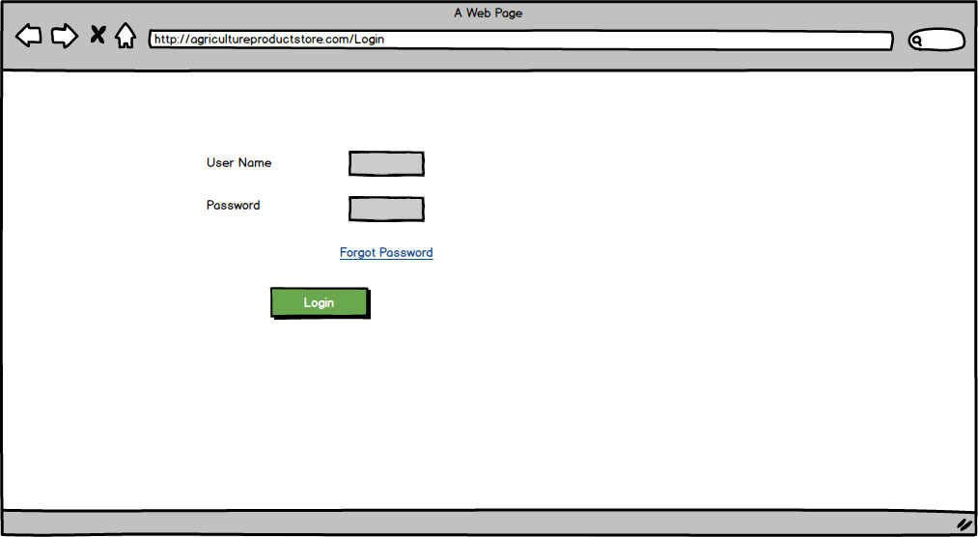
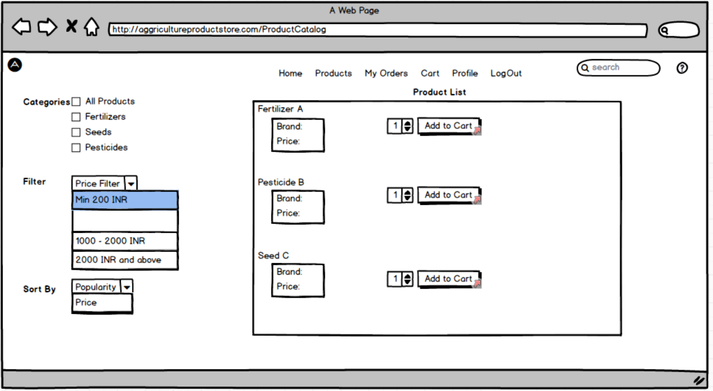
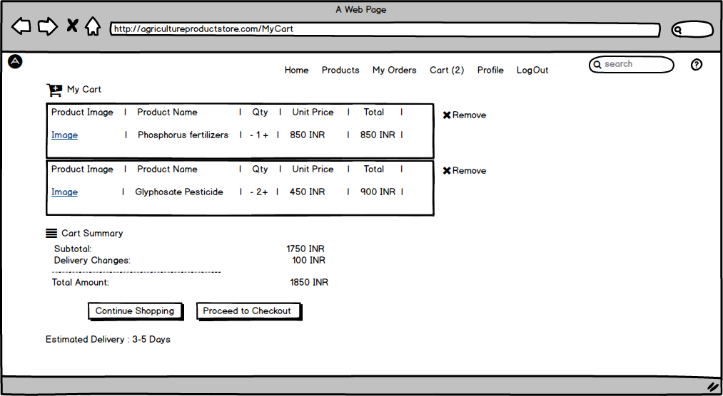
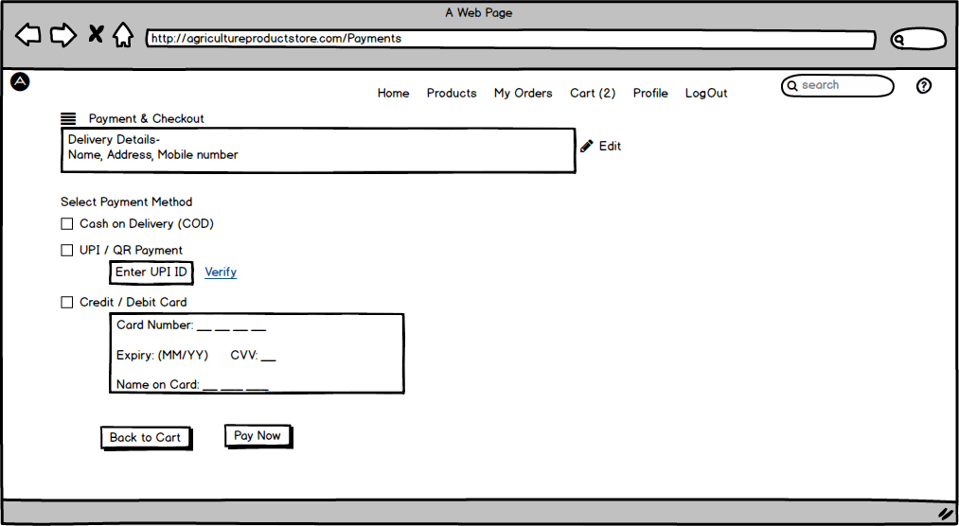
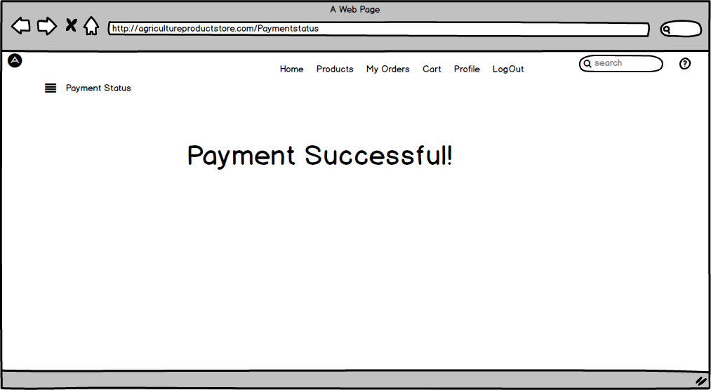

Prototypes (Axure RP):
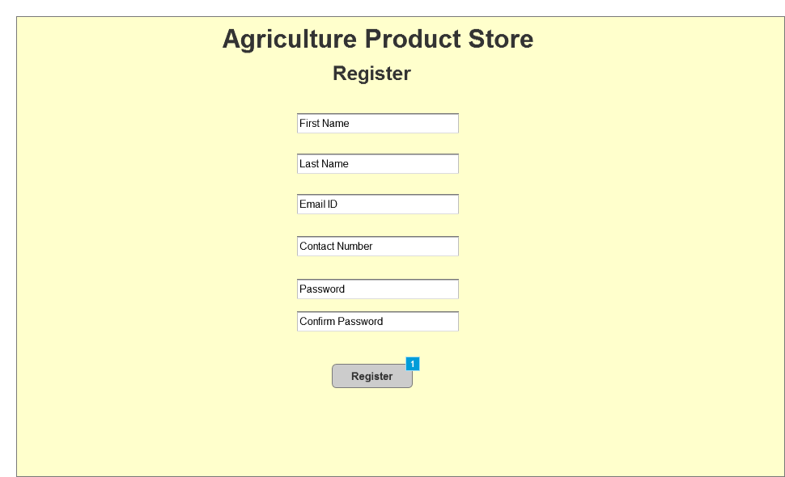
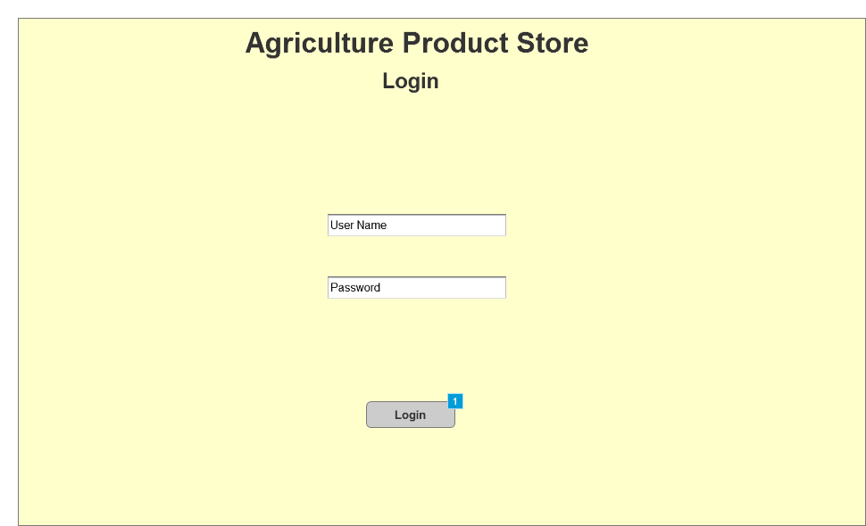
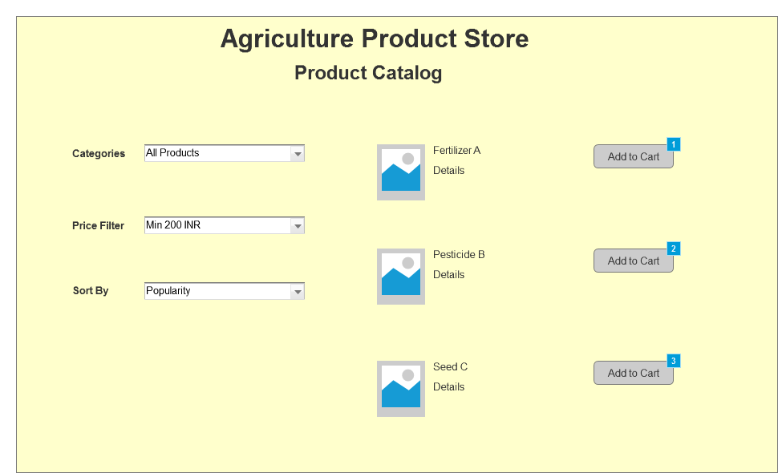
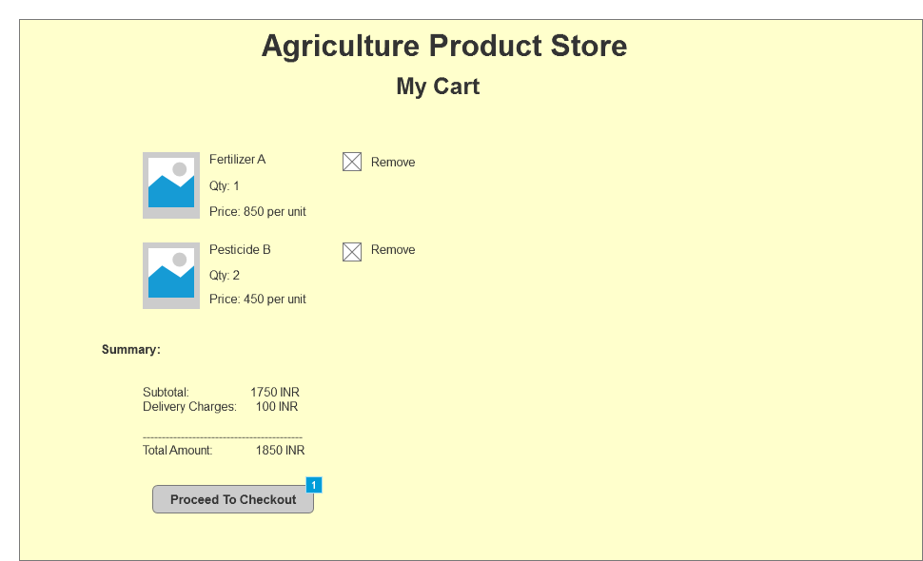
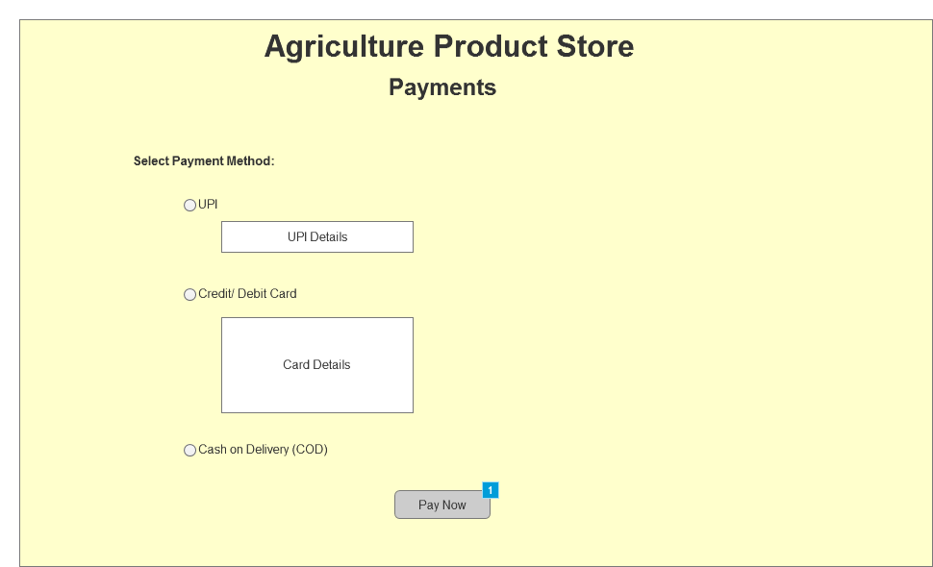
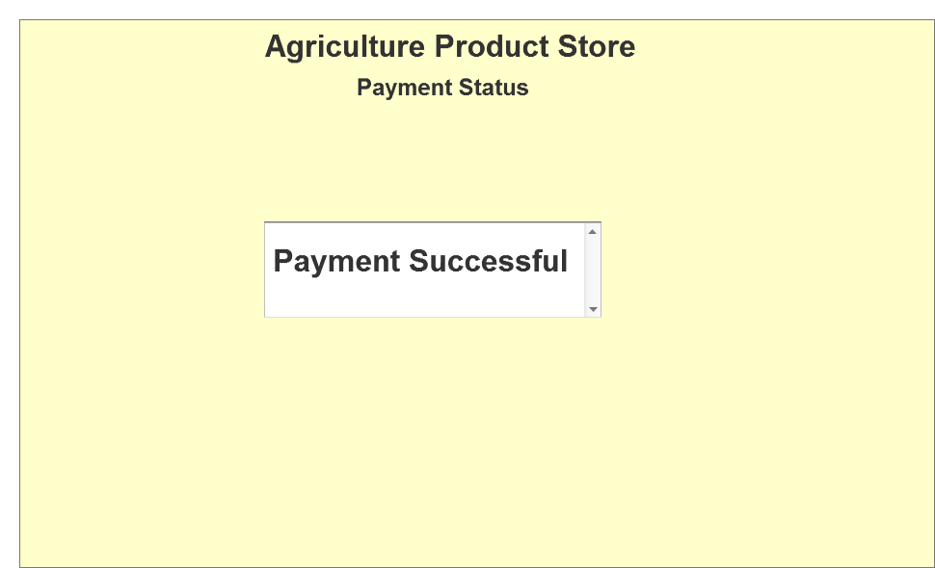
Question 3: Tools (Visio, Balsamiq)
Make a note of the Tools, which you are using for above concepts.
Answer:
Microsoft Visio:
- It is a diagramming and vector graphics application, used to create UML diagrams like use case diagrams, activity diagrams, flowcharts and other visual representations of complex information.
- It is used for visual modeling of business processes and system architecture.
- It provides drag-and-drop shapes for flowcharts, ER diagrams, org charts, etc.
- Integrates with Microsoft Office suite (Word, Excel, PowerPoint).
- Allows collaboration and cloud sharing via Microsoft 365.
- Tool consists of- Features, Canvas and UML Components.

- Use MS Visio when your goal is to visualize processes, workflows, or system models rather than user interfaces.
Balsamiq:
- It is a rapid wire framing tool used to create mockups and prototypes of user interfaces, for web and mobile applications. It is a drag and drop tool. Balsamiq Studio is founded in March 2008 by Peldi Guilizzoni.
- Tool: It has UI library, Canvas (to draw mockups), Property Panel (for creating pages), and Property Inspector (to set properties). We can link the pages and Preview is available to see the linked pages after complete creation.
- As compared to Axure, it is less advanced and simple to learn and use, more focused on creating static wireframes and mockups and exporting them in formats such as PNG and PDF, only one person can involve, more affordable i.e. one-time fee.
- Drag-and-drop interface for quick wireframes.
- Useful for early-stage design discussions.
- Helps stakeholders visualize the structure of a system before development.
- Demonstrating page layouts, navigation, and content placement.
Axure RP:
- It is a more advanced prototyping tool, used to create high fidelity, interactive wireframes and prototypes for web, mobile and desktop application with screen navigations. It has clickable buttons, input and output
- It allows the business stakeholders to get the feel of the future system and you can capture their feedback during the session.
- The AxureRP is used at the starting of a project during both the Research and Design phases of a project.
- As compared to Balsamiq, more advanced, requires more time to master, advanced prototyping features. For collaboration, it allows team to work on same project simultaneously, share design assets; manage changes and comments more efficiently. It has subscription based pricing model. Supports a wider range of output formats, including html, css and javascript.
- Tool consists of- Site map, UI Library, Canvas, Widgets, Widgets properties and styles, Interaction and notes.
- Use Axure RP when you want to demonstrate the working behavior of a system, not just static screens.
-------------------------------------------------------------------------------------------------------------------
Question 4: RTM
A business analyst’s key responsibilities are to keep track of the requirements and make sure that no requirement is missed.
Mr. Henry and peter have approached you regarding the current status of the project. How will you tackle this situation? Prepare RTM
Answer:
An RTM ensures that:
- Every business requirement is mapped to functional and non-functional requirements,
- Each is further linked to design, development, and test cases,
- Nothing is left out or untested.
Need to convey to Mr. Henry, that, I’ve prepared a Requirements Traceability Matrix to ensure all stakeholder requirements are being implemented and tested.
This matrix shows each requirement, corresponding design modules, and testing status.
As of now, following functionalities are completed- User Registration, User Login, Manufacturer Product Upload, Product Catalog Display, Search for the Products, Place Order, Payment with, different modes, Inventory Management, Track delivery, Generate Downloadable Invoice/Receipt, User Profile Management, Feedback & Ratings, Order Confirmation Email, Customer Support, Order History, Notifications, Adding products to the wishlist, Admin Dashboard, Buy Again.
And Add to Cart and Payment modules are under progress, and delivery tracking and email confirmation are next in the development queue.
RTM:
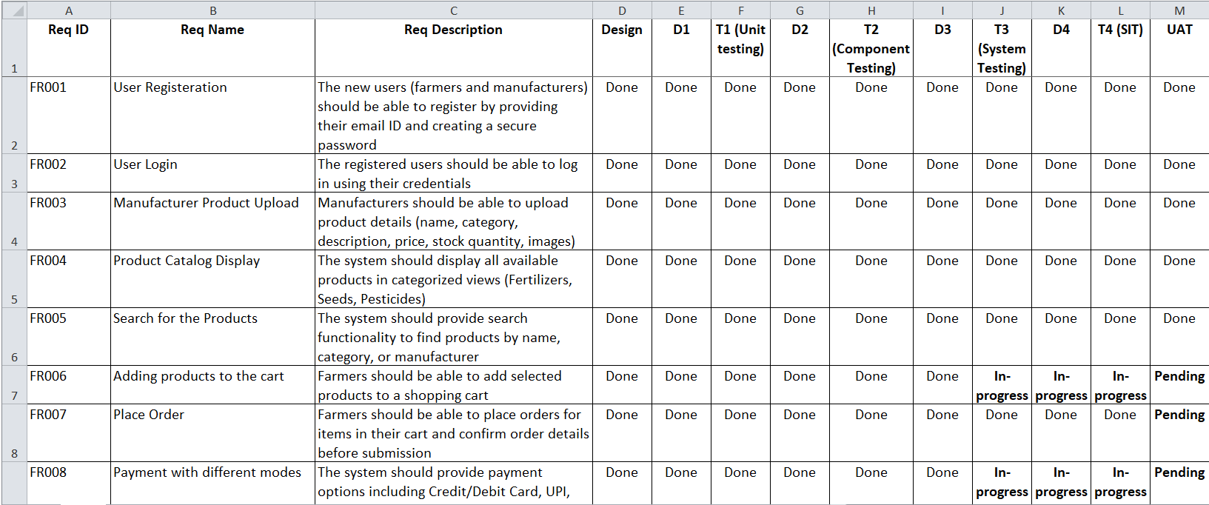
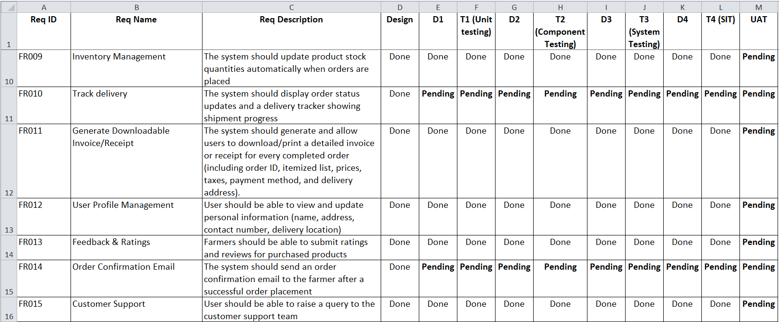
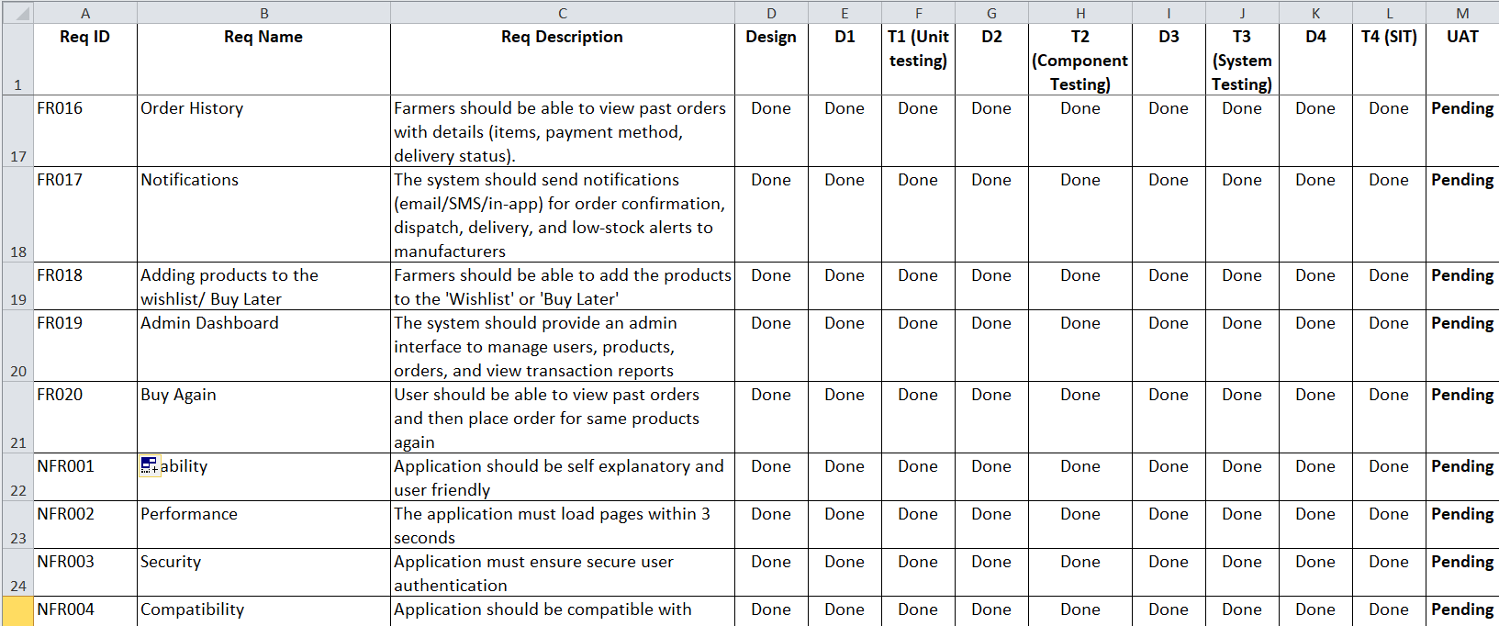
-------------------------------------------------------------------------------------------------------------------------------
Question 5: 10 Test Case Documents
Prepare 10 Test Case Documents
Answer: A Test
case document is a detailed outline used by testers to ensure that a software application or system is working as expected.
Test case document is created by tester and tracking will be done by BA. BA needs to track whether the testing is done in expected timeline and in a proper way, BA can interfere in testing to track testing.
Test case ID | TC_001 | Test case Name | User Registration
Project ID | P001 | Project Name | Online Agriculture Products Store
PM ID | PM_01 | PM Name | Mr. Vandanam
Test strategy ID | TS_01 | Tester ID | T001
Test plan ID | TP_01 | Tester Name | Mr. Jason
Test schedule ID | SCH_01 | Date of Test | 25-Oct-25
Scenario | Register new user (Farmer)
Link to that page: | Registration Page
Input Data | farmer@gmail.com  , Password: Abc@123 | farmer2@gmail.com  , Password: #123ABC#
Expected behavior | Account successfully created and confirmation email sent
Actual behavior | Account created successfully
Comments | Working as expected
Result (Pass/Fail) | Pass

Test case ID | TC_002 | Test case Name | User Login
Project ID | P001 | Project Name | Online Agriculture Products Store
PM ID | PM_01 | PM Name | Mr. Vandanam
Test strategy ID | TS_01 | Tester ID | T002
Test plan ID | TP_01 | Tester Name | Ms. Alekya
Test schedule ID | SCH_02 | Date of Test | 25-Oct-25
Scenario | Login with valid credentials
Link to that page: | Login Page
Input Data | farmer@gmail.com  , Password: Abc@123 | farmer2@gmail.com  , Password: #123ABC#
Expected behavior | User logged in successfully and redirected to home page
Actual behavior | User logged in successfully
Comments | Working as expected
Result (Pass/Fail) | Pass

Test case ID | TC_003 | Test case Name | Invalid Login Attempt
Project ID | P001 | Project Name | Online Agriculture Products Store
PM ID | PM_01 | PM Name | Mr. Vandanam
Test strategy ID | TS_01 | Tester ID | T002
Test plan ID | TP_01 | Tester Name | Ms. Alekya
Test schedule ID | SCH_02 | Date of Test | 25-Oct-25
Scenario | Farmer views product categories
Link to that page: | Login Page
Input Data | farmer@gmail.com  , Password: Abc@999
Expected behavior | Error message “Invalid credentials” displayed
Actual behavior | Error displayed correctly
Comments | Security validation working fine
Result (Pass/Fail) | Pass

Test case ID | TC_004 | Test case Name | Browse Product Catalog
Project ID | P001 | Project Name | Online Agriculture Products Store
PM ID | PM_01 | PM Name | Mr. Vandanam
Test strategy ID | TS_01 | Tester ID | T002
Test plan ID | TP_01 | Tester Name | Ms. Alekya
Test schedule ID | SCH_02 | Date of Test | 25-Oct-25
Scenario | Farmer views product categories
Link to that page: | Home -> Product Catalog
Input Data | Click on “Seeds” category
Expected behavior | List of seeds with price and manufacturer details displayed
Actual behavior | Works as expected
Comments | Display layout verified
Result (Pass/Fail) | Pass

Test case ID | TC_005 | Test case Name | Search for Product
Project ID | P001 | Project Name | Online Agriculture Products Store
PM ID | PM_01 | PM Name | Mr. Vandanam
Test strategy ID | TS_01 | Tester ID | T002
Test plan ID | TP_01 | Tester Name | Ms. Alekya
Test schedule ID | SCH_02 | Date of Test | 25-Oct-25
Scenario | Search for Fertilizer
Link to that page: | Product Search
Input Data | Keyword: “Fertilizer”
Expected behavior | All fertilizer-related products displayed
Actual behavior | Accurate search results displayed
Comments | Search filters functioning correctly
Result (Pass/Fail) | Pass

Test case ID | TC_006 | Test case Name | Add to Cart
Project ID | P001 | Project Name | Online Agriculture Products Store
PM ID | PM_01 | PM Name | Mr. Vandanam
Test strategy ID | TS_01 | Tester ID | T002
Test plan ID | TP_01 | Tester Name | Ms. Alekya
Test schedule ID | SCH_02 | Date of Test | 25-Oct-25
Scenario | Add selected product to cart
Link to that page: | Product Details Page
Input Data | Product: Urea Fertilizer → Click “Add to Cart”
Expected behavior | Product added successfully, cart count updated
Actual behavior | Works fine
Comments | NA
Result (Pass/Fail) | Pass
Test case ID | TC_007 | Test case Name | Payment via UPI
Project ID | P001 | Project Name | Online Agriculture Products Store
PM ID | PM_01 | PM Name | Mr. Vandanam
Test strategy ID | TS_01 | Tester ID | T002
Test plan ID | TP_01 | Tester Name | Ms. Alekya
Test schedule ID | SCH_02 | Date of Test | 25-Oct-25
Scenario | Complete payment using UPI
Link to that page: | Checkout Page
Input Data | Payment Method: UPI → UPI ID: 9876543210@upi
Expected behavior | Payment successful and order confirmation shown
Actual behavior | Payment completed successfully
Comments | Verified with mock transaction
Result (Pass/Fail) | Pass

Test case ID | TC_008 | Test case Name | Payment via COD
Project ID | P001 | Project Name | Online Agriculture Products Store
PM ID | PM_01 | PM Name | Mr. Vandanam
Test strategy ID | TS_01 | Tester ID | T002
Test plan ID | TP_01 | Tester Name | Ms. Alekya
Test schedule ID | SCH_02 | Date of Test | 25-Oct-25
Scenario | Select Cash on Delivery option
Link to that page: | Payment Page
Input Data | Payment Method: COD
Expected behavior | Order placed successfully with COD confirmation
Actual behavior | Works as expected
Comments | NA
Result (Pass/Fail) | Pass

Test case ID | TC_009 | Test case Name | Email Confirmation after Order
Project ID | P001 | Project Name | Online Agriculture Products Store
PM ID | PM_01 | PM Name | Mr. Vandanam
Test strategy ID | TS_01 | Tester ID | T002
Test plan ID | TP_01 | Tester Name | Ms. Alekya
Test schedule ID | SCH_02 | Date of Test | 25-Oct-25
Scenario | Verify order confirmation mail
Link to that page: | Order Confirmation Page
Input Data | Order ID: 12345
Expected behavior | Email sent with order and tracking details
Actual behavior | Confirmation email received
Comments | Verified mail format and content
Result (Pass/Fail) | Pass

Test case ID | TC_010 | Test case Name | Track Delivery Status
Project ID | P001 | Project Name | Online Agriculture Products Store
PM ID | PM_01 | PM Name | Mr. Vandanam
Test strategy ID | TS_01 | Tester ID | T002
Test plan ID | TP_01 | Tester Name | Ms. Alekya
Test schedule ID | SCH_02 | Date of Test | 25-Oct-25
Scenario | Track order using order ID
Link to that page: | My Orders → Track Order
Input Data | Order ID: 12345
Expected behavior | Delivery status displayed (“Out for delivery”)
Actual behavior | Payment completed successfully
Comments | Status updated correctly
Result (Pass/Fail) | Working fine
-------------------------------------------------------------------------------------------------------------------------------
Question 6: DB Design
After the requirements are thoroughly explained to the entire project team by business analyst, the Database architects have decided to do the database design and also to represent the in-flow and out-flow of data. Draw database schema and ER diagram
Answer:
DB Schema and Entity relationship diagram together called DB design.
DB Schema is a blueprint that outlines the structure of a database, including its tables, fields, relationships, constraints, and other characteristics.
An Entity Relationship diagram is a visual representation of the relationships between entities in a database. It depicts the entities (such as tables), attributes (properties or fields), and relationship between them.
Database Schema:
-------------------------------------------------------------------------------------------------------------------------------
Question 7: Data Flow Diagram
What is a data flow diagram? Draw a data flow diagram to represent the in-flow and out-flow of data when a Farmer is placing an order for the product.
Data Flow Diagram is a graphical representation of the flow of data within a system. It usually shows how data moves from one process to another, how it’s stored, and where it ends up.
It helps analysts and designers understand the flow of data within a system, identify potential bottlenecks or inefficiencies, and communicate system requirements to stakeholders.
It shows the flow of information, not the control flow or logic.
Symbol:
- Rounded rectangle: Process- represents a function/ activity that transform data
- Two parallel lines: Data Store- where data is stores (database, file)
- Rectangle: External entity- source/ destination of data outside the system
- Arrow: Data flow- shows direction of data movement
Steps:
- Farmer searches for a product - system retrieves data from Product Catalog.
- Farmer selects a product and places an order - data goes to Order Management System.
- System sends payment details to Payment Gateway for validation.
- Once payment succeeds, order data is saved in Order Database.
- Order details are sent to Delivery Service for dispatch.
- Farmer receives order confirmation and receipt.
-------------------------------------------------------------------------------------------------------------------------------
Question 8: Change Request
Due to change in the Government Taxation structure we should change the Tax structure how do you handle change requests in a project?
Answer:
A Change request is a formal proposal to alter the system, product or project.
Steps to handle a change request in a project:
  - Understand the scope of change request, analyze it and document the change request
  - Do the impact analysis- project scope, schedule, budget, resources and risk
  - Prioritize change request based on its urgency, importance and impact on project
  - Seek approval from the project sponsor
  - Communicate the change request and its potential impacts to all relevant stakeholders, including the project team.
Scope of CR: Update the taxation structure as per new government norms.
Change Request Document:
Project Start Date: 01-Sep-2025
Project Manager: Mr Vandanam
Project Team Members: | Ms. Juhi, Mr Teyson, Ms Lucie, Mr Tucker, Mr Bravo, Mr Mike, - Mr John, Mr Jason, Ms Alekya, Ms Pooja
Change Request ID | CR001
Received Date | 25-Oct-25
Received By | Pooja
Change Request Description | Due to a change in Government Taxation structure, the tax logic and rates in the online agriculture product store need to be updated.
Priority | High
Assigned to | Ms Juhi
Target  date | 05-Nov-25
Total Hours Estimated | 80 Hours
Impact Analysis Description | Modify existing tax calculation logic to apply new GST structure per Government of India regulation effective [date].  Will affect pricing calculation, invoice module, and tax reports.
Effected Code Components | System functionality (tax calculation module, invoices, payment gateway, reports)
CR Status | Open
Reviewed By | Project Steering Committee-  Mr. Henry, Mr. Pandu, Mr. Dooku
Delivery Date | 05-Nov-25
Test Case Document Reference | TC_006, TC_007, TC_008
Release Document Reference | NA
Impact Analysis:
- The BA, Project Manager, and technical team (developers, testers, DB admin) evaluate how the change affects:
  - Business requirements
  - System functionality (tax calculation module, invoices, payment gateway, reports)
  - Budget, timelines, and resources
  - Dependencies and risks
Impact: Will affect pricing calculation, invoice module, and tax reports. Estimated 2 weeks of development and testing effort.
Feasibility Study: The purpose of the feasibility study is to assess whether implementing the change to the system is viable- technically (existing technology, infrastructure, and skills are sufficient to develop), operationally (system will function effectively in the organization and be accepted by end users), economically (project is financially viable and within budget) and legally (project complies with government and legal regulations)
Priority:
The priority for this CR will ‘High’, because the change is in consideration of government taxation rule and that should be effective from the given date so to meet those criteria, team need to work on this on high priority. Otherwise this will impact on government policy breach and impact customer satisfaction, eventually will impact the business.
Review and Approval:
Submit the impact analysis to the Project Steering Committee (e.g., Mr. Henry, Mr. Pandu, Mr. Dooku).
They decide whether to:
- Approve the change,
- Reject it, or
- Defer it to a future release.
Decision: Approved. The change is mandatory to comply with government law.

Update Project Documents
If approved:
Update all relevant documents —
- Business Requirement Document (BRD)
- Functional Requirement Specification (FRS)
- RTM (Requirements Traceability Matrix)
- Test Cases
Communicate updates to all team members (Project team, developers, testers, etc.).
Notify all stakeholders (especially end users like farmers and manufacturers) about the new tax changes through app updates or email notifications.
-------------------------------------------------------------------------------------------------------------------------------
Question 9: Change Request Vs an Enhancement
As the project is in process, Ben and Kevin have contacted you. The reason is to inform you that they want the Farmers to sell their crop yields through this application i.e. Farmers should be able to add their crop yields or products and display to general public and should be able to sell them. They also want to introduce Auction system for their Crop yields. As a BA, what will be your response? Is this a change request or an enhancement???
Answer:

Change Request
A change request is when the existing approved scope, functionality, or requirement is modified or replaced.

Enhancement
An enhancement means adding a new feature or capability that was not part of the original approved scope- something extra that expands the system’s purpose.
In this case-
The original goal of the project was to help farmers buy inputs (fertilizers, seeds, pesticides).
The new request is to allow farmers to sell their own crops and even introduce an auction mechanism- a completely new business process.
Therefore this is an Enhancement, not a change request.
Because it adds new functionality and broadens the scope of the project beyond what was originally planned.
As a BA,
I will acknowledge to the idea shared by Ben and Kevin and covey them that, allowing farmers to sell their crop yields and introducing an auction system would significantly enhance the platform’s value.
However, this functionality was not part of the original project scope, which currently focuses on facilitating farmers to purchase agricultural products from manufacturers.
Hence, this will be treated as an enhancement request.
I’ll document the requirements in detail and work with the development team, to determine the feasibility and impact of the new feature to the system (how it affects architecture, budget, and schedule). Also need to consider the potential benefits, risks and costs associated with the enhancements before making any recommendations to the client, and then present the proposal to the project steering committee for their review and approval.
-------------------------------------------------------------------------------------------------------------------------------
Question 10: Estimations
Come up with estimations – How many Manhours required
Answer:
Estimation: The technique of finding an approximation with the help of limited available information is called estimation. This is done with sampled data or sources.
Estimation is part of business planning and it is a responsibility of Bas to estimate the factors related to cost, revenue, resources and future enhancements. They are supervised by senior managers who are skilled in resource allocation and budgeting in order to avoid any future ambiguities.
Manhours: Manhours is the required effort for the resources to complete a project. There are 3 types of projects:
Small: upto 500 hours
Medium: upto 1000 hours
Large: upto 1500 hours
Available Information:
Vendor: APT IT Solutions
Budget: ₹2 Crores INR
Duration: 18 months
BA: Me
Team: PM, Senior Java Developer, Java Developers, Testers, DB Admin, Network Admin
Analysis:
As per the case study, the duration of the project is 18 months and the current team size is around 15. This will come under medium project.
As the trained resources are available, trainers are not required.
As the structure of the project is available, New and enhanced infrastructure is not required.
Main modules/features:
- User Login/Registration (Farmers, Manufacturers)
- Product Catalogue (Fertilizers, Seeds, Pesticides)
- Product Search
- Add to Cart / Buy-Later List
- Payment Gateway (COD, UPI, Card)
- Order Confirmation Email
- Delivery Tracking
- Admin / Manufacturer Dashboard
Functionality breakdown and estimation:
Module | Description | Complexity | Estimated Effort (Manhours)
User Management | Login, Registration, Forgot Password, Profile Management | Medium | 60 hrs
Product Management | Manufacturers add products (fertilizers, seeds, pesticides), edit/delete, view | High | 80 hrs
Product Catalogue | Farmers browse products by category | Medium | 50 hrs
Search Functionality | Search by name, category, and filter by price/brand | Medium | 40 hrs
Cart & Buy-Later | Add, remove, view items, save for later | Medium | 60 hrs
Payment Gateway Integration | UPI, COD, Debit/Credit Card | High | 80 hrs
Order Confirmation & Notifications | Email/SMS notifications for order status | Medium | 40 hrs
Delivery Tracking | Track orders in real-time using tracking ID | High | 70 hrs
Admin Panel / Dashboard | Manage users, orders, payments, reports | High | 90 hrs
Reports & Analytics | Order reports, sales analysis, product stock | Medium | 40 hrs
Development efforts: 610 Manhours
Supporting Activities, Testing:
 | Activity | Role | Effort (Manhours)
1 | Requirement Elicitation & Documentation | BA | 40 hrs
2 | System Design (Architecture, ERD, DFD, UML) | Architect + BA + Dev | 60 hrs
3 | UI/UX Design (Wireframes, Prototype) | UI/UX Designer | 50 hrs
4 | Database Design | DB Admin | 40 hrs
5 | Testing (Unit, Integration, System, UAT) | Testers | 100 hrs
6 | Deployment & Hosting Setup | Network Admin | 30 hrs
7 | Project Management & Coordination | PM | 60 hrs
8 | Training & Handover | BA + PM | 20 hrs
Supporting Activities, Testing efforts: 400 manhours
Category | Manhours
Functional Modules | 610 hrs
Non-Functional & Support Activities | 400 hrs
Total Estimated Effort | ≈ 1,010 Manhours

The timeline includes phases like requirement gathering, approvals, multiple sprints, UAT, deployment, and training.
So, actual calendar duration = 12 - 14 months (development + testing + review),
and the remaining buffer is for CSR reporting, maintenance, and enhancements.
-------------------------------------------------------------------------------------------------------------------------------
Question 11: UAT
Project has finally completed all the stages i.e., design, development, testing etc. Now, it is the role of a business analyst to contact the client for testing of the final product and have to successfully complete it. How are you going to handle this situation? And once it is done, what will be the process to close the project? Explain UAT Acceptance process
Answer:
As a Business Analyst, the main role is to facilitate User Acceptance Testing (UAT)- the final phase where the client verifies that the delivered system meets their business needs and agreed requirements.
UAT:
Planning and Prepare: In this step, blueprints are made to implement UAT testing for every feature that needs to be test and minimum standards for accepting the test.
- Review Requirements Traceability Matrix (RTM):
Ensure every business requirement has been implemented and tested.
- Prepare UAT Plan:
Document the scope, objectives, approach, test schedule, entry/exit criteria, and responsibilities.
- Identify UAT Participants:
Usually includes end users or client representatives (e.g., Peter, Kevin, Ben).
- Set up UAT Environment:
Ensure the testing environment mirrors production setup.
Designing: The test cases are designed to cover all possible situations that the software might face in real-world use. These are derived directly from business scenarios and requirements.
Example: “Farmer logs in -> searches product -> adds to cart ->makes payment -> tracks order.”

Conduct UAT
- Kick-off Meeting:
Conduct a session with the client to explain UAT objectives, process, and expectations.
- Execute Test Cases:
Users perform tests while BA observes and records results.
- Log Issues/Defects:
Any discrepancy between expected and actual results is recorded in a defect tracker.
- Coordinate Fixes:
Work with developers and testers to fix defects and retest.
UAT Testers: A testing team consists of a end users that meet the criteria for implementing testing. They should know the test cases to run and understand the functionalities.
Bug Fixing: whatever bugs are found in the UAT testing, the development team should work on them and make the software error free.
Obtain Client Sign off: after removing all the bugs, the testing team indicates acceptance of the completion of the bugs. In this phase, all the stakeholders come to a conclusion that the software is ready to Go Live and sign it off.
Once all critical issues are resolved and test cases pass:
  - Prepare UAT Summary Report including:
    - List of test cases executed
    - Results (pass/fail)
    - Defect summary and resolutions
  - Get formal acceptance/sign-off from the client (e.g., Mr. Henry or Project Committee).
This document confirms that the system meets the business requirements and is ready for deployment
-------------------------------------------------------------------------------------------------------------------------------
Question 12: Project Closure Document
Explain Project closure document
Answer:
A Project Closure Document is the final formal report prepared at the end of a project to confirm that all project activities are completed successfully and that the project has officially been closed. It serves as an official record of project outcomes, performance, and lessons learned - and ensure that the client, project team, and organization agree that the project has met its objectives.

Purpose of Project Closure Document
- Formal acceptance of the project deliverables by the client.
- Release of resources - project team members, equipment, and budget.
- Capture of lessons learned for future projects.
- Ensure accountability - verify that all tasks, testing, and documentation are complete.
- Provide a performance summary - time, cost, quality, and risks.
Project Closure Document:
Project Summary:
The Online Agriculture Products Store project was initiated by Mr. Henry under the CSR initiative of SOONY Pvt. Ltd. to help farmers in rural areas procure agricultural products such as fertilizers, seeds, and pesticides easily through an online platform.
The application enabled farmers to connect directly with manufacturers, browse product catalogs, search for items, make secure payments (via COD, UPI, and Card options), and track deliveries. The project successfully completed all phases- Requirement Gathering, Design, Development, Testing, UAT, and Deployment- within the planned schedule and budget.
The core objectives of this project were to:
- Develop a user-friendly platform for both farmers and manufacturers.
- Allow manufacturers to upload product details (fertilizers, seeds, pesticides).
- Enable farmers to browse, search, and purchase products online.
- Integrate a secure payment gateway supporting COD, Credit/Debit Card, and UPI options.
- Provide order confirmation via email and delivery tracking functionality.
The system architecture was designed to support scalability, security, and ease of use for first-time digital users. Key stakeholders- Peter, Kevin, and Ben- played an important role in defining user requirements and validating functional expectations.
- Client: SOONY Pvt. Ltd.
- Vendor: APT IT Solutions
- Project Duration: 18 Months
- Budget: ₹2 Crores
- CSR Initiative: Yes
- Key Stakeholders: Mr. Henry (Sponsor), Mr. Pandu (Financial Head), Mr. Dooku (Project Coordinator), Peter, Kevin, Ben (Farmer Representatives)
- Key Features: Login system, Product catalog, Search function, Payment gateway, Order tracking
- Outcome: Successfully implemented and signed off by client post-UAT
Achievement:
The Online Agriculture Products Store successfully completed all stages of the Software Development Life Cycle (SDLC) - requirement gathering, design, development, testing (including UAT), and deployment. The final product achieved its goal of bridging the gap between farmers and agricultural product manufacturers, ultimately contributing to rural development and agricultural productivity.
Lesson learned:
- Early Stakeholder Engagement is Critical: Continuous communication with stakeholders like Peter, Kevin, and Ben ensured that farmer needs were accurately captured.
- Clear Documentation Prevents Misunderstandings: Maintaining requirement traceability and regular sign-offs helped avoid scope creep.
- User-Centric Design is Key: Creating simple and intuitive interfaces was essential for non-technical users (farmers).
- Change Control Process: Implementing a structured change request process prevented project delays when new requirements emerged.
- Collaborative Tools Help Efficiency: Tools like MS Visio, Axure RP, and JIRA improved coordination between development and testing teams.
Quality Assurance:
- Testing Performed: Unit Testing, Integration Testing, System Testing, and User Acceptance Testing (UAT) were successfully completed.
- Defect Rate: Reduced to less than 2% before UAT completion.
- UAT Sign-Off: Received from client representative Mr. Henry on 31 Oct 2025.
- Quality Metrics: Achieved 95% customer satisfaction rate; no major post-deployment defects reported in the first 3 months.
- Continuous Improvement: Testing templates and review checklists have been documented for future projects.
Resource Utilization:
- Team Size: 15 members
- Key Roles:
  - Project Manager – Mr. Vandanam
  - Senior Developer – Ms. Juhi
  - Java Developers – Mr. Teyson, Ms. Lucie, Mr. Tucker, Mr. Bravo
  - Network Admin – Mr. Mike
  - Database Admin – Mr. John
  - Testers – Mr. Jason & Ms. Alekya
  - Business Analyst – Me
- Utilization Summary:
  - Developers – 90% utilization across SDLC phases
  - Testers – 80% utilization during development and full-time during QA phase
  - BA – Continuous engagement across requirement elicitation, validation, and UAT support
  - No additional hiring or external trainers required due to experienced internal resources
Risk Management:
Risk ID | Description | Impact | Mitigation Strategy | Status
R01 | Delay in product data submission by manufacturers | Medium | Follow-up schedule and early onboarding of vendors | Resolved
R02 | Payment gateway integration issues | High | Partnered with a reliable third-party provider | Resolved
R03 | Low user adoption among farmers | High | Conducted demo sessions and user training | Resolved
R04 | Internet connectivity in rural areas | Medium | Optimized app for low-bandwidth performance | Resolved
Challenges:
- Requirement Volatility: Stakeholders requested additional features like product auctions mid-project (handled as change requests).
- Data Accuracy: Manufacturers’ product information required multiple rounds of validation.
- Technical Constraints: Ensuring application worked smoothly under low network conditions.
- Time Management: Coordinating development and testing activities within tight timelines.
- UAT Coordination: Scheduling client availability for user testing sessions took additional effort.

Sr. No | Points | Details | Reference Link
1 | Did the client signed off on the UAT Testing
1 | Date of the signoff: | 01-Nov-25
1 | Name of the resource: | Mr. Henry , Mr Pandu , and Mr Dooku | 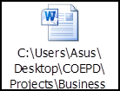
2 | Objectives of the project
2 | User friendliness | Achieved
2 | Customer satisfaction | ROI in 6 months
2 | Allow manufacturers to upload product details | Achieved
2 | Enable farmers to browse, search, and purchase products online | Achieved
2 | Provide order confirmation via email and delivery tracking functionality | Achieved
3 | Functionalities worked on
3 | Secure payment processing | Achieved
3 | Login System | Achieved
3 | Product Catalog | Achieved
3 | Search Function | Achieved
3 | Payment gateway | Achieved
3 | Order Tracking | Achieved
4 | Infrastructure
4 | Softwares Installed | Achieved
4 | Laptops configured | Achieved
5 | Funding
5 | Amount approved | Rs. 2 crore
5 | Amount used | Rs. 2 crore
6 | Overall project information
6 | Escalations | 3
6 | Customer satisfaction | High
7 | Value to the company | Positive – 90%
7 | Value to the company | Company has gained an edge over the competitors
7 | Value to the company | Increased clients
7 | Value to the company | Trained employees

