https://www.scribd.com/document/724244437/Capstone-Project-3-part-1-Solution-Copy

NURTURING PROCESS – CAPSTONE PROJECT – 3

A customer can make a payment either by Card or by Wallet or by Cash or by Net banking.
Q1. Draw a Use Case Diagram
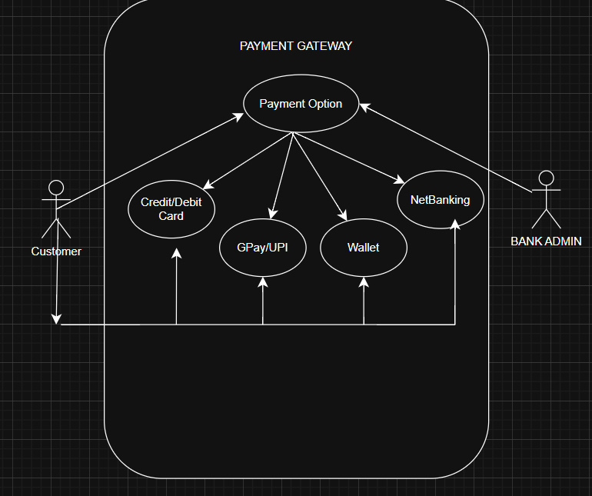
0D65AFCF-B6DB-46C-B091-21809C4D007E

Q2. Derive Boundary Classes, Controller classes, Entity Class
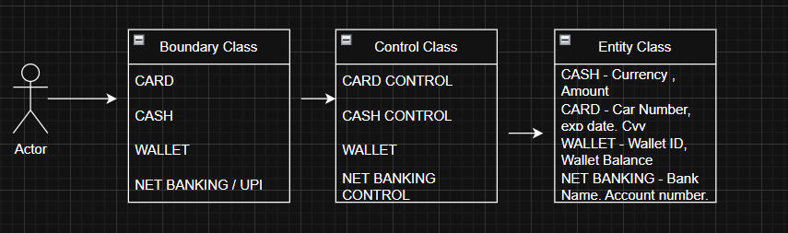

Q3. Place these classes on a three tier Architecture

Client Handles the presentation layer – Application server handles application layer & server system handles database layer
Presentation layer – This is the layer we see when we use a software . By using this we can access the webpages. The core functionality of this layer is to communicate with the application . I mean payment access gateway

Application layer – Is also known as business logic layer. As per the payment gateway option., we selects the payment option. Application layer will interact will the database layer. This acts as a mediator between presentation layer & database layer. It will gather the requirement or the data which we selects
Example – Credit-card? Gpay? Wallet? Net-banking?) & communicate to the presentation layer. It use to perform the operations of the application

Database layer – Data is stored in data layer. Application layer communicate with data layer to retrieve the input & performs required action
Which means API (Application program interface) – using JAVA / PYTHON etc
Example – After selecting the payment option will initiate the process to complete the transaction
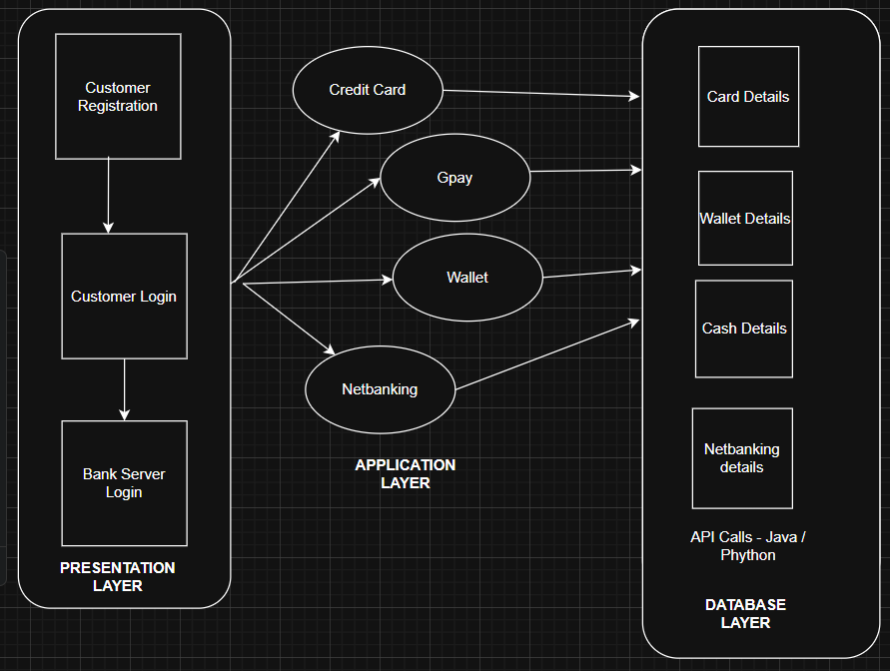

Q4. Explain Domain Model for Customer making payment through Net Banking

Domain Model for Net Banking Payment (Entities + Relationships)
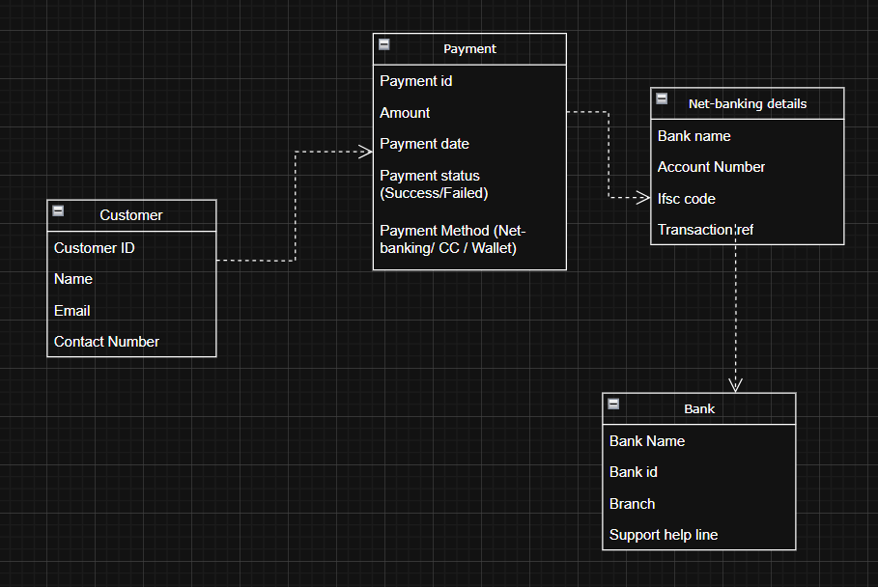

Relationships

- A Customer initiates a Payment.
- A Payment is associated with NetBankingDetails
- NetBankingDetails belongs to a Bank

Q5. Draw a sequence diagram for payment done by Customer Net Banking –

Interaction between classes in the sequential order. It is a step- step process .

It is used to show the flow of message (Event or action)

- Initially customer opens the bank website & then he or she will be entering their credentials to login.

- Once it takes you to the home-screen

- Select for payment (Netbanking)

- Add the details of the person to whom the transfer must be done. (Which includes his Name - account number- branch code- ifsc)

- Enter the amount - Initiate the payment – get otp – transaction done
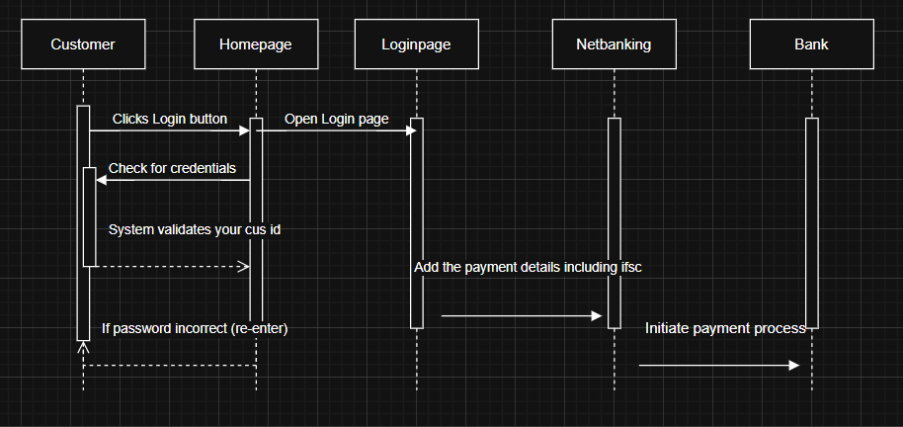

Q6. Explain Conceptual Model for this Case

Conceptual Data means data connected by lines . It represents the entity & the line represents the relationship between the entity

Bank – Represent the service provider who offer services

Security & Privacy – Bank should provide at-most security & privacy for their net-banking users. This should built a trust among customers . It should enable various features under the privacy restriction. The bank should provide strong infrastructure.

Login Credentials – Customers must use their customer id or user id along with password to login to their net-banking page. Adding to that it must have additional features like multi-level authentication like otp to the registered number or virtual authentication

Payment option – Picking the Net-banking as preferred payment option & adding the 3rd party transfer person details along with his IFSC / Account number / Branch code etc

Policies – This includes various policies RBI regulations , netbanking services, ensuring flawless services, & monitoring the compliance
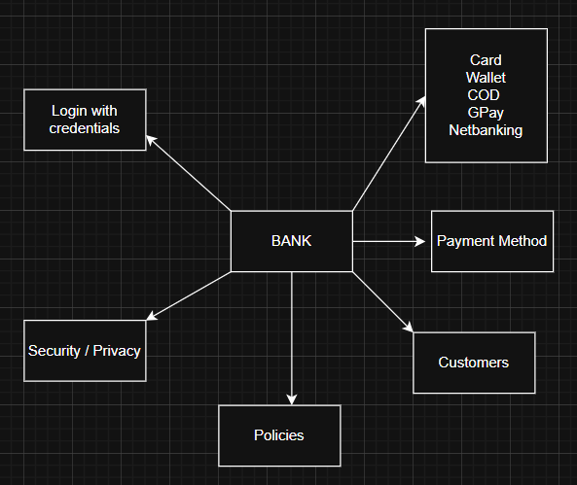

Q7. What is MVC architecture? Explain MVC rules to derive classes from use case diagram and guidelines to place classes in 3-tier architecture

MVC (Model–View–Controller) is a design pattern used to separate responsibilities in a system:

Payment ------> Card Details ------ > Wallet Details ----- > Netbanking Details ------ > Gpay

Model represents the data & the Business Logic . It is also responsible for multiple task like

Managing the application data
Performing data validation
Implementing business rules

It is not depend on how data is presented or how the user interacts with the application
It represents the data that is being transferred between view and controller
All the models are represented as entity class

View is responsible for presenting data to the user
It can be a web-page desktop application window

Controller - It acts as a Intermediary between model and view

