Nurturing Process - Capstone Project1 – Part -2/3 V2D2- August 2024
COEPD – Traditional Development
Capstone Project1 – Part -2/3

Online Agriculture Products Store Mr. Henry, after being successful as a businessman and has become one of the wealthiest persons in the city. Now, Mr. Henry wants to help others to fulfil their dreams. One day, Mr. Henry went to meet his childhood friends Peter, Kevin, and Ben. They live in a remote village and do farming. Mr. Henry asked his friends if they are facing any difficulties in their day-to-day work.
Peter told Mr. Henry that he is facing difficulties in procuring fertilizers which are very important for farm. Kevin said that he is also facing the same problem in-case of buying seeds for farming certain crops. Ben raised his concern on lack of pesticides which could help in greatly reducing pests in crops.
After listening to all his friends’ problems, Mr. Henry thought that this is a crucial problem faced not only by his friends but also by so many other farmers. So, Mr. Henry decided to make an online agriculture product store to facilitate remote area farmers to buy agriculture products. Through this Online Web / mobile Application, Farmers and Companies (Fertilizers, seeds and pesticides manufacturing Companies) can communicate directly with each other.
The main purpose to build this online store is to facilitate farmers to buy seeds, pesticides, and fertilizers from anywhere through internet connectivity. Since new users are involved, Application should be user friendly.
This new application should be able to accept the product (fertilizers, seeds, pesticides) details from the manufacturers and should be able to display them to the Farmers. Farmers will browse through these products and select the products what they need and request to buy them and deliver them to farmers location.
Mr. Henry has given this project through his Company SOONY. In SOONY Company, Mr Pandu is Financial Head and Mr Dooku is Project Coordinator. Mr. Henry , Mr Pandu , and Mr Dooku formed one Committee and gave this project to APT IT SOLUTIONS company for Budget 2 Crores INR and 18 months Duration under CSR initiative. Peter, Kevin and Ben are helping the Committee and can be considered as Stakeholders share requirements for the Project.
Mr Karthik is the Delivery Head in APT IT SOLUTIONS company and he reached out to Mr Henry through his connects and Bagged this project. APT IT SOLUTIONS company have Talent pool Available for this Project. Mr Vandanam is project Manager, Ms. Juhi is Senior Java Developer, Mr Teyson, Ms Lucie, Mr Tucker, Mr Bravo are Java Developers. Network Admin is Mr Mike and DB Admin is John. Mr Jason and Ms Alekya are the Tester. And you joined this team as a BA.

Question – 1: Audits
4 Quarterly Audits are planned Q1, Q2, Q3, Q4 for this Project. What is your knowledge of how these Audits will happen for a BA?

Quarterly audits are essential for ensuring that the project remains on track, meets its objectives, and adheres to established processes. For a Business Analyst (BA), these audits will focus on several key areas:

Q1 Audit: Planning and Requirements Gathering
- Review of Requirements: Evaluate the completeness and clarity of the requirements gathered during the initial phase.
- Stakeholder Engagement: Assess how well the BA has engaged with stakeholders to ensure their needs are accurately captured.
BA Responsibilities:
- Ensure all business requirements are gathered, documented, and approved (BRD/SRS).
- Present the initial structure of the RTM, demonstrating the link between high-level requirements and initial design considerations.
- Conduct interviews with stakeholders to confirm their satisfaction with the requirements collected.
- Present any changes or clarifications raised by stakeholders.
- Share status of Requirement Workshops, Stakeholder Analysis, Use Case Diagrams, etc.
Outcome:
- A report detailing strengths in stakeholder engagement and areas for improvement in gathering practices.

Q2 Audit: Design Alignment and Test Planning
Demonstrating how the refined requirements are being translated into the design phases and informing test planning.
BA Responsibilities:
- Review requirement prioritization methods and their alignment with business value.
- Ensure that requirements are traceable to design artifacts.
- Present findings on how well the BA has communicated requirements to the development team.
- Ensure test cases are aligned to business requirements
- Document clarifications, deviations, and change requests (CRs) during design.
Outcome:
- A feedback report that highlights effective analysis techniques used and recommendations for enhancing prioritization processes.

Q3 Audit: Design Support and Communication
- Collaboration with Design: Evaluate the BA's role in collaborating with the design team to translate requirements into design specifications.
- Communication Effectiveness: Assess how well the BA communicates changes in requirements to stakeholders and the project team.

BA Responsibilities:
- Review design documents to ensure they reflect the analysed requirements accurately.
- Validate if features under development meet user expectations.
- Help in gap analysis between developed features and business needs.
- Collect feedback from stakeholders regarding the clarity of communication related to design changes.

Outcome:
- A summary of the BA's contributions to the design phase, including strengths and areas for improving communication strategies.

Q4 Audit: UAT Readiness & Business Alignment
- User Acceptance Testing (UAT) Support: Assess the BA's involvement in facilitating UAT and collecting user feedback.
- Final Documentation: Review the completeness and accuracy of final project documentation, including requirement specifications and user manuals.
BA Responsibilities:
- Help prepare and review UAT scenarios.
- Present the completed RTM, demonstrating full traceability from initial requirements through design, testing, and UAT planning.
- Support stakeholder demos and walkthroughs.
- Review the final documentation to ensure it captures all requirements and changes made throughout the project.
- Conduct interviews with stakeholders to discuss the overall project delivery and any lessons learned.
- Ensure all requirements are closed or deferred with proper documentation.

Outcome:
A comprehensive audit report summarizing the BA's contributions to the project's success and recommendations for future projects based on user feedback and documentation completeness.

Question – 2: BA Approach Strategy
Before the Project is going to Kick Start, The Committee asked Mr Karthik to submit BA Approach Strategy.
Write BA Approach strategy (As a business analyst, what are the steps that you would need to follow to complete a project – What Elicitation Techniques to apply, how to do Stakeholder Analysis RACI/ILS, What Documents to Write, What process to follow to Sign off on the Documents, How to take Approvals from the Client, What Communication Channels to establish n implement, How to Handle Change Requests, How to update the progress of the project to the Stakeholders, How to take signoff on the UAT- Client Project Acceptance Form)
Your Team
- Project Manager - Mr Vandanam
- Senior Java Developer - Ms. Juhi
- Java Developers - Mr Teyson, Ms Lucie, Mr Tucker, Mr Bravo
- Network Admin - Mr Mike
- DB Admin - Mr John
- Testers - Mr Jason and Ms Alekya
- BA – You
Technical Team have assembled to discuss on the Project approach and have finalised to follow 3-tier architecture for this project.

- BA Approach Strategy
As a Business Analyst (BA) for the online agriculture product store project, I will implement a structured approach to ensure successful completion. Here’s the detailed strategy that outlines the steps to be followed, elicitation techniques, stakeholder analysis, documentation, approval processes, and communication methods.

- BA Project Lifecycle Approach
 | Step | Description
1. | Project Kick-off and Planning | Schedule and conduct a kick-off meeting with the committee, technical team, and stakeholders to align on project objectives, roles, expectations, and collaboratively define the project scope, deliverables, and success criteria.
2. | Requirements Elicitation | Use multiple elicitation techniques to gather detailed and validated requirements
3. | Documentation | Develop BRD, SRS, Use Case Diagrams, RTM, Process Flows, and UI Wireframes
4. | Validation and Sign-off | Conduct walkthroughs, resolve queries, and obtain formal stakeholder approvals
5. | Approval process from the Client | Schedule regular meetings with key Stakeholders and Submit the finalized documents formally
6. | Handling Change Requests | Document, assess, and get formal approval for scope changes
7. | Progress Update to Stakeholders | Prepare and distribute monthly progress reports summarizing accomplishments, challenges, and next steps.
8. | Support Design and Development | Assist in design validation and requirement traceability
9. | Testing Support | Review test cases, validate test coverage, support UAT
10. | User Acceptance Testing (UAT) and Sign-off | Collect feedback, close gaps, and get formal acceptance via Client Sign-off Form

- Requirement Elicitation Techniques
 | Technique | Purpose
1. | Interviews | Conduct one-on-one interviews with key stakeholders (e.g., farmers, manufacturers) to gather detailed insights into their needs and challenges.
2. | Workshops | Facilitate workshops with stakeholders to brainstorm and collaboratively define requirements.
3. | Questionnaires | Distribute surveys to a broader audience of farmers to gather quantitative data on their needs.
4. |  | Develop mock-ups of the application to gather feedback on features and usability.
  Prototyping
5. | Brainstorming | Discuss with SMEs and Developers to identify potential features
6. | Observation | Observe current farming practices and challenges faced by stakeholders to understand their environment better.

- Stakeholder Analysis and RACI Matrix
Stakeholder | Role | R | A | C | I
Mr. Henry | Client |  | A | C | I
Mr. Pandu | Financial Head |  | A |  | I
Mr. Dooku | Project Coordinator |  | A | C | I
Mr. Vandnam | Project Manager |  | A | C | I
Jaimin Shah | Business Analyst | R |  | C | I
Developers/Testers | Technical Team | R |  | C | I
Peter, Kevin, Ben | End Users |  |  | C

- R: Responsible | A: Accountable | C: Consulted | I: Informed
- I: Influencer | L: Leader | S: Supporter

- Documentation
 | Document | Description
1. | BA Work Plan | Detailed BA activities, timelines
2. | Stakeholder Register | List of all stakeholders, their roles and interests
3. | Business Requirement Document (BRD) | High-level business needs
4. | Software Requirement Specification (SRS) | Functional and non-functional requirements
5. | Use Case Document | User interactions with system modules
6. | Process Flow Diagrams | UML and Use Case Diagrams
7. | Wireframes / Prototypes | Functional UI Screens
8. | Requirements Traceability Matrix (RTM) | Mapping of requirements to test cases
9. | Change Request Log | Track changes post sign-off
10. | UAT Sign-off | Final acceptance of solution

- Document Sign-off Process
  - Share draft documents via email or internal portal.
  - Conduct walkthrough meetings with stakeholders
  - Collect feedback and make necessary adjustments based on stakeholder input.
  - Update the documents as needed.
  - Once finalized, obtain formal sign-off from stakeholders on the BRD and FRD to ensure alignment.
  - Store signed documents in project repository (Eg. Confluence)

- Approval Process from the Client
  - Schedule regular meetings with Mr. Henry and other key stakeholders to present findings and seek approvals.
  - Maintain a Change Control Board (CCB) for reviewing critical changes
  - Submit the finalized documents formally via email or project management tools for their review and approval.

- Communication Channels
  - Regular Updates: Establish weekly status meetings with the project team to discuss progress, challenges, and next steps.
  - Project Management Tool: Utilize a project management tool (e.g., Jira, Trello) for task assignments, tracking progress, and maintaining documentation.
  - Email Communication: Use email for formal communication and updates with stakeholders and the committee.

- Change Request (CR) Handling
  - Submission of change requests through a standardized form.
  - Evaluation by the BA and Project Manager to assess impact on scope, timeline, and budget.
  - Approval from stakeholders before implementation.
  - Update approved CRs in SRS/RTM.
  - Inform and do brainstorming session with Development and Testing Team.

- Progress Updates to Stakeholders
  - Monthly Reports: Prepare and distribute monthly progress reports summarizing accomplishments, challenges, and next steps.
  - Stakeholder Meetings: Schedule quarterly meetings to review overall project status and gather feedback.

- User Acceptance Testing (UAT) and Sign-off
  - UAT Planning: Collaborate with testers to define UAT criteria and prepare test scenarios based on requirements.
  - Conduct UAT: Facilitate UAT sessions with stakeholders, ensuring they validate the functionality against their requirements.
  - Client Project Acceptance Form: Once UAT is completed, present the Client Project Acceptance Form for sign-off, confirming that the project meets their expectations and requirements.

Question – 3: 3-Tier Architecture
Explain and illustrate a 3-tier architecture.

3-Tier Architecture is a client-server software architecture pattern that separates the application into three logical layers:
- Presentation Layer (Client Tier)
  - This is the topmost tier responsible for the user interface (UI) and user experience (UX). It's what the user directly interacts with.
- Application Layer (Business Logic Tier)
  - This middle tier sits between the presentation and data tiers. It contains the core logic and functionality of the application, processing user requests and interacting with the data tier.
- Data Layer (Database Tier)
  - This bottom tier is responsible for storing, retrieving, and managing the application's data. It typically consists of a database system.
Each tier is independent, which improves scalability, maintainability, and security.
- Presentation Layer (Client Tier):
  - Description: This is the topmost layer where user interaction occurs. It is responsible for displaying information to users and collecting user inputs.
  - Components: User interfaces such as web browsers, mobile applications, or desktop applications.
  - Functions: Display product listings, accept user inputs, show search results, and process orders.
- Example: A farmer logs into the web application and browses seeds and fertilizers.

- Application Layer (Business Logic Tier):
  - Description: This middle layer contains the core business logic of the application. It processes user requests, applies business rules, and interacts with the Data Tier to retrieve or store data.
  - Components: Application servers, web servers, and APIs that handle business logic.
  - Functions: Handles requests from the presentation layer, applies business rules, processes transactions, and manages sessions.
- Example: When the farmer clicks "Buy Now", this layer processes the order, checks product availability, and calculates shipping.

- Data Layer (Database Tier):
  - Description: The bottom layer is responsible for data storage and management. It handles all database operations, including data retrieval, updates, and management.
  - Components: Database management systems (DBMS) such as MySQL, Oracle, or NoSQL databases like MongoDB.
  - Functions: Stores user information, product catalogs, orders, inventory data, and payment records.
- Example: Stores list of fertilizers provided by a manufacturer and all previous orders by a farmer.

- Illustration:
+---------------------+
| Presentation Tier |
| (User Interface) |
| - Web Browser |
| - Mobile App |
+---------------------+
| (User Input)
v
+---------------------+
| Application Tier |
| (Business Logic) |
| - Application Server |
| - APIs |
+---------------------+
| (Data Requests)
v
+---------------------+
| Data Tier |
| (Database Layer) |
| - DBMS (e.g., MySQL)|
| - Data Storage |
+---------------------+

Benefits of 3-Tier Architecture for This Project
Feature | Benefit
Scalability | Each tier can be scaled independently. For example, if the application experiences increased traffic, additional servers can be added to the Presentation Tier without affecting the Data Tier.
Maintainability | Changes can be made to one tier without impacting the others, making it easier to update or modify the application.
Flexibility | Different technologies can be used for each tier, allowing for the use of the best tools for each specific function.
Security | Sensitive data can be isolated in the Data Tier, with controlled access through the Application Tier, enhancing overall security.

Conclusion:
The 3-Tier Architecture is a powerful model for building scalable and maintainable applications. By separating the user interface, business logic, and data management into distinct layers, developers can create systems that are easier to manage, update, and scale, ultimately leading to better performance and user experience.

Question – 4: BA Approach Strategy for Framing Questions
Business Analyst should keep What points in his/her mind before he frames a Question to ask the Stakeholder ( 5W 1H – SMART – RACI – 3 Tier Architecture – Use Cases, Use case Specs, Activity Diagrams, Models, Page designs)

As a Business Analyst (BA), it is crucial to approach stakeholder interactions with a structured mindset to ensure that the questions posed are effective and yield valuable insights. Here are the key points to keep in mind, incorporating methodologies such as the 5W-1H, SMART criteria, RACI model, and relevant documentation techniques.
- 5W-1H Method
The 5W-1H method (Who, What, Where, When, Why, and How) provides a comprehensive framework for formulating questions that uncover essential information about the project.
- Who: Identify the stakeholders involved. Ask questions like, "Who will be using this feature?" or "Who is impacted by this change?" This helps in understanding the audience and their needs.
- What: Clarify the requirements. Questions such as "What problem are we trying to solve?" or "What are the expected outcomes?" help define the scope and objectives.
- Where: Determine the context. Ask "Where will this feature be implemented?" or "Where do users encounter issues?" This provides insight into the operational environment.
- When: Assess timelines. Questions like "When do we need this feature?" or "When do issues typically arise?" help in planning and prioritization.
- Why: Understand motivations. Ask "Why is this feature important?" or "Why do users need this functionality?" This uncovers the underlying reasons for requirements.
- How: Explore implementation. Questions such as "How will this feature be integrated?" or "How will we measure success?" guide the technical and strategic approach.

- SMART Criteria
When framing questions, ensure they align with the SMART criteria (Specific, Measurable, Achievable, Relevant, Time-bound):
- Specific: Questions should be clear and focused.
- Measurable: Ensure that the responses can be quantified or assessed.
- Achievable: Frame questions that consider the feasibility of the requirements.
- Relevant: Ensure that questions are pertinent to the project goals.
- Time-bound: Incorporate timelines into your questions.

- Stakeholder Analysis Using RACI
Utilize the RACI model (Responsible, Accountable, Consulted, Informed) to identify stakeholders and their roles:
- Responsible: Who is responsible for executing the tasks? Frame questions like, "Who will be responsible for implementing this feature?"
- Accountable: Who is ultimately accountable for the outcomes? Ask, "Who is accountable for ensuring this feature meets user needs?"
- Consulted: Who needs to be consulted for input? Questions such as "Who should we consult for feedback on this feature?" help identify key contributors.
- Informed: Who needs to be kept informed? Ask, "Who should be updated on the progress of this feature?”

- 3-Tier Architecture
Mentally align with the tier before asking system-related or technical questions:
Tier | Logic | Example
Presentation Layer | UI/UX, Page Layouts, Navigation | Where can the User see the History or Types of Filters, etc?
Application Layer | Business Logic | How will the discounts be applied, and what other business rules?
Data Layer | Data Inputs/Outputs | What fields must be stored for each part, pesticide, etc?

- Use Cases and Related Artifacts:
When preparing to ask questions, consider the types of documentation that will be created:
- Use Cases: Frame questions that help define user interactions. For example, "What are the primary use cases for this feature?”
- Use Case Specifications: Ask detailed questions to capture specific requirements, such as "What are the success criteria for each use case?”
- Activity Diagrams: Inquire about workflows by asking, "What are the key activities involved in this process?”
- Models and Page Designs: Discuss visual representations by asking, "What should the user interface look like for this feature?”

Conclusion:
By keeping these points in mind, a Business Analyst can effectively frame questions that elicit valuable information from stakeholders. Utilizing structured methodologies like the 5W-1H, SMART criteria, and RACI model ensures that the questions are comprehensive, relevant, and aligned with project goals, ultimately leading to successful project outcomes.

Question – 5: Elicitation Techniques
As a Business Analyst, What Elicitation Techniques you are aware of? ( BDRFOWJIPQU)
As a Business Analyst (BA), employing effective elicitation techniques is crucial for gathering accurate and comprehensive requirements from stakeholders. Here are some key elicitation techniques, illustrated with the acronym BDRFOWJIPQU:
BDRFOWJIPQU – Elicitation Techniques
Technique | Description
Brainstorming (B) | A group creativity technique where stakeholders generate ideas and solutions collaboratively. Best when gathering innovative solutions or identifying potential risks and features.
Document Analysis (D) | Reviewing existing documentation to extract relevant information and requirements. Useful for understanding the current system (AS-IS).
Requirements Workshops (R) | Facilitated sessions where stakeholders collaboratively discuss and define requirements. Time-efficient and consensus-driven.
Focus Groups (F) | A moderated discussion with a group of stakeholders to gather diverse perspectives on a topic. Useful for validating requirements and understanding stakeholder attitudes towards proposed solutions.
Observation (O) | Watching users interact with a system or process to gather insights into their behaviors and needs. Helps identify implicit requirements and understand real-world challenges that users face.
Workshops (W) | Broader sessions used to discover and define scope, requirements, and priorities; can involve stakeholders across departments. Facilitates real-time collaboration and decision-making, ensuring all voices are heard.
Joint Application Development (J) | A structured workshop format that brings together stakeholders and developers to define requirements collaboratively. Ensures alignment between business needs and technical capabilities, leading to more effective solutions.
Interviews (I) | One-on-one or group discussions with stakeholders to gather detailed information, clarify doubts, or explore workflows. Allows for in-depth exploration of specific topics and helps build rapport with stakeholders.
Prototyping (P) | Creating wireframes or mockups of the system screens to help stakeholders visualize and validate requirements early. Engages stakeholders by allowing them to interact with a tangible representation of the solution, leading to valuable feedback.
Questionnaires (Q) | Surveys or structured forms used to gather information from a larger audience. Efficient for collecting quantitative data and opinions from a broad group of stakeholders, especially when geographical dispersion is a factor.
Use Cases (U) | Describing specific user actions and system responses to understand how users interact with the system and what is needed. Detailed functional requirements, clear understanding of user-system interactions, input for design and testing.

Question – 6: This Project Elicitation Techniques
Which Elicitation Techniques can be used in this Project and Justify your selection of Elicitation Techniques?
Prototyping
Use case Specs
Document Analysis
Brainstorming
Fertilizers, seeds, pesticides details from the manufacturers and should be able to display them to the Farmers.
To gather the business requirements from the client, you went to SOONY and met Mr. Henry. When Mr. Henry was asked about the project and what are they expecting from the project, Mr. Henry stated that he is expecting to have a login for all its users (fertilizers, seeds, pesticides manufacturers and Farmers) , a product catalog of fertilizers, seeds, pesticides, a search option to search for products, payment process, and delivery tracking.
After doing the stakeholder analysis, you have found out that Peter, Kevin, Ben are the key stakeholders and you have scheduled an appointment to meet them. After meeting with them and trying to gather the stakeholder requirements, Kevin said that, a Farmer should be able to browse through the products catalog once they visit the website and need to have a search option so that they can search for any product they need. Peter said that, if a farmer wants to buy any product or add them to buy-later list, they need to login first using their email id and password. If it is a new user, then they can create a new account by submitting their email ID and creating a secure password. Ben added saying that, Farmers needs to have an easy-to-use payment gateway which should include cash-on-delivery (COD), Credit/Debit card and UPI options so that the user’s experience should be better. Kevin mentioned that, a user gets an email confirmation regarding their order status. A delivery tracker to track the whereabouts of their order.
Identify Business Requirements (which includes Stakeholder Requirements)
- BR001 – Farmers should be able to search for available products in fertilizers, seeds, pesticides
- BR002 – Manufacturers should be able to upload and display their products in the application

Selected Elicitation Techniques for the Project
Based on the project requirements and stakeholder interactions described, here are the recommended elicitation techniques along with justifications for their selection:
    - Prototyping
Justification:
      - Prototyping allows stakeholders (e.g., Mr. Henry, Peter, Kevin, Ben) to visualize the application early in the development process.
      - By creating a working model of the online agriculture product store, stakeholders can interact with the prototype to provide feedback on features like the login system, product catalogue, and payment process.
      - This iterative approach helps ensure that the final product meets user expectations and allows for adjustments based on stakeholder feedback.

    - Use Case Specifications
Justification:
      - Developing use case specifications will help define the interactions between users (farmers and manufacturers) and the system.
      - This technique is beneficial for capturing the functional requirements of the application, such as searching for products, creating accounts, and processing payments.
      - By detailing use cases, stakeholders can better understand how the application will operate and validate that all necessary functionalities are captured accurately.

    - Document Analysis
Justification:
  - Analyzing existing documentation (if available) from similar projects or industry standards can provide valuable insights into best practices for building the online store.
  - This technique can help identify user needs that may not have been explicitly mentioned during meetings and ensure that the project aligns with regulatory and industry requirements.

- Document Analysis
Justification:
  - Conducting brainstorming sessions with stakeholders (including Mr. Henry, Peter, Kevin, and Ben) can generate a wide range of ideas for features and functionalities.
  - This technique encourages open dialogue and collaboration, allowing stakeholders to express their thoughts on desired features like the user-friendly payment gateway and delivery tracking system.
  - It can also help uncover additional requirements that may not have been initially considered.

Identifying Business Requirements
Based on the discussions with stakeholders and the elicitation techniques employed, the following business requirements (BR) have been identified:
- BR001: Farmers should be able to search for available products in fertilizers, seeds, and pesticides.
- Stakeholder Requirement: Kevin specifically mentioned the need for a search option to allow users to find products easily when they visit the website.
- BR002: Manufacturers should be able to upload and display their products in the application.
- Stakeholder Requirement: This aligns with Mr. Henry's expectation of having a product catalog that includes details from manufacturers.
Conclusion:
By utilizing the selected elicitation techniques—prototyping, use case specifications, document analysis, and brainstorming—the Business Analyst can effectively gather comprehensive business requirements from stakeholders. This ensures that the online agriculture product store will meet the needs of farmers and manufacturers, leading to a successful project outcome.

Question – 7: Business Requirements
Make suitable Assumptions and identify at least 10 Business Requirements.
Assumptions:
Assumptions are crucial as they define the context within which requirements are gathered and the project proceeds. They help manage expectations and identify potential risks if they prove false.
    - User Accessibility: The application will be accessible via both web and mobile platforms to accommodate different user preferences.
    - Internet Connectivity: Users in remote areas will have sufficient internet connectivity to access the application.
    - User Base: The primary users of the application will be farmers and manufacturers of fertilizers, seeds, and pesticides.
    - Payment Security: The application will implement secure payment methods to protect users' financial information.
    - Regulatory Compliance: The application will comply with relevant agricultural and e-commerce regulations.
    - User Support: There will be a customer support system in place to assist users with any issues they may encounter while using the application.
    - Data Privacy: User data will be managed in compliance with data protection regulations to ensure privacy and security.
    - Inventory Management: Manufacturers will have real-time inventory management capabilities within the platform to update product availability.
    - Feedback Mechanism: There will be a mechanism for users to provide feedback on products and services offered through the application.
    - Scalability: The application will be designed to scale as the user base grows and additional features are added.

List of Business Requirements
Sr. No. | Business Requirement | Description
BR001 | Farmers must register and log in to add products to cart or save for later. | This requirement ensures user authentication and personalization.
BR002 | Farmers must be able to log in to their accounts using their email ID and password | This enables secure access to user-specific features.
BR003 | Farmers should be able to search for products by name, category, or crop use. | Enables efficient browsing for fertilizers, seeds, or pesticides based on farming needs.
BR004 | Manufacturers should be able to upload and manage their product listings, including descriptions, prices, and images. | Includes product name, category, description, price, stock quantity, and images.
BR005 | The application must provide a secure payment gateway that supports cash-on-delivery (COD), credit/debit cards, and UPI payment methods. | Facilitates ease of payment for rural users with varying preferences.
BR006 | Users must receive email confirmations for their orders, including order details and status updates. | This requirement provides transparency and keeps users informed about their purchases.
BR007 | A delivery tracking module should allow users to monitor the shipment status of their orders. | Visual and textual updates on shipment status and estimated delivery date.
BR008 | Manufacturers should receive notifications when an order for their product is placed. | Enables timely order processing and shipping from their end.
BR009 | The application must include a feedback system for users to rate and review products and services. | Promotes user engagement and helps improve product offerings based on user insights.
BR010 | The application should comply with relevant agricultural regulations and e-commerce standards to ensure legal adherence. | This requirement ensures that the application operates within the legal framework and maintains user trust.

Question – 8: Assumptions
List your assumptions
Assumptions for the Online Agriculture Product Store Project:
    - User Accessibility: The application will be designed to be accessible on both web and mobile platforms to cater to a diverse user base, including farmers in remote areas.
    - Internet Connectivity: Users will have sufficient internet connectivity to access the application, as reliable internet access is essential for an online platform.
    - User Base: The primary users of the application are assumed to be farmers and manufacturers of fertilizers, seeds, and pesticides, with varying levels of technical proficiency.
    - Payment Security: The application will implement secure payment processing methods to protect users' financial information and maintain trust.
    - Regulatory Compliance: The application will comply with all relevant agricultural and e-commerce regulations to ensure legality and safety in transactions.
    - User Support Availability: There will be a customer support system in place to assist users with any issues or inquiries they may have while using the application.
    - Data Privacy: User data will be managed in accordance with data protection regulations to ensure user privacy and security.
    - Inventory Management: Manufacturers will have the capability to manage product inventory in real-time, allowing them to update product availability dynamically
    - Feedback Mechanism: There will be a mechanism for users to provide feedback on products and services offered through the application, which will be used to improve offerings.
    - Scalability: The application will be designed with scalability in mind, allowing it to handle increased user traffic and additional features as the business grows.
    - User Training: It is assumed that sufficient resources will be available to provide training or guidance to users (especially farmers) who may not be familiar with online shopping.
    - Integration with Third-party Services: The application will have the capability to integrate with third-party services for payment processing, delivery tracking, and inventory management.
    - Multi-language Support: The application will support multiple languages to accommodate users from different regions, ensuring wider accessibility.
    - Performance Expectations: The application is expected to have a responsive design that provides a seamless user experience, even during high traffic periods.
    - Marketing and Outreach: There will be marketing efforts to promote the application among farmers and manufacturers to encourage adoption and usage.
These assumptions help ensure clarity while defining business requirements, identifying scope, and preparing for stakeholder discussions. If any of these change, the scope, timeline, or solution approach may need adjustment.

Question – 9: This project Requirements Priority
Give Priority 1 to 10 numbers ( 1 being low priority – 10 being high priority) to these Requirements after discussions with the stakeholders.
Req ID | Req Name | Req Description | Priority
BR001 | Farmer Search for Products | Farmers should be able to search for available products in fertilizers, seeds, pesticides | 8
BR002 | Manufacturers upload their Products | Manufacturers should be able to upload and display their products in the application | 8

Once the requirements are finalized, as a business analyst, one of the major roles is to act as a liaison between the client and the project team. To gather the requirements correctly from the client side and then to deliver those requirements to the project team in a way they understand. To make the project team understand the requirements, you need to convert those requirements into UML diagrams and screen mock-ups.

Req ID | Req Name | Req Description | Priority (1–10)
BR001 | Farmer Search for Products | Farmers should be able to search for available products in fertilizers, seeds, and pesticides. | 8
BR002 | Manufacturers Upload Products | Manufacturers should be able to upload and display their products in the application. | 8
BR003 | User Account Creation | Farmers should be able to create user accounts using their email ID and a secure password and must be able to log in to their accounts using their email ID and password | 10
BR004 | Product Catalog with Filters | The system should maintain a searchable product catalog with category filters. | 10
BR005 | Multiple Payment Options | The platform must support payment methods: COD, UPI, Credit/Debit Cards. | 9
BR006 | Order Confirmation Notifications | Farmers should receive email confirmations upon order placement and payment. | 7
BR007 | Delivery Tracking | A delivery tracking module should allow users to monitor shipment status. | 6
BR008 | Manufacturer Notifications | Manufacturers should receive notifications when an order for their product is placed. | 5
BR009 | Product Ratings and Reviews | Farmers can rate and review products after purchase. | 4
BR010 | Admin Product/User Management | Admin should monitor, approve, or deactivate users and product listings. | 7

Next Steps: UML Diagrams and Screen Mock-ups
As the Business Analyst, my role is to bridge the gap between stakeholders and the project team. To effectively communicate the finalized requirements, I will:
    - Create UML Diagrams:
      - Use Case Diagrams: Illustrate the interactions between users (farmers and manufacturers) and the system to capture functional requirements.
      - Activity Diagrams: Detail workflows for key processes, such as product searching, order placement, and payment processing.
    - Develop Screen Mock-ups:
      - Wireframes: Design low-fidelity wireframes for key screens, including the login page, product catalog, and payment interface.
      - High-Fidelity Mock-ups: Create detailed screen designs that reflect the final look and feel of the application, incorporating feedback from stakeholders.

Question – 10: Use Case Diagram
Draw use case diagram

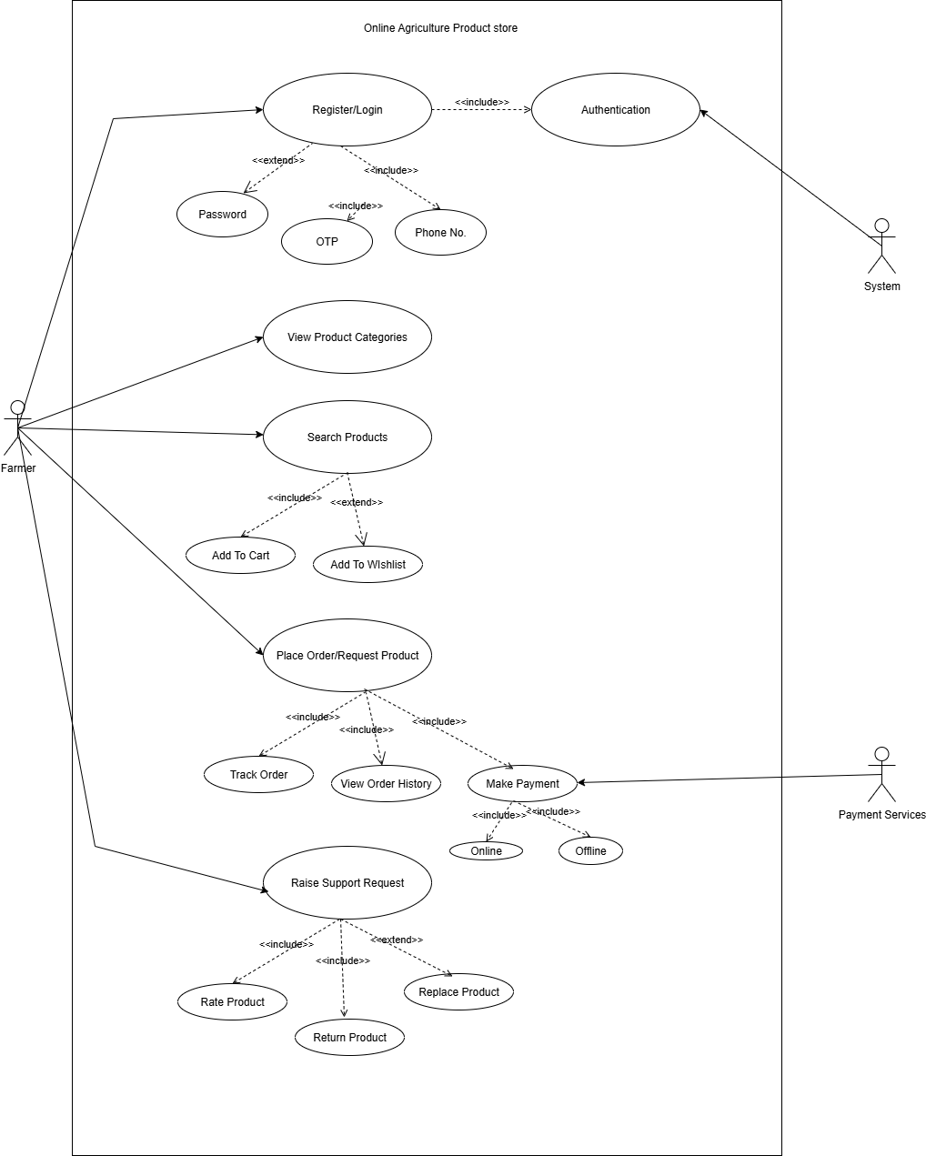
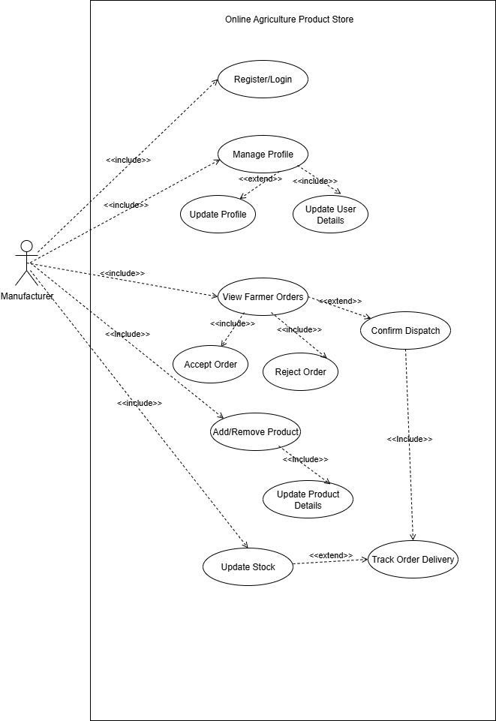
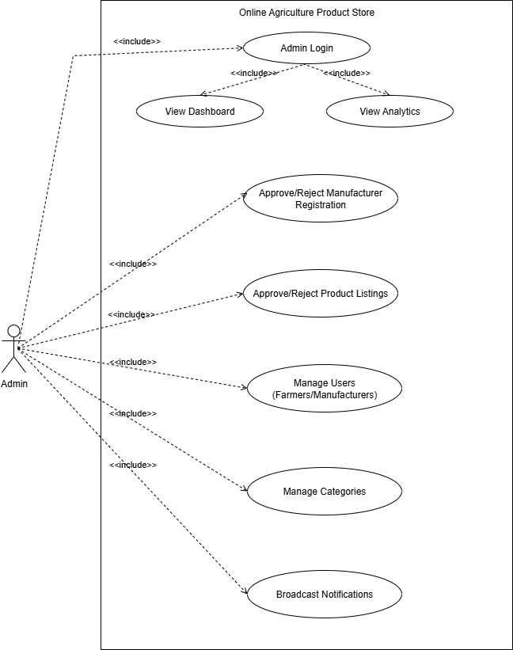

Question – 11: (minimum 5) Use Case Specs
Prepare use case specs for all use cases

Below are detailed use case specifications for five key use cases relevant to the online agriculture product store.
Use Case 1: Search Products
- Use Case ID: UC001
- Use Case Name: Search Products
- Actors: Farmer
- Preconditions: The farmer is logged into the application.
- Postconditions: The system displays the search results based on the entered query.
Main Flow:
- The farmer enters a product name or category in the search bar.
- The system retrieves matching products from the database.
- The system displays the list of products that match the search criteria.
Alternate Flow:
- A1: If no products match the search criteria, the system displays a message indicating that no products were found.

Use Case 2: Create Account
- Use Case ID: UC002
- Use Case Name: Create Account
- Actors: Farmer
- Preconditions: The farmer is on the Registration Page.
- Postconditions: A new user account is created, and the farmer is logged in.
Main Flow:
    - The farmer navigates to the registration page.
    - The farmer enters their email ID and creates a secure password.
    - The system validates the email format and checks if the email is already registered.
    - The system creates a new user account and sends a confirmation email.
    - The farmer is redirected to the login page.

Alternate Flow:
- A1: If the email is already in use, the system displays an error message prompting the farmer to use a different email.

Use Case 3: Place Order
- Use Case ID: UC003
- Use Case Name: Place Order
- Actors: Farmer
- Preconditions: The farmer is logged into their account and has products in their cart.
- Postconditions: The order is placed, and the farmer receives an order confirmation.
Main Flow:
- The farmer reviews the items in the cart.
- The farmer clicks on the "Checkout" button.
- The system prompts the farmer to select a payment method.
- The farmer selects a payment method (e.g., COD, Credit/Debit card, UPI).
- The system processes the payment and confirms the order.
- The farmer receives an email confirmation of the order.
Alternate Flow:
A1: If the payment fails, the system displays an error message and prompts the farmer to try again or choose a different payment method.

Use Case 4: Upload Products
- Use Case ID: UC004
- Use Case Name: Upload Products
- Actors: Manufacturer
- Preconditions: The manufacturer is logged into their account.
- Postconditions: The new product is added to the product catalog and is visible to farmers.
Main Flow:
  - The farmer reviews the items in the cart.
  - The manufacturer enters product details (name, description, price, images).
  - The system validates the entered information.
  - The manufacturer submits the product information.
  - The system saves the product details and displays a confirmation message.
Alternate Flow:
A1: If any required fields are missing, the system displays an error message indicating which fields need to be completed.

Use Case 5: Track Order
- Use Case ID: UC005
- Use Case Name: Track Order
- Actors: Farmer
- Preconditions: The farmer has placed an order and is logged into their account.
- Postconditions: The farmer can view the current status of their order.
Main Flow:
  - The farmer navigates to the "My Orders" section of their account.
  - The farmer selects the order they wish to track.
  - The system retrieves and displays the current status of the order (e.g., Processing, Shipped, Out for Delivery).
  - The farmer can view tracking details, including estimated delivery time.

Alternate Flow:
A1: If the order status is not available, the system displays a message indicating that tracking information is currently unavailable.

Question – 12: (minimum 5) Activity Diagrams
Activity Diagrams

Login Page

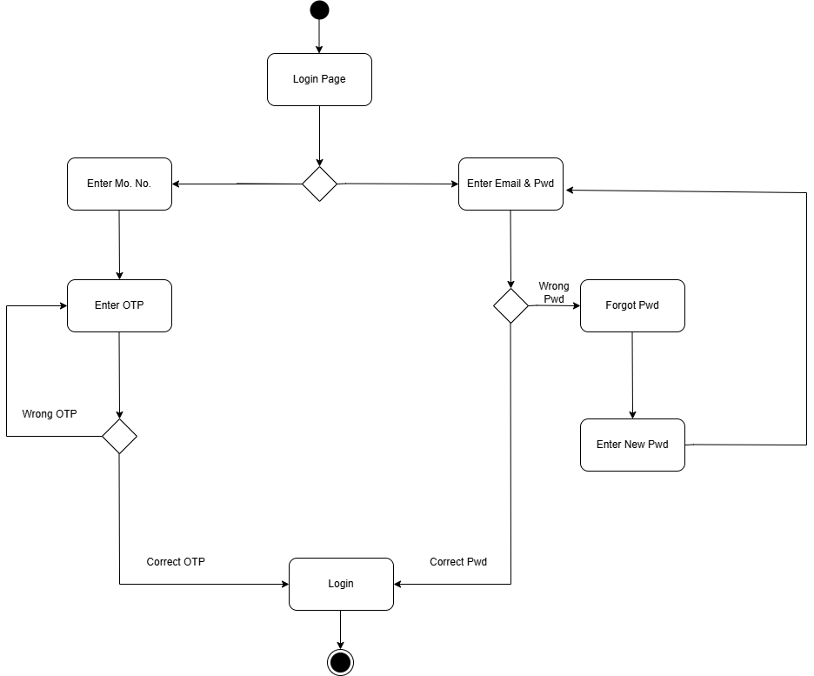

Registration Page
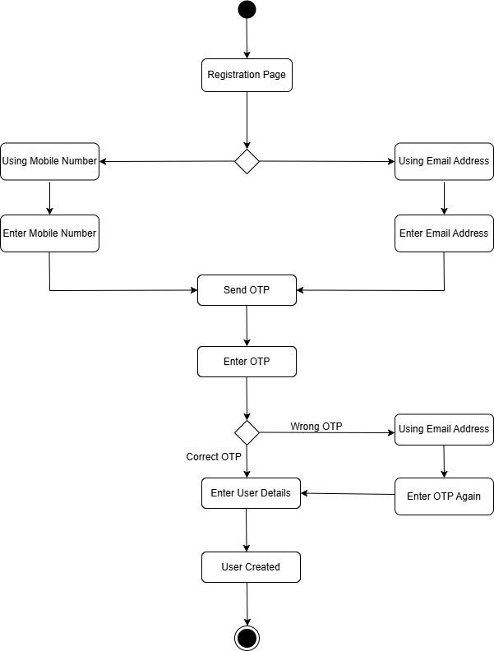

Buying Product/Fertilizer
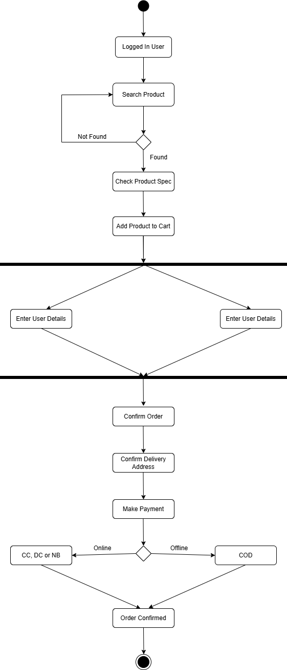
Order Cancellation
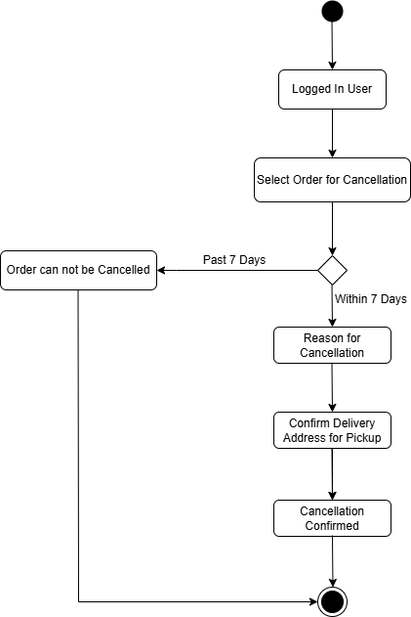

Adding or Updating Product
