Capstone Project-1 Part1
Online Agriculture Products Store
Q-1 Identify Business Process Model for Online Agriculture Store – (Goal, Inputs, Resources, Outputs, Activities, Value created to the end Customer)
Answer-
Goal – To build an application for an online agricultural product store to facilitate remote area farmers to buy agricultural products.
Inputs – agricultural products lists, suppliers product lists and prices, internet connectivity, web application
Resources – software, hardware, team of developers, budget, stakeholders
Outputs – efficiency in order placement and delivery, tracking of orders , notifications
Activities – login to app, browse products, place orders, make payments, dispatch of orders from suppliers, delivery of orders, feedback.
Value created to end customer- bridge the gap between buyer and seller ,

Q-2 Mr Karthik is doing SWOT analysis before he accepts this project. What Aspects he Should consider as Strengths, as Weaknesses, as Opportunity and as Threats.
Answer-
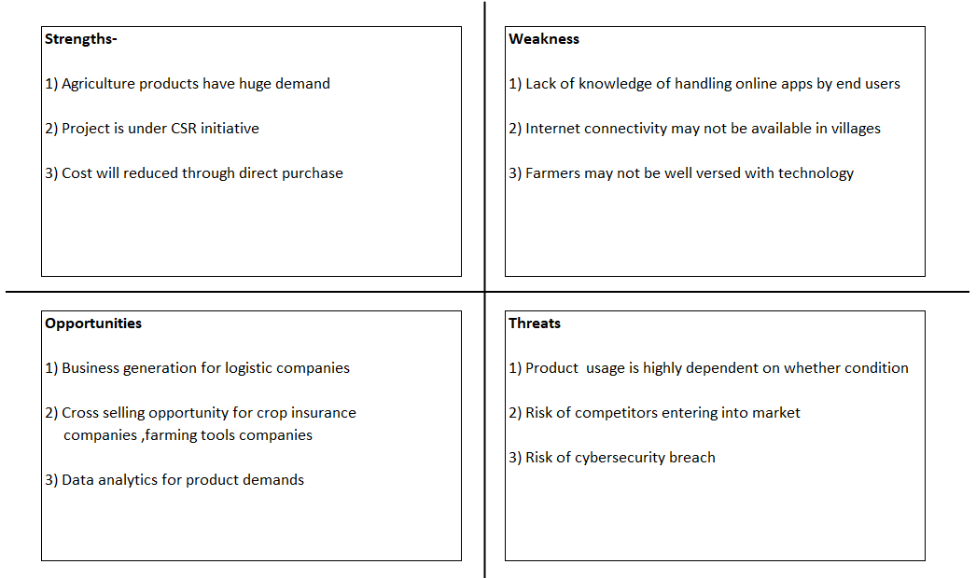

Q-3 Mr Karthik is trying to do feasibility study on doing this project in Technology (Java), Please help him with points (HW SW Trained Resources Budget Time frame) to consider in feasibility Study.
Answer-
Technical Feasibility
- Availability of experienced Java developers team with APT IT solutions
- Can integrate Java- based web backend with mobile app via REST APIs
- Technology stack readily available (Java, MySQL, clod hosting)
Operational Feasibility
- Farmers and manufacturers will be motivated to use online platforms for buying and selling of agricultural products.
- Mr Henry will ensure availability of strong network for adoption of new platform
- Training sessions needs to be conducted for farmers

Economic Feasibility
- Budget allocated to project is Rs 2 crores INR is sufficient to cover all costs
- Farmers will save in long term through cutting middleman
Time feasibility
- Project duration given is 18 months which is realistic with respect to team size available and scope of the project
Conclusion
Project is feasible to proceed

Q-4 Mr Karthik must submit Gap Analysis to Mr Henry to convince to initiate this project. What points (compare AS-IS existing process with TO-BE future Process) to showcase in the GAP Analysis
Answer-
AS-IS existing process
- Farmers go to various places to buy required products
- Product availability is not known farmers at alternate places
- Payment by cash
- Farmers needs to arrange for transport
- Manual record keeping of orders which has risk of loss

TO-BE future Process
- Farmers will be able to buy required products online from their home
- Farmers can view availability of required product online for various places
- Multiple payment options available like card, UPI or cash on delivery
- Doorstep delivery of product
- Digital history of product purchase will be maintained in app

Q-5 List down different risk factors that may be involved (BA Risks And process/Project Risks)
Answer-
BA Risk
- There may be language barrier during requirement gathering
- Misinterpretation of farmer’s requirements
- Need knowledge of regulatory compliance about agriculture product sales laws
Process Risk
- Delay in app development due to scope creep
- Poor UI/UX – low adoption
- Integration issues between web and mobile app
- Vendor/manufacturer delays in product updates
Project Risks
- Budget overrun due to extended testing/training
- Failure to meet 18 month deadline
- Security breach may affect farmers trust
- Dependence on single payment gateway provider

Q-6 Perform stakeholder analysis (RACI Matrix) to find out the key stakeholders who can take Decisions and Who are the influencers
Answer-
Stakeholder | Designation | Responsible | Accountable | Consulted | Informed
Mr Henry | Stakeholder |  | 
Mr Kevin, Peter and Ben | Stakeholder
Mr Pandu | Finance Head
Mr Dooku | Project co ordinator
Mr Karthik | Delivery Head
Mr Vandanam | Project Manager
Mr Juhi | Sr Java Developer
Mr Tyson, Ms Lucie, Mr Tucker, Mr Bravo | Java Developers
Mr Mike | Network Admin
John | DB Admin
Mr Jason, Ms Alekya | Testers

Q-7 Help Mr Karthik to prepare a business case document
Answer-
Project – Online Agriculture Products Store
Current Problems – Farmers in remote cities face problems while buying agricultural products, Availability of products are not known to them, Current process is costly, time consuming and inefficient.
Project Objective and benefits- To provide online platform to farmers to buy agricultural products such as fertilizes, pesticides and seeds directly from manufacturers, it will ensure faster access to quality products, reduced costs by removing middlemen, digital record keeping of orders, multiple payment options to farmers , doorstep delivery of products
Estimated Cost of Project – Rs 2 Crores
Estimated timeline given – 18 months
Risk and mitigations
Low digital literacy – conduct training programs
Internet issues -Enable offline order capture with later sync
Security concern -Implement robust data protection measures
Recommendations : Proceed with project implementation to improve rural agriculture supply chain efficiency and farmer income.

Q-8 The Committee of Mr. Henry , Mr Pandu , and Mr Dooku and Mr Karthik are having a discussion on Project Development Approach. Mr Karthik explained to Mr. Henry about SDLC. And four methodologies like Sequential Iterative Evolutionary and Agile. Please share your thoughts and clarity on Methodologies.
Answer-
1.Sequential (waterfall)- Linear, phase by phase approach, Each phase must be completed before moving to next phase.
2.Iterative- System is developed through repeated cycles, it allows feedback at each stage.
3. Evolutionary- Builds and improves product versions gradually based on stakeholder feedback.
4.Agile – Incremental delivery, adaptive planning and it has strong stakeholder involvement.

Q-9 They discussed models in SDLC like waterfall RUP Spiral and Scrum . You put forth your understanding on these models
When the APT IT SOLUTIONS company got the project to make this online agriculture product store, there is a difference of opinion between a couple of SMEs and the project team regarding which methodology would be more suitable for this project. SMEs are stressing on using the V model and the project team is leaning more onto the side of waterfall model. As a business analyst, which methodology do you think would be better for this project?
Answer-
Waterfall – This model follows structured approach. Each phase has specific deliverables. At the end of each phase review is taken to determine if the project is running fine. This model works well for smaller projects where requirements are well understood.
RUP – Rational unified process model where phase wise or module wise application is developed. It is useful in long term projects. We can track the defects at early stage and downward flow of defects can be avoided. Change request is welcomed in every phase of development. This model has multiple stages and it requires more budget and resources.

Spiral – It is risk driven process model. Software projects repeatedly passes through 4 phases in iterations i.e. planning , risk analysis , engineering and evaluation.
Scrum- Agile framework focusing on short iterations i.e. sprints, delivering increments and continuous collaboration.
For this project remote farmer e-commerce platform there is balance between fixed needs (core agricultural product listing, order placement) and possible future changes (new payment methods , seasonal product changes). So an Iterative or Agile model will be beneficial.

Q-10 Write down the differences between waterfall model and V model.
Answer-
Feature | Waterfall Model | V Model
Process flow | Linear, step by step | Linear but validation steps mapped to each development stage
Testing Phase | Happens after build | Testing planned alongside each development stage
Requirement changes | Hard to accommodate | Hard o accommodate
Documentation | Heavy | Heavy
Risk of defects | Found late | Found early due to parallel test planning
Best for | Well defined and stable requirements | Projects with zero tolerance for defects and high quality expectations

Q-11 As a BA, state your reason for choosing one model for this project
Answer- As a BA I would choose V model for this projects because-
- The requirements for agricultural procurement are fairly fixed and well defined.
- Stakeholders expect high reliability – farmers depends on the platform for essential supplies.
- Testing is critical for transaction accuracy, stock management, and payment security.
- Parallel testing reduces defect leakage to production.

Q-12 The Committee of Mr. Henry, Mr Pandu, and Mr Dooku discussed with Mr Karthik and finalised on the V Model approach (RG, RA, Design, D1, T1, D2, T2, D3, T3, D4, T4 and UAT) Mr Vandanam is mapped as a PM to this project. He studies this Project and Prepares a Gantt chart with V Model (RG, RA, Design, D1, T1, D2, T2, D3, T3, D4, T4 and UAT) as development process and the Resources are PM, BA, Java Developers, testers, DB Admin, NW Admin.
Answer- V -Model Process:
- Left side (Development) : RG (Requirement Gathering), RA( Requirement Analysis), Design (High-level and low level), D1-D4 (Detailed designs)
- Right side( Testing): T1-T4 (corresponding test phases), UAT( User Acceptance Testing)
- PM Vandanam coordinates tasks among:
PM, BA, Java Developers, Testers, DB Admin, NW Admin.
- Deliverables planned in sequence with matching verification and validation stages.

Q-13 Explain the difference between Fixed Bid and Billing projects
Answer -
Features | Fixed Bid | Billing Project
Pricing Basis | Agreed lump sum for full project scope | Chares based on time and material (hours worked)
Scope changes | Very restricted, needs change request | Easier to adjust
Risk | Vendor bears scope overrun risk | Client bears scope overrun risk
Predictability | High for cost, low flexibility | Flexible but cost can vary
Best for | Stable, clear scope | Evolving scope or R&D projects

Q-14 Design Timesheet of a BA ➢ Development Timesheet of a BA ➢ Testing Timesheet of a BA ➢ UAT Timesheet of a BA ➢ Deployment n Implementation Timesheet of a BA
Answer-
- Design Timesheet of a BA
Sr No | Tasks | Actionable Items | Start Time | End Time | Duration
1 | Prepare Wireframes | Draft process and screen flows | 10:00 AM | 12:00pm | 2 Hrs
2 | Review wireframes | Stakeholder walk-through | 12:15 PM | 1:15 PM | 1hr
3 | Create use Case diagrams | Map functional requirements | 2:00 PM | 3:30 PM | 1.5 hrs
4 | Document FRD | Add detailed design requirements | 3:45 PM | 5:15 PM | 1.5 hrs
5 | Team meeting | Align BA, Dev and Test on design | 5:30 PM | 6:30 PM | 1 hr

- Development Phase Timesheet ( BA role support)
Sr No | Tasks | Actionable Items | Start Time | End Time | Duration
1 | Sprint Planning meeting | Prioritize backlog, clarify scope | 10:00 AM | 11:00pm | 1 Hr
2 | Requirements clarification | Support Dev team on doubts | 12:15 PM | 1:15 PM | 1hr
3 | Mid day review | Track Dev progress with PM | 2:00 PM | 3:30 PM | 1.5 hrs
4 | Change requests handling | Analyze and document CRs | 3:45 PM | 5:15 PM | 1.5 hrs
5 | Daily stand up | Sync with Team | 5:30 PM | 6:30 PM | 1 hr

- Testing Timesheet
Sr No | Tasks | Actionable Items | Start Time | End Time | Duration
1 | Test case review | Validate test coverage vs requirements | 10:00 AM | 11:30pm | 1.5 Hr
2 | Defect triage meeting | Prioritize and assign defects | 12:15 PM | 1:00 PM | 1hr
3 | Requirement traceability matrix | Ensure requirements – test mapping | 2:00 PM | 3:30 PM | 1.5 hrs
4 | Re-test support | Clarify defect fixes | 3:45 PM | 5:15 PM | 1.5 hrs
5 | End-of-day review | Daily status with QA team | 5:30 PM | 6:30 PM | 1 hr

- UAT Phase Timesheet
Sr No | Tasks | Actionable Items | Start Time | End Time | Duration
1 | UAT kickoff meeting | Walkthrough with business users | 10:00 AM | 11:30pm | 1.5 Hr
2 | UAT support | Clarify business flows during testing | 12:15 PM | 1:00 PM | 1hr
3 | Defect review | Discuss UAT defects and resolutions | 2:00 PM | 3:30 PM | 1.5 hrs
4 | Feedback collection | Document stakeholder feedback | 3:45 PM | 5:15 PM | 1.5 hrs
5 | Sign off meeting | Get UAT approval | 5:30 PM | 6:30 PM | 1 hr

- Deployment Phase Timesheet
Sr No | Tasks | Actionable Items | Start Time | End Time | Duration
1 | Pre deployment checklist | Verify readiness of system | 10:00 AM | 11:30pm | 1.5 Hr
2 | Release notes preparation | Document deployment scope | 12:15 PM | 1:00 PM | 1hr
3 | Go-live support | Be available for queries and issues | 2:00 PM | 3:30 PM | 1.5 hrs
4 | Post deployment monitoring | Ensure system stability | 3:45 PM | 5:15 PM | 1.5 hrs
5 | Closure meeting | Final confirmation with PM and stakeholders | 5:30 PM | 6:30 PM | 1 hr

