Assignment 1: BRD and Process Flow Diagram of Inventory Management and Order Delivery.

Prepared By: Deepika
Prepared For: COEPD
Date Submitted: 23th July 2025
Project Sponsor: COEPD
Client Acceptor: COEPD
Project Manager: Rajendra
Document Number: 01072025/CaseStudy01/BRD
Version: 0.1
Contents
Document Revision 3
Approval 3
RACI Chart 3
Development and Resource Plan 4
Introduction 5
1. Document Purpose: 5
2. Business Goal: 5
3. Business Objective: 5
4. Background: 5
5. Project Objective: 6
6. Project Scope: 6
6.1. In Scope 6
6.2 Out Scope 6
7. Assumptions 6
8. Constraints 7
9. Risks 7
9.1 Technological Risks 7
9.2 Skills Risks 7
9.3 Business Risks 7
9.4 Political Risks 8
9.5 Requirement Risks 8
9.6 Other Risks 8
10. Business Process Review 8
10.1 Legacy System (AS-IS) 8
10.2 Proposed Recommendation (TO BE) 9
11. Process Flow Diagram: 10
12. Business Requirements 11
Process Flow Diagram 12
Assignment 2 13
Introduction Letter to client 13
Business Requirement Document (BRD) 14
Document Revision 14
Approvals 14
RACI Chart 14
Development and Resource Plan 15
Introduction 15
Project Scope 15
Assumptions 16
Constraints 16
Risks 16
Business Process Review 18
Business Requirements 19
Process Flow Diagram 20
SRS Document 21
ERD of a Ticketing System 23
E-Commerce User Stories 24

Document Revision
Date | Version | Document Changes
07/05/2025 | 1.0 | Initial Draft

Approval
This document shows the Roles and approvals required to move forward with this project.
Role | Name | Title | Signature | Date
Project Sponsor | Bala S | CEO |  | 07/05/2025
Business Owner | Prakash | Vice President |  | 07/05/2025
Project Manager | Naresh | Project Manager |  | 07/05/2025
System Architect | Manoj | Staff System Administrator |  | 07/05/2025
Development Lead | Gunjan | Principal Software Developer |  | 07/05/2025
User Experience Lead | Paresh | Senior Designer |  | 07/05/2025
Quality Lead | Sanyam G | Lead QA |  | 07/05/2025
Content Lead | Vihana | Lead Content Manager |  | 07/05/2025

RACI Chart
Name | Position | * | R | A | S | C | I
Bala S | CEO | 
Prakash | VP
Naresh | Project Manager
Manoj | System Administrator
Gunjan | Principal software Dev
Paresh | Senior UI/UX designer
Sanyam G | Lead QA
Viahana | Lead Content Manager
Vipul | Lead BA
Jay | BA
Vikash | Front-End Developer
Abhsihek | Backend Developer
Arindam | AI Engineer
Deepak | Devops Engineer
Akash | QA
Sonu | BI Developer
Pradeep | Product Owner
Ronak | Support Lead/ Delivery Lead
Deepshikha | Sales
Sushmita | Legal Associate

Development and Resource Plan
Project type: Fresh Implementation of Web-based application.
Duration: 12 months.
Budget: 5 Cr INR
Resource Plan:
Role | Responsibility | No. of Resources | Duration (Months)
Project Manager | End-to-end project oversight | 1 | 12
Business Analyst | Requirement elicitation, documentation, stakeholder coordination | 1 | 12
UI/UX Designer | Wireframes, prototypes, UI consistency | 1 | 1
Solution Architect | Design system architecture, technology stack, security | 1 | 2
Frontend Developers | UI implementation (React/Angular) | 2 | 5
Backend Developers | Core logic, APIs, DB logic | 3 | 5
QA Engineers | Manual + automation testing, regression, UAT support | 2 | 3
Database Admin | DB design, optimization, data migration | 1 | 2
DevOps Engineer | CI/CD setup, deployment, environment management | 1 | 2
Trainer / Change Agent | End-user training, manuals, change management | 1 | 1
Support Staff | Hypercare support post go-live | 1 | 1

Project Time-line:
Phase | Duration | Key Deliverables
Initiation & Planning | 1 Month | Project Charter, Resource Allocation, Kick-off.
Requirement Gathering & Analysis | 1 Month | BRD, FRS, Stakeholder Sign-off.
Design (UI/UX + Architecture) | 1 Month | Wireframes, Database Design, Solution Architecture.
Development Phase 1 (Core Modules) | 3 Months | Inventory, Order Management, Role Access, Product Setup.
Development Phase 2 (Advanced Features) | 2 Months | Delivery Scheduling, Route Optimization, Alerts.
Integration & Testing | 2 Months | QA, UAT, Bug Fixing, Regression Testing.
Deployment & Training | 1 Month | Production Deployment, User Training.
Post-Go-Live Support | 1 Month | Hypercare, Issue Resolution, Documentation.

Introduction

Document Purpose:
This document represents the overall business requirement of the web-based application that has been purposed to be build. This company is a manufacturing company that produces ice-creams and milk products in large scale. And, their products are been sold across the country.

Business Goal:
The goal of this project is:
- Achieve 95% inventory accuracy across all locations.
- Improve dispatch time by 40% after order has been placed.
- View stock in real time across all warehouses and plants.
- Achieve on time delivery performance of 98% above.
- Provide a scalable platform to onboard more warehouses and distributors in the future.

Business Objective:
The objectives of this case study include:
- Optimize Inventory Management
- Maintain real-time visibility of stock levels across all warehouses and plants.
- Automate stock replenishment based on dynamic thresholds and demand forecasting.
- Enable Fast and Reliable Deliveries
- Use technology to determine the quickest and most efficient delivery routes.
- Ensure timely dispatches and monitor delivery execution for both B2B and B2C customers.

Background:
The client is a large-scale dairy manufacturing company with production plants and warehouses located in various regions across the country. The company produces perishable products such as milk and ice-cream, and serves both distributor networks and direct retail customers.
Currently, the company lacks a centralized digital system to track and manage inventory, resulting in issues like overstocking, stockouts, spoilage, and delays in customer deliveries. Moreover, the absence of real-time data affects supply chain transparency and decision-making.
To address these issues, the client has initiated a fresh implementation of a web-based software platform to digitize and optimize inventory operations and streamline delivery services.

Project Objective:
The primary objective of this project is to design and implement a centralized, web-based software solution that enables the company to:
- Efficiently manage inventory across all manufacturing plants and warehouses in real-time.
- Ensure the fastest possible delivery of milk and ice-cream products to both retail and distributor customers.
- Reduce operational inefficiencies by automating inventory tracking, stock replenishment, and order fulfillment.
- Enhance visibility and traceability of stock movements, batch details, and product shelf life to reduce spoilage and improve compliance.
- Provide a scalable digital platform that can support future growth in distribution channels, warehouse locations, and product lines.

6. Project Scope:

6.1. In Scope
- Centralized web-based inventory management system.
- Real-time stock updates across all locations (plants + warehouses).
- Inventory tracking with batch number and expiry date handling.
- Stock transfer management between locations.
- Customer order management (retail + distributor).
- Delivery scheduling and route optimization.
- Role-based access (warehouse users, dispatch teams, admin, sales).
- Integration with barcode scanners / mobile devices.
- Reporting and analytics (stock aging, demand forecasts, KPIs).
- User training and documentation.

6.2 Out Scope
- Manufacturing process automation or plant machinery control.
- CRM or customer marketing systems.
- Mobile app for customers (initial release focuses on web interface).
- International expansion and localization. (only domestic operations covered for now).

Assumptions
- All manufacturing plants and warehouses have basic internet connectivity.
- Barcode/RFID scanners are available at all relevant locations.
- Delivery is handled by the company’s own logistics or approved partners.
- Warehouse staff are trained (or will be trained) to use the digital system.
- A Project Sponsor and key stakeholders from the client side are available for requirement validation and feedback.
- Inventory and product data will be made available in standardized formats for migration.

Constraints
- The system must be fully functional and deployed within 12 months.
- Budget cap of ₹5 Crores INR for software development, infrastructure, and training.
- Only web-based (not mobile app) in the first release.
- The platform must support high transaction volumes due to large-scale operations.
- Regulatory compliance must be ensured for perishable goods storage and tracking.
- Limited IT infrastructure at some remote warehouses may restrict advanced feature usage.

9. Risks

9.1 Technological Risks
Risk | Likelihood | Impact Cost | Strategy | Details
Integration issues with barcode/RFID scanners. | Medium | High | Mitigate | Ensure early hardware-software compatibility testing and use standard devices.
Limited internet access in remote warehouses. | Medium | Medium | Contingency | Include offline mode in application and sync when online.
Poor data quality during migration. | Medium | Medium | Mitigate | Cleanse and validate data before migration; conduct pilot testing.
Failure in route optimization logic. | Low | High | Mitigate | Use reliable third-party APIs and simulate delivery scenarios.
Difficulty in tracking product expiry. | Medium | High | Mitigate | Use batch-level inventory system and configure expiry alerts.
Failure to scale system with demand. | Medium | High | Mitigate | Deploy on scalable cloud infrastructure (e.g. AWS, Azure).

9.2 Skills Risks
Risk | Likelihood | Impact Cost | Strategy | Details
Inadequate technical skills of warehouse staff. | High | Medium | Mitigate | Provide structured training and intuitive user interfaces.
Limited development resources or SMEs. | Medium | High | Contingency | Cross-train team, maintain documentation, and have a backup hiring plan.

9.3 Business Risks
Risk | Likelihood | Impact Cost | Strategy | Details
Resistance to process change from staff. | High | Medium | Mitigate | Apply change management techniques, early involvement, and training.
Time or budget overrun due to scope creep. | Medium | High | Preventive | Set a scope baseline and change control process.
Legal issues from delivery of expired products. | Low | High | Preventive | Enable expiry validation, delivery logs, and alerts for near-expiry stock.

9.4 Political Risks
Risk | Likelihood | Impact Cost | Strategy | Details
Changing government regulations on dairy logistics. | Low | High | Monitor | Assign compliance role to track and update regulatory needs in the system.
Loss of stakeholder engagement. | Medium | Medium | Preventive | Hold regular reviews, updates, and demos with stakeholders.

9.5 Requirement Risks
Risk | Likelihood | Impact Cost | Strategy | Details
Unclear or evolving requirements. | High | High | Mitigate | Follow Agile approach, document changes, and engage stakeholders regularly.
Misalignment between business needs and system features. | Medium | High | Mitigate | Conduct detailed requirement validation sessions and use prototypes/wireframes.

9.6 Other Risks
Risk | Likelihood | Impact Cost | Strategy | Details
Cybersecurity breach or unauthorized access. | Low | High | Preventive | Implement role-based access, data encryption, and audit logs.

10. Business Process Review

10.1 Legacy System (AS-IS)
Process Area | Current (AS-IS) State
Inventory Management | Inventory is tracked manually via spreadsheets or standalone offline systems at each plant/warehouse. No real-time updates. No batch-level expiry tracking.
Stock Transfers | Stock transfers between locations are handled manually, with paper-based requests and approvals. No visibility of stock in transit.
Order Management | Orders from distributors and retailers are received via phone, email, or paper forms. Processing is slow and error-prone.
Delivery Scheduling | No intelligent route planning. Dispatch is done on first-come-first-serve or fixed routes. Delays are frequent.
Expiry & Quality Control | Manual tracking of expiry dates. High risk of dispatching expired or near-expiry products, leading to customer complaints.
Reporting & Analytics | Limited or no reporting tools. Decision-making is based on delayed or inconsistent data.
Stakeholder Communication | Poor communication between departments (procurement, warehouse, logistics) due to siloed systems. No real-time alerts or notifications.

10.2 Proposed Recommendation (TO BE)
Process Area | Proposed (TO-BE) State
Inventory Management | Centralized, web-based inventory system with real-time tracking of stock at all plants and warehouses. Supports barcode/RFID scanning and batch-level expiry tracking.
Stock Transfers | System-driven internal transfer process with digital requests, approvals, and automated inventory updates upon shipment and receipt.
Order Management | Unified digital order portal for both distributors and retailers. Orders can be placed, tracked, and managed online. Integration with inventory ensures stock validation before confirmation.
Delivery Scheduling | Intelligent route optimization using location data, delivery priority, and vehicle capacity. Real-time tracking of dispatches.
Expiry & Quality Control | Automatic alerts for near-expiry items. FIFO (First In, First Out) logic enforced. Integration with cold chain monitoring (IoT sensors for temperature tracking).
Reporting & Analytics | Dashboards and reports for inventory health, order fulfillment rate, delivery performance, product demand trends, and wastage analytics.
Stakeholder Communication | Real-time notifications via email/SMS for stock alerts, order status, delivery tracking, and approvals. Improved collaboration between departments and external partners.

11. Process Flow Diagram:

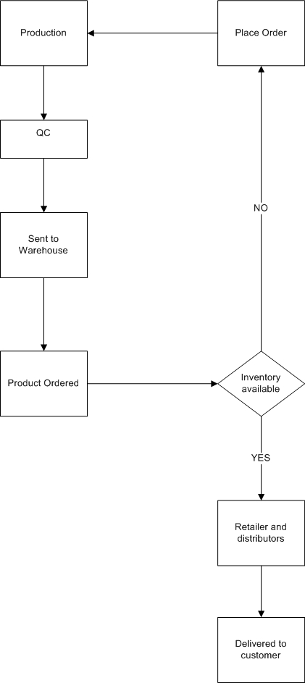

12. Business Requirements
Requirement ID | Requirement Description | Priority | Linked Use Case
BR-001 | Provide real-time inventory tracking across all warehouses and plants. | $500 | UC-001: Track Inventory Movement
BR-002 | Generate automatic purchase orders when inventory reaches reorder level. | $100 | UC-002: Reorder Point Management
BR-003 | Support batch-level tracking with expiry dates for perishable goods. | $50 | UC-003: Batch Management
BR-004 | Allow warehouse-to-warehouse internal stock transfers with approvals. | $20 | UC-004: Stock Transfer Process
BR-005 | Retailers and distributors must be able to place orders through a secure web portal. | $500 | UC-005: Order Placement
BR-006 | Route optimization for quickest delivery based on location, traffic, and delivery time windows. | $100 | UC-006: Dispatch Optimization
BR-007 | Real-time update of order status (Processing, Packed, Dispatched, Delivered). | $50 | UC-007: Order Status Tracking
BR-008 | Role-based access with different permissions for admins, warehouse staff, and delivery agents. | $10 | UC-008: Role Management
BR-009 | Alert users when stock is near expiry or expired. | $20 | UC-009: Expiry Notification
BR-010 | Ability to schedule deliveries based on available time slots and truck capacity. | $10 | UC-010: Delivery Scheduling
BR-011 | Generate reports and dashboards for stock levels, expiry status, order fulfillment, and logistics KPIs. | $20 | UC-011: Inventory & Delivery Reports
BR-012 | Support manual stock adjustment with logging and reason codes. | $10 | UC-012: Stock Adjustment
BR-013 | Maintain audit trail of all transactions and user actions. | $10 | UC-013: Audit Logging
BR-014 | Enable barcode/RFID integration for fast check-in/check-out and tracking. | $10 | UC-014: Scanner Integration
BR-015 | Allow forecasting of inventory based on historical order trends. | $10 | UC-015: Demand Forecasting
BR-016 | Allow bulk product uploads and initial stock import at go-live. | $10 | UC-016: Product & Data Import
BR-017 | Mobile-friendly interface for delivery agents and warehouse check-in/out. | $20 | UC-017: Mobile Compatibility
BR-018 | Notify customers via email/SMS about order confirmation and estimated delivery. | $20 | UC-018: Customer Communication
BR-019 | Auto-assign orders to warehouses based on proximity and stock availability. | $20 | UC-019: Smart Order Allocation
BR-020 | Support multi-location and multi-SKU inventory management with filtering. | $20 | UC-020: SKU Location Management

Process Flow Diagram

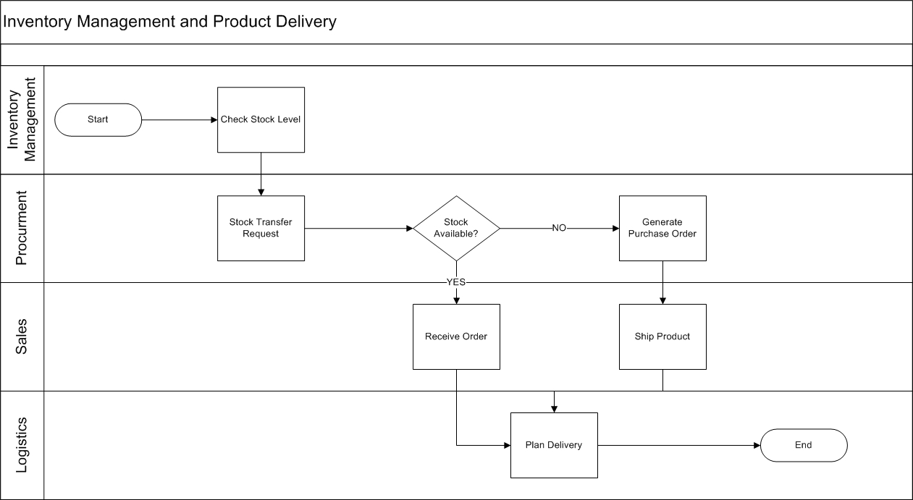

Assignment 2

Introduction Letter to client
Subject: Introduction as Your Business Analyst – Looking Forward to Collaborating
Hi XYZ,
I hope this message finds you well.
My name is Deepika Shekhawat, and I am the Business Analyst assigned to work closely with you and your team on upcoming project. I will be your primary point of contact for gathering business requirements, understanding your current processes, and ensuring we align our solutions with your goals and expectations.
To begin, I will be initiating the business understanding phase, which involves collaborating with stakeholders, identifying key objectives, and gaining clarity on the challenges and opportunities that this initiative seeks to address. This is a critical step in ensuring we design effective and value-driven solutions.
Over the next few days, I’ll be reaching out to schedule initial discussions with you and relevant team members. These conversations will help me gather essential insights and develop a clear picture of your business needs.
Please feel free to reach out to me at jaykishansahu.official@gmail.com if you have any questions or would like to discuss anything in advance.
I’m truly looking forward to working with you and contributing to the success of this initiative.
Regards,
Deepika shekhawat
Business Analyst
Deepikashekhawat592@gmail.com

Business Requirement Document (BRD)
Project Title: Online Electronics Store
Prepared by: Deepika Shekhawat, Business Analyst
Date: 21/7/2025
Version: 1.0

Document Revision
Date | Version | Document Changes
21/07/2025 | 1.0 | Initial Draft

Approvals
Role | Name | Title | Signature | Date
Project Sponsor | Bala S | CEO |  | 07/05/2025
Business Owner | Prakash | Vice President |  | 07/05/2025
Project Manager | Naresh | Project Manager |  | 07/05/2025
System Architect | Manoj | Staff System Administrator |  | 07/05/2025
Development Lead | Gunjan | Principal Software Developer |  | 07/05/2025
User Experience Lead | Paresh | Senior Designer |  | 07/05/2025
Quality Lead | Sanyam G | Lead QA |  | 07/05/2025
Content Lead | Vihana | Lead Content Manager |  | 07/05/2025

RACI Chart
Name | Position | * | R | A | S | C | I
Bala S | CEO
Prakash | VP
Naresh | Project Manager
Manoj | System Administrator
Gunjan | Principal software Dev
Paresh | Senior UI/UX designer
Sanyam G | Lead QA
Viahana | Lead Content Manager
Vipul | Lead BA
Jay | BA
Vikash | Front-End Developer
Abhsihek | Backend Developer
Arindam | AI Engineer
Deepak | Devops Engineer
Akash | QA
Sonu | BI Developer
Pradeep | Product Owner
Ronak | Support Lead/ Delivery Lead
Deepshikha | Sales
Sushmita | Legal Associate

Development and Resource Plan
Phase | Resources Involved | Timeline
Requirement Gathering | Business Analyst, Client Stakeholders | Week 1–2
Design | UI/UX Team, BA, PM | Week 3–4
Development | Frontend & Backend Devs, DBA | Week 5–10
Testing | QA Engineers, Test Automation Team | Week 11–12
UAT & Go-Live | Client Team, BA, PM, DevOps | Week 13–14
Post-Go-Live Support | Support Team | Week 15 Onwards

Introduction
- Document Purpose:
To outline the business, functional, and technical requirements for developing a multi-category online electronics store.
- Business Goal:
To establish a modern, scalable, and competitive online platform to sell electronics directly to consumers.
- Business Objective:
  - Increase online visibility and sales of electronics.
  - Provide customers with a seamless shopping experience.
  - Reduce dependency on physical retail operations.
- Background:
Due to evolving market trends and increased online buying behavior, the client has decided to launch a dedicated eCommerce platform for electronics.
- Project Objective:
To build an eCommerce platform that supports product listings, shopping cart, payments, user reviews, order tracking, and category-based browsing.

Project Scope
1. In Scope:
  - User registration and authentication
  - Category and sub-category product listings
  - Shopping cart and checkout
  - Payment gateway integration
  - Order and return management
  - Product reviews and ratings
  - Admin portal
  - Responsive design
  - Dashboard with sales and performance metrics
2. Out of Scope:
  - Warehouse and inventory management integration
  - Physical delivery/logistics operations
  - B2B or wholesale features
  - Mobile application (web version only in Phase 1)

Assumptions
  - Product catalog and pricing will be provided by the client.
  - A single payment gateway will be used in Phase 1.
  - All third-party APIs will be available and documented.
  - Product images and descriptions will be maintained by the admin team.

Constraints
  - Budget: ₹1.5 Crore
  - Timeline: 14 weeks
  - Technology stack: React.js, Node.js, MongoDB
  - Compliance with Indian IT and data privacy laws

Risks
- Technological Risks:
Risk | Likelihood | Impact Cost | Strategy | Details
Payment gateway downtime | Medium | High | Mitigate | Use multiple payment gateways and fallback options.
Server overload during sales | Medium | Very High | Mitigate | Implement cloud auto-scaling and performance monitoring tools.
Third-party API failure | Medium | Medium | Mitigate | Use health checks and caching for essential data from APIs.

- Skills Risks:
Risk | Likelihood | Impact Cost | Strategy | Details
Lack of skilled full-stack developers | High | Medium | Mitigate | Maintain a bench or contractor pool as backup.
New team members need onboarding | Medium | Medium | Accept | Include a buffer in the initial sprint for onboarding and knowledge transfer.
Key resource unavailability | Medium | High | Mitigate | Assign secondary resource ownership and maintain documentation.

- Business Risks:
Risk | Likelihood | Impact Cost | Strategy | Details
Delay in product data from client | High | High | Mitigate | Set early deadlines, add follow-ups, and escalate delays.
Inaccurate pricing/product info | Medium | Medium | Accept | Perform data validation and request confirmations from client.
Competitive pressure | Medium | Medium | Accept | Implement pricing flexibility and adjust marketing strategy.

- Political Risks:
Risk | Likelihood | Impact Cost | Strategy | Details
Change in eCommerce laws/regulations | Low | High | Transfer | Consult legal counsel and stay updated with compliance norms.
Data privacy law changes (e.g., DPDPA) | Low | High | Mitigate | Apply standard privacy practices and review policies quarterly.

- Requirement Risks:
Risk | Likelihood | Impact Cost | Strategy | Details
Changing requirements mid-sprint | Medium | High | Mitigate | Follow a formal change control and backlog grooming process.
Unclear or ambiguous requirements | High | Medium | Avoid | Conduct detailed stakeholder workshops and use wireframes.
Misalignment among stakeholders | Medium | Medium | Mitigate | Document assumptions and get sign-offs early.

- Other Risks:
Risk | Likelihood | Impact Cost | Strategy | Details
Cybersecurity/data breach | Medium | Very High | Mitigate | Use SSL, role-based access control, encryption, and regular audits.
Low user adoption post-launch | Low | Medium | Accept | Plan phased rollouts, gather feedback, and apply targeted marketing.
Browser/device compatibility | Medium | Medium | Mitigate | Test across browsers/devices and use responsive frameworks.

Business Process Review
- Legacy System (AS-IS):
- Current sales rely on third-party marketplaces (e.g., Amazon, Flipkart)
- No direct platform for customer engagement or brand loyalty
- Limited access to analytics and customer behavior insights

- Proposed Recommendation (TO-BE):
- Launch a branded eCommerce website
- Manage end-to-end sales and marketing in-house
- Offer personalized experience, loyalty programs, and customer support
- Collect direct user data for strategic insights

Business Requirements
Requirement ID | Requirement Description | Priority
BR-001 | User registration, login, and profile management | $100
BR-002 | Product catalog with categories, filters, and search | $500
BR-003 | Product detail page with specifications, images, and price | $100
BR-004 | Add to cart and manage cart contents | $100
BR-005 | Secure multi-step checkout process | $100
BR-006 | Integration with payment gateway (e.g., Razorpay, PayU) | $100
BR-007 | Order tracking with status updates | $50
BR-008 | Order history and invoice download | $20
BR-009 | Product reviews and ratings by verified buyers | $10
BR-010 | Admin portal to manage products, orders, and users | $50
BR-011 | Notifications (SMS/Email for order status, offers) | $10
BR-012 | Mobile-responsive design for all modules | $50
BR-013 | Dashboard for sales analytics and top-performing products | $20
BR-014 | Return and cancellation process | $20
BR-015 | Wishlist or save-for-later functionality | $5

Process Flow Diagram

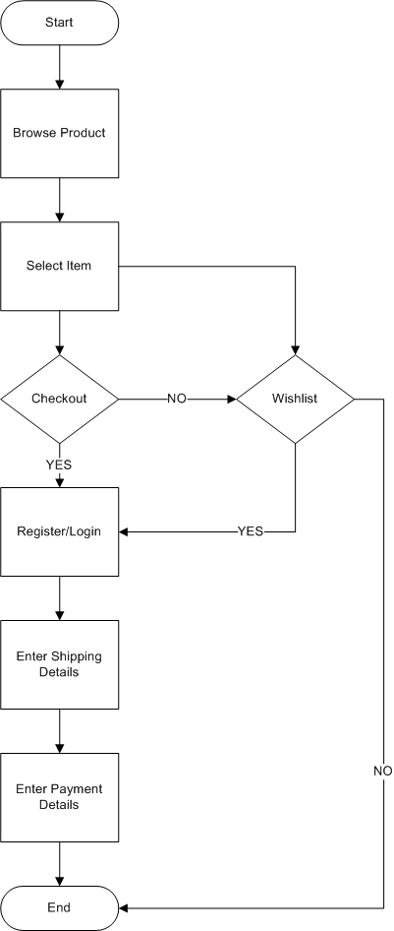

SRS Document
- Acronyms and Definitions
Term | Description

- Operational Requirements
Hardware Requirements:
- Web server with minimum 8-core CPU, 16 GB RAM, and 500 GB SSD.
- Database server with high IOPS SSD storage and 32 GB RAM.
- Secure firewall and load balancer for traffic distribution.
- Redundant internet connectivity for high availability.
Software Requirements:
- Operating System: Linux (Ubuntu 22.04 LTS or CentOS 8)
- Backend: Node.js (v18+) with Express.js framework
- Frontend: React.js (v18+) with Bootstrap or TailwindCSS
- Database: MongoDB (v6.0+)
- Payment Gateway: Razorpay API integration
- Web Server: Nginx or Apache
- Monitoring Tools: Prometheus, Grafana, ELK stack
- References
IEEE Std 830-1998: IEEE Recommended Practice for Software Requirements Specifications.
- Design and Implementation Constraints
  - The backend must be built using Node.js and MongoDB.
  - Frontend will use React.js with responsive design principles.
  - Must integrate with Razor pay and UPI as the primary payment gateway.
  - All pages must support English language initially.
- Assumed Factors That Could Affect the Requirements Stated In the SRS
- Change in government regulations (e.g., taxation, data privacy laws)
- Variability in internet access in rural areas
- Third-party API changes or deprecation (e.g., payment or SMS services)
- Increase in user traffic beyond forecasted values
- System Overview
  - Current System: Currently, the client sells electronics through physical retail outlets and third-party marketplaces. There is no dedicated online store or centralized digital customer database.
  - Proposed System: The proposed system is a centralized e-commerce platform that will allow customers to register, browse products, purchase items, track orders, and provide feedback—all within a single, secure web interface.
  - Benefits of Proposed System:
  - Enhanced customer reach through digital presence
  - Reduced dependency on intermediaries
  - Real-time order tracking and customer communication
  - Improved inventory and order management
  - Better marketing and upselling opportunities
- UI Requirements
- Clean, intuitive layout with mobile responsiveness
- Home page with categories and offers
- Product detail pages with images, descriptions, and reviews
- Cart and checkout interface with clear call-to-action
- User dashboard for order tracking and account management
- Project Contents:
  - User Registration/Login
  - Product Catalog Management
  - Cart and Checkout
  - Payment Integration
  - Order Management and Returns
  - Admin Portal
  - Reports and Analytics
  - Notifications and Alerts
- Acceptance
The system will be considered accepted when:
  - All core modules are implemented and tested successfully
  - UAT (User Acceptance Testing) is signed off by stakeholders
  - Security and performance benchmarks are met
  - No critical bugs remain unresolved in production

ERD of a Ticketing System

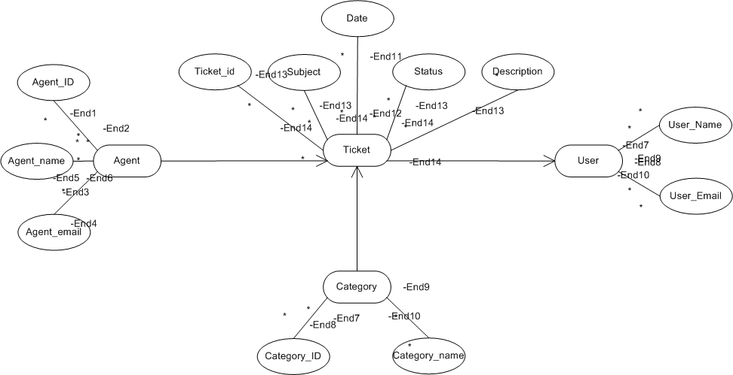

E-Commerce User Stories

User story No: 1 | Tasks: Form validation, DB entry, success message | Priority: High
Value statement:
As a user, I want to register using email/mobile.
BV: 100 | CP: 3
Acceptance criteria:
- User can enter email, password, and confirm password
- System sends verification email
- Account is created after verification

User story No: 2 | Tasks: Auth setup, error handling, session control | Priority: High
Value statement:
As a user, I want to log in securely using email/mobile.
BV: 100 | CP: 3
Acceptance criteria:
- Valid credentials log the user in.
- Invalid credentials display an error.
- User session is maintained post-login.

User story No: 3 | Tasks: Create reset form. | Priority: High
Value statement:
As a user, I want to reset my password.
BV: 100 | CP: 5
Acceptance criteria:
- "Forgot password" link is visible.
- User receives reset link via email.
- User can change password using the link.

User story No: 4 | Tasks: Category listing, filtering logic, UI design. | Priority: High
Value statement:
As a user, I want to browse products by categories.
BV: 500 | CP: 8
Acceptance criteria:
- Categories are listed clearly.
- Clicking a category filters the product list.
- URL reflects selected category.

User story No: 5 | Tasks: Search logic, backend indexing, UI integration. | Priority: High
Value statement:
As a user, I want to search for products by name or keyword.
BV: 200 | CP: 5
Acceptance criteria:
- A search bar is available on all main pages and accepts product names or keywords.
- Matching products are displayed based on title, description, or tags.
- Partial matches (e.g., "lap" for "laptop") return relevant results.
- If no results are found, a friendly message like “No products found” is shown.
- The search term remains in the input field after performing a search.

User story No: 6 | Tasks: Add to cart. | Priority: High
Value statement:
As a user, I want to add products to cart.
BV: 100 | CP: 3
Acceptance criteria:
- "Add to Cart" button is available on product listing and detail pages.
- Clicking the button adds the product to the user's cart.
- Cart icon updates in real time with the correct item count.
- The same item added again increases quantity instead of creating a duplicate entry.
- A confirmation message appears after an item is added.
- Cart contents persist across page refreshes and sessions (if logged in).

User story No: 7 | Tasks: Cart editing/removal features, update UI. | Priority: High
Value statement:
As a user, I want to update or remove items in cart.
BV: 100 | CP: 2
Acceptance criteria:
- User can increase or decrease the quantity of each item in the cart.
- Setting the quantity to zero or clicking "Remove" deletes the item from the cart.
- Subtotal and total prices update automatically based on changes.
- A confirmation message appears when an item is removed.
- Cart updates are reflected instantly without a full page reload.

User story No: 8 | Tasks: Checkout page, validation, user flow. | Priority: High
Value statement:
As a user, I want to proceed to checkout.
BV: 100 | CP: 35
Acceptance criteria:
- A clearly visible “Proceed to Checkout” button is available on the cart page.
- Clicking the button navigates the user to the checkout page with cart items preloaded.
- User is prompted to log in or continue as guest if not already logged in.
- All required billing and shipping information fields are displayed on the checkout page.
- The order summary (items, quantity, subtotal, total) is visible and accurate.
- Validation messages appear for any missing or incorrect required fields.

User story No: 9 | Tasks: Address DB schema. | Priority: Medium
Value statement:
As a user, I want to save multiple delivery addresses.
BV: 50 | CP: 3
Acceptance criteria:
- User can add new delivery addresses from the profile or during checkout.
- Each saved address includes fields like name, phone, street, city, state, zip, and country.
- User can view a list of all saved addresses in the profile section.
- User can set one address as the default delivery address.
- User can edit or delete any saved address.
- During checkout, user can choose from saved addresses for delivery.

User story No: 10 | Tasks: Payment gateway API, UI integration. | Priority: High
Value statement:
As a user, I want to choose payment options (COD, card, wallet).
BV: 500 | CP: 8
Acceptance criteria:
- All available payment options (COD, card, wallet) are displayed on the checkout page.
- User can select only one payment method per transaction.
- Card option allows entry of valid card details and performs basic validation.
- Wallet option displays available wallet balance before confirming.
- COD option is selectable only for eligible locations/orders.
- Selected payment method is confirmed before placing the order.

User story No: 11 | Tasks: Order status tracking UI | Priority: High
Value statement:
As a user, I want to track my order status.
BV: 200 | CP: 5
Acceptance criteria:
- User can view order status from the “My Orders” section after logging in.
- Each order displays a real-time status like “Processing,” “Shipped,” “Out for Delivery,” or “Delivered.”
- Tracking number and courier details are shown for shipped orders.
- A clickable “Track” link opens the detailed shipment progress (if available).
- Status updates are automatically reflected based on backend/courier data.
- Users receive email or SMS notifications when the status changes.

User story No: 12 | Tasks: Fetch orders. | Priority: Medium
Value statement:
As a user, I want to view my order history.
BV: 100 | CP: 3
Acceptance criteria:
- A “My Orders” section is accessible from the user’s account dashboard.
- Order history lists all past orders with basic details like order ID, date, total amount, and status.
- Each order entry is clickable to view detailed order summary.
- Order details include item names, quantities, prices, and delivery address.
- Orders are displayed in reverse chronological order (most recent first).
- Cancelled and returned orders are also visible with appropriate labels.

User story No: 13 | Tasks: Review form, rating logic, moderation. | Priority: Low
Value statement:
As a user, I want to rate and review products.
BV: 100 | CP: 3
Acceptance criteria:
- User can submit a rating (1 to 5 stars) for products they have purchased.
- Review input field is available for entering text feedback.
- Only users with a completed order for the product can submit a review.
- Submitted reviews are timestamped and displayed publicly on the product page.
- Reviews can be edited or deleted by the user from their account section.
- An average rating is calculated and shown based on all user reviews.

User story No: 14 | Tasks: Admin panel CRUD, image upload. | Priority: High
Value statement:
As an admin, I want to add/edit/delete products.
BV: 200 | CP: 5
Acceptance criteria:
- Admin can access a secure product management panel after login.
- Admin can add a new product by entering required fields (name, category, price, stock, image, description).
- Admin can edit existing product details and save changes successfully.
- Admin can delete a product, and it is immediately removed from the customer-facing catalog.
- All changes (add/edit/delete) are logged with timestamp and admin identifier.
- Validation prevents saving a product with missing required fields or invalid data types.

User story No: 15 | Tasks: Create/edit/delete category UI and logic. | Priority: High
Value statement:
As an admin, I want to manage categories.
BV: 100 | CP: 3
Acceptance criteria:
- Admin can add a new product category by entering a unique name and optional description.
- Admin can edit existing category names or descriptions and save the changes.
- Admin can delete a category only if it has no assigned products (or is reassigned).
- A list of all categories is displayed in the admin panel with search and filter options.

User story No: 16 | Tasks: User table, suspend/delete users. | Priority: Medium
Value statement:
As an admin, I want to manage user accounts.
BV: 50 | CP: 3
Acceptance criteria:
- Admin can view a list of all registered users with key details (name, email, status, registration date).
- Admin can activate, deactivate, or delete user accounts from the admin panel.
- Admin can search and filter users by name, email, or status.
- Admin can reset a user's password and send a reset link to their email.
- Deactivated users are unable to log in until reactivated.
- All changes to user accounts are logged with timestamps and admin identifiers.

User story No: 17 | Tasks: Coupon validation, discount logic. | Priority: Medium
Value statement:
As a user, I want to apply coupons at checkout.
BV: 100 | CP: 5
Acceptance criteria:
- A coupon input field is available on the checkout page.
- User can enter a valid coupon code and apply it to the order.
- The discount is reflected in the order summary after applying the coupon.
- If the coupon is invalid, expired, or not applicable, an appropriate error message is shown.
- Only one coupon can be applied per order.
- Applied coupon remains active unless the user manually removes it.

User story No: 18 | Tasks: Notification logic, templates. | Priority: High
Value statement:
As a user, I want to receive email/SMS confirmation for orders.
BV: 100 | CP: 5
Acceptance criteria:
- User receives a confirmation email immediately after placing an order.
- Email includes order ID, items purchased, total amount, delivery address, and estimated delivery date.
- SMS confirmation is sent to the registered mobile number, if provided.
- Both email and SMS messages are sent only after successful payment.

User story No: 19 | Tasks: Charts, KPIs, analytics | Priority: Medium
Value statement:
As an admin, I want to view sales dashboard.
BV: 200 | CP: 8
Acceptance criteria:
- Admin can access the sales dashboard from the admin panel after logging in.
- The dashboard displays key sales metrics such as total revenue, number of orders, average order value, and total units sold.
- Data is filterable by date range (e.g., today, last 7 days, custom range).
- Sales trends are visualized using charts (e.g., line graph for revenue over time, pie chart for category distribution).
- Dashboard includes top-selling products and most active customers.
- All metrics update in real-time or on demand with a refresh option.

User story No: 20 | Tasks: Wishlist DB table, UI toggle. | Priority: Medium
Value statement:
As a user, I want to save products to a wish list.
BV: 100 | CP: 3
Acceptance criteria:
- A “Add to Wishlist” icon/button is available on product listing and detail pages.
- Clicking the button adds the selected product to the user’s personal Wishlist.
- Users can view and manage their Wishlist from their account section.
- Users can remove items from the Wishlist with a single click.
- Wishlist persists across sessions for logged-in users.
- Products in the Wishlist can be added directly to the cart.

