LIVE PROJECT 1- PART 2.
SUBMITTED BY – AISHWARYA AJIT KHULE
BATCH – 10TH AUGUST, 2024.
SUBMISSION DATE – 13th November, 2024.

Retail Store Management System. The Retail Store Management System is a system designed for managing i.e. for ordering, arranging and selling goods. The Retailer checks for the availability of goods in the store. If the stock of goods is less than retailer places order for goods. While ordering the goods, goods area received at store, the retailer then arrange them by product or by price, then retailer makes payment. If the stock of goods is available, then he will arrange goods for selling. The retailer then sales the goods directly to the customer. The customer buys the items from retailer. The retailer prepares bill for goods purchased by the customer, he receives amount by credit or by cash from customer. The supplier supplies the goods to the store. The overall system is used to manage the goods in the store. Valid Considerations: Inclusion: ﻿﻿Retailer accepts payment from customer either by Credit card or by cash. ﻿﻿Arranging Goods in system either by Price or by product ﻿﻿Before generates bill, retailer should run the sales transaction. Exclusion: ﻿﻿Retailer makes payment directly or third-party services ﻿﻿Supplier supplies goods manually.

Part 2/2 Evaluation
Document 6- Please prepare a use case diagram, activity diagram and a use case specification document.
Document 7- Screens and pages
Document 8- Tools-Visio and Axure
Document 9- BA experience
My experience as BA in following phases:
1. Requirement gathering:
2. Requirement Analysis:
3. Design:
4. Development:
5. Testing:
6. Deployment:

Use case ID | US001
Use case Name | Product Management.
Created by | Ms. Esha. | Last Updated
Date created |  | Last Revision Date
Actor | Store Manager
Description | The store manager can add, update, or remove products from the system, including details like name, price, quantity, category, and description.
Pre-condition | - The system must be online and accessible.  - The store manager must be logged in.
Post- condition | - The product list is updated.  - Changes are reflected in the system’s inventory.
Basic flow | - The store manager navigates to the product management section.  - The store manager adds, updates, or removes product details.  - The system saves the changes.  - The updated product list is displayed.
Alternative flow | - If the store manager provides incomplete details, the system prompts for missing information.
Exceptions | - If the system is offline, changes cannot be made.  - If the store manager does not have the necessary permissions, access is denied.
Frequency of use | High.
Assumptions | - The store manager has valid login credentials.  - The product database is operational.

Use case ID | US002
Use case Name | Inventory Management
Created by | Ms. Esha. | Last Updated
Date created |  | Last Revision Date
Actor | Store Manager
Description | The system allows the store manager to monitor stock levels, update quantities, and receive low-stock alerts.
Pre-condition | - The system must be online and accessible.  - The store manager must be logged in.
Post- condition | - Inventory levels are updated.  - Low-stock alerts are sent if necessary.
Basic flow | - The store manager navigates to the inventory management section.  - The manager reviews stock levels.  - The manager updates inventory as needed.  - The system saves and updates inventory records.
Alternative flow | - If a product is out of stock, the system suggests restocking.
Exceptions | - If the system is offline, inventory updates are not possible.  - If stock details are incorrect, an error message is displayed.
Frequency of use | Medium.
Assumptions | - The store manager has valid login credentials.  - The inventory database is functional.

Use case ID | US003.
Use case Name | Order Processing.
Created by | Ms. Esha. | Last Updated
Date created |  | Last Revision Date
Actor | Cashier.
Description | The system processes customer purchases by scanning items, applying discounts, and generating receipts.
Pre-condition | - The system must be online and accessible.  - The cashier must be logged in.
Post- condition | - The order is processed and payment is recorded.  - A receipt is generated.
Basic flow | 1. The cashier scans the items.  2. The system calculates the total price.  3. The cashier applies discounts if applicable.  4. The customer makes payment.  5. The system generates a receipt.
Alternative flow | - If an item is not recognized, the cashier can enter it manually.
Exceptions | - If the payment is declined, the system prompts for another payment method.  - If an item is out of stock, the system alerts the cashier.
Frequency of use | High.
Assumptions | - The cashier has valid login credentials.  - The payment processing system is operational.

Use case ID | US004.
Use case Name | Customer Feedback Management
Created by | Ms. Esha. | Last Updated
Date created |  | Last Revision Date
Actor | Customer.
Description | Customers can submit feedback about their shopping experience, which is stored and analysed by the system.
Pre-condition | - The system must be online and accessible.  - The customer must be logged in.
Post- condition | - Feedback is recorded and available for store management to review.
Basic flow | - The customer navigates to the feedback section.  - The customer fills out and submits feedback.  - The system records the feedback.  - Store management can review and respond to feedback.
Alternative flow | - If feedback is incomplete, the system prompts the user.
Exceptions | - If the system is offline, feedback submission is not possible.  - If the user is not logged in, submission is restricted.
Frequency of use | Low.
Assumptions | - The customer has a valid login.  - The system can store and retrieve feedback.

Use case ID | US006.
Use case Name | Loyalty Program Management
Created by | Ms. Esha. | Last Updated
Date created |  | Last Revision Date
Actor | Customer.
Description | Customers can enroll in a loyalty program, track their points, and redeem rewards.
Pre-condition | - The system must be online and accessible.  - The customer must have a registered account.
Post- condition | - Loyalty points are updated and available for redemption
Basic flow | 1. The customer accesses the loyalty program section.  2. The customer enrolls or views their points.  3. The system updates and displays points balance.  4. The customer redeems rewards if eligible.
Alternative flow | - If the customer provides incorrect details, the system prompts for corrections.
Exceptions | - If the system is offline, point updates and redemptions cannot occur.
Frequency of use | Medium.
Assumptions | - The customer has a valid account.  - The loyalty program is active and functional.

Document 7- Screens and pages

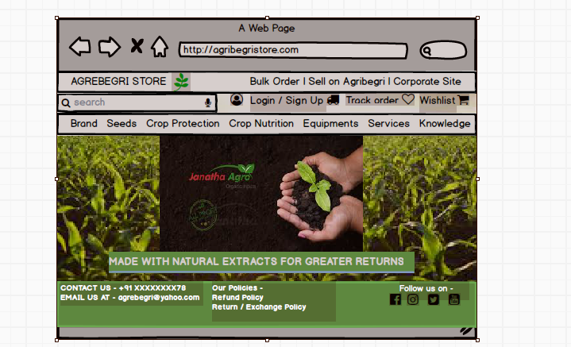

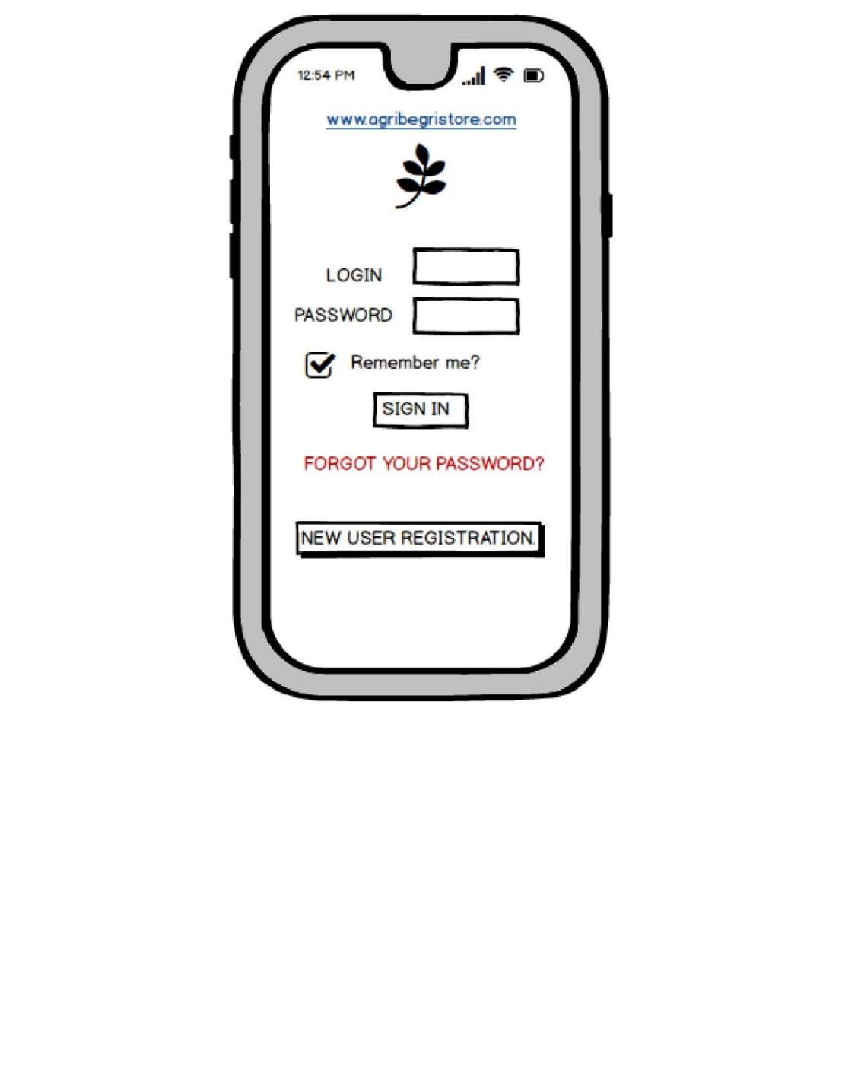

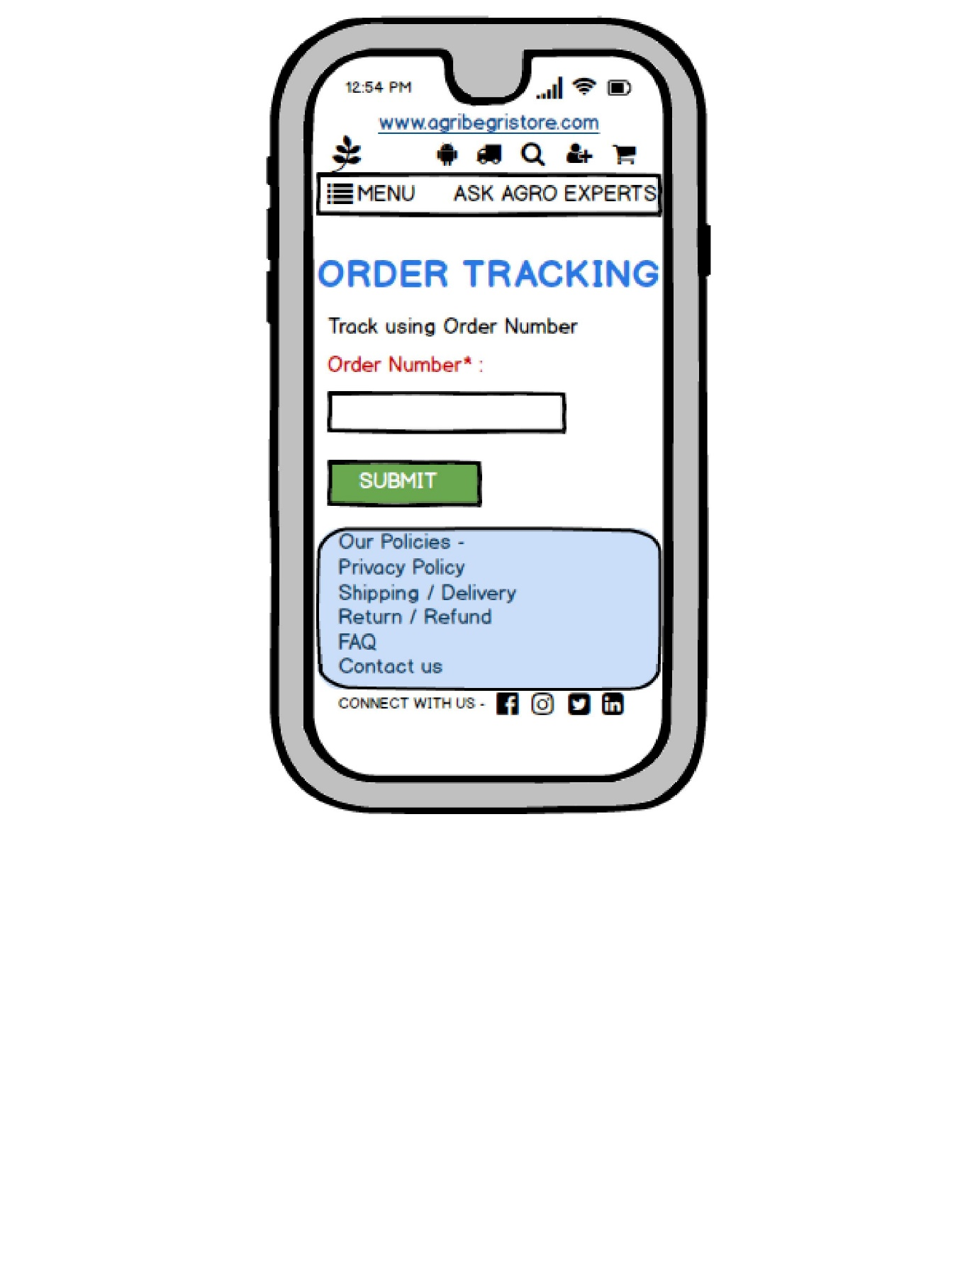

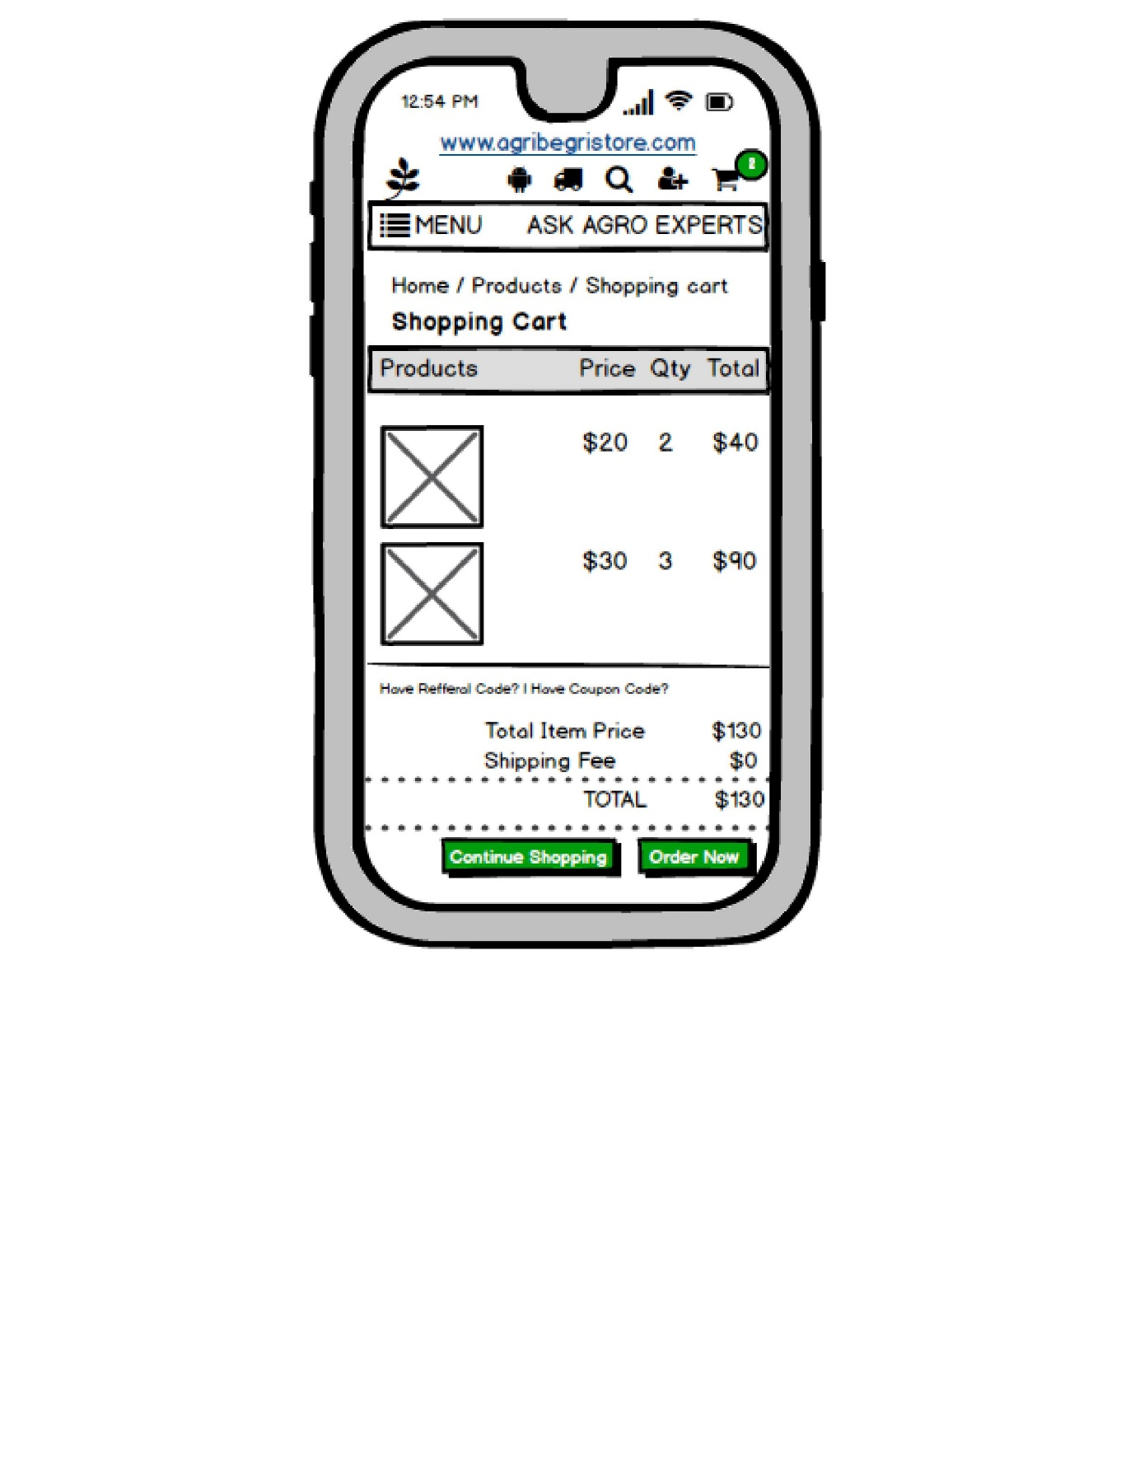

Document 8- Tools-Visio and Axure.

1. Visio:
- I have used Microsoft Visio tool to create Use cases and Activity diagrams
- Use Case Diagrams: Created diagrams to represent various system interactions, such as booking tickets, checking availability, and ticket cancellations.
- Activity Diagrams: Designed workflow diagrams to illustrate step-by-step processes, such as how customer books a ticket or cancels an i-ticket.
2. Axure / Balsamiq:
- I have used Balsamiq tool to create wireframes and prototypes. As a Business Analyst one of my key responsibilities is to clearly visualize the application flow and user experience to ensure that the project meets all the stakeholder’s requirements. To achieve this, Balsamiq is a tool for designing and wireframes that outline the flow and functionality of the store.
- It provides a simple drag-and-drop interface that lets me quickly create wireframes for each of the important pages of the online store.
- Balsamiq enables quick creation of wireframes, which is essential for collaborating with stakeholders

Document 9- BA experience.

My experience as BA in following phases:
1. Requirement gathering:
- Role & Activities: As a Business Analyst, my primary role during the requirement gathering phase was to engage with key stakeholders to understand their needs and business goals. I conducted interviews, workshops, and surveys to capture detailed requirements, facilitated discussions to align on objectives, and clarified expectations with end-users.
- Challenges: A major challenge was managing conflicting priorities among stakeholders. I addressed this by conducting prioritization sessions and using a MoSCoW (Must have, Should have, Could have, Won't have) technique to reach a consensus on essential requirements.
- Outcome: The outcome was a comprehensive set of well-documented, prioritized requirements that provided a solid foundation for the project. I also ensured stakeholder alignment and buy-in, which helped prevent misunderstandings later in the project.
2. Requirement Analysis:
- Role & Activities: In the analysis phase, I worked closely with both business and technical teams to analyze requirements for feasibility and alignment with business goals. I created detailed requirement specifications, user stories, and use cases, and worked on creating process flow diagrams to visualize how the solution would meet business needs.
- Challenges: Some requirements were initially vague or over-scoped, which created potential issues for implementation. To mitigate this, I conducted follow-up sessions with stakeholders to refine these requirements and worked with the technical team to assess feasibility and potential constraints.
- Outcome: I produced a detailed requirements document, including clear user stories and acceptance criteria, which enabled developers and testers to better understand the expectations. This also provided a structured reference for the rest of the project phases.

3. Design:
- Role & Activities: In the design phase, I collaborated with UI/UX designers to create wireframes and prototypes that translated the requirements into a visual representation of the solution. I provided feedback on design choices and ensured they aligned with user expectations and business goals.
- Challenges: Balancing user needs with technical constraints was a key challenge. I facilitated design review meetings between designers and developers to address any potential issues and ensure designs were technically feasible without compromising user experience.
- Outcome: The designs created were user-friendly and met the requirements outlined by stakeholders. These prototypes were presented to stakeholders for feedback, which helped in gaining early approval and reducing potential design-related changes during development.
4. Development:
- Role & Activities: During the development phase, I acted as the bridge between developers and stakeholders. I clarified requirements, addressed any questions from developers, and ensured alignment with the initial goals. I participated in sprint planning and review meetings, helping prioritize development tasks and resolve issues as they arose.
- Challenges: Occasionally, developers encountered challenges in implementing certain functionalities as specified in the requirements. To address this, I facilitated discussions to explore alternative solutions that could satisfy both business needs and technical limitations.
- Outcome: By maintaining close communication with the development team, I ensured that the functionality developed aligned closely with business objectives. This proactive collaboration helped minimize the need for extensive rework and kept the project on track.
5. Testing:
- Role & Activities: In the testing phase, I supported the creation of test cases and participated in User Acceptance Testing (UAT) to verify that the solution met business requirements. I reviewed test results, identified gaps, and worked with the team to ensure that all critical issues were resolved.
- Challenges: One challenge was ensuring that all edge cases and user scenarios were thoroughly tested. I worked closely with the QA team to develop comprehensive test cases and reviewed feedback from testers to ensure all aspects of the requirements were covered.
- Outcome: The testing phase was successful, with a high level of defect resolution and satisfaction from stakeholders. The rigorous UAT process ensured that the product was well-aligned with business needs and ready for deployment.
6. Deployment:
- Role & Activities: During deployment, I coordinated with stakeholders to prepare for go-live, which included creating user guides, conducting training sessions, and ensuring that all necessary documentation was ready. I also collaborated with the technical team to ensure a smooth transition to the live environment.
- Challenges: Some users were unfamiliar with the new system, which created a potential risk for user adoption. To address this, I organized training workshops and provided support during the initial rollout.
- Outcome: The deployment was successful, with minimal issues. My efforts in preparing users and providing adequate support helped ensure a smooth transition and high user satisfaction with the new system.

