BRD Document

Project name: ADP Dairy and Ice Cream’s Pvt Ltd

Project ID: Inventory & Delivery Optimization System

Version ID:0.1

Author: Srividya. M

Table of Contents – ADP Dairy and Ice Creams Pvt Ltd Project
1. Project Overview
2. Document Revisions and Approvals
3. RACI Chart
4. Business Goals
5. Business Objectives
6. Business Rules
7. Project Objectives
8. Scope of the Project
9. Assumptions
10. Constraints
11. Risk Analysis
12. Business Process Overview (AS-IS vs TO-BE)
13. Requirements
13.1 Business Requirements
13.2 Functional Requirements
13.3 Non-Functional Requirements
14. Development and Resource Plan
15. Process Flow Diagram
16. ERD Diagram

Document Revisions:

Approvals:

Role | Name | Title | Signature | Date
Project Name | ADP Dairy and Ice Cream’s Pvt Ltd
Business Owner | Narayanan
Project Manager | Swetha
System Architect | Natraj
Development Lead | Samhita
User Experience Lead | A.Shashank
Quality Lead | Krishna
Content Lead | Raveena

RACI chart:

NAME | Position | * | R | A | S | C | I
Narayanan | Business Owner | ✔️ |  | ✔️ |  | ✔️
Swetha | Project Manager | ✔️ | ✔️ |  |  |  | ✔️
Samhita | Development Lead |  | ✔️ |  | ✔️
Shashank | UX Lead |  | ✔️ |  |  | ✔️
Krishna | QA Lead |  | ✔️ |  |  | ✔️

1 Business Goals:

1 Streamlined Inventory Management: Ensure real time monitoring of inventory levels across all warehouses and plants to reduce spoilage and optimize stock levels.
2 Enhanced Delivery Efficiency: Implement a system to identify to the fastest delivery routes and automate order allocation based on proximity and inventory availability.
3 Improved customer Satisfaction: Minimize order fulfillment time and ensure product freshness at delivery.

2 Business objectives:

1 Developed a centralized system to track and manage inventory across all locations.
2 Automate order processing, allocation, and dispatch based on inventory and location proximity.
3 Integrate delivery route optimization with real time traffic and weather data.
4 Reduce inventory wastage by implementing an expiry data tracking mechanism.
5 Enable reporting and analytics for better decision making and demand forecasting.

3 Business Rules:

1 Inventory must be updated in real time upon receipt, dispatch or adjustment.
2 Orders should only be fulfilled if the inventory is availability and meets the required shelf line criteria.
3 Delivery routes must prioritize freshness while minimize transportation cost.
4 Customer priority orders (e.g. bulk orders) must be flagged for immediate action.
5 Warehouse reordering should trigger automated purchase orders.

4 Project objectives:

1 Manage Inventory:
Real time stock tracking across plants and warehouses.
Automated stock alert and replenishments
Batch tracking for perishable goods.

2 Quick Delivery:

Auto suggest delivery routes based on location, traffic, and stock availability.
Integration with GPS and mapping APIs.
Order assignment to nearest warehouse.

5 Scope of the Project:

1 In scope:

Inventory tracking at manufacturing plants and warehouses.
Order management and allocation.
Delivery route optimization.
Analytics and report dashboards.
2 Out scope:

Manufacturing process management
Customer relationship management (CRM).

6 Assumptions:

1 All warehouses and plants have internet connectivity for real time updates.
2 Delivery vehicles are GPS- enabled to support route optimization.
3 Data from external sources (e.g., traffic, weather) is available via APIs.

7 Constraints:

1 Budget limitations may restrict the scope of features.
2 Integration with legacy systems may pose technical challenges.
3 Project timelines must align with the company’s peak season schedules.

8 Risk Analysis:

Technical Risks:

Integration issue with existing systems.
System scalability with increasing business demand.

9 Political Risk:

Resistance from employees due to new processes and technology.
Potential vendors lock in with third party tools.

Requirement Risks:

Incomplete or evolving requirements from stakeholders.

10 Business Risks:

Downtime during system rollout.
Customer dissatisfaction due to transition delays.

Business process overview:

AS IS:
Inventory is managed manually or using isolated systems.
Order allocation is manually determined leading to inefficacies.
Delivery routes are planned based on experience not optimized.

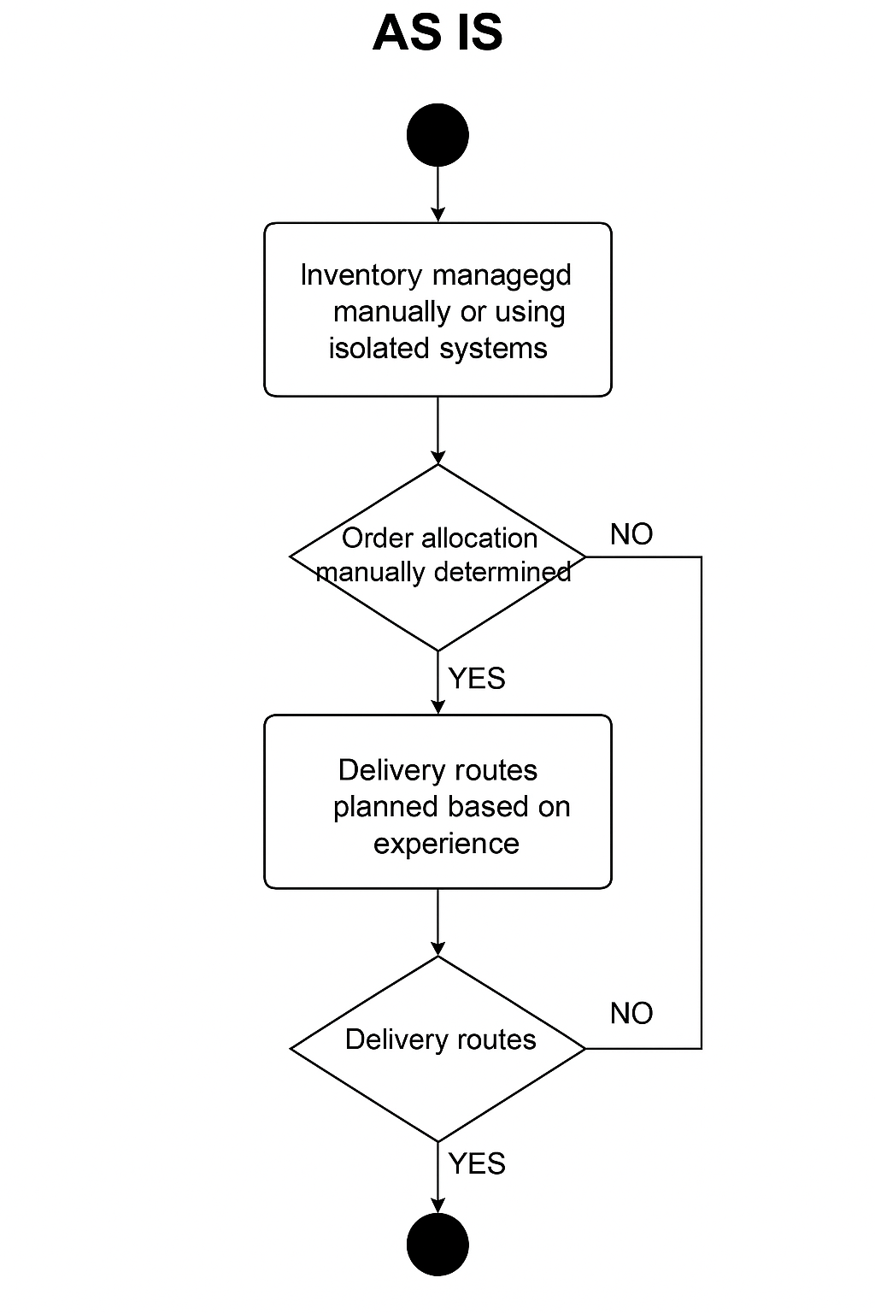

TO BE
A centralized system enables automated inventory management.
Orders re allocated and dispatched through an intelligent algorithm.
Delivery routes are optimized dynamically for speed and cost.

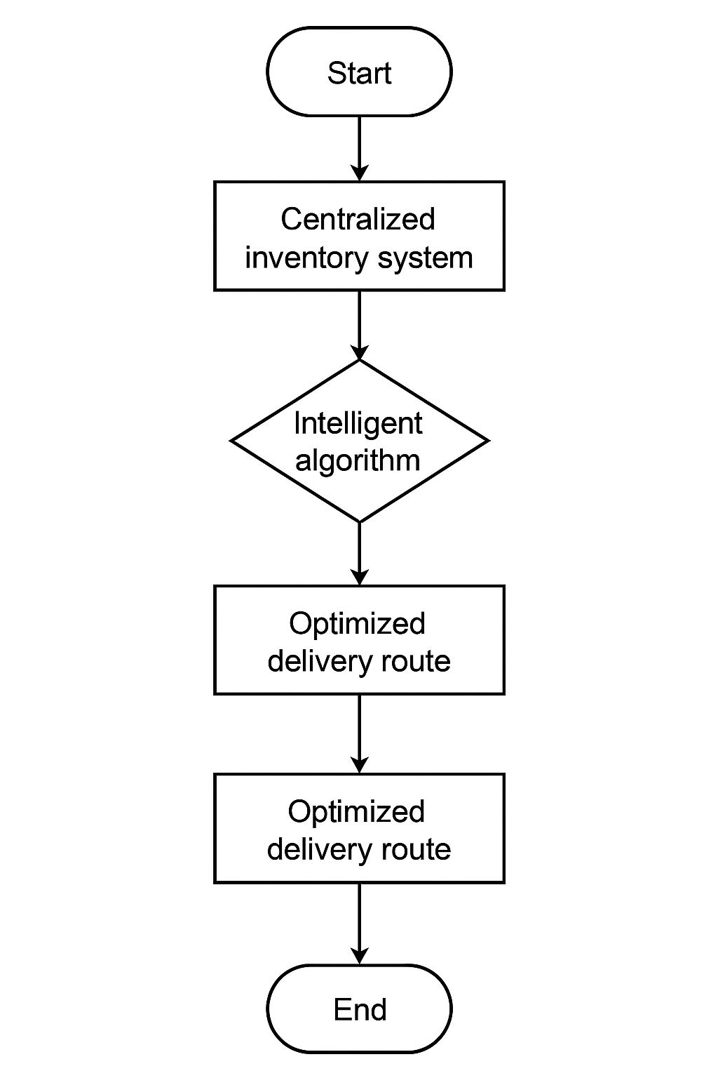

11. Requirements:

11.1. Business Requirements

1 inventory management module:
Real time inventory tracking across locations.
Expiry date monitoring and alerts for perishable items.

2 Order Management module:
Automated order allocation based on location and inventory
Bulk order prioritization.

3 Delivery Optimization module:
Integration with GPS and real time data for route planning.
Dynamic rerouting in case of delays.
4 Reporting Module:
Insights into inventory levels, order trends and delivery performance.

11.2. Functional Requirements

Requirement ID | Description | Priority
FR1 | The system shall allow users to manage inventory items including adding, editing, and deleting products. | High
FR2 | The system shall track real-time inventory levels and provide alerts for low stock. | High
FR3 | The system shall support barcode scanning for inventory intake and dispatch. | Medium
FR4 | The system shall generate reports for inventory movement, usage, and stock aging. | High
FR5 | The system shall enable role-based access control for different types of users. | Medium
FR6 | The system shall integrate with existing procurement and billing systems. | High

11.3 Non-Functional Requirements

Requirement ID | Description | Category
NFR1 | System shall have a response time of less than 2 seconds for inventory queries. | Performance
NFR2 | System shall maintain 99.9% uptime monthly. | Availability
NFR3 | Data shall be backed up daily and stored securely. | Reliability
NFR4 | System shall encrypt sensitive data both at rest and in transit. | Security
NFR5 | The system should support at least 50 concurrent users. | Scalability
NFR6 | The system shall have an intuitive user interface. | Usability

12 Development and resource plan.

Development plan:
1 Phase 1: Requirement gathering, stakeholder workshops, and system design (4 weeks).
2 Phase 2: Development of core modules (Inventory, order, Delivery) (12 weeks).
3 Phase 3: Integration with external system (API’s, GPS) and legacy systems (6 weeks).
4 phase 4: Testing and quality assurance (4 weeks.).
5 Phase 5: Deployment, training, and support. (4 weeks).
Resource plan:
Project manager: 1
Developers: 3 (backend, frontend, integration specialists).
QA engineers: 2
Business analysts: 1
Support team: 2

Glossary
BRD: Business Requirements Document – outlines the high-level business needs.
SRS: Software Requirements Specification – detailed system-level specifications.
ERD: Entity Relationship Diagram – shows relationships between database entities.
AS-IS: The current state of the system or process before improvement.
TO-BE: The future state of the system after implementation of the solution.
SLA: Service Level Agreement – commitment on service timelines or quality.
BV: Business Value – a numeric value indicating the importance of a feature.
CP: Complexity Point – a Fibonacci-based estimate of development effort.
RACI: Responsible, Accountable, Consulted, Informed – a matrix for role clarity.
API: Application Programming Interface – enables integration with other systems.
GPS: Global Positioning System – used for delivery route optimization.

2. Process Flow Diagram:
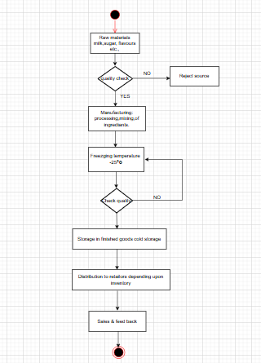

Assignment 2

Introduction Letter:

Subject: Introduction as business analyst

Dear team,

I hope this email finds you well. My name is a krithika, I would like to introduce myself as business analyst leading the engagement for your Ice-Cream & Milk Products Inventory & Delivery Management System. I will be working closely with you and your team to ensure that all business needs and translate them into a software solution.
I am to thoroughly understand your current process challenges and together we will explore optional workflows identify key requirements and strategically plan the business objectives.
I look forward for a formal discussion on your expectations and gather inputs from your team during the initial meeting. In the meantime, please feel free to share any documents on current process or initial thoughts that could help us o prepare for the meeting.

Thank you for this opportunity to collaborate on this project. Please let me know a convenient time, so that we can arrange formal discussion to connect further.

Looking forward to work with you.
Regards,
Srividya.M.

2. BRD AND SRS for ticketing system.

Project name: Ticketing SYSTEM

Project ID: Inventory & Delivery Optimization System

Version ID:0.1

Author: Srividya

Table of Contents – Ticketing System Project

1. Project Overview
2. Approvals
3. RACI Chart
4. Business Goals
5. Business Objectives
6. Scope of the Project
7. Assumptions
8. Constraints
9. Risk Analysis
10. Business Process Overview (AS-IS and TO-BE)
11. Business Requirements
12. Software Requirements Specification (SRS)
12.1 Purpose
12.2 Scope
12.3 Overview
12.4 Software Interfaces
12.5 Hardware Interfaces
12.6 Functional Requirements
12.7 Non-Functional Requirements
13. User Stories
14. ERD Diagram
15. Process Flow Diagram

Project overview:

The objective of the ticketing system project is to implement a comprehensive solution for managing customer support tickets efficiently. The system will streamline the end-to-end process of ticket creation, tracking, resolution, and closure. It is designed to enable seamless communication between users, support agents, and managers, thereby improving the overall effectiveness of customer support operations.
Additionally, the system will incorporate advanced features such as service level agreement (SLA) compliance monitoring, enhanced reporting capabilities, and integration with a knowledge base to facilitate faster and more effective issue resolution.
Approvals:

Role | Name | Title | Signature | Date
Project Name | Ticketing System
Business Owner | Pratap
Project Manager | Christy
System Architect | Shishya
Development Lead | Vinod
User Experience Lead | Karthik
Quality Lead | Umeed
Content Lead | Sathish

RACI:

NAME | Position | * | R | A | S | C | I
Pratap | Business Owner | ✅ |  | ✅ |  | ✅ | ✅
Christy | Project Manager | ✅ |  |  | ✅ |  | ✅
Vinod | Development Lead |  | ✅ |  |  |  | ✅
Karthik | UX Lead |  | ✅ |  |  |  | ✅
Umeer | QA Lead |  | ✅ |  |  |  | ✅

Business Goals:

Enable users to easily raise and track tickets while ensuring quick and efficient resolution by support teams.
Provide users and stakeholders with real time updates on ticket status and resolution timelines.
Introduce clear ownership of tickets through automated assignments and escalation mechanism.
Automate routine processes such as ticket routing and SLA monitoring to reduce manual intervention and errors.
Generate actionable insights through reporting and analytics to identify patterns, improve service quality, and optimize resources.

Business Objectives:

Reducing resolution time and ensuring timely support through SLA compliance.
By providing tools for assigning tickets to the appropriate agents, managing workloads and tracking performances.
By offering detailed reports on ticket trends, SLA performance, and agent efficiency.
By automating routine support processes, reducing human error, and speeding up the resolution process, leading to a reduction in operational costs.

Scope:

In Scope:
User portal for raising tickets.
Admin/support team portal for ticket management.
Automated ticket assignment and prioritization based on pre-defined rules.
SLA tracking and notification alerts for pending tickets.
Reports and dashboards for performance analysis.
Out Scope:
Integration with third-party tools (to be planned in future phases).
Hardware procurement and setup.

5. Assumptions

All users will have access to a computer or mobile device with an internet connection.
Support teams will adhere to SLA policies as defined by the organization.

6. Constraints:

The system must be developed and implemented within a 6-month timeline.
The system should be scalable to handle up to 10,000 tickets per day without performance degradation.
It must comply with applicable data privacy regulations (e.g., GDPR).

7. Risk:

1. Technical Risk:
Risk: Integration and compatibility issues with existing systems (CRM, email, chat, etc.) could lead to delays or functionality problems, causing disruptions in the ticket management process.
Mitigation: Conduct detailed technical assessments and integration testing to ensure compatibility with current systems Allocate time for troubleshooting and ensure robust APIs for seamless data exchange.

2. Political Risk:
Risk: Internal organizational changes, such as shifts in key personnel or management priorities, could affect the project's support or direction, causing delays or shifting project goals
Mitigation: Maintain regular communication with key stakeholders and senior leadership to ensure alignment. Create clear documentation to keep all parties informed, regardless of organizational changes.

3. Requirement Risk:
Risk: The requirements for the ticketing system might not be fully understood or documented, leading to misalignment between business needs and the delivered solution.
Mitigation: Engage stakeholders early in the project to define detailed requirements. Use iterative feedback and validation (e.g., user stories and prototypes) to refine the system according to actual needs.

4. Business Risk:
Risk: The new ticketing system might not achieve the expected improvements in customer satisfaction or operational efficiency, leading to a lack of return on investment (ROI)
Mitigation: Set clear, measurable business objectives before the project starts (e.g. reduced response time, SLA compliance). Regularly assess the system post-implementation and adjust processes as needed based on feedback and performance

8. Business Process Overview

(AS-IS)

The current ticketing process is largely manual, involving several disconnected systems and processes that result in inefficiencies and delays. Below are the key elements of the legacy system:
Ticket Creation: Customers submit support tickets via email or phone, which are manually entered into the system by agents. This often leads to errors in ticket categorization and delays in assignment.
Ticket Assignment: Tickets are manually assigned to support agents based on availability or expertise. This process is time-consuming and lacks prioritization, leading to unequal workload distribution among agent.
Resolution & Closure: Agents resolve tickets based on available information, but often have limited access to knowledge resources, requiring them to solve recurring issues from scratch. The closure process is also manual and lacks consistency, leading to reopened tickets.
Knowledge Sharing: Information related to past issues and resolutions is stored across different systems, making it challenging for agents to quickly access relevant solutions.

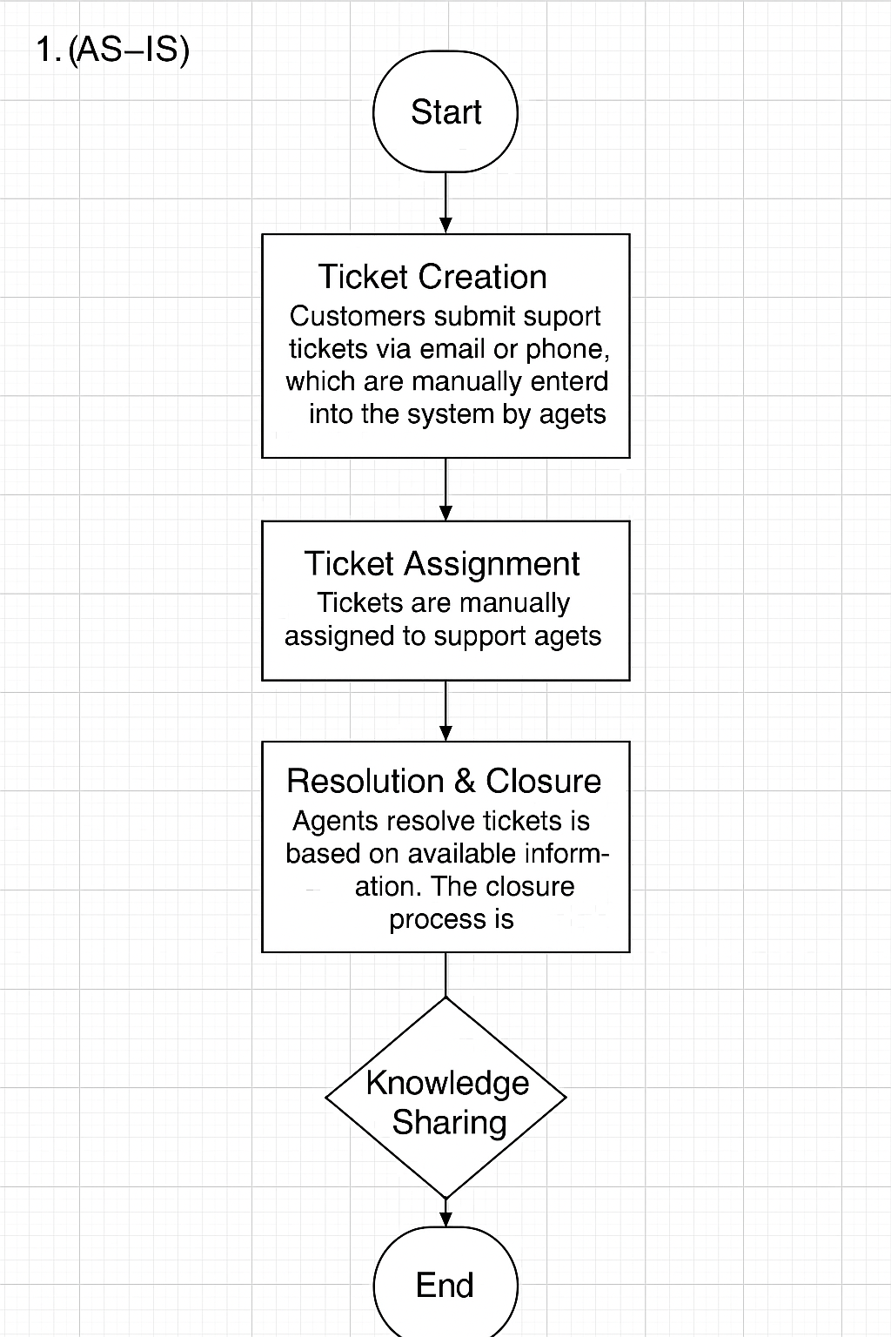

(TO-BE)

The proposed ticketing system aims to address the inefficiencies of the legacy system by automating and streamlining key processes. The following changes will improve the overall ticketing process:
Ticket Creation: The new system will allow customers to create tickets through multiple channels (email, web portal, chat, etc.). The system will automatically capture key details such as issue type, urgency, and customer information, eliminating manual data entry and reducing errors.
Ticket Assignment: The system will automatically categorize and prioritize tickets based on predefined rules (e.g., urgency, issue type). Tickets will be assigned to the most appropriate agent based on their expertise and availability, ensuring a more efficient workload distribution.
Resolution & Closure: The system will integrate a knowledge base, allowing agents to quickly access solutions for common issues. Automated workflows will guide agents through the ticket resolution process, ensuring consistency and reducing resolution time. Tickets will be automatically closed once all resolution steps are completed, and customers are satisfied
Knowledge Sharing: A centralized knowledge base will be integrated into the system, allowing agents to search for and contribute solutions to recurring issues. This will help reduce resolution times, improve consistency, and enable new agents to ramp up more quickly.

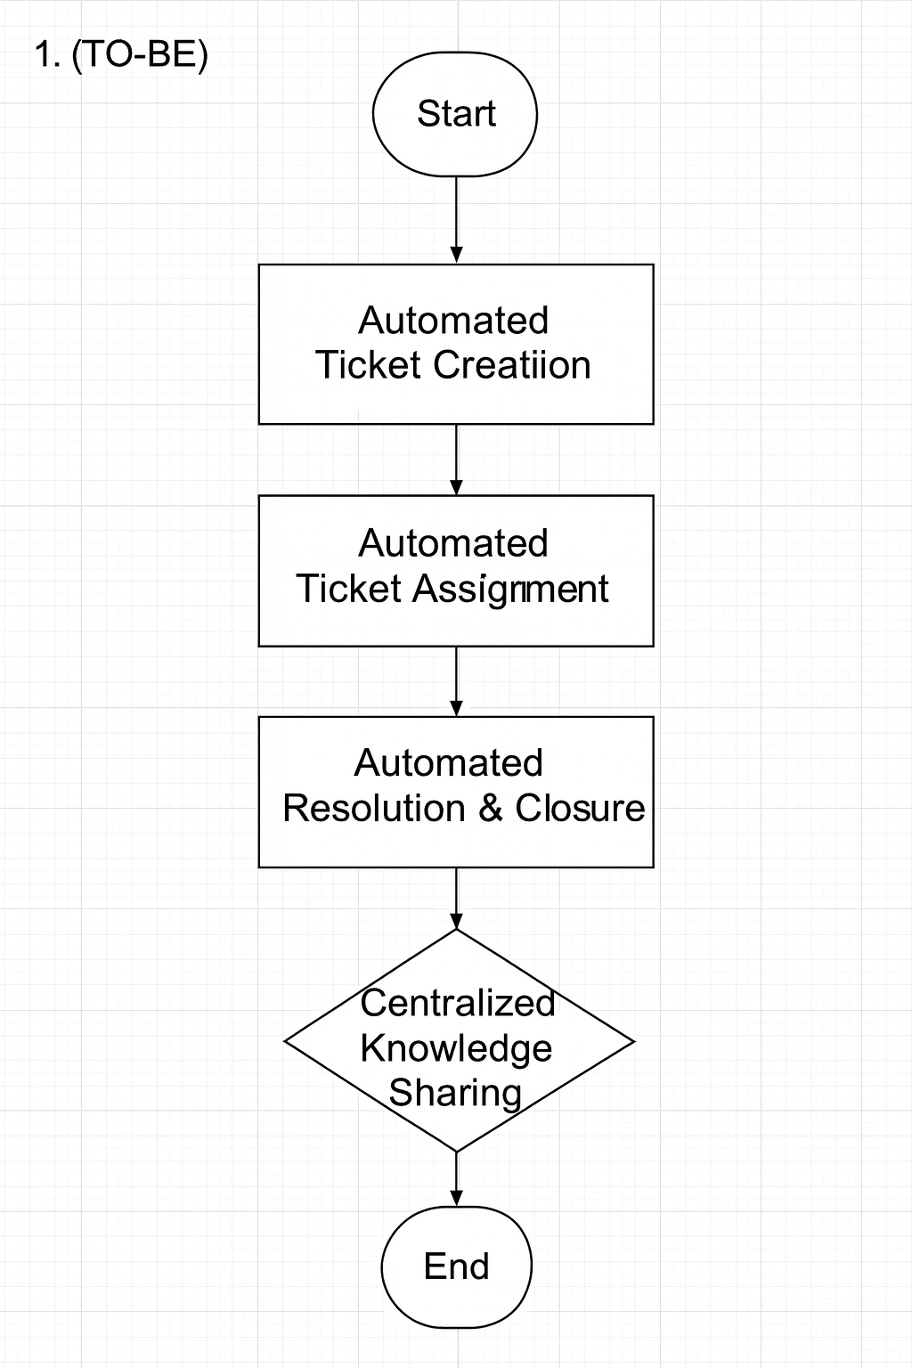

9. Business Requirements

The system must allow customers to submit tickets through multiple channels, including email, web portal, and chat, ensuring seamless ticket creation across various platforms.
The system must automatically categorize and prioritize tickets based on predefined criteria such as issue type, urgency, and customer profile.
The system must track and monitor ticket SLAs automatically, providing real-time alerts and escalation notifications for tickets approaching or breaching their SLA deadlines.
The system must automatically assign tickets to the most appropriate agent based on factors such as expertise, workload, and availability.
The system must integrate a centralized knowledge base that allows agents to access solutions for recurring issues. The knowledge base must be easily searchable and allow agents to contribute new solutions.
The system must provide an automated workflow for ticket resolution that guides agents through the necessary steps, ensuring consistency in the resolution process.

The system must maintain a complete history of all interactions related to each ticket, including agent notes, customer updates, and actions taken.

The system must include customizable reporting features and real-time dashboards to track KPIs such as ticket volume, resolution time, SLA compliance, and agent performance.
The system must have configurable user roles and permissions to restrict access to sensitive data and ensure that agents and managers can only view or edit information relevant to their roles.
The system must provide mobile access for support agents, allowing them to view and manage tickets from anywhere

The system must include an automated ticket escalation process that triggers based on predefined conditions (eg, unresolved ticket for a certain period or SLA breach).

The system must allow customers to provide feedback on ticket resolution and agent performance, and this data must be captured and analysed for continuous improvement.
The system must comply with relevant data privacy regulations (e.g., GDPR) and ensure secure handling of sensitive customer data.

SRS

1 Purpose:

The purpose of the Ticketing Life Cycle System is to streamline the process of issue reporting, tracking, and resolution within an organization. It provides users with a platform to create tickets for their concerns or inquiries, assigns these tickets to appropriate agents, and ensures timely updates on their progress. The system fosters effective communication between users and support teams, enhancing customer satisfaction while improving the efficiency of ticket management processes.

2 Scope:

The Ticketing Life Cycle System is designed to cater to organizations of varying sizes, supporting multiple roles such as users, agents, and administrators. Key functionalities include:
Ticket Creation and Management: Users can report issues, which are categorized and prioritized for resolution.
Agent Assignment and Resolution: Tickets are assigned to agents based on predefined rules and availability.
Role-Based Dashboards: Users, agents, and administrators have tailored views to manage their specific tasks efficiently.
Tracking and Notifications: The system keeps stakeholders informed through real-time updates and alerts.

SRS Scope Table – Ticketing System

The table below outlines the scope of the Ticketing System by mapping key modules to their core functionalities.

Module | Functionality Covered
User Management | User registration, login, role-based access control, profile management
Ticket Management | Ticket creation, assignment, status updates, priority handling, ticket escalation
Agent Dashboard | View assigned tickets, update status, add comments, access knowledge base
Admin Dashboard | Manage tickets, assign roles, monitor agent performance, generate reports
Notifications | Email/SMS alerts for ticket updates, escalation, resolution
SLA Monitoring | Track compliance with predefined SLA timelines and escalate when breached
Knowledge Base | Centralized access for common issue resolutions; agents can search and contribute
Reports & Analytics | Generate real-time reports on ticket volume, SLA, resolution time, agent performance
Mobile Access | Responsive UI to allow agents and users to manage tickets on mobile devices
Security & Compliance | Role-based access, data encryption, GDPR compliance, audit logs
Integration | Compatible with email systems, SMS gateways, and future support for Slack/MS Teams

Analytics and Reporting:

Administrators can analyse trends, monitor performance, and generate reports to optimize operations.
The system supports scalability, security, and compliance with industry standards, making it equitable for technical support, customer service, and other business functions requiring issue resolution.

3 Overview:

The Ticketing Life Cycle System is a web-based application offering a user-friendly interface accessible across devices. It incorporates modules for:
User Management: Facilitates user registration, login, and profile management.
Ticket Management: Covers the full ticketing workflow, including creation, assignment, status updates, and resolution.
Agent Management Allows administrators to assign roles, monitor workloads, and evaluate agent performance.
Notification System: Ensures users and agents receive timely updates about ticket status and escalation.
Integration and Extensibility: The system supports integration with third-party tools like Slack or Microsoft Teams and offers APIs for additional customization.
5. Software Interfaces

Operating Systems:
The system shall be compatible with Windows, macros, and Linux for on-premises deployments and accessible on any OS via a browser for cloud-based deployments.
Web Browsers:
Supports modern web browsers like Google Chrome, Mozilla Firefox, Microsoft Edge and Safari (latest versions).
Notification Services
Integrates with email systems (e.g., SMTPft and SMS gateways (e.g., Twilloft for sending ticket status notifications.
6.Hardware Interfaces
User devise
Users and agents require devices like desktops, laptops, tablets, or smartphones with internet connectivity to access the system.
Network Infrastructure:
Requires a reliable internet connection with a minimum bandwidth of 10 Mbps for smooth access and operation.

Functional Requirement:

Req ID | Requirement Name | Requirement Description | priority
FR-001 | User Registration | The system shall allow users to register by providing their name, email, and password. | High
FR-002 | User Login | The system shall allow registered users to log in using their email and password. | High
FR-003 | Ticket Creation | Users shall be able to create new tickets by entering a title, description, category, and priority | High
FR-004 | Ticket Assignment | The system shall automatically assign a ticket to an available agent based on the category. | High
FR-005 | Ticket Status update | Agents shall update the status of tickets to Open, In Progress, or Closed. | High
FR-006 | Ticket Priority | The system shall allow users or agents to update the ticket's priority. | Medium
FR-007 | View Ticket details | Users and agents shall be able to view all ticket details, including status, category, and assigned agent. | High
FR-008 | User Dashboard | Users shall have a dashboard displaying their open and closed ticket | Medium
FR-009 | Agent Dashboard | user and Agents shall be able to search for tickets using keywords filters like status and priority | Medium
FR-010 | Add ticket comments | Agents shall add comments to tickets for better collaboration | Medium
FR-011 | Email notification | The system shall send email notifications for ticket updates, such as status changes or new comments. | Medium
FR-012 | Auto- assign ticket to agent | The system shall use predefined rules to assign tickets automatically to agents based on their availability and category. | High
FR-013 | Ticket escalation | tickets not resolved within a specific timeframe shall be automatically escalated to a higher authority. | Medium
FR-014 | Role based access control | The system shall provide role-based access control, restricting features for users, agents, and admins. | Medium
FR-015 | view ticket history | context or support. Users and agents shall attach files to tickets for additional | High
FR-016 | add attachments to tickets | Users and agents shall view the history of changes made to a ticket, including status and priority updates. | Medium
FR-017 | Mobile friendly interface | The system shall provide a mobile-friendly interface for creating and managing tickets, | Medium
FR-018 | priority based alerts | The system shall notify agents about high-priority tickets through pop-up alerts or email. | Medium
FR-019 | Auto status transition | The system shall automatically transition a ticket's status to "In Progress" when an agent starts working on it. | Medium
FR-020 | Report generation | Admins shall generate reports on ticket trends, resolution times and categories wise breakdowns | Medium
FR-O21 | Feedback collection | Users shall provide feedback on ticket resolution | Medium

non-functional requirement

REQ ID | Requirement name | Requirement description
NFR-001 | System Availability | The system shall maintain an uptime of 99.9 % to ensure uninterrupted access to users and agents
NFR-002 | performance | The system shall handle up to 1,000 concurrent users without degradation in performance.
NFR-003 | Stability | The system shall scale horizontally to accommodate up to 10,000 users and 50,000 tickets per month.
NFR-004 | Security | The system shall comply with industry security standards, such as OWASP guidelines, to prevent unauthorized access.
NFR-005 | Data Encryption | All sensitive data, including passwords and ticket information, shall be encrypted at rest and in transit.
NFR-006 | Response time | The system shall provide responses to user actions, such as ticket creation, within 2 seconds under normal load.
NFR-007 | Browser computability | The system shall support all major browsers, including Chrome, Firefox, Safari, and Edge.
NFR-008 | Mobile capability | The system shall provide a responsive design for seamless operation on mobile devices.
NFR-009 | Accessibility compliance | The system shall adhere to WCAG 2.1 Level AA standards to ensure accessibility for users with disabilities.
NFR-010 | Maintainability | The system shall allow developers to update or extend features with minimal impact on existing functionality
NFR-011 | Backup and recovery | The system shall perform daily backups and provide data recovery within 2 hours in case of failure.
NFR-O12 | Logging and monitoring | The system shall log all critical events and provide real-time monitoring for troubleshooting and performance analysis.
NFR-013 | Usability | The system shall provide an intuitive user interface, requiring no more than 30 minutes of training for basic operations.
NFR-014 | Localization | The system shall support localization for at least 5 languages, including English, Spanish, French, German, and Chinese.
NFR-015 | Data Retention | Closed tickets and related data shall be retained for a minimum of 5 years
NFR-O16 | Integration | The system shall integrate with third-party tools such as Slack, Microsoft Teams, and email systems.
NFR-017 | Fault Tolerance | The system shall automatically recover from a single point of failure within 30 seconds.
NFR-018 | Auditability | All user and system actions shall be auditable for compliance and troubleshooting purposes.
NFR-019 | Cost efficiency | The system shall operate within an annual maintenance budget of $50,000.
NFR-020 | API Response Time | The system's APIs shall respond to requests within 500 milliseconds under normal load.

USER STORYS:

User Story 1
Task: Allow users to browse products by category
Priority: High
As a customer
I want to browse products by category
so that I can quickly find items of interest.
BV: 1000
CP: 89
Acceptance Criteria:
• Categories are displayed on the homepage and the product listing page.
• Users can filter products within a selected category.
User Story 2
Task: Enable a product search bar on the homepage.
Priority: High
As a customer
I want to search for products using a search bar
so that I can find specific items quickly.
BV: 500
CP: 89
Acceptance Criteria:
• The search bar is visible and functional on the homepage.
• Search results are displayed within 2 seconds after submission.
User Story 3
Task: Provide product sorting options (e.g. price, popularity).
Priority: High
As a customer
I want to sort products based on price or popularity
so that I can make an informed choice.
BV: 500
CP: 89
Acceptance Criteria:
• Sorting options are available on product listing pages.
• Products are sorted correctly based on the selected criteria.
User Story 4
Task: Implement a user-friendly product details page.
Priority: High
As a customer
I want to see detailed information about a product
so that I can decide whether to buy it.
BV: 100
CP: 89
Acceptance Criteria:
• The product page includes images, price, description, and reviews.
• "Add to Cart" and "Buy Now" buttons are visible and functional.
User Story 5
Task: Add a feature for customers to leave reviews and ratings.
Priority: Medium
As a customer
I want to leave a review for a product
so that I can share my feedback with other users.
BV: 50
CP: 34
Acceptance Criteria:
• Customers can submit reviews and ratings after purchasing a product.
• Reviews are displayed on the product details page.
User Story 6
Task: Enable customers to add items to a shopping cart.
Priority: High
As a customer
I want to add products to my shopping cart
so that I can purchase multiple items at once.
BV: 500
CP: 89
Acceptance Criteria:
• Items are added to the cart with correct quantity and pricing.
• Users can view, update, or remove items from the cart.
User Story 7
Task: Create a secure user authentication system.
Priority: High
As a customer
I want to log in securely
so that my personal information is protected.
BV: 500
CP: 89
Acceptance Criteria:
• Users can sign up, log in, and reset passwords securely.
• Passwords are encrypted, and two-factor authentication is available.
User Story 8
Task: Develop a wish list feature for saving favorite products.
Priority: Medium
As a customer
I want to save items to a wish list
so that I can purchase them later.
BV: 50
CP: 21
Acceptance Criteria:
• Users can add, view, and remove items from the wish list.
• Wish list items persist even after logout.
User Story 9
Task: Implement a secure checkout process.
Priority: High
As a customer
I want a secure and easy checkout process
so that I can complete my purchase confidently.
BV: 1000
CP: 89
Acceptance Criteria:
• Users can enter billing and shipping details securely.
• Payment is processed securely using industry standards.
User Story 10
Task: Offer multiple payment methods (credit card, PayPal, etc.).
Priority: High
As a customer
I want to choose my preferred payment method
so that I can complete my purchase conveniently.
BV: 1000
CP: 55
Acceptance Criteria:
• Payment gateway supports credit card, PayPal, and digital wallets.
• Transactions are processed within 5 seconds.

User Story 11
Task: Provide a product comparison feature.
Priority: Medium
As a customer
I want to compare products side-by-side
so that I can choose the best option.
BV: 50
CP: 34
Acceptance Criteria:
- Users can select up to three products to compare.
- Key attributes are displayed for easy comparison.
User Story 12
Task: Enable guest checkout without account creation.
Priority: High
As a customer
I want to check out as a guest
so that I can make a quick purchase without creating an account.
BV: 500
CP: 89
Acceptance Criteria:
- Users can complete the checkout process without signing in.
- Guest users can track orders using email and order ID.
User Story 13
Task: Develop an order tracking feature.
Priority: High
As a customer
I want to track my orders
so that I can know when they will arrive.
BV: 1000
CP: 89
Acceptance Criteria:
- Users can view the status of their orders in real-time.
- Notifications are sent for key updates (e.g., shipped, out for delivery).
User Story 14
Task: Display related products on product pages.
Priority: Medium
As a customer
I want to see related products
so that I can discover complementary items.
BV: 50
CP: 21
Acceptance Criteria:
- Related products are displayed dynamically based on user behaviour.
- Clicking on a related product redirects to its details page.
User Story 15
Task: Add an email and SMS notification system for orders.
Priority: Medium
As a customer
I want to receive notifications about my order status
so that I stay informed.
BV: 50
CP: 21
Acceptance Criteria:
- Notifications are sent for order confirmation, shipping, and delivery.
- Users can opt-in or opt-out of notifications.
User Story 16
Task: Implement advanced search with filters (e.g., price range, brand).
Priority: Medium
As a customer
I want to filter my search results
so that I can refine my product search efficiently.
BV: 50
CP: 55
Acceptance Criteria:
- Filters for price range, brand, and ratings are available.
- Results update dynamically based on selected filters.
User Story 17
Task: Allow users to view their order history.
Priority: Medium
As a customer
I want to view my past orders
so that I can reorder items easily.
BV: 10
CP: 21
Acceptance Criteria:
- Users can view a list of their completed orders.
- Clicking on an order shows detailed information, including items and total cost.
User Story 18
Task: Develop a loyalty rewards program.
Priority: Medium
As a customer
I want to earn rewards for my purchases
so that I feel valued.
BV: 50
CP: 34
Acceptance Criteria:
- Users earn points for each purchase.
- Points can be redeemed for discounts during checkout.
User Story 19
Task: Support multi-language functionality.
Priority: Low
As a global customer
I want to view the site in my preferred language
so that I can shop comfortably.
BV: 10
CP: 13
Acceptance Criteria:
- Users can select their preferred language from a dropdown menu.
- All text content updates dynamically based on the selected language.
User Story 20
Task: Implement a discount and promo code feature.
Priority: High
As a customer
I want to apply promo codes during checkout
so that I can save money.
BV: 1000
CP: 100
Acceptance Criteria:
- Users can enter promo codes at checkout.
- Discounts are applied correctly, and the updated total is displayed.
User Story 21
Task: Add a "frequently bought together" section on product pages.
Priority: Medium
As a customer
I want to see related items frequently purchased with the product
so that I can bundle my purchase.
BV: 100
CP: 21
Acceptance Criteria:
- Frequently bought together items are displayed dynamically on the product page.
- Users can add all items to the cart with one click.
User Story 22
Task: Allow customers to schedule delivery times.
Priority: Medium
As a customer
I want to schedule a delivery time
so that I can receive my order at a convenient time.
BV: 50
CP: 34
Acceptance Criteria:
- Users can select preferred delivery dates and time slots during checkout.
- Delivery preferences are confirmed in the order summary.
User Story 23
Task: Enable product availability notifications.
Priority: Medium
As a customer
I want to receive notifications when a product is back in stock
so that I don’t miss out.
BV: 50
CP: 13
Acceptance Criteria:
- Users can subscribe to back-in-stock alerts.
- Notifications are sent via email or SMS when the product becomes available.
User Story 24
Task: Create a user profile page with editable details.
Priority: Medium
As a customer
I want to update my personal information
so that my profile is accurate.
BV: 100
CP: 55
Acceptance Criteria:
- Users can update their name, address, and contact details.
- Changes are saved and reflected immediately.
User Story 25
Task: Add a feature for users to track shipping costs.
Priority: Medium
As a customer
I want to see the shipping cost before completing my purchase
so that I know the total expense.
BV: 50
CP: 21
Acceptance Criteria:
- Shipping costs are calculated dynamically based on the delivery location.
- The total cost, including shipping, is displayed in the cart.
User Story 26
Task: Provide support for multiple currencies.
Priority: Medium
As an international customer
I want to see prices in my local currency
so that I can understand costs better.
BV: 50
CP: 13
Acceptance Criteria:
- Users can select their preferred currency from a dropdown menu.
- Prices and totals update dynamically based on the selected currency.
User Story 27
Task: Add social media sharing for products.
Priority: Low
As a customer
I want to share products on social media
so that I can recommend them to others.
BV: 10
CP: 34
Acceptance Criteria:
- Product pages have social media sharing buttons (e.g., Facebook, Twitter, Instagram).
- Clicking a button opens a pre-filled post with the product link.
User Story 28
Task: Develop a referral program for customers.
Priority: Medium
As a customer
I want to refer my friends and earn rewards
so that I feel incentivized to promote the site.
BV: 50
CP: 21
Acceptance Criteria:
- Users receive unique referral codes.
- Referrals result in discounts or rewards for both parties.
User Story 29
Task: Introduce AI-based personalized product recommendations.
Priority: Medium
As a customer
I want personalized recommendations
so that I can discover products I like.
BV: 50
CP: 21
Acceptance Criteria:
- Recommendations are displayed based on browsing and purchase history.
- Recommendations refresh dynamically as users interact with the site.
User Story 30
Task: Add a blog or resource section for product guides and tips.
Priority: Low
As a customer
I want to read product-related guides
so that I can make informed decisions.
BV: 10
CP: 5
Acceptance Criteria:
- Blogs are categorized and accessible from the homepage.
- Users can search for specific topics within the blog section.
User Story 31
Task: Enable bulk ordering for businesses or large customers.
Priority: Medium
As a bulk buyer
I want to order large quantities of items easily
so that I can manage my purchases efficiently.
BV: 50
CP: 34
Acceptance Criteria:
- Users can specify bulk quantities for products.
- Discounts for bulk orders are applied automatically at checkout.
User Story 32
Task: Add a real-time chat support feature.
Priority: Medium
As a customer
I want instant help through live chat
so that I can resolve my queries quickly.
BV: 100
CP: 55
Acceptance Criteria:
- Live chat is accessible from the footer or help section.
- Responses are sent within 30 seconds of initiating the chat.
User Story 33
Task: Implement a "recently viewed products" section.
Priority: Medium
As a customer
I want to revisit products I recently viewed
so that I can make decisions more easily.
BV: 50
CP: 21
Acceptance Criteria:
- Recently viewed products are displayed dynamically on the homepage or product listing page.
- Items persist for the session or up to 24 hours.
User Story 34
Task: Add a filter for eco-friendly or sustainable products.
Priority: Low
As a customer
I want to filter for eco-friendly products
so that I can make environmentally conscious purchases.
BV: 10
CP: 2
Acceptance Criteria:
- An "eco-friendly" filter is available in product search.
- Only products tagged as sustainable appear when the filter is applied.
User Story 35
Task: Create an admin panel for managing inventory.
Priority: High
As an admin
I want to manage product inventory efficiently
so that stock levels are accurate.
BV: 1000
CP: 100
Acceptance Criteria:
- Admins can view, add, update, or remove products.
- Low-stock alerts are generated automatically.
User Story 36
Task: Provide an option for gift wrapping and personalized messages.
Priority: Low
As a customer
I want to add gift-wrapping and a message to my order
so that I can send personalized gifts.
BV: 10
CP: 1
Acceptance Criteria:
- Users can select gift wrapping during checkout.
- Users can enter a personalized message up to 250 characters.
User Story 37
Task: Add subscription-based purchasing for certain products.
Priority: Medium
As a customer
I want to subscribe to recurring purchases
so that I don’t have to reorder frequently used items manually.
BV: 50
CP: 34
Acceptance Criteria:
- Users can select subscription options (e.g., weekly, monthly).
- Subscriptions can be paused, modified, or cancelled at any time.
User Story 38
Task: Integrate product recommendations based on geographic location.
Priority: Low
As a customer
I want location-specific product recommendations
so that I can discover items relevant to my area.
BV: 10
CP: 5
Acceptance Criteria:
- Recommendations are tailored based on the user’s location.
- Location data is obtained with consent and is updateable.
User Story 39
Task: Develop a feature to calculate estimated delivery times.
Priority: Medium
As a customer
I want to see an estimated delivery date
so that I can plan accordingly.
BV: 50
CP: 21
Acceptance Criteria:
- Delivery dates are displayed based on the shipping method and location.
- Estimates are updated dynamically for different delivery options.
User Story 40
Task: Include accessibility features for differently abled users.
Priority: High
As a customer with accessibility needs
I want to use an inclusive interface
so that I can shop comfortably.
BV: 1000
CP: 89
Acceptance Criteria:
- Features include screen reader support, high-contrast mode, and keyboard navigation.

Glossary – Ticketing System
SRS: Software Requirements Specification – detailed technical documentation for system behavior.
AS-IS: The current state of the system before improvements.
TO-BE: The future state of the system after proposed changes are implemented.
SLA: Service Level Agreement – commitment defining response/resolution times.
BV: Business Value – importance of a feature to stakeholders or customers.
CP: Complexity Point – effort estimation based on Fibonacci scale.
ERD: Entity Relationship Diagram – shows entities and their relationships.
RACI: Responsible, Accountable, Consulted, Informed – clarifies roles in a project.
UI: User Interface – the part of the system the user interacts with.
API: Application Programming Interface – allows integration with other systems.
Ticket: A record of a reported issue or support request.
Escalation: Raising unresolved tickets to higher authority based on SLA or criticality.
Knowledge Base: A repository of solutions for common issues accessible by support agents.
UAT: User Acceptance Testing – final phase where end-users validate the system before release.

ERD DAIGRAM:

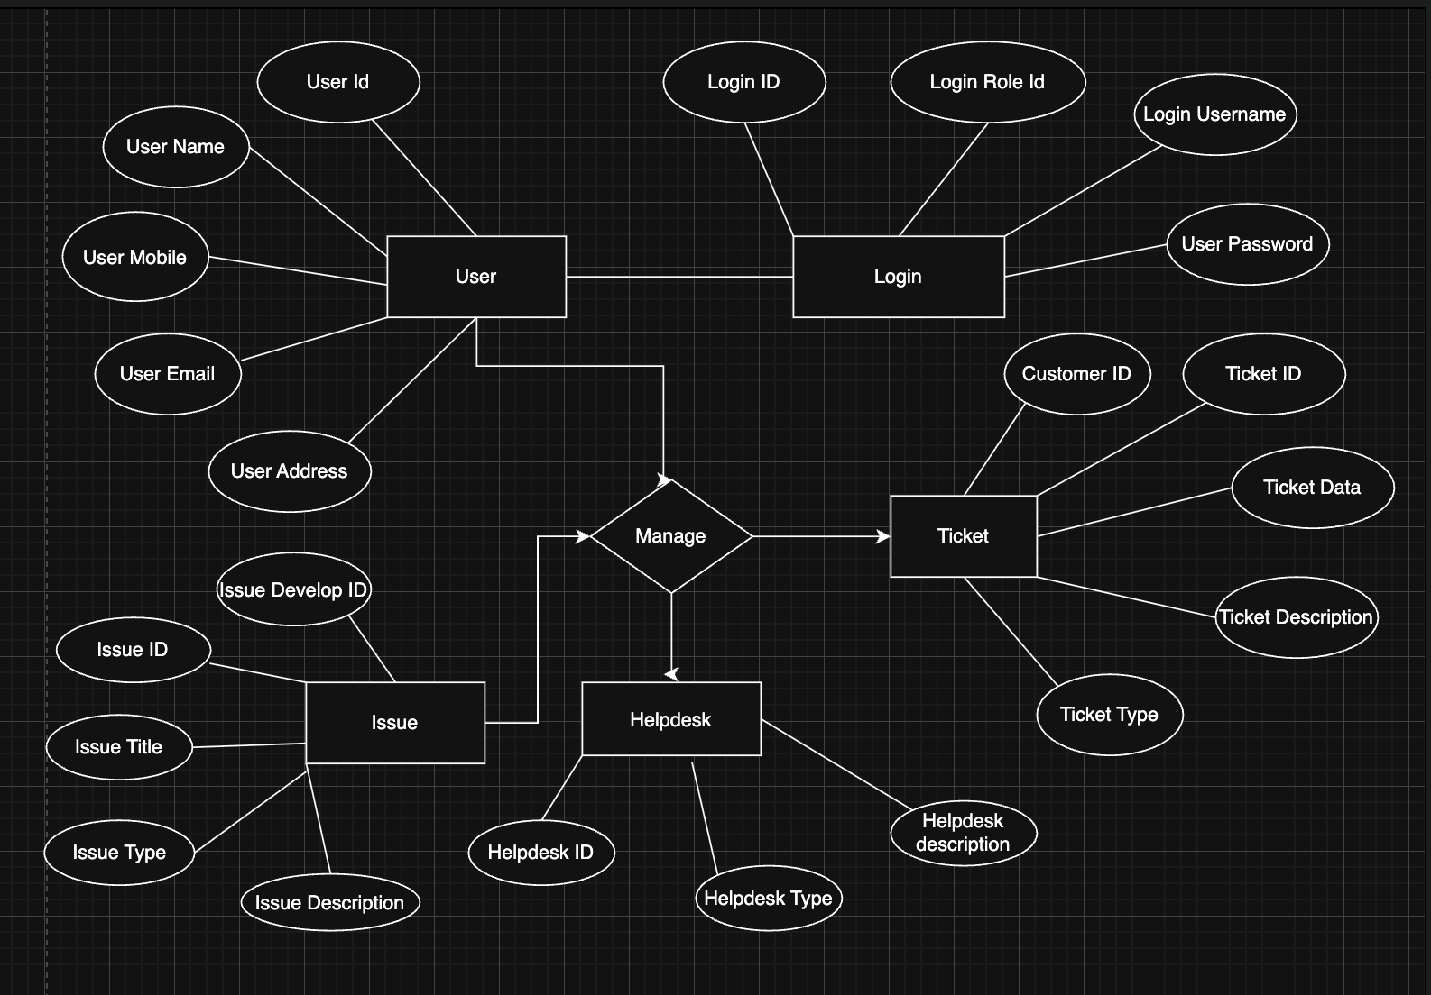

User Story – Shopping from Ecommerce

User Story 1:
Task: Enable product search functionality
Priority: High
As a customer, I want to search for products using keywords so that I can quickly find what I need.
BV: 950
CP: 21
Acceptance Criteria:
• Search bar displays relevant results within 2 seconds.
• Partial matches and filters are supported.

User Story 2:
Task: Allow users to filter products
Priority: High
As a customer, I want to filter products by category, price, and rating so that I can narrow down choices.
BV: 900
CP: 21
Acceptance Criteria:
• Filtering options are dynamic and applicable across categories.

User Story 3:
Task: Implement user registration
Priority: Medium
As a new user, I want to create an account so that I can make purchases and track orders.
BV: 700
CP: 13
Acceptance Criteria:
• Account creation form validates inputs and confirms email.

User Story 4:
Task: Enable guest checkout
Priority: Medium
As a customer, I want to checkout without creating an account so that I can buy quickly.
BV: 650
CP: 13
Acceptance Criteria:
• Guest users can provide shipping and payment info without registration.

User Story 5:
Task: Add product to wishlist
Priority: Low
As a customer, I want to save products to a wishlist so that I can purchase them later.
BV: 500
CP: 5
Acceptance Criteria:
• Wishlist saves across sessions and shows quantity available.

User Story 6:
Task: View order history
Priority: Medium
As a returning user, I want to view my previous orders so that I can reorder easily.
BV: 700
CP: 13
Acceptance Criteria:
• Order history includes order number, items, and total amount.

User Story 7:
Task: Rate and review a product
Priority: Medium
As a customer, I want to leave a review so that I can share my experience with others.
BV: 550
CP: 13
Acceptance Criteria:
• Review appears after moderation.
• One review per order.

User Story 8:
Task: Track order status
Priority: High
As a customer, I want to track my shipment so that I know when to expect delivery.
BV: 850
CP: 13
Acceptance Criteria:
• Order status updates in real-time and includes tracking link.

User Story 9:
Task: Add multiple addresses
Priority: Medium
As a user, I want to save different shipping addresses so that I can choose while checking out.
BV: 600
CP: 8
Acceptance Criteria:
• User can add/edit/delete addresses from their profile.

User Story 10:
Task: Receive promotional emails
Priority: Low
As a user, I want to receive discount alerts so that I can save on purchases.
BV: 350
CP: 3
Acceptance Criteria:
• Emails are sent only if user opts in and are personalized.

User Story 11:
Task: Integrate secure payment gateway
Priority: High
As a customer, I want to pay securely online so that my information is protected.
BV: 950
CP: 34
Acceptance Criteria:
• Payments go through certified gateway with encryption.

User Story 12:
Task: Apply coupon codes at checkout
Priority: Medium
As a customer, I want to apply discount codes so that I can save money.
BV: 700
CP: 8
Acceptance Criteria:
• Coupon codes validate and apply discounts instantly.

User Story 13:
Task: Enable cart auto-save
Priority: Medium
As a customer, I want my cart to be saved automatically so that I don’t lose selected items.
BV: 650
CP: 13
Acceptance Criteria:
• Cart persists across sessions for logged-in users.

User Story 14:
Task: Offer multiple payment options
Priority: High
As a customer, I want to choose between cards, wallets, and UPI so that I can pay easily.
BV: 850
CP: 13
Acceptance Criteria:
• All options are functional, secure, and user-selectable.

User Story 15:
Task: Show related product recommendations
Priority: Medium
As a shopper, I want to see similar items so that I can discover more products.
BV: 600
CP: 13
Acceptance Criteria:
• Recommendations are based on category and user behavior.

User Story 16:
Task: Enable live chat support
Priority: High
As a customer, I want instant help during shopping so that I can resolve issues quickly.
BV: 750
CP: 34
Acceptance Criteria:
• Live chat connects to support within 30 seconds.

User Story 17:
Task: Display stock availability
Priority: High
As a customer, I want to know if an item is in stock so that I don’t waste time ordering unavailable products.
BV: 900
CP: 8
Acceptance Criteria:
• Stock status updates in real-time on product pages.

User Story 18:
Task: Allow product comparison
Priority: Medium
As a shopper, I want to compare features of products so that I can choose the best one.
BV: 600
CP: 13
Acceptance Criteria:
• Comparison supports at least 3 products side-by-side.

User Story 19:
Task: Save preferred payment method
Priority: Medium
As a user, I want to save my card or wallet so that I can checkout faster next time.
BV: 650
CP: 13
Acceptance Criteria:
• Saved details are encrypted and can be managed by user.

User Story 20:
Task: Auto-apply best coupon
Priority: Medium
As a customer, I want the system to apply the best coupon so that I get maximum savings.
BV: 700
CP: 13
Acceptance Criteria:
• System checks active coupons and applies highest-value discount.

User Story 21:
Task: Notify users when an out-of-stock product is back in stock
Priority: Medium
As a customer, I want to be notified when a product is back in stock so that I don’t miss the chance to buy it.
BV: 600
CP: 13
Acceptance Criteria:
• “Notify Me” button is shown for out-of-stock items.
• Email or SMS is triggered once the product is restocked.

User Story 22:
Task: Provide real-time order updates via SMS and email
Priority: High
As a customer, I want to receive order updates via SMS and email so that I stay informed.
BV: 850
CP: 13
Acceptance Criteria:
• Notifications are sent on order confirmation, dispatch, and delivery.

User Story 23:
Task: Integrate wishlist sharing feature
Priority: Medium
As a user, I want to share my wishlist with friends so that they know what I want.
BV: 500
CP: 13
Acceptance Criteria:
• Shareable wishlist link is generated.
• Only selected wishlists can be shared.

User Story 24:
Task: Create referral system for users
Priority: High
As a customer, I want to refer friends and earn rewards so that I benefit from sharing the platform.
BV: 800
CP: 21
Acceptance Criteria:
• Unique referral codes are generated per user.
• Referral rewards are applied on successful purchases.

User Story 25:
Task: Add product bundling feature (e.g., Buy 1 Get 1)
Priority: Medium
As a customer, I want to see bundled product offers so that I get better deals.
BV: 650
CP: 21
Acceptance Criteria:
• Bundled items are clearly displayed with pricing logic.
• Auto-adds free items to cart where applicable.

User Story 26:
Task: Enable delivery date selection during checkout
Priority: High
As a customer, I want to choose my delivery date so that it aligns with my availability.
BV: 800
CP: 21
Acceptance Criteria:
• Delivery slot selection appears during checkout.
• Slots update based on address and delivery capacity.

User Story 27:
Task: Integrate address validation (pin code & format check)
Priority: High
As a customer, I want my address validated during checkout so that delivery is successful.
BV: 750
CP: 13
Acceptance Criteria:
• Pin code is validated against serviceable areas.
• Address field supports formatting and auto complete.

User Story 28:
Task: Add estimated delivery time calculator
Priority: High
As a customer, I want to see estimated delivery dates so that I can plan accordingly.
BV: 900
CP: 21
Acceptance Criteria:
• Delivery estimate is shown based on location and shipping type.
• Updates dynamically at checkout.

User Story 29:
Task: Allow users to cancel orders before dispatch
Priority: Medium
As a customer, I want to cancel my order before dispatch so that I can change my mind.
BV: 650
CP: 13
Acceptance Criteria:
• Orders can be canceled from order history.
• Cancellation is disabled post-dispatch.

User Story 30:
Task: Add order return and refund request feature
Priority: High
As a customer, I want to request returns or refunds easily so that I feel secure buying.
BV: 900
CP: 21
Acceptance Criteria:
• Return/refund form is available in order history.
• Refund is processed based on approval.

User Story 31:
Task: Create admin dashboard for product management
Priority: High
As an admin, I want to add, edit, and remove products so that inventory stays updated.
BV: 800
CP: 34
Acceptance Criteria:
• Admin can manage product listings with image and pricing.
• Changes reflect instantly on customer-facing site.

User Story 32:
Task: Build analytics dashboard for sales tracking
Priority: Medium
As a business user, I want to see sales data so that I can make strategic decisions.
BV: 700
CP: 34
Acceptance Criteria:
• Dashboard displays total sales, most sold items, and filter options.
• Data updates daily.

User Story 33:
Task: Add language selector for multilingual site
Priority: Medium
As a customer, I want to choose my language so that I can shop comfortably.
BV: 600
CP: 13
Acceptance Criteria:
• Language selector is accessible site wide.
• Page content updates without full reload.

User Story 34:
Task: Support dark mode on the UI
Priority: Low
As a user, I want dark mode so that my eyes are comfortable during night shopping.
BV: 400
CP: 13
Acceptance Criteria:
• Toggle available in settings.
• UI switches without impacting functionality.

User Story 35:
Task: Enable save-for-later feature in the cart
Priority: Medium
As a customer, I want to move items out of my cart temporarily so that I can revisit them later.
BV: 550
CP: 8
Acceptance Criteria:
• Items can be moved to "Saved for Later" section.
• Saved items can be re-added to cart.

User Story 36:
Task: Provide EMI calculator on product page
Priority: Medium
As a customer, I want to calculate EMI for products so that I can plan payment.
BV: 650
CP: 13
Acceptance Criteria:
• EMI calculator appears on eligible product pages.
• Calculations change based on selected tenure and interest rate.

User Story 37:
Task: Allow users to upload prescriptions for medicine orders
Priority: High
As a customer, I want to upload my prescription so that I can order restricted medicines.
BV: 850
CP: 21
Acceptance Criteria:
• Upload section available for restricted items.
• Only verified prescriptions enable checkout.

User Story 38:
Task: Implement autosuggestions in the search bar
Priority: High
As a customer, I want autosuggestions while typing so that I can search faster.
BV: 850
CP: 21
Acceptance Criteria:
• Suggestions load dynamically.
• Popular search terms and recent items shown.

User Story 39:
Task: Offer gift wrapping at checkout
Priority: Low
As a customer, I want to add gift wrap so that I can send products as gifts.
BV: 400
CP: 8
Acceptance Criteria:
• Gift wrap option appears at checkout.
• Optional message and wrapping type can be selected.

User Story 40:
Task: Enable voice search for mobile app
Priority: Medium
As a user, I want to search using voice so that I can find products hands-free.
BV: 700
CP: 34
Acceptance Criteria:
• Voice icon is visible in the search bar.
• Recognizes product-related speech queries accurately.

