4 BA Mock - Case study

Srishti Gupta – 05/08/2025

A company is having manufacturing plants and warehouses in various parts of the country. They manufacture ice-cream and milk products. They want to build software to achieve two goals.
• Manage the inventory
• Quickest delivery to the customers
Assignment 1:
1. Please make a BRD which can be presented to the client along with complete development and resource plan.

1. Executive Summary
This document outlines the requirements for developing software for XYZ, a manufacturer of ice-cream and milk products with a network of manufacturing plants and warehouses across the country. The proposed system will focus on two primary objectives: effective inventory management and enabling the quickest delivery to customers. By achieving these goals, the company aims to enhance operational efficiency, minimize waste, and improve customer satisfaction.
2. Business Goals

1. Streamlined Inventory Management: Ensure real-time monitoring of inventory levels across all warehouses and plants to reduce spoilage and optimize stock levels.
2. Enhanced Delivery Efficiency: Implement a system to identify the fastest delivery routes and automate order allocation based on proximity and inventory availability.
3. Improved Customer Satisfaction: Minimize order fulfilment time and ensure product freshness at delivery.
3. Business Objectives
- Develop a centralized system to track and manage inventory across all locations.
- Automate order processing, allocation, and dispatch based on inventory and location proximity.
- Integrate delivery route optimization with real-time traffic and weather data.
- Reduce inventory wastage by implementing an expiry-date tracking mechanism.
- Enable reporting and analytics for better decision-making and demand forecasting.
4. Business Rules
1. Inventory must be updated in real-time upon receipt, dispatch, or adjustment.
2. Orders should only be fulfilled if the inventory is available and meets the required shelf- life criteria.
3. Delivery routes must prioritize freshness while minimizing transportation costs.
4. Customer priority orders (e.g., bulk orders) must be flagged for immediate action.
5. Warehouse reordering thresholds should trigger automated purchase orders.
5. Scope of the System
In-Scope:
- Inventory tracking at manufacturing plants and warehouses.
- Order management and allocation.
- . Delivery route optimization.
- Analytics and reporting dashboards.

Out-of-Scope:
- Manufacturing process management.
- Customer relationship management (CRM).
6. Assumptions
- All warehouses and plants have internet connectivity for real-time updates.
- Delivery vehicles are GPS-enabled to support route optimization.
- Data from external sources (e.g., traffic, weather) is available via APIs.
7. Constraints
- Budget limitations may restrict the scope of features.
- Integration with legacy systems may pose technical challenges.
- Project timelines must align with the company's peak season schedules.

8. Risk Analysis
Technical Risks:
- Integration issues with existing systems.
- System scalability with increasing business demand.
Political Risks:

- Resistance from employees due to new processes and technology.
- . Potential vendor lock-in with third-party tools.
Requirement Risks:
- Incomplete or evolving requirements from stakeholders.
Business Risks:
- Downtime during system rollout.
- Customer dissatisfaction due to transition delays.

9. Stakeholders
Role | Name/Position | Responsibility
Project Sponsor | [Client CEO/CTO] | Funding and vision alignment
Product Owner | [Client Operations Manager] | Day-to-day decisions and requirement sign-off
Project Manager | [Software Team PM] | Development lifecycle and delivery
Development Team | [Dev Team Lead, Backend, Frontend Developers]
  Role | Name/Position | Responsibility
  Project Sponsor | [Client CEO/CTO] | Funding and vision alignment
  Product Owner | [Client Operations Manager] | Day-to-day decisions and requirement sign-off
  Project Manager | [Software Team PM] | Development lifecycle and delivery
  Development Team | [Dev Team Lead, Backend, Frontend Developers] | Technical implementation
  QA Team | [QA Lead] | Software testing and validation
  Logistics Manager | [Client] | Input on delivery systems and validation
  Warehouse Managers | [Client] | Input on inventory features
QA Team | [QA Lead] | Software testing and validation
Logistics Manager | [Client] | Input on delivery systems and validation
Warehouse Managers | [Client] | Input on inventory features

10. Business Process Overview
AS-IS:
- Inventory is managed manually or using isolated systems.
- . Order allocation is manually determined, leading to inefficiencies.
- Delivery routes are planned based on experience, not optimized.
TO-BE:
- A centralized system enables automated inventory management.
- .Delivery routes are optimized dynamically for speed and cost.
- Orders are allocated and dispatched through an intelligent . flow diagram

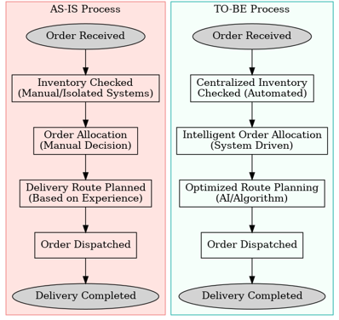

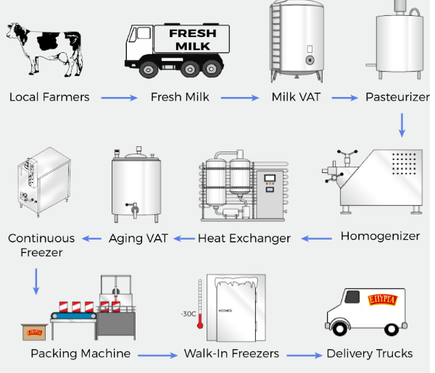

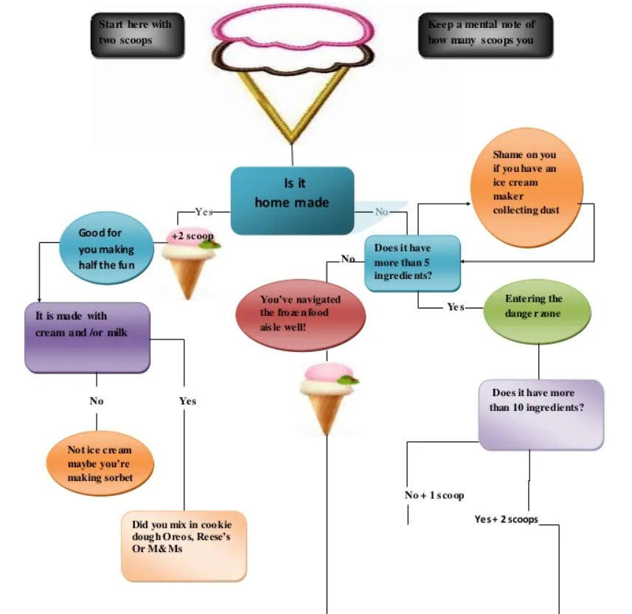
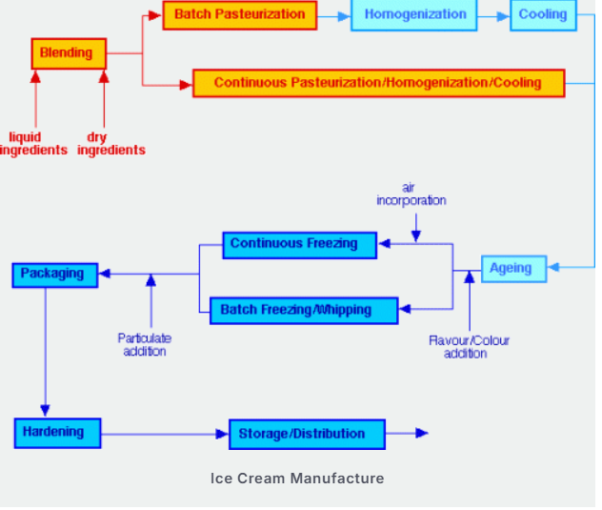
10. Business Requirements
1. Inventory Management Module:
- Real-time inventory tracking across locations.
- Expiry-date monitoring and alerts for perishable items.
2. Order Management Module:
- Automated order allocation based on location and inventory.
- Bulk order prioritization.
3. Delivery Optimization Module:
- Integration with GPS and real-time data for route planning.
- Dynamic rerouting in case of delays.
4. Reporting Module:
- Insights into inventory levels, order trends, and delivery performance.

11. Development and Resource Plan
Development Plan:
1. Phase 1: Requirement gathering, stakeholder workshops, and system design (4 weeks).
2. Phase 2: Development of core modules (Inventory, Order, Delivery) (12 wecks).
3. Phase 3: Integration with external systems (APIs, GPS) and legacy systems (6 weeks).
4. Phase 4: Testing and quality assurance (4 weeks).
5. Phase 5: Deployment, training, and support (4 weeks).

Resource Plan:
Project Manager: 1 FTE
- Developers: 3 FTE (Backend, Frontend, Integration specialists)
- QA Engineers: 2 FTE
- Business Analyst: 1 FTE
- Support Team: 2 FTE
12. Appendices
- Glossary of Terms
- Abbreviations Used

13. Related Documents
- Feasibility Study Report
- Market Analysis for Inventory and Delivery Optimization Software
- Stakeholder Requirements Document

- Prepare process flow diagram using your imagination.

Here’s a process flow diagram I’ve imagined for your ice-cream & milk products company, showing both inventory management and quickest delivery in workflow.

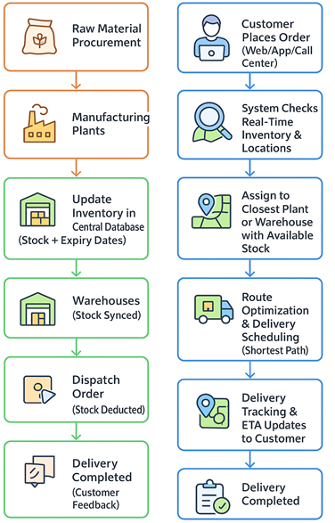

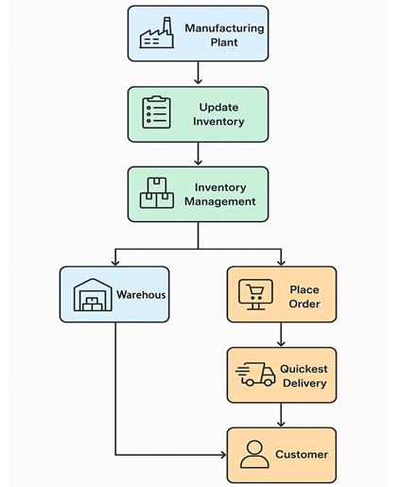
Assignment 2:

- Write an introduction letter to a client introducing yourself as a business analyst in charge of working with the client and his team to start the business understanding process.

Subject: Introduction as Your Business Analyst Partner
Dear [Client's Name],
I hope this message finds you well. My name is Srishti Gupta, and I am delighted to introduce myself as the Business Analyst assigned to collaborate with you and your team on this exciting project.
Understanding the challenges and opportunities within the manufacturing and logistics sectors, particularly in delivering exceptional customer service, is a domain I am passionate about. With your vision of managing inventory and ensuring the quickest delivery of your ice-cream and milk products, my role will be to work closely with you to transform these goals into a robust, tailor- made software solution.
To begin, I aim to thoroughly understand your current processes, challenges, and aspirations. Together, we will explore your operational workflows, identify key requirements, and map out a strategic plan that aligns with your business objectives. Your insights will be invaluable in ensuring the solution we design is practical, scalable, and optimized for your unique needs
I look forward to discussing your expectations and gathering inputs from your team during our initial meetings. In the meantime, please feel free to share any documents, current processes, or initial thoughts that could help us hit the ground running.
Thank you for the opportunity to collaborate on this project. I am confident that, together, we will develop a solution that adds significant value to your business operations. Please let me know a convenient time for us to connect further.
Looking forward to working with you.
Warm regards,
Srishti Gupta
Business Analyst
+91 74001927099

2. Prepare a brief BRD and SRS for a project- Horoscope or Ticketing system or online store.

Business Requirements Document (BRD)
Project Name: Ticketing System
Prepared By: Srishti Gupta
Date: 06 December 2024

Executive Summary

The objective of the Ticketing System project is to implement a comprehensive solution for managing customer support tickets effectively. The system will streamline the process of ticket creation, tracking, resolution, and closure. It will be designed to ensure seamless communication between users, support agents, and managers, improving the overall efficiency of customer support operations. Additionally, the system will include advanced features for monitoring service level agreement (SLA) compliance, enhancing reporting capabilities, and integrating with a knowledge base for faster problem resolution.

- Document Revision
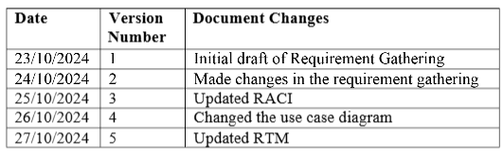
- Approval
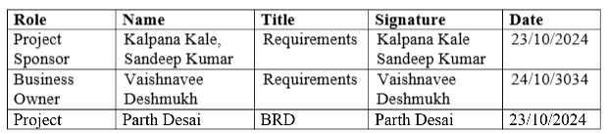

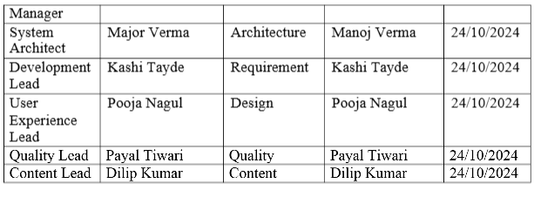

- RACI
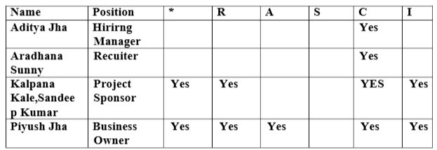

4. Introduction:

4.1 Business Goals

- Streamline Issue Resolution
Enable users to easily raise and track tickets while ensuring quick and efficient resolution by support teams.
- Enhance Transparency
Provide users and stakeholders with real-time updates on ticket status and resolution timelines.
- Improve Accountability
Introduce clear ownership of tickets through automated assignments and escalation mechanisms.
- Boost Operational Efficiency
Automate routine processes such as ticket routing and SLA monitoring to reduce manual intervention and errors.
- Enable Data-Driven Decisions
Generate actionable insights through reporting and analytics to identify patterns, improve service quality, and optimize resources.

4.2 Business Objectives
1. Enhanced Customer Satisfaction: By reducing resolution time and ensuring timely support through SLA compliance.
2. Optimized Support Team Performance: By providing tools for assigning tickets to the appropriate agents, managing workloads, and tracking performance.
3. Better Decision-Making: By offering detailed reports on ticket trends, SLA performance, and agent efficiency.
4. Cost Efficiency: By automating routine support processes, reducing human error, and speeding up the resolution process, leading to a reduction in operational costs.
4.3 Business Rules

- Tickets must be assigned to agents within 15 minutes of creation.
- Tickets cannot be closed until all required information is provided, and the issue is fully resolved.
- Support agents must adhere to the SLAs defined for each ticket type.
- A ticket must be reopened if a customer reports the issue again within 30 days of closure.
4.4 Background
- The company's current ticketing system is inefficient, causing slow response times, missed SLAs, and manual processing. To address these issues, the company will implement a new Ticketing System that automates ticket management, tracks SLAs, integrates a knowledge base, and provides detailed reporting. This system will streamline support processes, improve customer satisfaction, and ensure compliance with SLAs.
- The project aims to enhance efficiency, reduce costs, and provide better data insights for decision-making. Key stakeholders include customer support, IT, and business leadership. The project will be completed in 6 months, with phased rollout and ongoing support.

4.5Scope of the System
In-Scope:
- User portal for raising tickets.
- Admin/Support team portal for ticket management.
- Automated ticket assignment and prioritization based on predefined rules.
- SLA tracking and notification alerts for pending tickets.
- Reports and dashboards for performance analysis.

Out-of-Scope:
- Integration with third-party tools (to be planned in future phases).
- Hardware procurement and setup.

5. Assumptions
- All users will have access to a computer or mobile device with an internet connection.
- Support teams will adhere to SLA policies as defined by the organization.

6. Constraints:
- The system must be developed and implemented within a 6-month timeline.
- The system should be scalable to handle up to 10,000 tickets per day without
- performance degradation.
- It must comply with applicable data privacy regulations (e.g., GDPR).

7. Risk
1. Technical Risk:
Risk: Integration and compatibility issues with existing systems (CRM, email, chat, etc.) could lead to delays or functionality problems, causing disruptions in the ticket management process.
Mitigation: Conduct detailed technical assessments and integration testing to ensure compatibility with current systems. Allocate time for troubleshooting and ensure robust APIs for seamless data exchange.
2. Political Risk:
Risk: Internal organizational changes, such as shifts in key personnel or management priorities, could affect the project's support or direction, causing delays or shifting project goals.
Mitigation: Maintain regular communication with key stakeholders and senior leadership to ensure alignment. Create clear documentation to keep all parties informed, regardless of organizational changes.
- Requirement Risk:
Risk: The requirements for the ticketing system might not be fully understood or documented, leading to misalignment between business needs and the delivered solution.
Mitigation: Engage stakeholders early in the project to define detailed requirements. Use iterative feedback and validation (e.g., user stories and prototypes) to refine the system according to actual needs.
4. Business Risk:
Risk: The new ticketing system might not achieve the expected improvements in customer satisfaction or operational efficiency, leading to a lack of return on investment
(ROI).
Mitigation: Set clear, measurable business objectives before the project starts (e.g., reduced response time, SLA compliance). Regularly assess the system post- implementation and adjust processes as needed based on feedback and performance
metrics
.
8. Business Process Overview

1. Legacy System (AS-IS)

The current ticketing process is largely manual, involving several disconnected systems and processes that result in inefficiencies and delays. Below are the key elements of the legacy
system:
Ticket Creation: Customers submit support tickets via email or phone, which are manually entered into the system by agents. This often leads to errors in ticket categorization and delays in assignment.
Ticket Assignment: Tickets are manually assigned to support agents based on availability or expertise. This process is time-consuming and lacks prioritization, leading to unequal workload distribution among agents.
SLA Management: SLA compliance is monitored manually through spreadsheets or ad hoc tracking, which is prone to human error. Tickets often exceed SLA timelines, leading to customer dissatisfaction.
Resolution & Closure: Agents resolve tickets based on available information, but often have limited access to knowledge resources, requiring them to solve recurring issues from scratch. The closure process is also manual and lacks consistency, leading to reopened tickets.
Reporting: Reporting is done manually through ad hoc data collection and spreadsheets, making it difficult to track key performance metrics (KPIs) like ticket resolution time, agent performance, and SLA adherence.
Knowledge Sharing: Information related to past issues and resolutions is stored across different systems, making it challenging for agents to quickly access relevant solutions.
2. Proposed Recommendations (TO-BE)

The proposed ticketing system aims to address the inefficiencies of the legacy system by automating and streamlining key processes. The following changes will improve the overall ticketing process:
- Ticket Creation: The new system will allow customers to create tickets through multiple channels (email, web portal, chat, etc.). The system will automatically capture key details such as issue type, urgency, and customer information, eliminating manual data entry and reducing errors.
- Ticket Assignment: The system will automatically categorize and prioritize tickets based on predefined rules (e.g., urgency, issue type). Tickets will be assigned to the most appropriate agent based on their expertise and availability, ensuring a more efficient workload distribution.
- SLA Management: The new system will include automated SLA tracking, with real- time alerts and escalations for tickets nearing or exceeding their resolution deadlines. This will help ensure that tickets are resolved on time and SLAs are met.
- Resolution & Closure: The system will integrate a knowledge base, allowing agents to quickly access solutions for common issues. Automated workflows will guide agents through the ticket resolution process, ensuring consistency and reducing resolution time. Tickets will be automatically closed once all resolution steps are completed, and customers are satisfied.
- Reporting: The system will include built-in reporting features, providing real-time dashboards and detailed reports on KPIs such as ticket volume, resolution time, agent performance, and SLA compliance. These reports will be customizable, enabling managers to monitor performance and identify areas for improvement.
- Knowledge Sharing: A centralized knowledge base will be integrated into the system, allowing agents to search for and contribute solutions to recurring issues. This will help reduce resolution times, improve consistency, and enable new agents to ramp up more quickly.
9. Business Requirements
Ticket Creation and Submission

The system must allow customers to submit tickets through multiple channels, including email, web portal, and chat, ensuring seamless ticket creation across various platforms.
Automated Ticket Categorization and Prioritization
Ticket Creation and Submission The system must allow customers to submit tickets through multiple channels, including email, web portal, and chat, ensuring seamless ticket creation across various platforms.
Automated Ticket Categorization and Prioritization
The system must automatically categorize and prioritize tickets based on predefined criteria such as issue type, urgency, and customer profile.
SLA Management and Alerts

The system must track and monitor ticket SLAs automatically, providing real-time alerts and escalation notifications for tickets approaching or breaching their SLA deadlines.
- Ticket Assignment and Routing
The system must automatically assign tickets to the most appropriate agent based on factors such as expertise, workload, and availability.
- Knowledge Base Integration
The system must integrate a centralized knowledge base that allows agents to access solutions for recurring issues. The knowledge base must be easily searchable and allow agents to contribute new solutions.
- Ticket Resolution Workflow
The system must provide an automated workflow for ticket resolution that guides agents through the necessary steps, ensuring consistency in the resolution process.
- Ticket History and Audit Trail
The system must maintain a complete history of all interactions related to each ticket, including agent notes, customer updates, and actions taken.
Reporting and Dashboards
- The system must include customizable reporting features and real-time dashboards to track KPIs such as ticket volume, resolution time, SLA compliance, and agent
- User Roles and Permissions
The system must have configurable user roles and permissions to restrict access to Multi-Language Support sensitive data and ensure that agents and managers can only view or edit information relevant to their roles.
- Multi-Language Support
The system must support multiple languages to cater to a diverse customer base, allowing customers and agents to interact in their preferred language.
- Mobile Access for Support Agents
The system must provide mobile access for support agents, allowing them to view and manage tickets from anywhere.
- Ticket Escalation Process
The system must include an automated ticket escalation process that triggers based on predefined conditions (e.g., unresolved ticket for a certain period or SLA breach).

- Customer Feedback and Satisfaction Tracking
The system must allow customers to provide feedback on ticket resolution and agent performance, and this data must be captured and analyzed for continuous improvement.
- Security and Data Privacy Compliance
The system must comply with relevant data privacy regulations (e.g., GDPR) and ensure secure handling of sensitive customer data.
10. Appendices
10.1 List of Acronyms
  - AI - Artificial Intelligence
  - GDPR - General Data Protection Regulation
  - UAT - User Acceptance Testing
  - D&I - Diversity and Inclusion
  - ROI - Retum on Investment
  - KPI - Key Performance Indicator
  - TAT - Turnaround Time
  - SLA - Service Level Agreement
  - API - Application Programming Interface
  - UI - User Interface
  - UX - User Experience
  - BRD - Business Requirements Document
  - RTM - Requirement Traceability Matrix
  - DPA - Data Protection Act (often used with GDPR)

1. Ticket
A record of a customer's issue, question, or request that is tracked and managed through the ticketing system. Tickets are created by customers or automatically generated by the system, and they represent an individual support case to be resolved by an agent.
2. SLA (Service Level Agreement)
A formal agreement between the company and the customer that defines the expected timeframes for responding to and resolving tickets. SLAs outline the maximum time allowed for each stage of the ticket lifecycle.
3. Knowledge Base
A centralized repository of articles, solutions, FAQs, and troubleshooting guides accessible to support agents to assist in resolving tickets more efficiently.
4. Ticket Assignment
The process of routing a support ticket to the appropriate agent or team for resolution, based on factors such as expertise, availability, and workload ..
5. Ticket Lifecycle
The various stages a ticket goes through from creation to closure. These stages typically include ticket creation, categorization, assignment, resolution, and closure.
6. Escalation
The process of transferring a ticket to a higher level of support or management when it cannot be resolved at the current level within the defined SLA or requires additional expertise.
7. Agent
A support team member responsible for handling and resolving customer tickets within the ticketing system.
8. Customer Feedback
Feedback provided by customers after the resolution of their support tickets, typically
through surveys or ratings.
9. Report/Reporting Dashboard
A tool within the ticketing system that generates visual or written reports based on key performance metrics such as ticket volume, SLA compliance, resolution times, and agent performance.

SRS
- Purpose
The purpose of the Ticketing Life Cycle System is to streamline the process of issue reporting, tracking, and resolution within an organization. It provides users with a platform to create tickets for their concerns or inquiries, assigns these tickets to appropriate agents, and ensures timely updates on their progress. The system fosters effective communication between users and support teams, enhancing customer satisfaction while improving the efficiency of ticket management processes.

2. Scope
The Ticketing Life Cycle System is designed to cater to organizations of varying sizes, supporting multiple roles such as users, agents, and administrators. Key functionalities include:
Ticket Creation and Management: Users can report issues, which are categorized and prioritized for resolution.
Agent Assignment and Resolution: Tickets are assigned to agents based on predefined rules and availability.

. Role-Based Dashboards: Users, agents, and administrators have tailored views to
manage their specific tasks efficiently.
. Tracking and Notifications: The system keeps stakeholders informed through real-time updates and alerts.
. Analytics and Reporting: Administrators can analyze trends, monitor performance, and generate reports to optimize operations.

3. Overview
The Ticketing Life Cycle System is a web-based application offering a user-friendly interface accessible across devices. It incorporates modules for:
- User Management: Facilitates user registration, login, and profile management.
- Ticket Management: Covers the full ticketing workflow, including creation, assignment, status updates, and resolution.
- Agent Management: Allows administrators to assign roles, monitor workloads, and Evaluate agent performance.
- Notification System: Ensures users and agents receive timely updates about ticket status and escalations.
- . Integration and Extensibility: The system supports integration with third-party tools like Slack or Microsoft Teams and offers APIs for additional customization.

- Software Interfaces
- Operating Systems:
The system shall be compatible with Windows, macOS, and Linux for on-premises deployments and accessible on any OS via a browser for cloud-based deployments.
- Web Browsers:
Supports modern web browsers like Google Chrome, Mozilla Firefox, Microsoft Edge, and Safari (latest versionsft.
- Database Management System
Utilizes relational databases such as MySQL, PostgreSQL, or cloud-based alternatives like AWS RDS or Azure SQL Database.
- Notification Services
Integrates with email systems (e.g., SMTPft and SMS gateways (e.g., Twilioft for sending ticket status notifications.
6. Hardware Interfaces
- User devise
Users and agents require devices like desktops, laptops, tablets, or smartphones
- Network Infrastructure
Requires a reliable internet connection with a minimum bandwidth of 10 Mbps For smooth access and operation. With internet connectivity to access the system
.Functional Requirement
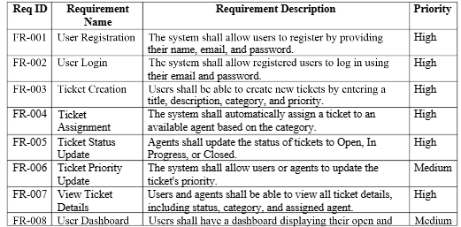
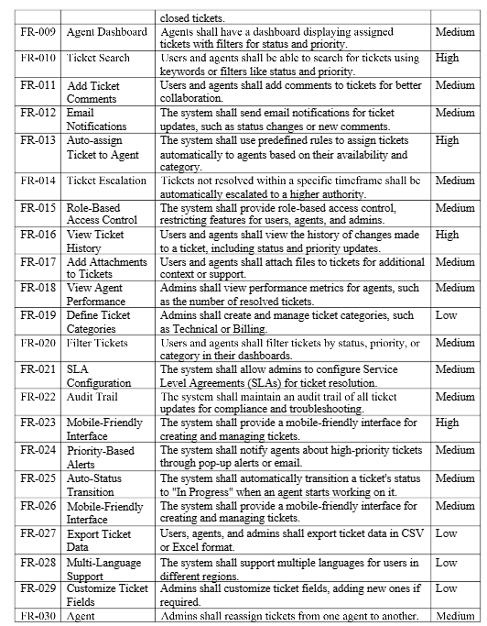
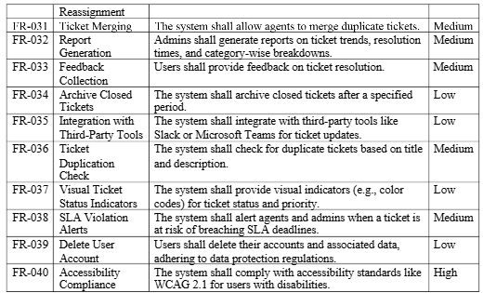

Non Functional Requirement

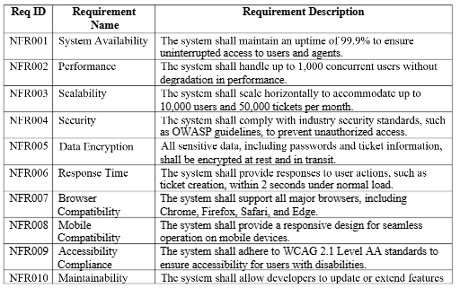
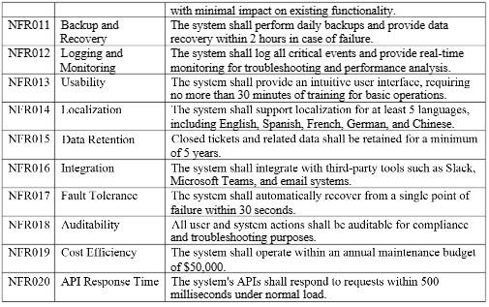
https://www.studocu.com/in/document/icfai-business-school/internet-marketing/mock-4/113411331
Use Case Specifications
Use Case 1: Raise a New Ticket

1. Use Case Name:
Raise a New Ticket

2. Description:
A user creates a ticket to report an issue, provide details, and request assistance.

3. Actors:

- . Primary: End-User
- . Secondary: System

4. Basic Flow:

- User logs into the ticketing system.
- User navigates to the "Raise a Ticket" section.
- User selects the issue type.
- User provides a detailed description of the issue.
- User attaches files, if necessary.
- User sets the ticket priority.
- User submits the ticket.
- Syslem generates a unique ticket ID and confirms submission.

5. Alternate Flow:
a. User saves the ticket as a draft instead of submitting it.
1. System stores the ticket as a draft for later editing.

6. Exceptional Flow:
6a. Required fields are incomplete:
1. System highlights missing fields and prevents submission.
6b. File exceeds the allowed size limit:
1. System displays an error and prevents file upload.
7. Pre-Conditions:
User must have an active account.
8. Post-Conditions:
- Ticket is logged in the system and assigned a unique ID.
- Notification is sent to the user.
9. Assumptions:
Users know how to navigate the ticketing system interface.
10. Constraints:
- Attachments must not exceed 5MB per file.
- Submission allowed only during system operational hours.

11. Dependencies:
Database and notification systems must be operational.
12. Inputs and Outputs:
Inputs: Issue type, description, priority, optional attachments.
Outputs: Ticket ID, confirmation notification.
13. Business Rules:
- Tickets must include all mandatory fields before submission.
- Duplicate tickets should be flagged.
14. Miscellaneous Information:
Interface should support mobile and desktop views.
Use Case 2: View Ticket Details
1. Use Case Name:
View Ticket Details
1. Use Case Name:
View Ticket Details
2. Description:
A user views the details of a previously submitted ticket.
3. Actors:
Primary: End-User
Secondary: System
4. Basic Flow:
- User logs into the system.
- User navigates to "My Tickets."
- User selects a ticket to view.
- System displays ticket details: ID, issue type, description, status, and history.
5. Alternate Flow:
- If the ticket is closed:
- System displays resolution details.
6. Exceptional Flow:
6a. Ticket is not accessible:
1. System displays "Ticket not found" error.
7. Pre-Conditions:
User must have access rights to the ticket.
8. Post-Conditions:
Ticket details are displayed to the user.
9. Assumptions:
System's database is up-to-date.
10. Constraints:
Users can view only their own tickets.
11. Dependencies:
Database must store ticket details accurately.
12. Inputs and Outputs:
- Inputs: Ticket ID or selection from list.
- Outputs: Detailed ticket information.
13. Business Rules:
Closed tickets should display resolution summaries.
14. Miscellaneous Information:
Interface may limit details for mobile views.
Use Case 3: Edit Draft Ticket
1. Use Case Name:
Edit Draft Ticket
2. Description:
User updates the details of a saved draft ticket.
3. Actors:
Primary: End-User
Secondary: System
4. Basic Flow:
1. User logs into the system.
2. User navigates to the "My Drafts" section.
3. User selects a draft ticket.
4. User updates fields and saves changes or submits the ticket.
5. Alternate Flow:
4a. If the user decides not to submit the ticket:
1. User saves changes and exits without submitting.
6. Exceptional Flow:
6a. Draft is not found:
.1. System displays "Draft not found" error.
7. Pre-Conditions:
A draft ticket must exist in the system.
8. Post-Conditions:
Draft is updated, or ticket is submitted.
9. Assumptions:
User has edit rights for the draft.
10. Constraints:
Drafts expire after 30 days.
11. Dependencies:
Drafts must be stored in the system.
12. Inputs and Outputs:
Inputs: Updated ticket details.
Outputs: Updated draft or new ticket ID.
13. Business Rules:
Mandatory fields must be completed for submission.
14. Miscellaneous Information:
Drafts support multiple edits before submission.
Use Case 4: Delete Draft Ticket
1. Use Case Name:
Delete Draft Ticket
2. Description:
User deletes a saved draft ticket they no longer wish to submit.
3. Actors:
- Primary: End-User
- Secondary: System
4. Basic Flow:
1. User logs into the system.
2. User navigates to the "My Drafts" section.
3. User selects a draft ticket.
4. User chooses the "Delete" option.
5. System confirms deletion.
5. Alternate Flow:
5a. If the user cancels the deletion:
o Draft remains in the system.
6. Exceptional Flow:
Draft not found:
o System displays "Draft not found" error.
7. Pre-Conditions:
Draft ticket exists in the system.
8. Post-Conditions:
Draft is removed from the system.
9. Assumptions:
User has the right to delete drafts.
10. Constraints:
Drafts cannot be recovered after deletion.
11. Dependencies:
. Draft tickets must be stored in the system.
12. Inputs and Outputs:
- Inputs: Draft ticket ID.
- . Outputs: Deletion confirmation.
13. Business Rules:
Only the ticket owner can delete their draft.
14. Miscellaneous Information:
Deletion requires user confirmation.

Use Case 5: Submit Feedback for a Resolved Ticket
1. Use Case Name:
Submit Feedback for a Resolved Ticket
2. Description:
A user provides feedback on the resolution of a ticket.
3. Actors:
- Primary: End-User
- . Secondary: System
4. Basic Flow:
1. User logs into the system.
2. User navigates to "Resolved Tickets."
3. User selects a ticket.
4. System displays the resolution details.
5. User submits feedback, including ratings and optional comments.
6. System saves the feedback and updates the ticket record.
5. Alternate Flow:
5a. User opts to skip providing feedback.
6. Exceptional Flow:
6a. Feedback submission fails due to system error:
1. System notifies the user and prompts them to retry later.
.
.



