Procurement Operations– Mount Sinai Healthcare (Enhancement Project)
Business Process Analysis Using Agile Methodology
Presented by: DEEPAK K / 29-OCT-2025
Business Analyst – Finance & Procurement Operations

SITUATION - What situation created to develop this project for further enhancement .
- Mount Sinai Healthcare, a major hospital network based in New York, USA, manages large-scale healthcare procurement involving medical equipment, consultants, software, and services & also maintenance.
- Their existing procurement process was highly decentralized and manual, handled internally across multiple hospital departments. That was too much to handle .
- This led to inconsistencies, delayed approvals, and poor visibility over budgets and payments.
- Each department managed its own approvals, SOW / Quote validation, and fund allocations to create new request to get the purchase order numbers
- No unified system existed to track CAPEX/OPEX usage across functions. These validations were handled manually which is tiring and time consuming.
- Stakeholders lacked real-time dashboards to monitor request status or vendor payments & All the TAT/ SLA metrics and KPI Dashboard are prepared manually every month to review the volumes & performance
- Fund validation, PO creation, invoice mapping took longer time.

PROBLEM - What problems we faced during the initial phase of this enhancement

- Creating process flow digram/ Framing SOP or DTP for all the activities which we are handling & get it approved and signed by the client

- Getting adapted to the new feature in the ERP – Tool and its functionality .
- Handling huge volumes (Inflow) for request creation & email queries
- Cross validation of budget files (CAPEX/ OPEX) . Locating the correct budget approvers and routing it to them before the request creation. Budget Validation Bot – automated CAPEX/OPEX check should not go wrong once it is automated.
- Delays in approvals and misunderstanding of process ownership. Because of time zone.
- Set up bi-weekly governance calls to align both onsite and offshore stakeholders.
- Handling issues/ escalations and preparing ROOTCAUSE analysis
- Approvers often missed emails, causing backlogs in fund request and invoice queues. So keep sending follow-up emails
- Initially, there was no dashboard or KPI system to monitor request status, pending queues, or SLA adherence. So for any reporting purpose there are no adequate data to project the performance.

OPPROTUNITIES of this enhancement

- Thinking of advanced automation and workflow enhancements
- Created weekly and monthly dashboards using ERP data extracts and Power BI reports.
- Published KPI metrics — Approval turnaround time, PO-to-Invoice accuracy, SLA performance — for leadership review are in green.
- Client appreciation emails for handling their monthly & daily activity without any noise / concerns.
- With Accenture’s offshore team now experienced in Mount Sinai’s processes, the model can scale easily to include: Procurement for new departments or hospital acquisitions.
- Additional finance functions (e.g., contract management, procurement analytics, accounts payable automation
- The stable, documented, and automated workflow ensures strong audit readiness and regulatory compliance (HIPAA, SOX, internal finance policies).
- Reduces audit exceptions to near zero.
- Once stabilized, the Mount Sinai Procurement project transforms into a strategic platform for automation, analytics, and scalability. The standardized process, accurate data, and offshore delivery capability create long-term opportunities for Mount Sinai to improve cost efficiency, vendor trust, compliance control, and decision-making intelligence

PURPOSE STATEMENT (GOALS)
- To design, implement, and stabilize a standardized, audit-ready procurement process for Mount Sinai Healthcare that integrates finance, procurement, and IT functions — ensuring operational efficiency, budget control
- Goals - Establish a consistent, end-to-end procurement framework covering SOW validation, request creation, PO generation, invoice approval, and payment release.
- Purpose - To create request based on the SOW/ QUOTE / INVOICE and validating the fund code to be applied and to get the approval from the fund owner & also from IT Finance head & then once the Purchase Order gets generated , the PO Copy will be shared with the requestor to apply that with the respective Invoices to make payment for the services or maintenance or any physical shipment

PROJECT OBJECTIVES
- Project Initiation & Governance
- Objective: align scope, roles, governance and measures of success with Mount Sinai.
Key activities
- Conduct workshops with Finance, Procurement, IT, requestors and vendors.
- Map AS-IS processes (SOW validation, fund checks, request creation, PO, invoice).
- Identify exceptions/rules for CAPEX vs OPEX.
- Create SOPs / DTPs for every transaction type and exception case.
- Define approval matrices, escalation rules and time windows (SLA).
- Cleanse vendor master, fund codes, cost centers; de-duplicate records.
- Run monthly performance reviews; convert improvement ideas into prioritized sprints or waterfall releases.

SUCCESS CRITERIA

- Process Standardization Achieved – 100%
- Unified workflows implemented across all hospital units.
- Consistent procurement SOPs and DTPs enforced organization-wide.
- Cross-departmental collaboration improved, eliminating redundant manual steps.

- Approval Turnaround Time Improved – 30%
- Average approval cycle reduced from >48 hours to <34 hours.
- Introduced automated approval routing for faster fund validation.
- Minimized bottlenecks through Agile sprint-based enhancements.

- Accurate Fund Validation & Budget Control – 98%

- Automated CAPEX and OPEX fund code validation integrated with ERP.
- Reduced manual errors in budget allocation and tracking.
- Enhanced financial accuracy and audit readiness.

- PO–Invoice Mapping Accuracy – 97%

- AI-driven reconciliation ensures correct PO-to-invoice mapping.
- Error rate in invoice processing reduced from 10% to 3%.
- Improved vendor payment predictability and trust.

- Real-Time Reporting & KPI Dashboard Availability – 100% Uptime

- Developed Power BI-based dashboards integrated with ERP system.
- Enabled leadership to access live procurement metrics and SLAs.
- Maintained uninterrupted system performance with continuous monitoring.

- Developed Power BI-based dashboards integrated with ERP system.
- Enabled leadership to access live procurement metrics and SLAs.
- Maintained uninterrupted system performance with continuous monitoring.

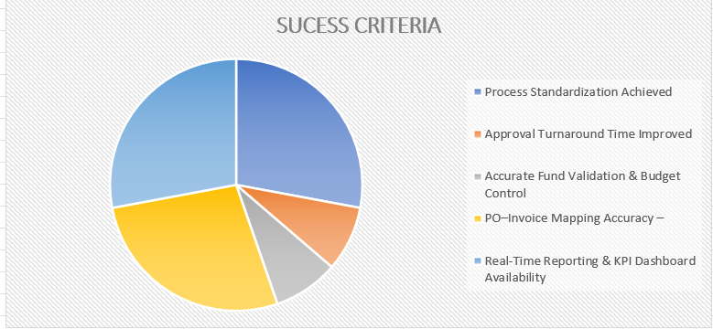

Methods and Approaches
Requirement Gathering (Elicitation Phase)
Objectives - To capture detailed business and system requirements from all relevant stakeholders (Finance, Procurement, IT, and Vendor Management) ensuring alignment with Mount Sinai’s operational, compliance, and financial goals.
Stakeholder Identification –
Procurement Lead | We connect with the Proc lead to know Oversees vendor selection, SOW/ QUOTE/RFP , and approvals
Finance Approvers | Validate fund codes (CAPEX/OPEX), budget ownership
Requestors | Initiate SOWs, Quotes, and fund requests
Vendors | Submit invoices, track payment progress
IT System Admins | ERP tool config , integration

Elicitation Techniques Used
Document Analysis |  | Reviewing the SOWs, Quotes, and budget files for the validation and approvals
Stakeholder Interviews |  | One-on-one sessions with Finance, Procurement. Discussing on ERP workflow and defining TAT / SLA (KPI Reporting)
Workshops & Joint Application Design (JAD) |  | Defined approval hierarchy, exception CAPEX/OPEX rules
Brainstorming Sessions |  | Idea generation for automation improvements. Led to proposal of Budget Validation
Prototyping (Wireframes) | Helps to validate design during UAT sessions

Requirement Analysis Phase
Objectives
To translate elicited requirements into structured, testable, and prioritized user stories that align with Mount Sinai’s business goals and technical feasibility.

AS-IS and TO-BE Process Mapping

AS-IS |  | TO-BE
Manual approvals, fragmented tools, limited visibility, and inconsistent fund validation. |  | Smart Approval Workflow – auto-routing based on rules
Manual validation of fund codes & referring budget files with CAPEX & OPEX (Capital exp & Operating exp) Sending for department approvers |  | Budget Validation Bot – automated CAPEX/OPEX check
After Purchase order gets generated by the PO team , we manually map that with the respective invoices and then, we route it to Accounts Payable team for validation and for payment.There are chances wrong PO may get mapped to the invoices. Invoice Billed vs PO actual Billed quantity may not match. |  | Invoice Reconciliation Engine – AI-based accuracy
All the TAT/ SLA metrics and KPI Dashboard are prepared manually every month to review the volumes & performance |  | Agile KPI Dashboard – to be embedded Power BI for real-time tracking
Functional Requirement | Essential supporting documents to be validated for new request creation or to make any changes to the existing Purchase Order  Sending for Approvals to the Budget owners / IT Finance Head  PO Generation & Invoice Mapping  Reporting & KPI Dashboards |  | SOW validation, Fund approval routing, PO generation, Invoice mapping  CAPEX/ OPEX Fund codes for request Creation  The system must automatically generate a Purchase Order (PO) once the final approval is granted.  The system must provide Power BI embedded dashboards displaying metrics such as:  - Approval Turnaround Time  - PO–Invoice Accuracy %  - Budget Utilization %  - SLA Compliance Rate
Non-functional Requirement | Performance and compliance parameters  Availability & Reliability |  | System uptime (99%) / All Healthcare Project associates must mandatorily complete this HIPAA Certification. To avoid risk of compliance issue.  The system must support at least 1,000 concurrent users without degradation.  The ERP must have 99 % uptime excluding scheduled maintenance.

Design Phase
Activity Diagram -1 (Request Creation by Accenture Procurement Team for U.S Healthcare Project)
This activity diagram outlines the procurement process, detailing the interactions between the Offshore Procurement team (Accenture), & its agreed US Healthcare -Newyork team (Onshore team) who has multiple vendors across the globe. Primary role of offshore team is to Validate the SOW/Quote / RFP along with the budget file (CAPEX/ OPEX) and to co-ordinate with the IT Finance head and department approvers to create request in-order to generate a new Purchase order numbers to pay the invoices for the multiple vendors who has a tie-up with US Healthcare project.

Off-shore- Accenture team should also co-ordinate with Purchase order team for all the request getting created, until it gets approved. Any rejection of request at any stage should also be handled by the off-shore team to find out the reason and that needs to be pushed to the queue again until final purchase order gets generated. That PO needs to be shared with vendor or with MSH team. They will in-turn share that P.O with the respective vendor. Those Purchase order will be applied against the respective Invoices and will be sent to Accounts Payable team for processing the payment.
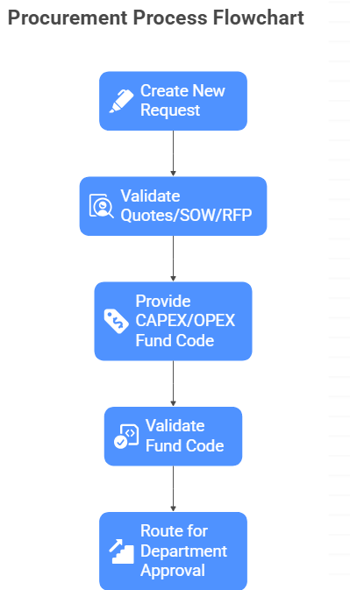
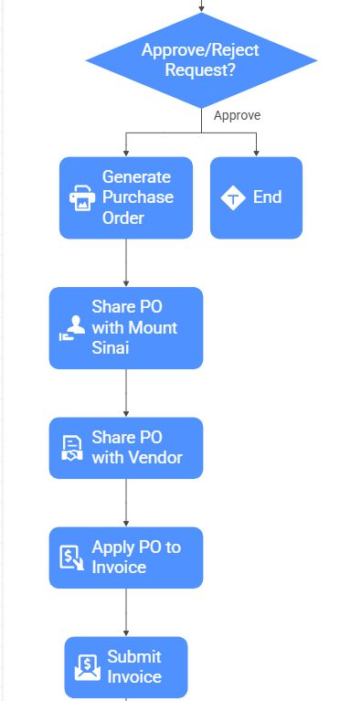
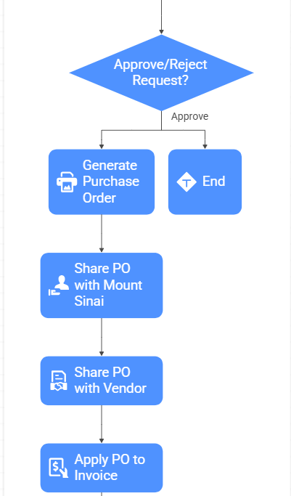
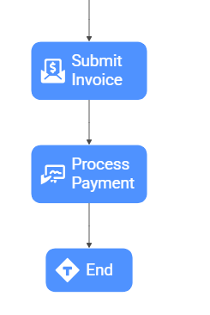

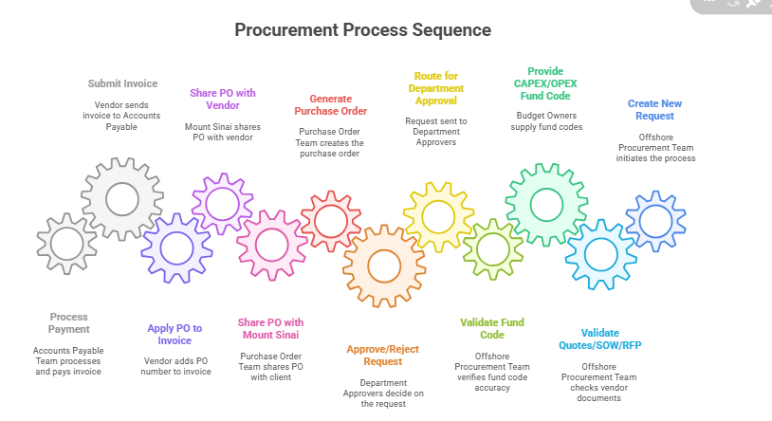

Activity Diagram -2 (Accounts Payables Invoice approval Flow after request converted into Purchase Order)
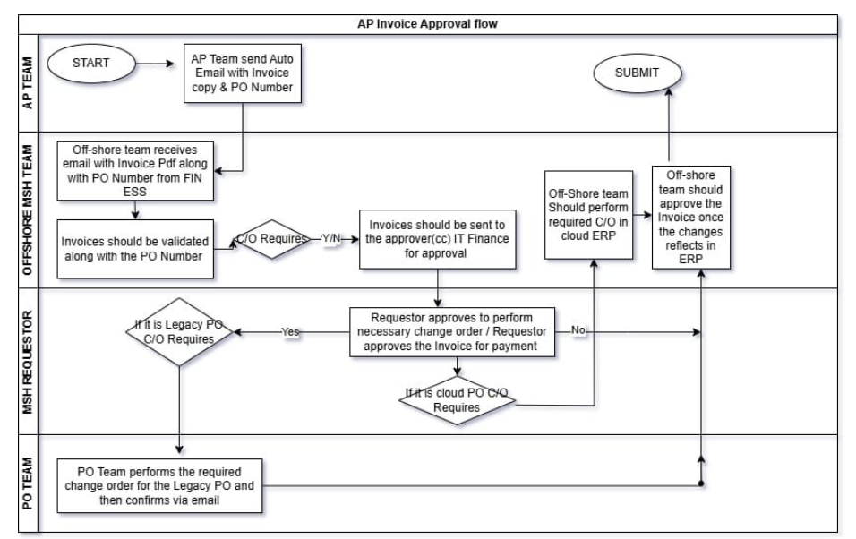

Use-Case Diagram (Request Creation by Accenture -Procurement team for U.S Healthcare Project)

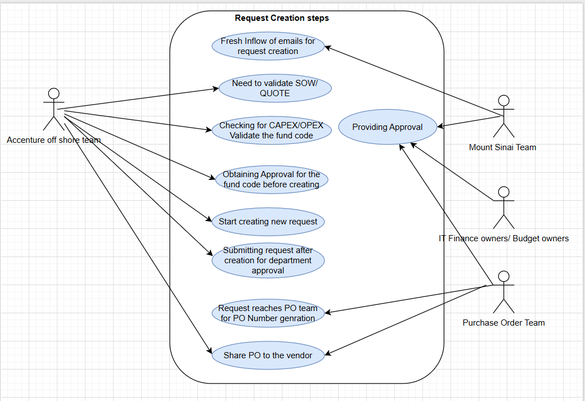

Wire-Framing Request Creation by Accenture -Procurement team for U.S Healthcare Project (Cloud ERP)
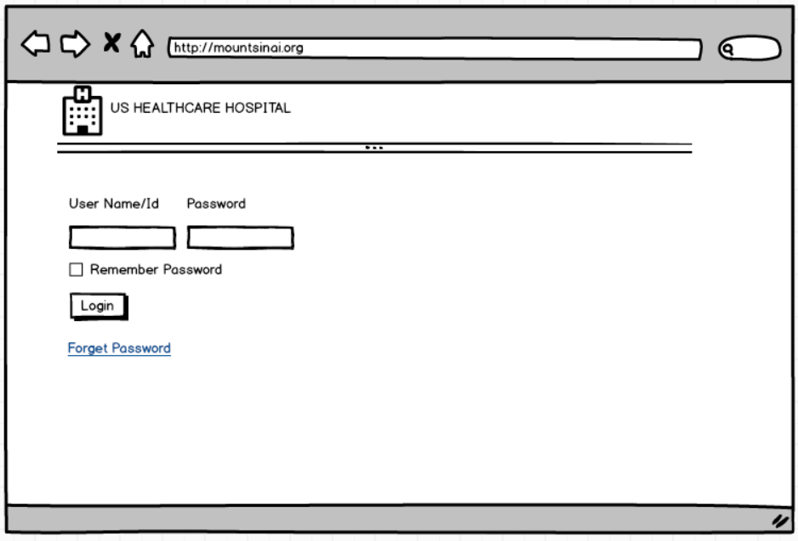
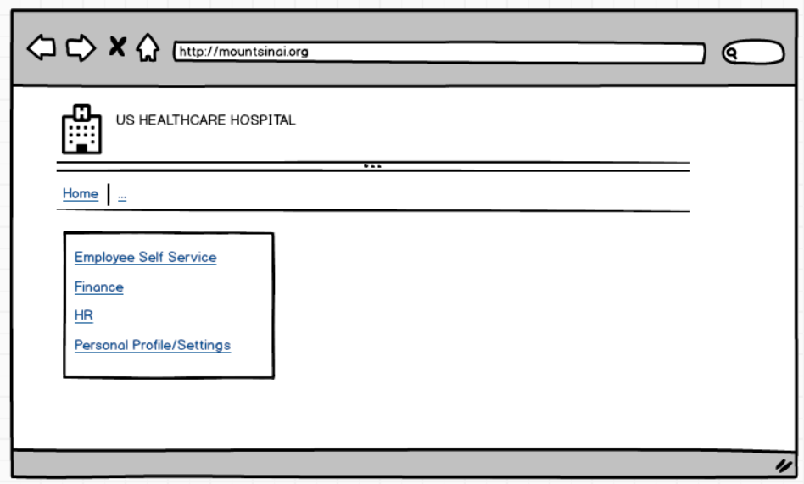

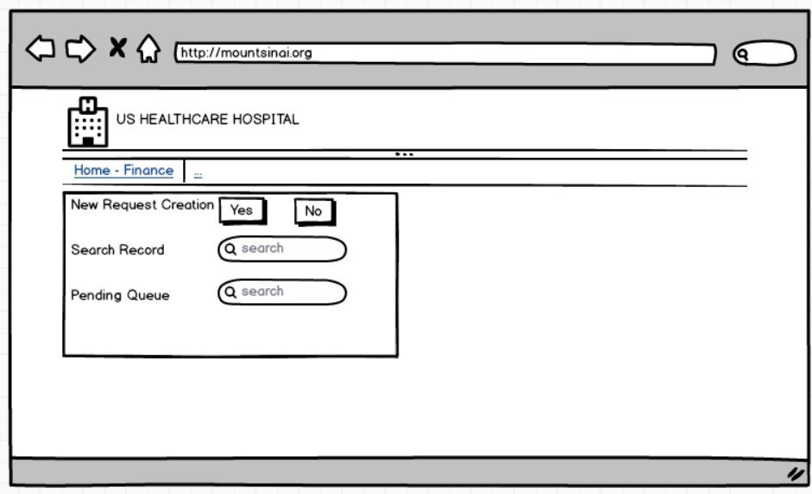
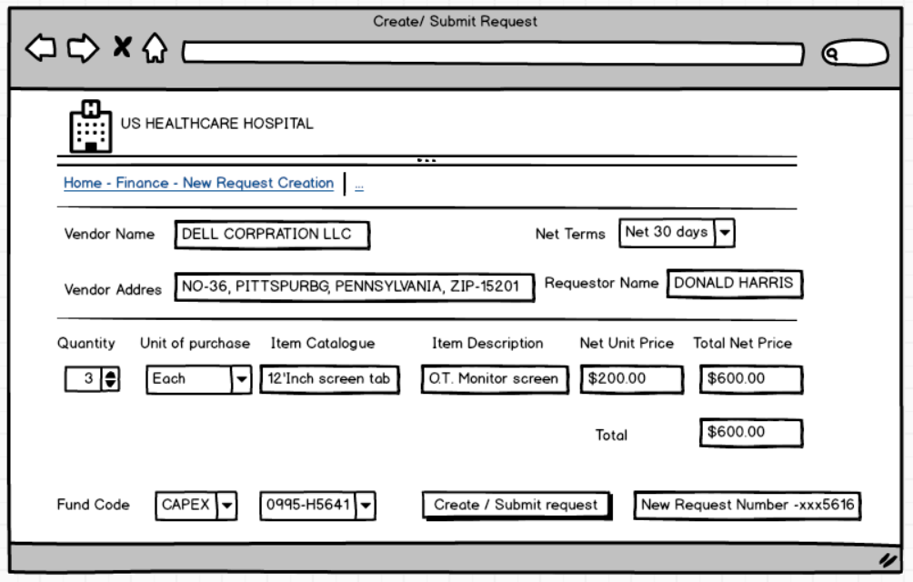

User Story 1: Validate Procurement Documents

- As a offshore procurement specialist, I want to validate SOW/Quote/RFP and budget files for each procurement request so that only compliant and accurate requests proceed to PO creation.
- Acceptance Criteria:
  - All documents are reviewed for accuracy and compliance.
  - Discrepancies are flagged and communicated for correction.

User Story 2: Coordinate PO Request Creation
- As a offshore procurement specialist, I want to coordinate with IT Finance Head and department approvers to create procurement requests so that new PO numbers can be generated efficiently.
- Acceptance Criteria:
  - All required approvals are obtained before request submission.
  - Requests are tracked until PO numbers are generated.

User Story 3: Fund code selection
- As a offshore procurement specialist, I want to able to select the CAPEX/OPEX Fund from the ERP drop-down list as per the fund code provided by the requestor. So that I can create the request
- Acceptance Criteria
  - All required fund code as per CAPEX/OPEX budget file must be listed in the ERP drop-down.

User Story 4: Vendor Data Base
- As a offshore procurement specialist, I want to able to search and see whether all the vendor listed in the ERP database. So that I can pull the required vendor for request creation
- Acceptance Criteria
Vendor database list consolidation should be reconciled between onshore team

User Story 5: Department approval

- As a offshore procurement team , after submitting the request . Based on the fund code applied the system must directly move those request to the respective department approvers for approval. So that they can validate and approve.

- Acceptance Criteria – Depart approver must be rightly mapped . Only then any new request created will be reaching to their notificaion

User Story 6: Vendor Data Base
- As a offshore procurement specialist, I want to able to send the supporting documents to the vendoring team for new vendor setup. If the vendor is not available in the ERP. So that that new vendor will be added by the vendoring team into ERP.
- Acceptance Criteria
Supporting documents like vendor setup template/ W9 Form/ Quote or SOW are essential.
Accessing to vendor setup link must be available 24/7

Resources
- BA gathers and validates requirements → with onsite Finance/Procurement teams. (QUOTE/ SOW/ RFP) along with fund code for request creation. Validates CAPEX/ OPEX Budget file
- Solution Architect + Developers configure ERP workflows in test environment.
- Testers validate the end-to-end procurement cycle (request → PO → invoice).
- Reporting Analyst builds Power BI dashboard using ERP extracts.
- Project Manager + BA review dashboards and workflows with stakeholders in governance calls.
- Time – The project for Enhancement (Agreed for 8 Months (2025 April-Nov).

BUDGET OVERVIEW – Mount Sinai Procurement Project
- Estimated Total Project Budget: ≈ $1.25 Million USD

