Capstone Project 1 _Part -2
Neha Gindi

- 4 Quarterly Audits are planned Q1 , Q2, Q3, Q4 for this Project What is your knowledge on how these Audits will happen for a BA ?
Answer:
Audits: Audits are checks to ensure project work meets standards. Internal audits are done within the company, and external audits are done by the client or third parties.

- Q1 Audit (Post requirements phase)
- Check if BRD, FRD, Use Case diagrams, and RTM are complete and signed off.
- Ensure requirements gathering and stakeholder sign-offs are documented.

- Q2 Audit (Post design phase)
- Verify design document traceability to requirements.
- Confirm updates in RTM after design phase.
- Stakeholder MOM
- Q3 Audit (During/After Development & Testing phase)
- JAD session reports
- Check documentation of clarifications given to the dev and testing teams.
- Review participation in defect triage meetings and change management
- BA and developer/tester MOM
- Q4 Audit (Deployment & closure phase)
- Confirm final RTM forwarded to client/PM for closure.
- Verify that end-user manuals and training sessions are completed
- Check “Lessons Learned” document prepared by BA.
- Ensure sign-offs are taken on BA acceptance forms.

- – BA Approach Strategy
Before the Project is going to Kick Start, The Committee asked Mr Karthik to submit BA Approach Strategy Write BA Approach strategy (As a business analyst, what are the steps that you would need to follow to complete a project – What Elicitation Techniques to apply, how to do Stakeholder Analysis RACI/ILS, What Documents to Write, What process to follow to Sign off on the Documents, How to take Approvals from the Client, What Communication Channels to establish n implement, How to Handle Change Requests, How to update the progress of the project to the Stakeholders, How to take signoff on the UAT- Client Project Acceptance Form )
Answer:

- Elicitation Techniques:
- Use Interviews, Surveys, and Questionnaires for detailed inputs.
- Analyze existing documents to gather baseline data.
- Facilitate Brainstorming for feature enhancements.
- Observe current workflows to identify gaps.

- Stakeholder Analysis (RACI / ILS):
- Identify all stakeholders: Sponsor, PM, SMEs, End Users, Developers, Testers.
- Prepare a RACI Matrix:
  - Responsible: BA, PM
  - Accountable: Sponsor
  - Consulted: SMEs, Developers, Testers
  - Informed: End Users
- Prepare ILS (Interest, Level of Influence, Support required) analysis to understand stakeholder expectations.

- Documents to Write:
At each phase:
- Requirements Documents: BRD, FRD, Use Case Diagrams
- RTM (Requirement Traceability Matrix)
- Meeting Minutes and Clarification Logs
- End User Manuals
- UAT Plan and Test Cases
- Lessons Learned Document

- Process to Follow for Document Sign-off:
- Share draft documents (SRS) with stakeholders for review.
- Conduct walkthrough sessions to explain the document.
- Collect feedback, incorporate changes.
- Share the final document for formal email approval/signature.
- Store signed documents in the project repository.

- How to Take Approvals from Client:
- Schedule a review meeting with the client.
- Demonstrate the document contents and clarifications.
- Collect written approval via email or signature on the approval form.

- Communication Channels to Establish:
- Use Emails for formal communication and approvals.
- Schedule weekly status meetings with the client and stakeholders.
- Maintain meeting minutes and share with all stakeholders for tracking.

- How to Handle Change Requests:
- Log the Change Request in the Change Request Tracker.
- Assess the impact on timeline, budget, and scope.
- Discuss with the PM and technical team for feasibility.
- Share impact analysis with the client for approval.
- Update RTM and related documents post-approval.

- How to Update Project Progress to Stakeholders:
- Share weekly status reports (planned vs actual, issues, next steps).
- Use visual dashboards if available for easy tracking.
- Highlight risks and mitigation plans proactively.
- Update RTM and share snapshots regularly for transparency.

- Taking Sign-off on UAT - Client Project Acceptance Form:
- Prepare the UAT Plan and Test Cases in advance.
- Train the client/end users for UAT.
- Support and document issues during UAT.
- Once UAT passes, prepare the Client Project Acceptance Form.
- Get it signed off by the client, marking formal acceptance of the project deliverables.

- Explain and illustrate 3-tier architecture?
Answer:
3-tier architecture is a client-server architecture where the application is divided into three logical layers:
- Presentation Layer (Client Tier)
- Application Layer (Business Logic Tier)
- Data Layer (Database Tier)

  - Presentation Layer (Client Tier)
- The user interface where users interact with the application
- Handles input, validation, and displaying data to the user.
- Examples: Web browser, mobile app screens.

  - Application Layer (Business Logic Tier)
- Also known as middle tier, this is the heart of the application.
- Takes input from the presentation layer, processes it, and interacts with the data layer.
- Examples: Server-side Java, Python, .NET applications.

- Data Layer (Database Tier)
- This is where the information that is processed by the application is stored and managed.
- Manages database operations like insert, update, delete, and read
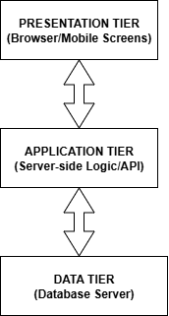
- Examples: MySQL, Oracle, SQL Server databases.

- BA Approach Strategy for Framing Questions – 10 Marks
Business Analyst should keep What points in his/her mind before he frames a Question to ask to the Stakeholder (5W 1H – SMART – RACI – 3 Tier Architecture – Use Cases, Use case Specs, Activity Diagrams, Models, Page designs)
Answer:

As a Business Analyst, before framing questions to ask stakeholders, I will keep the following structured points in mind:

  - Use 5W 1H to ensure clarity
  - Who is involved in the process?
  - What is the exact need or functionality?
  - When is this activity performed?
  - Where does it occur (system/module)?
  - Why is it needed (business reason)?
  - How is it currently done or expected to be done?

  - Use the SMART approach
  - Specific: Is my question clear and precise?
  - Measurable: Does it relate to measurable outcomes (volume, frequency)?
  - Achievable: Is the requirement feasible?
  - Relevant: Is it aligned with business goals?
  - Time-bound: Is there a timeline for this requirement?
  - Consider the RACI Matrix:
- Clarify who is Responsible, Accountable, Consulted, and Informed for the requirement or process before framing questions.
- Helps in asking the right questions to the right stakeholders.
  - 3-Tier Architecture Understanding:
Before framing questions:
- Understand which tier (Presentation, Application, Data) the query relates to.
- Example:
  - For UI design → Ask about presentation needs.
  - For business rules → Clarify application layer needs.
  - For data retrieval → Ask data structure and access questions
  - Use Cases and Related Models:
Before framing questions, the BA should:
- Review Use Cases and Use Case Specifications to identify missing flows or exceptions to confirm with stakeholders.
- Use Activity Diagrams to understand process steps and find gaps for clarification.
- Refer to Wireframes/Page Designs to ask about screen behaviour and user interactions.

- As a Business Analyst, What Elicitation Techniques you are aware of? ( BDRFOWJIPQU)
Answer:
Elicitation means gathering requirements and information from stakeholders and sources to understand what the business needs.
- B – Brainstorming:
Generating new ideas and solutions by discussing with stakeholders in a group session.
- D – Document Analysis:
Reviewing existing documents (SOPs, BRD, manuals) to gather initial requirements. One of the compulsory elicitation techniques for any project.
- R – Reverse Engineering:
Analyzing current systems to derive existing functionalities and processes. Generally done for migration projects
- F – Focus Groups:
Discussion with a group of users/stakeholders to gather opinions and needs.
- O – Observation:
Watching users perform their tasks to understand real workflows and issues.
- W – Workshops
Workshops can comprise 6-10 or more users/stakeholders, working together to identify requirements.
- J – JAD Sessions):
Structured joint sessions with stakeholders and the project team to elicit and refine requirements.
- I – Interviews:
Analyzing Interview is a systematic approach to elicit information from a person or group of people in an informal or formal setting by talking to the person
- P – Prototyping:
Building mock screens or wireframes to visualize requirements and get feedback.
- Questionnaires/Surveys:
Using structured questions to gather requirements from many stakeholders quickly.

- Which Elicitation Techniques can be used in this Project and Justify your selection of Elicitation Techniques? Prototyping Use case Specs Document Analysis Brainstorming
Answer:
The elicitation techniques that can be used for this ‘Online Agriculture products store ‘are:
- Prototyping
- Use case Specs
- Document Analysis
- Brainstorming
Justification:
- Brainstorming: Brainstorming session can be done with stakeholders like, farmers, technical team, etc to generate ideas for practical features and prioritize functionalities.
- Document Analysis: Review existing sales, order, and inventory documents used by farmers and suppliers. Helps understand: Current purchase processes , Challenges in remote procurement, Essential data fields for the system (product names, quantities, delivery details). Supports GAP Analysis between the current offline process and the proposed system.
- Use Case Specifications: Helps the development and testing teams understand user flows clearly. Useful for RTM preparation and aligning testing activities with requirements.
- Prototyping: Helps farmers and stakeholders visualize the system early and provide feedback. Creates mock screens/wireframes of the online portal and mobile app.

- Make suitable Assumptions and identify at least 10 Business Requirements
Answer:
BR001: The system should allow farmers to browse a product catalogue of fertilizers, seeds, and pesticides.
BR002: Farmers should be able to search for specific products using keywords, filters, or categories.
BR003: The system should allow manufacturers to upload, update, and manage product listings.
BR004: The application should support user registration and login functionality for farmers and manufacturers.
BR005: Farmers should be able to add products to a wishlist (buy-later list) after logging in.
BR006: The system should support secure payment methods including COD, Credit/Debit Cards, and UPI.
BR007: Farmers should receive email confirmations with order details after a purchase is made.
BR008: The system should provide delivery tracking for farmers to monitor their orders.
BR009: The system should provide multi-language support to improve usability for farmers in different regions.
BR010: The system should generate basic reports for manufacturers and admins on product sales and order statuses.
- List your assumptions
Answer:
- Farmers in remote areas have basic internet access and smartphones.
- Manufacturers are ready to upload and manage their product catalogues.
- The system will support multi-language options for farmer ease.
- Payment will include online and offline methods.
- The system will need basic reporting for order tracking and sales.
- Security features will be required for login and payment processes.
- Email communication will be the primary method for order confirmations.
- The application will be designed with simple navigation and UI.
- There will be basic user support/help options for farmers.
- The system will maintain basic inventory updates for manufacturers.
- Give Priority 1 to 10 numbers ( 1 being low priority – 10 being high priority) to these Requirements after discussions with the stakeholders.
Answer:
Req ID | Req Name | Req Description | Priority (1-10)
BR001 | Farmer Search for Products | Farmers should be able to search for available products in fertilizers, seeds, pesticides. | 8
BR002 | Manufacturers upload Products | Manufacturers should be able to upload and display their products in the application. | 8
BR003 | User Registration/Login | Farmers and manufacturers should have login and registration functionality. | 10
BR004 | Browse Product Catalogue | Farmers should be able to browse the full product catalogue. | 9
BR005 | Wishlist (Buy Later List) | Farmers should be able to add products to a wishlist to purchase later. | 5
BR006 | Secure Payment Options | The system should support COD, Credit/Debit Card, and UPI payment methods. | 10
BR007 | Email Order Confirmation | Farmers should receive email confirmation for their orders. | 7
BR008 | Delivery Tracking | Farmers should be able to track the delivery status of their orders. | 9
BR009 | Multi-language Support | The application should support multiple languages for farmer ease. | 6
BR010 | Reporting for Admins | The system should generate basic sales and order reports for manufacturers/admins. | 4

- Draw use case diagram
Answer:
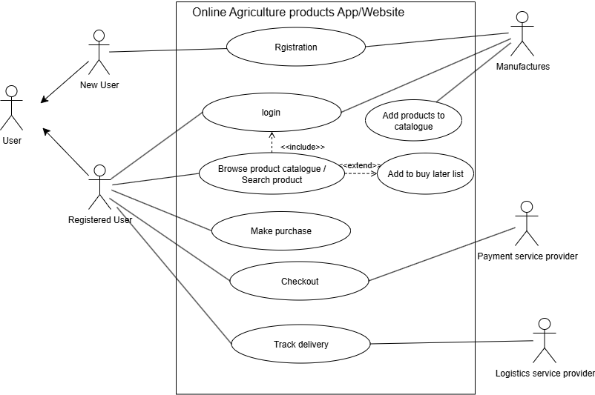

- Prepare use case specs for all use cases
Answer:
- Use Case: Registration
- Actor: New User (Farmer/Manufacturer)
- Precondition: User is not registered.
- Postcondition: User account is created with a unique ID.
- Main Flow:
  - User selects “Register”.
  - User enters email ID, password, and required details.
  - System validates details.
  - System creates account and confirms registration.
- Alternative Flow:
  - If email already exists, system prompts for login or password recovery.

- Use Case: Login
- Actor: Registered User (Farmer/Manufacturer)
- Precondition: User is registered.
- Postcondition: User is logged in and redirected to the dashboard.
- Main Flow:
  - User selects “Login”.
  - User enters email ID and password.
  - System validates credentials.
  - System logs in the user.
- Alternative Flow:
  - If credentials are incorrect, system shows an error.
- Use Case: Browse Product Catalog / Search Product
- Actor: Registered User (Farmer)
- Precondition: User is logged in.
- Postcondition: User views/searches products.
- Main Flow:
  - User selects “Browse Catalog” or uses the search bar.
  - System displays the list of fertilizers, seeds, and pesticides.
  - User views product details.
- Alternative Flow:
  - If the search has no results, system shows “No products found”
- Use Case: Add to Buy Later List (Wishlist)
- Actor: Registered User (Farmer)
- Precondition: User is logged in and browsing products.
- Postcondition: Product is added to the wishlist.
- Main Flow:
  - User selects “Add to Buy Later”.
  - System confirms the product is added to the wishlist.
- Use Case: Make Purchase
- Actor: Registered User (Farmer)
- Precondition: User is logged in and has products in the cart.
- Postcondition: Order is placed in the system.
- Main Flow:
  - User adds products to cart.
  - User selects “Proceed to Checkout”.
  - System shows order summary.
  - User confirms purchase.
- Alternative Flow:
  - If stock is unavailable, system notifies the user.
- Use Case: Checkout
- Actor: Registered User (Farmer), Payment Service Provider
- Precondition: User has confirmed the order.
- Postcondition: Payment is processed.
- Main Flow:
  - User selects payment method (COD, Credit/Debit, UPI).
  - System processes payment via Payment Service Provider.
  - System confirms successful payment.
- Alternative Flow:
  - If payment fails, system notifies the user.

- Use Case: Track Delivery
- Actor: Registered User (Farmer), Delivery Service Provider
- Precondition: User has placed an order.
- Postcondition: User views delivery status.
- Main Flow:
    - User selects “Track Delivery”.
    - System fetches tracking updates from the Delivery Service Provider.
    - User views delivery status and estimated delivery date.

- Use Case: Add Products to Catalog
- Actor: Manufacturer
- Precondition: Manufacturer is logged in.
- Postcondition: Product is added to the catalog.
- Main Flow:
  - Manufacturer selects “Add Product”.
  - Enters product details (name, price, quantity, description).
  - System validates and saves the product.
- Use Case: Receive Email Confirmation
- Actor: Registered User (Farmer)
- Precondition: User has completed payment.
- Postcondition: User receives an email confirmation.
- Main Flow:
  - System generates order confirmation.
  - System sends email to the user with order details.

- Activity diagrams
Answer:
- Registration
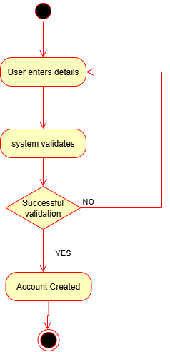

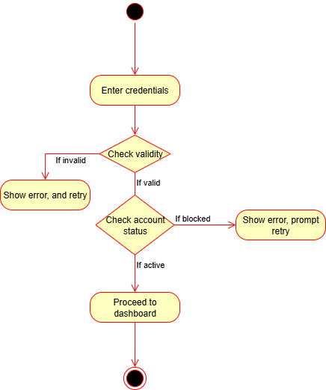
- Login

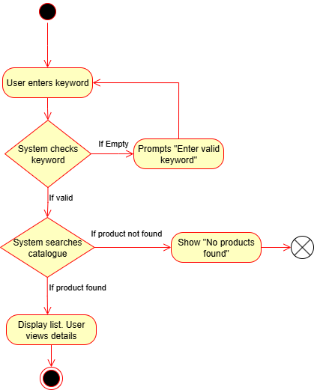
- Browse Product Catalog / Search Product

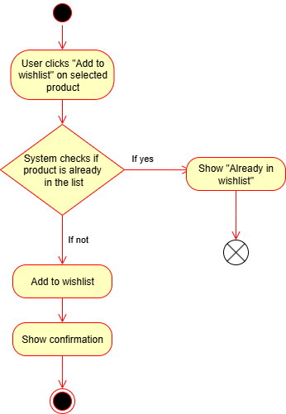
- Add to Buy Later List (Wishlist)

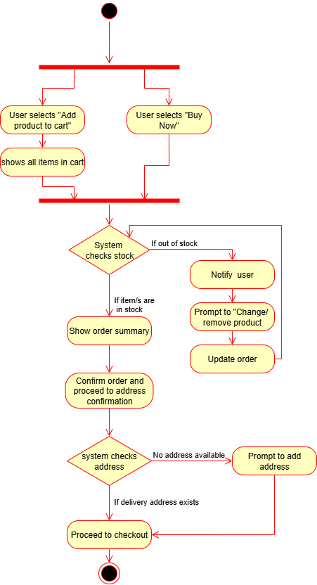
- Make Purchase

- Checkout
