AGILE DOCUMENTS

Agile Project – 100 Marks - Pass 60 %
Instructions to follow:
- Copy paste (either image, diagram or text) is not entertained. If done, the document will not be evaluated.
- After submission of the answers of this exam, you should be prepared to attend viva and justify your answers in the exams. If in Viva, participant is NOT justifying the answers, Viva will be repeated until Candidates justify 60% correctness.
- Mentor calls are scheduled only if the participant have submitted their task at least for one time. (should apply their knowledge in this task first)
- For attempting the exams participant should be thorough on the topics using their references.
- Please format the document properly (Always have a question no., question and answer).
- Have a consistent format (Font name: Arial/ Calibri -Font size 12, Font Color: Black).
- Answers should be elaborated in detail (not as per the allotted marks).
- Please focus on learning and applying the knowledge as this knowledge will be helpful in contributing at your BA job.
- In the evaluation, students must answer all questions and should be able to justify at least 60% content and correctness of each answer.

Agile Documents -
Document 1: Definition of Done Document 2- Product Vision Document 3: User stories Document 4: Agile PO Experience
Document 5: Product and sprint backlog and product and sprint burndown charts Document 6: Sprint meetings

Document 1: Definition of Done
Ans: -
Definition
As per the Agile Extension to the BABOK® Guide v2, the Definition of Done (DoD) is a technique where the team agrees on, and prominently displays, a list of criteria that must be met before a backlog item is considered complete.

A Definition of Done should be:
- Well-defined
- Unambiguous
- Measurable
- Agreed-upon
- Shared among all team members

The best representation of the Definition of Done is a checklist of activities that demonstrates the agreed value and quality of a user story. This checklist should include:
- Acceptance criteria – to ensure customer requirements for the product are satisfied.
- Quality criteria – to ensure quality standards for the product are met.

The Definition of Done may be applied at different levels of project work. In Agile/Scrum, these levels can include:
- User Story
- Sprint
- Release

Checklist for Definition of Done
A backlog item (e.g., user story) can be considered Done only when the following criteria are satisfied:
- Produced code for the intended functionality.
- Assumptions of the user story are met.
- Project builds without errors.
- Unit tests are written and passing.
- Project deployed on a test environment identical to the production platform.
- Tests on all required devices/browsers (as per project assumptions) are passed.
- Feature reviewed and approved by the UX designer.
- Quality Assurance (QA) testing performed and issues resolved.
- Feature validated against acceptance criteria.
- Feature approved by the Product Owner.
- Refactoring completed where necessary.
- Any configuration or build changes are documented.
- Documentation updated as required.
- Peer code review performed.

Document 2- Product Vision

Scrum Project  Name: | E-Commerce Enhancement Project
Venue:
Date: | Start time: January | End time: September | Duration: 9 Month
Client:
Stakeholder list: | Vivek Vinit
 | Manoj Das
 | Harpreet Singh
Scrum Team
Scrum Master: | Mohammed Taher Yousuf
Product owner: | Satya Ratnakar
Scrum Developer 1: | A. Lakshmikala
Scrum Developer 2: | Madhuri
Scrum Developer 3: | Varun
Scrum Developer 4: | Rakesh
Scrum Developer 5: | Rajesh

Vision: What is your vision, your overarching goal for creating the product?
Target group  Which market segment does the product address?  Who are the target users and  customers? | Needs  What problem does the product solve?  Which benefit does it provide? | Product  What product is it?  What makes it desirable and special?  Is it feasible to develop the product? | Value  How is the product going to benefit the company?  What are the business goals?  What is the business model?

Ans: -

Target Group
1. Market Segment
The project addresses the e-commerce and digital retail market segment, focusing on businesses
seeking to improve their online shopping experience, operational efficiency, and customer
engagement. This includes small to medium-sized enterprises (SMEs), as well as larger retailers aiming
to optimize their digital platforms.
2. Target Users and Customers
Target Users:
  - Online shoppers who want a smoother, faster, and more personalized shopping journey.
  - Retail staff and managers who will use enhanced backend tools for product management, order fulfillment, and customer support.
Target Customers:
  - B2B: E-commerce businesses, online retailers, and marketplace operators who will implement the enhancements to increase sales, retention, and competitiveness.
  - B2C: Indirectly, end consumers benefit through an improved shopping experience (personalized recommendations, better UX, secure checkout, etc.).

Needs
1. Problem the Product Solves
- Many e-commerce platforms struggle with low customer engagement, high cart abandonment, and inefficient backend operations.
- Online shoppers often face issues like slow websites, poor navigation, lack of personalization, and limited payment/delivery options, which reduce satisfaction and loyalty.
- Retailers lack data-driven insights to understand customer behavior and optimize sales strategies.

2. Benefits Provided
For Businesses (Customers):
  - Increased conversion rates through better user experience.
  - Streamlined operations (inventory, order, and customer management).
  - Data analytics for smarter marketing and personalization.
  - Higher customer retention and lifetime value.
For Shoppers (Users):
  - Faster, smoother, and more intuitive shopping experience.
  - Personalized product recommendations and offers.
  - More secure and convenient checkout and payment options.
  - Reliable delivery and customer support.

Product
1. What Product is it?
The E-Commerce Enhancement Project is a digital solution designed to upgrade existing online
retail platforms. It integrates advanced features such as personalized product
recommendations, AI-driven search, streamlined checkout, multi-channel integration, and
robust analytics dashboards to improve both customer experience and business efficiency.
2. What Makes it Desirable and Special?
For Shoppers:
  - Personalized and intuitive shopping journey.
  - Faster and more secure checkout process.
  - Access across devices and channels (web, mobile, social).
For Businesses:
  - Improved conversion rates through intelligent UX design.
  - Enhanced backend tools for inventory, order, and customer management.
  - Actionable insights from real-time analytics.
  - Scalable to fit small, medium, and large businesses.
What sets it apart is its holistic approach: it doesn’t just focus on the customer-facing side but also
strengthens backend operations, ensuring a seamless end-to-end experience.
3. Is it Feasible to Develop the Product?
Yes. The solution is feasible because:
- It builds on existing e-commerce infrastructure (platforms like Shopify, Magento, WooCommerce, or custom-built stores).
- Proven technologies—AI, machine learning, cloud integration, and data analytics—are readily available and scalable.
- Development can be phased (starting with essential features like UX/UI enhancements, then expanding into personalization and analytics).
- The demand for improved digital shopping experiences continues to grow, making the project commercially viable.

Value
1. How is the Product Going to Benefit the Company?
- Strengthens competitive advantage by offering a superior online shopping experience.
- Increases conversion rates, average order value, and customer lifetime value.
- Reduces operational inefficiencies through improved backend systems.
- Enhances brand reputation and customer loyalty by providing a reliable, user-friendly platform.
2. Business Goals
- Improve customer satisfaction and retention.
- Achieve measurable growth in sales and revenue.
- Expand into new markets or customer segments.
- Build a scalable e-commerce infrastructure that supports long-term innovation.
- Leverage data and analytics to drive smarter decision-making.
3. Business Model
- B2B SaaS Model: Offering the enhancement as a subscription-based service to e-commerce businesses (monthly/annual plans with tiered features).
- One-Time Custom Development: Providing tailored enhancements for larger retailers needing bespoke solutions.
- Value-Added Services: Upselling additional features such as advanced analytics, AI-driven marketing, or integration with emerging channels (social commerce, marketplaces).
- Partnership Ecosystem: Collaboration with logistics providers, payment gateways, and marketing tools to create bundled value.

Document 3: User stories

User story No: 01 | Tasks: 2 |  | Priority: HIGHEST
Value statement:
As a user, I want to add items to my cart and check out quickly, so that I can complete my purchase without frustration.
BV: 500 |  | CP: 2
Acceptance criteria:
- Add/remove items from cart.
- Real-time cart updates.
- Max 3-step checkout.
- Multiple secure payments.
- Stock validation before order.
- Confirmation email + on-screen.

User Story No: 02 | Tasks: 2 |  | Priority: HIGHEST
Value statement:
As a user, I want to search and filter products, so that I can easily find what I need.
BV: 500 |  | CP: 2
Acceptance Criteria:
- User can search for products by keyword (e.g., “red shoes”).
- Filters are available (price range, size, colour, category, availability).
- Search results update dynamically when filters are applied/removed.
- Relevant products appear at the top of the results (based on keyword relevance).
- No irrelevant or empty result pages (show suggestions like “Did you mean…?” if nothing matches).
- Works seamlessly on desktop and mobile devices.
- Handles large product catalogues without performance issues.

User Story No: 3 | Tasks:2 |  | Priority: HIGHEST
Value statement:
As a user, I want personalized product suggestions, so that I can discover items that interest
BV: 200 |  | CP: 3
Acceptance Criteria:
- Recommendations on homepage, product, and cart pages.
- Based on browsing/purchase history.
- Show trending products for new users.
- Updates dynamically.

User Story No: 4 | Tasks:2 |  | Priority: HIGHEST
Value statement:
As a user, I want to save items to a Wishlist, so that I can purchase them later.
BV: 100 |  | CP: 3
Acceptance Criteria:
- Add/remove items from Wishlist.
- Wishlist saved to user account.
- Accessible on all devices.
- Option to move Wishlist item → cart.

User Story No: 5 | Tasks:2 |  | Priority: HIGHEST
Value Statement:
As a user, I want to track my order status, so that I know when my delivery will arrive.
BV: 500 |  | CP: 2
ACCEPTANCE CRITERIA
- Real-time order status (Processing, Shipped, Delivered).
- Tracking link available in account + email.
- Notifications for status changes.

User Story No: 6 | Tasks:2 |  | Priority: Low
Value Statement:
As a user, I want to read/write product reviews, so that I can make informed purchase decisions.
BV: 50 |  | CP: 2
Acceptance Criteria:
- Users can leave reviews with ratings (1–5).
- Reviews appear on product page.
- Ability to flag inappropriate reviews.
- Verified purchase badge for authenticity.

User Story No:7 | Tasks:2 |  | Priority: Low
Value Statement:
As a user, I want the site to work smoothly on mobile, so that I can shop easily from my phone.
BV: 50 |  | CP: 2
Acceptance Criteria:
- Responsive design on all mobile devices.
- Touch-friendly navigation.
- Checkout and payment fully functional on mobile.

User Story No: 8 | Tasks:2 |  | Priority: HIGHEST
Value Statement:
As a user, I want secure payment options, so that I feel safe entering my details.
BV: 500 |  | CP: 3
Acceptance Criteria:
- Multiple payment gateways supported.
- Encrypted transactions (SSL, PCI-DSS compliance).
- Save payment details securely for future use (with user consent).

User Story No: 9 | Tasks:2 |  | Priority: MEDIUM
Value Statement:
As a user, I want to browse in my language and currency, so that I can shop comfortably.
BV: 200 |  | CP: 3
Acceptance Criteria:
- Multiple languages available (configurable).
- Currency auto-detect by location (with manual switch option).
- Prices updated in real-time exchange rates.

User Story No: 10 | Tasks: 02 |  | Priority: Medium
Value Statement:
As a business owner, I want an analytics dashboard, so that I can track sales and customer behavior.
BV: 200 |  | CP: 4
Acceptance Criteria:
- Dashboard with sales trends, customer behaviour, top products.
- Exportable reports.
- Real-time data updates.
- Role-based access (admins/managers).

User Story No: 11 | Tasks: 02 |  | Priority: Medium
Value Statement:
As a user, I want to subscribe to a newsletter, so that I can receive promotions and updates.
BV: 200 |  | CP: 4
Acceptance Criteria:
- Subscription form with email.
- Double opt-in confirmation.
- Success confirmation on signup.
- Option to unsubscribe anytime.

User Story No: 11 | Tasks: 02 |  | Priority: Medium
Value Statement:
As a user, I want to subscribe to a newsletter, so that I can receive promotions and updates.
BV: 200 |  | CP: 4
Acceptance Criteria:
- Subscription form with email.
- Double opt-in confirmation.
- Success confirmation on signup.
- Option to unsubscribe anytime.

User Story No: 11 | Tasks: 02 |  | Priority: Medium
Value Statement:
As a user, I want to subscribe to a newsletter, so that I can receive promotions and updates.
BV: 200 |  | CP: 4
Acceptance Criteria:
- Subscription form with email.
- Double opt-in confirmation.
- Success confirmation on signup.
- Option to unsubscribe anytime.

User Story No: 11 | Tasks: 02 |  | Priority: Medium
Value Statement:
As a user, I want to subscribe to a newsletter, so that I can receive promotions and updates.
BV: 200 |  | CP: 4
Acceptance Criteria:
- Subscription form with email.
- Double opt-in confirmation.
- Success confirmation on signup.
- Option to unsubscribe anytime.

User Story No: 12 | Tasks: 02 |  | Priority: Medium
Value Statement:
BV: 200 |  | CP: 4
Acceptance Criteria:
- Subscription form with email.
- Double opt-in confirmation.
- Success confirmation on signup.
- Option to unsubscribe anytime.

User Story No: 13 | Tasks: 02 |  | Priority: Medium
Value Statement:
As a user, I want to share products on social media, so that I can easily recommend them to friends.
BV: 200 |  | CP: 4
Acceptance Criteria:
- Social share buttons on product page.
- Links for Facebook, Instagram, Twitter, etc.
- Shared links include product image + link.

User Story No: 14 | Tasks: 02 |  | Priority: Medium
Value Statement:
As a user, I want to save multiple payment methods, so that I can check out faster in the future.
BV: 200 |  | CP: 4
Acceptance Criteria:
- Store credit/debit cards securely.
- Select from saved methods at checkout.
- Option to remove outdated cards.
- PCI compliance ensured

User Story No: 14 | Tasks: 02 |  | Priority: Low
Value Statement:
As a user, I want to chat with customer support in real-time, so that I can resolve issues quickly while shopping.
BV: 100 |  | CP: 4
Acceptance Criteria:
- Subscription form with email.
- Double opt-in confirmation.
- Success confirmation on signup.
- Option to unsubscribe anytime.

User Story No: 15 | Tasks: 02 |  | Priority: Low
Value Statement:
As a user, I want to select preferred delivery options, so that I can choose speed or cost of shipping.
BV: 50 |  | CP: 4
Acceptance Criteria:
- Standard, express, same-day delivery options.
- Display delivery cost + estimated time.
- User can select before payment.
- Default option auto-selected

Document 4: Agile PO Experience

Ans: -
The Product Owner (PO) plays a critical role in bridging the gap between business stakeholders, the market, and the Scrum team. A PO brings domain and industry knowledge, ensures alignment with market needs, and translates the product vision into actionable deliverables.

Key Responsibilities of a Product Owner
- Market Analysis
- Conduct analysis of market needs and demand
- Research availability of similar products in the market

- Enterprise Analysis
- Perform due diligence on market opportunities

- Product Vision and Roadmap
- Define the product vision based on need analysis
- Develop a roadmap with high-level features and timelines

- Managing Product Features
- Manage stakeholder expectations and prioritize needs
- Prioritize epics, stories, and features based on criticality and ROI

- Managing the Product Backlog
- Prioritize user stories effectively
- Reprioritize based on evolving stakeholder needs
- Plan and maintain epics

- Managing Overall Iteration Progress
- Review sprint progress regularly
- Reprioritize sprints and epics if required
- Conduct sprint retrospectives in collaboration with the Business Analyst

Agile Ceremonies and Meetings Handled
From this project, I gained hands-on experience in facilitating and participating in the following Scrum ceremonies:
- Sprint Planning Meeting
- Daily Scrum Meeting
- Sprint Review Meeting
- Sprint Retrospective Meeting
- Backlog Refinement Meeting

User Story Creation and Structure
I learned how to create and manage user stories effectively, ensuring they capture the right details for the development team. Key elements included:

- Story number
- Tasks
- Priority
- Acceptance criteria
- Business Value (BV) & Complexity Points (CP)

Role of the Product Owner in Scrum
- Acts as the liaison between multiple areas of the organization
- Communicates effectively with business stakeholders
- Collaborates closely with Scrum teams to keep all parties aligned
- Develops and communicates the product vision
- Defines features and breaks them down into product backlog items

Document 5: Product and sprint backlog and product and sprint burndown charts
Product backlog:

User story ID | User story | Tasks | Priority | BV | CP | Sprint

Sprint backlog:

User story ID | User story | Tasks | Owner | Status | Estimated effort
Ans:
Product Backlog

User Story ID | User Story (Summary) | Tasks | Priority | BV | CP | Sprint
US-01 | Checkout Optimization | 2 | HIGHEST | 1000 | 3 | Sprint 1
US-02 | Product Search & Filter | 2 | HIGHEST | 500 | 2 | Sprint 1
US-03 | Personalized Recommendations | 2 | HIGH | 400 | 3 | Sprint 2
US-04 | Wishlist Feature | 2 | HIGH | 300 | 2 | Sprint 2
US-05 | Order Tracking | 2 | HIGH | 450 | 2 | Sprint 2
US-06 | Customer Reviews & Ratings | 2 | MEDIUM | 350 | 2 | Sprint 3
US-07 | Mobile Optimization | 2 | HIGHEST | 600 | 2 | Sprint 1
US-08 | Secure Payments | 2 | HIGHEST | 700 | 3 | Sprint 1
US-09 | Multi-Language & Currency | 2 | MEDIUM | 250 | 3 | Sprint 3
US-10 | Analytics Dashboard | 2 | HIGH | 800 | 4 | Sprint 3

Sprint Backlog (Sprint 1)

User Story ID | User Story | Tasks | Owner | Status | Estimated Effort
US-01 | Checkout Optimization | 2 | Dev A | In Progress | 3 days
US-02 | Product Search & Filter | 2 | Dev B | Not Started | 2 days
US-07 | Mobile Optimization | 2 | Dev C | In Progress | 2 days
US-08 | Secure Payments | 2 | Dev D | Not Started | 3 days

Product burndown

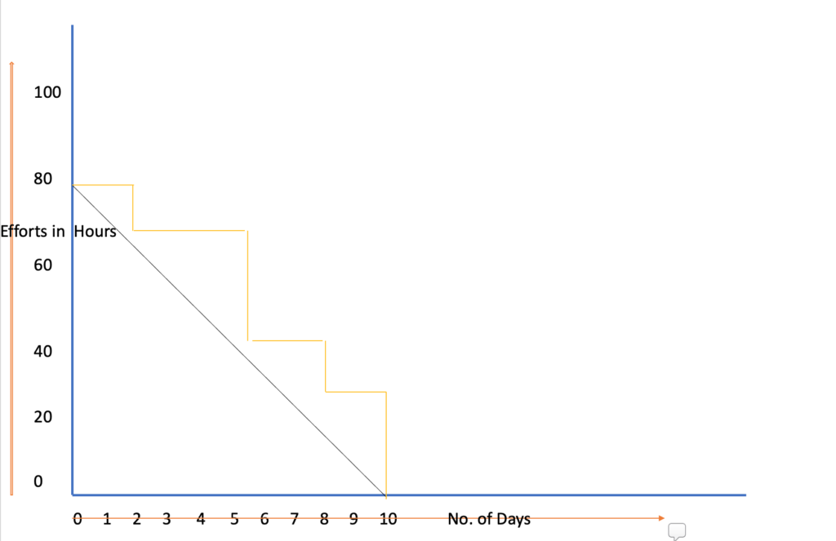
Sprint burndown

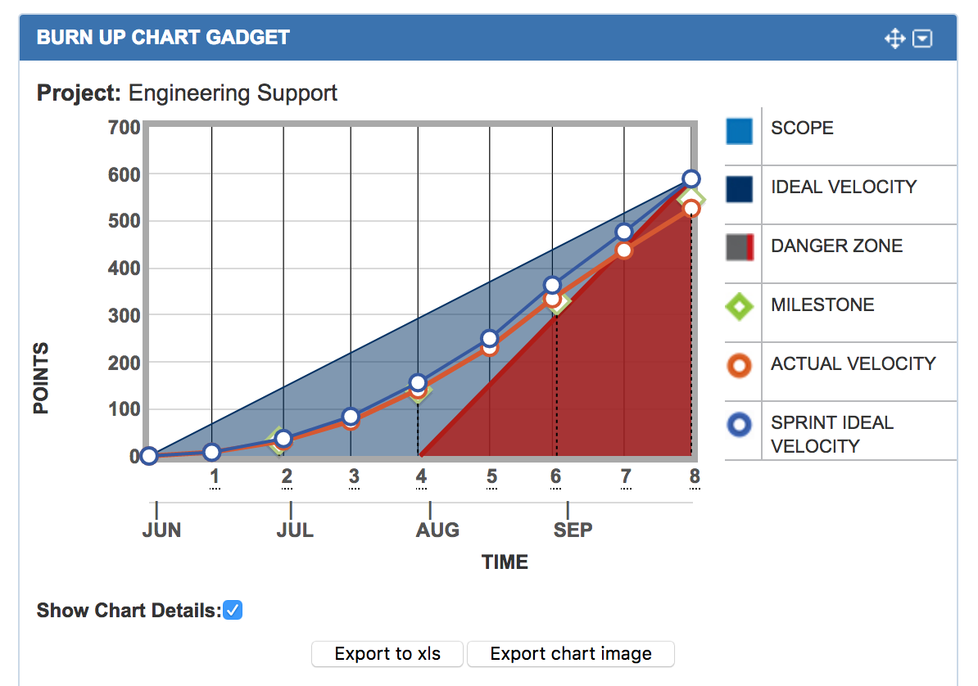

Document 6: Sprint meetings
Meeting Type 1: Sprint Planning meeting

Date | 09/09/2025
Time | 10:00AM
Location | Virtual- MS Teams
Prepared By | Mohammed Taher Yousuf
Attendees | 10

Agenda Topics
Topic | Presenter | Time Allotted
Review Product Backlog | Product Owner | 15 min
Define Sprint Goal | Scrum Master | 10 min
Select User Stories for Sprint | Development Team | 20 min
Break down tasks & estimate effort | Development Team | 20 min
Confirm Sprint Backlog & Commitment | Scrum Master | 10 min

Other Information

Observers | Stakeholders (optional)
Resources | Jira backlog, burndown chart, team velocity reports
Special Notes | Ensure team capacity and holidays are considered before finalizing sprint backlog

Meeting Type 2: Sprint review meeting

Date | 09/09/2025
Time | 10:00AM
Location | Virtual- MS Teams
Prepared By | Mohammed Taher Yousuf
Attendees | 10

Sprint status | Things to demo | Quick updates | What’s next
stories completed | - Checkout optimization (US-01)  - Product search & filter (US-02)  - Mobile optimization (US-07) | Any blockers faced and resolved | Prepare backlog refinement for Sprint 2 (recommendations, wishlist, order tracking).

Meeting Type 3: Sprint retrospective meeting

Date | 09/09/2025
Time | 10:00AM
Location | Virtual- MS Teams
Prepared By | Mohammed Taher Yousuf
Attendees | 10
Agenda

What went well | What didn’t go well | Questions | Reference
Team collaborated effectively, all high-priority tasks delivered. | Some stories were underestimated → caused slight delay. | How can we improve task estimation accuracy? | Sprint Backlog & Burndown Chart
Communication during daily stand-ups was clear and concise. | A few blockers took longer than expected to escalate. | Can we implement a faster escalation path for blockers? | Jira Task Board
Testing was integrated early, reducing last-minute bugs. | Limited time for documentation. | Should we allocate specific time for documentation in each sprint? | QA Notes

Meeting Type 4: Daily Stand-up meeting

Question | Name/Role |  |  | Week “39” (from 09-01-2025 to 09-09-2025)
Question |  |  |  | Monday | Tuesday | Wednesday | Thursday | Friday | Saturday | Sunday
What did you do yesterday? |  | Developer 1 |  | Notes | Notes | Notes | Notes | Notes | Notes | Notes
What did you do yesterday? |  | Developer 2
What did you do yesterday? |  | Developer 3
What will you do today? |  | Developer 1 |  | Notes | Notes | Notes | Notes | Notes | Notes | Notes
What will you do today? |  | Developer 2
What will you do today? |  | Developer 3
What (if any) is blocking your progress? |  | Developer 1 |  | Notes | Notes | Notes | Notes | Notes | Notes | Notes
What (if any) is blocking your progress? |  | Developer 2
What (if any) is blocking your progress? |  | Developer  3

