Question 1: Definition of Done
Answer:
The Definition of Done for CRMNEXT checklist
Definition of Done is a checklist of well-defined, measurable, and agreed-upon criteria that must be met before a backlog item is considered done.

Code Functionality
• Code implemented for all intended functionalities.
• Code reviewed and matches acceptance criteria.
User Story Validation
• Assumptions of user story verified.
• Acceptance criteria clearly met.
Build and Deployment
• Project builds successfully with no errors.
• Deployed to test environment identical to production.
Testing and QA
• Unit and integration tests written and passing.
• QA testing completed and issues resolved.
Cross-Platform Assurance
• Feature tested across all supported browsers/devices.
• No UI/UX discrepancies found on target platforms.
Design Approval
• UX designer reviewed and approved feature.
• Designs aligned with user expectations.
PO and Peer Review
• Product Owner signed off the feature.
• Peer code review completed successfully.
Documentation and Config
• Documentation updated as per new implementation.
• Any config/build changes logged and documented.
Refactoring and Cleanup
• Code refactored and optimized.
• No deprecated logic or commented code left behind.

Question 2: Product Vision

Answer:
Product Vision – CRMNEXT Lead Management System

Section | Details (CRMNEXT Project) | Reference
Project Name | Customer Lead Management System – CRMNEXT | Title Slide
Client | Retail Banking Business Division | Sign-off Slide
Stakeholders | Project Sponsor, CRMNEXT Vendor, Agile Coach, IT Integration Lead, Business Analysts, End-user Champions | Sign-off Slide
Scrum Master | To be assigned internally (Agile Coach / Project Manager likely candidate) | Assumed from Agile Coach role
Product Owner | Ritesh Nigam | Prepared By PO + PM Role
Scrum Developers | CRMNEXT Implementation Specialists, IT Integration Team | Resources Slide

VISION:
Banks today face significant challenges due to disjointed lead sources, delayed follow-ups, and poor visibility into customer engagement. CRMNEXT aims to transform banking lead management by offering a centralized, automated, and intelligent system that ensures faster response, improved conversions, and higher customer satisfaction. Our mission is to empower banks with real-time insights, process automation, and seamless integration—ensuring agility, transparency, and growth across every lead lifecycle touchpoint.

Market Segment | Target Users/Customers | Needs | Product Features | Feasibility & Value
Banking and financial services industry, especially retail and corporate banking | Bank sales managers, relationship officers, customer support teams, and IT/business heads | Banks need to unify their lead tracking and response process across channels to reduce leakage, improve conversions, and enhance visibility. | CRMNEXT offers automated lead assignment, escalation workflows, real-time dashboards, multi-device access, and integration with core banking systems. | Feasible via Agile delivery and vendor-backed CRM modules. High ROI potential via increased conversion rates, reduced TAT, and improved customer engagement.
 | Customers seeking faster query responses or product support (loans, cards, savings, etc.) | Timely communication and proper follow-up from the bank to avoid dissatisfaction or churn. | Features include instant notifications, lead aging alerts, self-service lead creation, and UAT-tested CRM dashboards. | Adds value through faster go-to-market, scalability, and audit-ready digital process trails that enhance trust and compliance.

Question 3: User Stories
Answer:
User Story No: 1 | Tasks: 2
Priority: Highest
AS A SALES MANAGER
I WANT TO VIEW REAL-TIME DASHBOARDS
SO THAT I CAN MONITOR TEAM PERFORMANCE
BV: 10 | CP: 03
ACCEPTANCE CRITERIA :
Dashboard Screen
Filters for Region, RM, and Status
Real-time data refresh
Export to Excel option

User Story No: 2 | Tasks: 3
Priority: High
AS A RELATIONSHIP MANAGER
I WANT TO GET NOTIFIED ON LEAD ASSIGNMENT
SO THAT I CAN TO RESPOND TO CUSTOMERS IMMEDIATELY
BV: 20 | CP: 05
ACCEPTANCE CRITERIA
SMS/Email trigger on assignment
Notification within 1 minute
Log for notification delivery

User Story No: 3 | Tasks: 2
Priority: Medium
AS A DATA ENTRY EXECUTIVE
I WANT TO CAPTURE LEAD DATA
SO THAT I CAN TO ENSURE COMPLETE LEAD DETAILS
BV: 30 | CP: 02
ACCEPTANCE CRITERIA
Lead entry form with mandatory validation
Dropdowns for product, branch, and channel
Save and edit functionality

User Story No: 4 | Tasks: 4
Priority: Highest
AS A SYSTEM ADMIN
I WANT TO AUTO-ASSIGN LEADS BASED ON RULES
SO THAT I CAN TO REDUCE LEAD ASSIGNMENT TIME
BV: 80 | CP: 01
ACCEPTANCE CRITERIA
Rule engine configuration screen
Test rule engine against sample data
Audit trail on lead assignment

User Story No: 5 | Tasks: 2
Priority: Medium
AS A BRANCH MANAGER
I WANT TO REVIEW ESCALATED LEADS
SO THAT I CAN TO FOLLOW UP ON DELAYED RESPONSES
BV: 50 | CP: 13
ACCEPTANCE CRITERIA
Escalation screen listing stale leads
Click to assign or close
Remarks required on action

User Story No: 6 | Tasks: 1
Priority: Low
AS AN ADMIN
I WANT TO VIEW LEAD REPORTS
SO THAT I CAN TO ANALYZE PERFORMANCE
BV: 130 | CP: 08
ACCEPTANCE CRITERIA
Monthly reports page
Filters for region, product, and date
Export PDF/Excel

Question 4: Agile PO Experience
Answer:
Product Owner Experience Summary – CRMNEXT Project
Market Analysis
I proactively analyzed market demand for CRM tools in the retail banking sector and benchmarked competitors like Salesforce and Zoho CRM. This helped identify key gaps in automation and visibility, shaping our value proposition.
Enterprise Analysis
I conducted thorough due diligence to uncover lead management improvement opportunities, estimating a potential 30% business increase through better conversion rates and reduced leakage.
Product Vision and Roadmap
I played a key role in defining a clear product vision focused on unifying and automating lead management. I developed a phased roadmap across three Agile sprints covering lead capture, dashboard creation, and system integration.
Managing Product Features
I worked closely with stakeholders to gather and prioritize requirements using MoSCoW and ROI techniques. This approach ensured alignment with business objectives and helped finalize key epics effectively.
Managing Product Backlog
I consistently maintained a prioritized product backlog, conducting regular grooming sessions. I collaborated with business analysts to break down epics into actionable, detailed user stories.
Managing Overall Iteration Progress
I actively monitored sprint progress through Agile boards and engaged in daily standups. My participation in sprint reviews and retrospectives ensured iterative improvements and alignment with team goals.
Lessons Learned from Sprint Meetings
Through facilitating sprint planning and reviews, I honed my ability to drive team alignment. I ensured backlog refinement sessions and retrospectives were focused and outcome-oriented.
User Story Creation
I contributed to drafting user stories with structured attributes such as ID, priority, business value, complexity points, and acceptance criteria. This helped in maintaining clarity and traceability for development.
Stakeholder Communication
I served as a critical bridge between stakeholders and Scrum teams. By providing timely updates and promoting transparency, I built trust and ensured consistent engagement from all parties.
Product Feature Definition and Backlog Items
I conceptualized core features like rule-based lead allocation and real-time dashboards. I also defined the Definition of Done (DoD) and broke features down into detailed backlog items to streamline delivery.

Question 5: Product and sprint backlog and product and sprint burndown charts
Answer:
Product Backlog:
User story ID | User story | Tasks | Priority | BV | CP | Sprint
US-01 | View real-time dashboards | 2 | Highest | 10 | 03 | Sprint 2
US-02 | Lead assignment notification | 3 | High | 20 | 05 | Sprint 1
US-03 | Capture lead data | 2 | Medium | 30 | 02 | Sprint 1
US-04 | Auto-assign leads | 4 | Highest | 80 | 01 | Sprint 2
US-05 | Review escalated leads | 2 | Medium | 50 | 13 | Sprint 3
US-06 | View lead reports | 1 | Low | 130 | 08 | Sprint 3

Sprint Backlog:
User story ID | User story | Tasks | Owner | Status | Estimated effort
US-02 | Lead assignment notification | Design notification system | Ravi | In Progress | 5 hrs
US-02 | Lead assignment notification | Integrate with SMS/Email API | Anita | Not Started | 6 hrs
US-03 | Capture lead data | Create lead form | Karan | Completed | 4 hrs
US-03 | Capture lead data | Add dropdowns | Pooja | In Progress | 3 hrs
US-01 | View real-time dashboards | Design dashboard UI | Deepak | Not Started | 8 hrs
US-04 | Auto-assign leads | Rule engine backend | Vikram | In Progress | 10 hrs
US-05 | Review escalated leads | Escalation screen | Sonal | Not Started | 6 hrs
US-06 | View lead reports | Reports layout and filter | Anuj | Not Started | 4 hrs

PRODUCT BURNDOWN TABLE
PRODUCT BURNDOWN TABLE
Task | Start Hours | Hours spent Day1 | Hours spent Day2 | Hours spent Day3 | Hours spent Day4 | Hours spent Day5 | Total Hours
US-01 | 8 | 2 | 1 | 0 | 3 | 2 | 8
US-02 | 6 | 1 | 2 | 1 | 1 | 1 | 6
US-03 | 4 | 1 | 0 | 1 | 1 | 1 | 4
US-04 | 10 | 3 | 2 | 2 | 2 | 1 | 10
US-05 | 6 | 0 | 2 | 1 | 1 | 2 | 6
US-06 | 4 | 1 | 1 | 0 | 1 | 1 | 4
Estimated Remaining Hours | 38 | 30.4 | 22.8 | 15.2 | 7.6 | 0
Actual Remaining Hours | 38 | 30 | 24 | 19 | 11 | 0

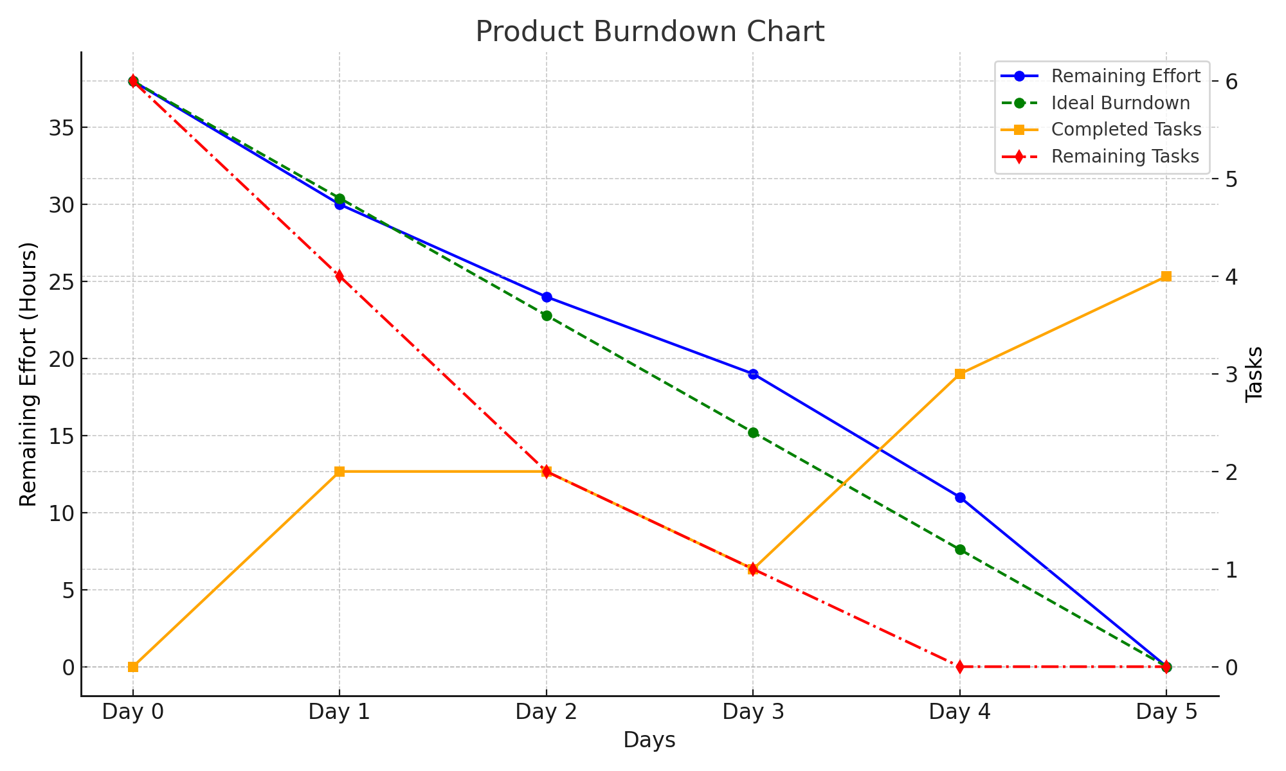

SPRINT BURNOUT TABLE
Day | Ideal Burndown (hrs) | Actual Remaining Effort (hrs)
Day 0 | 38 | 38
Day 1 | 34.2 | 35
Day 2 | 30.4 | 32
Day 3 | 26.6 | 29
Day 4 | 22.8 | 25
Day 5 | 19 | 21
Day 6 | 15.2 | 17
Day 7 | 11.4 | 12
Day 8 | 7.6 | 8
Day 9 | 3.8 | 3
Day 10 | 0 | 0

SPRINT BURNOUT CHART

SPRINT BURNDOWN CHART PREPARED IN JIRA TOOL
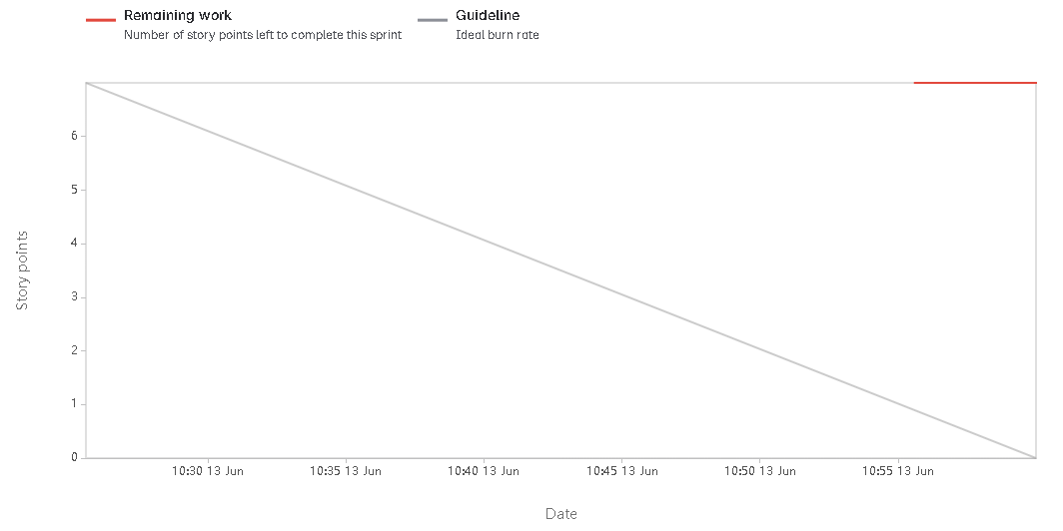

Question 6: Sprint Meetings
Answer:
Meeting Type 1: Sprint Planning Meeting
Date | 03/06/2025
Time | 10:00 AM
Location | Conference Room A / MS Teams
Prepared By | Ritesh Nigam
Attendees | BA Team, CRMNEXT Team, Agile Coach

Agenda Topics
Topic | Presenter | Time allotted
Backlog Review | Agile Coach | 15 mins
Sprint Goals Discussion | Product Owner | 20 mins
Task Assignment | Scrum Master | 25 mins

Other Information
Observers | IT Head, Business Sponsor
Resources | Kanban Board, Projector
Special Notes | Focus on integration backlog items

Meeting Type 2: Sprint Review Meeting
Date |  | 24/06/2025
Time |  | 4:00 PM
Location |  | Zoom / Conference Room B
Prepared By |  | Ritesh Nigam
Attendees |  | All Stakeholders
Sprint status | Things to demo | Quick updates | What's next
Completed Sprint 2 | Dashboard, Notifications | Integration module pending | Start UAT planning

Meeting Type 3: Sprint Retrospective Meeting
Date | 25/06/2025
Time | 11:00 AM
Location | MS Teams
Prepared By | Agile Coach
Attendees: Scrum Team, PO, Agile Coach
Agenda | What went well | What didn't go well | Questions / Reference
Sprint 2 Review | Daily stand-ups effective | Integration delay | Check CI/CD pipeline issues

Meeting Type 4: Daily Stand-up Meeting
Week: 3 (from 17-06-2025 to 23-06-2025)
Question: What did you do yesterday? | Name/Role | Monday | Tuesday | Wednesday | Thursday | Friday | Saturday | Sunday
Question: What did you do yesterday? | Developer 1 | Worked on lead assignment logic | Integrated feedback notification service | Integrated feedback notification service | Refined user stories with BA | Updated CRMNEXT dashboard UI | Worked on lead assignment logic | Worked on lead assignment logic
Question: What did you do yesterday? | Developer 2 | Updated CRMNEXT dashboard UI | Integrated feedback notification service | Refined user stories with BA | Refined user stories with BA | Fixed bug in lead escalation rules | Worked on lead assignment logic | Integrated feedback notification service
Question: What did you do yesterday? | Developer 3 | Refined user stories with BA | Integrated feedback notification service | Updated CRMNEXT dashboard UI | Refined user stories with BA | Integrated feedback notification service | Refined user stories with BA | Integrated feedback notification service
Question: What will you do today? | Name/Role | Monday | Tuesday | Wednesday | Thursday | Friday | Saturday | Sunday
Question: What will you do today? | Developer 1 | Conduct unit testing on new modules | Sync with integration team | Prepare for sprint demo | Update sprint board and blockers | Sync with integration team | Complete UAT test cases | Complete UAT test cases
Question: What will you do today? | Developer 2 | Update sprint board and blockers | Sync with integration team | Complete UAT test cases | Complete UAT test cases | Complete UAT test cases | Sync with integration team | Complete UAT test cases
Question: What will you do today? | Developer 3 | Prepare for sprint demo | Sync with integration team | Sync with integration team | Complete UAT test cases | Update sprint board and blockers | Conduct unit testing on new modules | Prepare for sprint demo
Question: What (if any) is blocking your progress? | Name/Role | Monday | Tuesday | Wednesday | Thursday | Friday | Saturday | Sunday
Question: What (if any) is blocking your progress? | Developer 1 | Waiting for API response mapping | Issue with environment setup | None | None | Waiting for API response mapping | None | Database access pending
Question: What (if any) is blocking your progress? | Developer 2 | Need clarification on sprint goal | None | None | Issue with environment setup | Issue with environment setup | Issue with environment setup | None
Question: What (if any) is blocking your progress? | Developer 3 | Need clarification on sprint goal | Waiting for API response mapping | Waiting for API response mapping | Issue with environment setup | Need clarification on sprint goal | Waiting for API response mapping | Issue with environment setup

