Online Agriculture Product Store
Prepared by: Deepika
Question 1: 4 Quarterly Audits for the project?
Quarterly audits will involve ensuring that the project aligns with business objectives, stakeholder expectations and document requirements. Each audit will check if the project meets quality, compliance and business objectives. As a BA my role is to provide documentation and clarify requirement-related queries.
Below are the 4 audits along with some key checklists.
Q1 Audit - Initiation & Requirement Phase Review
- Review and validate business requirements, functional & non-functional requirements.
- Ensure all stakeholder inputs are documented and addressed.
- Check if requirement gathering is complete and signed off.
- Provide necessary documentation (BRD, Use Cases, and Process Flows) for audit review.
Q2 Audit - Design & Development Progress Check
- Ensure requirements are correctly designed & developed.
- Validate traceability between requirements and developed features.
- Conduct gap analysis if any requirements are missed.
- Assist in reviewing documentation for changes and updates.
Q3 Audit - Testing & UAT Readiness
- Ensure test cases align with documented requirements.
- Verify that UAT is planned based on business scenarios.
- Assist in tracking defects that impact business requirements.
Q4 Audit - Final Review & Deployment Readiness
- Validate that all requirements have been delivered and tested.
- Confirm that the system is ready for go-live with minimal risk.
- Ensure documentation is complete (User Manuals, Training Materials, etc.).
- Support post-deployment monitoring and feedback collection.

Question 2: BA Approach strategy?
1. Steps need to follow to complete a project as a BA?
- Understand project scope & object.
- Conduct stakeholder analysis.
- Gather and document requirement.
- Validate & get sign-off on requirements.
- Support design & development.
- Assist in testing & UAT
- Manage change requests.
- Ensure proper documentation & approvals for project closure.

2. What Elicitation Techniques to apply?
We have many Elicitation techniques to gather requirements, some of them which can be implemented in this project are
- Workshops - Conduct requirement workshops with stakeholders.
- Interviews - One-on-one discussions with key stakeholders (Farmers, Manufacturers).
- Surveys & Questionnaires - Gather input from multiple farmers.
- Prototyping - Create UI wireframes to visualize requirements.
- Observation - Understand current manual processes of gathering products in villages.
- Document Analysis: Study existing agriculture product procurement methods.

3. How to do Stakeholder Analysis RACI/ILS?
Stakeholder Analysis can be done through RACI matrix which is already done in ‘Prep 1 Part 1’ document, below is the roles assigned to those stakeholders.
Role | Requirement Gathering | Development | Testing | Deployment | Sign-Off
Mr. Henry (Sponsor) | Informed | Informed | Consulted | Accountable | Accountable
Farmers (Peter, Kevin, Ben) | Consulted | Informed | Consulted | Informed | Consulted
Mr. Pandu (Finance Head) | Consulted | Informed | Consulted | Accountable | Accountable
Mr. Dooku (Coordinator) | Consulted | Consulted | Consulted | Accountable | Accountable
Mr. Karthik (Delivery Head) | Accountable | Accountable | Informed | Responsible | Responsible
Mr. Vandanam (PM) | Accountable | Responsible | Accountable | Responsible | Accountable
BA (Myself) | Responsible | Consulted | Consulted | Informed | Consulted
Development Team | Informed | Responsible | Informed | Responsible | Informed
Testers | Informed | Informed | Responsible | Informed | Informed
ILS (Interest, Level, Support) Analysis:
- High Interest, High Influence: Mr. Henry, Mr. Pandu, Mr. Dooku (Core decision-makers).
- High Interest, Low Influence: Farmers (Key contributors but not decision-makers).
- Low Interest, High Influence: Delivery Head, Finance Head.
4. What Documents to Write?
As a BA, it’s my responsibility to write some documents in different stage of project implementation.
- Business Requirement Document (BRD)
- Functional Requirement Specification (FRS)
- Use Case Document & User Stories
- Process Flow Diagrams
- AS-IS & TO-BE Documents
- Gap Analysis Documents
- Test Cases (for UAT support)
- Change Request Document (CRD)
- User Manual & Training Manual Documents.
- Client Project Acceptance Form (Sign-off document)
5. What process to follow to Sign off on the Documents?
- Prepare the document and validate it internally.
- Share it with key stakeholders for review.
- Conduct a walkthrough meeting to clarify doubts.
- Make revisions based on feedback.
- Get formal approval via email or digital signature.
6. How to take Approvals from the Client?
- Use formal email communication for document approvals.
- Use meetings and presentations to explain deliverables before approval.
- For major approvals, get a signed document or digital confirmation.
7. What Communication Channels to establish and implement?
There are different communication channels used by different companies where a BA need to communicate to all stakeholders.
- Project Updated – Through Email, Status reports
- Requirement Discussion – Through Meetings using MS Teams/Zoom calls
- Issue Resolution – Through Online meeting channels, WhatsApp Group
- Change Request Review – Through CR Tracker, Approval Emails
- Testing & UAT Updates – Through Jira, Test Management Tools
- Stakeholder Meetings – Through Monthly Review Meetings
8. How to Handle Change Requests?
Changes request can be come from any stakeholder based on need, to handle this below are the steps.
- Identify the Change - Receive a request from a stakeholder.
- Analyse the Impact - Assess scope, budget and timeline for the new change.
- Get Approvals – Need to take Stakeholder approval.
- Update Requirements & Documentation - Modify BRD, FRS, TO-BE and test cases.
- Implement & Test the Change - Ensure proper testing before deployment.
9. How to update the progress of the project to the Stakeholders?
- Weekly status report with business scenarios status and bug status.
- Demo sessions to showcase completed modules.
- UAT observations status to update UAT feedback report.
10. How to take signoff on the UAT- Client Project Acceptance Form?
- A final UAT session need to conduct with key stakeholders.
- Need to document all UAT observations and feedbacks.
- Ensure all requirements are met and tested.
- Prepare the Client Project Acceptance Form with Scope of work, UAT test results, Issues addressed & Final acceptance statement.
- Get client sign-off via email or official document.

Question 3: Explain 3-tier architecture?
A 3-tier architecture is a client-server architecture that separates an application into three layers:
- Presentation Layer – User Interface (UI)
This is the frontend/UI that interacts with users. It can be a web browser, mobile app or desktop application. Ex: HTML, CSS, JavaScript, etc.
- Application Layer – Processes business logic
It handles the application's core business logic and processes. Interacts with both the UI and the database. Ex: Java, Python, .Net, etc.
- Data Layer – Manages data storage
Stores, manages and retrieves data. Ensures data integrity, security, and backup.
Ex: SQL, Oracle, DB2, etc.
Question 4: BA Approach Strategy for Framing Questions?
As a Business Analyst, asking the right questions is crucial to understanding requirements, identifying gaps and defining the right solutions. Below is the approach using various techniques?
1. 5W 1H Approach Strategy.
- Who: Identifies stakeholders & users involved.
Ex: Who will use the system? (Farmers, Manufacturers, Admin)
- What: Determines features, requirements and functionalities.
Ex: What products will be listed? (Fertilizers, seeds and pesticides)
- When: Defines timelines, frequency.
Ex: When should farmers be notified about order updates?
- Where: Identifies locations, interfaces or platforms.
Ex: Where will the system be hosted, Web, Mobile or Both?
- Why: Justifies the need, purpose to be solved.
Ex: Why do farmers prefer this system over local suppliers?
- How: Explains processes, workflows and implementation.
Ex: How will payments be processed?
How will deliveries happen?
2. SMART Approach Strategy.
SMART stands for Specific, Measurable, Achievable, Relevant & Time-bound, it ensures that requirements are Clear and actionable.
- Specific: Need to ask questions which are clearly defines scope.
Ex: Should the system support bulk orders from farmers?
- Measurable: This defines the criteria.
Ex: How many orders system should handle per hour?
- Achievable: This defines the feasibility of the requirement.
Ex: Can farmers track their delivery in real-time?
- Relevant: This defines whether it aligns with business needs
Ex: Should the system provide credit-based purchases for farmers?
- Time-bound: This defines the timeline of the requirements
Ex: When should we complete the basic version of the system?
3. RACI Approach Strategy.
RACI helps to structure the stakeholder communication when framing the questions in different phases.
Tasks | Responsible | Accountable | Consulted | Informed
Gathering Requirements | BA | PM | Farmers, Manufacturers | Mr. Henry, Mr. Pandu
Approving System Design | Dev team | PM | BA, QA, Network Admin | Mr. Dooku, Client
Testing | Testers | QA Lead | BA, Dev team | Mr. Karthik
Final UAT Sign-off | Client | Mr. Henry | BA | All Stakeholders

4. 3 Tier Architecture Approach Strategy.
- Presentation Layer (UI/UX):
How the UI should be designed for ease of use?
Should it support multiple languages?
- Business Logic Layer:
Should there be role-based access?
- Database Layer:
How should data be structured for scalability?
What security measures should be implemented for data?
5. Use Cases, Use case Specs and Activity Diagrams Approach Strategy.
This helps to visualize workflow of each activity done by farmers.
Ex: What happen if an order is placed?
What happens if payment fails?
Can farmers cancel orders?
How will delivery tracking work? Etc.
6. Models and Page designs Approach Strategy.
This helps to ensure proper dataflow and UI design.
Ex: What data fields should be captured for each product?
What reports are required?
What are the must-have features on the homepage?
How many steps should be there in the checkout process? Etc.

Question 5: As a Business Analyst, What Elicitation Techniques you are aware of? (BDRFOWJIPQU)
Elicitation is the process of gathering requirements from stakeholders to ensure project success. There are different elicitation techniques which are used based on project & stakeholders availability.
Brainstorming: Used to generate new ideas and solutions through open discussion.
Document Analysis: Reviews existing reports, policies, workflows & system documents.
Reverse Engineering: Studying existing system like competitors online agriculture store to identify necessary features.
Focus Group: Conducting a discussion with farmers by bringing them together to discuss system expectations.
Observations: Watching stakeholders (Farmers) in their real work environment to understand pain points.
Workshop / JAD: Group discussion with stakeholders, developers and testers to collaboratively define requirements like, Order fulfilment workflow.
Interview: One-on-one or group discussion with farmers to gather deep insights.
Prototype: Creating wireframes or Prototype of the application to get the feedback from the stakeholders.
Questionnaire: Doing surveys with farmers with structured Questionnaire to collect feedback like, asking about their preferred payment methods.
Use Case Specs: Defining use cases to understand system interactions and functionalities with users. Like, process of a farmer placing an order online.

Question 6: Elicitation Techniques used for this project?
Below are the Elicitation Techniques used in this Project
- Prototyping
- Use case Specs
- Document Analysis
- Brainstorming
Prototyping: Why this should be considered because as Farmers and Manufacturers are not technical users, a visual representation will help gather accurate feedback from them, so creating some prototypes of UI pages which include product catalogue, search functionality, payment process and delivery tracking can be very useful for us to know how to implement the product.
Once the prototypes are created, share them to required stakeholders (Mr. Henry, Peter, Kevin, Ben, and manufacturers) for validation.
Collect the feedback from them and do the changes in design accordingly before starting the actual development. This will reduce time effort and money
Use case Specs: Why this should be considered because, this project has multiple user roles and specific actions, so defining step-by-step workflows is necessary. This technique helps to define system interaction between different users like Farmers, Manufactures & Admin.
Use cases can be specified for below with actors Involved, Conditions, Process flow and Exceptions.
- Farmers search & purchase a product
- Manufacture uploads product details
- Farmers login and manages account
- Order payment and delivery tracking
Use Case Example: Search for product
Actor: Farmer
Condition: Farmer visit the website
Process flow: Enter product name -> Click on Search -> view product details
Exception: If no product found -> Display message as “No product is available”
Document Analysis: Why this should be considered because, this helps in understanding existing agricultural regulations provided by government, existing applications in market and SOONY company business goals.
We can achieve this by reviewing existing government regulation on online agriculture product, and by studying competitor’s e-commerce application for best practice.
Brainstorming: Why this should be considered because, this can be used to engage key stakeholders (Farmers, Manufacturers & Mr. Henry) at one place and gather their thoughts for innovative ideas for implementing online agriculture store and process improvements.
In this session we can discuss with stakeholders regarding Payment options, agricultural products, delivery options and more. As the stakeholders are farmers, they can give real time solutions how to do deliveries in rural areas, what kind of payment options can be used and what type of products can be on boarded.
Business Requirements
BR001 - Farmers should be able to search for available products in fertilizers, seeds, pesticides
BR002 - Manufacturers should be able to upload and display their products in the application
BR003 - Farmers should be able to log in/sign up before making a purchase.
BR004 - Farmers should have an easy-to-use payment gateway supporting COD, UPI, Credit / Debit Card.
BR005 - The system should send email /SMS confirmation of order status to farmers.
BR006 - Farmers should have a delivery tracking system for their orders through mobile.

Question 7: Write 10 Business Requirements.
BR001 - Farmers should be able to search for available products (fertilizers, seeds, pesticides) using filters like price, category and manufacturer.
BR002 - Manufacturers should be able to upload, update and manage their products in the system with descriptions, prices and images.
BR003 - Farmers should be able to register and log in using an email ID and password or mobile OTP authentication.
BR004 - The system should support multiple payment methods including COD, UPI, Credit/Debit Card and Net Banking.
BR005 - Farmers should receive real-time notifications via SMS and Email for order confirmation, dispatch and delivery updates.
BR006 - The system should provide a delivery tracking feature where farmers can check the status and estimated delivery time of their orders.
BR007 - The application should support multiple languages e.g., English, Hindi, Telugu, Tamil, etc. to farmers in different regions.
BR008 - Farmers should be able to rate and review purchased products and provide feedback to help other users make informed decisions.
BR009 - The platform should allow an admin user to manage user accounts, product listings, payments and dispute resolutions.
BR010 - The system should generate monthly reports on sales, orders and user activity for analysis by SOONY and APT IT SOLUTIONS.

Question 8: Assumptions.
Project Assumptions:
- The platform will be web and mobile app for accessibility.
- The system will have three primary user roles – Farmers, manufactures and Admin.
- The platform will serve in remote areas with ease of use and having multiple language option.
Functional Assumptions:
- Farmers can able to browse the application for products without logging in, but need to register for placing an order.
- A search and filter option based on products, category and price can help farmers to find what they need.
- Manufacturers are responsible to list out their products with details including price, availability and images.
- The system should allow multiple payment options including COD, Debt/Credit card, Net banking and UPI.
- Orders will be delivered to farmer’s location and a real time delivery tracking system will be available.
- Farmers will receive SMS / Email for their order confirmation, Dispatch and delivery status.
Security Assumptions:
- Farmers and Manufacturers financial and personal data will be secured with encryption.
- Role based access control (RBAC) will be provided to prevent unauthorized access. (will be managed by Admin)
Business Assumptions:
- SOONY Company will own the product and will be responsible for its funding and operations.
- The system will generate monthly reports for SOONY and APT IT SOLUTIONS on sales, orders and other activities.

Question 9: This project Requirements Priority
ID | Business Requirement | Priority (1-10) | Justification
BR001 | Farmers should be able to search for available products (fertilizers, seeds, pesticides) using filters like price, category and manufacturer. | 10 | Core functionality for farmers to find products.
BR002 | Manufacturers should be able to upload, update and manage their products in the system with descriptions, prices and images. | 9 | Important for keeping product data up to date.
BR003 | Farmers should be able to register and log in using an email ID and password or mobile OTP authentication. | 10 | Required for user authentication.
BR004 | The system should support multiple payment methods including COD, UPI, Credit/Debit Card and Net Banking. | 9 | Required for multiple payment options.
BR005 | Farmers should receive real-time notifications via SMS and Email for order confirmation, dispatch and delivery updates. | 8 | Important for keeping farmers informed about their orders.
BR006 | The system should provide a delivery tracking feature where farmers can check the status and estimated delivery time of their orders. | 8 | Improve trust of farmers on application.
BR007 | The application should support multiple languages e.g., English, Hindi, Telugu, Tamil, etc. to farmers in different regions. | 7 | Important for customer accessibility but can be in Phase 2
BR008 | Farmers should be able to rate and review purchased products and provide feedback to help other users make informed decisions. | 6 | Helps to gain trust of customers and reviews
BR009 | The platform should allow an admin user to manage user accounts, product listings, payments and dispute resolutions. | 8 | Essential for system maintenance and smooth flow.
BR010 | The system should generate monthly reports on sales, orders and user activity for analysis by SOONY and APT IT SOLUTIONS. | 5 | Useful for business analysis but not an immediate requirement.

Question 10: Draw use case diagram
A use case diagram is a visual representation of the interactions between users and system.
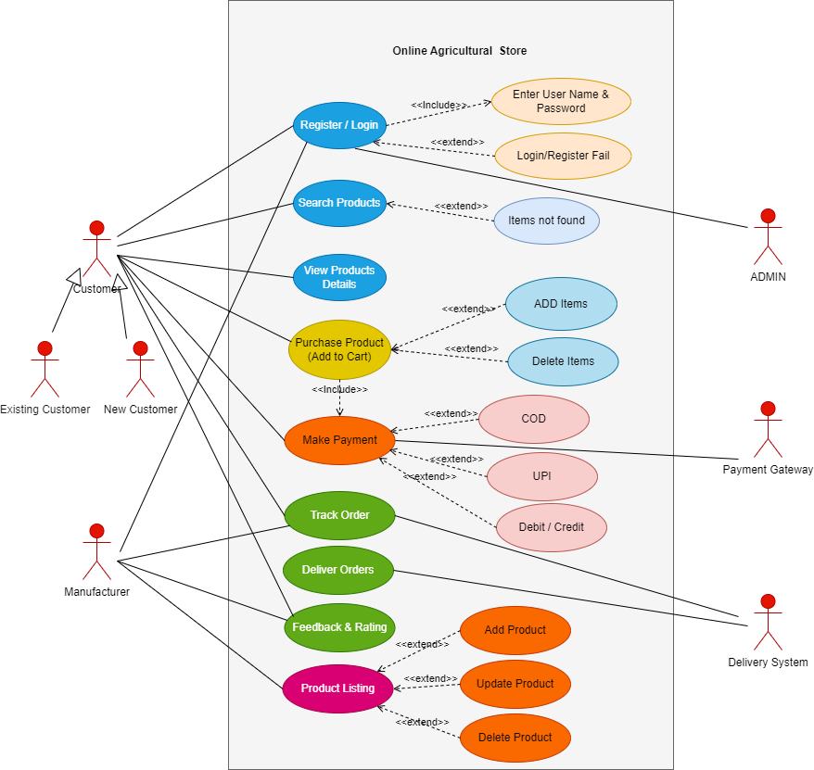

Question 11: Use Case Spec
1. User Login
Use Case ID: USD_OAS_01
Use Case Name: User Login
Use Case Description: User can login in to the system.
Actor: Farmer, Manufacturer & Admin
Precondition: Prerequisites to perform the Use Case
1. Active Internet
2. System should be up and running
3. Login - User should have valid user name & password.
Basic Flow of Events:
1. User will enter User name and Password and click on Login button.
2. System validates credentials and give Login Success message
3. User enters into the system
Alternative Flow:
1. User enter credentials and click on Login button.
2. System validates and show wrong credentials if not valid
3. User Re-enter credentials and click on Login button.
4. If Valid User enters into the system
Exceptional Flow:
1. User enter credentials and click on Login button.
2. System validates and show wrong credentials if not valid
3. User Re-enter credentials and click on Login button.
4. If not valid shows Error message
5. After 3 attempts, System will block the user and ask to retry after some time.
Post Condition: User successfully logs in.
2. Farmers Search for Product
Use Case ID: USD_OAS_02
Use Case Name: Search of Product
Use Case Description: User can search the products of his choice.
Actor: Farmer
Precondition: Prerequisites to perform the Use Case
1. Active Internet
2. System should be up and running
3. Login is not mandatory.
4. User need have clarity of what product he is looking for.
Basic Flow of Events:
1. User enters product name or selects category.
2. System retrieves the searched products from the database.
3. Products are displayed with filters and sorting options.
Alternative Flow:
1. User enters product name or selects category.
2. If product not found, System retrieves nearby matching products from the database.
3. Products are displayed with filters and sorting options.
Exceptional Flow:
1. User enters product name or selects category.
2. If product not found, System shows error message as “No Product Found”
Post conditions: Search results are displayed.
3. View Product Details
Use Case ID: USD_OAS_03
Use Case Name: View Product Details
Use Case Description: User can view details of the product for which he is searching for.
Actor: Farmer
Precondition: Prerequisites to perform the Use Case
1. Active Internet
2. System should be up and running
3. Login is not mandatory.
4. User need to select the product from the category.
Basic Flow of Events:
1. User enters product name.
2. System retrieves the searched products from the database.
3. User selects the product from the displayed list.
4. System displays product details (name, price, description, manufacturer, stock availability).
5. User can choose to add the product to the cart or wish list.
Alternative Flow:
1. User enters product name or select category.
2. If product not found, System retrieves nearby matching products from the database.
3. User selects the product which he likes and view the details.
Exceptional Flow:
1. User enters product name or selects category.
2. If product not found, System shows error message as “No Product Found”
Post conditions: Product details are displayed.
4. Add Products to Cart.
Use Case ID: USD_OAS_04
Use Case Name: Add Products to Cart
Use Case Description: User can add the products to cart and can proceed for checkout.
Actor: Farmer
Precondition: Prerequisites to perform the Use Case
1. Active Internet
2. System should be up and running
3. Login is mandatory.
4. User need to add the product to the cart.
Basic Flow of Events:
1. User selects a product and add to cart.
2. System stores the product in the cart.
3. User can continue shopping to add more products or proceed to checkout.
Alternative Flow:
1. User selects a product and add to cart.
2. System fails to stores the product in cart due to server issue or non-availability of product.
3. User can continue shopping to add another products or User can click on “Notify me” to buy the product when available.
Exceptional Flow:
1. User selects the product to add in cart.
2. System shows error as “Product out of Stock”
Post Condition: Product is added to cart.
5. Place an Order
Use Case ID: USD_OAS_05
Use Case Name: Placing an Order
Use Case Description: User can place the order of selected products by doing payment from the given options.
Actor: Farmer
Precondition: Prerequisites to perform the Use Case
1. Active Internet
2. System should be up and running
3. Login is mandatory.
4. User need to add the product to the cart.
5. User need to choose one payment mode.
6. User need to have valid card / UPI details if chosen that option.
Basic Flow of Events:
1. User selects the products and add to cart.
2. User clicks "Checkout" and reviews the order summary.
3. User selects a payment method and enter the payment details.
4. System validated the details and confirms the order.
4. System processes the order and generates an order ID.
5. User receives confirmation via SMS/Email.
Alternative Flow:
1. User selects the products and add to cart.
2. User clicks "Checkout" and reviews the order summary.
3. User selects a payment method and enter the payment details.
4. System validates the payment details, if not valid, asks to select another payment mode.
5. User selects another payment mode and provide the details.
6. System validates and processes the order and provides order ID.
7. User receives confirmation via SMS/Email.
Exceptional Flow:
1. User selects the products and add to cart.
2. User clicks "Checkout" and reviews the order summary.
3. User selects a payment method and enter the payment details.
4. System validated the details and if not valid shows alert as “Payment Failed”.
5. System shows message as “Order not confirmed, please try again”.
Post conditions: Order is successfully placed along with Order ID.
6. Make Payment
Use Case ID: USD_OAS_06
Use Case Name: Payment for placing an order.
Use Case Description: User can place the order of selected products by doing payment from the given options.
Actor: Farmer
Precondition: Prerequisites to perform the Use Case
1. Active Internet
2. System should be up and running
3. Login is mandatory.
4. User need to add the product to the cart.
5. User need to choose one payment mode.
6. User need to have valid payment details.
Basic Flow of Events:
1. User selects the products and add to cart.
2. User clicks "Checkout" and reviews the order summary.
3. User selects a payment method and enter the payment details (UPI no/Card Details/ Bank details).
4. System validated the details from Payment gateway and confirms the order.
4. System processes the payment and shows “Payment Successful” message.
5. User receives confirmation via SMS/Email.
Alternative Flow:
1. User selects the products and add to cart.
2. User clicks "Checkout" and reviews the order summary.
3. User selects a payment method and enter the payment details.
4. System validates the payment details from payment gateway, if not valid, asks to select another payment mode.
5. User selects another payment mode and provide the details.
6. System validates and Payment details from Payment gateway, if valid shows “Payment Successful” message.
7. User receives confirmation via SMS/Email.
Exceptional Flow:
1. User selects the products and add to cart.
2. User clicks "Checkout" and reviews the order summary.
3. User selects a payment method and enter the payment details.
4. System validated the details and if not valid shows alert as “Payment Failed”.
5. System shows message as “Order not confirmed, please try again”.
Post conditions:
1. Payment is completed successfully.
2. Order confirmed with Order ID.
7. Track Order
Use Case ID: USD_OAS_07
Use Case Name: Track Order.
Use Case Description: User can track his order status.
Actor: Farmer
Precondition: Prerequisites to perform the Use Case
1. Active Internet
2. System should be up and running
3. Login is mandatory.
4. Order must be placed successfully.
5. User need to have valid Order ID.
Basic Flow of Events:
1. User login in to the system.
2. User should navigate to “Track Order” option.
3. User should enter valid Order ID and click on submit.
4. System will display Order delivery status.
Alternative Flow:
1. User login in to the system.
2. User should navigate to “Track Order” option.
3. User should enter valid Order ID and click on submit.
4. If Order ID not valid, System throws error message as “Enter Valid Order ID”
5. User need to enter Order ID again.
6. System validates and displays Order delivery status.
Exceptional Flow:
1. User login in to the system.
2. User should navigate to “Track Order” option.
3. User enter Order ID and click on submit.
4. If tracking system is down or Order ID not valid, System throws error message as “Invalid Order ID / Data not available”
Post conditions: Order status is displayed.
8. Add/Update/Delete Product Listings
Use Case ID: USD_OAS_08
Use Case Name: Product Listing.
Use Case Description: Manufacturer can Update, Delete or Add products in the system.
Actor: Manufacturer
Precondition: Prerequisites to perform the Use Case
1. Active Internet
2. System should be up and running
3. Login is mandatory.
4. Products should be available in stock.
5. Detailed specifications need to update.
Basic Flow of Events:
1. User login in to the system.
2. User navigates to "Manage Products" and selects an action (Add, Update or Delete)
3. User need to Add or Update or Delete the products into system.
4. System will validate the details and update in the database.
Alternative Flow:
1. User login in to the system.
2. User need to Add or Update or Delete the products.
3. System will validate the details if any details missing, will through alert as Invalid Product / Unable to delete / Unable to update.
4. User need to re update / Add / Delete the product.
5. System will validate and through message as “Successfully updated / Added / Deleted”
Exceptional Flow:
1. User login in to the system.
2. User need to Add or Update or Delete the products.
3. System will validate the details if not matching with Data base, will through alert as Invalid Product / Unable to delete / Unable to update.
Post conditions: Product is updated successfully.

Question 12: Minimum 5 Activity Diagrams.
Below are five essential Activity Diagrams for the Online Agriculture Product Store project:
1. User Registration and Login, Activity Diagram.
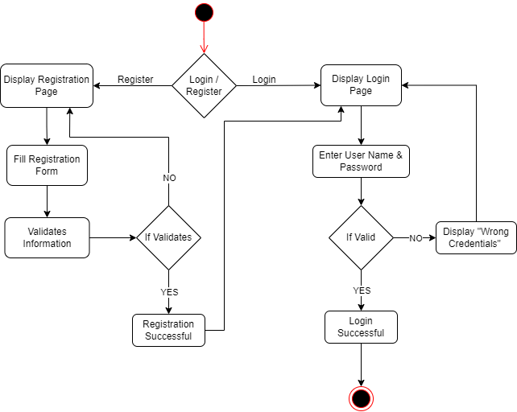

2. Product Search & View, Activity Diagram.
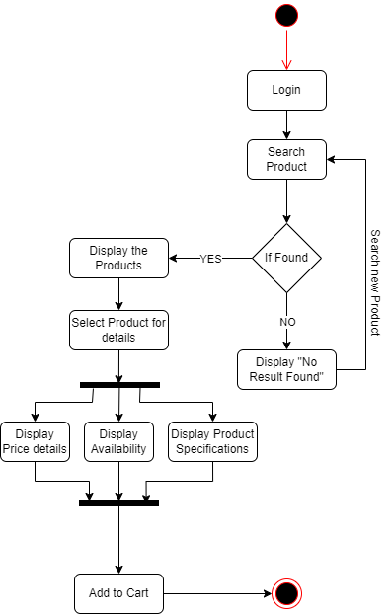

3. Order Placement & Payment, Activity Diagram

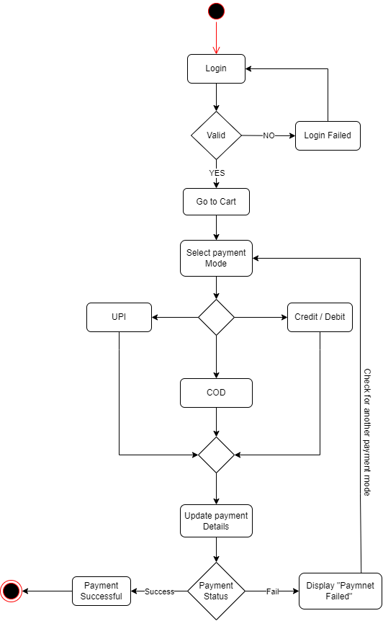

4. Order Tracking Activity Diagram.
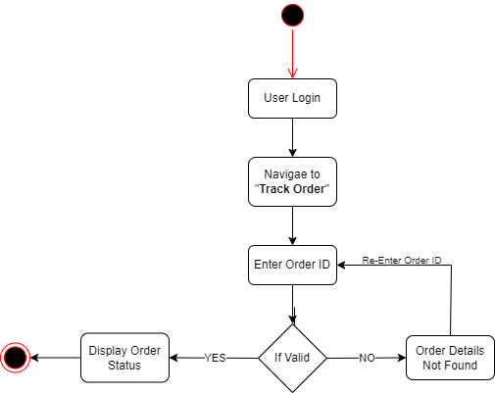

5. Manufacturer Product Management Activity Diagram
