Document 1. Business case document template
Why is this project initiated?
Ans: My intention is To develop an online shopping application for customers to purchase the products and other things in online go through with internet.
What are the current problems?
Ans: The current problems are
People/customers now a days they will go to the shops and buying the products here is the its time westing process and it create like problem, my concern is creating a online shopping application and provide products in online for the customers, but during this application developing aim facing some problems like,
- Security Concerns: Online shoppers often face risks like data breaches and payment fraud.
- Product Mismatch: Items received may differ from what was shown online, leading to dissatisfaction.
- Delivery Delays: Unexpected shipping delays can affect customer trust and experience.
- Return and Refund Issues: Complicated return processes and delayed refunds frustrate users.
With this project how many problems could be solved?
Ans: 1. Some of the processes can be resolved with cloud only here we can see,
- Enhanced Security: Implementing strong encryption and secure payment gateways reduces fraud.
- Accurate Listings: High-quality images and detailed descriptions help match customer expectations.
- Faster Delivery: Integrated logistics systems improve delivery speed and tracking.
- Easy Returns: A user-friendly return and refund process boosts customer satisfaction.
What are the resources required?
Ans:
People: project manager, business analyst, developers, testers and UI/UX team, architect and sponsor
Time: the total duration of the project is 8 months
Budget: the total budget of the project is 2cr
Other: third party software like JAVA, HTML does not exceed 5,00,000
How much organizational change is required to adopt this technology?
Ans: Organization needs to hire product team of team lead and 5 product managers for training and monitoring by end users
New skills required for system administration and maintenance. Some staff may need training on the new system
Time frame to recover ROI?
Ans: Estimated ROI (Return On Investment) Recovery Time
Based on industry benchmarks and assuming a moderate to high level of efficiency gains and revenue growth, here are some estimated ROI recovery time frames:
1. Best-Case Scenario: 6-12 months
High business volume
Significant efficiency gains
Strong revenue growth
2. Average Scenario: 12-24 months
Moderate business volume
Moderate efficiency gains
Steady revenue growth
3. Worst-Case Scenario: 24-36 months
Low business volume
Limited efficiency gains
Slow revenue growth
How to identify stakeholders?
Ans: Identifying the stakeholders is the important step before starting a project. By using stake holder analysis. we can identify the stake holders. Firstly we need to define the project scope(objectives). Then we need to grouping the stakeholders based on their interest their level of participation, experience and influence in the project and how they give their best to involve and communicate each of these stakeholder groups. We can also use RACI matrix for identifying stakeholders
Document 2. BA Strategy
Write a BA approach strategy (as a Business Analyst, what are the steps that you would need to follow to complete a project – what elicitation techniques to apply, how to do stake holder analysis RACI/ILS, what documents to write, what process to follow to sign off on the documents, how to handle change requests, how to update the progress of the project to the stakeholders, how to take sign off on the UAT- client acceptance form)
Ans: BA STRATEGY
Elicitation Techniques:
Conducting interviews with the stakeholders(client) to gather the requirements. By organizing focus group sessions to understand the customer needs and preferences. Review existing system and documents to gather additional information. Conduct surveys and questionnaire to gather the customer perspective.
Stakeholder analysis:
Conduct RACI (Responsible, Accountable, Consulted, Informed) or ILS (Involved, Lead, Support) analysis to determine the roles and responsibilities of each stakeholder. Identify the key stakeholders and prioritize their requirements. Establish effective communication channels with the stakeholders to keep them informed about the progress of the project.
Documents:
Write a Requirements Document (RD) to outline the functional and non-functional requirements of the project. Create a Business Requirements Document (BRD) to provide a detailed description of the project's objectives, scope, and deliverables. Prepare a Project Charter to define the project's goals, deliverables, timeline, and budget. Develop a Use Case Document to describe the processes and workflows involved in the project
Sign Off:
Obtain sign-off from the stakeholders on the Requirements Document, Business Requirements Document, Project Charter, and Use Case Document. Ensure that the stakeholders understand and agree with the requirements, scope, and objectives of the project.
Approvals
Obtain the client's approval on the project deliverables, budget, timeline, and approach. Ensure that the client's expectations are aligned with the project's goals and objectives.
Communication Channels:
Establish a regular communication schedule with the stakeholders to keep them informed about the project's progress. Create a communication plan to outline the channels and methods of communication. Schedule regular status meetings with the stakeholders to discuss the project's progress and address any issues or concerns. Change Requests:
Handle change requests in a structured and systematic manner. Evaluate the impact of each change request on the project's scope, timeline, and budget. Obtain approval from the stakeholders before implementing the change request.
Progress Updates:
Keep the stakeholders informed about the project's progress through regular status reports and progress meetings. Highlight any risks or issues that need to be addressed. Provide regular progress updates to the stakeholders and seek their feedback.
UAT Sign-off:
Conduct User Acceptance Testing (UAT) to validate the project's deliverables. Obtain sign-off from the client on the UAT results and the Project Acceptance Form. Ensure that the project meets the client's expectations and requirements. Through mails we got approval from client
Document 3. FUNCTIONAL SPECIFICATIONS
Project Name | Online shopping application system
Customer Name | Shopping buddy
Project Version | OSAS-V.1.1.2
Project Sponsor | Mr. Bhanu& Mr. Venkatesh  CEO & VP of Shopping buddy
Project Manager | Mr, srikanth suthari
Project Initiation Date | 23-07-2025

Functional Requirement Specifications:
REQ ID | REQ Name | REQ Description | Priority
FR001 | Registration | User should be able to register with the application | 9
FR002 | Login | User can login with their unique ID and password after this the system shows their profile | 9
FR003 | User profile management | User should be able to view, edit and delete the details | 8
FR004 | Search for the products | User should be able to search for the products they want to buy | 8
FR005 | Multiple language support | The application should support the multiple languages for users | 6
FR006 | Add to Cart & Buying | User should be able to select the products and add to cart and buying in online | 7
FR007 | Payment options | User should be able to see the payment options | 8
FR008 | Order confirmation | User should be able to confirm their product details with invoice and price | 8
FR009 | Order cancellation | User should be able to cancel their order | 8
FR010 | Customer support | User should be able to contact the customer for any information | 7

Non-Functional Requirements:
REQ ID | REQ NAME | REQ DESCRIPTION | PRIORITY
NFR001 | Page loading time | The application should load in 2 seconds time 10 | 10
NFR002 | Availability | The system should be available 24/7, with minimal downtime and fast response times. | 10
NFR003 | Useability | The system should be user-friendly and easy to purchase, with an intuitive interface for customers products. | 9
NFR004 | Security | The system should ensure the security and integrity of customer data, including payment information and personal details | 8
NFR005 | Scalability | The system should be able to handle a large volume of orders and customers, and scale to meet the needs of growing tour operators. | 9
NFR006 | Integration | The system should be able to integrate with existing systems, including payment gateways, accounting software, and customer relationship management (CRM) systems. | 7
NFR007 | Capability | Capacity of the application should be high to store the data | 6
NFR008 | Performance | Application performance should be fast | 7
NFR009 | Description | Description of the Order should be mentioned | 8
NFR010 | Maintainability | Application should be maintained without errors and bugs | 7

DOCUMENT 4 Requirement Traceability Matrix

REQ ID | REQ Name | REQ Description | Design | D1 | T1 | D2 | T2 | UATD
FR001 | Registration | User should be able to register with the application | Yes | yes | Yes | Yes | Yes | Yes
FR002 | Login | User can login with their unique ID and password after this the system shows their profile | Yes | Yes | Yes | Yes | No | Yes
FR003 | User profile management | User should be able to view, edit and delete the details | Yes | Yes | No | No | No | Pending
FR004 | Search for the products | User should be able to search for the products they want to buy | Yes | Yes | Yes | Yes | No | Yes
FR005 | Multiple language support | The application should support the multiple languages for users | Yes | Yes | Yes | No | No | Pending
FR006 | Order& Confirmation | User should be able to order the products and buying products in online | Yes | Yes | No | Yes | No | Pending
FR007 | Payment options | User should be able to see the payment options | Yes | No | No | Yes | No | Yes
FR008 | OC-confirmation | User should be able to confirm their Order | Yes | Yes | Yes | Yes | No | Yes
FR009 | Order cancellation | User should be able to cancel their Order | Yes | No | No | yes | Yes | Yes
FR010 | Customer support | User should be able to contact the customer for any information | Yes | Yes | No | Yes | No | Pending

DOCUMENT 5 BRD Template
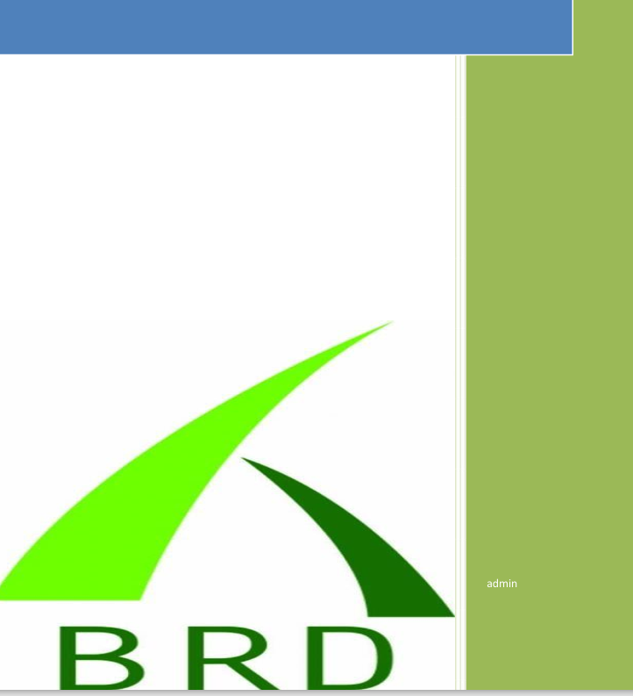

<Online shopping management system >
<OSM2122024>
<OMS-V.1.1.2>
<Srikanth Suthari>
1.Document Revisions
Date | Version number | Document changes
05/06/2025 | 0.1 | Initial draft
10/06/2025 | 0.2 | Requirements obtained
15/06/2025 | 0.3 | BRD approved
20/06/2025 | 0.4 | BRD and Use case diagrams shared
25/06/2025 | 0.5 | Activity diagram
30/06/2025 | 1.1 | Protype approved and added
6/07/2025 | 1.2 | Final draft

2. Approvals
Role | Name | Tittle | Signature | Date
Project sponsor | Bhanu | CEO of Shopping buddy | Bhanu | 05/06/2025
Business owner | Srikanth | Vice President | Srikanth | 31/06/2025
Project manager | Venkatesh | Senior manager | Venkatesh | 04/06/2025
System architect | Karthik | Asst manager | Karthik | 03/06/2025
Development lead | Sravani | Senior manager | Sravani | 03/06/2025
User experience lead | Ayyappa | Asst manager | Ayyappa | 03/06/2025
Quality lead | Kiran | Senior manger | Kiran | 03/06/2025
Content lead | Srinu | Asst manager | Srinu | 03/06/2025

3. RACI Chart for This Document
The RACI chart identifies the persons who need to be contacted whenever changes are made to this document. RACI stands for responsible, accountable, consulted, and informed. These are the main codes that appear in a RACI chart, used here to describe the roles played by team members and stakeholders in the production of the BRD. They are adapted from charts used to assign roles and responsibilities during a project. (RACI Can be made for IT side [Project stakeholder] as mentioned above, a part from that Can also Be made for Client side [Business Stakeholder]).
The following describes the full list of codes used in the table:
Codes used in RACI chart
Authorize has the ultimate singing authority for any changes to the document
R Responsible Responsible for creating this document
A Accountable Accountable for accuracy of this document
(for example, the project manager)
S Support provide supporting services in the production of this document
C Consulted provides input (such as an interviewee)
I Informed must be informed for any changes
RACI chart
Name | Position | * | R | A | S | C | I
Bhanu | Project sponsor |  |  |  |  |  | I
Srikanth | Business owner |  | R |  | S
Venkatesh | Project manager |  | R |  |  | C | I
Karthik | System architect |  |  |  |  | C
Sravani | Development lead |  | R | A

4.Introduction
4.1 Business Goals
(this should describe the organization goals and needs)
Ans: The purpose of this project to create a ONLINE SHOPPING MANAGEMENT SYSTEM for Customers to help them to find/check the availability of their desired quality products in online with (Price, information, delivery boys’ details, products). Shopping buddy made life very easy for customers by saving time and energy
4.2 Business objectives
Automate manual process: Reduce manual errors and increase productivity by automating tasks such as ordering, invoicing, and payment processing.
Increase online Sales: Provide a user-friendly online orders platform to increase direct sales and reduce commission fees.
Streamline products operations: Improve products quality, reasonable price, and management to reduce costs and enhance customer experience.
Personalized planed products : Offer customized plans based on customer preferences, budget, and time constraints.
4.3. Business Rules
[List Organization Policies, Procedures, and Rules& Regulations]
Business rules:
Organization Policies
1. ordering Policy: All selected orders must be made through the online platform or through authorized Shopping buddy agents.
2. Cancellation Policy: Cancellations must be made at least 72 hours prior to departure to avoid penalties.
3. Payment Policy: Full payment is required at the time of ordering.
4. Refund Policy: Refunds will be processed within 7-10 business days.

Procedures
1. products ordering Procedure: Customers must provide required documentation and payment information to complete product and ordering details.
2. Check-in Procedure: Customers must check-in at least 30 minutes prior to departure.
3. Complaint Handling Procedure: Customers can submit complaints through the website or by contacting customer support.
Rules and Regulations
1. Order Documentation: Customers must provide their details like home address and delivering address and point of contact ID documents, including phone numbers and near by land mark
2. Health and Safety: Customers must comply with health and safety regulations, including vaccination requirements.
3. Liability: The company is not liable for damages or losses resulting from customer negligence or non-compliance with rules and regulations.
4.4. Background
[Provide a brief history of how the project came to be proposed and initiated, including the business issues/problems identified, and expected benefit of implementing the project/developing the product.]
Ans: Customers order the different products. They need to search for the purchase to order product which he want. And themselves need to make the confirmation.
And sometimes they mis delivered by some delivery boys and they couldn’t find the products they want to buy. Almost every customer waste most of the time for shopping, like waiting list, transport and waiting offline
To over come this issue the SHOPPING BUDDY (SHOPPING MANAGEMENT SYSTEM) is developed to help the Customers regarding that buying products in online with internet, product confirmation, provide good things and quality products
Issues:
1.Inefficient Ordering Process: Manual products order processes led to errors, delays, and lost revenue.
2. Lack of Real-time Information: Outdated systems made it difficult to access real-time information on tour availability, customer orders, and payment status.
3. Ineffective Customer Communication: Manual communication processes led to missed notifications, lost documents, and dissatisfied customers.
Expected benefits:
1. Improved Operational Efficiency: Automate ordering processes, reduce manual errors, and increase productivity.
2. Enhanced Customer Experience: Provide real-time information, personalized itineraries, and timely notifications to improve customer satisfaction.
3. Increased Revenue: Optimize pricing, improve sales conversions, and reduce cancellations to increase revenue.
4.5. Project Objective
[These should describe the overall goal in developing the product, high level descriptions of what the product will do, how they are aligned to business objectives, and the requirements for interaction with other systems]
Project objective:
To develop a SHOPPING BUDDY (ONLINE SHOPPING MANAGEMENT SYSTEM) for Users by these customers can check whether the desired products with reasonable price is available or not. The users can confirm and cancel the product order by staying at home through online. Also they can select and different products which they want buy in online made confirmation, This will help the people to save their time and energy
4.6. Project Scope
[What we are going to develop in the current project]
We are going to develop Shopping Buddy application for ONLINE SHOPPING MANAGEMENT SYSTEM where users can order the products and made confirmation through online.
4.6.1. In Scope Functionality
[List what functionalities we are going to do with in the project in bullets]
- User should be able to register
- User should be able to login with the application
- User should be able enter and edit the personal details
- Users should be able to see the payment options
- User should be able to check the payment
- User should be able to logout
- User should able to through online
4.6.2. Out Scope Functionality
[List of functionalities what is not included in the current project]
Out scope functionality
- Integration with external CRM systems
- Integration with social media platforms
- Integration with third-party review and rating systems
- Shopping insurance management
- Customer chat and calls support services
- Orders documentation management (e.g. e-order confirmation, customer ID address and delivery location with invoice of product)
- Specialized payment operations (e.g. Offers with coupons and discounts with cards)
5. Assumptions
[List all assumptions requirements are based on]
Assumptions:
System is only accessible with the ONLINE SHOPPING MANAGEMENT SYSTEM only
Each user should have unique ID & PASSWORD
The system will be used to manage 100000 orders per a year
The system will be used by a single product operator with multiple branches.
Users will have access to a stable internet connection.
Users will be willing to provide feedback and suggestions for improving the system
6. Constraints
[List all Constraints]
Ans: Constraints
- Each user must have a valid user id and password.
- Server must be running for the system to function.
- The total developmental budget is 2cr
- The system must comply with industry-standard security protocols
- Only the Administrator can delete orders
7. Risks
In this section of the BRD, you describe risks. A risk is something that could affect the success or failure of a project. Analyse risks regularly as the project progresses. While you may not be able to avoid every risk, you can limit each risk’s impact on the project by preparing for it beforehand. For each risk, you’ll note the likelihood of its occurrence, the cost to the project if it does occur, and the strategy for handling the risk. Strategies include the following:
• Avoid: Do something to eliminate the risk
• Mitigate: Do something to reduce damage if risk materializes.
• Transfer: Pass the risk up or out to another entity.
• Accept: Do nothing about the risk. Accept the consequences.
Technological Risks:
In ONLINE SHOPPING Management System, we need strong network connection. Otherwise, we can’t do anything. It’s a main technological risk.
There must be a data backup at least in two instances in order to manage the data corruption.
Size of the database should be enough to hold all the customers/users data
Skills Risks
Mainly for miscommunication between the stakeholders
Every Business Analyst should full fill the client needs
As a BA, he should update the knowledge day by day
Business risks:
Conducting meeting with the key stakeholders/clients
Conducting meeting with full team to discuss about the work
Defining the team roles
Requirements Risks:
Incomplete/improper requirement gathering
Changing requirements
Lack of prioritization
Lack of stake holder involvement
8. Business Process Overview
[This describes the overall process flow from each phase]
Ans: To develop a ONLINE SHOPPING MANGEMENT system firstly we need to create login page, and enter login details then login screen leads to the screen displayed the products interface, and we choose our desired product after choosing the product we want to buy the product system will leads to payment section after making the payment the system displays the product order confirmation notification.
8.1. Legacy System (AS-IS)
[Brief Explanation about the process in legacy system and draw process flow diagrams]
Ans: AS-IS diagram
The diagram illustrates a Legacy (AS-IS) system workflow for a product ordering Process.
The process starts with a New User Decision and proceeds through registration, login, products search, and order steps, ending with a successful order confirmation.
The flow incorporates user validation, product search, and payment handling.

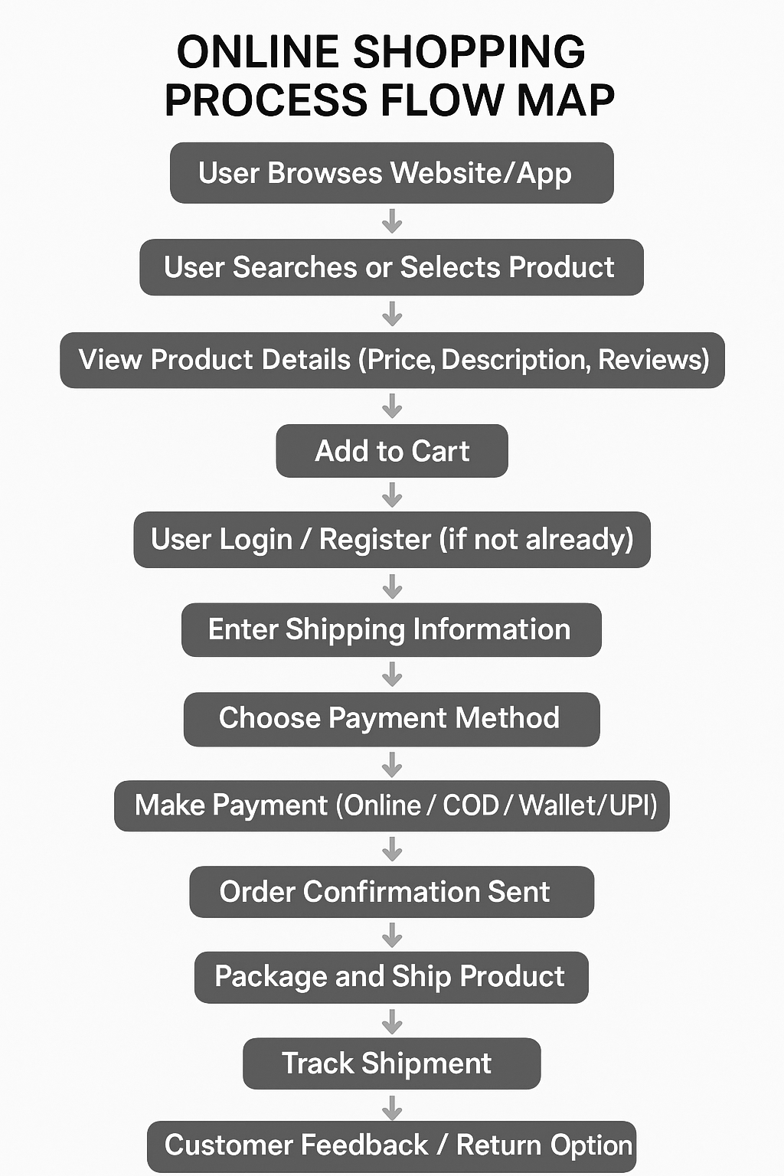
8.2. Proposed Recommendations (TO-BE)
[Describe the recommended process and how the proposed system will address the challenges in legacy system]
Ans: TO-BE diagram: The below diagram represents a proposed (TO-BE) process for a products order System. The TO-BE system streamlines the user buying by incorporating enhancements and handling additional features, such as multi-orders (point, frizz, car) and improved payment validation.
The TO-BE system improves the product booking process by enabling multiple products (point, frizz, car) in parallel after a user orders a product. It also ensures better payment validation and user flow efficiency.

9. Business Requirements
[The specific business requirements elicited from stakeholders should be listed, categorized by both priority and area of functionality to smooth the process of reading and tracking them. Include links to use case documentation, and other key reference material as needed to make the requirements as complete and understandable as possible. You may wish to incorporate the functional and non -functional requirements into a traceability matrix that can be followed throughout the project]
Ans: BUSINESS REQUIREMENTS
REQ ID | REQ Name | Description
BROO1 | products management | The system should allow different products to create, edit, and manage quality products, including itinerary, pricing, and availability
BR002 | Order management | The system should enable customers to order the products online, and allow products managers to manage orders, including payment processing and confirmation.
BR003 | Customer management | The system should allow manager to manage customer information, including contact details, booking history, and loyalty programs.
BR004 | Payment management | The application should allow users to place orders and make payments online
BR005 | Multi language support | The system should support the multiple languages for users
BR006 | Security | The system should ensure the security and integrity of customer data, including payment information and personal details
BR007 | Scalability | The system should be able to handle a large volume of orders and customers, and scale to meet the needs of growing tour operators.
BR008 | Availability | The system should be available 24/7, with minimal downtime and fast response times.
BR009 | Integration | The system should be able to integrate with existing systems, including payment gateways, accounting software, and customer relationship management (CRM) systems.
BR010 | Usability | The system should be user-friendly and easy to order, with an intuitive interface for customers and products managementors.

10.Appendices
10.1. List of Acronyms
Ans: List of Acronyms
Acronym | Full Form | Description
OSMS | Online shopping management System | The core system managing shopping-related operations.
CRM | Customer Relationship Management | A system for managing interactions with customers.
API | Application Programming Interface | A set of tools for building and interacting with software applications.
OSA | Online shopping Agency | Third-party services that sell products pricing or products online.
CNR | Customer Name Record | A record in the database of a CONFIRMATION system.
ERP | Enterprise Resource Planning | A business process management software for managing resources.
GPS | Global Positioning System | Used for buying and real-time location tracking.
GDS | Global Distribution System | A network for accessing shopping inventory like products, offline stores, and car rentals.

10.2. Glossary of Terms
ANS: Glossary of Terms
Term | Definition
Order products | Software that allows users to select the products and provide the services to customers like services online service, offline service,
ordering Itinerary | A detailed plan of products, including good quality and pricing, timings, and activities.
Vendor | Suppliers such as online stores, offline stores, or online shopping services they will provide
Product pricing | A pre-arranged combination of online shopping services sold as a single price.
Online store Agent | An individual or business that plans and order products for customers.
Cancellation Policy | Terms and conditions outlining refund and charges for cancelled ordering.
Confirmation | The customers or users get cancellation confirmation via mail or messaging option .
Dynamic Pricing | Real-time pricing changes based on demand and supply factors.
Online shopping Insurance | Coverage for potential risks or losses during online shopping, such as incorrect product or damaged products deliverer to customer, we will provide cancellation or refund replace option

10.3. Related Documents
Ans: Related Documents
Document Name | Description
System Requirements Document | Detailed technical and functional requirements for the OSMS.
User Manual | Instructions for users on how to Order products and use the OSMS system.
API Documentation | Guidelines for developers on integrating external systems or services.
Data Flow Diagram (DFD) | Visual representation of data flow within the system.
ER Diagram | Entity-Relationship diagram for database structure of the system.
Service Level Agreement (SLA) | Defines service expectations between the online shopping management system and users.
Privacy Policy Document | Explains how user data is collected, stored, and protected.
Test Case Document | Lists test scenarios to ensure system functionality and performance.
Training Material | Resources for training delivery agents and staff on using the TMS.

