Why is this project initiated?
Document 1- Business case document template
- The CRM system regularly logs and tracks all incoming leads, including those marked as disqualified.
- Disqualified leads are flagged when they fail to meet predefined qualification criteria during the sales process.
- The sales and marketing teams periodically review disqualified leads, but analysis is often limited to basic metrics.
- Most disqualified leads are categorized by reasons such as lack of budget, no
decision-maker.

What are the current problems?
- A high percentage of leads are being disqualified at early stages, reducing the pool of potential customers.
- The primary reasons for disqualification —such as incomplete information or unqualified prospects—are recurring and not systematically addressed.
- There is no consistent process for capturing detailed feedback on why leads are disqualified, leading to data gaps.
- Sales and marketing efforts may be misdirected, wasting resources on poorly targeted campaigns.

With this project how many problems could be solved?
- Analyzing disqualified leads can reveal patterns and root causes, enabling refinement of lead qualification criteria.
- Implementing structured feedback mechanisms can improve the accuracy and usefulness of disqualification data.
- Insights from disqualified leads can inform adjustments to marketing strategies, targeting, and messaging.
- Regular training sessions for sales teams based on disqualification trends can
enhance qualification accuracy.
- Leveraging this analysis can increase the overall quality of leads, reduce wasted effort, and improve conversion rates over time.

What are the resources required?
- People:
The project team will have about 8 to 10 members from both the client side and the ITS team. Team members will include a project manager, business analyst, technical experts, and users who know the business well. They will work together to make sure the project meets all the goals and runs smoothly.

Time:
The project to create the disqualified lead report will take 8 months to finish. This time includes all steps like gathering requirements, designing, building, testing, and launching the report. It is important to complete the project on time to avoid delays in business.

Budget:
The total budget for the project, including hardware, software, training, and services, will not go over Rs. 2,50,000. This money will cover all needed tools, licenses, and training for users. Careful spending will keep the project within budget.

Other:
There is an extra budget of Rs. 50,000 for things like checking third-party software, visiting sites, and buying Dataquest reports. These will help in making good decisions and ensuring the project works well. All extra costs will be controlled to stay within the overall budget.

How much organizational change is required to adopt this technology?
- Data migration and integration: Accurate transfer and integration of existing lead data into the CRM is essential before the report can be built, as clean and complete data forms the foundation for reliable reporting.
- User training and adoption: The success of the report depends on users being trained to enter disqualification reasons correctly and consistently, making training sessions and support resources a critical dependency.
- Technical setup and CRM customization: Customizing the CRM to include mandatory fields, workflows, and reporting features must be completed before the report can function as intended and may require coordination with IT or external consultants.
- Stakeholder input and approval: Gathering requirements, validating the report design, and securing sign -off from business stakeholders are necessary steps that must occur before final deployment to ensure the solution meets business needs.

Time frame to recover ROI ?

The project to create the disqualified lead report will take 8 months to finish. This time includes all steps like gathering requirements, designing, building, testing, and launching the report. It is important to complete the project on time to avoid delays in business work.

How to identify Stakeholders?
Using RACI matrix

Project Phase / Task | Project Manager | BA | Developers | Testers | Client/ S.H
Requirements Gathering | A | R | C | C | I
Requirements Documentation (SRS) | A | R | C | C | I
System Design | A | C | R | C | I
Implementation (Coding) | C | C | R/A | I | I
Unit Testing | C | I | R | A | I
Integration & System Testing | C | C | C | R/A | I
User Acceptance Testing (UAT) | I | R | C | A | R
Deployment | A | C | R | C | I
Maintenance & support | A | C | R | R | I

Document 2: BA Strategy

What Elicitation Techniques to apply: We have many elicitation techniques to apply used to gather requirements. Some of them are Brainstorming, Document Analysis, Reverse engineering, Focus Groups, Observation, etc. But in this project we use Interview (SH) , Focus group ( sales & marketing team) & if it required JAD session .

How to do Stakeholder Analysis RACI: Stakeholder analysis can be done by using the
RACI matrix involves identifying stakeholders and defining their roles and responsibilities within a project. - Identify Stakeholders, Define Roles and Responsibilities, Create the RACI Matrix, Assign RACI Roles.
What Documents to Write: BRD, FRD, Use Case Documentation, Test Case Documents

What process to follow to Sign off on the Documents: Sign Off to be taken on SRS as this is the primary and important document. Sign off can be taken by using E-mail confirmation from Client.
How to take Approvals from the Client: Establish a formal meeting with the clients to keep them informed and get continuous feedback.
What Communication Channels to establish n implement: Regular Meetings - Weekly status meetings, bi-weekly sprint reviews, and monthly stakeholder updates.
How to Handle Change Requests: Change Request Form, Do Impact Analysis, Approval Process, Documentation.
How to update the progress of the project to the Stakeholders: Weekly Status Reports, Monthly Review Meetings.
How to take signoff on the UAT- Client Project Acceptance Form) : UAT Preparation, Conduct UAT, Fix Issues, Acceptance Form, Final Review Meeting, Obtain Sign-off.

Document 3- Functional Specifications

Project name | ENHANCED CRM DISQUALIFIED  LEAD TRACKING REPORT
Customer name | Daniel
Project Version | Version 1.1.1
Project Sponsor | Logesh
Project Manager | Kirubakaran
Project Initiation date | 15/06/2025

Functional Requirement specifications:

Req ID | Req Name | Req Description | Priority
FR0001 | Login | User should be able login CRM  with their email id and pswd | 10
FR0002 | Disqualified lead filter | User should be select the disqualified lead  using filter report | 10
FR0003 | Disqualified lead  report | User should be  able view report | 10

 |  | with piechart percentage
FR0004 | Logout | User should be able logout CRM redirect to login  page | 10

Document 4- Requirement Traceability Matrix

Req  ID | Req  Name | Req  description | Design | D1 | T1 | D2 | T2 | UAT
FR000 1 | Login | User should be able login CRM with their email id and  pswd | Yes | yes | yes | yes | yes | yes
FR000 2 | Lead filter | User should be select the disqualified lead among all incoming leads using  filter report | yes | yes | yes | no | no | no
FR000 3 | Disqu alified lead report | User should be able view report with pie chart percentage and specific  details (reason) | yes | yes | no | no | no | no
FR000 4 | Logout | User should be able logout CRM redirect to  login page | yes | no | no | no | no | no

Document 5- BRD Template

PROJECT NAME: ENHANCED CRM DISQUALIFIED LEAD TRACKING REPORT.
PROJECT ID: PROJ-1234 -CRM-2025-A01
VERSION ID: Version 1.1.1
Author: Sam Rajan

Contents

- DocumentRevisions. 8
- Approvals. 8
- RASCI Chart for This Document 8
Codes Used in RASCI Chart 9
RASCI Chart 9
- Introduction 9
  - Business Goals. 9
  - Business Objectives. 9
  - Business Rules. 10
  - Background 10
  - Project Objective 10
  - Project Scope 10
    - In Scope Functionality 10
    - Out Scope Functionality 10
- Assumptions 10
- Constraints. 10
- Risks. 10
Technological Risks. 11
Skills Risks. 11
Political Risks. 11
Business Risks. 11
Requirements Risks 11
Other Risks. 11
- Business Process Overview 11
  - Legacy System (AS-IS) 11
  - Proposed Recommendations (TO-BE) 11
- Business Requirements. 11
- Appendices. 12
  - List of Acronyms. 12
  - Glossary of Terms. 12
  - Related Documents 12

Document Revisions
Date | Version Number | Document Changes
05/06/2025 | 0.1 | Initial Draft

Approvals.

Role | Name | Title | Signature | Date

Project Sponsor
Business Owner
Project
Manager
System Architect
Development
Lead
User
Experience Lead
Quality Lead
Content Lead

- RACI Chart for This Document
The RACI chart identifies the persons who need to be contacted whenever changes are made to this document. RACI stands for responsible, accountable, consulted, and informed. These are the main codes that appear in a RACI chart, used here to describe the roles played by team members and stakeholders in the production of the BRD. They are adapted from charts used to assign roles and responsibilities during a
project.( RACI Can be made for IT side[Project stakeholder] as mentioned above, apart from that Can also Be made for Client side[Business Stakeholder]). The following describes the full list of codes used in the table:
Codes Used in RACI Chart
* Authorize Has ultimate signing authority for any changes to the document. R Responsible Responsible for creating this document.
A Accountable for accuracy of this document (for example, the project manager) S Supports Provides supporting services in the production of this document
C Consulted Provides input (such as an interviewee). I Informed Must be informed of any changes.

Project Phase / Task | Project  Manager | BA | Developers | Testers | Client/S.H
Requirements Gathering | A | R | C | C | I
Requirements  Documentation (SRS) | A | R | C | C | I

System Design | A | C | R | C | I
Implementation (Coding) | C | C | R/A | I | I
Unit Testing | C | I | R | A | I
Integration & System Testing | C | C | C | R/A | I
User Acceptance Testing (UAT) | I | R | C | A | R
Deployment | A | C | R | C | I
Maintenance &  support | A | C | R | R | I

Introduction

Business Goals:
- To clearly define the objectives for analyzing disqualified leads within the CRM system.
- To identify and understand the key reasons behind lead disqualification in order to minimize lost opportunities.
- To enhance the lead qualification process by using data-driven insights for continuous improvement.
- To improve the efficiency and effectiveness of sales and marketing efforts by
focusing on high-potential leads.
- To ultimately increase the overall conversion rate and contribute to the organization’s revenue growth by reducing the number of disqualified leads through targeted strategies and informed decision -making.

Business Objectives :
- Define and document the specific business requirements for disqualified lead reporting, including required data fields such as disqualification reasons, lead source, and timestamps.
- Evaluate available CRM customization options to ensure the solution
supports mandatory selection of disqualification reasons and allows for future scalability.
- Select a reporting framework or tool within the CRM that enables easy extraction, filtering, and visualization of disqualified lead data.
- Develop a prototype of the disqualified lead report, incorporating all specified
fields and filters.
- Conduct user acceptance testing (UAT) with sales and marketing teams to validate the accuracy, usability, and completeness of the report.

- Collect feedback from testers to identify gaps or areas for improvement in the prototype.
- Refine the report design and underlying data processes based on test results before final deployment.

List what the functionalities are going to develop in software:
Disqualified report within CRM

Business Rules
[List Organization Policies, Procedures, and Rules& Regulations]

Policies:
All disqualified leads must adhere to a standardized list of reasons and be recorded in compliance with organizational data integrity and retention policies.

Procedures:
Users must follow the defined CRM workflow to review, mark, and document disqualified leads, ensuring timely reporting and future analysis.

Rules& Regulations:
Leads can only be disqualified based on clear, predefined criteria, with mandatory justification logged in the CRM to support accountability and consistency.

Background
The disqualified leads report within the CRM project was proposed in response to recurring business challenges where sales teams struggled with large volumes of unqualified leads clogging the CRM, inconsistent recording of disqualification reasons, and poor data quality, which collectively reduced sales productivity and compromised decision-making. These problems were identified when management realized that many leads remained unjustifiably open, and reporting on lead disposition lacked transparency, making it difficult to refine marketing and sales strategies. By implementing a standardized, mandatory process for tracking disqualified leads and their reasons in the CRM, the project aims to improve lead management efficiency, enhance reporting accuracy, and provide actionable insights for sales and marketing to focus their efforts on higher-quality opportunities, ultimately driving better conversion rates and business outcomes.

Project Objective:

- Define and document the specific business requirements for disqualified lead reporting, including required data fields such as disqualification reasons, lead source, and timestamps.
- Evaluate available CRM customization options to ensure the solution supports mandatory selection of disqualification reasons and allows for future scalability.
- Select a reporting framework or tool within the CRM that enables easy extraction, filtering, and visualization of disqualified lead data.
- Develop a prototype of the disqualified lead report, incorporating all specified fields and filters.
- Conduct user acceptance testing (UAT) with sales and marketing teams to validate the accuracy, usability, and completeness of the report.
- Collect feedback from testers to identify gaps or areas for improvement in the
prototype.
- Refine the report design and underlying data processes based on test results before final deployment.

Project Scope
The business scope of the disqualified leads report within the CRM project encompasses designing, implementing, and maintaining an automated system that captures, categorizes, and reports on all leads marked as disqualified by sales and marketing teams, ensuring that each disqualification is documented with a standardized reason in the CRM to improve data integrity and support actionable insights. This scope includes establishing clear disqualification criteria, integrating user-friendly workflows for accurate status updates, and providing comprehensive reporting functionalities to optimize lead management, enable better prioritization of resources, and ultimately enhance overall sales and marketing efficiency.

In Scope Functionality

      - Enable marking leads as disqualified with selection of a standardized reason field in the CRM.
      - Automate the update of lead status to “disqualified” and record relevant details in
the system.
      - Provide reporting and analytics functionalities to display disqualified leads and their disqualification reasons.

      - Allow searching and viewing of disqualified lead records for audit and analysis purposes.
      - Ensure compliance with business rules for mandatory documentation of disqualification reasons.
      - Support integration with other modules to automate removal of disqualified leads
from campaigns or sequences.
      - Permit periodic review of disqualified leads for potential re-engagement or requalification per defined workflow.

Out Scope Functionality
      - Automated requalification and lifecycle reset of disqualified leads to active status.
      - Bulk disqualification of multiple leads from the same company/location in a single action.
      - Custom scoring adjustments or advanced lead scoring logic based on disqualification reasons.
      - Modification of disqualified lead records after their status is set (unless through reactivation process).
      - Integration with external platforms beyond core CRM campaign/sequence tools.
      - Changes to the criteria or workflows for lead qualification and conversion to opportunity.
      - Implementation of marketing automation processes unrelated to disqualified leads.

Assumptions

- All sales and marketing users will have timely access to the updated CRM system with the disqualified leads reporting functionality enabled.
- Users will consistently select a standardized reason from a pre-approved list when marking leads as disqualified, and additional description fields will be completed as required.
- Only leads that truly do not meet the product/service fit, budget, authority, or readiness criteria will be marked as disqualified according to clearly defined business rules.
- Customizations required for capturing and reporting lead disqualification reasons can be implemented within the current CRM framework and do not require third- party platform integrations.
- All relevant historical leads in the CRM can be updated to include disqualification reasons where needed, ensuring complete and accurate reporting.

- There will be support and training provided to all users to ensure they understand the new workflow and compliance requirements.
- The CRM will maintain proper data retention and access controls for disqualified lead records as per company policies and compliance standards.

Constraints

- Only standardized disqualification reasons approved by the organization can be selected when marking leads as disqualified, restricting user input to predefined options.
- Modification of disqualification reasons or lead status after submission is not permitted except through approved requalification workflows.
- The system does not support bulk disqualification or requalification of multiple leads; each action must be performed individually.
- Search and reporting functionalities for disqualified leads may be limited by CRM platform configurations, which could affect data visibility for some users.
- Integration with external sales or marketing tools falls outside the scope; all disqualification processes must be managed within the existing CRM environment.
- Data access and retention policies for disqualified leads are governed by internal data governance and compliance standards.
- Accurate data entry by users is essential, as automation is limited and relies heavily on manual compliance with disqualification procedures.

RISK

While the Disqualified Leads Report project introduces valuable improvements in lead management and reporting, it is subject to various risks that may impact timelines, deliverables, or effectiveness. The project team will monitor and reassess these risks throughout the project lifecycle.

- Technological Risks : The current CRM platform may not fully support the custom reporting or workflow automation needed for the disqualified leads feature.
  - Likelihood: Medium
  - Impact: High
  - Strategy: Mitigate – Conduct early feasibility and compatibility analysis with technical teams to ensure implementation is possible within platform limitations.

- Skills Risks: Lack of technical or domain expertise among available staff might delay development and result in suboptimal configurations.
  - Likelihood: Medium
  - Impact: Medium
  - Strategy: Mitigate – Identify resource gaps early and provide targeted training or hire external consultants if needed.

- Political Risks: Resistance from sales or marketing leadership who may perceive the tracking of disqualified leads as micromanagement.
  - Likelihood: Low
  - Impact: Medium
  - Strategy: Mitigate – Involve stakeholders in requirement discussions, clarify benefits, and encourage alignment around consistent lead management standards.
- Business Risks: If the project is delayed or canceled, lead data quality and reporting inconsistencies will persist, affecting marketing effectiveness and sales targeting.
  - Likelihood: Low
  - Impact: High
  - Strategy: Accept – Ensure executive sponsorship and demonstrate long- term value to business operations.
- Requirements Risks: Ambiguities in disqualification criteria or inconsistent understanding of workflow among users could lead to incorrect implementation.
  - Likelihood: Medium
  - Impact: Medium
  - Strategy: Mitigate – Validate requirements regularly through user walkthroughs, workshops, and documentation reviews.
- Other Risks: Users may not consistently complete required fields when disqualifying leads, affecting data accuracy.
  - Likelihood: High
  - Impact: High
  - Strategy: Mitigate – Implement system validations and provide user training to reinforce correct usage.
- Reporting tools may respond slowly or display incomplete data when filtering large volumes of disqualified leads.
  - Likelihood: Medium
  - Impact: Medium
  - Strategy: Mitigate – Optimize reports during development and test thoroughly under real-world data volumes.

- This risk analysis serves as a living section, to be updated as new risks arise or
existing ones evolve during the project’s course.

Business Process Overview
The Business Process Overview outlines the end-to-end flow for managing leads within the CRM, particularly focusing on the handling of disqualified leads. It highlights the transformation from the manual, inconsistent legacy process to a streamlined, standardized system that ensures consistent lead status updates and informed decision-making through reporting and analytics.

Current Lead Management Process Phases (AS-IS)

- Lead Capture
Leads are captured manually, through import, or via online forms and entered the CRM without validation rules for data quality or completeness.
- Initial Lead Review
Sales or marketing teams manually review leads with no automated prompts or qualification rules, leading to inconsistent treatment.
- Informal Disqualification (If Any)
If a lead is not pursued, it is either abandoned or marked inactive with no required documentation or reasoning for disqualification.
- Reporting (Manual)
Disqualified lead data is scattered or missing, and reporting is done through ad- hoc queries, often lacking accuracy and consistency.

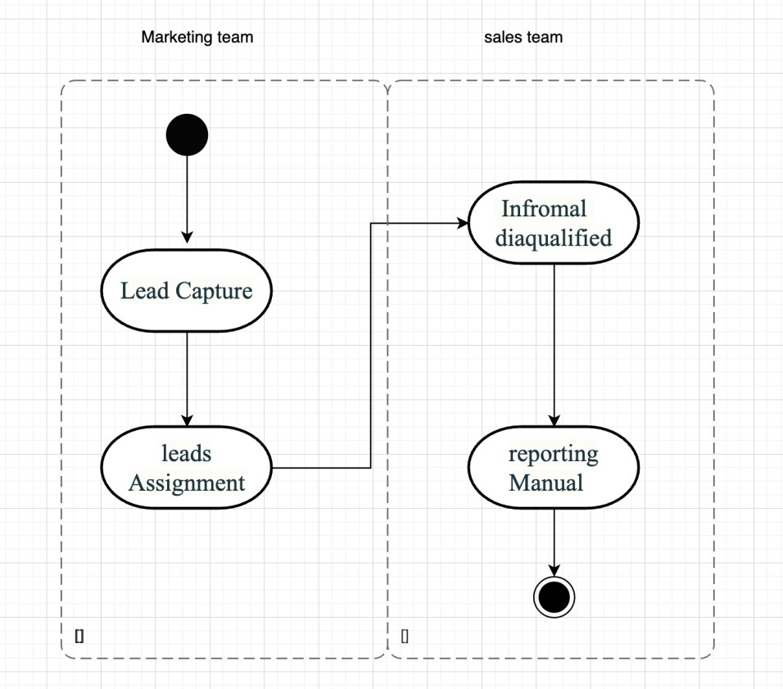

Proposed Lead Management Process Phases (TO-BE)
- Lead Capture with Validation
Leads are captured through integrated systems with validation checks to ensure complete and accurate data entry.
- Automated Lead Review Workflow
The system prompts users to evaluate leads based on predefined qualification criteria (e.g., budget, authority, need, timeline).
- Disqualification with Mandatory Reason Selection
If disqualified, users must select a reason from a standardized dropdown list and optionally enter additional notes.
- Disqualification Logging and Audit Trail
The system logs each disqualification event along with the user, date, and selected reason, ensuring auditability and consistency.
- Automated Disqualified Lead Reporting
A real-time dashboard and exportable reports provide visibility into disqualified leads, reasons, patterns, and actionable insights.

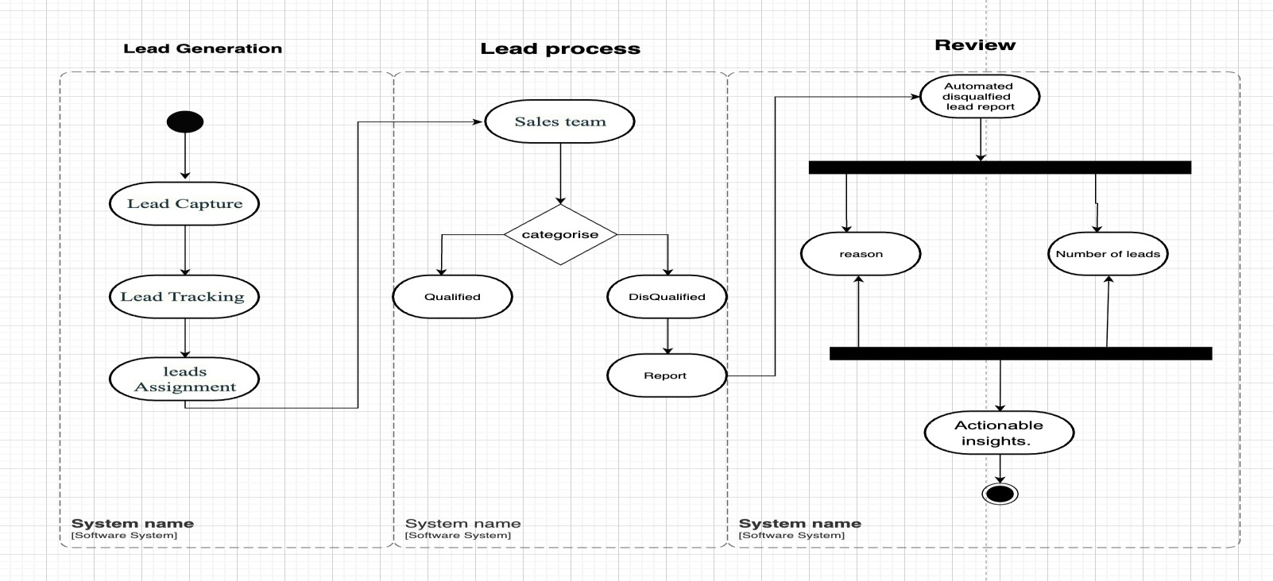

Business Requirements
The specific business requirements elicited from stakeholders should be listed, categorized by both priority and area of functionality to smooth the process of reading and tracking them. Include links to use case documentation, and other key reference material as needed to make the requirements as complete and understandable as possible. You may wish to incorporate the functional and nonfunctional requirements into a traceability matrix that can be followed throughout the project.

Appendices

List of Acronyms

Glossary of Terms

Related Documents

