Capstone Project Prep- 2
Question 1: Write Agile Manifesto
Answer: Agile Manifesto have 4 main values and 12 principles
4 main Values:
- Individuals and interactions over processes and tools
- Working software over comprehensive documentation
- Customer collaboration over contract negotiation
- Responding to change over following plan
12 Principles of Agile Software:
- Satisfy the customer through early and continuous delivery of valuable software.
- Welcome changing requirements, even late in development. Agile processes harness change for the customer’s competitive advantage.
- Deliver working software frequently, from a couple of weeks to a couple of months, with a preference to the shorter timescale.
- Business people and developers must work together daily throughout the project.
- Build projects around motivated individuals. Give them the environment and support they need and trust them to get the job done.
- The most efficient and effective method of conveying information to and within a development team is face-to-face conversation.
- Working software is the primary measure of progress.
- Agile processes promote sustainable development. The sponsors, developers, and users should be able to maintain a constant pace indefinitely.
- Continuous attention to technical excellence and good design enhances agility.
- Simplicity – the art of maximizing the amount of work not done – is essential.
- The best architectures, requirements and designs emerge from self-organizing teams.
- At regular intervals, the team reflects on how to become more effective, then tunes and adjusts its behaviour accordingly.
Question 2: Write minimum 40 User stories and their Acceptance Criteria along with their BV and CP
Answer: User stories: It is a short feature description from the user’s perspective. It keeps the focus on user needs instead of technical details. The format for user stories goes like, “As a <User>
I want to <what is the purpose>
so that <what you gain by this story>”
Acceptance criteria: It is a checklist of conditions that must be true for the user story to be considered complete and acceptable.
Complexity Points (CP): A number like (1,2,3,5,8 like Fibonacci series) showing how difficult or time consuming the story is to implement. It is used by the Scrum Team to estimate effort and plan sprints realistically.
Business Vale (BV): A value like (500,200,100,50) or priority label showing how important the story is for business/customer. It helps the Product Owner decide which features should be delivered first.

Sprint-1
User Story No: 1 | Tasks: 2 |  | Priority: Highest
As a customer
I want to register on the application
So that I can create my own account and use the app features
BV: 500 |  | CP: 3
Acceptance Criteria:
- Customer can register with email/phone
- Verification link/OTP must be sent
- Successful registration redirects to login page
Business Rules:
User must register with unique email or phone number
Duplicate accounts are not allowed

User Story No: 2 | Tasks: 2 |  | Priority: Highest
As a customer
I want to log in with my credentials
So that I can access my profile and place orders
BV: 500 |  | CP: 2
Acceptance Criteria:
- Valid credentials allow login
- Invalid credentials show error
- Login session should persist until logout

User Story No: 3 | Tasks: 2 |  | Priority: Highest
As a customer
I want to search for restaurants by name, cuisine or location
So that I can quickly find my desired food options
BV: 500 |  | CP:5
Acceptance Criteria:
- Search suggestions must appear as user types
- Search should filter by cuisine/location
- Relevant results must display with ratings

User Story No: 4 | Tasks: 2 |  | Priority: High
As a customer
I want to view restaurant’s menus
So that I can decide what food to order
BV: 200 |  | CP: 3
Acceptance Criteria:
- Menu must show food items, prices and availability
- Images of items should display if available
- Out of stock items should be marked clearly

User Story No: 5 | Tasks: 2 |  | Priority: Highest
As a customer
I want to place a food order
So that I can get food delivered to my location
BV: 500 |  | CP: 8
Acceptance Criteria:
- Customer can add multiple items to cart
- Customer can select delivery address
- Order confirmation must be shown with estimated delivery time
Business Rules:
Orders cannot be placed if the restaurant is closed or the selected items are out of stock

User Story No: 6 | Tasks: 2 |  | Priority: Highest
As a customer
I want to make online payments
So that I can complete my purchase securely
BV: 500 |  | CP: 8
Acceptance Criteria:
- Payment gateway integration (credit/debit cards, UPI, wallets, COD)
- Successful payment updates order status
- Failed payment shows retry option

Business Rules:
Payment must be processed only through approved and secure payment gateways

User Story No: 7 | Tasks: 2 |  | Priority: High
As a customer
I want to track my order in real time
So that I can know the status and estimated time of delivery
BV: 200 |  | CP: 8
Acceptance Criteria:
- Map view shows live location of delivery boy
- Status updates (preparing, out of delivery, delivered)
- ETA should refresh every few minutes

User Story No: 8 | Tasks: 2 |  | Priority: High
As a customer
I want to cancel an order before preparation starts
So that I can avoid paying for something I don’t need
BV: 200 |  | CP: 3
Acceptance Criteria:
- Cancellation allowed before “preparing” stage
- Refund process should trigger for prepaid orders
- Notification must be sent to restaurant

Business Rules:
Customers can cancel orders only before the order status changes to “preparing”

User Story No: 9 | Tasks: 2 |  | Priority: Low
As a customer
I want to give feedback and ratings
So that I can share my experience with food and delivery
BV: 50 |  | CP: 3
Acceptance Criteria:
- Customers can give 1-5star ratings
- Optional text feedback allowed
- Feedback visible to restaurant/admin

User Story No: 10 | Tasks: 2 |  | Priority: Low
As a customer
I want to log out from my account
So that I can secure my account after use
BV: 50 |  | CP: 2
Acceptance Criteria:
- Logout button must be available
- Session should clear after logout
- Redirect to login/landing page

User Story No: 11 | Tasks: 2 |  | Priority: High
As a delivery boy
I want to register on the app
So that I can become an active delivery partner
BV: 200 |  | CP: 3
Acceptance Criteria:
- Registration requires ID and verification
- Notification once account is approved

Business Rules:
A delivery boy must upload valid ID proof, license and bank details before approval

User Story No: 12 | Tasks: 2 |  | Priority: High
As a delivery boy
I want to log in with my credentials
So that I can access my orders and delivery tasks
BV: 200 |  | CP: 2
Acceptance Criteria:
- Verification login required
- Invalid login shows error
- Password reset option available

User Story No: 13 | Tasks: 2 |  | Priority: Highest
As a delivery boy
I want to view available orders
So that I can choose and accept deliveries
BV: 500 |  | CP: 5
Acceptance Criteria:
- List of unassigned orders should display
- Orders must show restaurant location, delivery address and estimated time.
- Refresh option for new orders

User Story No: 14 | Tasks: 2 |  | Priority: Highest
As a delivery boy
I want to accept an order
So that I can start the pickup and delivery the order to customer
BV: 500 |  | CP: 5
Acceptance Criteria:
- Accept button visible for available orders
- Accepted order should move to “My Orders”
- Other delivery boys should not see the order once accepted

User Story No: 15 | Tasks: 2 |  | Priority: Highest
As a delivery boy
I want to update order status (picked up, delivered)
So that customers and restaurants stay informed
BV: 500 |  | CP: 5
Acceptance Criteria:
- Status update buttons available
- Notifications sent to customer when updated
- Status should sync in real time

User Story No: 16 | Tasks: 2 |  | Priority: Medium
As a delivery boy
I want to receive payment for cash on delivery (COD)
So that I can collect money from customers and report
BV: 100 |  | CP: 3
Acceptance Criteria:
- COD option must display for certain orders
- Delivery boy must confirm collection
- Report should log collected amount

Business Rules:
Delivery boy must mark COD as collected before closing an order, failure to do so keeps the order “pending”

User Story No: 17 | Tasks: 2 |  | Priority: Low
As a delivery boy
I want to view my delivery history
So that I can track my completed orders
BV: 50 |  | CP: 2
Acceptance Criteria:
- History page shows past deliveries with details
- Filter by date option available
- Earnings show alongside competed orders

User Story No: 18 | Tasks: 2 |  | Priority: Low
As a delivery boy
I want to raise issues through the app
So that I can get help in case of delivery problems
BV: 50 |  | CP: 2
Acceptance Criteria:
- Issue form available in profile
- Categories: payment, customer, restaurant, technical
- Ticket number generated for tracking

Business Rules:
Issues must be logged under valid categories (Payment, customer, restaurant, technical)

User Story No: 19 | Tasks: 2 |  | Priority: Medium
As a delivery boy
I want to view my revenue report
So that I can monitor my earnings
BV: 100 |  | CP: 5
Acceptance Criteria:
- Daily/weekly/monthly earnings visible
- Graph or table format
- Option to download/ export report

User Story No: 20 | Tasks: 2 |  | Priority: Low
As a delivery boy
I want to logout from the app
So that I can secure my account after work
BV: 50 |  | CP: 3
Acceptance Criteria:
- Logout button available
- Session clears after logout
- Redirects to login page

User Story No: 21 | Tasks: 2 |  | Priority: High
As a restaurant
I want to register on the app
So that I can list my food items and receive orders
BV: 200 |  | CP: 3
Acceptance Criteria:
- Registration requires restaurant details, license and bank information
- Admin must approve before activation
- Notification sent after approval
Business Rules:
Only licensed restaurants with valid FSSAI certificate and GST number

User Story No: 22 | Tasks: 2 |  | Priority: High
As a restaurant
I want to log in with my credentials
So that I can access my dashboard
BV: 200 |  | CP: 2
Acceptance Criteria:
- Valid login required
- Invalid login shows error message
- Forgot password option available

User Story No: 23 | Tasks: 2 |  | Priority: Highest
As a restaurant
I want to view incoming food orders
So that I can prepare food for customers
BV: 500 |  | CP: 8
Acceptance Criteria:
- Orders must display with items, quantity and delivery time
- Order must display any requests regarding food items by customer
- Notification sound for new orders

User Story No: 24 | Tasks: 2 |  | Priority: Medium
As a restaurant
I want to verify delivery boy boys assigned to my orders
So that I can ensure safe food handover
BV: 100 |  | CP: 3
Acceptance Criteria:
- Delivery boy’s ID and profile visible
- Retaurant can confirm pickup via OTP/digital signature

User Story No: 25 | Tasks: 2 |  | Priority: Highest
As a restaurant
I want to update food item availability
So that customers only see items that are in stock
BV: 500 |  | CP: 8
Acceptance Criteria:
- Admin panel for menu management
- Out-of-stock toggle for each item
- Changes must reflect in real time
Business Rules:
If an item is marked “out of stock”, it must instantly reflect for all customers to prevent orders

User Story No: 26 | Tasks: 2 |  | Priority: Highest
As a restaurant
I want to receive payments for completed order
So that I get my revenue share
BV: 500 |  | CP: 8
Acceptance Criteria:
- Payment statement must show order wise revenue
- Weekly/monthly payouts should be tracked
- Notification when payment is credited
Business Rules:
Restaurants receive payments only after order delivery confirmation from customer or delivery boy

User Story No: 27 | Tasks: 2 |  | Priority: Medium
As a restaurant
I want to view customer feedback and ratings
So that I can improve my food quality and service
BV: 100 |  | CP: 3
Acceptance Criteria:
- Feedback visible per order
- Overall average rating visible
- Negative feedback flagged separately

User Story No: 28 | Tasks: 2 |  | Priority: Low
As a restaurant
I want to raise issues through app
So that I can report problems regarding payments, delivery or app issues
BV: 50 |  | CP: 2
Acceptance Criteria:
- Issue form available in dashboard
- Categories: Delivery, Payment, Technical
- Ticket number generated and tracked

User Story No: 29 | Tasks: 2 |  | Priority: Medium
As a restaurant
I want to view my revenue reports
So that I can track business performance
BV: 100 |  | CP: 5
Acceptance Criteria:
- Daily, weekly monthly revenue shown
- Graphical representation of sales
- Option to export/download report

User Story No: 30 | Tasks: 2 |  | Priority: Low
As a restaurant
I want to log out from my account
So that my data remains secure
BV: 50 |  | CP: 2
Acceptance Criteria:
- Logout button available
- Session clears on logout
- Redirects to login page

User Story No: 31 | Tasks: 2 |  | Priority: High
As a Regional Admin
I want to log in with my credentials
So that I can manage operations
BV: 200 |  | CP: 2
Acceptance Criteria:
- Secure login with username and password
- Invalid login should show error
- Option to reset password available

User Story No: 32 | Tasks: 2 |  | Priority: High
As a Regional Admin
I want to track delivery boy activities
So that I can monitor timely deliveries
BV: 200 |  | CP: 2
Acceptance Criteria:
- Dashboard showing active/inactive delivery boys
- Status of ongoing deliveries updated in real time
- Ability to filter by date/region

User Story No: 33 | Tasks: 2 |  | Priority: High
As a Regional Admin
I want to manage restaurants in my region
So that I can approve, reject them when needed
BV: 500 |  | CP: 5
Acceptance Criteria:
- List of registered restaurants must be visible
- Admin can approve or reject applications
- Status updates must notify restaurants

Business Rules:
Admin cannot approve restaurants without mandatory documents such as License, bank information, GST

User Story No: 34 | Tasks: 2 |  | Priority: High
As a Regional Admin
I want to view customer feedback
So that I can address complaints and maintain quality
BV: 100 |  | CP: 4
Acceptance Criteria:
- Feedback categorized as delivery/restaurant/service
- Negative feedback flagged
- Action notes can be added for tracking

User Story No: 35 | Tasks: 2 |  | Priority: Medium
As a Regional Admin
I want to handle issues raised by delivery boys or restaurants
So that I can resolve them quickly
BV: 200 |  | CP: 5
Acceptance Criteria:
- Issue dashboard with ticket ID and status
- Option to assign issue to support team
- Notifications sent once issue is resolved

User Story No: 36 | Tasks: 2 |  | Priority: High
As a Regional Admin
I want to process refunds
So that customers get their money back in valid cases
BV: 200 |  | CP: 5
Acceptance Criteria:
- Refund request must be linked to order ID
- Refund approval/rejection must tigger notification
- Refund timeline tracked
Business Rules:
Refunds can only be approved if cancellation is within the allowed time widow or if food was not delivered

User Story No: 37 | Tasks: 2 |  | Priority: High
As a Regional Admin
I want to manage regional delivery boys
So that I can assign, remove or suspend them
BV: 200 |  | CP: 3
Acceptance Criteria:
- List of delivery boy’s region wise available with status
- Admin can block/unblock accounts
- Notifications sent to delivery boy on status change
Business Rules:
A delivery boy can only be suspended with valid reasons such as fraud, repeated delays or misconduct

User Story No: 38 | Tasks: 2 |  | Priority: Medium
As a Regional Admin
I want to view revenue reports regionally
So that I can analyse earnings from the selected area
BV: 200 |  | CP: 8
Acceptance Criteria:
- Report by day/week/month
- Sata split by restaurants and delivery boys
- Option to export/download reports

User Story No: 39 | Tasks: 2 |  | Priority: High
As a Regional Admin
I want to view payments made to restaurants in my region
So that I can confirm settlement accuracy
BV: 200 |  | CP: 8
Acceptance Criteria:
- Transaction history per restaurant shown
- Payment date, amount and status visible
- Option to download/export payment summary

User Story No: 40 | Tasks: 2 |  | Priority: Low
As a Regional Admin
I want to log out from the system
So that my account stays secure
BV: 50 |  | CP: 2
Acceptance Criteria:
- Logout button available on dashboard
- Session clears after logout
- Redirects to login page
Question 3: – What is epic? Write 2 epics
Answer:
Epic is a collection of user stories, which can be broken down into several user stories. Each epic usually covers a major functionality area.
Epic 1: Customer Food Ordering & Delivery Experience
Description:
This epic covers all functionalities that allow a customer to register & login, search for restaurants, view menus, place orders, make payments, track delivery and provide feedback.
Epic 2: Delivery Partner and Restaurant Management
Description:
This epic focuses on how restaurants and delivery partners register, manage their task, update statuses and get paid along with admin controls for approvals and issue resolution.
Question 4: What is the difference between BV and CP
Business Value (BV) | Complexity Points (CP)
- BV shows how important a feature is for the business and customer | - CP shows how important a feature is for the business and customer
- This value is decided by Product Owner and stakeholders | - This point is estimated by the Scrum team (developers, testers, designers)
- Higher BV means more impact on revenue, customer satisfaction or core business goals. | - Higher CP = more effort, risk or technical challenges.
- Example: Placing an order -> BV = 500 (because it is a critical feature) | - Example: Real-time tracking -> CP = 8 (as this feature is technically complex to build)

Question 5: Explain about Sprint
Answer:
- A Sprint is a scrum based agile methodology concept that similar to an iteration. A sprint is time boxed to deliver a specific set of user stories and produce working features within a set time period. During a sprint, user stories can be removed from sprint scope, but new stories cannot be added, this allows project teams to focus on the goals of the sprint and deliver rapidly.
- Sprint duration is how long the sprint runs (2 weeks to 4 weeks) and Sprint value is the business value delivered at the end of that sprint, based on the completed user stories.
- Scrum is a subunit of sprint where a Sprint contains many scrums/daily scrums. A daily scrum is a 15-minute meeting held every day during the sprint. It helps the team to inspect progress and adjust tasks for the next 24 hours. So, scrum is like a daily checkpoint inside Sprint
- Scrum duration= 1 day, because daily scrum happens once per day.
Scrum value is the progress/clarity gained in that day about work status, blockers and next steps. It measured in terms of alignment and WIP tracking

Question 6: Explain Product backlog and sprint back log
Answer: Product Backlog:
Product Backlog is the master list of everything that needs to be built in the product. It contains all Product Backlog Items (PBI).
- A Product Backlog Item (PBI) is simply a feature, bug fix or task from the product backlog.
Example: User login, Payment gateway integration, real-time tracking
- A task is a small piece of work that helps complete PBI. One developer should be able to finish a task within a day.
Example: Create login screen (UI), connect API for login.
- WIP (work in progress) refers to the tasks or PBI currently being worked on. Limiting WIP avoids bottlenecks and improves flow.
Example: If too many PBIs are in WIP, then nothing gets finished and sprint value drops.
Sprint Backlog:
Sprint Backlog is a subset of the Product Backlog selected for a specific sprint (e.g., 2 weeks). It contains PBIs that the team commits to deliver in the sprint. Each PBI is broken into tasks and is owned by scrum team.
Sprint Backlog by considering few tasks for this project are below:
PBI | TASK | WIP | DONE
Customer Login | Design login UI screen | WIP | Incomplete
Customer Login | Develop login API integration | WIP | Incomplete
Customer Login | Create database table for users | Completed | Completed
Customer Login | Implement password encryption | WIP | Incomplete
Customer Login | Write unit test cases for login | Completed | Completed

Question 7: What is impediments log? write 2 impediments
Answer: An impediments log is a list maintained by the Scrum Master (or team) to track problems, blockers or obstacles that slow down or stop the Scrum Team’s progress. It ensures that the issues are visible, tracked and resolved quickly. Impediments can be technical, organizational or external.
Sprint planning is the first event of a sprint. During sprint planning, the team might identify risks, dependencies or knows blockers before starting the sprint. These potential issues can be recorded in the impediments log so that they are monitored from the very start. During the sprint, if new impediments appear, they are also added to the log and handled.
Two Impediments for this project are:
S No | Issue | Description | Status
1 | Payment Gateway Issue | The integration with the payment gateway is failing, preventing completion of the “Payment Feature” | Needs coordination with external payment provider
2 | Unstable Development Server | The server keeps crashing during testing, blocking developer from testing new features. | Needs urgent fix from IT infra

Question 8: Explain Velocity of the Team
Answer:
Velocity is defined by the amount of work completed by a Scrum Team in one sprint. It is usually measured in story points. Velocity helps in predicting how much work the team can deliver in future sprints.
Velocity = Sum of Story Points of “Done” User Stories in a Sprint

Question 9: Draw Sprint Burn Charts and Product Burn Down Charts
Answer: Sprint Burndown Chart: It is a visual representation that shows the amount of work remaining in a sprint versus the time left. It tracks daily progress by plotting story points or tasks yet to be completed against the sprint timeline. The chart helps the team see if they are on track to finish all committed work by the end of the sprint and highlights delays or bottlenecks.
Sprint Burnup Chart: It is used to show the amount of work completed during the print compared to the total sprint scope. It starts at zero and burns up as tasks or story points are completed. Unlike the burndown chart, it also makes scope changes visible if new work is added mid-sprint, the scope line goes up while the completed work line continuous to rise until both meet at the end.
Product Burndown Chart: This chart focuses on the entire product backlog over multiple sprints, not just one. It shows how much work (user stories, features or points) remains across the whole project or release, and it helps stakeholders understand whether the team is progressing toward delivering the full product within the planned timeframe. This chart gives a higher-level view compared to sprint charts, making it useful for long-term planning.

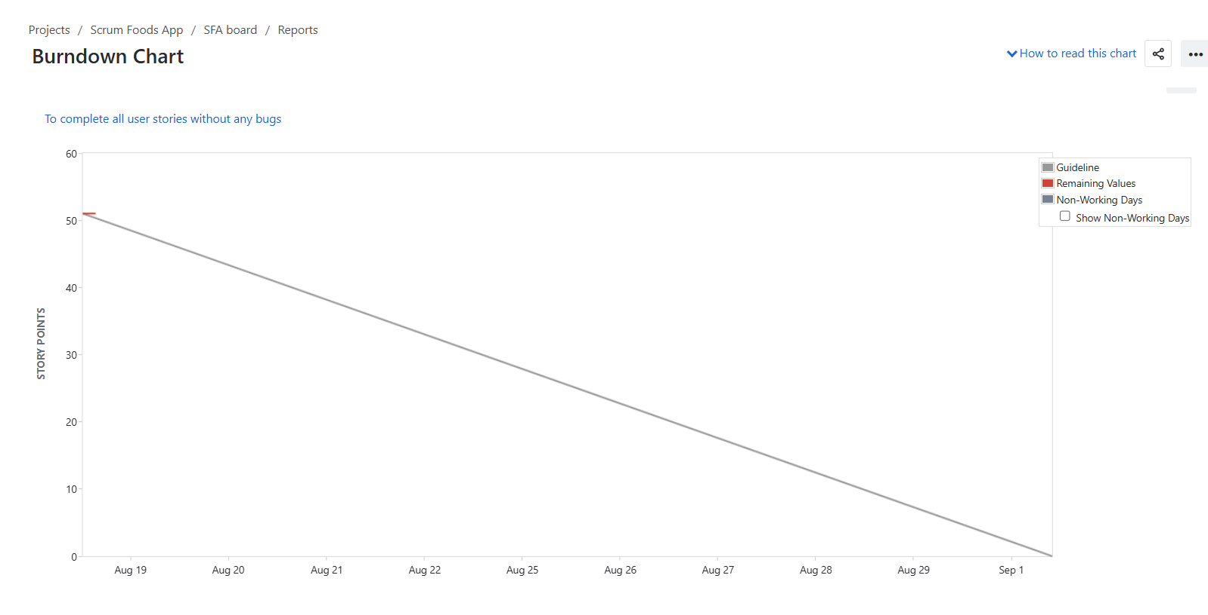
Sprint Burndown Chart
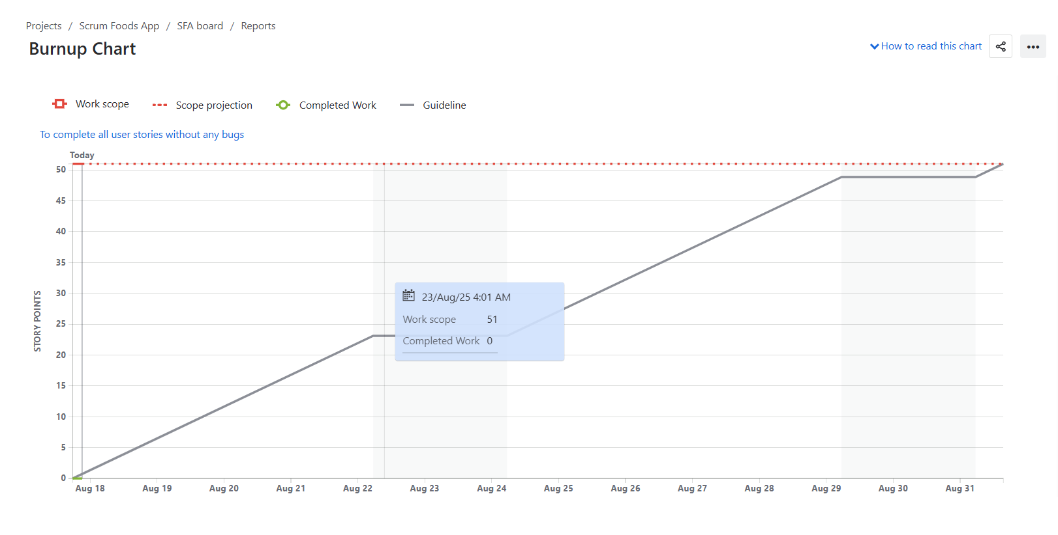
Sprint Burnup Chart

Question 10: Explain about Product Grooming
Answer: Product grooming is a process where the Product Owner and team review the product backlog to make sure it is clear, updated and prioritized. During grooming, new user stories are added, large epics are broken down into smaller stories, acceptance criteria are clarified, estimates are given and unnecessary items are removed.
This is important because it ensures that the team has well-prepared backlog items ready for the next sprint, reducing confusion and saving time in sprint planning. Grooming session are usually led by the Product Owner with participation from Scrum Master and the development team.
Question 11: Explain the roles of Scrum Master and Product Owner
Answer: Product Owner
The product owner is responsible for defining the vision of the food delivery app (or the project), managing the product backlog, prioritizing features and making sure the development team builds the most valuable features firsts.
Example: In this project, Me being the Product Owner, I will decide whether to first build “Customer Order placement” or “Delivery Tracking” based on business needs.
Scrum Master
The Scrum Master ensures that the Scrum process is followed correctly, facilitates meetings, removes obstacles faced by the team and helps the team stay focused on sprint goals.
Example: If developers can’t proceed because API issues with restaurant integration, the Scrum Master helps resolve it.
Question 12: Explain all Meetings Conducted in Scrum Project –
Answer:
- Sprint Planning Meeting: This is held at the start of every sprint decide what work (user stories) will be completed and to set the sprint goal. It also helps the team estimate effort (Story points) and commit to realistic tasks.
- Daily Scrum (Stand-up Meeting): A short daily meeting (15 minutes) where each team member shares what they did yesterday, what they will do today and if they have any blockers. It keeps the whole team aligned and identifies issues early before they become bigger problems.
- Sprint Review Meeting: This meeting is conducted at the end of the sprint to demonstrate the completed work to stakeholders and collect feedback. It ensures transparency and gives the client/stakeholders a chance to suggest improvements.
- Sprint Retrospective Meeting: This meeting is held after the sprint to demonstrate the completed work to stakeholders and collect feedback. It builds a culture of continuous learning and strengthens team collaboration.
- Backlog Refinement (Product Grooming) Meeting: Ongoing meeting during the sprint where the Product owner and team review, clarify and prioritize backlog items to prepare for future sprints. It makes sure the backlog is always updated, clear and ready for sprint planning.

Question 13: Explain Sprint Size and Scrum Size
Answer: Sprint size: Sprint size means the duration of sprint (commonly 2 weeks. But can be 1-4 weeks). It defines how long the development team works on a fixed set of tasks. It ensures that work is delivered in small, predictable time-boxed cycles.

Scrum Size: Scrum Size usually refers to the size the scrum team (which includes Scrum Master, Product Owner, developers, ideally 5-9 members). It ensures that the team is neither too small nor too large for effective collaboration. It helps balance communication, collaboration and productivity within team.

Question 14: Explain DOR and DOD
Answer: Definition of Ready (DOR): A checklist that ensures a user story is well-defined, clear and ready to be taken into a sprint. Example: Requirements are clear, acceptance criteria written, dependencies identified. It prevents half-baked or unclear stories from entering a sprint.
Definition of Done (DOD): A checklist that ensures a user story is fully completed at the end of a sprint. Example: Code developed, tested, reviewed, integrated and potentially shippable. It creates a shared understanding of what completion means across the team.

Question 15: Explain Prioritization Techniques and MVP
Answer: Prioritization Techniques: It is the methods to decide which features or backlog items should be done first. These techniques ensure the team works on highest value items first, avoiding wasted effort, ensuring maximum benefit to clients or end-users, efficient use of resources, educed risks, better planning, structured decision making and clear transparency for all stakeholders.
Examples include MoSCoW (Must, Should, Could, Won’t), Kano Model, WSJF (Weighted Shortest Jon First), and Value vs Effort matrix.
Minimum Viable Product (MVP): The smallest version of the product that delivers value to users with core features. It allows early market feedback before building the full product. It reduces risk by validating assumptions before investing heavily in full development.

Question 16: Difference between Business Analyst n Product Owner
Answer: Business Analyst: BA focuses on eliciting requirements, analysing business needs, documenting and acting as a bridge between business and technical teams. BA ensures the solution aligns with business processes and stakeholder needs.
Product Owner: A Product Owner focuses on maximising product value, owns the product backlog, prioritize features and makes decisions about what gets built and when. A Product Owner ensures the development team is always working in the most valuable product features.

Question 17: Prepare a sample Resume of 3yrs exp Product Owner
Answer:
SUNITA ACHARYA
📍 Location: [Hyderabad, India] | 📞 +91-8984439577 | 📧 sunitaacharya74@gmail.com | 🔗 LinkedIn: https://www.linkedin.com/in/sunita-acharya

Professional Summary
Results-driven Product Owner with 3 years of experience in Agile/Scrum environments, skilled in bridging business needs with technical teams. Proven expertise in creating user stories, managing product backlogs, defining sprint goals, and collaborating with cross-functional stakeholders. Strong background in requirements gathering, prioritization, and delivering high-value product increments that align with business objectives.

Work Experience
Product Owner | XYZ Tech Solutions, Hyderabad | Aug 2022 – Present
- Owned product backlog for a food delivery app; defined epics, user stories, and sprint goals.
- Prioritized features based on Business Value (BV) and Complexity Points (CP).
- Released 4 major updates (user registration, order tracking, payment integration).
- Improved app adoption by 35% and reduced delivery partner complaints by 20%.
Associate Product Owner | ABC Digital Services, Hyderabad | Jul 2021 – Jul 2022
- Supported backlog refinement and sprint reviews.
- Created wireframes/mock-ups and defined DoR & DoD with QA.
- Delivered reporting dashboard that cut manual effort by 30%.

Key Skills
- Agile & Scrum (CSPO Certified)
- Backlog & Roadmap Management (Jira, Confluence)
- User Stories & Acceptance Criteria
- Sprint Planning & Release Management
- Prioritization (MoSCoW, WSJF)
- Wireframing & Prototyping (Balsamiq, Draw.io, Axure)
Tools
Jira | Confluence | MS Visio | Balsamiq | Axure | Draw.io | Power BI | SQL Basics | MS Excel

Education
🎓 Bachelor of Technology (BTech) – Computer Science
Siksha O Anusandhan University, 2015-2019

Certifications
- Certified Scrum Product Owner (CSPO®) – Scrum Alliance
- Agile Fundamentals – Coursera
- Jira Agile Project Management – Atlassian

