Q1. A customer can make payment either by card or by wallet or cash or net banking. Draw a use case diagram.

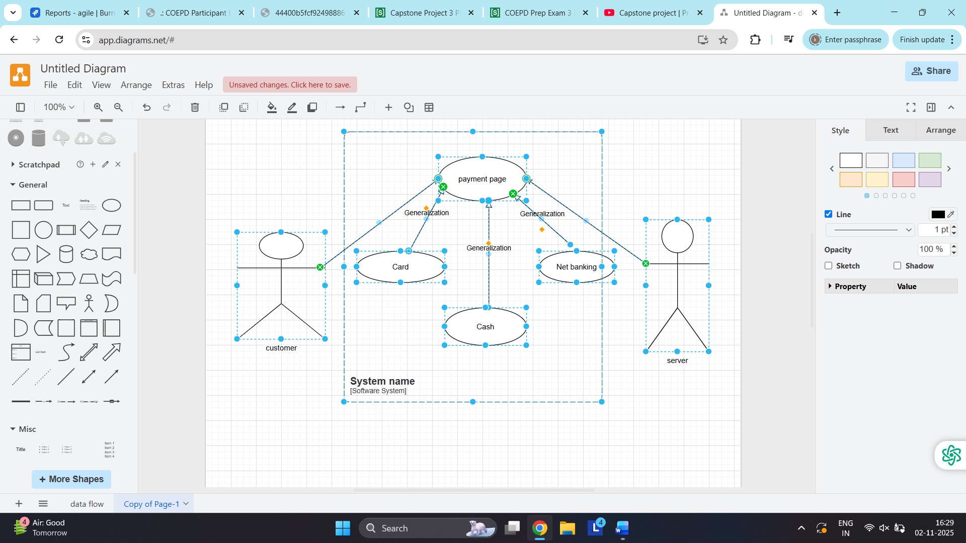

Q2. What id boundary cla sses, controller classes, entity classes?
Boundary Classes: this is used to handle interaction between the system and the external actors. These classes handles all input and output acting as communication layer. The attributes of this class and screen layout are defined at the basic design

Controller Class: This acts as a intermediary between boundary and entity class. This class is a class to achieve use case in use case diagram.

Entity Class : entity class is the class that has data Represents core data and business logic of the application

Q3. Place these classes on three tire architecture.?
A. In 3 tire architecture the application layer handles the user interface ie. Any inputs by the user, business logic layers communicates with the other tier and data layer handles the data storage and reterival
Application Layer | Customer registration  Customer login  Server login
Business Logic layer | Customers  Server
Data Layer | Customer  Bank server  Cash  Card  Net banking

Q.4. Explain domain model for the customer making
A. It is a conceptional representation that define structure, relationship behavior of the entity within a specific problem. Domain model is similar to entity relationship model, were the tables are connected to each other.

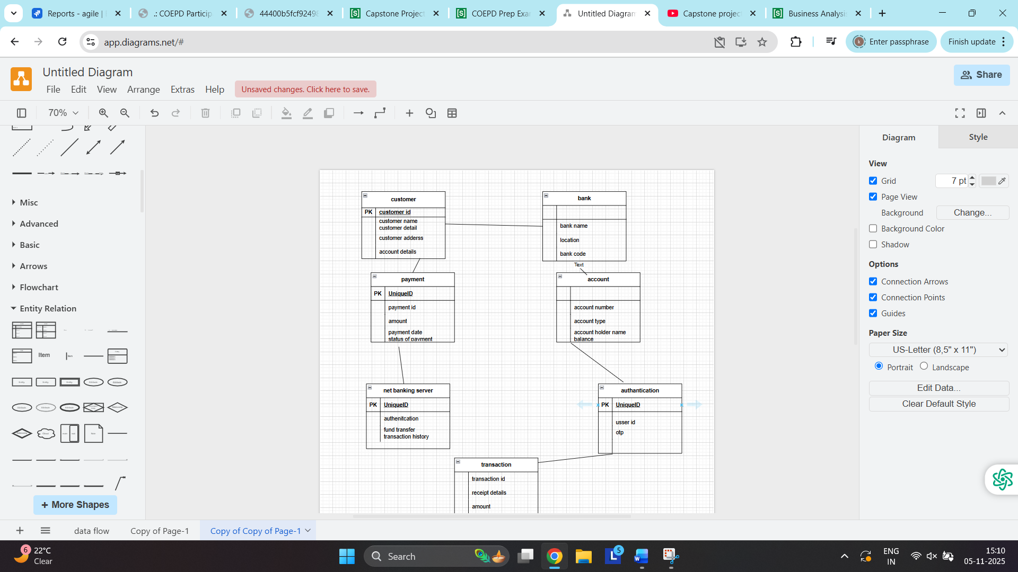

Q3. Sequence diagram
- It is made by developer. It is the interaction between the primary actor and the secondary actor, it shows the flow of the system.

Q.4. Conceptual Model
A. A conceptual Model is a high level representation of a system that helps in understanding, visualizing and communicating the essential accepts of the domain.
It provides clear and simple version of the domain making it easy to understand. Key element of conceptual model is entity, attributes and relationship

Q7. What is MVC?
- Model view controller framework that separates an application into 3 logical component, Model, View and Controller
View-Represents the presentation layer of the application
Model- Represents the data and the business logic layer of the application
Controller- Acts as a intermediary between view and model.

Rules to derive the classes from use case diagram
- Combination on one actor and one usecase results in one boundary class
Combination on two actor and one use case results in two boundary class
Combination of three actors and and one use case results in three boundary class
- Use case will result in controller class
- Each use case will result in one entity class
For example:
Model Class: customer, payment, card, cash, net banking
View class: login view, payment option view, net banking view, payment confirmation view
Controller Class: Login control, payment option net banking control, payment confirmation control
3 tire architecture
Presentation layer: this is a user interface layer. Presentation layer is responsible for displaying information and receiving input from the user. View class is in this layer
Business logic layer: This layer handles the input received from the presentation layer and coordinates with the data layer. Model and controller are in this layer.
Data layer: this layer stores the data and helps to retrieve and process the data form the data base

Q8. BA contribution in the project
- Waterfall model project is divided into difference stages, below are the contrib ution of the BA in each stage:

Requirement gathering :
This is the initial stage of the project where the BA will be gathering the information and documenting it. He will use the elicitation techniques.
Ba is responsibility is to prepare the BRD

Requirement Analysis:
Requirement are analyzed to understand the scope of the project . BA will check the feasibility of the project and confirm with the development team about the feasibility of the project. He will analise and bifurcate the requirement to functional and non functional requirement and prepare the FRS ( Functional requirement specification) and also prepares the RTM ( requirement tracibility matrix)

Design Phase
In this phase the team will start designing the system based on the BA’s input. BA will help him to clear the doubts about the requirement.
Design document, mockup, prototypes and UML diagram will be prepared

Development:
Development phase include implementation. This involves coding of software based in design specification. BA acts as a intermediary between development team and stakeholder team. BA clarify the requirement and checks if the development is going on right track

Testing:
In this phase the tester will test the software and BA will check if the same meets the requirements and free from any bugs.
The BA will felicitate the UAT

Deployment:
Once the software has been tested and approved it is deployed to the production environment. BA ensures there is a smooth transition from development to production.

Q9. Conflict Management and Thomas-Kilmann technique
- Conflict management is the process of resolving the conflict or the disagreement between individuals or a group in a constructive way.
Thomas -Kilmann technique is widely used as a conflict management technique.
5 steps involved in conflict management are
- Identify the conflict
- Discuss the conflict
- Agree with the root problem
- Check for every possible solution
- Negotiate the solution to avoid the future conflict.
In this method there is Assertiveness and cooperativeness
If both the groups are highly assertive and cooperative it means they are working together to find solution
If 1 group is high assertive and one is low cooperative it means defensive, and standing for your individual beliefs and trying to win
If one group is low assertive and one is high cooperative it means stakeholder will priotrize their needs over others.
If both are low assertive and cooperative it means ignoring the conflict.

Q10. List down the reasons for project failure
- Reasons for project failure
- Improper Planning: the project fails due to poor planning . the goals should be discussed properly as if there is no proper planning the team may face difficulty in addressing the issue and track the plan
- Poor risk management: The team fails to identify the risk and do proper risks analysis which can lead to unexpected challenge or delay in the project.
- Lack of stakeholder involmnent: the stakeholders inputs and feedback plays a very important role to meet the goal. The project can fail if the stakeholder are not actively particapting in the project
- Ineffective Communication: If there are communication issues between the stake holders, team members then this can lead to misunderstanding and delay or sometimes failure of the project
- Scope Creep: change in requirement or scope of the project during the project lifecycle can lead to failuer or delay of the project.
- Continuous change in the requirement: if the requirement of the project keeps changing the projects tends to fail as the scope of the project will also be changing.
- Insufficient resource: Insufficient resources can lead to project failure
- Technical challenges: less technical knowledge leads to project failure

Q.11 List of challenges faced by the BA in the project.
A. Below are the challenges faced by the BA:
- Unclear or Changing requirements: If the BA gets the change in requirements very frequently there will be difficulty to adjust the same every time in the project.
- Managing the stakeholder expectation: Unable to understand what the stakeholder is trying to convey. Differences in the view and unclear communication by the stakeholders to the ba.
- Scope creep and scope management: The BA continuously gets the change request which effects the scope of the projects.
- Lack of Domain Knowledge: BA may face difficult in understanding if he is not familier with the domain.
- Poor communication: Ba faces difficulty if all the requirement are not been communicated to him properly.
- Time and Resource constraints
- Quality assurance and testing
- Technology constraints and complexity

Q12. Write about the document naming standards
- Document naming standard is a systametic approach to assign unique identifiers to various documents created and used throughout the development process. As it would be easy for tracking.
For example
If we have a project id with Id “ Proj123” and we are working in requirement specification document
Project Id: Proj123
Document type: REQ
Version: 1.0
Date: 2025-06-11
The document identifier could be Proj123-REQ-1.0-2025-06-11
Q13. Dos and Donts of Business Analyst

Sr no | Do’s | Don’t’s
1 | Consult an SME for clarification in requirement | Say NO to the client
2 | Go to the client with the plain mind with no assumption listen carefully and completely until the client is done | There is no word as By default
3 | Try to extract maximum information from the client | Never imagine anything in terms of GUI
4 | Concentrate on important requirement | Don’t interrupt the client when he is giving you the problem
5 | Question the existence of existence | Never try to give solution to the client straight away

Q14. Write the difference between the package and the subsystem
- Package: it is a group of classes or use cases used to organize the modern element.
It is a collection of components which are not reuseable in nature
Package can be nested within other packages
These are used as acontainers to organize elements
Subsystem: It is alogical grouping of reletated components
These are reuseable in nature
It is a collection of classes,packages,and other sub system that works together to deliver a specific set of functionality

Q15. Camel casing and its uses
- Camel casing is a naming convention used in computer programing . It is used for naming variables, function and identifires
In camel chasing the starting letter of the first word starts with small letter and other words first letter starts with capital letter
In requirement documentation BA often uses camel-casing to name entity like use case, features user stories etc
For naming the functional and non functional also camel casing is used

Q16. Illustrate development server and what are the access does business analyst has
- Development server refers to the dedicate environment that is used during the software development process.
It provide platform for the testers and developers to develop, test, build and debug the application.
Depending upon the project needs the BA will be granted with limited access for the module. Usually the BA will be provided with the read only access to the developer server.

Q17. What is data mapping?
- Data Mapping is a process of connecting data from one source to another. There are various scenario where the data needs to be mapped from one table to another.
Below are the main purpose of data mapping
- Data integration: while combining the data from difference sources, it ensures that the data is properly matched
- Data Migration: while migrating the data from legacy system to the new system the data elements are mapped accurately to the new system
- Data transformation

Q18. What is API ? explain how would you use API interigation in the case of your application
- API is application programming interface.
It is a software intermediary which allows two application to communicate with each other. It is a set of rules protocalls and tools that defines how different software application should communicate with each other. API shares only the necessary and limited information and keeps the internal system details hidden which helps the system security.

For the above scenario
Do data formatting- while sending the data from one application to other while converting the data from dd-mm-yyyy to mm-dd-yyyy
While receiving the data from other application extract the date, month and year and re-arrange them accordlingly.
Preform data validation and ensure that the converted data remains in valid format.

