Aamir S
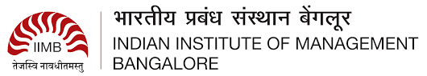
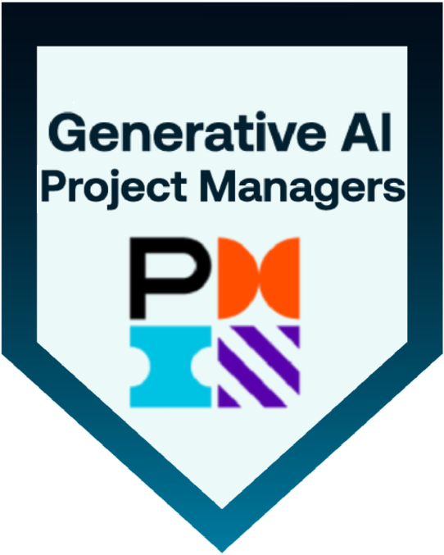
Sr Business Analyst | Product Owner
saifleader001@gmail.com | M: +91-9966577563
Linkedin  Core Competencies:  - Agile Product Development.  - Backlog Management & Prioritization, Business Process Reengineering.  - KPI Tracking, Stakeholder Analysis.  - Change Management, User Training.  - Risk Analysis, Business Case Development  - Data Modeling  - UAT Planning, Agile Ceremonies.  - Requirements Elicitation.  - Workflow Optimization  Domain knowledge:  - Financial  - Healthcare  - Supply Chain Management.  Technical Skills:  - Software Methodologies:  - Agile, Scrum, SDLC, Waterfall  - Programming Languages: Python, SQL.  - Databases: Oracle, MS SQL Server, PostgreSQL, MySQL  Operating Systems: Windows, Linux, Unix, macOS  Data Visualization Tools: Power BI, Tableau, Airtable  UI/UX Design & Prototyping:  Balsamiq, MS Visio, Axure RP, Figma, Adobe XD, Zephyr  Packages: MS SharePoint, MS Office, Airtable  Project Management &  Collaboration Tools: Jira, Confluence, MS Suite, Google Suite  Certifications:  - Certified Generative Overview for Project Managers by PMI.  - IT Business Analyst Training from IIBA (COEPD)  Education  - Post Graduate Level Program- Strategic Management from IIM Bangalore. -(2024-2025)  - Masters of Computer Applications -(MCA) from JNTUK. - (2008-2011)  Achievements:  - Best Employee Award for the years 2020 & 2021 at Arla Foods for consistently reducing the manual tasks by up  to 30%.  - Got a Silver Award from Google Inc. along with a Certificate of Excellence for the best productivity as a lead of a Navigation Project-2012 | PROFESSIONAL SUMMARY:  - Senior Business Analyst with 7 years of experience in business analysis, requirement elicitation, documentation, process modeling, and functional testing with overall 14 years of experience. Experienced across all phases of the SDLC (i.e waterfall & agile)  - Proficient in Waterfall Model: Gathered requirements using Elicitation Techniques and prepared BRD, FRD, SRS prepared RACI Matrix, BCD, created UML Diagrams and Prototypes and requirements tracking through RTM well versed with UAT handling Change Request.  - Expert in Agile Scrum: Creation of user stories and Added Acceptance Criteria, BV & CP, Sprint & Product Backlogs conducted various Sprint Meetings; Sprint & Product Burndown charts ensured DOR and DOD checklist.  - Proficient in requirements planning, facilitating stakeholder sessions, user story creation, and backlog prioritization in Agile environments.  - Well-versed in JIRA for project tracking, and Axure/Balsamiq for prototyping.  PROFESSIONAL EXPERIENCE  Company Name: ProhireIT Inc, Hyderabad, India August 2024- Present  Client: Worldpay Financial Services, Cincinnati, Ohio  Project: Payments Integrations  Role: Sr Business Analyst | Product Owner | Agile  Responsibilities  - Defined and prioritized product backlog aligned with customer needs, business goals, and stakeholder input.  - Led initiatives to adjudication and payment reconciliation workflows in financial systems, Credit, debit entries, ensuring accuracy and reduced turnaround times.  - Created UML, Use Cases, Activity Diagrams, DFDs, ERDs, and web mockups using modeling tools.  - Gathered and documented business requirements in confluence to implement KYC/AML compliance workflows; collaborated with risk, legal, and IT teams to ensure alignment with Basel III and regulatory mandates  - Wrote and prioritized user stories with acceptance criteria.  - Collaborated with developers and addressed various bugs in Java, .NET, Oracle, Spring, Kafka & accordingly reported those bugs on JIRA for tracking.  Company Name: Amvotech Solutions Inc, Hyderabad, India June 2022- July 2024  Client: Axia Women’s Health, Voorhees, New Jersey  Project: Healthcare RCM  Role: Sr Business Analyst | Agile  Responsibilities:  - Led cross-functional collaboration with Product, UI/UX, and Salesforce Mobile App teams to design barcode-compatible, mobile-first interfaces.  - Gathered and analyzed functional/non-functional requirements via interviews, workshops, and surveys; created traceability matrices for scope alignment.  - Developed HL7 healthcare prototypes using Figma and Balsamiq; validated user journeys and system behavior.  - Supported system integrations between ServiceNow ITSM and external HR platforms; developed dashboards in Tableau and ServiceNow to track fulfillment KPIs.  - Facilitated Agile ceremonies; defined UAT scope, created test cases, and supported QA in test planning and execution.  Company Name: Arla Foods, Riyadh, KSA. Oct 2019 - May 2022  Project: I) Supply Chain Mgmt. | Agile  Role: Business Analyst  Responsibilities  - Translated product vision into actionable user stories and acceptance criteria, aligning with strategic goals and technical feasibility.  - Led sprint planning, JAD sessions, agile ceremonies, and stakeholder demos to drive delivery using Scrum and modern product practices.  - Designed UML diagrams in MS Visio, wireframes, and process flows; improved brand management efficiency by 30% through automation.  - Collaborated with supply chain SPOCs to gather backlog requirements and supported end-to-end operations.  II) Financial Management | Waterfall  Responsibilities  - Used MoSCoW prioritization and RTMs to ensure delivery of high-impact features; partnered with dev teams on Salesforce LWC interactions.  - Conducted end-to-end process mapping and gap analysis of financial workflows using AS-IS/TO-BE modeling.  - Developed BRDs and user stories in JIRA to support cost allocation and budgeting system enhancements.
Company Name: Dr. Mamdooh Ashy Hospitals, Jeddah, KSA. August 2018 - Sept 2019
Project: Patient Info. Management System (PIMS)
Role: Business Analyst | Waterfall

Responsibilities:
- Led cross-functional requirement gathering (HR, IT, Ops); authored BRD, FSD, SRS, RTM; conducted interviews, workshops, and observations.
- Delivered full-cycle project under Waterfall with Saudi Ministry of Health compliance; mapped processes using BPMN/UML; performed stakeholder analysis and impact assessments.
Supported ServiceNow (HRSD & non-HR) post-deployment via JAD sessions, root cause analysis, and hyper care.
Company Name: Wathba International Company Ltd, Jeddah, KSA June 2014 - July 2018
Project: Wathba Merger
Role: Asst. Manager -Operations

Responsibilities:
- Led cross-functional teams to manage IT service delivery and trade operations, ensuring SLA compliance, timely import/export, ERP-based inventory systems during Wathba–Ashy Group merger.
- Integrated WooCommerce with backend systems for real-time inventory/order sync and connected ZKTeco fingerprint system to MS SQL Server for automated reporting and data accuracy

Company Name: GlobalLogic May 2011-May 2014
Client: Google Inc., Hyderabad, India,
Project: Content Engineering
Role: Sr. Analyst/Team Lead,
Responsibilities:
- Validated and tested front-end Maps interfaces and internal tools for Google Maps Local Data Operations, ensuring GIS data accuracy and consistency of linear road segments across platforms.
- Created ad-hoc reports and dashboards using Excel, VB Script, and Macros to support data-driven decision-making; coordinated with vendors to validate third-party geospatial data and support Maps program execution and innovation.

