Nurturing Process – Capstone Project 1 – Part 2/3

Case Study: Online Agriculture Products Store

Question 1 – Audits (5 Marks)
Q: 4 Quarterly Audits are planned (Q1, Q2, Q3, Q4) for this Project. What is your knowledge on how these Audits will happen for a BA?

Solution:

Audits are checkpoints to ensure requirements and BA deliverables align with project goals. For a BA, audits focus on requirements documentation, stakeholder sign-offs, and traceability.

- Q1 Audit (Initiation & Planning):

- Verify stakeholder analysis is complete.
- Confirm elicitation techniques chosen and applied.
- Ensure BA approach document and initial BRD draft exist.

- Q2 Audit (Analysis Stage):

- Validate finalized Business Requirements Document (BRD).
- Confirm Requirements Traceability Matrix (RTM) is created.
- Ensure use cases and diagrams are consistent with BRD.

- Q3 Audit (Design & Development Stage):

- Check requirements are mapped to functional designs.
- Ensure prototyping and mockups align with requirements.
- Confirm change requests are tracked and baselined.

- Q4 Audit (Testing & Closure):

- Verify requirements coverage in test cases.
- Ensure UAT is planned and executed.
- Confirm client sign-off and closure of all requirements.

BA Role: Provide updated BRD, SRS, RTM, participate in walkthroughs, justify requirements, and ensure alignment with client expectations.

Question 2 – BA Approach Strategy (6 Marks)
Q: Write BA Approach strategy.

Solution: As a BA, my approach includes:

- Elicitation Techniques:

- Interviews (with Mr. Henry, Farmers, Manufacturers).
- Workshops (with key stakeholders).
- Prototyping (for login, catalogue, payment).
- Document Analysis (CSR reports, procurement process).

- Stakeholder Analysis (RACI):
- Responsible: BA, Developers, Testers.
- Accountable: Project Manager.
- Consulted: Farmers, Manufacturers, Committee.
- Informed: Sponsor, Finance Head.

- Documents to Write:
- Business Requirements Document (BRD).
- System Requirements Specification (SRS).
- Use Case Specs.
- UML Diagrams (Use Case, Activity).
- RTM, Change Request Log.

- Process for Sign-off:
- Draft Internal Review Stakeholder walkthrough Final approval Baseline.
- Approvals from Client:
- Through committee sign-off (Mr. Henry, Pandu, Dooku).

- Communication Channels:
- Weekly reports, Steering Committee meetings, Teams/Slack.

- Change Requests:
- Logged in CR register Impact analysis CCB approval.

- Project Progress Updates:
- Weekly status reports, monthly reviews.

- UAT & Client Acceptance:
- UAT plan Execution with Farmers/Manufacturers Feedback incorporated UAT sign-off Client Acceptance Form.

Question 3 – 3-Tier Architecture (5 Marks)
Q: Explain and illustrate 3-tier architecture.

Solution: -

3-Tier Architecture separates the system into:
- Presentation Layer (UI): Web/Mobile screens for login, product catalogue, cart, payment.
- Business Logic Layer (Application Server): Handles rules like authentication, product search, payments, order management.
- Data Layer (Database): Stores Farmers, Manufacturers, Products, and Orders.

Example:
A farmer logs in (UI) Request validated (Logic) User details retrieved (DB).

Benefits: Scalability, Security, Maintainability, Modularity.

Question 4 – BA Approach Strategy for Framing Questions (10 Marks)
Q: What should a BA keep in mind before framing questions?

Solution: -

When framing questions, a BA should consider:

- 5W1H: Who, What, When, Where, Why, How.
- Ex: “How should delivery status updates be provided?”

- SMART: Questions should be Specific, Measurable, Achievable, Relevant, Time-bound.

- RACI Awareness: Ask only role-relevant questions (farmers = usability, finance = payment rules).

- 3-Tier Awareness:
- UI questions Farmers.
- Business logic questions Development Team.
- Database questions DB Admin.

- Model-based: Use case diagrams, activity flows, page mock-ups as aids.

- Example: Instead of vague “Do you want tracking?”, ask:
- “Should farmers see real-time GPS delivery tracking, or just estimated delivery date?”

Question 5 – Elicitation Techniques (6 Marks)
Q: What elicitation techniques are you aware of?

Solution: -

Using mnemonic BDRFOWJIPQU:

- Brainstorming
- Document Analysis
- Reverse Engineering
- Focus Groups
- Observation
- Workshops
- JAD (Joint Application Development)
- Interviews
- Prototyping
- Questionnaires
- User Stories

Question 6 – Elicitation Techniques for this Project (5 Marks)
Q: Which elicitation techniques apply here and why?

Solution: -

Best-fit for Online Agriculture Products Store:

Prototyping: Farmers are new to digital platforms, so mock-ups for login, search, payment will help them visualize.

Use Case Specs: Define interactions like product upload, order tracking clearly.

Document Analysis: Review CSR reports and existing systems.

Brainstorming: With farmers & manufacturers to refine catalogue and payment features.

Question 7 – Business Requirements (10 Marks)
Q: Identify at least 10 business requirements.

Solution: -

- BR001 – Farmers can search products.
- BR002 – Manufacturers can upload/display products.
- BR003 – Farmers/manufacturers can register new accounts.
- BR004 – Secure login/logout.
- BR005 – Multiple payment options (COD, UPI, Cards).
- BR006 – Farmers can track order status.
- BR007 – System sends email/SMS confirmations.
- BR008 – Manufacturers can edit/delete products.
- BR009 – Farmers can create a Wishlist/Buy later list.
- BR010 – System supports mobile-friendly interface.

Question 8 – Assumptions (5 Marks)
Q: List assumptions.

Solution: -

- Farmers have access to smartphones and internet.
- Payment gateways (UPI, Cards) are available in rural areas.
- Online sale of seeds/fertilizers/pesticides is legally permitted.
- Logistics partners can deliver to remote villages.
- Regional language support is feasible.

Question 9 – Requirements Prioritization (8 Marks)
Q: Assign priority (1 = low, 10 = high).

Solution: -

Req ID Requirement Priority
BR001 Farmers Search for Products 9
BR002 Manufacturers Upload Products 8
BR003 Account Registration 10
BR004 Login/Logout 9
BR005 Payment Gateway 10
BR006 Delivery Tracking 8
BR007 Notifications (Email/SMS) 7
BR008 Manage Products/Inventory 7
BR009 Wishlist/Buy Later 6
BR010 Mobile-friendly UI 8

Question 10 – Use Case Diagram (10 Marks)
Q: Draw use case diagram.

Solution: -

Actors: Farmer, Manufacturer, Admin.
Use Cases: Register, Login, Search Products, View Catalogue, Add to Cart, Wishlist, Checkout, Payment, Track Order, Upload Products, Manage Products.

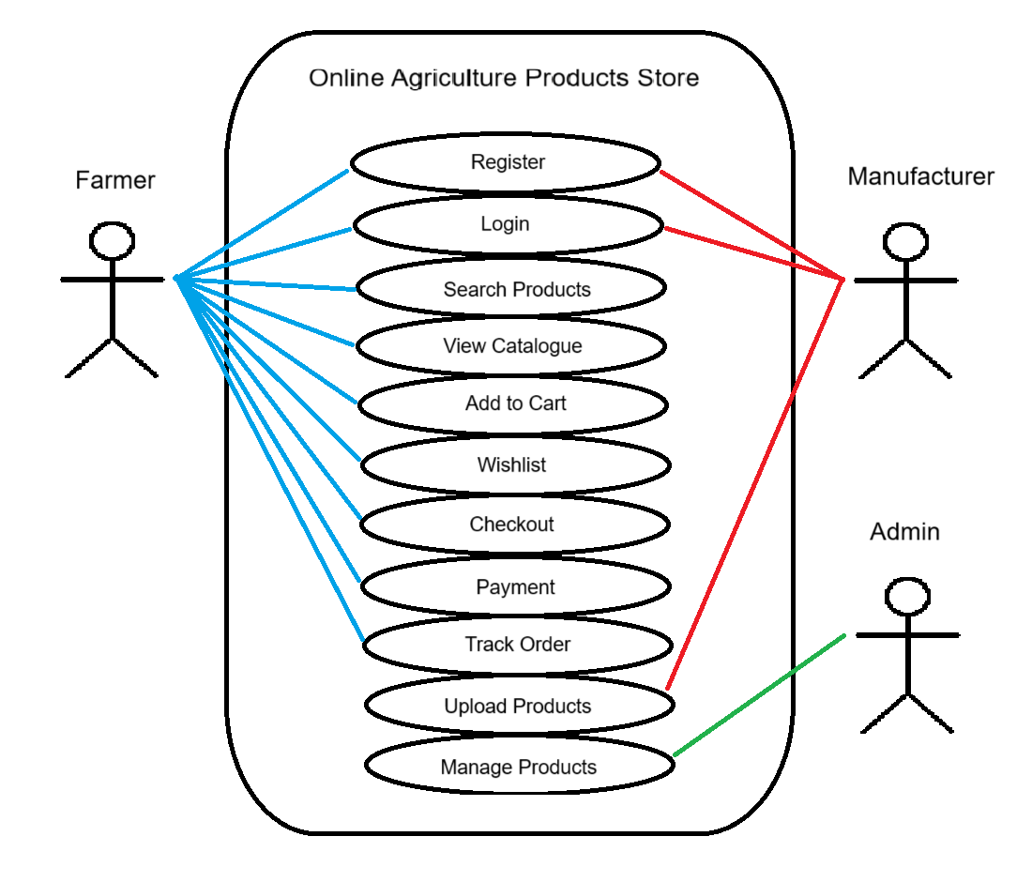
Question 11 – Use Case Specs (15 Marks)
Q: Prepare use case specs (minimum 5).

Solution: -

Use Case Spec – 1: Register Account

- Actors: Farmer, Manufacturer
- Preconditions: User is on registration page.
- Main Flow: Enter details Validate OTP SMS/Email Verify Account active.
- Alternate Flows: Duplicate email, OTP expired.
- Postcondition: Active account created.

Use Case Spec – 2: Login/Logout

- Actors: Farmer, Manufacturer, Admin
- Preconditions: User account exists.
- Main Flow: Enter credentials Validate Access dashboard Logout.
- Alternate Flows: Invalid credentials, locked account.
- Postcondition: Session created/ended.

Use Case Spec – 3: Search Products

- Actors: Farmer
- Preconditions: User logged in.
- Main Flow: Enter keyword System fetches results Display.
- Alternate Flows: No results found Suggestions.
- Postcondition: Products displayed.

Use Case Spec – 4: Upload Products

- Actors: Manufacturer.
- Preconditions: Manufacturer logged in.
- Main Flow: Enter product details System validates Save.
- Alternate Flows: Invalid data, failed upload.
- Postcondition: Product visible in catalogue.

Use Case Spec – 5: Checkout & Payment

- Actors: Farmer.
- Preconditions: Items in cart.
- Main Flow: Confirm order Select payment Process payment Confirm order.
- Alternate Flows: Out-of-stock, payment failed.
- Postcondition: Order created with ID.

Question 12 – Activity Diagrams (15 Marks)
Q: Draw activity diagrams (minimum 5)

Solution: -

- Login Flow:

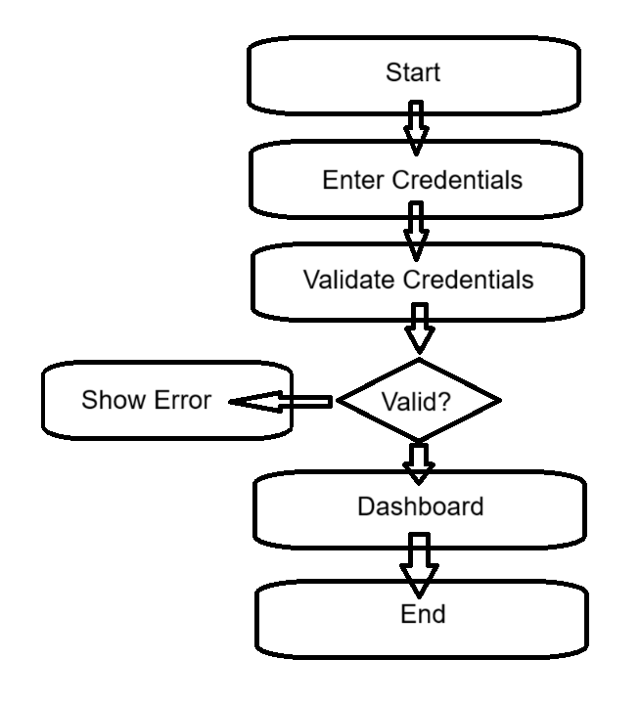

- Product Search:

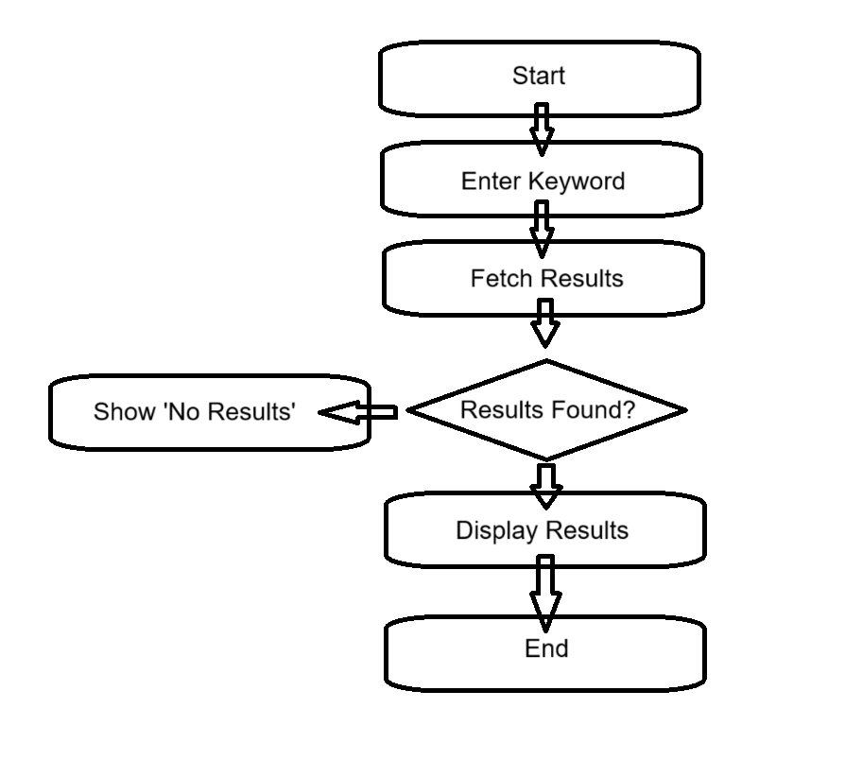

- Checkout:

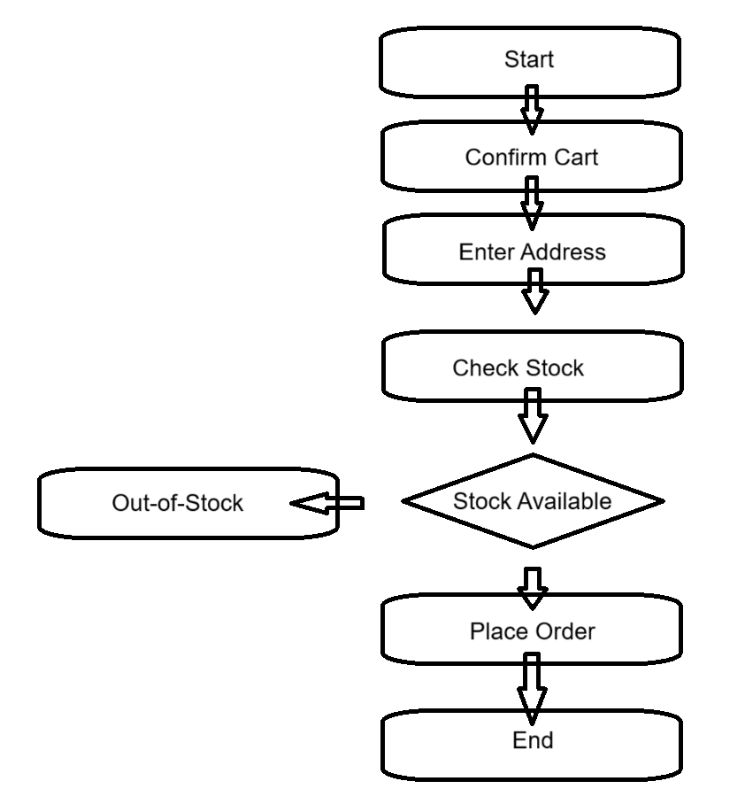

- Payment:

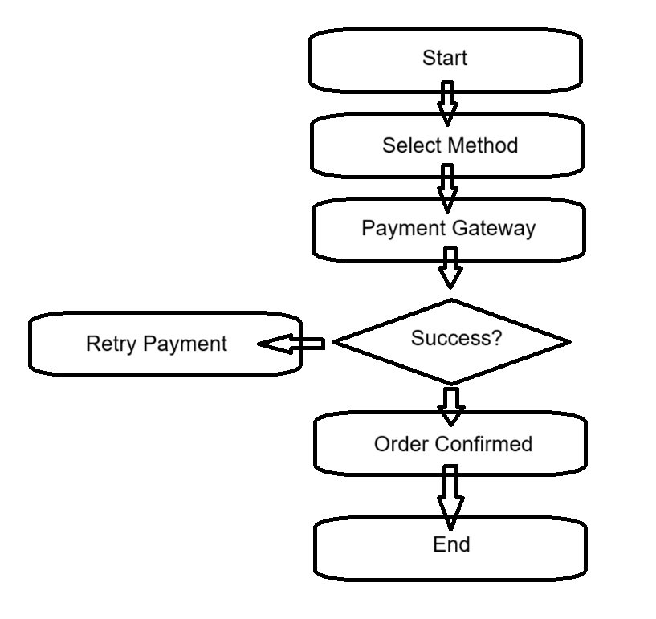

- Track Order:

