COEPD- BUSINESS ANALYSIS COURSE

CAPSTONE PROJECT (PART-1)
Online Agriculture Products Store Project

Introduction:
This case study revolves around a Corporate Social Responsibility (CSR) initiative taken by Mr. Henry, a successful businessman who wanted to give back to society by helping farmers from remote areas. After a casual conversation with his childhood friends Peter, Kevin, and Ben—who are farmers—Mr. Henry became aware of the challenges they face in procuring essential agricultural products like fertilizers, seeds, and pesticides. These problems highlighted a gap in the agricultural supply chain, especially in rural areas where access to quality products is limited.
To address this issue, Mr. Henry proposed the idea of building an Online Agriculture Products Store, which would serve as a digital platform enabling direct communication between farmers and manufacturing companies. Through this platform, farmers would be able to browse and purchase required products conveniently from their mobile devices or computers.
The project is funded by Mr. Henry’s company, SOONY, with a budget of ₹2 Crores and a planned duration of 18 months. The project is being executed by APT IT SOLUTIONS, a technology company selected for their skilled talent pool and relevant experience. A dedicated team comprising developers, testers, network and database admins, along with project managers and business analysts, has been formed to bring this idea to life.
The main goal of this initiative is to simplify access to essential agricultural inputs for farmers and contribute to their growth and productivity. The project not only has commercial potential but also a strong social impact, making it a significant example of how technology can be used to solve real-world problems.

Team Overview:
For the successful execution of the Online Agriculture Products Store project, a collaborative team structure has been established, involving various stakeholders, technical experts, and support roles from both the client and service provider sides.
Below is the breakdown of the team involved in the project:

Client Side (SOONY Company)
- Mr. Henry – He is the initiator of the project and also one of the wealthiest businessmen in the city. He came up with this idea as part of a CSR initiative to help remote farmers, including his childhood friends.
- Mr. Pandu – Financial Head at SOONY. He is responsible for overseeing the financial management and budget allocation for the project.
- Mr. Dooku – Project Coordinator from SOONY. He is involved in supervising the project progress and coordination from the client's side.
- Committee Members – Mr. Henry, Mr. Pandu, and Mr. Dooku form a decision-making committee for this project.
- Stakeholder Farmers – Peter, Kevin, and Ben (friends of Mr. Henry) are farmers from a remote village and are acting as key stakeholders. They are actively involved in sharing requirements and feedback based on actual farming needs.

Vendor Side (APT IT SOLUTIONS)
APT IT SOLUTIONS was selected as the execution partner for this CSR project. The team structure from their side includes:
- Mr. Karthik – Delivery Head. He played an important role in bagging the project for APT IT SOLUTIONS through his professional network and will oversee overall delivery.
- Mr. Vandanam – Project Manager. He is responsible for planning, execution, and ensuring the project is completed within budget and timeline.
- Ms. Juhi – Senior Java Developer. She leads the technical development efforts and helps guide junior developers.
- Java Developers – Mr. Teyson, Ms. Lucie, Mr. Tucker, and Mr. Bravo are part of the Java development team working on core features of the application.
- Mr. Mike – Network Administrator. He handles networking and infrastructure-related aspects to support the application.
- Mr. John – Database Administrator. He is in charge of designing and managing the project’s database.
- Mr. Jason and Ms. Alekya – QA Testers. They are responsible for testing the application and ensuring its quality before deployment.
- My Role – Business Analyst (BA) – I have joined this project as the Business Analyst. I’m responsible for gathering and analyzing requirements from stakeholders, preparing documentation like SRS and use cases, and ensuring the developed solution meets the business needs.

Question 1: BPM

Business Process Model – Online Agriculture Products Store
A Business Process Model (BPM) is a visual or structured representation of the steps, resources, inputs, and outputs involved in a business process.
It is used to clearly map how work flows within a system or organization, showing how tasks are carried out, who is involved, what resources are needed, and what results are produced.
I have inserted the image of the BPM diagram I’ve created via MS Visio below:
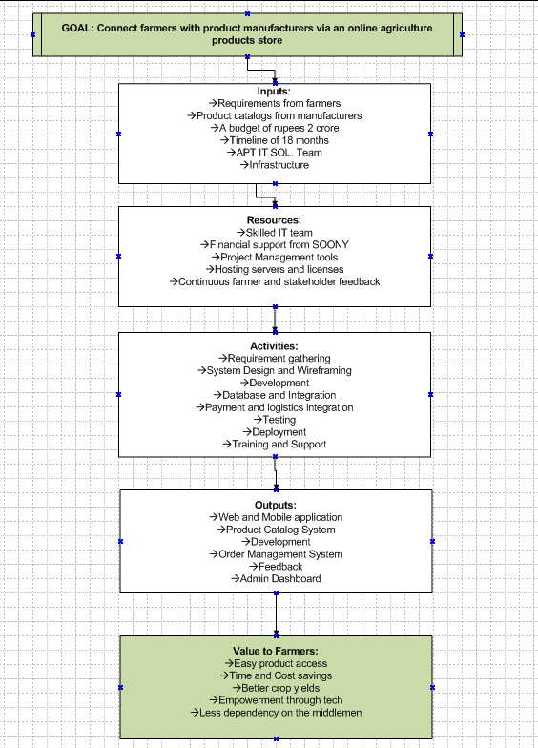

Question 2: SWOT Analysis

Strengths | Weaknesses
→ Strong talent pool available in APT IT Solutions (developers, testers, etc.) | → First time working on an agriculture domain project (limited domain knowledge)
→ Clearly defined requirements from stakeholder farmers | → Risk of requirement changes during development
→ Backed by a good budget (₹2 Crores) and 18-month timeline | → User training and adoption in remote areas could be challenging
→ Direct involvement of real end-users (Peter, Kevin, Ben) as stakeholders | → No existing platform to reuse (building everything from scratch)

Opportunities | Threats
→ Chance to build a high-impact CSR project with visibility | → Unstable internet connectivity in rural areas may affect usability
→ Potential to scale the product to other regions or B2B use | → Possibility of poor adoption due to lack of digital literacy among farmers
→ Chance to build long-term partnership with SOONY company | → Delay in integration with logistics or payment providers
→ Positive social impact and potential media attention | → Competition from existing agriculture e-commerce platforms (like DeHaat)

Question 3: Feasibility Study

Aspect | Points to Consider
Hardware | - Check availability of servers for development, testing, and deployment  - Ensure team systems have required configurations for Java IDEs and frameworks  - Internet connectivity and network infrastructure for development and deployment
Software | - Use Java (Spring Boot) for backend, supported by tools like IntelliJ/Eclipse  - Frontend with HTML/CSS/JS (React or Angular optional)  - MySQL or PostgreSQL for database  - JIRA for project tracking, Git for version control  - Selenium/JUnit for testing- Ensure licensing (if any) is managed properly
Trained Resources | - Confirm availability of Java developers (Senior and Junior)  - Check experience of team with Spring Boot, REST APIs, ORM, etc..  - Ensure testers are skilled in automation and manual testing  - Validate presence of skilled DB Admin and Network Admin  - Project Manager and Business Analyst must have experience with similar SDLCs
Budget | - ₹2 Crores is sufficient for staffing, infrastructure, licenses, testing, and buffer for risks  - Cost allocation must be planned phase-wise (development, testing, deployment, training)  - CSR nature of project means cost-effective decisions are preferred
Time Frame | - 18 months is a reasonable duration for requirements gathering, design, development, testing, and UAT  - A phased delivery (e.g., MVP in 6–8 months) can help track progress  - Agile, iterative or V model approach can help manage evolving requirements

Question 4: GAP Analysis

Process Area | AS-IS (Current Process) | TO-BE (Future Process – With Online Store) | Gap Identified
Product Procurement | Farmers travel to nearby towns to manually buy fertilizers, seeds, and pesticides | Farmers can browse, select, and order products online via the web/mobile app | Time-consuming, physically exhausting process is replaced by a convenient one
Product Availability | Limited stock availability at local stores; often poor quality or damaged products | Verified manufacturers upload product details directly to the platform | Inconsistent access to quality products is resolved
Farmer-Manufacturer Communication | No direct communication between farmers and companies; middlemen have the upper hand | Direct connection via platform chat/support modules | Removes dependency on middlemen; improves transparency
Pricing & Cost | Prices fluctuate due to middlemen; farmers often pay more | Transparent pricing directly from manufacturers | Overpricing due to involvement of middlemen is eliminated
Awareness of Products | Farmers are unaware of latest products or their correct usage | Platform can provide product descriptions, reviews, and recommendations | Information asymmetry is reduced; informed decisions enabled
Order Tracking | No order tracking; farmers rely on verbal updates from shopkeepers | Real-time order tracking, confirmation, and delivery status via the application | Improved reliability and peace of mind for farmers
Feedback System | Farmers have no way to report bad quality or give feedback on products | Integrated feedback/review system for each product and manufacturer | Quality assurance through ratings and reviews

Question 5: Risk Analysis
- Business Analyst Risks:

Risk Factor | Description | Mitigation Strategy
Incomplete Requirements | Stakeholders (farmers) may not express all requirements clearly due to limited technical exposure | Use multiple elicitation techniques (interviews, observation, prototypes)
Miscommunication with Stakeholders | Misunderstandings may occur between rural stakeholders and technical team | Use simple, local language during discussions and confirm understanding with mockups
Changing Requirements Midway | As farmers get familiar with digital tools, new requests might emerge | Use an agile or iterative approach to handle evolving needs
Lack of Domain Knowledge (Agriculture) | BA may not be familiar with farming-specific terminology or needs | Conduct domain research and involve SMEs or farmers in requirement validation
Documentation Gaps | BA may miss documenting some scenarios or edge cases | Regular peer reviews and walkthroughs with development and testing teams

- Process/Project Risks:

Risk Factor | Description | Mitigation Strategy
Delays in Project Schedule | Development and testing may take longer than estimated due to complexity | Maintain a detailed project plan with buffer time; monitor progress weekly
Budget Overrun | Unplanned features or delays may increase project costs | Follow phase-wise budgeting; avoid gold plating
Low User Adoption (Farmers) | Farmers in remote areas may hesitate to use the application | Conduct training sessions and provide help guides in local language
Technical Issues | Application performance issues may arise post-deployment | Implement robust testing and maintain support team for timely fixes
Third-party Integration Failures | Payment gateway or logistics partner APIs might fail or delay integration | Have backup vendors or offline fallback mechanisms in place
Security Concerns | Farmer data or transactions may be at risk | Use SSL encryption, secure login, and follow best practices for data privacy
Infrastructure Challenges in Rural Areas | Internet or device limitations in target areas might restrict access | Design app with offline mode and lightweight UI for low bandwidth

Question 6: Stakeholder Analysis (RACI Matrix)
PS: (I have attached the screenshots of the tables I’ve created on canva below for this question as this word document could not support tables with a lot of coloumns and rows [it messed with the format]. I chose to answer this question in a tabular form as they’re more clear, precise and easy to summarize. Kindly consider the images.)
The bold format in certain places as they’re more important to that particular phase in the lifecycle.
- Project Planning and Approval:
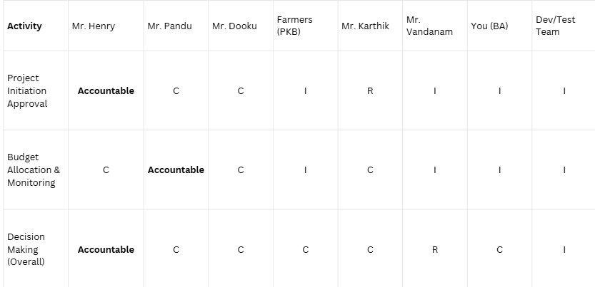
- Requirements and Analysis:
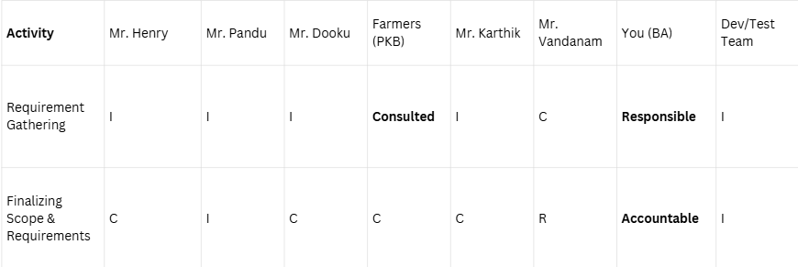

- Design, Development & Testing:
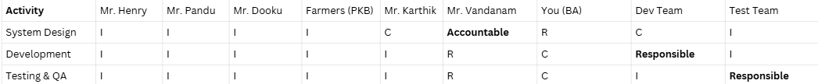

- Deployment, Training & Support:
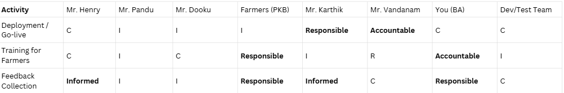

Key Roles:
- A = Accountable (Final decision authority)
- R = Responsible (Task ownership and execution)
- C = Consulted (Provides input/advice)
- I = Informed (Kept in the loop)

Decision makers:
- Mr. Henry – Final initiator and project sponsor
- Mr. Pandu – Budget-related decisions
- Mr. Vandanam – Technical and execution-related decisions
- You (BA) – Own the requirement definition and stakeholder alignment
Influencers:
- Peter, Kevin, Ben (Farmers) – Shape the platform features with real-world inputs
- Mr. Karthik – Guides delivery model and team allocation

Question 7: Business Case Document

Business Case Document
Project Title: Online Agriculture Products Store
Prepared By: Mr. Karthik (Delivery Head, APT IT SOLUTIONS)
Submitted To: Mr. Henry and CSR Committee (SOONY Company)
Date: dd/mm/yyyy

1. Executive Summary
This business case proposes the development of a web and mobile-based Online Agriculture Products Store to solve the procurement challenges faced by farmers in remote areas. The platform aims to directly connect farmers with manufacturers of seeds, fertilizers, and pesticides, eliminating intermediaries, improving product quality access, and reducing operational challenges. This project is being executed under the CSR initiative of SOONY Company. Our project comes under the B2C model.

2. Problem Statement
Farmers in rural areas are struggling to access quality agricultural products due to:
- Lack of nearby supply centers
- High dependence on intermediaries (middlemen)
- Lack of awareness about product availability
- Delayed or uncertain procurement cycles
These issues lead to poor crop outcomes and economic loss. There is a need for a digital system that can connect farmers with genuine suppliers efficiently.

3. Project Objective
- To create a user-friendly application (web + mobile) where farmers can browse, compare, and purchase agricultural products directly.
- To bridge the communication gap between farmers and product manufacturers.
- To support digital transformation in agriculture through CSR.
4. Proposed Solution
APT IT SOLUTIONS proposes to build an end-to-end digital platform using Java-based technologies with the following features:
- Farmer and Manufacturer Registration
- Product Listings (Seeds, Fertilizers, Pesticides)
- Online Ordering and Payment Integration
- Order Tracking and Delivery Management
- Reviewing & Feedback
- Admin Dashboard for monitoring

5. Expected Benefits

To Farmers:
- Easy access to certified agricultural products
- Cost savings through elimination of intermediaries
- Timely procurement leads to better crop yield

To SOONY Company:
- Strong CSR impact and brand reputation
- Opportunity to scale the model to other areas

To APT IT Solutions:
- Long-term partnership opportunity with SOONY
- CSR-focused project experience for the portfolio

6. Financial Summary
Component | Estimated Cost (INR)
Software Development | ₹90,00,000
Testing and QA | ₹15,00,000
Infrastructure & Hosting | ₹20,00,000
Training and Documentation | ₹10,00,000
Support and Maintenance (1 year) | ₹15,00,000
Project Management & Admin | ₹20,00,000
Total Estimated Cost | ₹2,00,00,000

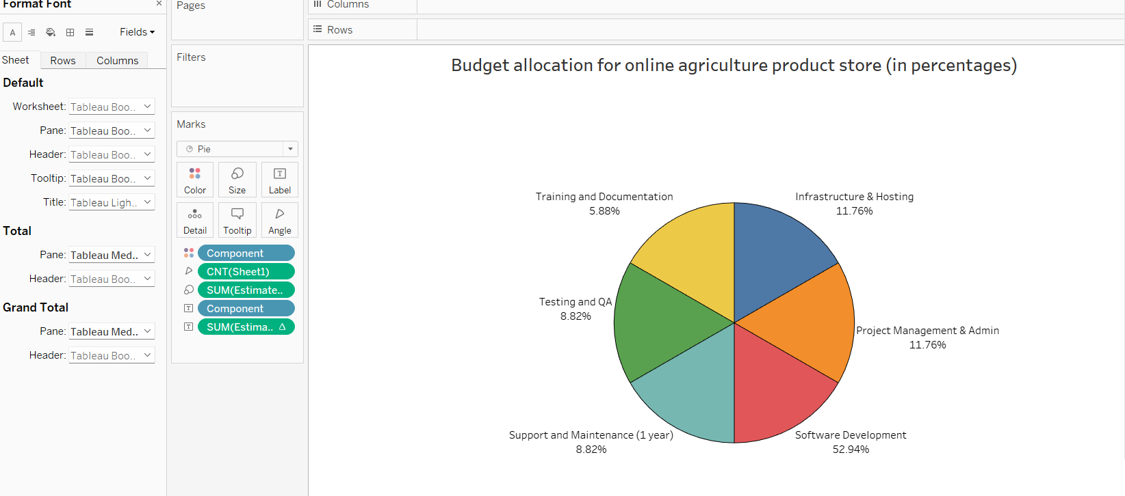
Here is a pie chart I created for better understanding. I used the Hundred Dollar Method to allocate funds according to the priority of each component. Since software development is the core deliverable, it received the largest share, followed by infrastructure, project management, and quality assurance. Lower but essential allocations went to training and ongoing support, ensuring both adoption and sustainability of the platform.

7. Timeline
- Project Duration: 18 months
- Phase 1 (0–3 months): Requirement Gathering & Analysis
- Phase 2 (4–9 months): Design & Development (MVP Release)
- Phase 3 (10–15 months): Testing, Feedback Incorporation
- Phase 4 (16–18 months): Training, Deployment & Support

8. Risk Overview
Risk | Mitigation Strategy
Low digital literacy in rural areas | Provide training and local language support
Internet connectivity issues | Build a lightweight, mobile-friendly UI
Changing requirements | Follow Agile methodology and keep room for iterations
User adoption resistance | Engage stakeholders (farmers) early and continuously

9. Conclusion
This project aligns with SOONY’s vision of social impact through technology. By investing in this platform, the company will not only help farmers but also build a model that can be expanded or adapted across regions. With a skilled team at APT IT SOLUTIONS and defined scope, the project is both technically and financially feasible.

10. Approval (sign-offs)
Name | Designation | Signature | Date
Mr. Henry | Project Sponsor (SOONY)
Mr. Pandu | Finance Head (SOONY)
Mr. Dooku | Project Coordinator
Mr. Karthik | Delivery Head (APT IT)

Question 8: Four SDLC Methodologies
During the project planning phase, Mr. Karthik explained to Mr. Henry and the other stakeholders that Software Development Life Cycle (SDLC) is a structured approach used to plan, design, develop, test, and deploy software projects effectively. To help choose the right project management approach for the Online Agriculture Products Store, he discussed four major SDLC methodologies:
- SEQUENTIAL MODEL (Waterfall Model)
This is a traditional model where each phase (requirement, design, development, testing, deployment) happens in a linear sequence—one after the other.
→ Best suited for projects where the requirements are very clear and fixed from the beginning.
Pros: →Simple to understand and manage
→ Easy to track progress as each stage has specific deliverables
Cons: →Not flexible; changes cannot be handled easily
→Late discovery of issues (during testing phase)
Example (in our case):
→ If Mr. Henry had all requirements finalized and no changes expected during the 18 months, Waterfall could work—but this is unlikely in real-world CSR projects.

- ITERATIVE MODEL
In this model, the project is developed in repeated cycles (iterations). Each version is built with feedback from the previous one, improving features and functionality gradually.
→ Useful when requirements are mostly known but may evolve over time based on stakeholder input or pilot feedback.
Pros: →Flexibility to refine product as development progresses
→Feedback-driven improvement
Cons: →Can be time-consuming if too many iterations happen
→Budget can increase due to frequent changes
Example:
→ For this agriculture platform, we can first develop a core version (catalog + ordering), then add feedback and build order tracking or language features later.

- EVOLUTIONARY MODEL
The system is developed partially and incrementally, with more features added as the understanding improves. It’s like building in layers based on evolving customer needs.
→ Best for CSR-based projects where user requirements evolve due to limited digital exposure (like farmers in remote areas).
Pros: →User feedback can be incorporated in real time
→Faster to deliver a working version to end users
Cons: →Can lead to scope creep
→Requires strong project control and communication
Example:
→ We can start by launching the web app in a single region with basic features, observe farmer responses, and scale to other regions or add important features like payment later.

- AGILE MODEL
Agile is an adaptive and flexible approach that uses small time-boxed sprints (usually 2–4 weeks) to build and deliver features. Frequent collaboration with stakeholders is key.
→ Ideal for projects like this one, where there is user involvement, scope changes, and a need for quick feedback.
Pros: → Continuous delivery and improvement
→ Active stakeholder involvement
→Suitable for uncertain or changing environments
Cons: → Needs experienced team
→ Requires constant communication and time commitment
Example:
→ Mr. Karthik can use Agile sprints to deliver modules like user registration, product catalog, and cart separately—while incorporating farmer and sponsor feedback after every sprint.

Question 9: Waterfall RUP Spiral and Scrum Models
During the team meeting, I contributed by sharing my understanding of four commonly used SDLC models: Waterfall, RUP, Spiral, and Scrum. Each of these models has its own approach to software development, and choosing the right one depends on the project's nature, scope, and stakeholder expectations.

Waterfall Model
Waterfall is the oldest and most traditional SDLC model. It follows a linear and sequential approach, where one phase must be completed before moving to the next. The stages include Requirements → Design → Implementation → Testing → Deployment → Maintenance.
When to Use:
- When requirements are clear and fixed
- Suitable for short-term projects with limited complexity
Pros: → Easy to manage and follow
→ Well-documented process
Cons: → No flexibility for changes
→ Errors discovered late in the process are compromised on
Example: For the agriculture store, if every requirement was known in detail from the start, Waterfall could work—but this is rarely the case in CSR-based digital platforms.

RUP (Rational Unified Process)
RUP is a framework-based model developed by IBM. It divides the project into four phases: Inception, Elaboration, Construction, and Transition. It is iterative and emphasizes documentation, risk management, and architecture-first design.
When to Use:
- For large enterprise-level systems
- When detailed documentation and multiple stakeholders are involved
Pros: → Supports iterative development with defined milestones
→ Risk is handled early
Cons: → Requires experienced team members
→ Can be heavy on process and documentation
Example: If SOONY wanted to later scale this platform nationwide with additional integrations, RUP could help manage that complexity.

- Spiral Model
Spiral combines elements of both iterative and waterfall models. It focuses heavily on risk assessment and development occurs in a spiral form—through repeated cycles of planning, risk analysis, engineering, and evaluation.
When to Use:
- For complex, high-risk projects
- When frequent changes are expected
Pros: → Risk is managed early and continuously
→ Allows for early prototypes and feedback
Cons: → Expensive and time-consuming
→ Requires expertise in risk analysis
Example: Since the agriculture platform is CSR-funded and must serve remote users with unknown digital behavior, Spiral could be useful to identify and reduce technical, budget, and usability risks gradually.

Scrum (Agile Framework)

Scrum is a lightweight Agile methodology focused on delivering products in short, time-boxed iterations called sprints (usually 2–4 weeks). Roles include the Scrum Master, Product Owner, and Development Team.
When to Use:
- When requirements are expected to evolve
- Where customer involvement and quick releases are needed
Pros: → Flexible and adaptive
→ Faster time to market
→ Involves regular customer feedback
Cons: → Needs disciplined team and daily involvement
→ May lack clear documentation if not managed well
Example: Scrum would be ideal for the agriculture project—features like order tracking, product reviews, or multi-language support can be developed in different sprints with feedback from farmers.

Question 10: Waterfall Vs V-Model
As a Business Analyst, I was asked to help resolve a difference of opinion between the Subject Matter Experts (SMEs) and the project team. While the SMEs preferred the V-Model, the project team favored the traditional Waterfall model. To address this conflict, I first laid out the key differences between the two models to ensure both sides had a common understanding.

Waterfall Model | V-Model (Verification & Validation)
Linear and sequential | Linear but with corresponding test phase for each stage
Begins after the implementation phase | Testing is planned parallel to each development stage
Less focused on early validation | Focuses on validation from the beginning
Difficult to implement changes once the process starts | Also, rigid but better planning for defects through early tests
Defects found late – higher cost | Defects found earlier – reduced cost and effort
Risks are not planned early | Risks are addressed during early validation stages
Suitable for smaller, simple projects | Best for projects where quality is critical
Documentation-heavy but not linked to testing | Emphasizes strong documentation with test mapping
Low | Still low, not as adaptive as Agile
One-time delivery at the end | One-time delivery but better-tested product

Question 11: Justify your choice

As a Business Analyst working on the Online Agriculture Product Store project, I have carefully evaluated all the commonly used Software Development Life Cycle (SDLC) models such as Waterfall, V-Model, Spiral, RUP, and Scrum. After considering the nature of the project, stakeholders involved, the user base (remote farmers), budget, and timeline (₹2 Crores, 18 months), I believe that the V-Model is the most suitable methodology for this project.

Justification for Choosing V-Model:
- Emphasis on Quality:
Since the platform will directly impact farmers’ ability to access critical agricultural inputs like seeds, fertilizers, and pesticides, quality and reliability are extremely important. V-Model ensures validation and verification at each stage.
- Clear Requirements from Start:
In this project, major stakeholders like Mr. Henry, Peter, Kevin, and Ben have clearly defined the needs and expectations, which suits the V-Model, where changes mid-way are limited.
- Early Test Planning:
Every development phase in V-Model has a corresponding testing phase. This helps in detecting defects early, reducing the cost and effort of fixing them later.
- Suitable for Fixed Budget and Time Projects:
Since this project is being executed under CSR funding with a fixed budget (2 Crores) and strict timeline (18 months), the V-Model’s predictable structure helps in staying on track.
- Low Technical Risk:
The project is not extremely complex or uncertain, making it a good fit for structured models like V-Model rather than highly adaptive models like Agile.
- Limited Need for Iterations:
Farmers may not give frequent feedback like typical end-users, which reduces the suitability of Agile or Evolutionary models. So a non-iterative model is more appropriate here.

Question 12: Gantt Chart
Methodology Used: V-Model
Project Duration: 18 months
Project Phases:
Requirements
- RG – Requirements Gathering
- RA – Requirements Analysis
Design & Testing
- D1 – Development Phase 1
- T1 – Testing Phase 1
- D2 – Development Phase 2
- T2 – Testing Phase 2
- D3 – Development Phase 3
- T3 – Testing Phase 3
- D4 – Development Phase 4
- T4 – Testing Phase 4
- UAT – User Acceptance Testing
Team Roles:
- PM – Project Manager (Mr. Vandanam); Delivery Head- (Mr. Karthik)
- BA – Business Analyst (Myself)
- Java Developers
- Testers
- DB Admin
- Network Admin

Here is the Gantt chart representing each month of the 18-month project clearly:
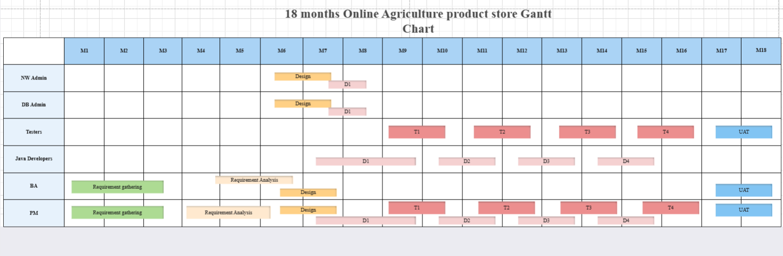
https://www.edrawmax.com/online/share.html?code=74f0f3ea774811f098df0a951ba8b83d
(I have created the chart online, here is the link to it, I have attached the image as exporting the file is a paid feature)

Question 13: Fixed Bid Vs Billing

Fixed Bid Project | Billing Project
A project with a predefined scope, cost, and time. | A project billed based on actual time and resources used.
Fixed upfront – no change unless re-negotiated. | Flexible – depends on hours/days worked.
Rigid – changes require scope revision and new contract. | Flexible – scope can evolve during development.
Vendor bears the risk of overruns. | Client bears the risk if project takes longer.
Small to medium projects with clear requirements. | Complex or evolving projects where requirements may change.
Less control for client once a contract is signed. | Client has continuous control over progress & budget.

Question 14: Prepare Timesheets of a BA in various stages of SDLC
As a Business Analyst (BA), I’m involved in almost all phases of the Software Development Life Cycle (SDLC). The BA role is crucial in bridging the gap between stakeholders and technical teams.
The timesheets created are representative samples with sample dates that highlights key involvement of the Business Analyst (BA) during major phases of the SDLC (Design, Development, Testing, UAT, and Deployment). It doesn’t mean the BA only worked during those weeks — rather, it showcases typical weeks of detailed BA activity for academic purposes- in my case, this capstone project.
Below are the timesheets representing BA activities and time allocation during various SDLC stages:

(i) Design Timesheet of BA-

Date | Task | Hours Spent | Remarks
04-09-2025 | Participated in HDD/LDD meetings | 3 hrs | Collaborated with design team
05-09-2025 | Validated wireframes with stakeholders | 2 hrs | Feedback incorporated
06-09-2025 | Prepared design documentation | 4 hrs | Shared with developers
07-09-2025 | Updated BRD/SRS with UI design alignment | 3 hrs | Minor changes to reflect UI elements

(ii) Development Timesheet of BA-

Date | Task | Hours Spent | Remarks
10-10-2025 | Clarified doubts raised by developers | 2 hrs | Requirement explanation provided
11-10-2025 | Reviewed dev progress with Project Manager | 1.5 hrs | Ensured alignment with requirements
12-10-2025 | Participated in sprint planning discussion | 3 hrs | Prioritized feature delivery
13-10-2025 | Conducted walkthrough on key use cases | 2 hrs | Shared examples and scenarios

(iii) Testing Timesheet of BA-

Date | Task | Hours Spent | Remarks
15-11-2025 | Prepared test scenarios and reviewed test cases | 3 hrs | Validated against SRS
16-11-2025 | Participated in bug/issue review meeting | 2 hrs | Prioritized defects/bugs with testers
17-11-2025 | Performed requirement traceability check | 2 hrs | Ensured test coverage
18-11-2025 | Reviewed test results for key modules | 2.5 hrs | Logged deviations

(iv) UAT Timesheet of BA-

Date | Task | Hours Spent | Remarks
01-01-2026 | Prepared UAT plan and shared with stakeholders | 3 hrs | Based on business use cases
02-01-2026 | Conducted UAT session with farmers & committee | 4 hrs | Took feedback from users
03-01-2026 | Collected sign-offs on key modules | 2 hrs | Approval received from Mr Henry
04-01-2026 | Logged UAT issues and updated status sheet | 2 hrs | Shared with Dev and QA teams

(v) Deployment & Implementation Timesheet of BA-

Date | Task | Hours Spent | Remarks
15-02-2026 | Prepared user manuals and training materials | 3 hrs | Simple instructions for farmers
16-02-2026 | Conducted training sessions for end users | 4 hrs | Farmers from multiple regions attended
17-02-2026 | Supported live deployment & post-implementation queries | 5 hrs | Immediate support after Go-Live
18-02-2026 | Helped in feedback collection post-launch | 2 hrs | Inputs for future improvements

