CAPSTONE PROJECT 1
PART 3
Question 1 - Functional Requirements
Identify minimum 20 functional requirements
Example:
Functional requirement: When an order is fulfilled, the local printer shall print a packing slip.
Non-Functional Requirement: Packing slips shall be printed on both sides of 4”x 6” whitepaper, the standard size for packing slips used by local printers.
Answer
Functional Requirement:
Req ID | Req Name | Req Description | Priority
FR0001 | Farmer Registration | Farmers should be able to register in the Application | 9
FR0002 | Search for the Products | Farmers should be able to search for the available products in Fertilizers, Pesticides and Seeds | 8
FR0003 | No Matching Product | Farmers should notified if not matching product found | 5
FR0004 | Product Selection | Farmers should be able to select the product | 7
FR0005 | Out of Stock | Farmers should be notified if products are out of stock | 7
FR0006 | Filter | Farmers should be able to Filter and Select the products as per Brand and Price | 7
FR0007 | Similar Products | Farmers should able to search similar products if any products are out of stock | 6
FR0008 | Bought Together | Once the product is finalized, farmers will be suggested for the related products bought together, as a package with the price | 6
FR0009 | Add to Cart | Farmers should be able to add the selected products to cart for Purchase | 8
FR0010 | Wishlist | Farmers should have an option to add their selected products to Wishlist | 6
FR0011 | Save it Later | Farmer should be able to see the option for Save it later to Purchase Later | 7
FR0012 | Delivery Address | Farmers should be able to select or add Delivery address to get the product | 8
FR0013 | Payment options | Once delivery address is selected the Application should Prompt the payment options to continue purchase | 8
FR0014 | Payment Confirmation | Farmers should receive the Payment confirmation via email and SMS | 10
FR0015 | Order Confirmation | Farmers should receive the Order confirmation by Email and SMS both | 9
FR0016 | Expected delivery date | Farmers should be able to see the Expected date of Delivery | 9
FR0017 | Track Delivery | Farmers should be able to Track the product for until it gets delivered | 8
FR0018 | Cancel/Return/Replacement | Farmers Should be able to Cancel/Return/Replacement for the products if they don’t liked the same | 9
FR0019 | Return Pick up | Farmers should be given pick up date and time for Cancel/Return/Replacement | 7
FR0020 | Return Confirmation | Farmers should get the confirmation by Email & SMS for Return | 7

Non-Functional Requirements
Req ID | Req Name | Req Description | Priority
NFR001 | Page Loading Time | Each page should load within 2 seconds | 9
NFR002 | Technical Supported System | Application can be used in any OS(Windows/IOS) | 9
NFR003 | Time limit for OTP | OTP time limit should be given maximum 5 mins for Login and Registration | 4
NFR004 | Logout System | If the page is not accessed more than 5 mins then the page will be logged out automatically | 4
NFR005 | Stock Availability | Stock availability should be updated on real time basis | 8
NFR006 | SMS & Email Confirmation | Automated notification should be send to user through Email & SMS | 8
NFR0017 | Back up | All data should get back up automatically | 9
NFR008 | Connectivity | System should be connected with Internet | 10
NFR009 | Stock Alerts | Seller should receive alerts when stocks will be reduced, every weekly | 8
NFR010 | Net Banking | Bank account should be active for smooth payment process | 9
NFR011 | Check Stock | Once the product is sold the stock status will be updated | 7
NFR012 | Email ID | A valid email id should be there to receive Email Notifications | 3
NFR013 | Taxation System | All products should be included with additional Tax | 8
NFR014 | Password | User Should receive password change alert every 30 days | 5

Question 2–Minimum 5-page designs
Make wireframe and prototypes
- Answer –

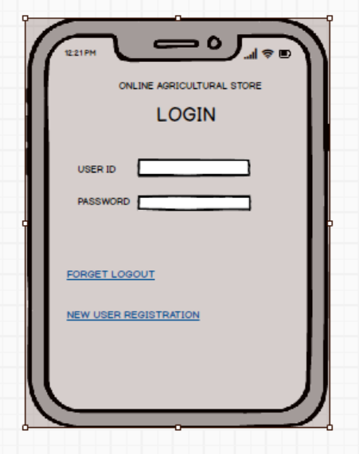
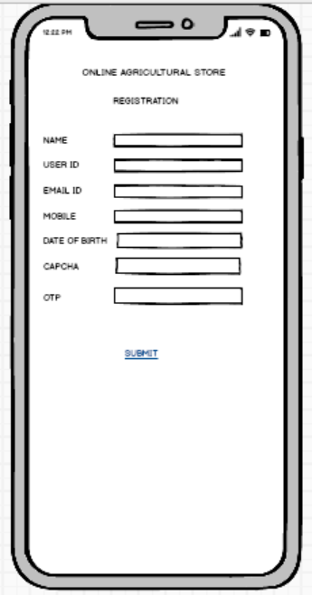

Question 3 – Tools (Visio, Balsamiq)
Make a note of the Tools, which you are using for above concepts.
Answer
- MS-VISIO:
Microsoft Visio is a powerful diagramming and vector graphics application that is part of the Microsoft Office family. It is widely used for creating a variety of diagrams, such as:
- Flowcharts
- Organizational Charts
- Floor Plans
- Network Diagrams
- UML Diagrams
- Mind Maps
- Business Process Models
Visio is especially beneficial in business and technical environments for process mapping, visual collaboration, and data visualization. The latest version includes integration with Excel and Power BI, allowing users to:
- Create diagrams directly from Excel data.
- Embed Visio diagrams into Power BI dashboards for enhanced insights.
Uses of Microsoft Visio for Business Analysts
Microsoft Visio simplifies the creation of complex diagrams, making it a valuable tool for Business Analysts (BAs). Here are key types of diagrams BAs can create using Visio:
1. Flowchart
- Represents steps in a process in a sequential order.
- Useful for documenting workflows, decision points, and system flows.
- Effective in simplifying and communicating complex processes across teams.
2. Organization Chart (Org Chart)
- Illustrates the hierarchical structure of an organization.
- Shows reporting relationships, employee roles, and departments.
- Useful in onboarding, HR planning, and team restructuring.
3. Floor Plan
- Provides a blueprint layout of rooms or entire floors.
- Used by architects and facility managers to place doors, windows, furniture, etc.
- Helpful for planning office layouts or emergency evacuation maps.
4. Business Process Model and Notation (BPMN)
- A standardized method for visualizing business processes.
- Clearly outlines the steps, decisions, and roles involved in a business workflow.
- Helps stakeholders understand, improve, or automate processes.
- BALSAMIQ:
Balsamiq Mock ups is a useful tool for showcasing software requirements through wireframes. It allows the development team to get a clear visual understanding of the project's design early in the development process. This brief tutorial will guide you through the fundamental steps to begin using Balsamiq Mock ups.
Question 4 – RTM
A business analyst’s key responsibilities are to keep track of the requirements and make sure that no requirement is missed.
Mr. Henry and peter have approached you regarding the current status of the project. How will you tackle this situation?
Answer –
Req ID | Req Name | Req Description | Design | D1 | T1 | D2 | T2 | D3 | T3 | D4 | T4 | UAT
FR0001 | Farmer Registration | Farmers should be able to register in the Application | Y | Y | Y | Y | Y | Y | Y | Y | Y | N
FR0002 | Search for the Products | Farmers should be able to search for the available products in Fertilizers, Pesticides and Seeds | Y | Y | Y | Y | Y | Y | Y | Y | Y | N
FR0003 | No Matching Product | Farmers should notified if not matching product found | Y | Y | Y | Y | Y | Y | Y | N | N | N
FR0004 | Product Selection | Farmers should be able to select the product | Y | Y | Y | Y | Y | Y | N | N | N | N
FR0005 | Out of Stock | Farmers should be notified if products are out of stock | Y | Y | Y | N | N | N | N | N | N | N
FR0006 | Filter | Farmers should be able to Filter and Select the products as per Brand and Price | Y | Y | Y | N | N | N | N | N | N | N
FR0007 | Similar Products | Farmers should able to search similar products if any products are out of stock | Y | Y | Y | N | N | N | N | N | N | N
FR0008 | Bought Together | Once the product is finalized, farmers will be suggested for the related products bought together, as a package with the price | Y | Y | Y | Y | Y | N | N | N | N | N
FR0009 | Add to Cart | Farmers should be able to add the selected products to cart for Purchase | Y | Y | Y | Y | N | N | N | N | N | N
FR0010 | Wishlist | Farmers should have an option to add their selected products to wishlist | Y | Y | Y | Y | N | N | N | N | N | N
FR0011 | Save it Later | Farmer should be able to see the option for Save it later to Purchase Later | Y | Y | Y | Y | N | N | N | N | N | N
FR0012 | Delivery Address | Farmers should be able to select or add Delivery address to get the product | Y | Y | Y | N | N | N | N | N | N | N
FR0013 | Payment options | Once delivery address is selected the Application should Prompt the payment options to continue purchase | Y | Y | Y | N | N | N | N | N | N | N
FR0014 | Payment Confirmation | Farmers should receive the Paymen t confirmation via email and SMS | Y | Y | Y | Y | N | N | N | N | N | N
FR0015 | Order Confirmation | Farmers should receive the Order confirmation by Email and SMS both | Y | Y | Y | N | N | N | N | N | N | N
FR0016 | Expected delivery date | Farmers should be able to see the Expected date of Delivery | Y | Y | Y | N | N | N | N | N | N | N
FR0017 | Track Delivery | Farmers should be able to Track the product for until it gets delivered | Y | Y | Y | N | N | N | N | N | N | N
FR0018 | Cancel/Return/Replacement | Farmers Should be able to Cancel/Return/Replacement for the products if they don’t liked the same | Y | Y | Y | Y | N | N | N | N | N | N
FR0019 | Return Pick up | Farmers should be given pick up date and time for Cancel/Return/Replacement | Y | Y | Y | N | N | N | N | N | N | N
FR0020 | Return Confirmation | Farmers should get the confirmation by Email & SMS for Return | Y | Y | Y | N | N | N | N | N | N | N

Req ID | Req Name | Req Description | Design | D1 | T1 | D2 | T2 | D3 | T3 | D4 | T4 | UAT
NFR001 | Page Loading Time | Each page should load within 2 seconds | Y | Y | Y | Y | Y | Y | Y | Y | Y | N
NFR002 | Technical Supported System | Application can be used in any OS(Windows/IOS) | Y | Y | Y | Y | Y | N | N | N | N | N
NFR003 | Time limit for OTP | OTP time limit should be given maximum 5 mins for Login and Registration | Y | Y | Y | N | N | N | N | N | N | N
NFR004 | Logout System | If the page is not accessed more than 5 mins then the page will be logged out automatically | Y | Y | Y | N | N | N | N | N | N | N
NFR005 | Stock Availability | Stock availability should be updated on real time basis | Y | Y | Y | N | N | N | N | N | N | N
NFR006 | SMS & Email Confirmation | Automated notification should be send to user through Email & SMS | Y | Y | Y | Y | Y | N | N | N | N | N
NFR0017 | Back up | All data should get back up automatically | Y | Y | Y | Y | N | N | N | N | N | N
NFR008 | Connectivity | System should be connected with Internet | Y | Y | Y | Y | Y | N | N | N | N | N
NFR009 | Stock Alerts | Seller should receive alerts when stocks will be reduced, every weekly | Y | Y | Y | N | N | N | N | N | N | N
NFR010 | Net Banking | Bank account should be active for smooth payment process | Y | Y | Y | N | N | N | N | N | N | N
NFR011 | Check Stock | Once the product is sold the stock status will be updated | Y | Y | Y | Y | Y | N | N | N | N | N
NFR012 | Email ID | A valid email id should be there to receive Email NNotifications | Y | Y | Y | N | N | N | N | N | N | N
NFR013 | Taxation System | All products should be included with additional Tax | Y | Y | Y | N | N | N | N | N | N | N
NFR014 | Password | User Should receive password change alert every 30 days | Y | Y | Y | N | N | N | N | N | N | N

Question 5 – 10 Test Case Documents
Prepare 10 Test Case Documents
Answer –
Project Name | Online Agriculture Product Store | Test Designed by | Sayanee Pramanick
Module Name | Login with user details | Test Design Date | DD-MM-YY
Release Version |  | Test Executed by | Sayanee Pramanick
Test Case Document 2: User Registration Functionality
Test Case ID: TC001
Test Case Name: User Registration
Description: Verify that a new user can register successfully.
Preconditions: Valid Email id or Mobile Number
Test Steps:
- Navigate to the registration page.
- Fill in required fields (name, email, password).
- Submit the registration form.
Expected Result: User receives a confirmation email and is redirected to the welcome page.
Actual Result:
Status: Pass/Fail
Remarks:
Test Case Document 2: Product Search Functionality
Test Case ID: TC002
Test Case Name: Product Search
Description: Verify that users can search for products (seeds, fertilizers, pesticides) using the search bar.
Preconditions: The store has products listed.
Test Steps:
- Navigate to the home page.
- Enter a product name in the search bar.
- Click the search button.
Expected Result: Relevant products are displayed in the search results.
Actual Result:
Status: Pass/Fail
Remarks:
Test Case Document 3: Product Filtering
Test Case ID: TC003
Test Case Name: Product Filtering
Description: Verify that users can filter products based on category, price, and rating.
Preconditions: The store has multiple products listed.
Test Steps:
- Navigate to the product listing page.
- Apply filters (e.g., category: fertilizers, price range).
- Review the filtered product list.
Expected Result: Only products that meet the filter criteria are displayed.
Actual Result:
Status: Pass/Fail
Remarks:
Test Case Document 4: Adding Products to Cart
Test Case ID: TC004
Test Case Name: Add to Cart
Description: Verify that users can add products to their shopping cart.
Preconditions: User is logged in and products are available.
Test Steps:
- Navigate to a product page.
- Select quantity and any variations (e.g., size).
- Click the "Add to Cart" button.
Expected Result: Product is added to the cart, and a confirmation message is displayed.
Actual Result:
Status: Pass/Fail
Remarks:
Test Case Document 5: View Cart Functionality
Test Case ID: TC005
Test Case Name: View Cart
Description: Verify that users can view the contents of their shopping cart.
Preconditions: User has added products to the cart.
Test Steps:
- Click on the cart icon.
- Review the items listed in the cart.
Expected Result: All added items are displayed with correct details (name, quantity, price).
Actual Result:
Status: Pass/Fail
Remarks:
Test Case Document 6: Checkout Process
Test Case ID: TC006
Test Case Name: Checkout Process
Description: Verify that users can complete the checkout process successfully.
Preconditions: User has items in the cart.
Test Steps:
- Navigate to the cart and click "Checkout."
- Enter shipping and payment information.
- Confirm the order.
Expected Result: Order confirmation is displayed, and an email is sent to the user.
Actual Result:
Status: Pass/Fail
Remarks:
Test Case Document 7: Order History
Test Case ID: TC007
Test Case Name: Order History
Description: Verify that users can view their order history.
Preconditions: User has made at least one purchase.
Test Steps:
- Navigate to the user profile section.
- Click on "Order History."
- Review the list of past orders.
Expected Result: All past orders are displayed with details (order date, products, status).
Actual Result:
Status: Pass/Fail
Remarks:
Test Case Document 8: User Profile Management
Test Case ID: TC008
Test Case Name: User Profile Management
Description: Verify that users can update their profile information.
Preconditions: User is logged in.
Test Steps:
- Navigate to the user profile section.
- Update necessary fields (name, address, phone number).
- Save changes.
Expected Result: Profile is updated successfully, and a confirmation message is displayed.
Actual Result:
Status: Pass/Fail
Remarks:
Test Case Document 9: Product Reviews
Test Case ID: TC009
Test Case Name: Product Reviews
Description: Verify that users can leave reviews for purchased products.
Preconditions: User has purchased at least one product.
Test Steps:
- Navigate to a purchased product page.
- Click on "Write a Review."
- Enter review content and rating, then submit.
Expected Result: Review is posted successfully and is displayed on the product page.
Actual Result:
Status: Pass/Fail
Remarks:
Test Case Document 10: Wishlist Functionality
Test Case ID: TC010
Test Case Name: Wishlist Functionality
Description: Verify that users can add products to their wishlist.
Preconditions: User is logged in and products are available.
Test Steps:
- Navigate to a product page.
- Click on the "Add to Wishlist" button.
Expected Result: Product is added to the wishlist, and a confirmation message is displayed.
Actual Result:
Status: Pass/Fail
Remarks:

Question 6 – DB Design
After the requirements are thoroughly explained to the entire project team by business analyst, the Database architects have decided to do the database design and also to represent the in-flow and out-flow of data.
Draw database schema and ER diagram
Answer-
Database Schema Design
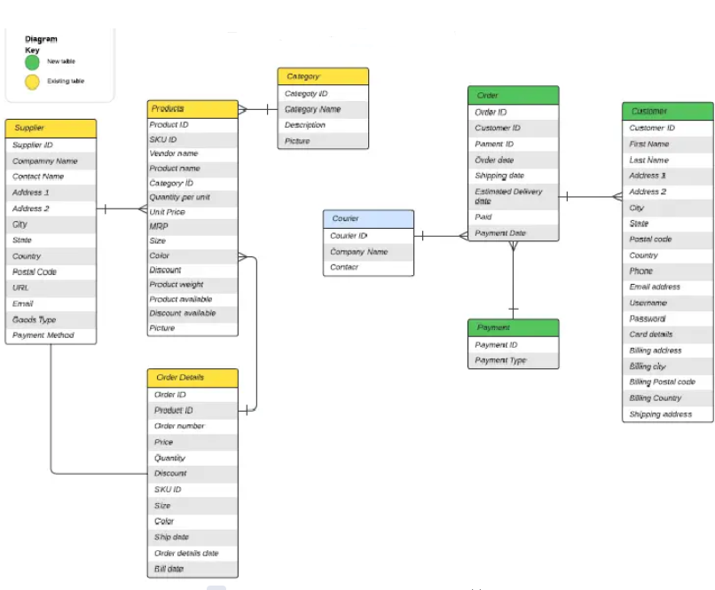

ER Diagram
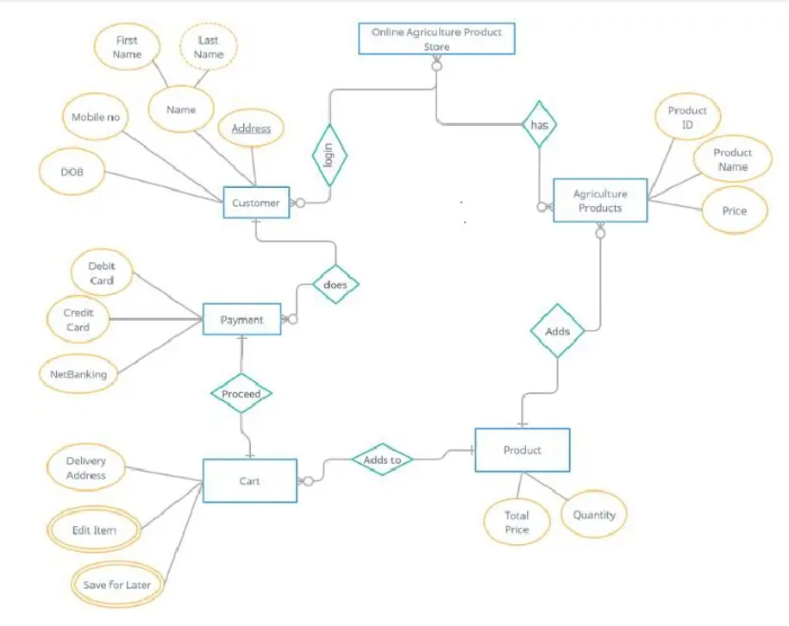

Question 7 – Data Flow Diagram
What is a data flow diagram? Draw a data flow diagram to represent the in-flow and out-flow of data when a Farmer is placing an order for the product
Answer –
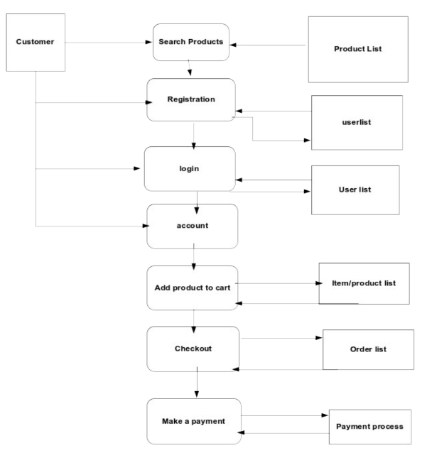
Question 8 – Change Request
Due to change in the Government Taxation structure. we should change the Tax structure.
How do you handle change requests in a project?
Answer –
Change requests arise when a stakeholder—whether a client, internal team, or department—proposes a modification to the project’s initially agreed-upon processes or deliverables. In this case, the request stems from a change in the government's taxation policy, which directly impacts the Online Agriculture Product Store.
As a Business Analyst, my first step would be to thoroughly analyse the change request and ensure all stakeholders clearly understand what adjustments are required in the system. Typically, I would conduct a feasibility study to evaluate how realistic and practical the proposed change is within the current project context. However, since this request is mandated by the government, a feasibility study is unnecessary. The change must be implemented to comply with the new tax regulations.
To handle this change efficiently, I will follow these steps:
- Document the change request in detail.
- Gather any supporting materials or references related to the new government taxation policy.
- Assess the scope of the change—whether it is within the existing project scope or outside of it. Since this is out-of-scope, it will impact the budget and timeline.
- Work with the Project Manager to determine whether the change is minor or major. A change in government policy is considered major, and we must ensure compliance with the updated regulations.
- Complete the change request form and obtain formal approval from the Project Manager.
- Communicate the priority and urgency of this change to the project team.
- Present the change to the Change Control Board (CCB) for review and recommendations.
- Once approved, update all relevant project deliverables, such as:
  - Project plans and timelines
  - Business process documentation
  - Requirements specifications
This approach ensures that the change is properly managed and implemented in alignment with both client expectations and government requirements.
Question 9 – Change Request Vs an Enhancement
As the project is in process, Ben and Kevin have contacted you. The reason is to inform you that they want the Farmers to sell their crop yields through this application i.e. Farmers should be able to add their crop yields or products and display to general public and should be able to sell them. They also want to introduce Auction system for their Crop yields.
As a BA, what will be your response?
Is this a change request or an enhancement???
Answer
Ben and Kevin's request is categorized as an enhancement, as they are proposing the addition of a new feature to the online store. This feature would enable farmers not only to purchase products but also to sell their yields directly through the platform. Given the value this feature brings, my response would be supportive.
As a Business Analyst, my role is to evaluate the enhancement request thoroughly. This involves preparing a project plan, gathering and documenting requirements, designing the solution, and defining testing strategies. I will also need to complete an enhancement request form and determine the resources and effort required in terms of manpower and man-hours to successfully implement this feature.
Question 10 – Estimations
Come up with estimations – How many Manhours required
Answer
Manhours Required = Total hours working per day x Total number of members x Total numbers of days worked over the specific period.
Number of Working Hours a day = 8 hours
Number of Resources = 12
Time period provided = 18 months = 547 days = 78 weeks (Including Weekends and Public Holidays)
Assuming Weekend = 156
Assuming Public Holidays = 10
Total = 166
547-166 = 381 Working Days
Hence, Estimated Manhours = 8 hours * 12 Resources *381 days = 36,576 hours required.
Question 11 – UAT
Project has finally completed all the stages i.e., design, development, testing etc. Now, it is the role of a business analyst to contact the client for testing of the final product and have to successfully complete it. How are you going to handle this situation? And once it is done, what will be the process to close the project?
Explain UAT Acceptance process.
Answer –
User Acceptance Testing (UAT) is an essential stage in the software development lifecycle where users of the Online Agriculture Product Store assess whether the system meets their expectations and requirements. As a Business Analyst (BA), I will first ensure all validations are thoroughly checked before preparing the UAT test cases. These test cases will focus on evaluating the system’s functionality, its operating environment, identifying any potential defects, and outlining strategies to handle them.
UAT plays a vital role in confirming that the system aligns with user needs. Below are the standard steps involved in carrying out UAT:
1. UAT Planning
- Set Clear Goals: Define the purpose and expected outcomes of the UAT phase.
- Select Testers: Choose end-users who reflect a broad range of actual users.
- Develop a UAT Strategy: Outline the testing scope, schedule, required resources, and environment setup.
2. Designing Test Cases
- Understand Requirements: Analyze business needs and user stories.
- Create Real-Life Scenarios: Design test scenarios based on practical usage situations.
- Draft Test Cases: Write detailed test cases, including input data and expected results.
3. Setting Up the Test Environment
- Configure the UAT Setup: Make sure the environment closely resembles the production system.
- Load Test Data: Insert relevant data to reflect real operational conditions.
4. Test Execution
- Run Test Cases: Users perform the test steps and record their observations.
- Report Issues: Any bugs or discrepancies are logged using a defect-tracking system.
5. Evaluation and Feedback
- Collect User Input: Organize review meetings to discuss user experiences.
- Sort and Prioritize Bugs: Categorize issues based on severity and decide which to address first.
6. Retesting
- Resolve Reported Issues: Developers fix the identified problems.
- Verify Fixes: Users re-run the relevant test cases to confirm the issues are resolved.
7. Final Sign-off
- Approval for Release: Stakeholders evaluate test outcomes and approve the system for production.
- Document Everything: Keep a record of test results, defects, and resolutions for reference.
8. Post-UAT Evaluation
- Review the Process: Conduct a retrospective to assess what went well and what didn’t.
- Capture Lessons Learned: Document valuable insights for improving future UAT cycles.
9. System Deployment
- Launch Preparation: Finalize plans for moving the system to production based on UAT findings.
- User Communication: Notify users about the release and provide any necessary training.
10. Post-Launch Monitoring
- Track System Behavior: Monitor the live system for performance and user issues.
- Provide Support: Offer ongoing assistance to resolve any problems after deployment.
Question 12 – Project Closure Document
Explain Project closure document
Answer –
The project closure document is primarily created to capture and reflect on the overall performance of the project. It highlights what went wrong, the correct methods that were adopted, both the positive and negative aspects, and the various initiatives taken by the team. It also documents the challenges faced by team members and the solutions implemented. In essence, this report provides a comprehensive overview of the project’s successes and shortcomings, serving as a valuable reference to prevent similar mistakes in future projects. Additionally, it contributes to enhancing the future performance of team members. Ultimately, the closure report acts as a management tool to evaluate the effectiveness of the project and the contribution of its team.

