Q1. Write Agile Manifesto
- Agile is one of the SDLC methodology, it is a incremental and iterative approach. It emphasis on the customer feedback and small and frequent delivery of the task form the project.it encourage to work in a short cycle by adapting the changed called as sprints. Agile manifesto is a foundation document for the agile software development. It is a guiding value or principle for software devlopement
It is a shift from the traditional, rigid project management system to the more flexible and iterative process for the project management.
There are 4 key values for the Agile:
- Individual interaction over Processes and tools
- Working software over Compressive documentation
- Customer collaboration over Contract negotiation
- Responding to the change over following the plan
Agile manifesto is supported by 12 principles:
- Satisfy the customer through early and continuous delivery of the software
- Welcome change in requirement even if it is late in development
- Delivering working software frequently.
- Business people and the developers should work together throughout the project
- Build project around the motivated individual and trust them to get the job done.
- The most effective and efficient method of conveying information is face to face conversion.
- Working software is a primary measure of progress
- Maintain a sustainable pace indefinitely
- Give continuous attention to technical excellence
- Simplicity- the art of maximizing the amount of work done is essential
- Team self organize
- Team regularly reflects and adjust to become more effective

Q.2 Write minimum 40 user stories and acceptance criteria along with BV and CP
A. User Stories – A user story is concise and a simple description of a feature or functionality from the end user or customer prospective. It is a key component in Agile methodology as it helps the team to understand what and why theuser needs.
User stories are written in a plain language and focuses on delivering the value
Task : Task is a small piece of work to complete a user stories
Acceptance criertia : they are the conditions of the user stories that must be true for considering the user stories to be completed.
Priority: means how important or urgent is a user story or the task is in comparison with others.

Example of user stories:
User Story:1 | Task:2 | Priority: Highest
As a delivery boy
I want to register in Scrum Foods
So that I can deliver the order

BV: 500 | CP:02
Acceptance Criteria
Registration Screen
Text Box for user name, password, mobile no., email id, address,
Click on register button
Send successful notification to the user

User Story:2 | Task:2 | Priority: Highest
As a restaurant owner
I want to view orders
so that I can view the list of orders

BV: 500 | CP:02
Acceptance Criteria
View orders, display list of orders in tabular form

User Story:3 | Task:2 | Priority: Highest
As a customer
I want to add the address
So that I can get the delivery in the chosen address

BV: 500 | CP:03
Acceptance Criteria
Text box to enter the address
Rules: within the radius of 5km

User Story:4 | Task:2 | Priority: Highest
As a customer
I want to select the payment option
So that I can make the payment of my choice
BV: 500 | CP:03
Acceptance Criteria
Display payment mode, radio buttons to select the payment mode, payment button
Rules: only 1 payment option can be selected
User Story:5 | Task:1 | Priority: Highest
As a Admin
I want to view the restaurants
So that I can approve the registration
BV: 500 | CP:02
Acceptance Criteria
Register in the platform with the details

User Story:6 | Task:1 | Priority: Low
As a customer
I want to view the price
So that I can order the food

BV: 500 | CP:01
Acceptance Criteria
Display price in the list of menu to place order

User Story:7 | Task:1 | Priority: low
As a customer
I want to view the contact details of the delivery boy
so that I can contact him and track him

BV: 500 | CP:01
Acceptance Criteria
Display delivery boy mobile number, tracking details , name and photo

User Story:8 | Task:01 | Priority: Medium
As a restaurant owner
I want to provide time slots
So that thew customer can view the opening and closing time

BV: 100 | CP:02
Acceptance Criteria
Click on restaurant dashboard
Add from and to time
Click on submit
Display updated successfully

User Story:9 | Task:2 | Priority: High
As a business owner
I want to view the restaurant revenue report
so that I can view the restaurants revenue

BV:200 | CP:03
Acceptance Criteria
Select revenue report ,
Select from and to dates
Generate all the reports
Download the report in excel

User Story:10 | Task:3 | Priority: High
As a admin
\I want to manage the reginal reports
So that I can track performance of regional restaurant
BV: 200 | CP:03
Acceptance Criteria
Click on open performance of restaurant
Select from and to date, click on generate report , click in export report to excel

User Story:11 | Task:2 | Priority: Medium
As a admin
I want to manage the reginal reports
So that I can view performance of regional restaurant
BV: 100 | CP:03
Acceptance Criteria
Select Reginal drop down
View performance of each restaurant of that region in tabular form, which includes restaurant name, revenue generated, download in excel or pdf

User Story:12 | Task:2 | Priority: high
As a customer
I want to chat with reg admin
So that I can ask for the refund
BV: 200 | CP:02
Acceptance Criteria
Text box field
Display order id
Text box for description
Submit button
Generate issue id
Display successfully

User Story:13 | Task:2 | Priority: High
As a user
I want to browse near by restaurant
So that I can order food
BV: 200 | CP:02
Acceptance Criteria
Each restaurant display its name, cusine type and rating
The list can be sorted by distance or rating

User Story:14 | Task:2 | Priority: High
As a customer
I want to I want to browse different restaurant and menu
So that I can find a place to order food
BV: 200 | CP:02
Acceptance Criteria
The menu include different price and description
Show the restaurant is open or closed

User Story:15 | Task:1 | Priority: High
As a customer
I want to I want to browse for the specific dish of a cusines
So that I can find a place to order
BV: 200 | CP:02
Acceptance Criteria
Apps displays relevant restaurant and dishes matching the query

User Story:16 | Task:1 | Priority: High
As a customer
I want to I want to filter the restaurant
So that I can place the order
BV: 200 | CP:02
Acceptance Criteria
Filter restaurant by cuisine type and dietary option (veg, non veg)

User Story:17 | Task:1 | Priority: High
As a customer
I want to I want to track my order
So that I can know the time of delivery
BV: 200 | CP:02
Acceptance Criteria
App should show real time update on order status
Display estimated delivery time
User Story:18 | Task:1 | Priority: High
As a customer
I want to I want to rate and review the restaurant
So that all can know the rating and revied of restaurant visited
BV: 200 | CP:02
Acceptance Criteria
Can see revied from other user which will help making the dining decision

User Story:19 | Task:1 | Priority: High
As a customer
I want to I want to save the favorite dishes
So that I can re order
BV: 200 | CP:02
Acceptance Criteria
Access my list of favorite for future order

User Story:20 | Task:1 | Priority: High
As a user
I want to view past order history
So that I can order again

BV: 200 | CP:02
Acceptance Criteria
Can see the details such as order items, total cost and order dates.

User Story:21 | Task:3 | Priority: High
As a customer
I want to I want receive notification
So that I can receive updates
BV: 200 | CP:02
Acceptance Criteria
Notification of order details , dispatch and delivery

User Story:22 | Task:1 | Priority: Medium
As a customer
I want to I want to contact customer support
So that I can submit queries or issuese
BV: 200 | CP:02
Acceptance Criteria
Customer support section with contact information

User Story:23 | Task:1 | Priority: high
As a restaurant owner
I want to receive and manage the order
So that I can update order status
BV: 200 | CP:02
Acceptance Criteria
Manage order status
Notify restaurant about the order status

User Story:24 | Task:2 | Priority: high
As a restaurant owner
I want to access customers review
So that I can view and respond to customer review
BV: 200 | CP:02
Acceptance Criteria
Owner can address the feedback
Owner can improve their service

User Story:25 | Task:1 | Priority: medium
As a customer
I want to view promocodes and discount so that I can order in lower rate
BV: 100 | CP:04
Acceptance Criteria
Active promo codes

User Story:26 | Task:1 | Priority: medium
As a customer
I want to apply promo code
So that I can order food in lower rate
BV: 100 | CP:04
Acceptance Criteria
Active promo code

 | User Story:27 | Task:7 | Priority: high
As a delivery boy
I want to view the order
So that I can accept the order
 | BV: 200 | CP:04
Acceptance Criteria
Order visibility
Real time update
Order detail, order map view
User Story:28 |  | Task:5 | Priority: high
As a delivery boy
I want to login so that I can accept the orders
BV: 200 |  | CP:04
Acceptance Criteria
User authentication
Error handling password security

User Story:29 | Task:5 | Priority: medium
As a delivery boy
I want to know the feedback
So that I can know the customers feedback
BV: 200 | CP:04
Acceptance Criteria
Access to feedback system
User support

User Story:30 | Task:5 | Priority: medium
As a admin
I want to know the feedback
So that I can know the customers feedback
BV: 200 | CP:04
Acceptance Criteria
Access feedback support
User support

User Story:31 | Task:1 | Priority: medium
As a restaurant owner
I want to view the feedback
So that I can know customer feedback
BV: 200 | CP:04
Acceptance Criteria
Access feedback support
User support

User Story:32 | Task:3 | Priority: high
As a admin
I want to know the issue
So that I can resolve the issue

BV: 100 | CP:03
Acceptance Criteria
Display issue session

Editing and modifying the issue

User Story:33 | Task:3 | Priority: high
As a regional admin
I want to know the issue so that I can resolve the issue
BV: 200 | CP:04
Acceptance Criteria
Display issue section
Editing and modifying the issue

User Story:34 | Task:6 | Priority: high
As a restaurant owner
I wan to view the revenue generated
So that I can view restaurant revenue
BV: 200 | CP:04
Acceptance Criteria
Select revenue report, select to and from date, generate report , download report in excel

User Story:35 | Task:2 | Priority: high
As a restaurant owner
I want to know the delivery boy so that I can verify the delivery boy
BV: 200 | CP:04
Acceptance Criteria
Id proof, punctuality and reliability

User Story:36 | Task:2 | Priority: low
As a delivery boy
I want to view the contact number of the delivery boy
So that I can check the status with him

BV: 100 | CP:01
Acceptance Criteria
Display delivery boy mobile no, name and picture

User Story:37 | Task:2 | Priority: medium
As a restaurant owner
I want to provide time slots so that the customer can check the opening and closing time
BV: 100 | CP:02
Acceptance Criteria
Click on restaurant dashboard, add from time and to time click on submit

User Story:38 | Task:3 | Priority: high
As a user
I want to receive notification
So that I can get the updates
BV: 200 | CP:02
Acceptance Criteria
Notification of order confirm ,dispatch, delivery

User Story:39 | Task:1 | Priority: high
As a customer I want to contact customer support
So that I can submit query or issue

BV: 200 | CP:02
Acceptance Criteria
Customer support section with the contact details

User Story:40 | Task:4 | Priority: medium
As a customer
I want to view the order do that I can cancel it

BV: 100 | CP:03
Acceptance Criteria
Order status, method of cancellation and refundime frame,

Q3 What is epic? Writ 2 epic.
Epic is large user story or collection of user stories that represents the significant feature or functionality. epic is a set of user stories completed to achieve one task .
1 Registration
As a customer I want to register to in scrum food app so that I can login and place order
2 Login
As a customer I want to login so that I can order food and make payment

Q4. What is the difference between BV and CP?
- Business Value referse to the importance or a benefit that a specific task or a feature brings to the business project. It measures how much value/ importance/ benefit does a particular task/ feature has for the project.
Business value helps to prioritize the task based on their importance on the project objective.
This is decided by the business owner or product owner
BV value is measured in form of currency notes (10,20,50,100,500)

Complexity points is also known as story points, refers to the effort or complexity required by the team to complete a task. They are used to estimate/ measure the efforts, time or resourse used to complete a taks. This is given by the development team.
CP is estimated in the form of Fibonacci series

Q5. Sprint
- Sprint is a timebox period mostly 1 to 4 weeks. It is a short fixed length period during which the development team works to complete the task

Q6. What is a product backlog and sprint backlog
- Product backlog is a prioritized list of all the user stories, features, enhancements, bug fix and all the other items that needs to be addressed over
course of the project. It is managed by the Product owner and is continuously updated based on the feedback and changing requirements.

Sprint backlog is a subset of the product backlog that represent the work which the development team commits to complete within a specific timeframe called Sprint. Sprint is a fixed duration iteration, lasting for 2-4 weeks in which the team works on set of items from the product backlog.
Sprint backlog is created in sprint planning meeting, where the development team selects set of items to work based on the capacity and priorities decided by the product owner.
Q7. What is impediment Log?
- Impediment log is document or tool which tracks and manage the obstacles, hurdles or blockers any factors which effocts the progress of project.
They are the blockers preventing the team from completing the work/task. Scrum master is responsible to manage the impediment log
All challenges faced by the team will be logged in the impediment log.
Example:
- Lack of system knowledge about the project
- Lack of management support
- Delivery partner shortage in a particular region
Q8. Explain velocity of the team?
- Amount of work the team can complete in 1 sprint is the velocity of the team. It is usually measured in story points ie. Complexity points. It can be calculated after the completion of sprint

Q9. Draw Sprint Burn Down chart and product burn down chart.
A Sprint Burn Down chart gives the update of the day to day work pending in the sprint. It shows how much work is pending in the sprint on daily basis. It is maintained on daily basis by the scrum master.
Sprint Burnup Chart shows how much work is completed in the sprint.
Product burn down chart shows the overall progress of the entire product backlog across multiple sprints

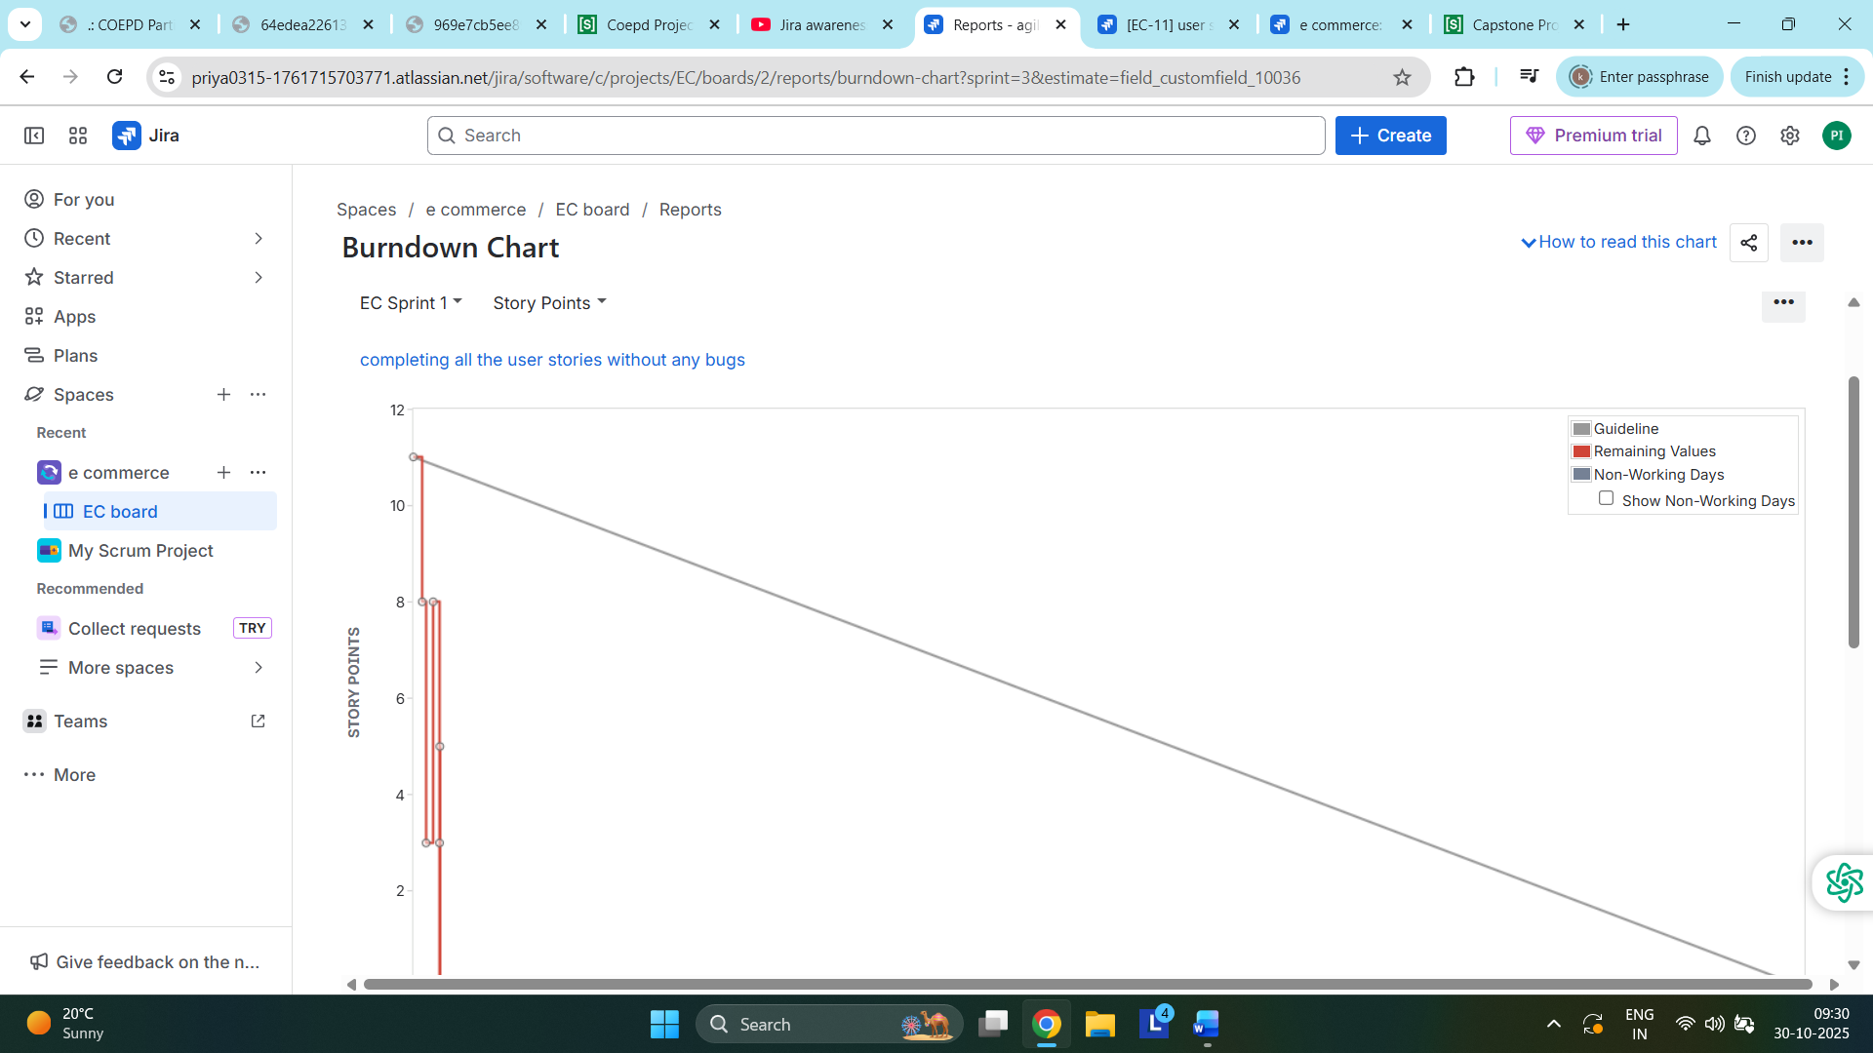

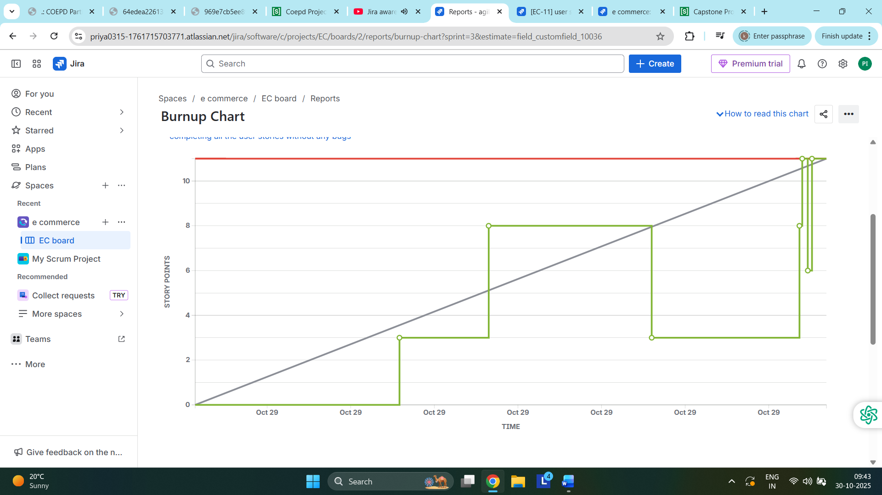

Q10. Explain about product grooming.
- Product grooming is also known as backlog refinement. It is a regular meeting or a session conducted by the product owner and the development team to reviews and update the product backlog. The main aim of this is to clear the backlogs and raise and prioritize the backlog in the upcoming sprint and get it cleared
Q11. Explain the role of scrum master and Product owner
- Scrum master acts as a team coach, ensure that the scrum framework agile principles is followed and help the development team to create a quality product.He ensures the scrum process is followed and removers the obstacle or any blocker. He is responsible for conducting daily standups, sprint planning, sprint review, retrospective etc. he will protect teams with the distraction and work closely with the development team.
Product owner defines the product vision, manages the product backlog, and prioritize work. He will focus on customer satification and priorities. He will create and maintain product backlog. He will write user stories and write acceptance criteria. He will prioritize backlog items based on the BV value . he clarifies requirement to the development team. He acts as a bridge between the development team and the stakeholders/ client.
Q12. Explain al meetings conducted in Scrum Project.
- There are five types of scrum meeting held during the scrum process which are as follows:
- Sprint Planning meeting
- Daily scrum Meeting
- Sprint Review Meeting
- Sprint retrospective Meeting
- Backlog refinement meeting
Sprint Planning Meeting: It is a meeting conducted by the scrum master. In this meeting the product owner will explain the vision of the project and how the team will complete the task within the sprint. The team will decide upon as to what should be delivered in the particular sprint. This time the team will move the work from the product backlog to sprint backlog.
Daily scrum meeting: This meeting conducted by the scrum masted will be for fixed duration of time that is for 15mins . Here team will discuss on what they did yesterday, what they are going to do today and is there any impediments on their way.
Sprint Review Meeting: It shows the completed work to the stakeholders and get feedback for any changes or enhancement When the user stories or the task is completed by the developer he will give the demo to the stakeholders and product owner.
Sprint Retrospective Meeting: These meeting will be conducted in the end of the sprint. After the completion of the 1st or upon the completion of any sprint the team will discuss as to what went well? What didn’t went well? And how we need to improve for the next sprint
Sprint Refinement Meeting: This is a regular meeting or a session by the product owner and the development team to address the product backlogs. The main aim is to clear the backlogs by prioritizing it in the next sprint.

Q13. Explain Sprint Size and Scrum size?
- Sprint Size: It refers to the duration of the sprint, as to how long will it take to complete the assigned task/ user story/ backlog items. Usually it will be the 1 to 4 weeks of time
Scrum Size: it is the number of people in a scrum team. Usuall it will be 4 to 9 members, including the product owner or a scrum master, 4 to 5 developer, testes based on the project

Q14. Explain DOR and DOD?
- The definition of Ready DOR: the product owner could work with the team to define the artifacts, definition of ready for defining the items at the top of the backlog are ready to moved into the sprint so that the development team can complete it by the end of the sprint.
The definition of done DOD: it is structured as a list of items, each one use to validate a user story which ensures that the development team agreed about the quality of work they are attempting to produce. It serves as a checklist that is used to serve each product backlog.

Q15. Explain prioritization technique and MVP?
- Prioritization technique helps to decide upon what features/ task/ user story needs to be taken first based on their values or the research done.
We generally use MOSCO as a prioritization technique
MOSCOW prioritization is a project management technique for categorizing the requirement into four groups.
M-Must have- These are the non- negotiable requirements of features that the project needs to be successful
S-should have- should have requirement are not important but critical
C- could have- could have feature are less important and have lesser impact
W- Will not have-Wont have features are been agreed upon as not part of current scope.

MVP- Minimum Viable Product- It is a simplest version of the product that can be released to user to get feedback from the real customers. It helps to validate ideas quickly and avoid wasting efforts in unnecessary features.

Q.16 Difference between business analyst and product owner.
A. Product Owner:
The Product owner owns the vision of the product and he decide upon what to build.
Product owner focus upon the product vision, priorities and customer’s needs.
Product owner maintains product backlog, prioritize features, defines acceptance criteria and write user stories and make business decisions.
Business Analyst:
Business analyst analysis the requirement and define how to build the project.
Business analyst focuses upon functional needs, process and details specification.
Business analyst will gather and document the requirements, create work flow like use cases and user stories and communicate between the stakeholders and the development team

Q.17 Sample resume of 3yr experienced product owner
A.

Riya Shah
Riya_shah @gmail.com
8885558885

Objective:
Motivated product owner with 3+ yrs of experience, eager to support the team with the leadership and guidance over wide range of product development efforts.

Work Experience:
American bank
07/2023- 04/2025
Created user story acceptance criteria to get buy-in from stakeholders and refined those stories with Scrum teams.
- Owned the planning and scheduling of two-week sprints and articulated the product vision to engineering, resulting in hitting 98% of the product goals defined at the beginning of the year in 2017.
- Managed and re-prioritized the product backlog, resulting in coming under budget by an average of $45,000 on products.
- Directed vendor relationship and 30% of contracts, including execution and financial payments, leading to a 28% increase in successful contract negotiations.

Skills
Product Management Software
Zoho Porjects
Data Analysis
Google Analytics
Tablea

Education:
MBA, B.com
Bangalore.
Certification :
Certigy SAFe Prodyct owner

