Business Case Document
1. Executive Summary
The Finance Flow Optimization project is an initiative to develop an integrated finance automation software that replaces the current piecemeal tools. By consolidating critical functions—such as general ledger management, tax and audit, forecasting and budgeting, compliance, data handling, return filing, payroll, cash flow, inventory, and reporting—into one synchronized system enabled by artificial intelligence, the organization anticipates error-free operations, adherence to accounting standards, enhanced data security, scalability, and reduced operational turnaround times. The project will be executed using the waterfall method ensuring clear requirement definitions and structured implementation phases.

2. Project Initiation
Why Is This Project Initiated?
- Centralization of Processes: The firm currently relies on multiple standalone software systems. This results in operational fragmentation and lack of coherence across financial processes.

- Error Reduction and Accuracy: Manual reconciliations and data transfers between systems often introduce errors affecting decision-making and compliance.

- Regulatory and Compliance Needs: With increasing regulatory requirements, the firm must ensure that all financial operations consistently meet industry standards.

- AI Integration for Enhanced Insight: Leveraging artificial intelligence to sift through complex financial data improves forecasting, auditing, and reporting efficiency for better strategic decision-making.

- Competitive Advantage & Growth: A unified system will support scalability, positioning the firm for future growth in a data-driven financial landscape.

3. Current Problem Analysis
What Are the Current Problems?
- Fragmented Software Environment: Multiple disjointed applications lead to inconsistent data across systems.

- Operational Errors: Manual entry across unintegrated systems increases the risk of mistakes in financial transactions.

- Compliance Gaps: Disparate systems struggle to ensure that all accounting and legal compliances are uniformly met.

- Inefficient Processes: Redundant manual processes and lack of real-time integration slow down decision-making and response time.

- Security Vulnerabilities: Multiple systems create multiple points of vulnerability, increasing data and system security risks.

- Scalability Limitations: Inability to adapt to growing volumes and complexity of financial data due to inflexible legacy systems.

Each of these challenges contributes to operational inefficiencies and places the firm at risk of financial inaccuracies and compliance issues.

4. Problem Resolution through the Project.
With This Project, How Many Problems Could Be Solved?
The integrated solution is designed to address the following issues:

- Combining Functional Excellence: By uniting general ledger, tax management, auditing, forecasting, and other essential areas into one solution, the system will ensure seamless and accurate data flow.

- Error Mitigation: Automation powered by AI minimizes manual interventions, drastically reducing operational errors.

- Enhanced Compliance: The system will be built to meet and continuously update accounting standards and regulatory requirements, ensuring legal compliance.

- Improved Efficiency: Automated streamlined workflows reduce processing time and operational costs.

- Robust Security Measures: Centralized data management allows for the implementation of uniform and robust security protocols.

- Scalable Architecture: Designed with future growth in mind, the system will support additional modules and integrations as the firm expands its operations.

In summary, the development of this integrated and AI-enabled solution is expected to solve the bulk of the current operational, compliance, and data security challenges.

5. Resource Requirements
What Are the Resources Required?
Implementing Finance Flow Optimization involves multiple resources:

- Human Resources:

  - Project Manager: Oversees overall project execution using the structured waterfall approach.

  - Business Analysts: To gather requirements, validate processes, and ensure alignment with business goals.

  - System Architects and Developers: Create the software solution incorporating AI capabilities.

  - Quality Assurance (QA) Teams: Conduct rigorous testing at various stages to ensure the system meets functional and performance standards.

  - Change Management Experts: Assist with training and transition for various teams.

- Technical Resources:

  - Hardware and Infrastructure: Servers or cloud infrastructure capable of handling large sets of financial data and AI processes.

  - Software Tools: Development environments, AI analytics platforms, database management systems, and security software.

  - Integration Middleware: To ensure smooth interoperability between the new system and any legacy systems still in use.

- Financial Resources:

  - Budget Allocation: For development, testing, training, and potential infrastructure upgrades.

  - Contingency Reserves: To address unforeseen challenges especially given the structured nature of the waterfall methodology.

These resources are critical to ensure that the project is implemented on time, within budget, and meets the firm’s strategic objectives.

6. Organizational Change Requirements
How Much Organizational Change Is Required to Adopt This Technology?
- Process Reengineering: The firm will need to redesign existing processes to fully leverage the unified system. Standard operating procedures must be updated to reflect new workflows.

- Cultural Shift to Automation: Employees and management must adopt a mindset that embraces digital transformation. Resistance to change will be managed via extensive training and clear communication of benefits.

- Training and Onboarding: Comprehensive training programs will be instituted to ensure all relevant staff, from finance teams to IT support, understand and utilize the new system.

- Governance and Oversight: New compliance and governance frameworks may be necessary as the integrated system will likely change reporting structures and audit trails.

- Interdepartmental Coordination: Enhancing communication between IT, finance, and compliance teams will be key for a smooth transition and continuous improvement.

While the change is significant, structured change management coupled with stakeholder involvement will facilitate a smooth transition.

7. ROI and Time Frame for Recovery
Time Frame to Recover ROI
- Initial Investment vs. Long-Term Savings: Estimations suggest that while the initial investment—covering software development, training, system integration, and change management—will be substantial, operational efficiencies and error reduction will yield measurable cost savings.

- Break-Even Analysis: With reduced manual processing times, enhanced accuracy in financial operations, and improved regulatory compliance, the project is expected to break even in approximately 18 to 24 months post-implementation.

- Additional Benefits: Beyond the basic break-even timeline, the new system will continuously offer scalability and improved decision-making tools that can further boost organizational performance over time.

A detailed financial model will be developed during the planning phase to refine these estimates, but industry benchmarks support an ROI recovery period within the stated range.

8. Stakeholder Identification
How to Identify Stakeholders
Identifying stakeholders is critical for successful project adoption:

- Internal Stakeholders:

  - Executive Leadership: Provides strategic direction and approvals. Their buy-in is essential since the project will shape the firm’s financial operations.

  - Finance and Accounting Teams: Primary users who will benefit from automation and improved accuracy.

  - IT Department: Responsible for system integration, maintenance, and supporting the new technology.

  - Audit and Compliance Officers: Ensure that the new system meets regulatory requirements and internal control standards.

  - Human Resources and Training Departments: Facilitate onboarding and manage organizational change.

- External Stakeholders:

  - Regulatory Bodies: Ensure that the system continues to adhere to evolving legal and compliance standards.

  - Customers and Vendors: Their transactions and interactions might be influenced by changes in the financial operations.

  - Third-party Service Providers: Partners involved in the technology and infrastructure supporting the new system.

- Techniques for Stakeholder Identification:

  - Stakeholder Mapping: Develop a matrix based on influence and interest to prioritize engagement.

  - Surveys and Interviews: Collect input from different departments to understand expectations and concerns.

  - Workshops and Focus Groups: Facilitate discussions to align on requirements and validate project assumptions.

BA Approach Strategy

1. Project Initiation and Planning
- Define Project Scope and Objectives: Identify the overall vision, key deliverables, and the specific business needs. Ensure you have a well-articulated project charter that outlines goals, timelines, budget, and success criteria.
- Establish Governance Structures: Set up the Change Control Board (CCB) or similar governance bodies needed to manage change requests and critical decisions throughout the project lifecycle.
- Initial Stakeholder Engagement: Organize a kick-off meeting with primary stakeholders to explain the project’s purpose, align expectations, and introduce the planned BA approach.

2. Stakeholder Identification and Analysis
- Techniques to Identify Stakeholders:
  - Interviews: Conduct one-on-one interviews with key decision-makers and department leads in finance, IT, compliance, and HR.
  - Surveys/Questionnaires: Reach out to end users and operational teams to gather initial input on current challenges and expectations.
  - Document Analysis: Review organizational charts, prior project documents, and meeting minutes to ensure no stakeholder is overlooked.
- RACI/ILS Analysis:
  - RACI Matrix: Construct a Responsibility Assignment Matrix detailing who is Responsible, Accountable, Consulted, and Informed for each project phase and deliverable.
  - ILS (Information Logistics Strategy): Define how and what information flows between you, the stakeholders, and the project team. Document the data required by each stakeholder group, outlining access rights and communication frequency.
- Stakeholder Register: Maintain a detailed register capturing stakeholder roles, contact details, interests, influence levels, and expectations. This will guide your communication and engagement planning.

3. Requirements Elicitation
- Choose Elicitation Techniques Based on Stakeholder Type:
  - Interviews: Deep-dive sessions with senior finance managers, compliance officers, and IT leads to understand strategic requirements.
  - Workshops/Focus Groups: Facilitate group sessions that bring together multiple stakeholders to map out process flows, identify pain points, and brainstorm solutions.
  - Observations and Document Analysis: Observe current processes in action and review existing process manuals, standard operating procedures, and legacy system documentation.
  - Prototyping (where applicable): Use simple prototypes or wireframes to validate ideas with stakeholders, especially when discussing AI-enabled features.
- Record and Categorize Requirements: Ensure that both functional (e.g., general ledger, payroll, tax management) and non-functional (e.g., data security, scalability) requirements are captured. Use a Requirements Traceability Matrix (RTM) to keep everything linked back to business objectives.

4. Documentation and Sign-Off Processes
- Core Documents to be Developed:
  - Business Requirements Document (BRD): Captures high-level business objectives and requirements.
  - Functional Requirements Specification (FRS): Detailed requirements including workflows, use cases, and system interactions.
  - Process Flow Diagrams and Use Cases: Visual representations of current and future-state processes that clarify system interactions.
  - Requirements Traceability Matrix (RTM): Links requirements to business objectives and later to test cases.
  - Change Request Log/Documentation: Format for capturing and tracking change requests, including impact analysis.
- Review and Approval Process:
  - Internal Reviews: Schedule review sessions within the BA team and subject matter experts to refine documentation.
  - Formal Review Meetings with Clients: Present the documented requirements. Walk through each section, obtain feedback, and make necessary revisions.
  - Sign-Off Process:
    - Use formal sign-off sheets (digital or physical) to obtain documented approval for each deliverable.
    - Maintain version control and an audit trail of feedback/responses to ensure alignment with client expectations before moving to the design phase.

5. Communication Management
- Establish Communication Channels:
  - Regular Meetings: Set up recurring project status meetings (e.g., weekly stand-ups, bi-weekly review sessions) with clear agendas.
  - Digital Collaboration Tools: Leverage email updates, instant messaging (e.g., Microsoft Teams, Slack), and document-sharing platforms (e.g., SharePoint, Confluence) to maintain transparency.
  - Dashboard Reporting: Use project management dashboards (via tools like Power BI or Jira) to share progress reports, risk updates, milestone achievements, and upcoming tasks.
  - Stakeholder Newsletters/Briefings: Keep all involved parties in the loop via periodic newsletters or updates summarizing progress, issues, and changes.
- Feedback Loops: Establish clear lines for stakeholders to provide feedback throughout the project lifecycle. This includes a mechanism to replay requests or suggestions back to stakeholders and get timely responses.

6. Managing Change Requests
- Change Request Process:
  - Formal Submission: Use a standardized change request form where any stakeholder can submit changes.
  - Impact Analysis: Evaluate each request for its impact on scope, timeline, risks, and budget. Involve technical teams, finance, and management in this evaluation.
  - Approval Workflow: Submit the change request to the Change Control Board (or designated decision-makers) for review.
  - Documentation and Communication: Log approved changes in the requirements documents and notify all stakeholders about the updates. Update the RTM and other relevant documents accordingly.
  - Version Management: Maintain clear versions of documents so that all parties are working with the latest information.

7. Project Progress Updates
- Regular Status Reports:
  - Prepare detailed status reports covering milestones achieved, upcoming tasks, issues raised, and risk assessments.
  - Utilize dashboards for real-time progress tracking and share reports during scheduled meetings.
- Stakeholder Meetings:
  - Host periodic review sessions (with frequency defined during project initiation) where progress is discussed, and feedback is obtained.
  - Highlight any changes, delays, or challenges and discuss mitigation strategies.
- Escalation Processes:
  - Define clear escalation paths for issues that may impact project success. Ensure that all stakeholders are aware of whom to contact for critical issues.

8. UAT and Client Project Acceptance
- UAT Planning:
  - Develop a detailed UAT plan including test scenarios, acceptance criteria, and responsibilities.
  - Coordinate with users and client representatives to schedule UAT sessions.
  - Ensure training and preparatory sessions are in place so that users know what to expect during testing.
- UAT Execution:
  - Guide the UAT process by facilitating testing sessions, tracking defects, and ensuring remediation of issues.
  - Use a defect tracking system to log errors, assign responsibilities, and manage resolutions.
- Formal Sign-Off:
  - After successful UAT, conduct a final review meeting with key client representatives to discuss outcomes.
  - Obtain formal sign-off through a documented acceptance letter or signed UAT acceptance form that confirms the solution meets the agreed-upon criteria.
  - Archive all UAT documents along with feedback and sign-off records for future reference and compliance needs.

Document 3- Functional Specifications

Request ID | Request Name | Request Description | Priority
FRD-GL-001 | Transaction Recording | Record all financial transactions in real time, integrating data from subsidiary modules and automating journal entries. | High
FRD-GL-002 | Chart of Accounts Management | Provide capabilities for creating, updating, and managing the chart of accounts with role-based permissions. | High
FRD-GL-003 | Automated Reconciliation | Automatically reconcile transactions across modules and flag any discrepancies for review. | Medium
FRD-TAX-001 | Automated Tax Calculations | Compute applicable taxes based on real-time transaction data in alignment with current tax regulations. | High
FRD-TAX-002 | Tax Filing Report Generation | Generate standardized tax reports that comply with local and national regulatory formats. | Medium
FRD-TAX-003 | Regulatory Update Integration | Integrate a mechanism to update tax rules and compliance changes automatically as regulations evolve. | Medium
FRD-AUD-001 | Comprehensive Audit Trails | Maintain detailed and immutable audit logs—including timestamps, user IDs, and change records—for all financial transactions. | High
FRD-AUD-002 | AI-Based Anomaly Detection | Leverage AI to detect irregular or anomalous transactions and automatically alert the audit team for review. | High
FRD-AUD-003 | Audit Report Generation | Generate customizable audit reports to support both internal and external auditing processes. | Medium
FRD-FB-001 | Budget Creation and Maintenance | Enable users to create, edit, and manage budgets, including versioning and tracking historical data for comparison. | High
FRD-FB-002 | AI-Driven Forecasting Tools | Utilize AI algorithms on historical data to produce predictive models and accurate financial forecasts. | High
FRD-FB-003 | Scenario Simulation | Allow users to run "what-if" scenarios to assess potential impacts on budgets and cash flows. | Medium
FRD-LCM-001 | Compliance Monitoring | Continuously monitor statutory and regulatory requirements and update compliance statuses in real time. | High
FRD-LCM-002 | Non-Compliance Alerts | Automatically notify designated personnel when deviations from regulatory or statutory requirements are detected. | Medium
FRD-LCM-003 | Secure Documentation Repository | Maintain a secure repository for legal and compliance documents with strict access control. | Medium
FRD-DM-001 | Centralized Data Repository | Use a single, secure database for storing all financial data, ensuring encryption in transit and at rest. | High
FRD-DM-002 | Data Import/Export Functionality | Enable seamless data migration from legacy systems and support data exchange using standardized formats (e.g., CSV, XML). | Medium
FRD-DM-003 | Data Cleansing and Validation | Automate data validation and cleansing routines to ensure data integrity before committing to the system. | Medium
FRD-RFM-001 | Automated Data Aggregation | Automatically compile necessary data from various systems to pre-fill regulatory return forms, reducing manual intervention. | Medium
FRD-RFM-002 | Filing Scheduling and Archiving | Allow scheduling of return filings and maintain a digital archive following regulatory retention guidelines. | Medium
FRD-PAY-001 | Automated Payroll Processing | Automate payroll calculations—including deductions, benefits, and tax computations—based on predefined company policies. | High
FRD-PAY-002 | Electronic Payslip Generation | Generate and distribute detailed electronic payslips to employees on a scheduled basis. | Medium
FRD-PAY-003 | Tax Integration for Payroll | Integrate payroll data with the tax management module to ensure real-time compliance and accurate tax computation. | High
FRD-CF-001 | Real-Time Cash Flow Tracking | Monitor incoming and outgoing cash flows in real time across all financial functions to support liquidity management. | High
FRD-CF-002 | AI-Based Cash Flow Forecasting | Utilize AI to analyze transaction data and predict future cash flow trends, identifying potential shortfalls early. | High
FRD-CF-003 | Alerting for Cash Flow Anomalies | Generate alert notifications when cash levels reach or deviate from predefined critical thresholds. | Medium
FRD-IM-001 | Real-Time Inventory Tracking | Maintain up-to-date tracking of inventory levels, movements, and associated costs in real time. | Medium
FRD-IM-002 | Ledger Integration for Inventory | Automatically update inventory-related entries in the general ledger to maintain synchronized financial records. | Medium
FRD-IM-003 | AI-Based Demand Forecasting | Predict future inventory needs using AI analysis of historical trends and market conditions. | Medium
FRD-RA-001 | Customizable Dashboard Reporting | Provide configurable dashboards that display key financial KPIs and metrics relevant to various user roles. | High
FRD-RA-002 | Ad-Hoc Reporting Capability | Enable users to generate ad-hoc, customizable reports based on specified criteria and dynamic filters. | Medium
FRD-RA-003 | Report Export Functionality | Allow for exporting generated reports in multiple formats (PDF, Excel, CSV) with secure sharing options. | Medium
FRD-AI-001 | Predictive Analytics Integration | Integrate AI models to enhance financial forecasting accuracy and support anomaly detection across all modules. | High
FRD-AI-002 | Self-Learning Algorithms | Enable AI components to continuously learn from both historical and real-time data, improving performance over time. | High
FRD-AI-003 | Explainability for AI Decisions | Provide clear transparency and rationale behind AI-driven outputs to ensure users can understand and trust the recommendations. | Medium

Document 4- Requirement Traceability Matrix

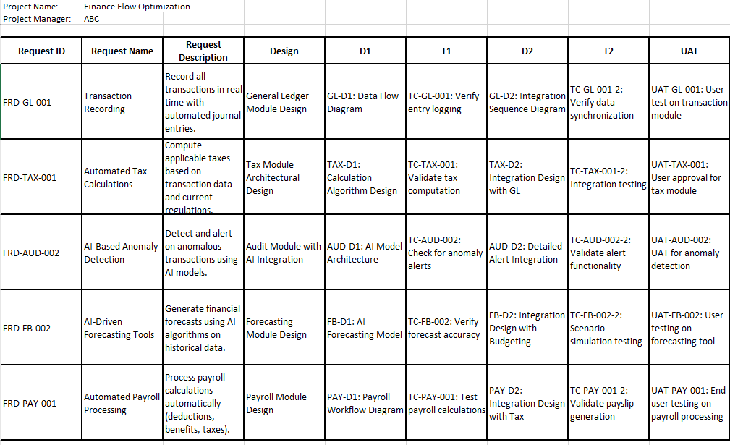

Business Requirements Document (BRD)
Project Name: Finance Flow Optimization
Methodology: Waterfall

Contents

1. Document Revisions

2. Approvals

3. RASCI Chart for This Document

Codes Used in RASCI Chart

RASCI Chart

4. Introduction

4.1. Business Goals

4.2. Business Objectives

4.3. Business Rules

4.4. Background

4.5. Project Objective

4.6. Project Scope

4.6.1. In Scope Functionality

4.6.2. Out Scope Functionality

5. Assumptions

6. Constraints

7. Risks

Technological Risks

Skills Risks

Political Risks

Business Risks

Requirements Risks

Other Risks

8. Business Process Overview

8.1. Legacy System (AS-IS)

8.2. Proposed Recommendations (TO-BE)

9. Business Requirements

10. Appendices

10.1. List of Acronyms

10.2. Glossary of Terms

10.3. Related Documents

1. Document Revisions
Revision No. | Date | Description | Author
0.1 | 2025-06-07 | Initial draft created
0.2 | YYYY-MM-DD | Updated sections after review
1.0 | YYYY-MM-DD | Final version approved

2. Approvals
Name | Title | Signature (if applicable) | Date
[Sponsor Name] | Project Sponsor |  | YYYY-MM-DD
[Manager Name] | Finance Manager / Stakeholder |  | YYYY-MM-DD
[BA Name] | Business Analyst |  | YYYY-MM-DD
[IT Head Name] | IT Director |  | YYYY-MM-DD

3. RASCI Chart for This Document

Codes Used in RASCI Chart
- R – Responsible: The person(s) who perform the work.
- A – Accountable: The person who is ultimately accountable and approves the work.
- S – Supportive: Individuals or teams that provide help or support.
- C – Consulted: Key stakeholders who must be consulted before a decision is made.
- I – Informed: Those who need to be kept informed of progress.

RASCI Chart for BRD Creation
Document Section | Business Analyst | Project Manager | IT Team Lead | Finance Manager | Legal/Compliance | End-Users (Finance Staff)
Document Revisions | A, R | I | I | I | I | I
Approvals | I | A | I | R, C | C | I
Introduction | R | A | I | C | C | I
Business Goals | R | A | I | R, C | C | I
Business Objectives | R | A | I | R, C | C | I
Business Rules | R | I | C | A, C | R | I
Background | R | I | I | I | I | I
Project Objective | R | A | I | I | I | I
Project Scope | R | A, C | I | C | C | I
Assumptions & Constraints | R | A | C | I | I | I
Risks | R | A, C | C | I | I | I
Business Process Overview | R | C | C | I | I | I
Business Requirements | R | A | C | C | C | I
Appendices | R | I | I | I | I | I

4. Introduction

4.1 Business Goals
- Centralize Financial Operations: Consolidate disparate software systems into one integrated platform.
- Enhance Accuracy: Achieve error-free operations through automation and AI integration.
- Compliance & Security: Ensure all operations meet accounting standard requirements, legal compliance, and maintain data/system security.
- Boost Efficiency: Reduce operational time and improve the scalability for future growth.

4.2 Business Objectives
- Streamline Processes: Integrate key financial functions (e.g., general ledger, tax, audit, payroll) into one system for enhanced coordination.
- Incorporate AI: Utilize artificial intelligence for data synchronization, error detection, process automation, and intelligent reporting.
- Reduce Human Error: Automate repetitive tasks to lower the risk of errors and improve audit trails.
- Improve Decision Making: Equip managers with real-time reporting, forecasting, and budgeting capabilities for strategic decision-making.

4.3 Business Rules
- All transactions must adhere to internationally recognized accounting standards.
- User access must comply with role-based security protocols.
- Mandatory data backups and encryption are required for data and system security.
- Critical functions (e.g., general ledger and tax management) must include audit trails for compliance and review.

4.4 Background
Currently, the firm relies on multiple software solutions for different finance functions. This fragmented approach leads to synchronization issues, inaccuracies, and increased errors. The need for an integrated, AI-enabled system arose from the desire to improve workflow, reduce manual effort, and meet evolving regulatory standards.

4.5 Project Objective
Develop and implement a comprehensive finance automation software system—Finance Flow Optimization—that synchronizes all critical finance functions into one cohesive, error-free, and AI-augmented platform.

4.6 Project Scope

4.6.1 In Scope Functionality
- General Ledger Management: Automated journal entries, reconciliation, and balances.
- Tax Management: Automated tax calculation, reporting, and filings.
- Audit: Integrated real-time audit trail and compliance monitoring.
- Forecasting & Budgeting: Tools for financial forecasting, scenario analysis, and budget management.
- Legal Compliance Management: Built-in rules to ensure adherence to financial regulations.
- Data Management: Secure handling, storage, and retrieval of financial data.
- Return Filing Management: Automation of tax return preparation and submission.
- Payroll Management: Automated payroll processing integrated with tax and benefits.
- Cash Flow Management: Monitoring, forecasting, and optimization of cash flows.
- Inventory Management: Synchronize inventory levels with financial records.
- Reporting & Analysis: Dynamic dashboards and reports enhanced by AI for intelligent analysis.

4.6.2 Out Scope Functionality
- Non-Financial Human Resource Processes: Advanced HR functions beyond payroll (e.g., recruitment management).
- Non-integral Business Modules: Systems not directly impacting financial operations such as CRM or supply chain modules.
- Custom Third-party Integrations: Integrations outside predefined APIs or modules unless explicitly approved.

5. Assumptions
- Sufficient budget and skilled resources will be available during the project timeline.
- Integration with existing databases and legacy systems will be achieved via established APIs.
- Stakeholders will provide timely and accurate information during all phases of the project.
- The waterfall methodology will be strictly followed with definitive phases and sign-offs at each milestone.
- Regulatory changes during the project lifecycle will be minimal or manageable within the initial scope.

6. Constraints
- Fixed Timeline: The project must be delivered within the predefined schedule with limited flexibility for scope changes.
- Budget Limitations: The project must remain within budgetary constraints, influencing technology and resource choices.
- Legacy System Dependencies: Integration with existing systems may limit options for technology upgrades or modifications.
- Compliance Requirements: Adherence to evolving local and international financial regulations may impose additional development constraints.
- Waterfall Methodology: Sequential release cycles reduce iterative feedback opportunities compared to agile methods.

7. Risks

Technological Risks
- AI Integration Challenges: Unforeseen issues while integrating AI modules for error detection and reporting.
- System Downtime: Potential risks during migration from legacy systems to the new integrated solution.

Skills Risks
- Resource Expertise: Limited availability of personnel with experience in AI-driven financial systems.
- Training Needs: Adequate training for finance staff on the new system may extend the implementation schedule.

Political Risks
- Regulatory Changes: New financial regulations or compliance standards could impact project scope or timeline.
- Stakeholder Dynamics: Internal resistance from departments accustomed to legacy systems.

Business Risks
- Operational Disruption: Transition period may temporarily disrupt ongoing financial operations.
- Budget Overruns: Unanticipated expenses may lead to budgetary pressure.

Requirements Risks
- Changing Business Needs: Evolving business requirements during the project lifecycle could necessitate scope adjustments.
- Incomplete Information: Insufficient initial information from stakeholders could lead to redevelopment if overlooked.

Other Risks
- Data Security: Risks related to data migration, encryption, and integrity must be continuously monitored.
- Vendor Reliability: Dependence on third-party vendors for integrations or technical support may affect project delivery.

8. Business Process Overview

8.1 Legacy System (AS-IS)
- Multiple Disparate Systems: Currently, the finance team uses separate software for general ledger, tax management, payroll, etc.
- Manual Interventions: Significant manual entry and reconciliation lead to errors and inefficiencies.
- Fragmented Reporting: Reports are generated from different systems, impeding real-time analysis and decision-making.
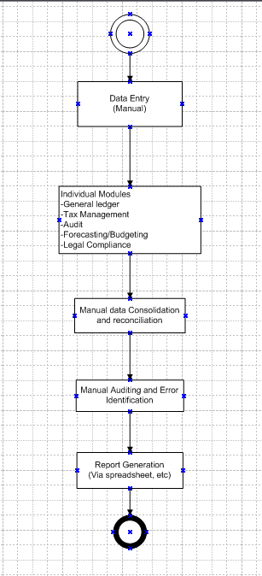

8.2 Proposed Recommendations (TO-BE)
- Unified Platform: Transition to a single solution where all financial operations are integrated and synchronized.
- AI Augmentation: Embed AI capabilities to automate routine tasks, detect anomalies, and generate advanced analytical reports.
- Improved Workflow: Standardize processes to reduce manual interventions and enhance data accuracy, thereby ensuring timely compliance and decision-making.

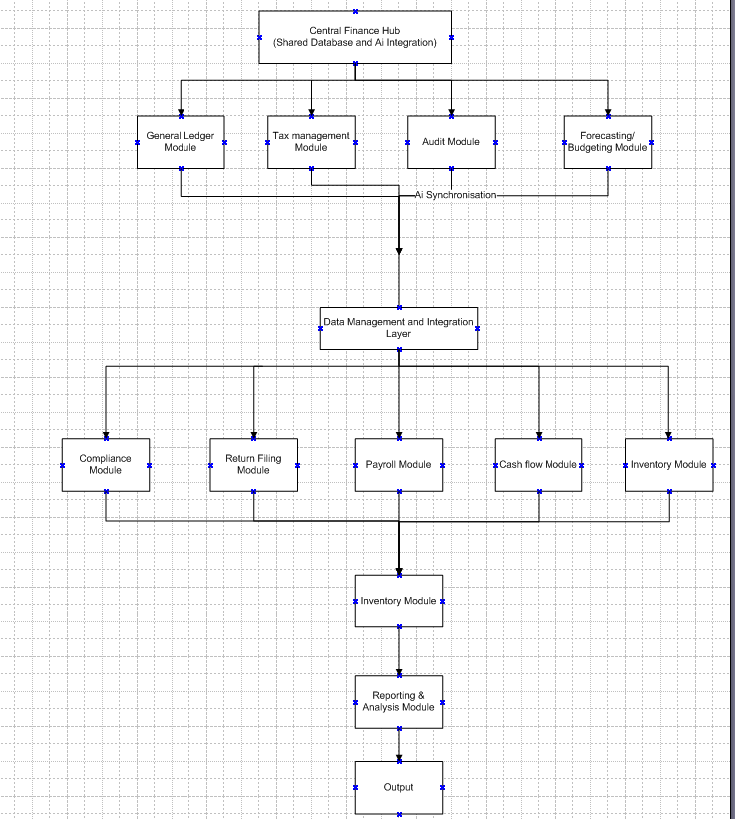

9. Business Requirements
Below are the key business requirements grouped by functionality:
Functionality | Business Requirements
General Ledger Management | - Automated entries and reconciliations. <br> - Real-time updated financial statements and audit trails.
Tax Management | - Automated tax calculations and reminders. <br> - Compliance filters for various jurisdictions and regulatory rules.
Audit | - Comprehensive audit trail with timestamped entries. <br> - Automated flags for anomalies or deviations from normal activity.
Forecasting and Budgeting | - Integrated forecasting models with scenario planning capabilities. <br> - Automated variance analysis and budget tracking.
Legal Compliance Management | - Rule-based compliance checks triggered pre- and post-transaction. <br> - Regular updates in line with evolving regulations.
Data Management | - Secure storage solutions with regular backups. <br> - Role-based data access and encryption protocols.
Return Filing Management | - Automated preparation of return forms with integrated data sources. <br> - Submission tracking and error notifications.
Payroll Management | - Automated payroll processing including deductions, benefits, and taxes. <br> - Integration with tax and HR data sources.
Cash Flow Management | - Real-time tracking of incoming/outgoing cash flows. <br> - Predictive analytics to forecast cash surpluses or shortfalls.
Inventory Management | - Synchronization of inventory levels with financial records. <br> - Automated alerts for reordering thresholds.
Reporting and Analysis | - Dynamic dashboards and customizable financial reports. <br> - AI-driven insights highlighting operational efficiencies and discrepancies.
Each function will be supported by AI modules designed to ensure error-free operations, provide compliance alerts, and enhance decision-making—ultimately reducing operational time and adapting to growth demands.

10. Appendices

10.1 List of Acronyms
- GL: General Ledger
- AI: Artificial Intelligence
- BRD: Business Requirements Document
- ROI: Return on Investment
- KPI: Key Performance Indicator

10.2 Glossary of Terms
- Forecasting: The process of predicting future financial conditions based on historical data and trends.
- Budgeting: Creating a plan for income and expenditure over a defined period.
- Audit Trail: A record that shows who has accessed a computer system and what operations they have performed during a given period.
- Compliance: Adherence to laws, regulations, guidelines, and specifications relevant to business operations.

10.3 Related Documents
- Legacy System Analysis Report
- Technical Architecture Document
- Regulatory Compliance Guidelines
- Stakeholder Interview Summaries
This BRD sets the foundation for moving forward with a synchronized, AI-enabled finance management solution. With unified operations and advanced analytics, Finance Flow Optimization will drive improved accuracy, legal compliance, and operational efficiency.

