Capstone Project 1 – Part -2

Question 1 – Audits- 4 Quarterly Audits are planned Q1, Q2, Q3, Q4 for this Project What is your knowledge on how these Audits will happen for a BA?
Answer 1: Audit is an inspection of work for quality assurance and for the progress of the project. Audit has been done in time-to-time intervals to check whether the project is running properly or not. BA is responsible to update the progress of the project to the stakeholder.
In our project audit has been done in the following manner.
- Audit 1 - After gathering of requirements BA has taken audit to verify if the information is gathered properly or not. QA will check whether the collected information is sufficient to move ahead with the project. It would be regarding the BRD template, elicitation results report, etc.

- Audit 2 – It is planned after requirement analysis and before initiating the project. Here QA gets clarity about the gathered information is properly analysed and the understanding of the team Is proper or not. For e.g. Business to functional requirements mapping, UML diagrams, client signoff document, etc.

- Audit 3 – After the first phase of designing and testing is done, QA conducts an audit to check if there are any errors while designing the first phase or they found any kind of issues.

- Audit 4 – After completion of project, i.e. the project is ready with no errors, audit is before deployment. Also, audits are conducted for test case summary, training reports. It is ensured that all the requirements are working fine. QA highlights if any issue is found in the project.

Question 2 – BA Approach Strategy -Before the Project is going to Kick Start, The Committee asked Mr Karthik to submit BA Approach Strategy Write BA Approach strategy (As a business analyst, what are the steps that you would need to follow to complete a project – What Elicitation Techniques to apply, how to do Stakeholder Analysis RACI/ILS, What Documents to Write, What process to follow to Sign off on the Documents, How to take Approvals from the Client, What Communication Channels to establish n implement, How to Handle Change Requests, How to update the progress of the project to the Stakeholders, How to take signoff on the UAT- Client Project Acceptance Form )
Answer 2:
1)What elicitation techniques to apply?
We have many elicitation techniques to apply to gather information. Some of the elicitation techniques that can be applied are document analysis, observation, interview, brainstorming, focus groups, etc.

2)How to do Stakeholder Analysis RACI/ILS?
Stakeholder analysis is based on two techniques ILS and RACI.
- ILS technique consists of three steps:
Identifying the stakeholder
Stakeholder listing document
Stakeholder summary

- In RACI matrix, a chart is prepared where the stakeholder is given the priority or roles as who is responsible, accountable, consulted and informed.

3)What Documents to Write?
The following documents are to be written:
- BRD (Business case document)
- URD (User Requirement document)
- SRS (Software requirement specification)
- SSD (Supplementary support document)
- Test case documents

4)What process to follow to Sign off on the Documents?
We need to have a document review followed by explaining the content in the document. Signoff is to be taken on SRS as it is primary and important document. It can be taken by email confirmation from the client.

5) How to take Approvals from the Client?
While taking approval from the client, these steps are followed:
- Understanding the role of stakeholder
- Discussing the requirements with the client
- Answer to any doubt/query of the client
- Establish a formal meeting and get client approval.

6) What Communication Channels to establish n implement?
We should have regular meetings like schedule weekly meeting , bi-weekly sprint reviews and monthly stakeholder analysis. This keeps the client informed regarding the progress of the work and we can communicate regarding queries, etc.

7) How to Handle Change Requests?
We can handle change requests by following steps:
- Impact analysis
- Feasibility study
- Effort estimation

8) How to update the progress of the project to the Stakeholders?
The progress has to be updated by weekly status reports, montly review meeting, etc

9) How to take signoff on the UAT- Client Project Acceptance Form?
After the development is complete, UAT (User acceptance testing) is performed. Fix is provided for any issues and when the UAT is clear, Client provides the Sign-off.

Question 3 – 3-Tier Architecture -Explain and illustrate 3-tier architecture?
Answer 3: 3-tier application divide the application into three parts:
- Application layer – It is known as ‘Presentation layer’. It has UI components, GUI like screen and pages.
- Business logic layer – It’s the middle layer of the architecture. It acts as an intermediary between the application layer and the database layer and contain the core logic of the application.
- Database layer – It is the bottom layer of the architecture. All the database components are in the database layer and it is responsible for storing and retrieving data for e.g MySQL, Oracle database.

Question 4 –BA Approach Strategy for Framing Questions –Business Analyst should keep What points in his/her mind before he frames a Question to ask to the Stakeholder (5W 1H – SMART – RACI – 3 Tier Architecture – Use Cases, Use case Specs, Activity Diagrams, Models, Page designs)
Answer 4:
- The 5W1H framework is a useful tool for gathering information and understanding situation by answering questions about who, what, when, where, why, and how. It’s about asking questions like -What is the desired output, Why do we need this feature, who are the stakeholders and users, When is the deadline, where does the process take place and how should the feature work?

- The SMART technique can help in creating questions: (Specific, Measurable, Attainable, Relevant & Time Bound.

- RACI charts help define and clarify roles and responsibilities within a team by outlining who is responsible, accountable, consulted, and informed for each task.
- For 3-tier architecture, BA should frame technical questions in alignment with system architecture layers:
- Presentation layer – What data should the user see on the dashboard?
- Business layer – What will be the rules/workflow?
- Database layer - Where will be the customer information stored and how it can be accessed?

- UML, or Unified Modeling Language, is a standardized way of diagramming and modeling software systems to aid in design, development, and communication between team members. It is mostly done with the help of Use case diagrams, activity diagrams, models, etc.

Question 5 – Elicitation Techniques - As a Business Analyst, What Elicitation Techniques you are aware of? (BDRFOWJIPQU)
Answer 5: The following are given the elicitation technique
1) Document Analysis:
Document analysis is done through reading a document and understanding the product, process and project.
2) Reverse Engineering:
Reverse engineering also called back engineering, is the process of extracting or design information from anything man-made and re-producing it or re-producing anything based on the extracted information. The process often involves disassembling something and analyzing its components and working in details. Majorly used in migration projects.
3) Focus Groups:
A focus group is a means to elicit ideas and attitudes about a specific product, service or opportunity in an interactive group environment.
4) Observation:
Observing users or doing a part of their job, can provide information of existing processes inputs and outputs.
5) Workshop:
A requirements workshop is a structured approach to capture requirements. A workshop may be used to scope, discover, define prioritize and reach closure on requirements for the target system.
6) JAD (Joint Application Development):
Application developed through JAD has higher customer satisfaction and less number of errors as user is directly involved in the development process.
7) Interview:
Interview of a user and stakeholder are important in creating software. An interview is a systematic approach where interviewee is going to ask relevant questions related to software and documenting the responses.
8) Prototyping:
Prototyping is an attractive idea for complicated and large system for which there is no manual process or existing system to help determining the requirements.
9) Survey/Questionnaire:
Questionnaire can be useful for obtaining limited requirements details from the users/stakeholders, who have minor input or are geographically remote.
10) Brainstorming:
Brainstorming can be done either individually or in groups. The ideas collected during the brainstorming session are reviewed or analysed. Brainstorming is an effective way to generate lots of ideas on a specific issue and then determine which idea is the best solution.

Question 6 – This project Elicitation Techniques - Which Elicitation Techniques can be used in this Project and Justify your selection of Elicitation Techniques?
Answer 6: We can use Prototyping, use case Specs, Document Analysis and Brainstorming, etc for requirements gathering for this project.
1) Prototyping: It is an attractive idea for which there is no normal process or existing system. Here in this project no such manual process or existing system is available. So we can easily go with prototyping technique in which by using design and follow chart we can collect the required information.
2) Use Case Specifications describes system behaviour from the user’s perspective for a specific goal or task. This helps stakeholders and technical teams:
- Understand what the system should do step-by-step.
- Visualize real-world interactions with the system.
- Align expectations between business and IT teams.
3) Document Analysis: The document which are provided from the client will read by us properly, understood their requirements and asked them question if any required.
4) Brainstorming: Brainstorming is an effective way to generate lot of ideas on a specific requirement which is the best solution for creating the application.

Question7 – 10 Business Requirements-Make suitable Assumptions and identify at least 10 Business Requirements.
Answer 7:
BROO1) Farmers should be able to search for available products in fertilizers, seeds, pesticides in the application.
BROO2) Manufactures should be able to upload and display their products in the application.
BRO03) Farmers should be able to login in the application as a 'user so that they can buy the products.
BRO04) Manufacturers of fertilizers seeds, pesticides should be able to login as 'merchant' to sell their products through the application.
BROO5) Farmers should have specific login-id that will be their email-id and a specific password.
BRO06) Any new user needs to register by creating a new account with their email-id and choosing a secure password.
BRO07) Manufactures should have specific login-id and password and new manufactures need to register themselves on the website.
BROO8) All the product are kept in their separate catalogue so that farmers can easily navigate to specific category e.g. fertilizer, seeds and pesticides.
BROO9) A separate search option should be available which can search any product of any category by just entering the name of the product.
BRO010) Selected product will be added to the cart and then move to purchase section.
BRO011) Purchase section to have different modes of payment i.e, credit/debit card, UPI and COD (Cash on Delivery). User to be able to choose any one of this option and complete the purchase.
BRO012) A purchase confirmation to be sent to farmers email-id which will have the invoice details, product details, date of purchase, purchase price and delivery tracker Id.
BROO13) Delivery tracker Id to be used to track the status of the order placed by farmers.

Question 8 –Assumptions- List your assumptions.
Answer 8:
1) For the user who forget their login detail can go to the tab of forget password and they can get a recovery email by entering their registered email-id.
2) The user has favourite list option in which they can add their product which they are frequently purchasing.
3) After receiving the product farmers can give their feedback on a particular product on the website, so that other users can see it.
4) If the product is damage/ expired / not the same product as user order then the user can claim for return and get back the money.

Question 9 – This project Requirements Priority- Give Priority 1 to 10 numbers ( 1 being low priority – 10 being high priority) to these Requirements after discussions with the stakeholders.
Answer 9:
Req ID | Req Name | Req Description | Priority
BR001 | Farmer Search for  Products | Farmers should be able to search for available products in fertilizers, seeds, pesticides. | 8
BR002 | Manufacturers  upload their products | Manufactures should be able to upload  Manufacturers login to Manufacturers of  Application and display their products in the application | 8
BR003 | Farmer login to the application | Farmers should be able to login in the application as a 'user so that they can buy the products. | 6
BR004 | Manufactures login to the application | Manufacturers of fertilizers seeds, pesticides should be able to login as 'merchant' to sell their products through the application. | 6
BR005 | Unique login-id for each farmer | Farmers should have specific login-id that will be their email-id and a specific password. | 9
BR006 | Registering a new user | Any new user needs to register by creating a new account with their email-id and choosing a secure password. | 7
BR007 | Unique login-id for each manufacturer | Manufactures should have specific login-id and password and new manufactures need to register themselves on the website. | 8
BR008 | Sorting product in their catalogue | All the product are kept in their separate catalogue so that farmers can easily navigate to specific category e.g. fertilizers, seeds and pesticides. | 6
BR009 | Product searching  option. | A separate search option should be available which can search any product of any category by just entering the name of the product. | 6
BR0010 | Product added to cart | Selected product will be added to the cart and then move to purchase section. | 7
BR0011 | Selection of mode of payment | Purchase section to have different modes of payment i.e, credit/debit card, UPI and COD (Cash on Delivery). User to be able to choose any one of this option and complete the purchase. | 7
BR0012 | Purchase invoice | A purchase confirmation to be sent to farmers email-id which will have the invoice details, product details, date of purchase, purchase price and delivery tracker Id. | 6
BR0013 | Delivery tracker | Delivery tracker Id to be used to track the status of the order placed by farmers. | 8

Question 10 – Use Case Diagram- Draw use case diagram
Answer 10:
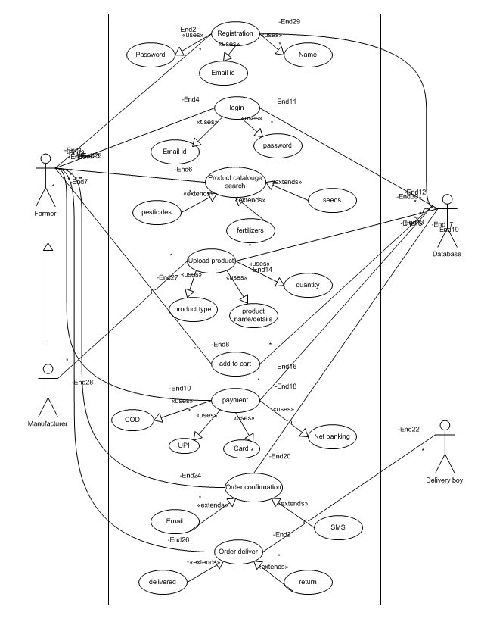

Question 11 – (minimum 5) Use Case Specs- Prepare use case specs for all use cases
Answer 11:
1) Use case name: Login
Use case description: User-id, Password
Actor: Farmers, Manufacturer
Pre-condition: Active internet, connection, Browser compatible.
Post-condition: Home page of the user should be displayed
Basic Flow: User-id & Password are correct.
Alternate Flow: Password is wrong; User-id is wrong; User-id and Password are wrong.
Exceptional Flow: Forget password.
Assumption: User have basic mobile knowledge & know how to handle an application and website.
Constrains: User-id cannot be same.
Dependencies: User should be registered on website.
Inputs: User-id and Password
Outputs: Login successful or Fail Login
Business rule: User-id must be valid and unique; Password must be strong more than eight digit.
Miscellaneous Information: Interactive design, browser compatible.

2) Use case name: Product catalogue
Use case description: Catalogue of seeds, fertilizers and pesticides
Actor: Farmers
Pre-condition: Access to application, smartphone, internet connection.
Post-condition: View catalogue of products (seeds, fertilizers and pesticides)
Basic Flow: All the categories of product seen on the screen.
Alternate Flow: Search for specific product in the catalogue.
Exceptional Flow: Product unavailable, Product out of stock
Assumption: User know the name of the product which he wants to search.
Constraints: Product other than pesticides, seeds and fertilizers are not shown.
Dependencies: Product should be avail able in the list
Input: Name of the productor the product category
Output: Search product show on the screen
Business Rule: Product name must be specific and correct
Miscellaneous information: Basic knowledge of product must be required

3) Use case name: Payment
Use case description: Payment by card, payment by UPl or payment by COD (cash on delivery)
Actor: Farmers
Pre-condition: Product added to cart, credit/debit card, UPI-id
Post-condition: Payment made successful.
Basic Flow: Received payment from farmer
Alternate Flow: Payment selected as cash on delivery mode.
Exceptional Flow: Payment is on pending, Payment failed.
Assumption: Account must have balance more than the billing amount.
Constrains: Order will not be placed
Dependencies: Proper and correct detail need to mentioned while making payment
inputs: Card detail, UPI Id
Outputs: Payment received and order ready to use to dispatch
Business rule: Card detail or UPI-4d must be correct, correct OTP to be entered.
Miscellaneous Information: User should know about credit/debit card banking and UPI banking

4) Use case name: Delivery Tracker
Use case description: Order-id of the product, delivery tracker application.
Actor: Farmer
Pre-condition: Delivery-id or Order-id, Access to delivery tracking application
Post condition: Current status of order
Basic Flow Delivery date and location, Order status
Alternate Flow Order-id is wrong, Current order status is not updated.
Exceptional Flow: Order is yet to dispatch, delivery status is not updated
Assumption User can access to email-d to get his order-id
Constrains: Order Id cannot be same
Dependencies: Order should be placed successfully
Inputs: Order-id or delivery-id
Outputs Current: status or order will be shown
Business rule: Order-id or delivery tracker-id must be correct: Order should be placed successtully
Miscellaneous Information: User must know how to track order or to track it Current status.

5) Use case name: Upload Products
Use case description: Product name and image, product information and product price
Actor: Manufacturer or Seller
Pre-condition: Access to application through browser or smartphone
Post-condition: List the product with details and price
Basic Flow: Product listed with correct name and price
Alternate Flow: Product image is not mentioned, details are not available, Price is incorrect
Exceptional Flow: Product category is not available
Assumption: Manufacturer have knowledge about product and their quality
Constrains: Same product can be uploaded multiple times
Dependencies: Listed products must be available
Inputs: Product name, Product detail, Product prize, Product weight
Outputs Product will be shown in the application to the buyers
Business rule Product name must be correct, product information must be right, product prize must be correct
Miscellaneous Information: Manufacturer must know about the product and its uses, Product which is expired will be take down is the responsibility of manufacturer.

Question 12 – (minimum 5) Activity Diagrams- Activity diagrams
Answer 12:
1)Login Activity Diagram:
2) Catalogue Activity Diagram:
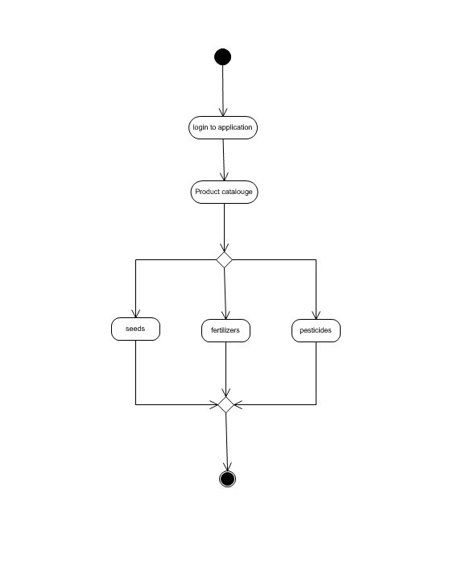

3) Payment Activity Diagram:

4) Delivery Tracker Activity Diagram:
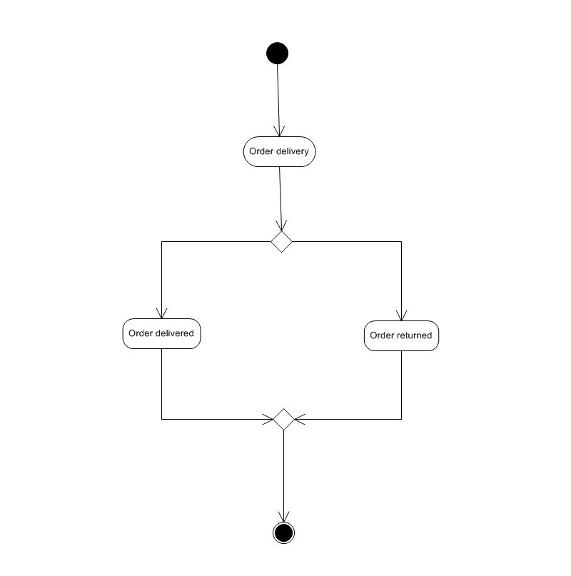

5) Upload Product Catalogue:
