Question 1: Agile Manifesto
The Agile Manifesto, created in 2001 by 17 software professionals, defines the core values and guiding principles for Agile software development. It focuses on flexibility, continuous improvement, customer satisfaction, and delivering working software in short cycles.
The 4 Values of the Agile Manifesto:
- Individuals and Interactions over Processes and Tools
Agile believes people, communication, and teamwork are more valuable than strict processes or tools.
- Working Software over Comprehensive Documentation
The primary measure of progress is working software, not lengthy documents. Documentation is important but should not delay delivery.
- Customer Collaboration over Contract Negotiation
Instead of arguing over contract terms, Agile encourages continuous customer engagement and feedback throughout development.
- Responding to Change over Following a Plan
Agile welcomes changing requirements, even late in development. Adapting quickly is more important than blindly following a fixed plan.

The 12 Principles Behind the Agile Manifesto:
- Our highest priority is to satisfy the customer through early and continuous delivery of valuable software.
- Welcome changing requirements, even late in development. Agile processes turn change into competitive advantage.
- Deliver working software frequently, from a couple of weeks to a couple of months.
- Business people and developers must work together daily throughout the project.
- Build projects around motivated individuals. Give them support and trust them to get the job done.
- Face-to-face conversation is the most effective method of conveying information.
- Working software is the primary measure of progress.
- Agile processes promote sustainable development—teams should maintain a constant pace indefinitely.
- Continuous attention to technical excellence and good design enhances agility.
- Simplicity—the art of maximizing the amount of work not done—is essential.
- The best architectures, requirements, and designs emerge from self-organizing teams.
- At regular intervals, the team reflects on how to become more effective, then tunes and adjusts its behavior accordingly.

Question 2: Write minimum 40 User stories and their Acceptance Criteria along with their BV and CP

Project: Scrum Foods Application (Online Food Delivery System)
Total Epics: 8
Total User Stories: 40+
EPIC 1 – User Registration & Login
This epic covers all onboarding activities such as registration, login, and password reset for customers, delivery boys, restaurant owners, and admins.
User Story 1:
As a Delivery Boy
I want to register in Scrum Foods
so that I can deliver orders.
Acceptance Criteria:
- Registration screen should display fields: Name, Password, Nation ID, Mobile No, Email, Address
- All fields are mandatory
- On clicking Register, data should validate
- Send a “Registration Successful” message
BV: 500
CP (Story Points): 2

User Story 2
As a Customer
I want to register using my mobile number
so that I can create my account.
Acceptance Criteria:
- User can enter mobile number
- OTP is sent to entered mobile
- OTP verification screen appears
- Successful registration message after OTP validation
BV: 500
CP (Story Points): 3

User Story 3
As a Customer
I want to log in using my mobile number and password
so that I can access my account.
Acceptance Criteria:
- Customer enters mobile number and password
- System validates credentials
- If valid → login successful & redirect to dashboard
- If invalid → show 'Invalid mobile number or password'
- After 3 failed attempts → show 'Account locked, please reset your password'
BV: 400
CP (Story Points): 2

User Story 4
As a Restaurant Owner
I want to register my restaurant
so that I can receive orders.
Acceptance Criteria:
- Owner enters Restaurant Name, Owner Name, FSSAI Number, Address, Contact Number
- Owner uploads license documents
- System validates mandatory fields
- Registration is submitted for Admin approval
- Display 'Registration submitted successfully'
BV: 500
CP (Story Points): 3

User Story 5
As an Admin
I want to approve or reject registration requests
so that only valid users can access the platform.
Acceptance Criteria:
- Admin views pending registration request
- Admin can approve a request
- Admin can reject with comments
- System updates user status
- Notification sent to the user
BV: 600
CP (Story Points): 3

User Story 6
As any user
I want to reset my password
so that I can regain access to my account.
Acceptance Criteria:
  - User clicks 'Forgot Password'
  - User enters registered mobile number or email
  - OTP is sent for verification
  - User enters new password and confirms it
  - System updates password
  - User receives confirmation notification
BV: 300
CP (Story Points): 2

EPIC 2 – Restaurant & Menu Management

User Story 1
As a Customer
I want to view available restaurants
so that I can choose where to order food.
Acceptance Criteria:
- Customer views list of active restaurants
- Restaurant list shows name, cuisine type, rating, estimated delivery time
- Customer can scroll through the list
- Customer can tap on a restaurant to view its menu
BV: 500
CP (Story Points): 3

User Story 2
Title: As a Customer
I want to view menu items with price
so that I can make my food selection.
Acceptance Criteria:
- Menu displays item name, price, description
- Veg/Non-veg icon is visible
- Item availability is shown
- Customer can tap an item to view details
BV: 450
CP (Story Points): 2

User Story 3
Title: As a Restaurant Owner, I want to add menu items so that customers can see what I offer.
Acceptance Criteria:
- - Owner can add item name, category, price, description, image
- - Owner can set veg/non-veg label
- - Owner can mark item as available or unavailable
- - System saves menu successfully
BV: 600
CP (Story Points): 3

User Story 4
Title: As a Restaurant Owner, I want to update item availability so that customers only see items that are available.
Acceptance Criteria:
- - Owner can toggle item availability
- - Unavailable items appear grayed out to customers
- - Unavailable items cannot be added to cart
- - Changes update instantly
BV: 350
CP (Story Points): 2

User Story 5
Title: As a Restaurant Owner, I want to provide delivery time slots so that customers know when orders will arrive.
Acceptance Criteria:
- - Owner can add delivery time slots
- - Owner can edit or remove slots
- - Customer sees selected slot during checkout
- - System validates overlap in time slots
BV: 400
CP (Story Points): 2

User Story 6
Title: As a Restaurant Owner, I want to manage my restaurant profile so that customers see accurate information.
Acceptance Criteria:
- - Owner updates restaurant name, address, contact number, cuisine type
- - Owner uploads banner and logo
- - Updated details reflect to customers
- - System validates mandatory fields
BV: 500
CP (Story Points): 3

EPIC 3 – Cart & Order Placement

This epic covers features related to cart management, updating quantities, viewing cart summary, and placing customer orders.

User Story 1

As a customer
I want to add items to my cart
so that I can place an order.

Acceptance Criteria:

- Customer can add an item to the cart
- Cart updates item count automatically
- Customer sees updated price
- Adding the same item again increases quantity

BV: 500
CP (Story Points): 3

User Story 2

As a Customer
I want to increase or decrease item quantity
so that I can modify my order.

Acceptance Criteria:

- Customer can increase or decrease item quantity
- If quantity becomes zero, item is removed from cart
- System validates maximum quantity limit

BV: 450
CP (Story Points): 2

User Story 3

As a Customer
I want to view my cart summary
so that I can verify my order before checkout.

Acceptance Criteria:

- Customer sees a list of items added
- Each item shows name, price, quantity, subtotal
- System displays taxes, delivery fee, total amount
- Customer can proceed to checkout

BV: 400
CP (Story Points): 2

User Story 4

As a Customer
I want to place an order
so that the restaurant receives and processes it.

Acceptance Criteria:

- Customer selects address and delivery slot
- System shows final summary before placing order
- System generates a unique order ID
- Restaurant receives order notification
- Customer sees 'Order Placed Successfully' message

BV: 600
CP (Story Points): 3

EPIC 4 – Payment & Checkout

This epic covers checkout, payment method selection, online payment processing, and order confirmation features.

User Story 1

As a Customer
I want to choose a payment method
so that I can complete my order.

Acceptance Criteria:

- Customer can choose from COD, UPI, Card, or Wallet
- Selected payment option is highlighted
- System validates payment method selection
- Customer cannot proceed without choosing a method

BV: 500
CP (Story Points): 3

User Story 2:

As a customer
I want to make online payment securely
so that my transaction is safe and successful.
Acceptance Criteria:
- System redirects to secure payment gateway
- Customer enters UPI/Card details
- System validates payment information
- Successful payment redirects to confirmation page
- Failed payment shows error and retry option
BV: 600
CP (Story Points): 3

User Story 3

As a Customer
I want to review my full order summary
so that I can confirm everything before payment.
Acceptance Criteria:
- Summary shows items, price, taxes, delivery fee, total amount
- Customer can edit cart if needed
- Customer sees delivery address and time slot
- Customer can proceed to pay
BV: 400
CP (Story Points): 2

User Story 4
As a Customer
I want to receive confirmation after payment
so that I know my order is placed.
Acceptance Criteria:
- System displays 'Payment Successful'
- System generates order ID
- Customer receives order confirmation SMS/Email
- Order appears in 'My Orders' section
BV: 450
CP (Story Points): 2

EPIC 5 – Order Tracking & Delivery
This epic covers the end-to-end order tracking and delivery flow, including assignment, status updates, live tracking, and delivery completion.

User Story 1
As a Customer
I want to track my order status
so that I know its current stage.
Acceptance Criteria:
- Customer sees statuses: Order Accepted, Preparing, Ready for Pickup, Out for Delivery, Delivered
- Status auto-updates based on restaurant/delivery actions
- Customer can refresh and see latest updates
- Status displayed in 'My Orders' section
BV: 600
CP (Story Points): 3

User Story 2
As a Delivery Manager
I want to assign a delivery boy to an order
so that the order can be delivered.
Acceptance Criteria:
System shows list of available delivery boys
Admin/Manager can assign a delivery boy
Delivery boy receives order notification
Assigned delivery boy is shown in customer tracking
BV: 500
CP (Story Points): 3

User Story 3
As a Delivery Boy
I want to update order status
so that customers know the delivery progress.
Acceptance Criteria:
- Delivery Boy can mark 'Picked Up'
- Delivery Boy can mark 'Out for Delivery'
- Delivery Boy can mark 'Delivered'
- Updates instantly reflect to customer
BV: 450
CP (Story Points): 2

User Story 4
As a Customer
I want to track the delivery boy on the map
so that I know when my order will arrive.
Acceptance Criteria:
- Customer sees delivery boy’s live location on a map
- Estimated arrival time is displayed
- Map updates periodically
- Tracking ends after order is delivered
BV: 700
CP (Story Points): 5

User Story 5
As a Delivery Boy
I want to confirm deliver
so that the system can close the order.
Acceptance Criteria:
- Delivery Boy confirms successful delivery
- System updates order as 'Delivered'
- Customer receives notification
- Delivered order moves to Order History
BV: 400
CP (Story Points): 2

EPIC 6 – Notifications & Alerts
This epic handles real‑time alerts and notifications for customers, delivery personnel, and restaurant owners regarding order updates, payments, and promotions.

User Story 1
As a Customer
I want to receive notifications for every order status update
so that I stay informed.
Acceptance Criteria:
- Customer receives notifications for: Order Confirmed, Preparing, Ready for Pickup, Out for Delivery, Delivered
- Notifications appear as in‑app and push alerts
- Tapping the notification opens order details page
- Notifications are real‑time
BV: 500
CP (Story Points): 3

User Story 2
As a Delivery Boy
I want to receive order assignment notifications
so that I can start the delivery process.
Acceptance Criteria:
- Delivery Boy receives notification when order is assigned
- Notification includes order ID, pickup address, customer name, contact
- Tapping the notification opens order details
- Notification delivery is real‑time
BV: 450
CP (Story Points): 2

User Story 3
As a Customer
I want to receive payment success or failure notifications
so that I know my transaction status.
Acceptance Criteria:
- Customer receives notification after payment success
- Failed payments trigger an alert with retry option
- Notifications appear in‑app and as push alerts
- Notification redirects to the payment summary screen
BV: 400
CP (Story Points): 2

User Story 4
As a Customer
I want to receive promotional offers
so that I don’t miss discounts.
Acceptance Criteria:
- Customer receives promo alerts for discounts
- Notification displays offer name and expiry date
- Tapping notification opens offer details page
- Offers are stored in the notification’s inbox
BV: 300
CP (Story Points): 2

EPIC 7 – Ratings & Reviews
This epic enables customers to provide feedback through ratings and reviews, and allows admins to moderate inappropriate content.

User Story 1
As a Customer
I want to rate the restaurant
so that other users can see restaurant quality.
Acceptance Criteria:
- Customer can rate restaurant from 1 to 5 stars
- Customer can add a short comment (optional)
- Rating is allowed only after order is delivered
- Average rating is updated in real time
BV: 400
CP (Story Points): 2

User Story 2
As a Customer
I want to rate the delivery boy
so that service quality can be improved.
Acceptance Criteria:
- Customer can rate delivery boy from 1 to 5 stars
- Customer can add feedback comment (optional)
- Rating allowed only after delivery completion
- Delivery boy’s average rating is updated instantly
BV: 350
CP (Story Points): 2

User Story 3
Title: As a Customer, I want to view restaurant ratings so that I can choose the best option.
Acceptance Criteria:
- - Customer can view average restaurant rating
- - Customer can read recent reviews
- - Ratings appear on restaurant list and detail page
- - System shows number of total ratings
BV: 450
CP (Story Points): 3

User Story 4
As an Admin
I want to moderate reviews
so that inappropriate content is removed.
Acceptance Criteria:
- Admin can view all reviews
- Admin can approve, hide, or delete reviews
- Inappropriate words flagged automatically
- Removed reviews do not affect rating calculation
BV: 500
CP (Story Points): 3

EPIC 8 – Admin Management & System Settings
This epic covers administrative functionalities such as user management, system settings, analytics reports, and permissions configuration.

User Story 1
As an Admin
I want to manage all users
so that I can control platform access.
Acceptance Criteria:
- Admin can view all users (Customer, Restaurant Owner, Delivery Boy)
- Admin can activate or deactivate user accounts
- Admin can search users by name or ID
- System logs all admin actions for audit purposes
BV: 500
CP (Story Points): 3

User Story 2
As an Admin
I want to configure system settings
so that platform operations run smoothly.
Acceptance Criteria:
- Admin can update tax percentages
- Admin can modify delivery fee rules
- Admin can configure default time slots
- All settings changes reflect across the system instantly
BV: 450
CP (Story Points): 3

User Story 3
As an Admin
I want to view platform reports
so that I can analyze performance.
Acceptance Criteria:
- Admin can view total orders, revenue, active users, ratings
- Admin can filter reports by date range
- Reports show charts and tabular data
- Reports can be exported as PDF
BV: 700
CP (Story Points): 5

User Story 4
As an Admin
I want to assign roles and permissions
so that only authorized users access restricted features.
Acceptance Criteria:
- Admin can add, update, or remove roles
- Admin can configure permissions for each role
- Restricted features cannot be accessed without appropriate permissions
- Permission updates are applied instantly across the system
BV: 550
CP (Story Points): 3
Question 3: What is an Epic?
An Epic is a large, high-level user requirement that is too big to complete in a single sprint. Because an Epic is big, it cannot be developed as a single piece of work.
So it is broken down into smaller User Stories, which can be completed within individual sprints.
Example:
"User Registration & Login" is too large to complete in 1 sprint, so we break it into smaller stories like Customer Registration, Delivery Boy Registration, Restaurant Owner Registration, Password Reset, etc.
EPIC 1 – User Registration & Login
Epic Description:
This epic covers all features required for onboarding all types of users including customer, delivery boy, restaurant owner, and admin.
It includes registration, login authentication, approval process, and password reset.
User Stories Covered Under This Epic:
EPIC 1 – User Registration & Login
Epic Description:
This epic covers all features required for onboarding all types of users including customer, delivery boy, restaurant owner, and admin.
It includes registration, login authentication, approval process, and password reset.
User Stories Covered Under This Epic:
- Customer Registration
- Delivery Boy Registration
- Restaurant Owner Registration
- Login
- Admin Approval
- Password Reset
EPIC 2 – Order Tracking & Delivery
Epic Description:
This epic covers end-to-end process of assigning delivery boys, tracking orders in real time, updating delivery status, and marking orders as delivered.
User Stories Covered Under This Epic:
- Assign Delivery Boy
- Order Status Tracking
- Delivery Boy Status Update
- Live Tracking
- Delivery Completion
Question 4: What is the difference between BV and CP

BV stands for Business value.
- It tells how important a user story is to the business.
- It is Decided by Product Owner.
- Higher BV states that story gives more benefit to customer/business.
- Used for prioritizing user stories in product backlog.
- Example: Payment integration will have High BV
CP stands for Complexity Points. It might be also called as Story Points
- It tells how difficult the story is to develop.
- Decided by developers.
- Higher CP means it takes more effort, time, coding.
- Used for estimating sprint capacity and velocity.
- Example: Payment gateway integration might have huge story points (high effort)

Question 5: Explain about Sprint–
Sprint means the period of time to complete user stories. It is decided by Product owner and a team (dev, QA, Scrum Master), usually 2-4 weeks of time.
Sprint is also called as Iteration. Within 2-4 weeks team will deliver a piece of software with some functionality. Complete the user stories means the development and testing will be completed.
Sprint Planning Meeting: Meeting conducted with the team to define what can be delivered in the sprint and duration
Sprint backlog: List of committed stories by Dev and QA team for a specific sprint.
Question 6:
Product Backlog
A Product Backlog is a prioritized list of all features, enhancements, bug fixes, and technical tasks required for a product.
It is owned by the Product Owner and evolves throughout the project.
Items are typically written as user stories and ranked by business value, urgency, or complexity.

Sprint Backlog
A Sprint Backlog is a subset of the Product Backlog selected for a specific sprint.
It contains only those user stories the team commits to complete in that sprint.
Created during Sprint Plan Meeting, it is owned and managed by the development team.
It provides a clear work plan for the sprint, often broken down into actionable tasks.
Question 7: What is an Impediments Log?
An Impediments Log is a document or list used by the Scrum Master to record, track, and remove obstacles (impediments) that slow down or stop the development team during a sprint.
Impediments can be:
- Technical
- People-related
- Environmental
- Process-related
The Scrum Master reviews the impediments daily during the Daily Scrum and works to remove them.
Two Sample Impediments
Impediment 1 – Environment Not Available
The testing environment was down for 2 days, so the QA team could not test the user stories.
Impediment 2 – Dependency on Third Party
Payment gateway API documentation was delayed by the external vendor, blocking integration work.
Question 8:
Velocity is the total number of story points completed by the Scrum Team in a single sprint
It tells:
- How fast the team works
- How much work the team can deliver
- How many story points the team can commit in future sprints
- Helps in Release Planning and Forecasting
Question 9
Draw Sprint Burn Charts n Product Burn Down Charts
Sprint Burn down Chart:

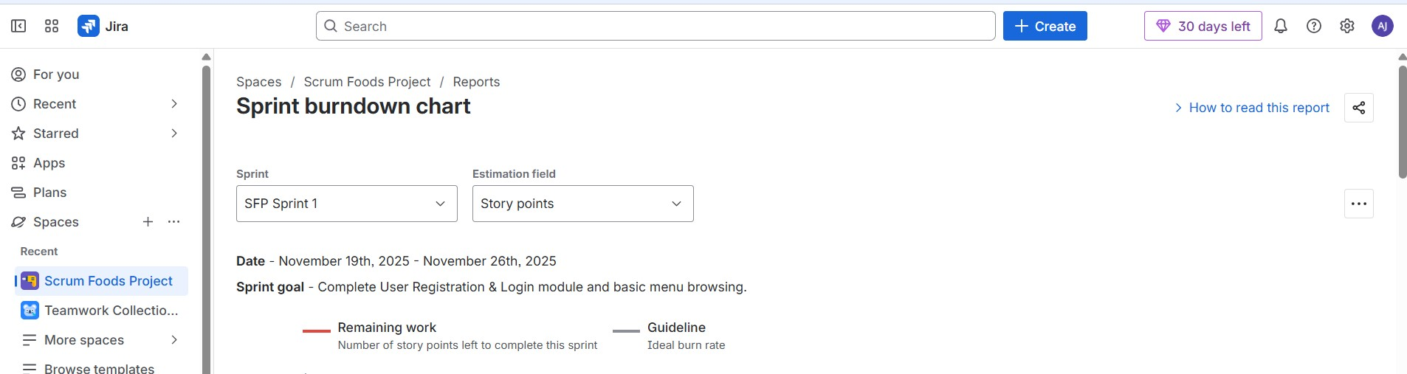

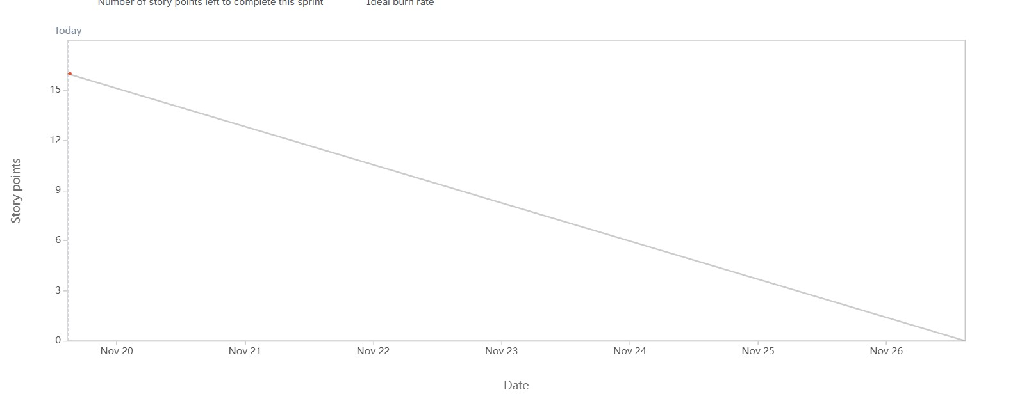

Product Burn down Chart

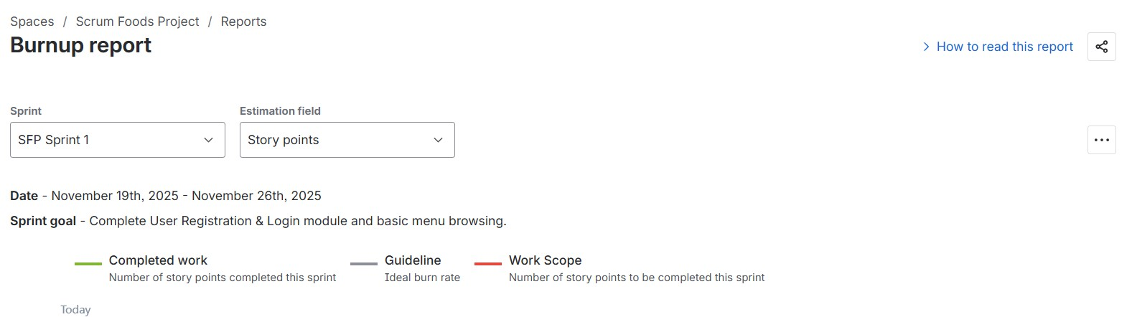

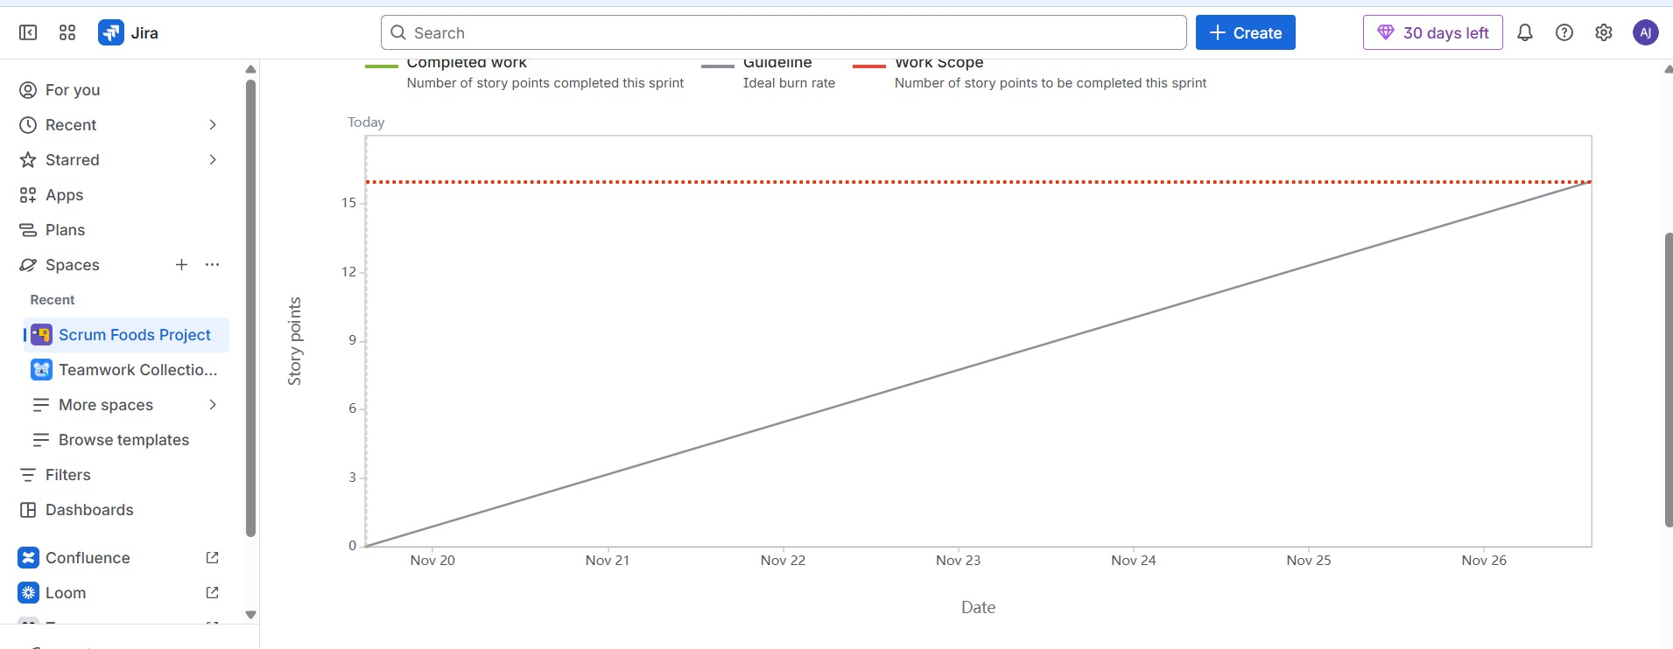

Question 10: Product Grooming
Product Grooming is a regular meeting where the Product Owner and team refine the Product Backlog.
Key Activities in Product Grooming:
- Clarifying user stories: Ensuring each item has a clear description, acceptance criteria, and business value.
- Prioritizing items: Reordering backlog items based on urgency, impact, and stakeholder feedback.
- Estimating effort: Assigning story points or time estimates to help with sprint planning.
- Splitting large items: Breaking down epics or complex stories into smaller, manageable tasks.
- Removing outdated items: Cleaning up irrelevant or obsolete backlog entries.
Product Owner, Scrum Master, Dev Team, and sometimes Stakeholders and BA might also join the meeting
Question 11: Explain the roles of Scrum Master and Product Owner
Scrum Master – Roles & Responsibilities
The Scrum Master is a facilitator and coach for the Scrum Team.
They ensure the Scrum process is followed properly.
Responsibilities:
- Conducts Scrum ceremonies (Daily Scrum, Sprint Planning, Review, Retrospective)
- Removes impediments for the team
- Shields the team from external distractions
- Coaches the team on Agile principles
- Ensures smooth communication between team members
- Helps improve team productivity
- Works to maintain transparency and remove blockers
Product Owner – Roles & Responsibilities
The Product Owner represents the customer and business.
They decide what should be built and in what priority.
Responsibilities:
- Creates and maintains the Product Backlog
- Writes and prioritizes User Stories
- Defines Business Value (BV)
- Accepts or rejects completed work
- Communicates vision and goals to the team
- Ensures the product delivers maximum value
- Works with stakeholders for requirements
QUESTION 12 – Explain All Meetings Conducted in Scrum Project

1. Sprint Planning Meeting
This meeting happens at the beginning of every sprint. The team decides:
- What user stories will be taken into the sprint
- How many story points they can complete
- Sprint Goal
- Tasks required to complete each story
2. Daily Scrum (Daily Stand-up)
This is a 15-minute meeting every day of the sprint.
Each team member answers three questions:
- What did I do yesterday?
- What will I do today?
- Are there any blockers?
3. Sprint Review
This meeting happens at the end of the sprint.
- Team demonstrates the completed work to Product Owner & stakeholders
- Product Owner accepts or rejects the stories
- Stakeholders give feedback
4.Sprint Retrospective
This meeting happens after the Sprint Review and before the next Sprint Planning.
The team discusses:
- What went well
- What didn’t go well
- What can be improved next sprint
Question 13:
Sprint Size:
Sprint Size means the duration of one sprint (how long a sprint will be). Different teams choose different sprint sizes based on project need.
Typical Sprint Sizes: 1 week, 2 weeks, 3 weeks, 4 weeks. Most 2 weeks is preferred
Scrum Size:
The fundamental unit of Scrum is a small team of people, a Scrum Team.
The Scrum Team consists of one Scrum Master, one Product Owner, and Developers. Within a Scrum Team, there are no sub-teams or hierarchies
Developers mean QA/Testers, Front-end developers, Back-end developers, UX designers, Database engineers, Analysts who do development tasks
All of them are called Developers inside Scrum
Question 14:

Definition of Ready means a user story is fully prepared and clear enough for the team to start working on it in the sprint.
- A story is “Ready” when:
- User Story is clearly written
- Acceptance Criteria is defined
- Business Value is assigned
- Story Points (CP) are estimated
- Dependencies are identified
- UI mock-ups/wireframes are provided (if needed)
- Team fully understands the story
- Story is small enough to finish in one sprint
Definition of Done means the story is fully completed, tested, and meets the quality standards agreed by the Scrum Team.
- A story is “Done” when:
- Development is completed
- Code is reviewed
- Unit testing is done
- Integration testing is done
- Acceptance Criteria is met
- No major defects remain
- Product Owner has accepted the story
- Increment is ready for release/demo
Question 15: Prioritization techniques help the Product Owner decide which user stories should be developed first based on value, urgency, and impact.
Here are the main techniques
MoSCoW Technique: Stories are grouped into 4 categories:
- M – Must Have → Mandatory for the product
- S – Should Have → Important but not urgent
- C – Could Have → Good to have
- W – Won’t Have (Now) → Not needed in this release
KANO Analysis: It is a technique used to clarify customer requirements based on how they impact customer satisfaction. It was developed by Prof Kano in 1980’s.
KANO Categories:
- Must-Be (Basic) requirements:
They are expected and essential features. They don’t notice when they are present. But will be unhappy if they are missing.
Ex: login functionality.
- One Dimensional (Performance) requirements:
Features that create satisfaction. The better they are implemented, the happier the customer.
Ex: Search speed, accurate filters.
- Delighters (Excitement) requirements
Unexpected features that wow (or) surprise the customer. Their absence does not cause dissatisfaction but their presence creates excitement.
Ex: WhatsApp order tracking, voice-based navigation
- Indifferent Requirements:
- Features that don’t affect customer satisfaction whether they are implemented or not.
- Customers don’t care about these.
Example: Colour themes, Clickable app logo.
- Reverse Requirements:
Features some customers love and some customers hate.
Example: Auto purchase subscription (some farmers may love it and some may hate).
100 Dollar method:
Every stakeholder gets a 100 virtual budget. They spend it on features based on perceived value. Features with most dollars get high priority.
Weighted Scoring model:
Assign weights to evaluation criteria like Cost, Risk, Customer value.
Calculated total weight score → Highest gets top priority.
RICE Scoring (Used in Product Management):
- Reach – How many users will benefit
- Impact – What will be the user impact
- Confidence – How confident are we about this estimate
- Efforts – Time required
Score = (Reach × Impact × Confidence) / Effort
MVP (Minimum Viable Product:
The smallest version of the product that can be released to customers which still delivers value.
Characteristics of MVP:
- Only must-have features
- Provides real value
- Helps gather customer feedback early
- Saves time and cost
Example: For a Food Delivery App, MVP may include Registration, Login, Restaurant List, Menu, Add to cart, Place order. Rating, Reviews, Tracking might come later.

Question 16: Difference between Business Analyst and Product Owner

Aspect | Business Analyst (BA) | Product Owner (PO)
Primary Role | Bridge between business stakeholders and technical teams | Owns the product vision and backlog
Focus | Requirements gathering, process modeling, documentation | Maximizing product value and prioritizing backlog
Decision Authority | Typically advisory- supports decision-making | Has final say on backlog priorities and scope
Stakeholder Interaction | Deeply involved in stakeholder interviews and workshops | Represents stakeholders but may rely on BA for details
Backlog Involvement | Helps refine and clarify backlog items | Owns and prioritizes the backlog
Documentation | Writes BRDs, user stories, process flows, acceptance criteria | May write user stories but focuses on value and outcomes
Technical Involvement | Often works closely with devs/testers to clarify requirements | Sets direction but may not handle low-level details
Reporting Line | Often part of PMO or Business Team | Part of scrum team

Question 17: Prepare a sample Resume of 3yrs exp Product Owner

Ravibabu Anka
Product Owner / Business Analyst
M: +91 98765 43210 | ravi999@gmail.com | Hyderabad, India

Summary
Product Owner / Business Analyst with 3+ years of experience in driving agile product delivery, translating business needs into user-centric solutions, and maximizing product value. Strong in backlog prioritization, stakeholder management, sprint planning, and requirements analysis.

Experience

Tech Innovators Pvt Ltd – Product Owner
Hyderabad, India | 01/2021 – Present
- Defined product vision and strategy aligned with business goals.
- Led cross-functional teams to deliver features improving user engagement by 25%.
- Collaborated with stakeholders to refine and prioritize backlog.
- Drove sprint planning, review, and refinement sessions ensuring timely delivery.

Smart Solutions Inc. – Product Assistant
Hyderabad, India | 06/2020 – 12/2020
- Supported Product Owner in requirement gathering and documentation.
- Performed competitive analysis to identify product improvement opportunities.
- Coordinated with developers and designers to align solution implementation.

Education:

BV Raju College of Engineering, Hyderabad – Bachelor of Technology
Hyderabad, India | 08/2018 – 05/2022

Key Achievements:
- Successfully led feature rollout resulting in 25% rise in user engagement.
- Recognized as Employee of the Month for strong collaboration and initiative.

Strengths:
- Customer-Centric Mindset
- Analytical Problem Solver
- Cross-Functional Leadership

Languages:
English — Native
Hindi — Proficient
Telugu — Native
Tamil — Intermediate

Skills:
Agile Product Management • User Story Writing • Backlog Prioritization • Sprint Planning • Roadmap Development • Requirements Gathering • Acceptance Criteria Definition • Stakeholder Management • Process Mapping • UAT Coordination

