- A customer can make a payment either by Card or by Wallet or by Cash or by Net banking. Draw a Use Case Diagram?
- Below shows the Payment Use Case Diagram
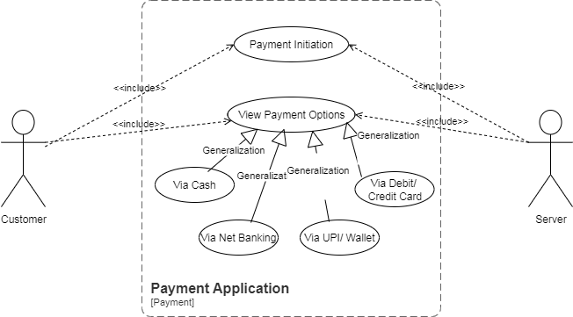

- Derive Boundary Classes, Controller classes, Entity Classes?
- Boundary Class: It is used to handle interactions between the System and external actor. Example:
- Payment Option Boundary
- Card Payment Boundary
Controller Class: Act as Intermediaries between Boundary and entity classes. Example:
- Payment Initiated Controller
- Card Payment Controller
Entity Class: Represent the core data and business logic of the Application. Example:
- Customer
- Payment

- Place these classes on a three tier Architecture?
- User Layer:
- Payment Method Selection Boundary
- Card Payment Boundary
Business Logic:
- Payment Controller
- Wallet Controller
Data Tier:
- Customer ( Entity Class)
- Payment ( Entity Class)

- Explain Domain Model for Customer making payment through Net Banking?
- A Domain Model is a conceptual representation that defines the structure, relationships, and behaviors of entities within a specific problem domain
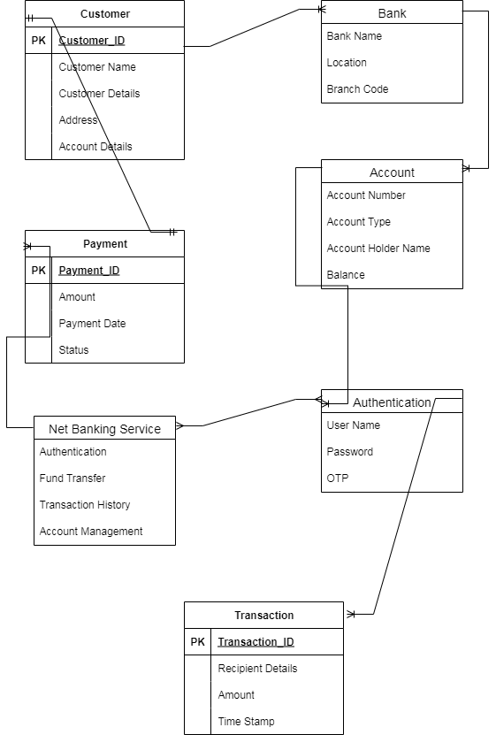

- Draw a sequence diagram for payment done by Customer Net Banking?
- A sequence diagram is a type of interaction diagram used in software engineering and systems design to illustrate how processes operate with one another and in what order.
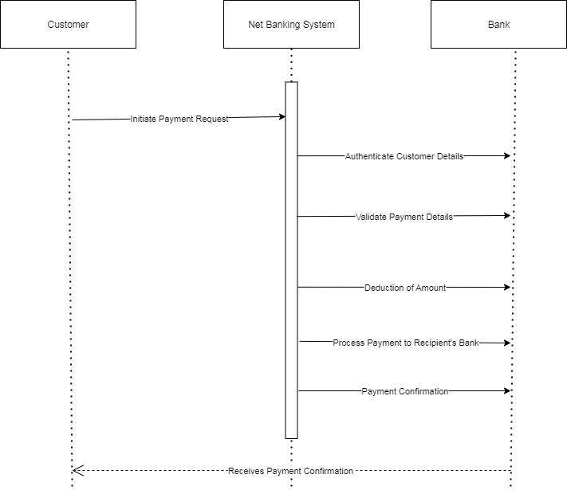
- Explain Conceptual Model for this Case?
- A conceptual model is a high – level representation of a system that helps in understanding, visualizing and communicating the essential system of a Domain. It Provides a clear and simplified view of the domain, making it easier to understand. Key elements of this model:
- Entities: Customer, Product, Order, Payment
- Attributes: Customer ID, Name, Email, Phone Number
- Relationships: For example, a Customer places an Order

- What is MVC architecture? Explain MVC rules to derive classes from use case diagram and guidelines to place classes in 3-tier architecture?
- To identify Classes from use case Diagram, we apply MVC rules on each use case to derive Classes
- Model: The model class knows about all the data that need to be displayed. It is model who is aware about all the operations that can be applied to transform that class. It only represents the data of an application. The model represents enterprise data and the business rules that govern access to and updates of this data. This represents Database ( Tables in DB). All Model Classes are represented as Entity Classes
- View: The View represents the presentation of the application. The view class refers to the model. It uses the query methods of the model to obtain the contents and renders it. The view is not dependent on the application logic. It remains same if there is any modification in the business logic. View Class is the data required by the query. View Class is represented as Boundary Class or Form Class
Actor speaks to system and vice-versa through boundary
Authenticating information between boundary and entity class
- Controller: Whenever the user sends a request for something then it always go through the controller. The controller is responsible for intercepting the requests from view and passes it to the model for the appropriate action. After the action has been taken on the data, the controller is responsible for directing the appropriate view to the user. In GUIs, the views and the controllers often work very closely together.
Controller class is working based on the user’s command. Understands the command/request given by user through Boundary/Form Class
MVC Architecture Rules
- Combination of One Actor and an use case results in one Boundary class
- Combination of Two Actors and an use case results in two Boundary classes
- Combination of Three Actors and an use case results in Three Boundary classes and so on....
Note: only one primary actor is to be considered with a use case.
- Use case will result in a controller class
- Each Actor will result in one entity class
Guidelines to place identified MVC Classes in a 3 Tier Architecture
- Place all Entity Classes in DB Layer
- Place Primary Actor associated Boundary Class in Application Layer
- Place Controller Class in Application Layer
- If governing Body influence or Reusability is there with any of remaining Boundary Classes, place them in Business Logic Layer else place them in Application Layer

- Explain BA contributions in project (Waterfall Model – all Stages)?
- Below are some BA contribution in Waterfall Model Project
Stage | Activities | Artifacts & Resources
Pre-Project | - Understand business need  - Feasibility analysis  - Stakeholder identification | - Business Case  - Feasibility Report  - Stakeholder Register
Planning | - Contribute to project scope  - Define BA approach  - Identify information sources | - Project Charter (BA contribution)  - BA Plan  - Stakeholder Analysis Document
Project Initiation | - Conduct stakeholder analysis  - Define requirements management plan  - Support project kick-off | - Requirements Management Plan  - Communication Plan  - Kick-off Presentation
Requirements Gathering | - Elicit requirements via workshops, interviews, etc.  - Capture business and user needs | - Business Requirements Document (BRD)  - Use Cases / User Stories  - Interview Notes
Requirements Analysis | - Analyze and validate requirements  - Resolve conflicts  - Prioritize requirements | - Functional Requirements Document (FRD)  - Process Flows  - Requirements Traceability Matrix (RTM)
Design | - Support design decisions  - Clarify requirements  - Participate in design reviews | - Updated RTM  - Design Review Notes  - UI Wireframes (BA-supported)
Development | - Clarify functional requirements  - Handle change requests  - Support developers | - RTM Updates  - Change Request Logs  - Clarification Documents
Testing | - Support test case creation  - Validate test coverage  - Help with defect triage | - Test Scenarios (BA-reviewed)  - RTM Verification  - Defect Logs
User Acceptance Testing (UAT) | - Support UAT planning  - Assist users during UAT  - Facilitate issue resolution | - UAT Plan  - UAT Feedback Reports  - Sign-Off Document

- What is conflict management? Explain using Thomas – Kilmann technique?
- Conflict Management: It is the process of resolving conflicts or disagreements between individuals or groups in a constructive manner
Thomas Kilmann Technique: It is a widely used tool for assessing conflict resolution styles & guiding individuals in selecting appropriate strategies to manage conflicts
- Conflict Management - Thomas Kilmann Technique
X Axis- Co-operation, Y Axis- Assertiveness
- 5 Options of Conflict Management
Competing
Avoiding
Accommodating
Collaborating
Compromising
- 5 Steps to Conflict Management
Identify Conflict
Discuss the details
Agree with root problem
Check for the every possible solution for the conflicts.
Negotiate the solution to avoid the future conflicts

- List down the reasons for project failure?
- Below are some of the reasons for project failure
Category | Reason for Failure
Requirements | - Incomplete or unclear requirements  - Changing requirements (scope creep)  - Poor requirements gathering process
Planning | - Inadequate project planning  - Unclear project scope  - Unrealistic timelines or budgets
Stakeholder Issues | - Lack of stakeholder involvement  - Misalignment of stakeholder expectations  - Poor communication with stakeholders
Resource Constraints | - Inadequate resources (time, money, people)  - Unskilled team members  - Poor resource allocation
Leadership & Management | - Poor project management  - Lack of executive support  - Ineffective decision-making
Communication | - Poor communication across teams  - Miscommunication of requirements or progress  - Lack of transparency
Technology | - Use of outdated or unsuitable technology  - Integration issues  - Technical complexity underestimated
Risk Management | - Failure to identify or manage risks  - No contingency planning
Testing & Quality | - Inadequate testing  - Defects found too late  - No proper QA processes
Change Management | - Resistance to change  - Poor user adoption  - No training or transition plan
Monitoring & Control | - Lack of performance tracking  - No corrective actions for deviations from plan

- List the Challenges faced in projects for BA?
- Below are some of the Challenges faced in projects by BA:
- Obtaining sign-off on requirement
- Change Management- with respect to cost and timelines
- Coordination between developers & testers
- Conducting meetings
- Driving client for UAT completion
- People Management (coordinating with different people and different teams)
- Unclear or Changing Requirements
- Managing Stakeholder Expectations
- Scope Creep and Scope Management
- Time and Resource Constraints
- Quality Assurance and Testing
- Documentation and Knowledge Management
- Technology Constraints and Complexity
- Lack of Training

- Write about Document Naming Standards?
- A document numbering standard is a systematic approach to assigning unique identifiers to various documents created and used throughout the development process
Example: Suppose we have a project with the ID “PROJ123”, and we are working with a Requirements Specification Document
Project ID: PROJ123
Document Type: REQ
Version: 1.0
Date: 2024 – 05 – 26
The document identifier could be: PROJ123 – REQ – 1.0 – 2024 – 05 – 26

- What are the Do’s and Don’ts of a Business analyst?
- Do’s of a Business Analyst:
- Understand the Business
Take time to learn the organization’s goals, processes, and pain points.
Align your analysis with strategic business objectives.
- Ask the Right Questions
Use open-ended, clarifying, and probing questions to uncover real needs.
Challenge assumptions respectfully to get to the root cause.
- Listen Actively
Pay attention to what stakeholders say—and don’t say.
Listen without bias to ensure balanced, complete requirements gathering.
- Document Requirements Clearly
Use standard formats like BRDs, use cases, or user stories.
Be concise, unambiguous, and ensure traceability.
- Facilitate Communication
Act as a bridge between technical teams and business stakeholders.
Translate technical jargon into business language and vice versa.
- Validate and Verify Requirements
Ensure all requirements are testable, feasible, and approved.
Confirm that the solution addresses the original business need.
- Adapt to Change
Be flexible and open to changing requirements (especially in Agile environments).
Use change control processes where appropriate.
- Use Visual Aids
Leverage flowcharts, wireframes, diagrams (e.g., ERDs) to clarify complex ideas.
Visuals often communicate faster than text alone.
- Stay Neutral
Remain objective when mediating between conflicting stakeholder views.
Base decisions on data and business value, not personal opinions.
- Continuously Improve
Reflect on past projects to learn what worked and what didn’t.
Stay updated on BA tools, techniques, and methodologies.
Don’ts of a Business Analyst:
- Don’t Make Assumptions
Never assume you know what the user needs—ask and validate instead.
- Don’t Skip Stakeholder Engagement
Missing key stakeholders can lead to incomplete or incorrect requirements.
- Don’t Focus Only on the Solution
Concentrate on understanding the problem before jumping into solutions.
- Don’t Use Vague Language
Ambiguous requirements cause misunderstandings and rework.
Avoid terms like “user-friendly”, “ASAP”, or “etc.”
- Don’t Ignore Non-Functional Requirements
Performance, security, and usability are often overlooked but critical.
- Don’t Overpromise
Be realistic about timelines, technical feasibility, and scope.
Overpromising can damage trust and lead to project failure.
- Don’t Isolate Yourself
Business analysis is collaborative—don't try to do it all alone.
- Don’t Neglect Testing
Ensure requirements are testable and participate in user acceptance testing (UAT) when possible.
- Don’t Resist Feedback
Accept constructive criticism and be willing to refine your work.
- Don’t Forget the “Why”
Always understand why a feature or request exists—don’t just capture the what.

- Write the difference between packages and sub-systems?
- Packages: Collection of components which are not reusable in nature. Ex.: Application development companies work on Packages.
Sub Systems: Collection of components which are reusable in nature. Ex.: Product development companies work on Sub Systems
Aspect | Packages | Sub-systems
Definition | A collection of components that are not reusable across different systems or projects. | A collection of components that are reusable and designed for integration into multiple systems.
Reusability | Low or no reusability — developed for a specific application or client. | High reusability — designed as modules or services used across products or platforms.
Typical Use Case | Used in application development for client-specific solutions. | Used in product development where modules are shared across multiple applications.
Business Focus | Focused on project-based delivery — custom software for individual clients. | Focused on product-based development — scalable, reusable solutions.
Development Nature | Usually tightly coupled and tailored to a specific need or environment. | Usually loosely coupled and built with reusability and modularity in mind.
Scalability | Not designed for scalability or reuse outside of the specific application. | Designed to be scalable and pluggable into various systems.
Maintenance Complexity | Higher, as changes need to be made uniquely per package or client. | Lower, since improvements to sub-systems benefit all products using them.
Examples | A billing system developed uniquely for one telecom company. | A reusable authentication module used in multiple SaaS products.

- What is camel-casing and explain where it will be used?
- Camel – Casing is a naming convention used in computer programming. It is used for naming variables, functions and identifiers.
Example: CamelCase: camelCaseExample
In Camel casing, the first words starts with a lower case letter and each subsequent word begins with an uppercase letter
Area | Usage Example | Type
Programming (Variables) | username, totalPrice | Lower camel case
Programming (Function names) | calculateTotal(), getUserData() | Lower camel case
Class names (OOP) | CustomerDetails, InvoiceData | Upper camel case
File naming (in codebases) | OrderSummary.java | Upper camel case

- Illustrate Development server and what are the accesses does business analyst has?
- Development Server: A development server is an environment or server used during the software development lifecycle where developers and Testers build, test, and debug applications before they are moved to staging or production.
Key Characteristics:
- Hosted internally or in the cloud.
- Usually runs in debug mode with logging.
- Not accessible by external users (only dev/test teams).
- Not optimized for performance or security (unlike production).
- Can be reset or modified frequently.

Business Analysts do not typically do coding, but they do interact with the development environment to gather information, validate features, and support documentation.
Area | Access Type | Purpose
Development Server | Read-only or limited UI access | To test or demo features as they are developed.
Development Database | Usually no direct access (or read-only via tools) | To view data structures or sample data.
APIs / Postman Access | Read/test access to API endpoints | To understand how the system communicates.
JIRA / Azure DevOps | Full access | To manage requirements, track bugs/tasks.
Documentation Tools | Full access (Confluence, SharePoint, etc.) | To write BRDs, user stories, and test cases.
QA/Testing Tools | May access tools like Selenium, TestRail, etc. | To support UAT and validate requirements.
What BA Typically Don’t Have:
- Admin or root access to servers.
- Write access to codebases or core database changes.
- Deployment rights (handled by DevOps or developers).

- What is Data Mapping?
- Data Mapping is the process of connecting data from one source to another. It’s like creating a guide or map that shows how the data in one place corresponds to data in another place. This is especially important when you’re moving data between different systems or databases to ensure that the data says consistent and accurate.
Role of a Business Analyst in Data Mapping A BA often:
- Works with stakeholders to understand source/target data fields.
- Documents the mapping in spreadsheets or tools.
- Defines transformation logic with technical teams.
- Ensures data accuracy and completeness post-migration.

- What is API. Explain how you would use API integration in the case of your application Date format is dd-mm-yyyy and it is accepting some data from Other Application from US whose Date Format is mm-dd-yyyy?
- API stands for Application Programming Interface. It is a set of rules and protocols that allows different software applications to communicate with each other. For example.
Think of API like a Waiter in a Restaurant:
- You (Application A) tell the waiter (API) what you want.
- The waiter takes your request to the kitchen (Application B).
- The kitchen processes it and gives the result to the waiter.
- The waiter brings the result back to you in a way you understand.
API integration is the process of connecting two or more systems via APIs to exchange data automatically.
We can use API Integration for the above question as follows:
- API Request (Incoming Data)
Your system sends an API request to the US HR system
- Data Parsing in Middleware or Backend Code
Your application receives this response and parses the date.
- Date Conversion Logic
Use code (e.g., in Python, JavaScript, Java) to convert from MM-DD-YYYY to DD-MM-YYYY
- Save Converted Data into Your System
Store 31-12-2025 in your database, ensuring consistency with your app's format
Business Analyst’s Role in API Integration:
- Gather API specs from the US HR system.
- Identify data formats (like the date issue).
- Work with developers to define transformation rules.
- Document field mappings and conversion logic.
- Participate in testing to ensure correct integration.

