Que 1. Identify minimum 20 functional requirements

Req ID | Req Name | Req Description | Priority
FR001 | User registration | User should be able to register with the application | 8
FR002 | User Login | User should be able to do login with login credentials | 8
FR003 | Search for products | User should be able to search for available products | 9
FR004 | Filtering out products | User should be able to apply filters to product list as per requirement | 8
FR005 | Product details | User should be able to view product detailed description | 9
FR006 | Adding the product to the cart | User should be able to products to the cart | 9
FR007 | Adding products to the Wishlist | User should be able to add products to the Wishlist | 7
FR008 | Selecting mode of payment | User should be able to make payment by different payment modes | 9
FR009 | Payment confirmation | User should be notified about payment confirmation | 9
FR010 | Order tracking | User should be able to track the order status | 9
NFR001 | User Friendly | Application should be easy to use for all users | 10
NFR002 | Loading time | Each page of application should load within 3 seconds | 8
NFR003 | Language support | Application should be available in multiple language | 8
FR004 | Accessibility | Application should be easily accessible from mobile and web | 9
FR005 | Security and privacy | User information should be secured | 8
NFR006 | Response time | Application should be able to respond all inputs within 2 seconds | 7
NFR007 | Payment compliance | All transactions must be in compliance with regulation authority | 9
NFR008 | Compatibility | Application should be compatible with major web browsers | 8
NFR009 | Maintenance | Application should be easy to maintain and update | 8
NFR010 | Scalability | User should be able to handle large number of users while maintaining the performance | 8

Question 2- Make wireframe and prototypes

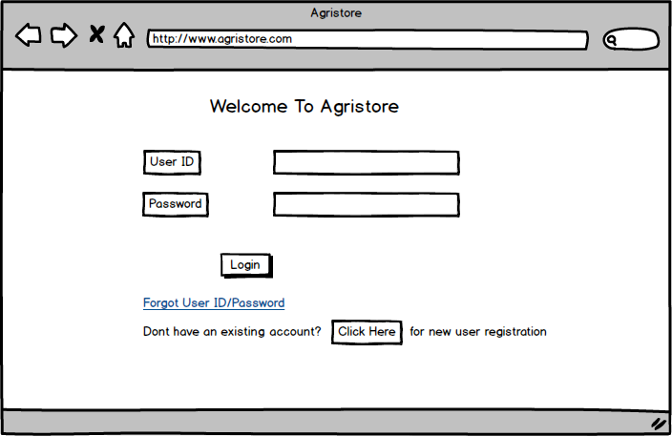
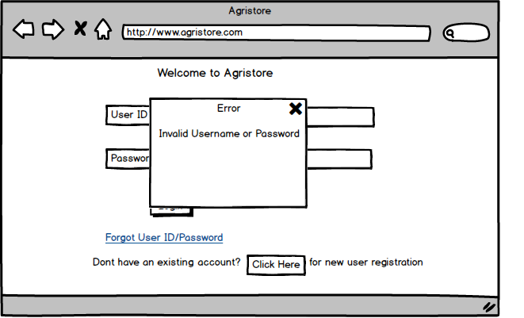

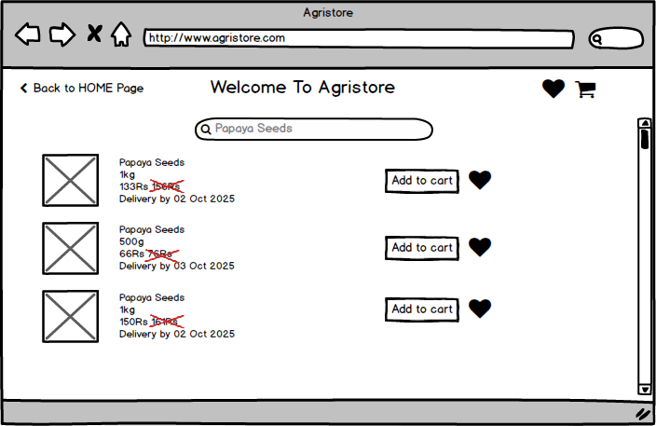

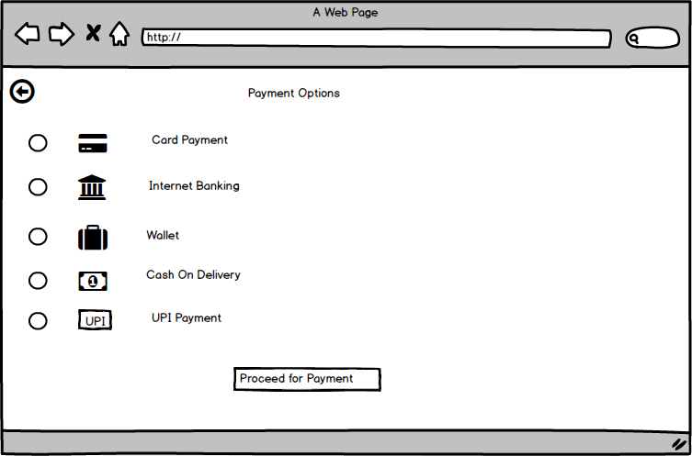
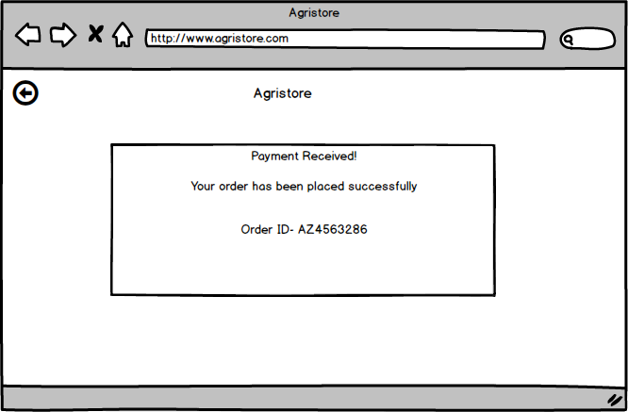

Question 3 – Make a note of the Tools, which you are using for above concepts.

Microsoft Visio- it is a diagramming application used for creating various diagrams including wireframes, flowcharts and network diagrams. It is used for designing user interfaces and planning information architecture.
Balsamiq- It is a wireframing tool used for creating mock-ups and prototype of user interface
Axure RP- It is advanced prototyping tool used for creating high-fidelity, interactive wireframes and prototypes for web and mobile applications.

Question 4 – RTM
Req ID | Req Name | Req Description | Design | D1 | T1 | D2 | T2 | D3 | T3 | D4 | T4 | UAT
FR001 | User registration | User should be able to register with the application | Complete | Complete | Complete | Complete | Complete | Incomplete | Incomplete | Incomplete | Incomplete | Incomplete
FR002 | User Login | User should be able to do login with login credentials | Complete | Complete | Complete | Complete | In Progress | Incomplete | Incomplete | Incomplete | Incomplete | Incomplete
FR003 | Search for products | User should be able to search for available products | Complete | Complete | Complete | In Progress | In Progress | Incomplete | Incomplete | Incomplete | Incomplete | Incomplete
FR004 | Filtering out products | User should be able to apply filters to product list as per requirement | Complete | Complete | In Progress | In Progress | In Progress | Incomplete | Incomplete | Incomplete | Incomplete | Incomplete
FR005 | Product details | User should be able to view product detailed description | Complete | Complete | In Progress | In Progress | In Progress | Incomplete | Incomplete | Incomplete | Incomplete | Incomplete
FR006 | Adding the product to the cart | User should be able to products to the cart | Complete | Complete | In Progress | In Progress | In Progress | Incomplete | Incomplete | Incomplete | Incomplete | Incomplete
FR007 | Adding products to the Wishlist | User should be able to add products to the Wishlist | Complete | Complete | In Progress | In Progress | In Progress | Incomplete | Incomplete | Incomplete | Incomplete | Incomplete
FR008 | Selecting mode of payment | User should be able to make payment by different payment modes | Complete | Complete | In Progress | In Progress | In Progress | Incomplete | Incomplete | Incomplete | Incomplete | Incomplete
FR009 | Payment confirmation | User should be notified about payment confirmation | Complete | Complete | In Progress | In Progress | In Progress | Incomplete | Incomplete | Incomplete | Incomplete | Incomplete
FR010 | Order tracking | User should be able to track the order status | Complete | Complete | In Progress | In Progress | In Progress | Incomplete | Incomplete | Incomplete | Incomplete | Incomplete
 |  |  |  |  |  |  |  |  | Incomplete | Incomplete | Incomplete | Incomplete
NFR001 | User Friendly | Application should be easy to use for all users | Complete | Complete | In Progress | In Progress | In Progress | Incomplete | Incomplete | Incomplete | Incomplete | Incomplete
NFR002 | Loading time | Each page of application should load within 3 seconds | Complete | Complete | In Progress | In Progress | In Progress | Incomplete | Incomplete | Incomplete | Incomplete | Incomplete
NFR003 | Language support | Application should be available in multiple language | Complete | Complete | In Progress | In Progress | In Progress | Incomplete | Incomplete | Incomplete | Incomplete | Incomplete
NFR004 | Accessibility | Application should be easily accessible from mobile and web | Complete | Complete | Complete | Complete | Complete | In Progress | Incomplete | Incomplete | Incomplete | Incomplete
NFR005 | Security and privacy | User information should be secured | Complete | Complete | Complete | Complete | In Progress | Incomplete | Incomplete | Incomplete | Incomplete | Incomplete
NFR006 | Response time | Application should be able to respond all inputs within 2 seconds | Complete | Complete | In Progress | In Progress | In Progress | Incomplete | Incomplete | Incomplete | Incomplete | Incomplete
NFR007 | Payment compliance | All transactions must be in compliance with regulation authority | Complete | Complete | In Progress | In Progress | In Progress | Incomplete | Incomplete | Incomplete | Incomplete | Incomplete
NFR008 | Compatibility | Application should be compatible with major web browsers | Complete | Complete | In Progress | In Progress | In Progress | Incomplete | Incomplete | Incomplete | Incomplete | Incomplete
NFR009 | Maintenance | Application should be easy to maintain and update | Complete | Complete | In Progress | In Progress | In Progress | Incomplete | Incomplete | Incomplete | Incomplete | Incomplete
NFR010 | Scalability | User should be able to handle large number of users while maintaining the performance | Complete | Complete | In Progress | In Progress | In Progress | Incomplete | Incomplete | Incomplete | Incomplete | Incomplete

Question 5 – Prepare 10 Test Case Documents
- User Registration
Test case ID | TC001 |  | Test case name |  | User Registration
Project ID | PRJ001 |  | Project Name |  | Online Agriculture products store
PM ID | PM001 |  | PM Name |  | Mr. Vandanam
Test strategy ID | TS001 |  | Tester ID |  | T001
Test plan ID | TP001 |  | Tester Name |  | Mr. Jason
Test Schedule ID | TSCH001 |  | Date of Test |  | (Date to be determined)
Scenario | To verify that user can register into the application successfully
Link to that page | User Registration Page
Input Data | User Credential 1 | User Credential 2 |  | User Credential 3 |  | User Credential 4
Input Data | Email:user1@mail.com | Email:user2@mail.com |  | Email:user3@mail.com |  | Email:user@mail.com
Input Data | Password: User1 | Password: User2 |  | Password: User3 |  | Password: User4
Expected behaviour | User is able to register into application successfully
Actual behaviour | (To be filled during testing)
Comments | (To be filled during testing)
Result (Pass/Fail) | (To be filled during testing)

- User Login
Test case ID | TC002 |  | Test case name |  | User Login
Project ID | PRJ001 |  | Project Name |  | Online Agriculture products store
PM ID | PM001 |  | PM Name |  | Mr. Vandanam
Test strategy ID | TS001 |  | Tester ID |  | T002
Test plan ID | TP001 |  | Tester Name |  | Mr. Jason
Test Schedule ID | TSCH002 |  | Date of Test |  | (Date to be determined)
Scenario | To verify that user can Login into the application successfully
Link to that page | User Login Page
Input Data | User Credential 1 | User Credential 2 |  | User Credential 3 |  | User Credential 4
Input Data | Email:user1@mail.com | Email:user2@mail.com |  | Email:user3@mail.com |  | Email:user@mail.com
Input Data | Password: User1 | Password: User2 |  | Password: User3 |  | Password: User4
Expected behaviour | User is able to Login into application successfully
Actual behaviour | (To be filled during testing)
Comments | (To be filled during testing)
Result (Pass/Fail) | (To be filled during testing)

- Adding product details by manufacturer
Test case ID | TC003 |  | Test case name |  | Uploading Product details by manufacturer
Project ID | PRJ001 |  | Project Name |  | Online Agriculture products store
PM ID | PM001 |  | PM Name |  | Mr. Vandanam
Test strategy ID | TS001 |  | Tester ID |  | T003
Test plan ID | TP001 |  | Tester Name |  | Ms. Alekya
Test Schedule ID | TSCH003 |  | Date of Test |  | (Date to be determined)
Scenario | To verify that manufacturer can successfully upload product details in the application
Link to that page | Uploading Product Page
Input Data | Product 1 | Product 2 |  | Product 3 |  | Product 4
Input Data | Product Name: Pesticide | Product Name: Papaya Seeds |  | Product Name: Tomato Seeds |  | Product Name: Fertilizer
Input Data | Price: 312/Kg | Price:130/kg |  | Price:56/kg |  | Price:109/kg
Expected behaviour | Product details are successfully getting uploaded in the application
Actual behaviour | (To be filled during testing)
Comments | (To be filled during testing)
Result (Pass/Fail) | (To be filled during testing)

- Product Search
Test case ID | TC004 |  | Test case name |  | Product Search
Project ID | PRJ001 |  | Project Name |  | Online Agriculture products store
PM ID | PM001 |  | PM Name |  | Mr. Vandanam
Test strategy ID | TS001 |  | Tester ID |  | T004
Test plan ID | TP001 |  | Tester Name |  | Mr. Jason
Test Schedule ID | TSCH004 |  | Date of Test |  | (Date to be determined)
Scenario | To verify that user can successfully search the product in the application
Link to that page | Product Search Page
Input Data | Keyword 1 | Keyword 2 |  | Keyword 3 |  | Keyword 4
Input Data | Fertilizer | Seed |  | Pesticide |  | Organic
Expected behaviour | User is able to search the required product in the application
Actual behaviour | (To be filled during testing)
Comments | (To be filled during testing)
Result (Pass/Fail) | (To be filled during testing)

- Applying Search Filter
Test case ID | TC005 |  | Test case name |  | Applying Search Filter
Project ID | PRJ001 |  | Project Name |  | Online Agriculture products store
PM ID | PM001 |  | PM Name |  | Mr. Vandanam
Test strategy ID | TS001 |  | Tester ID |  | T005
Test plan ID | TP001 |  | Tester Name |  | Mr. Jason
Test Schedule ID | TSCH005 |  | Date of Test |  | (Date to be determined)
Scenario | To verify that user can successfully apply filter on searched products
Link to that page | Product List Page
Input Data | Filter 1 | Filter 2 |  | Filter 3 |  | Filter 4
Input Data | Price Range | Delivery Date |  | Quantity |  | Brand
Expected behaviour | User is able to apply filter on searched products successfully
Actual behaviour | (To be filled during testing)
Comments | (To be filled during testing)
Result (Pass/Fail) | (To be filled during testing)

- View Product Details

Test case ID | TC006 |  | Test case name |  | View Product Details
Project ID | PRJ001 |  | Project Name |  | Online Agriculture products store
PM ID | PM001 |  | PM Name |  | Mr. Vandanam
Test strategy ID | TS001 |  | Tester ID |  | T006
Test plan ID | TP001 |  | Tester Name |  | Ms. Alekya
Test Schedule ID | TSCH006 |  | Date of Test |  | (Date to be determined)
Scenario | To verify that user can view selected product details
Link to that page | Product List Page
Input Data | Keyword 1 | Keyword 2 |  | Keyword 3 |  | Keyword 4
Input Data | Product 1 | Product 2 |  | Product 2 |  | Product 3
Expected behaviour | User is able to view detailed description of the required product
Actual behaviour | (To be filled during testing)
Comments | (To be filled during testing)
Result (Pass/Fail) | (To be filled during testing)

- Adding product to the cart
Test case ID | TC007 |  | Test case name |  | Adding product to the cart
Project ID | PRJ001 |  | Project Name |  | Online Agriculture products store
PM ID | PM001 |  | PM Name |  | Mr. Vandanam
Test strategy ID | TS001 |  | Tester ID |  | T007
Test plan ID | TP001 |  | Tester Name |  | Mr. Jason
Test Schedule ID | TSCH007 |  | Date of Test |  | (Date to be determined)
Scenario | To verify that user can add selected product to the cart
Link to that page | Product Page
Input Data | Keyword 1 | Keyword 2 |  | Keyword 3 |  | Keyword 4
Input Data | Product 1 | Product 2 |  | Product 2 |  | Product 3
Expected behaviour | User is able to add selected product into the cart successfully
Actual behaviour | (To be filled during testing)
Comments | (To be filled during testing)
Result (Pass/Fail) | (To be filled during testing)

- Different Payment Mode
Test case ID | TC008 |  | Test case name |  | Different Payment Mode
Project ID | PRJ001 |  | Project Name |  | Online Agriculture products store
PM ID | PM001 |  | PM Name |  | Mr. Vandanam
Test strategy ID | TS001 |  | Tester ID |  | T008
Test plan ID | TP001 |  | Tester Name |  | Mr. Jason
Test Schedule ID | TSCH008 |  | Date of Test |  | (Date to be determined)
Scenario | To verify that user can select from different payment modes and place the order
Link to that page | Payment Mode Page
Input Data | Payment Option 1 | Payment Option 1 |  | Payment Option 1 |  | Payment Option 1
Input Data | Cash On Delivery | UPI |  | Card Payment |  | Net banking
Expected behaviour | User is able to select payment mode as per their convenience from different payment mode options and process for placing product order
Actual behaviour | (To be filled during testing)
Comments | (To be filled during testing)
Result (Pass/Fail) | (To be filled during testing)

- Order Confirmation
Test case ID | TC009 |  | Test case name |  | Order Confirmation
Project ID | PRJ001 |  | Project Name |  | Online Agriculture products store
PM ID | PM001 |  | PM Name |  | Mr. Vandanam
Test strategy ID | TS001 |  | Tester ID |  | T009
Test plan ID | TP001 |  | Tester Name |  | Mr. Jason
Test Schedule ID | TSCH009 |  | Date of Test |  | (Date to be determined)
Scenario | To verify that user receive confirmation on placing the order
Link to that page | Order Page
Input Data | Order ID 1 | Order ID 2 |  | Order ID 3 |  | Order ID 4
Input Data | 1234 | 3456 |  | 9876 |  | 6789
Expected behaviour | User is able to receive confirmation on his registered Email/SMS about order placement.
Actual behaviour | (To be filled during testing)
Comments | (To be filled during testing)
Result (Pass/Fail) | (To be filled during testing)

- Delivery tracking
Test case ID | TC010 |  | Test case name |  | Delivery tracking
Project ID | PRJ001 |  | Project Name |  | Online Agriculture products store
PM ID | PM001 |  | PM Name |  | Mr. Vandanam
Test strategy ID | TS001 |  | Tester ID |  | T010
Test plan ID | TP001 |  | Tester Name |  | Ms. Alekya
Test Schedule ID | TSCH010 |  | Date of Test |  | (Date to be determined)
Scenario | To verify that user can track their order
Link to that page | Delivery Tracking Page
Input Data | Order ID 1 | Order ID 2 |  | Order ID 3 |  | Order ID 4
Input Data | 1234 | 3456 |  | 9876 |  | 6789
Expected behaviour | User is able to track the status of their product delivery
Actual behaviour | (To be filled during testing)
Comments | (To be filled during testing)
Result (Pass/Fail) | (To be filled during testing)

Question 6 – DB Design

Database Schema- It is logical structure that defines how the data is organised in database. It outlines tables, columns, relationships and constraints. It acts as blueprint of the database
Entity Relationship Diagram- It is visual representation of the relationships between entities in the database. This has different components such as entities, attributes, relationships, primary key and foreign key

Question 7 – Data Flow Diagram
Data Flow Diagram is graphical representation of the data flow within the system. It shows how data enters, how processed and how exit the system. They are used to analyze and model the structure of the system.

Question 8 How do you handle change requests in a project?
How to handle change requests
  - Understand the nature of change request- understanding the source of change request and recognise the type of required change whether it related to scope, budget schedule or any other type
  - Establish a change control process
- Submission- stakeholder submits the change request
- Evaluation-assess the impact of the change
- Approval-a change control board or relevant decision makers approval or rejection of request
- Implementation-incorporation of approved changes
- Communication-informing about changes to stakeholders
  - Maintain change log- maintain detail log of all change request
  - Conduct impact analysis- Conducting impact analysis on affected areas, resources and risk
  - Facilitate decision making- facilitate discussion with stakeholders to perform informed decision
  - Prioritize changes- prioritise the changes according to their urgency, impact and feasibility
  - Communicate effectively- regular communication with stakeholders for informing the update
  - Document changes- documentation of all the changes
  - Review and learn- review the impact and take insights for improving next process or future project

Question 9 – Change Request/Enhancement

As a business analyst, my response to Ben and Kavin’s request would be to classify it as an enhancement rather than a change request. A change request typically involves modifications to existing functionality or requirement, while an enhancement introduces new features or capabilities that were not initially specified.
In this case, the request to allow farmers to add their crop yields, display them to the general public and enable selling through the application represents an enhancement because it introduces new functionality that goes beyond the initial scope of the project.
Additionally, the introduction of an auction system for crop yields adds another layer of functionality to the application.
To address this enhancement request, I would follow the standard process for handling new requirement. I will properly document the requirements and by working jointly with development team will understand the feasibility of the enhancement along with its impact on the entire project. Before committing to client I will analyse the risks involved, cost required and possible benefits of the enhancement.

Question 10 – Come up with estimations – How many Manhours required
Estimating the number of manhours required would depend on various factors including the complexity of the features, the team size, team expertise and development methodologies used. Approximate estimations are as follows-
- Requirement gathering an analysis- 70 manhours
- Design and architecture- 150 manhours
- Development and coding- 180 manhours
- Testing and quality assurance- 190 manhours
- Deployment and user acceptance testing- 180 manhours
- Documentation and training— 60 manhours

Total estimated time- 800 manhours

Question 11 – Explain UAT Acceptance process
- Preparation and Understanding
- Understand the Purpose: Know the scope and business value of the document to focus on necessary details and avoid extraneous information.
- Identify Key Stakeholders: Know precisely who holds the final sign-off authority to ensure you're engaging the right person.
- Prepare the Document: Create clear, well-structured documentation that stakeholders can easily understand and review.
- Engagement and Review
- Conduct Walkthroughs: Organize sessions to walk stakeholders through the document, ensuring they understand its contents and feel confident in its accuracy.
- Use a Feedback Log: Implement a system to track feedback, including the reviewer's ID, date, feedback type (observation, question, or required change), and the feedback itself.
- Incorporate Early & Iterative Feedback: Don't wait until the end to get feedback. Submit the document in iterations or review parts to allow for course corrections and build trust
- Securing Buy-In
- Address Feedback: Use the feedback log to resolve any conflicts or issues, ensuring all stakeholders' concerns are considered and addressed appropriately.
- Focus on Consensus: Work to build consensus and ensure stakeholders are confident and have bought into the document's content.
- Customise Your Approach: Tailor your engagement and presentation for different stakeholders to better meet their specific needs and expectations
- Formal Sign-Off
- Formal Procedure: Once consensus is reached and concerns are addressed, the formal sign-off is the final step.
- Formal Acceptance: The stakeholder applies their signature, whether electronically or physically, to formally approve the document, confirming its acceptance.
- Record the Event: The sign-off event should be recorded in an audit trail, which provides a formal record of approval.

Question 12 – Explain Project closure document
Project closure document is a formal document that summarizes the key outcomes, lessons learned and final details of the project.
It includes project accomplishments, challenges and overall performance providing valuable insights for stakeholder and future projects.
Points to include in the project closure document are-
- Project overview
- Achievements
- Lessons learned
- Quality assurance
- Resource utilisation
- Risk management
- Challenges

