Document 6- Please prepare a use case diagram, activity diagram and a use case specification document.
Use case Diagram For (HBS)
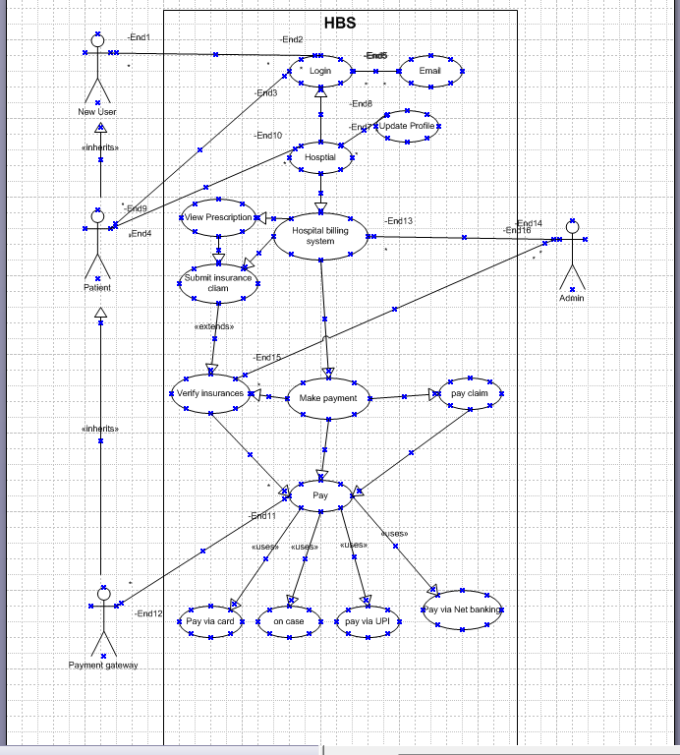

Activity diagram
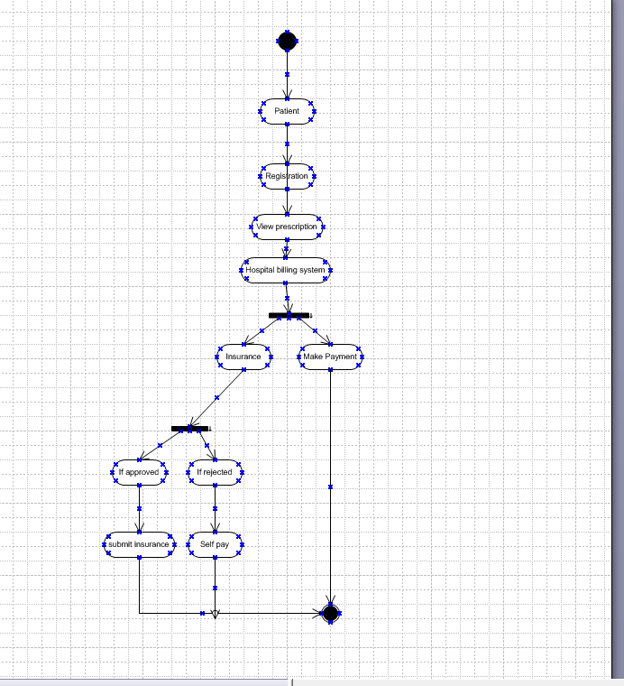

USE CASE SPECIFICATION
1.Patient Registration Use Case specification

Field | Details
Use Case Name | Patient Registration
Use Case Description | Allows new Patient to create an account on HBS
Actors | Primary: Patients  Secondary: System (automated email service)
Basic Flow | - patient clicks on "Sign Up".  - Patient enters required details (name, email, password, etc.).  - System validates inputs and creates an account.  - System sends an email verification link.  - patient verifies email and account is activated.
Alternate Flow | If the Patient does not verify their email, the account remains inactive.
Exceptional Flow | If the email is already registered, an error message is displayed.
Pre-Conditions | Patient must have a valid email and internet access.
Post-Conditions | Account is created, and the patient can log in.
Assumptions | Patient provide correct information.
Constraints | Password must meet security guidelines.
Dependencies | Email verification service.
Inputs and Outputs | Input: patient details  Output: Account confirmation email
Business Rules | Duplicate emails are not allowed.
Miscellaneous Information | None

2. Patient login Use Case specification
Use Case Name | Patient Login
Use Case Description | Allows registered Patient to log in.
Actors | Primary: Patients  Secondary: System (to verify credentials and manage sessions)
Basic Flow | - Patient enters email and password.  - System validates credentials.  - Patient is redirected to the home page.
Alternate Flow | If the Patient forgets their password, they can reset it.
Exceptional Flow | If credentials are incorrect, an error message is shown.
Pre-Conditions | Patient must be registered.
Post-Conditions | Patient is logged in successfully.
Assumptions | Patient remember their credentials.
Constraints | Password retry limit: 3 attempts.
Dependencies | Authentication system.
Inputs and Outputs | Input: Login credentials  Output: User authentication status
Business Rules | Locked out after 3 failed attempts.
Miscellaneous Information | All login attempts (both successful and failed) must be logged with a timestamp and IP address for security auditing purpose.

3.INSURANCES CLAIM USE CASE SPECIFICATION

Element | Description
Use Case Name | Process Insurance Claim
Primary Actor | Billing Clerk / Insurance Coordinator
Secondary Actors | Patient, Insurance Provider, Hospital Admin System
Goal | To submit and process insurance claims for patient billing
Preconditions | - Patient has valid insurance details  - Medical services are documented
Postconditions | - Claim submitted to insurer>  Claim status updated (Approved/Rejected)
Main Flow | 1. Clerk selects patient record  2. System retrieves billable services  3. Insurance details verified  4. Claim form auto-filled  5. Claim submitted electronically  6. Confirmation received  7. Status updated in system
Alternative Flows | - Insurance expired → Notify patient  Manual submission required → Print form  - Missing documents → Request from departments
Exceptions | - Network failure during submission  - Invalid insurance policy number  - Claim rejected due to coverage limits
Business Rules | - Only verified treatments are claimable  - Claims must be submitted within insurer’s time window  Co-pay amounts must be calculated
Assumptions | - Insurance provider systems are integrated  - Staff trained in claim protocols

4. Use Case Specification: Insurance Claim Reconciliation
Element | Description
Use Case Name | Reconcile Insurance Claim
Primary Actor | Billing Clerk / Finance Officer
Secondary Actors | Insurance Provider, Hospital Admin System
Goal | To verify and reconcile payments received from insurance providers
Preconditions | - Insurance claim has been submitted  - Payment advice received from insurer
Postconditions | - Payment matched with claim  - Patient account updated  - Discrepancies flagged
Main Flow | 1. Clerk accesses claim status dashboard  2. System retrieves insurer payment details  3. Payment matched against submitted claim  4. Any shortfall or excess is identified  5. Adjustments made in patient account  6. Reconciliation report generated
Alternative Flows | - Partial payment received → Notify patient for balance  - Overpayment → Refund initiated  - Payment not received → Follow-up with insurer
Exceptions | - Mismatch in claim and payment data  - Payment advice missing  - System error during reconciliation
Business Rules | - Reconciliation must be completed within 7 days of payment receipt  - All discrepancies must be documented  - Refunds require admin approval
Assumptions | - Insurer sends electronic payment advice  - System supports automated matching logic

5. Use Case Specification: Insurance Claim Appeal
Element | Description
Use Case Name | Appeal Rejected Insurance Claim
Primary Actor | Insurance Coordinator / Billing Clerk
Secondary Actors | Patient, Insurance Provider
Goal | To appeal a rejected insurance claim and seek reconsideration
Preconditions | - Claim has been rejected  - Rejection reason is documented
Postconditions | - Appeal submitted  - Claim status updated (Pending/Approved/Final Rejection)
Main Flow | 1. Clerk reviews rejection reason  2. Gathers supporting documents  3. Fills appeal for  4. Submits appeal to insurer  5. Tracks appeal status  6. Updates patient billing accordingly
Alternative Flows | - Appeal denied → Patient billed directly  - Appeal approved → Claim processed  - Additional documents requested by insurer
Exceptions | - Appeal deadline missed  - Incomplete documentation  - System error during submission
Business Rules | - Appeals must be submitted within insurer’s appeal window  - Only one appeal per claim allowed  - All communications must be logged
Assumptions | - Insurer provides appeal portal or contact  - Hospital maintains complete treatment records

6.Checkout and Payment Case specification
Field | Details
Use Case Name | Patient Checkout and Payment
Use Case Description | Patient complete visit and system calculating the amount /due
Actors | Primary: Front desk staff  Secondary: Patient
Basic Flow | - Patient proceeds to checkout.  - Enters Payment details.  - Selects payment method.  - Completes payment.
Alternate Flow | If the payment fails, user can retry.
Exceptional Flow | If internet disconnects, transaction is canceled.
Pre-Conditions | User must have valid payment details.
Post-Conditions | The appointment status is updated to complete
Assumptions | Payment gateway is working.
Constraints | Payment processing time: < 10 seconds.
Dependencies | Payment service provider.
Inputs and Outputs | Input: Patient ID/ Appointment ID  Output: Calculate amount due.
Business Rules | Secure payment required.
Miscellaneous Information | Credit card no. should not be stored in the system primary database.

Document 7- Screens and pages
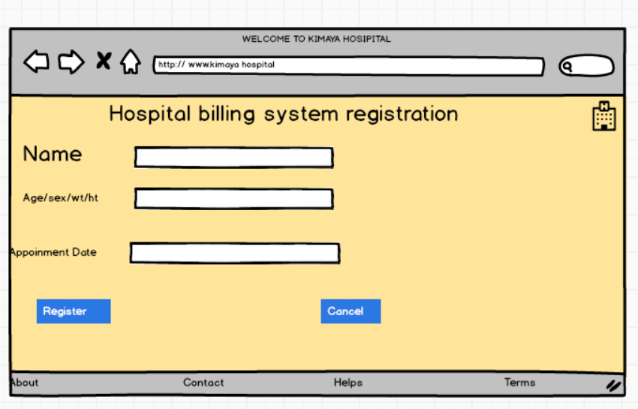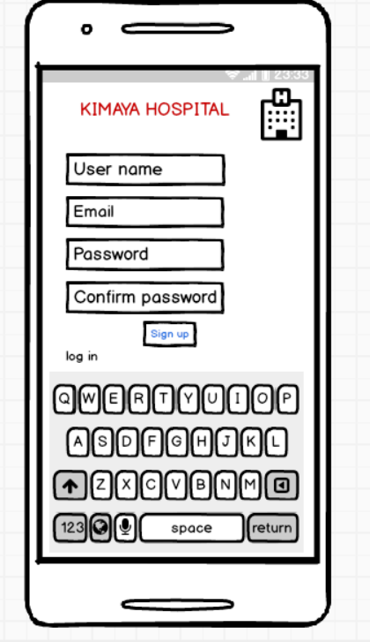

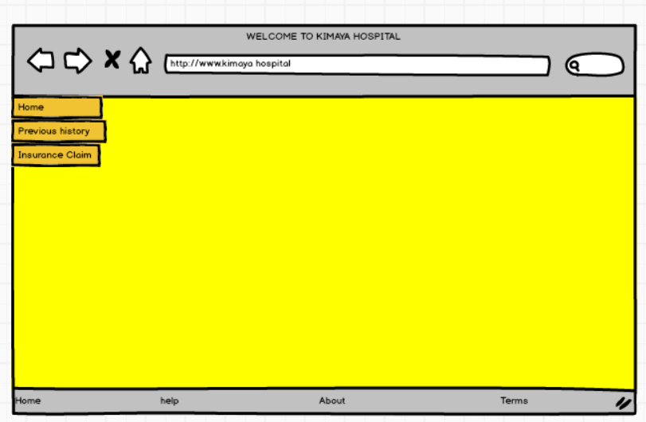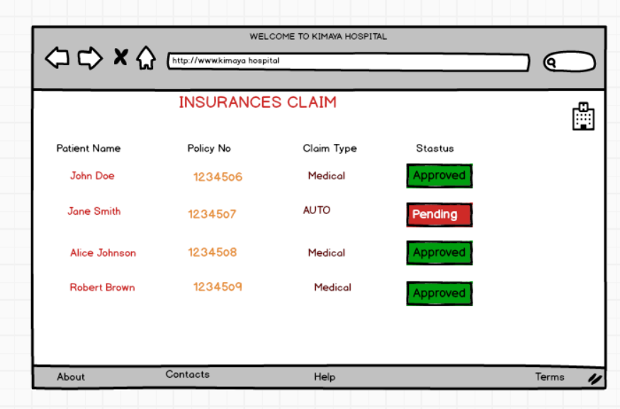

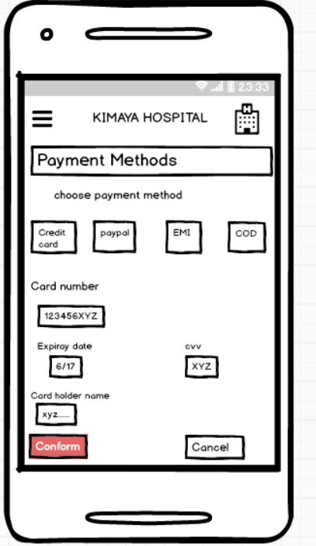

Document 8- Tools-Visio and Axure
I used Visio and Axure for the project. Visio helped me draw diagrams and flowcharts. It was easy to put shapes and lines together to show how things work. Axure let me make prototypes of the app. I created screens and buttons that looked real. Both tools were simple to use and made my work easier.
When I am working on a project, tools like Visio and Axure help me a lot. They make it easy to share ideas and plans with others.

Document 9- BA experience
My experience as BA in following phases:
- Requirement Gathering
- Conducted stakeholder meetings using Moscow prioritization and FURPS validation.
- Created the Business Requirement Document (BRD) and gathered inputs via prototyping.
- Managed stakeholder unavailability by sourcing alternative contacts. Challenges:
Handled requirement conflicts through impact analysis.

- Requirement Analysis
- Created Use Case Diagrams, Activity Diagrams, and RTM to track requirements.
- Finalized functional/non-functional requirements in the Functional Specification Document (FSD).
- Conducted peer reviews to align with stakeholders. Challenges:
Managed mid-phase requirement changes via structured Change Requests (CRF).

- Design
- Collaborated with UI/UX designers using Axure to create wireframes & mockups.
- Ensured easy navigation, accessibility, and responsive UI in the design phase.
- Created test case scenarios from Use Case Diagrams. Challenges:
Balanced UI expectations vs. technical feasibility through discussions with designers & developers.

- Development
- Conducted JAD sessions to ensure alignment between business and tech teams.
- Verified business rules implementation and assisted in payment gateway integration.
- Regularly reviewed progress and provided feedback.

Challenges:
Addressed misinterpretation of requirements through daily standups.

- Testing
- Created test cases from use cases and ensured full functional coverage.
- Assisted QA team with testing and conducted UAT with stakeholders.
- Verified error handling & security measures before deployment. Challenges:
Managed post-UAT defect fixes with a prioritized bug resolution approach.

- Deployment
- Coordinated training sessions & user manuals for smooth onboarding.
- Ensured compliance with GDPR & PCI DSS before launch.
- Planned post-deployment monitoring and resolved user adaptation challenges. Challenges:
Addressed post-launch bugs via a structured tracking system.

