BA MOCK-4

Assignment 1 — Part 1: BRD

Business Requirement Document (BRD)

Project: Inventory Management & Quick Delivery System

Client: Ice-cream & Milk Product Manufacturer

- Document Revisions

Date | Document Version | Document Changes
15/11/2025 | 1.0 | This BRD is for a dairy company that needs to manage inventory across multiple warehouses and speed up deliveries. The system gives real-time stock visibility, auto-updates after production, and suggests the best delivery routes. The main aim is to reduce wastage and improve delivery speed. So here I defined clear scope, stakeholders, risks, and measurable success metrics to ensure the project stays focused and trackable.”

- Approvals

Role | Name | Title | Signature | Date
Project Sponser | Head of Operations / Chief Operating Officer (COO) |  |  | 15/11/2025
Business owner
Project Manager | NEHAL SINHA
System Architect | System Designers
Development Lead | Developers
User Experience Lead
Quality Lead | Developers
Content Lead

- RACI Chart for this Document
The RACI Matrix is a project management tool that clearly defines and communicates the roles and responsibilities of different stakeholders for each task or deliverable in a project. The term RACI stands for Responsible, Accountable, Consulted, and Informed, and each of these represents a level of involvement in completing a task.
Codes Used in RACI Chart

Responsible Who is Responsible for creating the document
Accountant Accountable for Accuracy of this project
Support Provide Supporting Services in the production of this document
Consultant Provides Input
Informed Must be informed of any change

RACI CHART
TASK | Project Sponsor | Project Manager | Business Analyst | Developers/Testers | Client(RM/BM)
Req. Gathering | A | R | R/A | C | C
System Design | C | A | R | C | C
Implementation(  Development/integration) | C | A | C | R | C
Testing & quality verification | C | A | C | R/A | C
UAT & Client review | C | A | R | C | R/A
Maintenance & Updates | C | A | C | R | C
Final approval & Handover | A | R | C | C | C

- Introduction
4.1 Business Goal: The client operates multiple manufacturing plants and warehouses across the country. They want to build a software solution to:
- Manage inventory across all locations
- Ensure quickest delivery to customers
The proposed system will streamline stock movement, reduce wastage, track orders, and optimize delivery times.

4.2 Business Objectives
- Centralize real-time inventory visibility across locations.
- Minimize stock mismatch & wastage of perishable products.
- Improve order fulfilment time.
- Reduce logistics cost & optimize delivery route.
- Enhance customer satisfaction through faster delivery.
4.3 Business Rules
• Perishable items must be delivered within defined temperature limits
• Delivery routes must be auto-assigned based on nearest warehouse
• Users can apply only valid and active promo codes
• Inventory updates must sync in real time across all warehouses
  - Background
The company operates multiple manufacturing plants and warehouses across the country, producing ice-cream and dairy products. Due to increasing customer demand and delivery expectations, they need a digital system that manages inventory efficiently and ensures fast, accurate deliveries. The project aims to modernize their operations and improve customer satisfaction.
4.5 Project Objectives
The objective of this project is to build a unified digital system that streamlines inventory management and delivery operations across all dairy manufacturing plants and warehouses. The solution aims to provide real-time visibility of stock, automate delivery scheduling, reduce manual errors, and ensure faster, more accurate order fulfillment. By integrating all operational processes into a single platform, the project seeks to improve efficiency, minimize wastage of perishable goods, enhance customer satisfaction, and support data-driven decision-making for the business.
4.6 Project Scope

4.6.1 In Scope
- Inventory management (plants + warehouses)
- Purchase & production stock update
- Order management
- Stock transfer between warehouses
- Delivery route planning for fastest delivery
- Customer order tracking
- Admin dashboards & reporting

4.6.2 Out of Scope
- Payment gateway integration
- Vendor onboarding
- HR / Payroll

5. Assumptions
- Internet availability at all locations
- All warehouses will adopt the new workflow
- GPS tracking available for delivery vehicles

6. Constraints
- Perishable products require fast movement
Seasonal demand fluctuations

7. Risks
Risk | Mitigation
Operational resistance | Training
Data inaccuracy during migration | Data validation
GPS not available | Manual route assignment

8. Business Process Overview

AS-IS (Current State)
• Inventory tracked manually or in spreadsheets
• No real-time visibility of stock across plants & warehouses
• Delivery planning done manually, leading to delays
• No unified system for order status, dispatch, or routing
• Frequent stock-outs or overstock situations
• Limited tracking of vehicle movement and delivery performance

TO-BE (Future State with New System)

• Centralized inventory management across all locations
• Real-time stock visibility for plants, warehouses, and retail points
• Automated delivery routing & scheduling for fastest delivery
• Unified order tracking from placement to dispatch to delivery
• Alerts for low stock, expiry, and temperature-sensitive (perishable) goods
• Mobile app for delivery partners and warehouse staff
• Performance dashboards for operations, logistics, and demand forecasting

9. Business Requirements

ID | Requirement | Priority | Notes
BR1 | System should track stock at each plant & warehouse | High | Ensures real-time visibility of available stock across multiple locations.
BR2 | System should update stock automatically after production or transfer | High | Reduces manual effort and prevents data mismatch; integrates with production module.
BR3 | System should allow creation & tracking of customer orders | High | Core functionality — needed for managing orders from placement to fulfillment.
BR4 | System should suggest nearest warehouse for fastest delivery | Medium | Optimizes delivery time; requires integration with location and route data.
BR5 | System should generate delivery route recommendations | Medium | Improves logistics efficiency and reduces delivery cost and time.
BR6 | System should manage returns & damaged goods | Medium | Helps maintain accurate stock and customer satisfaction through reverse logistics.
BR7 | System should generate inventory & delivery related reports | High | Essential for management insights and performance tracking; integrates with reporting tools.

Appendices
10.1 List of Acronyms

PO → Purchase Order
• QC → Quality Control
• SLA → Service Level Agreement
• UI → User Interface
• UX → User Experience
• DB → Database
• BA → Business Analyst
• QA → Quality Assurance

10.2 Glossary of terms
- Centralize real-time inventory visibility across locations.
- Minimize stock mismatch & wastage of perishable products.
- Improve order fulfilment time.
- Reduce logistics cost & optimize delivery route.
- Enhance customer satisfaction through faster delivery.

  - Related Documents
  - Business Requirement Document (BRD)
  - Functional Requirement Specification (FRS)
  - RACI Matrix
  - Test Plan & UAT Sign-off Forms

Assignment 1 — Part 1: Development & Resource Plan (High-level)

1. Suggested Delivery Approach
- Agile delivery with 2-week sprints.
- Minimum Viable Product (MVP) covering core inventory and order-to-delivery flow in 3–4 sprints (6–8 weeks) for a pilot.
- Staged rollout across regions after pilot validation.

2. Team & Roles (suggested)
- Product Owner (client-side)
- Business Analyst (1) — lead requirements & UAT
- Scrum Master (1)
- Backend Developers (2–3)
- Frontend Developers (2)
- Mobile Developers (2) — warehouse & driver apps
- QA Engineers (2)
- DevOps / SysAdmin (1)
- Database Administrator (1)
- UX/UI Designer (1)
- Training & Change Manager (1)

3. High-level Timeline (example for pilot MVP)
- Sprint 0 (2 weeks): Discovery, requirement workshops, architecture, provisioning
- Sprints 1–4 (8 weeks): Core development (inventory master, receive/issue, batch tracking, pick/pack, basic routing, mobile scanning)
- Sprint 5 (2 weeks): Integration, reporting, user acceptance testing (UAT)
- Pilot deployment (2 weeks): Pilot at 1 plant + 1 warehouse + 1 route; training & hypercare
- Rollout (Phased, per region): 4–12 weeks depending on region size

4. Tech Stack Recommendation (example)
- Backend: Node.js / Java Spring Boot
- Database: PostgreSQL (with timescale extension optional) + Redis for caching
- Mobile: React Native (warehouse & driver apps)
- Frontend: React / Next.js for dashboards
- Hosting: Cloud (AWS/Azure/GCP) with containers (Kubernetes) or managed services
- Integrations: REST APIs, message queue (RabbitMQ / Kafka) for events
- Reporting: Power BI / Metabase or custom dashboards

5. Estimated Effort & Cost
- Pilot MVP: 12–16 person-months (combined across roles) over 3–4 months.
- Full rollout: depends on number of sites — budget planning recommended after pilot. (Provide T-shirt estimates after discovery.)

6. Deliverables
- BRD (this document)
- Functional specification / user stories
- SRS (detailed)
- UI prototypes & mobile screens
- Deployment & runbook
- Training material & knowledge transfer

Assignment 1 — Part 2: Process Flow Diagram

Assignment 2 — Part 1: Introduction Letter (as Business Analyst)

Subject: Introduction — Business Analyst assigned for Inventory & Delivery Optimization Project
Dear [ice-cream and milk products Co.],
My name is Neha Richhariya, and I will be the Business Analyst assigned to work with you and your team on the Inventory & Delivery Optimization project for IceCreamCo. My role is to understand your current operations, gather and document requirements, and ensure the delivered solution meets your business goals.
Over the next two weeks, I propose we schedule the following:
- Stakeholder kickoff meeting (1 hour) — align on objectives, risks, and timelines.
- Site visits / process walkthroughs at 1 plant and 1 warehouse (half-day each).
- Data & systems discovery session — review existing ERP/ spreadsheets and hardware.
- Draft & review BRD and user stories.
I look forward to collaborating with you. Please let me know your availability for a kickoff meeting this week.
Warm regards,
Neha Richhariya (BA)

Assignment 2 — Part 2: Brief BRD & SRS (Project: Online Store)

Brief BRD — Online Store
Project Goal: Build an online storefront for direct-to-consumer sales of ice-cream and milk products, integrated with inventory and delivery modules.
Key Stakeholders:
- E-commerce Manager
- Marketing
- Warehouse Ops
- Logistics, IT
- Customers.
Primary Features:
- Product catalog,
- shopping cart,
- checkout,
- payment integration,
- order management
- inventory sync,
- delivery scheduling,
- promotions,
- customer accounts.
Business Metrics:
- Conversion rate,
- Average order value,
- On-time delivery %,
- Cart abandonment rate.

SRS:

1. Functional Requirements

ID | Req. Name | Description | Priority
FR1 | User Registration & Login | The system should allow users to register using email/phone and log in securely. Includes password encryption and forgot password feature. | 1
FR2 | User Profile Management | Registered users can view and update personal information like name, contact details, and shipping addresses. | 2
FR3 | Product Browsing | Users can browse all products categorized by type, brand, and price. Pagination and sorting should be supported. | 3
FR4 | Product Filtering & Search | Users can filter products by price range, rating, category, or availability, and use search to find specific items. | 4
FR5 | Product Detail Page | Each product should have a detailed page showing name, description, price, stock availability, images, and reviews. | 5
FR6 | Shopping Cart | Users can add, update, or remove products from the shopping cart before proceeding to checkout. | 6
FR7 | Coupon Code Application | Users can apply discount coupons or promo codes during checkout; system validates and applies eligible discounts. | 7

2. Non-Functional Requirements
Type | Description
Performance | The website should load within 3 seconds under standard internet speed. Each transaction (add to cart, payment) should complete within 2 seconds.
Scalability | The system should handle up to 10,000 concurrent users during peak load (festive or sale periods).
Security | User data and payment information must be encrypted.
Availability
  System should ensure 99.5% uptime and implement backup and failover support.
Usability | UI should be user-friendly, responsive (mobile/tablet/desktop compatible), and accessible.

Assignment 2 — Part 3: Entity Relationship Schema

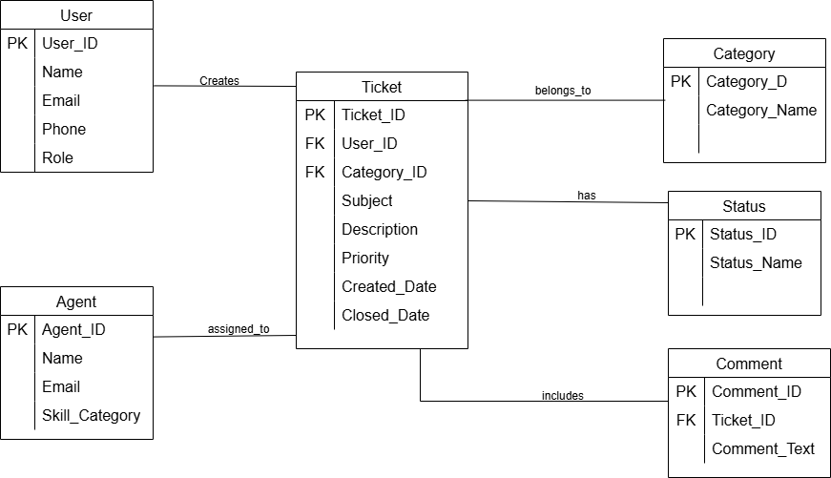

Entity Relationship Diagram:-
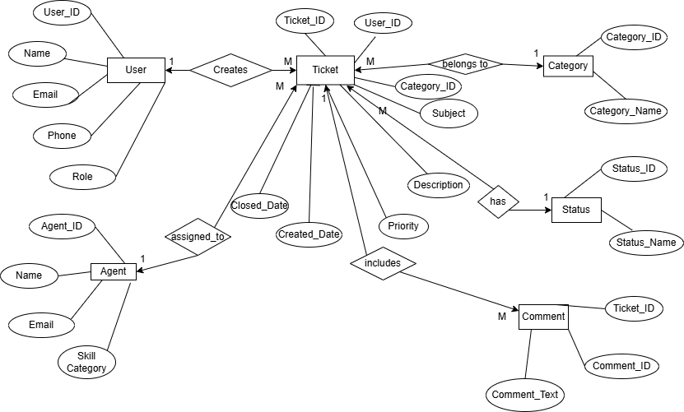

Assignment 2 — Part 4: User Stories of Shopping from E-commerce

User Story No: 1 | Tasks: 2 | Priority: High
Value Statement:

As a new user,
I want to register using my email/phone
So that I can create an account

BV: 200 CP: 3
Acceptance Criteria:

User must provide name, email/phone, and password.
System must verify email/phone via OTP
Successful registration redirects to login.

- User Login

User Story No: 2 | Tasks: 2 | Priority: High
Value Statement:

As a registered user,
I want to login securely
So I can access my profile

BV: 500 CP: 8
Acceptance Criteria:

User enters valid login ID and password.
Invalid credential show an error
Login session must remain secure.

- Search Product

User Story No: 3 | Tasks: 2 | Priority: Medium
Value Statement:

As a customer,
I want to search product by name/category
So I can find items quickly

BV: 100 CP: 3
Acceptance Criteria:

Search box must be visible.
Show message if no results found
Filter options should be available.

- View Product Details

User Story No: 4 | Tasks: 2 | Priority: Medium
Value Statement:

As a customer,
I want to see product details
So I can make buy decisions

BV: 100 CP: 5
Acceptance Criteria:

Product page displays name, images, price, description, ratings, and availability.
User can zoom view image
If out of stock – show “unavailable”.

- Add to Cart
User Story No: 5 | Tasks: 2 | Priority: Low
Value Statement:

As a customer,
I want to add products to my cart
So I can buy later

BV: 50 CP: 5
Acceptance Criteria:

Click “Add to Cart” stores item.
Cart retains items until removed
Show confirmation message.

- Manage cart

User Story No: 6 | Tasks: 2 | Priority: Low
Value Statement:

As a customer,
I want to update or remove items from cart
So I can adjust purchase list.

BV: 20 CP: 2
Acceptance Criteria:

User can increase/decrease quantity.
User can remove products
Cart reflects stock changes.

- Checkout

User Story No: 7 | Tasks: 2 | Priority: High
Value Statement:

As a customer,
I want to checkout
So I can place an order.

BV: 500 CP: 13
Acceptance Criteria:

User must provide address.
Payment summary is shown
System validates cart & availability.

- Make Payment

User Story No: 8 | Tasks: 2 | Priority: High
Value Statement:

As a customer,
I want to pay securely
So I can confirm order.

BV: 200 CP: 8
Acceptance Criteria:

Multiple payment methods are supported.
Retry option is available if payment fails
Secure authentication required.

- Track Order
User Story No: 9 | Tasks: 2 | Priority: Medium
Value Statement:

As a customer,
I want to track order status
So I know delivery progress.

BV: 100 CP: 5
Acceptance Criteria:

Order status visible (Packed → Shipped → Delivered)..
Show estimated delivery date
Notifications sent on status change.

- Request Return
User Story No: 10 | Tasks: 2 | Priority: High
Value Statement:

As a customer,
I want to return a product
So I can resolve issues.

BV: 200 CP: 3
Acceptance Criteria:

Return allowed within policy.
User select return reason
System generates return request.

- Rate & Review Product
User Story No: 11 | Tasks: 2 | Priority: High
Value Statement:

As a customer,
I want to rate product
So I can share my experience.

BV: 500 CP: 5
Acceptance Criteria:

Only purchased users allowed.
User can give rating and comment

- Create Support Ticket
User Story No: 12 | Tasks: 2 | Priority: Medium
Value Statement:

As a customer,
I want to raise a support ticket
So I can get help.

BV: 100 CP: 3
Acceptance Criteria:

User must select issue category.
Ticket ID auto generated
User can track status

- Manage Products

User Story No: 13 | Tasks: 2 | Priority: High
Value Statement:

As an admin,
I want to add, edit, delete products
So I can maintain catalog.

BV: 200 CP: 2
Acceptance Criteria:

Admin can create & update items.
System validates mandatory fields
Deleted items no longer show

- Manage Orders

User Story No: 14 | Tasks: 2 | Priority: High
Value Statement:

As an admin,
I want to manage orders
So I can ensure delivery.

BV: 500 CP: 3
Acceptance Criteria:

Admin can update order status.
Customer notified on change.

- View Reports

User Story No: 15 | Tasks: 2 | Priority: Medium
Value Statement:

As an admin,
I want to view sales analytics
So I can improve business.

BV: 100 CP: 8
Acceptance Criteria:

View sales, returns, monthly stats.
Export option available.

- Apply discount/ coupon code
User Story No: 16 | Tasks: 2 | Priority: High
Value Statement:

As a customer,
I want to apply a discount/coupon code during checkout
So I can save money.

BV: 200 CP: 2
Acceptance Criteria:

User can enter coupon code at checkout.
Discount is correctly applied to total amount
Invalid/expired coupon shows an error..

- Save Payment Methods
User Story No: 17 | Tasks: 2 | Priority: High
Value Statement:

As a returning customer,
I want to save my payment method securely
So I can checkout faster next-time.

BV: 200 CP: 5
Acceptance Criteria:

User can opt-in to save card or wallet details.
Payment method is stored securely
User can delete or update saved payment method.

- Multi-Address Management

User Story No: 18 | Tasks: 2 | Priority: High
Value Statement:

As a customer,
I want to save multiple delivery address
So I can choose the right address for each order.

BV: 500 CP: 8
Acceptance Criteria:

User can add, edit, or delete address in profile.
User can select delivery address during checkout
Selected address appears on order confirmation and invoice.

- Low Stock Notification

User Story No: 19 | Tasks: 2 | Priority: High
Value Statement:

As a customer,
I want to receive a low stock alert for my favourite product
So I can order before it runs out.

BV: 200 CP: 5
Acceptance Criteria:

User can mark products as favourites.
System sends notification when stock falls below threshold
User can unsubscribe from notifications.

- Admin Role-Based Access Control (RBAC)

User Story No: 20 | Tasks: 2 | Priority: Medium
Value Statement:

As an admin,
I want role-based access
So I can control who can perform specific actions in the system.

BV: 100 CP: 5
Acceptance Criteria:

System allows defining roles (Admin, Inventory Manager).
Each role has specific permissions (create, edit, delete, view)
Access changes are logged for audit purposes.

- Stock transfer between warehouse
User Story No: 2 | Tasks: 2 | Priority: Medium
Value Statement:

As a Warehouse Manager,
I want to transfer stock from one warehouse to another
So I can balance inventory based on demand

BV: 100 CP: 5
Acceptance Criteria:

System must allow selecting source and destination warehouse
Stock quantity cannot exceed available stock at source

- Batch & Expiry tracking

User Story No: 2 | Tasks: 2 | Priority: High
Value Statement:

As a Quality Manager,
I want to track product batches and expiry dates
So I can reduce wastage and avoid expired deliveries

BV: 500 CP: 3
Acceptance Criteria:

System must captures batch no. and expiry date
Items with nearing expiry (<10 days) should generate alerts

- Low Stock Alerts

User Story No: 22 | Tasks: 2 | Priority: Low
Value Statement:

As a Warehouse Supervisor ,
I want low stock notifications
So that I can re-order stock before it runs out

BV: 50 CP: 3
Acceptance Criteria:

System must generates alerts when quantity is below threshold
Alerts should be visible on dashboards and optional email/SMS

- Order Prioritization

User Story No: 23 | Tasks: 2 | Priority: High
Value Statement:

As a Logistic Manager,
I want system to prioritise urgent orders
So that perishable items reach customer faster

BV: 200 CP: 13
Acceptance Criteria:

Urgent orders must be highlighted in the system
Urgent orders must appear at the top of the dispatch list

- Real-Time Vehicle tracking

User Story No: 24 | Tasks: 2 | Priority: High
Value Statement:

As a Delivery Manager,
I want to track delivery vehicles in real-time
So that I can ensure timely delivery and handle delays

BV: 500 CP: 3
Acceptance Criteria:

System should show live vehicle location on map
ETA should update automatically based on movement

- Damaged goods reporting

User Story No: 25 | Tasks: 2 | Priority: Low
Value Statement:

As a Warehouse staff ,
I want to report damaged or melted products
So that stock accuracy is maintained

BV: 20 CP: 2
Acceptance Criteria:

Staff can mark items as damaged with batch and reason
Damaged stock must be automatically removed from inventory

- Customer order history

User Story No: 26 | Tasks: 2 | Priority: Medium
Value Statement:

As a Customer,
I want to see my past orders
So that I can re-order easily

BV: 100 CP: 5
Acceptance Criteria:

System should display all previous orders
Customer should be able to re-order with one click

- Delivery route optimization

User Story No: 27 | Tasks: 2 | Priority: Low
Value Statement:

As a Delivery planner ,
I want route optimization suggestions
So that derivers follow the shortest and fastest path

BV: 50 CP: 8
Acceptance Criteria:

System should suggest best route using distance and traffic data
Deriver app must display the recommended route

- Multi- Plant production entry
User Story No: 28 | Tasks: 2 | Priority: Medium
Value Statement:

As a Plant supervisor ,
I want to enter produced quantities daily
So that stock updates automatically after production

BV: 100 CP: 2
Acceptance Criteria:

Production entry must include product, batch and quantity
System should update plant inventory instantly

- Reporting dashboard
User Story No: 29 | Tasks: 2 | Priority: High
Value Statement:

As a Business Head,
I want a dashboard with key metrics
So that I can track performance across plant & warehouses

BV: 500 CP: 8
Acceptance Criteria:

Dashboard should show stock levels , orders, delivery items, expiry alerts
User should be able to filter by region, warehouse, and product

- Temperature monitoring for perishable goods

User Story No: 30 | Tasks: 2 | Priority: High
Value Statement:

As a Logistic supervisor,
I want the system to record and track the temperature of cold-storage vehicle
So that ice-cream and milk products are delivered without melting or spoiling

BV: 500 CP: 5
Acceptance Criteria:

System must capture temperature readings from vehicle
If temperature goes above the allowed limit, an alert should be triggered

