Question 1 - Audis:
Answer :-
Stage | Q1 Audit - Requirement gathering phase
timeframe | 1st to 4th month
Key focus areas | Requirement gathering & documentation.  Stakeholder identification & analysis  Business case validation & scope definition.  Initial risk & feasibility assessments

Stage | Q2 Audit - Design & early development phase
timeframe | 5th to 9thmonth
Key focus areas | System design alignment with business needs.  Traceability from requirements to system design.  Mid - term risk assessment.  Provide updates RTM ( requirements traceability matrix).  Support project manager by updating any change requests in scope or features.

Stage | Q3 Audit - Development & early testing phase
timeframe | 10th to 13th month
Key focus areas | Development progress against plan.  Unit testing results.  User acceptance planning.  Data flow, integration validations.
.

Stage | Q4 Audit - Final Testing
timeframe | 14th to 18th month
Key focus areas | Final testing & validation.  Training of end - users (farmers & company reps).  Deployment & go - live readiness.  CSR impact reporting.

-
Question 2 - BA Approach Strategy: -
Answer :- 1 - What Elicitation Techniques to apply ?
Workshop - with committee & farmer representative to understand product pain points.
Interviews - One on one with Mr. Henry, manufacturers & tech team.
Observation - Farming processes to understand workflows & seasonal needs.
Questionnaires/Survey - Together broader farmer feedback.
Prototyping - Low-fidelity UI mock-ups to validate usability for rural users.

2 - how to do Stakeholder Analysis ?
Stakeholder analysis can be done by using the RACI matrix involves identifying stakeholders & defining their roles & responsibility within a project.

3 - What documents to write ?
BRD - business requirement document
FRS - functional requirement specification.
NFR - non functional requirements
Use case/ user stories
Change request log.

4 - What process to follow to Sign off on the Documents ?
Share drafts with stakeholders via email or document repository.
Conduct walk through sessions to explain documents.
Gather feedback & update accordingly.
Obtain sign - off through formal email confirmation or digital signature.
Approves: Mr. Henry , Mr. Pandu & Mr. Dooku.
Maintain version control for every document update.
5 - How to take Approvals from the Client ?
To get a continuous feedback & to keep them informed, organize a formal meeting with the clients.
6 - What Communication Channels to establish n implement ?
Tools: email, zoom/ms team, watsapp for farmers(if needed).
Stand-ups - Daily or alternate day sync with development/ testing teams.
Weekly reports - Progress reports shared with Mr. Henry & stakeholders.
Monthly committee meetings - for stategic review & budget tracking.
Communication log - to track all major discussions & decisions.

7 - How to Handle Change Requests ?
Maintain a change request form.
Assess impact on scope, time,& budget.
Review with PM, technical lead, & sponsor.
Update BRD/RTM & get revised approval.
Communicate approved changes to all stakeholders.

8 - How to update the progress of the project to the Stakeholders ?
RTM updates - map implemented features to original requirements.
Sprint reviews - demo to committee & end users.
Risk register - highlight issues & mitigation plans.
Status reports - share weekly status reports covering:
Completed tasks, pending items, risk & mitigation, next steps.

9 - How to take signoff on the UAT- Client Project Acceptance Form )
Develop UAT test cases with client input.
Conduct UAT in the presence of stakeholders.
Capture feedback, report defects, & manage fixes.
Final round of testing post - fix.
Obtain sign-off.

Question - 3-Tier Architecture:
Answer - Presentation Layer - also known as application layer.
Purpose - Interact directly with user.
Technology example - web browser, mobile app.
In this case - the farmers & manufacturers use a web/mobile app to browse & interact with the online agriculture store.

Business Logic layer - Processes user inputs, enforces business rules, handles data flow between UI & database.
Technology ex. - java, spring boot, NET, node.js.
In this case - this layer will contain all logic for - registering farmers & companies, product listings, order processing, notifications, validations.

Database layer - Purpose- stores, retrieves & manage data.
Technology ex - My SQL, Oracle, PostgreSQL.

Question 4 - BA Approach Strategy for Framing Questions
Answer - 5W1H - Apply 5W1H - who, when, why , where, what, How)
SMART - Stakeholder expectations should be translated into SMART requirements - Specific, measurable,achievable, relevant & time bound.
RACI - Keep RACI roles in mind, know who is responsible accountable, consulted & informed.
Target questions according to the stakeholder’s RACI role.
3 tier architecture - Is the question tied to UI, logic or data ?
Use Cases & use case specifications - what is the user’s goal, what are the main steps & alternate flows.
Activity diagrams & models - Can I visualize this process clearly ?
Qustion 5 - Elicitation Techniques:BDRFOWJIPQU

Answer:- Brainstorming - Generating ideas in a group setting to explore possibilities.
Document analysis - Reviewing existing documentation to understand systems, processes, or history.
Reverse engineering- analyzing an existing system, product, or process to infer its design, functionality, and requirements
Focus group- Facilitated group discussion to gather opinions and perceptions.

Observation - Watching users in their environment to understand tasks and behaviors.

Workshop - Interactive sessions for collaborative discussion and decision-making.

JAD - (Joint Application Development) JAD is a structured, facilitated workshop that brings together business stakeholders, end users, and IT professionals to define and refine system requirements or solutions — in real time.

Interview - One-on-one or group conversations to gather detailed information.

Prototype- Using mockups to visualize requirements and gather feedback.

Questionnaire - Structured forms to collect quantitative or qualitative data.

Use case specification - Descriptions of user interactions with a system to clarify requirements.

Question 6 - This project Elicitation Techniques

Answer - 1 -Prototyping - Encourage feedback from non-technical stakeholders like peter, kevin & ben who may struggle to explain needs verbally.
2 - Use case specifications - Clarifies functional requirements & sysytem behaviour for developers, testers, & stakeholders.
3 - Documents Analysis - Save time & ensures that the new application align with industry standards & existing frameworks.
4 - Brainstorming - Encourage collaborative idea generation & helps prioritize key funtionalities for MVP (minimum viable product).

Question 7 - Business Requirements
Answer - BR001 - product listing by manufacturers
BR002 - product browsing by farmers
BR003 - Multi- language interface.
BR004 - order placement by farmers.
BR005 - order management by manufacturers.
BR006 - notification & alerts
BR007 - product review & rating
BR008 - Admin dashboard & reports
BR009 - secure login & user management.
BR010 - support for CSR tracking

Question 8 - Assumptions:
Answer - Assumption 1 - The primary users of the system are farmers & manufacturing companies dealing in seed, fertilizers & pesticides.

Assumption 2 - Internet access in rural areas may be low- bandwidth or intermittent, so the application will be lightweight & mobile-friendly

Assumption 3 - Both web & mobile platforms will be developed for max. Reach.

Assumption 4 - Farmers & manufacturers will be responsible for registering themselves on the platform, with basic verification by admin.

Question 9 - This project Requirements Priority
Answer -
Req ID | Req name | Req description | Priority
BR001 | User regis & login sys | Should allow farmers & manufacturers to register & securely login | 10
BR002 | Product listing | manufacturers can list seds, fertilizer & pesticides with details. | 9
BR003 | Product browsing | Farmers can search & filter products y name, category, price etc | 9
BR004 | Order placement | Farmers can place an order for selected products with quantity & address. | 10
BR005 | Delivery tracking | Farmers can view the current status of their order. | 7
BR006 | Multilingual interface | UI should support regional language for brtter accessibility in rural areas. | 8
BR007 | Admin dashboard | SOONY admin can view reports, manage users & monitor platform usage. | 6
BR008 | Notification | SMS/email/app alerts for order status & system messages. | 8
BR009 | Product rating | Farmers can give rating & review after purchase. | 5
BR010 | Csr impact report | Report & metrics for CSR tracking(region wise usage, product distribution, etc. ) | 4

Qusestion 11 - Use case specification -
Answer -
Use case name | Use Case 1: Register User
Actor | Customer
Description | A customer registers by providing required personal information.
Pre-conditions | Customer must have a valid email ID.
Post-conditions | Customer is successfully registered and receives login credentials.
Basic flow | 1 Customer clicks on the “Register” button.  2 System displays the registration form.  3.Customer enters details (name, email, phone, address, password).  4.System validates input.  5.System creates a new account.  6.Confirmation message is displayed.
Alternative flow | A1: Email already exists → Display error and prompt for a different email.
Exception | E1: System error while saving data → Show error message and ask to try again later.

Use case name | Use Case 2: Login
Actor | Customer, Admin
Description | Allows users to access their respective dashboards.
Pre-conditions | User must be registered
Post-conditions | User is directed to the appropriate dashboard.
Basic flow | 1.User enters username and password.  2.System validates credentials.  3.If valid, system redirects to dashboard.
Alternative flow | A1: Invalid credentials → Prompt error message and allow retry.
Exception | E1: Too many failed attempts → Lock account temporarily.

Use case name | Use Case 3: Search and View Products
Actor | Customer
Description | Customer searches and views available agriculture products.
Pre-conditions | User is logged in.
Post-conditions | Search results are displayed
Basic flow | 1.Customer enters keywords or selects category/filter.  2.System retrieves matching products.  3.System displays products with price, description, and availability.
Alternative flow | A1: No matching product found → Display “No results” message.
Exception | E1: System timeout while fetching results → Show error message.

Use case name | Use Case 4: Place Order
Actor | Customer
Description | Customer places an order for selected products.
Pre-conditions | Customer is logged in and has selected products.
Post-conditions | Order is created and confirmation is sent.
Basic flow | 1.Customer reviews cart and clicks “Checkout”.  2.Enters shipping and payment details.  3.System validates and processes order.  4.Order ID is generated.  5.Confirmation message is shown
Alternative flow | A1: Payment failed → Prompt user to retry or select another method
Exception | E1: Product goes out of stock during checkout → Inform user and update cart.

Use case name | Use Case 5: Manage Inventory
Actor | Admin
Description | Admin adds, updates, or deletes product listings.
Pre-conditions | Admin is logged in.
Post-conditions | Inventory is updated successfully
Basic flow | 1.Admin accesses the inventory module.  2.Selects action: Add / Edit / Delete.  3.Enters or updates product details.  4.System validates input.  5.Changes are saved and reflected on the customer side.
Alternative flow | A1: Admin tries to delete a product with pending orders → System denies action.
Exception | E1: Database error → Inform admin and log the issue.

Question 10 - Use case daigram
Answer -
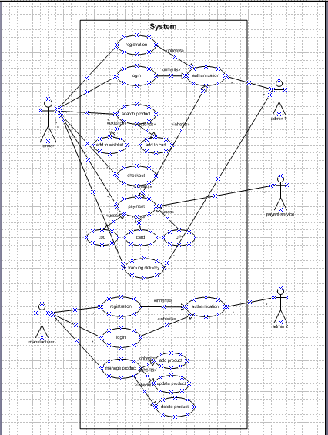

Question 12 - Activity diagram
Answer - Add to cart
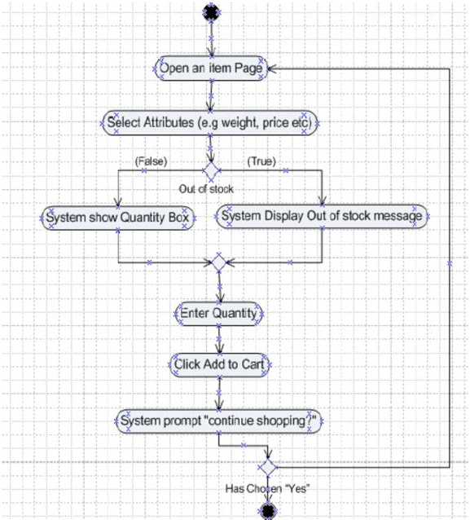

Payment -
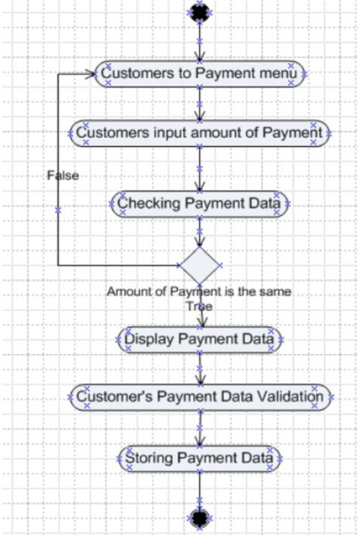

Delivery boy

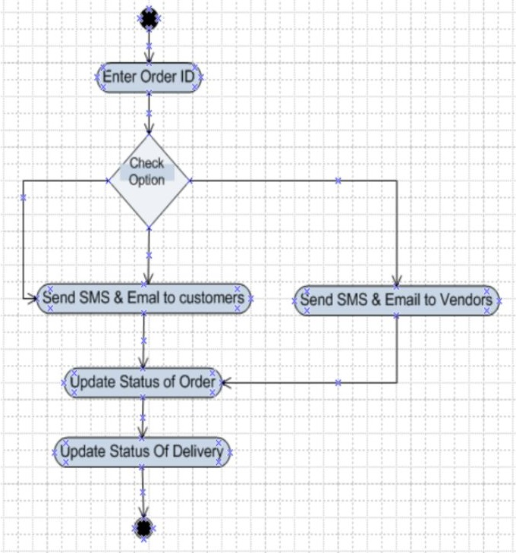

Registered customer login
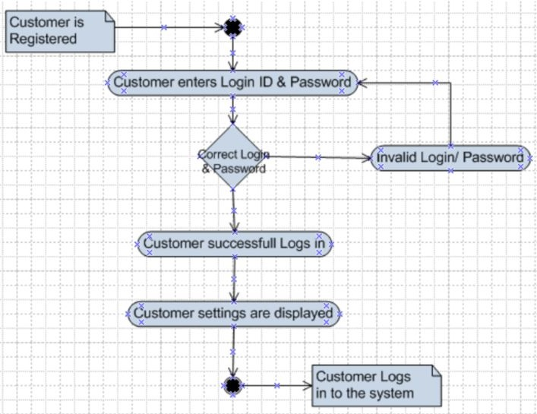

Product retuen
