QUESTION 1:
Functional Requirements
Functional Requirement ID | Description | Priority  (1-10)
FR1 | User registration and login functionality | 10
FR2 | Browse product catalog (seeds, fertilizers, etc.) | 9
FR3 | Product search using keyword or filters | 9
FR4 | Add product to cart or buy later list | 8
FR5 | Secure payment gateway integration | 10
FR6 | Order tracking system for farmers | 8
FR7 | Email notifications for order status | 7
FR8 | Manufacturers can upload product details | 9
FR9 | Delivery status update by manufacturer | 7
FR10 | Admin approval for product listings (optional) | 6

Non-functional Requirements

Non-Functional  Requirement ID | Description | Priority  (1-10)
NFR1 | Application must be mobile responsive | 10
NFR2 | System should support minimum 1000 concurrent users | 9
NFR3 | System uptime should be 99.5% or higher | 9
NFR4 | Payment processing time must be under 5 seconds | 8
NFR5 | Application should be secure with HTTPS & data encryption | 10
NFR6 | Easy-to-use interface for users in rural areas | 9
NFR7 | Email notifications must be delivered within 1 minute | 7
NFR8 | Search results should load within 2 seconds | 8
NFR9 | System should support both English and local languages | 6
NFR10 | Backup and recovery should happen daily | 7

QUESTION 2:
Wireframes - Simple blueprint-style screens, Low-Fidelity UI Blueprints
Screen  No. | Wireframe Page Name | Description
WF1 | Login / Register Page | Email, Password, Login, Register
WF2 | Home Page (Farmer) | Welcome banner, categories (seeds, fertilizers, etc.)
WF3 | Product Details Page | Product name, price, description, Add to Cart / Buy Later
WF4 | Cart & Payment Page | Cart items, total amount, payment options
WF5 | Track Order Page | Order history + live tracking for current orders

Wireframe 1: Login / Register Page

Wireframe 2: Home Page
Wireframe 3: Product Details Page
Wireframe 4: Cart & Payment Page
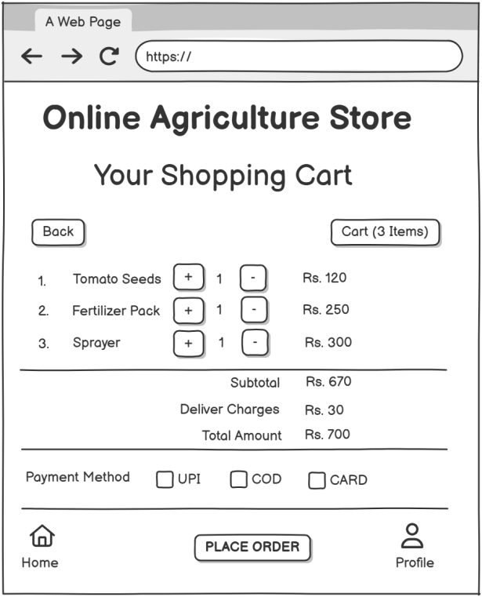
Wireframe 5: Order Confirmation Page
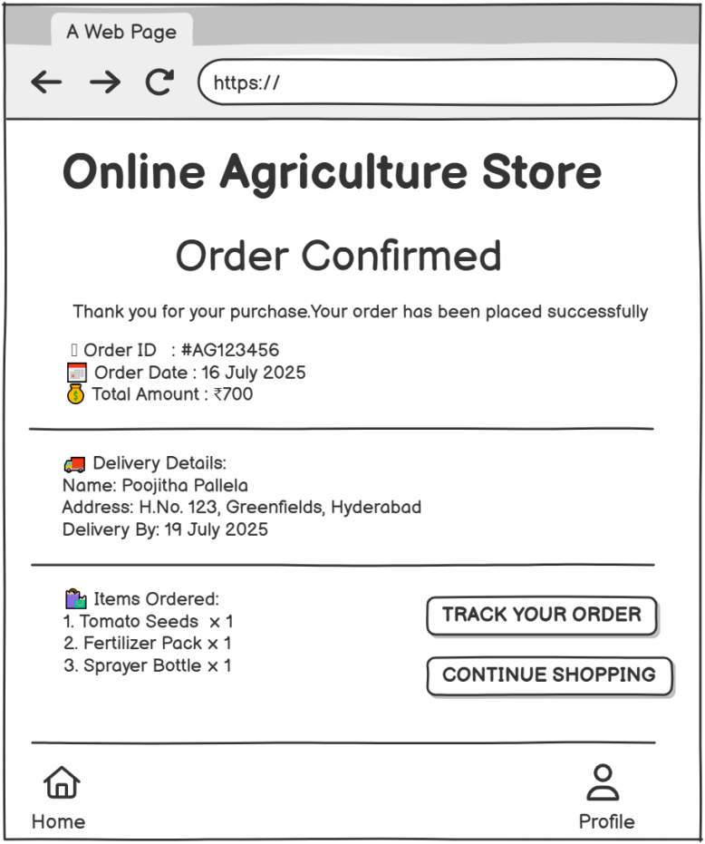

Prototypes
Screen Name | UI Elements | User Actions
1. Login / Register | Mobile Number field | Enter credentials and tap Login
1. Login / Register | Password field | Tap Register Now → go to registration
1. Login / Register | Remember Me checkbox | Tap Forgot Password → reset screen
1. Login / Register | Forgot Password link
1. Login / Register | Login button
1. Login / Register | Register Now button
1. Login / Register | Social login options
2. Home/Dashboard | Search bar | Tap product → go to Product Details
2. Home/Dashboard | Category icons (Seeds, Fertilizers, Tools, More) | Tap Cart → go to Cart & Payment
2. Home/Dashboard | Featured products (with price and View button) | Tap Profile → open account
2. Home/Dashboard | Cart & Profile icons
3. Product Details | Product Image | Tap Add to Cart → goes to cart
3. Product Details | Name, Price, Description | Tap Buy Now → goes to payment
3. Product Details | Quantity Selector ([-] [+])
3. Product Details | Add to Cart button
3. Product Details | Buy Now button
4. Cart & Payment | List of items with quantity & price | Modify quantity
4. Cart & Payment | Subtotal, Delivery, Total | Select payment method
4. Cart & Payment | Payment method options (UPI, COD, Card) | Tap Place Order → go to Order Confirmation
4. Cart & Payment | Place Order button
5. Order Confirmation | Order ID, Date, Total | Tap Track Order → go to tracking
5. Order Confirmation | Delivery Address, ETA | Tap Continue Shopping → return to Home
5. Order Confirmation | Item Summary
5. Order Confirmation | Track Order & Continue Shopping buttons

Prototype 1: Login / Register Page

2. Home/Dashboard

3. Product Details

4. Cart & Payment

5. Order Confirmation

QUESTION 3:
Tools Used Each Concept
Concept | Tool / Method Used | Purpose
Text-Based Prototypes | Manual design using plain text layout | To easily visualize UI flow without graphics (ideal for planning in docs)
Wireframes | Paper sketch / MS Visio / Balsamiq / Figma (low-fi) | For low-fidelity wireframes showing screen layout before visual styling
High-Fidelity Prototypes (optional) | Figma / Adobe XD / Sketch / proto.io | For clickable or visual mockups with UI elements
Activity Diagrams | Lucidchart / MS Visio / Draw.io / Creately | To show process flow and user interaction with system components
Requirements Tables | Microsoft Excel / Google Sheets | For listing functional & non-functional requirements with priorities
Project Planning / Notes | Notion / MS Word / Google Docs | To document the capstone process, assumptions, goals, and test cases
Presentation / Report | MS PowerPoint / Canva / Google Slides | To present the final capstone solution professionally

QUESTION 4:

Showing how requirements link to use cases, design elements, and test cases
ID | Requirement Description | Type | Priority | Related  Use Case | Design Element | Test  Case ID
FR1 | User should be able to register/login | Functional | High | UC1 | Login/Register Page Wireframe | TC01
FR2 | User can browse product categories | Functional | High | UC2 | Home Page Wireframe | TC02
FR3 | View detailed product info | Functional | High | UC3 | Product Details Page | TC03
FR4 | Add product to cart | Functional | High | UC4 | Product Details & Cart Page | TC04
FR5 | Edit quantity and remove items from cart | Functional | Medium | UC5 | Cart Page | TC05
FR6 | Place an order using multiple payment modes | Functional | High | UC6 | Payment Section - Cart Page | TC06
FR7 | Confirm order and display details | Functional | High | UC7 | Order Confirmation Page | TC07
FR8 | Track order status | Functional | Medium | UC8 | Future Scope UI / Placeholder | TC08
NFR1 | App must load under 3 seconds | Non-Functional | High | All | N/A | TCN01
NFR2 | App must be mobile responsive | Non-Functional | High | All | All Pages | TCN02

RTM
Req ID | Req Name | Req Description | Design | T1 | T2 | T3 | T4 | UAT
FR1 | User Login/Register | User should be able to register/login | D1 | ✓ |  | ✓ |  | Pending
FR2 | Browse Categories | User can browse product categories | D2 |  | ✓ |  |  | Pending
FR3 | View Product Details | View detailed product info | D3 | ✓ |  |  |  | Pending
FR4 | Add to Cart | Add product to cart | D4 | ✓ |  |  |  | Pending
FR5 | Edit/Remove Cart Items | Edit quantity and remove items from cart | D5 |  | ✓ |  |  | Pending
FR6 | Place Order | Place an order using multiple payment modes | D6 |  | ✓ |  |  | Pending
FR7 | Confirm Order | Confirm order and display details | D7 |  |  | ✓ |  | Pending
FR8 | Track Order | Track order status | D8 |  |  |  | ✓ | Planned
NFR1 | Page Load Time | App must load under 3 seconds | D9 | ✓ |  | ✓ |  | Not Required
NFR2 | Mobile Responsiveness | App must be mobile responsive | D10 | ✓ | ✓ |  | ✓ | Pending

QUESTION 5:
Test Case Document 1
Test Case ID | TC01
Test Case Name | User Registration
Related Requirement | FR0001 – Farmer Registration
Preconditions | App installed, user not logged in
Test Steps | 1. Open app  2. Tap Register  3. Enter valid data  4. Submit
Expected Result | Account is created and user is navigated to the Home Page
Actual Result
Status
Remarks

Test Case Document 2
Test Case ID | TC02
Test Case Name | User Login with Email
Related Requirement | FR0001 – Farmer Registration
Preconditions | User already registered
Test Steps | 1. Open app  2. Enter email/password  3. Tap Login
Expected Result | User logs in and lands on Home Page
Actual Result
Status
Remarks

Test Case Document 3
Test Case ID | TC03
Test Case Name | Search Products
Related Requirement | FR0002 – Search for Products
Preconditions | App is running
Test Steps | 1. Tap Search  2. Enter 'Seeds'  3. Tap Search button
Expected Result | Product list matching 'Seeds' is displayed
Actual Result
Status
Remarks

Test Case Document 4
Test Case ID | TC04
Test Case Name | Browse Categories
Related Requirement | FR0002 – Search for Products
Preconditions | User on Home Page
Test Steps | 1. Tap Categories  2. Select 'Pesticides'
Expected Result | Product list filtered by Pesticides category
Actual Result
Status
Remarks

Test Case Document 5
Test Case ID | TC05
Test Case Name | View Product Details
Related Requirement | FR0003 – View Product Info
Preconditions | Product list available
Test Steps | 1. Tap on any product
Expected Result | Product Details page is shown
Actual Result
Status
Remarks

Test Case Document 6
Test Case ID | TC06
Test Case Name | Add Product to Cart
Related Requirement | FR0004 – Add to Cart
Preconditions | User logged in
Test Steps | 1. Tap product  2. Tap 'Add to Cart'
Expected Result | Product is added to the cart
Actual Result
Status
Remarks

Test Case Document 7
Test Case ID | TC07
Test Case Name | Edit Cart Quantity
Related Requirement | FR0005 – Edit/Remove Items from Cart
Preconditions | Product in cart
Test Steps | 1. Go to Cart  2. Change quantity to 2
Expected Result | Quantity updated to 2
Actual Result
Status
Remarks

Test Case Document 8
Test Case ID | TC08
Test Case Name | Place Order with UPI
Related Requirement | FR0006 – Place Order
Preconditions | Cart has items, UPI setup complete
Test Steps | 1. Go to Cart  2. Select UPI  3. Confirm payment
Expected Result | Order placed, confirmation received
Actual Result
Status
Remarks

Test Case Document 9
Test Case ID | TC09
Test Case Name | Order Confirmation Screen
Related Requirement | FR0007 – Confirm Order
Preconditions | Order placed
Test Steps | 1. Place order  2. View confirmation screen
Expected Result | Order ID, details, total, and delivery info shown
Actual Result
Status
Remarks

Test Case Document 10
Test Case ID | TC10
Test Case Name | Track Order Status
Related Requirement | FR0008 – Track Order
Preconditions | Order exists in history
Test Steps | 1. Go to Orders  2. Tap on order  3. Tap 'Track Order'
Expected Result | Shows delivery status timeline (e.g., Packed, Shipped)
Actual Result
Status
Remarks

QUESTION 6:
Database schema
Table | Field Name | Data Type | Description
Users | user_id | INT (PK) | Unique User ID
Users | name | VARCHAR | Full Name
Users | email | VARCHAR | Email Address (unique)
Users | phone_number | VARCHAR | Mobile Number
Users | password | VARCHAR | Encrypted password
Users | user_type | ENUM | Farmer / Admin
Users | created_at | TIMESTAMP | Registration date
Products | product_id | INT (PK) | Unique Product ID
Products | name | VARCHAR | Product Name
Products | description | TEXT | Product Description
Products | category_id | INT (FK) | Linked to Categories
Products | price | DECIMAL | Price
Products | stock_quantity | INT | Available Quantity
Products | image_url | VARCHAR | Product Image Path
Categories | category_id | INT (PK) | Unique Category ID
Categories | name | VARCHAR | Category Name
Orders | order_id | INT (PK) | Unique Order ID
Orders | user_id | INT (FK) | Customer placing the order
Orders | total_amount | DECIMAL | Total order value
Orders | order_date | TIMESTAMP | Date and time of order
Orders | payment_method | VARCHAR | UPI / COD / Card
Orders | order_status | VARCHAR | Confirmed, Shipped, Delivered
Order_Items | order_item_id | INT (PK) | Unique Item ID in order
Order_Items | order_id | INT (FK) | Linked to Orders
Order_Items | product_id | INT (FK) | Linked to Products
Order_Items | quantity | INT | Quantity Ordered
Order_Items | item_price | DECIMAL | Price at time of order
Cart | cart_id | INT (PK) | Unique Cart ID
Cart | user_id | INT (FK) | Linked to Users
Cart | product_id | INT (FK) | Linked to Products
Cart | quantity | INT | Selected quantity

ER diagram
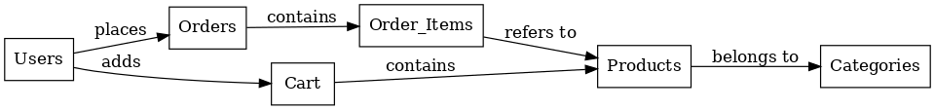
QUESTION 7:
A Data Flow Diagram (DFD) is a graphical representation of how data moves through a system. It shows:
- Processes (actions or tasks)
- Data Stores (storage locations)
- External Entities (users or systems interacting with your app)
- Data Flows (movement of data between the components)
DFDs help visualize the flow of information, making it easier to understand how input is transformed into output within the system.
Data flow diagram to represent the in-flow and out-flow of data when a Farmer is placing an order for the product
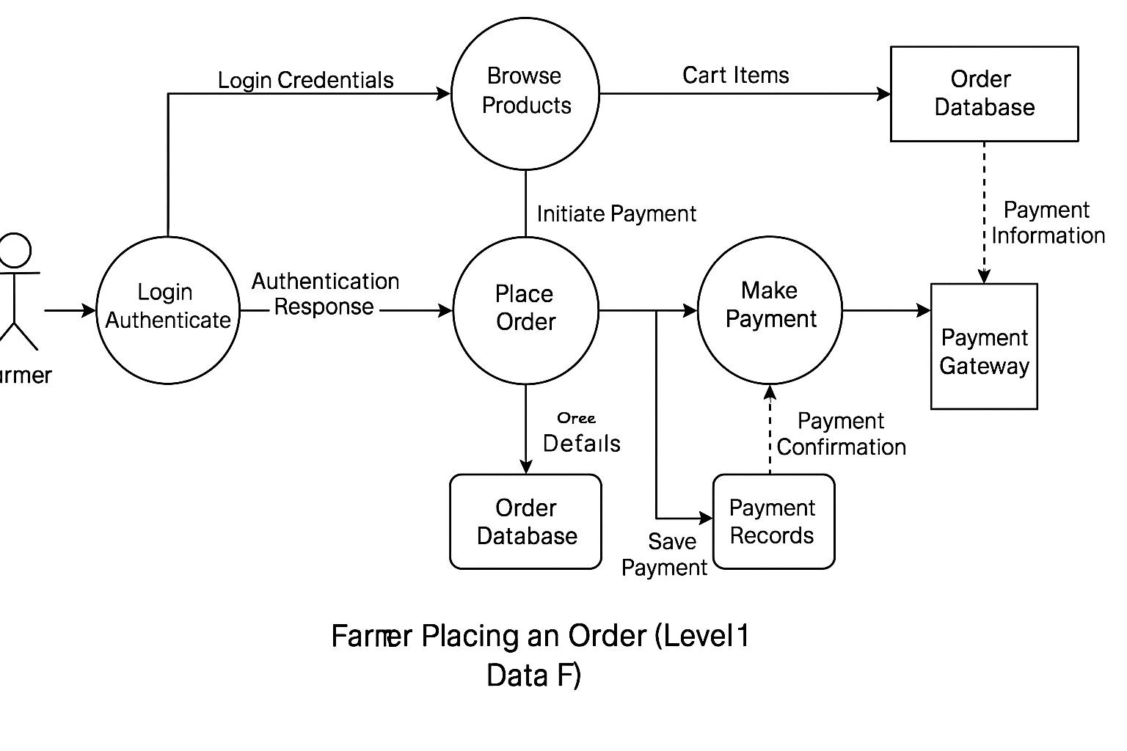

Question 8:
Change Request
1. Identify and Document the Change Request
When the client (e.g., Mr. Henry or Project Committee) informs about the change in taxation policy, I will:
- Record the change request using a Change Request Form (CRF)
- Capture the reason: “Government has changed taxation structure applicable to agricultural products”
- Mention what areas it may impact (product prices, checkout calculations, invoices, backend formulas)
2. Analyze the Impact
Conduct Impact Analysis along with Project Manager and Technical Team:
- Affected modules: Pricing logic, Payment Gateway API, Invoice generation, Tax Reports
- Check how much code, DB, UI logic will be affected
- Determine if this affects timeline or cost
- Assess if any regression testing is needed
3. Discuss with Stakeholders
- Present findings to key stakeholders: Mr. Henry, Mr. Dooku, and APT IT team
- Discuss whether the change is critical and how soon it needs implementation
- Get formal approval before proceeding
4. Update Documentation
- Update BRD, FRD, and RTM to reflect new tax rules
- Include it in sprint backlog (if Agile) or raise a Change Control Form (if Waterfall)
5. Plan and Implement
- Work with developers and testers to implement new tax logic
- Coordinate testing for price calculations and invoice generation
- Ensure compliance with new tax regulations
6. Communicate and Confirm
- Update all stakeholders once the change is deployed
- Include it in the release notes
- Get a sign-off from client (Mr. Henry/Committee)
7. Archive the Change
- Store change request documents with versioning
- Update the project change log for audit/compliance

Change Request Template
Section | Details
CR ID | CR-2025-001
Project Name | Online Agriculture Products Store
Request Date | 19 July 2025
Requested By | Mr. Henry (Client – SOONY)
Raised By | Poojitha Pallela (Business Analyst)
Description of Change | Update tax calculation logic due to changes in Government Taxation Structure
Type of Change | Regulatory Compliance
Business Justification | The government has issued new tax slabs applicable to agricultural products
Impact Areas | Product Pricing, Checkout Page, Invoice Generation, Payment Module
Priority | High
Effort Estimation | 40 man-hours (Development + Testing)
Timeline Impact | +2 working days
Cost Impact | None (CSR-funded)
Risk | Incorrect tax may lead to legal or financial issues
Approval Status | Approved by Committee on 20 July 2025
Signature (Client)
Signature (Project Manager)
Impact Analysis
Component | Impacted  (Yes/No) | Details of Impact | Action Required
Product Catalog | No | Product base prices remain unchanged | No action
Price Calculation Logic | Yes | Need to apply new tax % as per updated slabs | Update backend pricing service
Checkout Page | Yes | Recalculate total incl. tax | Modify UI to reflect updated totals
Invoice Generation | Yes | Invoices must show correct tax breakdown | Update invoice template and engine
Payment Gateway | No | No direct change unless invoice total is sent | Retest to confirm
Database (Tax Tables) | Yes | Tax values may need to be stored or updated | Alter DB schema or table entries
Reports/Analytics | Yes | Tax component affects financial reporting | Modify report generation logic
Testing Scope | Yes | Regression testing needed on price flows | Plan and execute test cases

Question 9:
As a Business Analyst, after evaluating the request from Ben and Kevin to introduce:
- Farmer-to-Customer (F2C) crop selling
- An Auction system for crop yields
I would classify this as an Enhancement, not a simple change request.

Justification:
Factor | Reason
Scope Impact | This introduces a new business module: farmers becoming sellers, public becoming buyers, and auction features.
New Users | It adds a new user role (general public/buyers) not covered in original scope.
New Features | Requires major functional additions: Product listing by farmers, buyer interface, bidding logic, time-based auctions, payment flow.
Complexity | Adds complexity to database, user flows, admin moderation, and pricing logic.
Timeline & Budget | Would affect initial delivery timeline and possibly exceed current CSR-funded budget.

Proposed Next Steps:
- Document Enhancement Request (ERF)
Record the new requirements formally and present to the client committee (Mr. Henry, Mr. Pandu, Mr. Dooku).
- Conduct Feasibility Study
Collaborate with Tech Lead, PM, and Developers to analyze impact on architecture, timeline, and cost.
- Get Client Approval
Share feasibility findings with SOONY committee for approval and potential budget extension.
- Update Project Scope
If approved, update SRS, BRD, RTM, and add new use cases & wireframes for:
  - Farmer Product Upload
  - Public Buyer Portal
  - Auction Bidding System

Question 10:
Man-hours required
Gantt-Chart
Task | Role | Estimated Hours
Requirement Gathering & Analysis | Business Analyst | 30
Wireframes & UI Design | UI/UX Designer | 20
Frontend Development | Frontend Developer | 50
Backend Development | Backend Developer | 70
Database Design & Changes | DB Admin | 15
Testing & Bug Fixing | Tester (QA) | 30
Project Coordination | Project Manager | 15
Deployment & Release | DevOps | 10

Task | Role | Duration  (Days) | 22/07/2025 | 25/07/2025 | 26/07/2025 | 28/07/2025 | 29/07/2025 | 04/08/2025 | 05/08/2025 | 14/08/2025 | 8/215/2025 | 16/08/2025 | 17/08/2025 | 21/08/2025 | 22/08/2025 | 24/08/2025 | 25/08/2025 | 26/08/2025
Requirement Gathering & Analysis | Business Analyst | 4
Wireframes & UI Design | UI/UX Designer | 3
Frontend Development | Frontend Developer | 7
Backend  Development | Backend Developer | 10
Database Design & Changes | DB Admin | 2
Testing & Bug Fixing | Tester (QA) | 5
Project  Coordination | Project Manager | 3
Deployment & Release | DevOps | 2

Question 11:

Step 1: Initiating UAT (User Acceptance Testing)
As a Business Analyst, your role is to coordinate with the client (e.g., Ben and Kevin) to ensure they:
- Understand the testing scope,
- Have access to the UAT environment,
- Are clear on how to use the application,
- Know what scenarios/test cases to verify.

Actions to Take:
- Send UAT Kickoff Email to stakeholders with:
  - Project overview
  - Features ready for testing
  - Test credentials (if needed)
  - UAT schedule/timeline
  - UAT Guide/User Manual (if applicable)
- Provide UAT Test Cases
Share a UAT test case document with predefined steps and expected outcomes.
- Monitor & Support Testing
  - Be available for clarifications.
  - Collect feedback from users.
  - Record any defects or change requests.

Step 2: UAT Acceptance Process

Typical Flow:
Stage | Description
1. Plan UAT | Define scope, prepare test cases, and schedule testing.
2. Execute UAT | Client performs tests using real-world scenarios.
3. Log Defects | Issues are reported and tracked to resolution.
4. Retesting | Once fixed, client retests the affected areas.
5. Final Approval | Client signs the UAT Sign-Off Document indicating satisfaction.

UAT Sign-Off Includes:
Module-wise test status, Pending issues (if any) and their impact, Client's approval for release & Date and signature

Question 12:

Project Closure Process
Once UAT is complete and accepted, the following steps ensure proper project closure:

Closure Activities:
- Final Documentation Submission:
  - User Manuals
  - Architecture Diagrams
  - Codebase handover (if agreed)
  - UAT Sign-Off Sheet
- Production Deployment:
  - Coordinate with DevOps for live deployment
  - Perform sanity checks in production
- Project Closure Meeting:
  - Review deliverables
  - Gather feedback from client
  - Identify lessons learned
- Prepare Closure Report:
  - Summary of the project lifecycle
  - Budget and time comparisons
  - Key decisions and learnings
- Client Handover & Training:
  - Train client team if necessary
  - Share support contacts

