Document 6- Please prepare a use case diagram, activity diagram and a use
Case specification document.
Use Case Specification Document

Project Name: Project Client 360
Use Case Name: View Consolidated Client Profile

1. Use Case Name
View Consolidated Client Profile
2. Use Case Description
This use case describes how a user (e.g., Relationship Manager) retrieves a unified 360-degree view of a client, which includes personal details, contact information, transaction history, communication logs, product holdings, and service tickets, aggregated from multiple legacy systems.

3. Actors
Primary Actor: Relationship Manager (or Sales Agent)
Secondary Actors:
- CRM System
- Data Warehouse
- Product Management System
- Ticketing System

4. Basic Flow (Main Success Scenario)
- User logs into the Client 360 platform.
- User searches for a client using name/ID/contact.
- System retrieves client data from integrated sources.
- System consolidates and displays client details on a single screen.
- User views all client-related information in one place.
- User logs out or navigates to a different section.

5. Alternate Flows
- 5A: If multiple clients match the search, the system displays a list and the user selects one.
- 5B: If user wants to download a client profile, the system provides a PDF export option.

6. Exceptional Flows
- 6A: No matching client found → System displays “Client Not Found.”
- 6B: Data fetch fails from any system → Display “Partial data retrieved. Retry or contact support.”
- 6C: Session timeout → User is logged out automatically.

7. Pre-Conditions
- User is authenticated and has appropriate access rights.
- All integrated systems (CRM, data warehouse, etc.) are online and accessible.

8. Post-Conditions
- The user successfully views or downloads the client profile.
- System logs access to the client profile for audit trail.

9. Assumptions
- All backend systems are integrated via APIs or batch jobs.
- Data is synchronized and up to date at the time of request.

10. Constraints
- Data must be displayed within 5 seconds of request.
- Access control must be enforced as per role-based access.
- GDPR/Privacy compliance must be ensured for data visibility.

11. Dependencies
- Integration with core CRM and ticketing systems
- SSO login services
- Data mapping definitions from legacy systems

12. Inputs and Outputs
Inputs:
- Client Search Input (ID, Email, Phone, Name)

Outputs:
- Consolidated client profile
- Exported report (PDF or Excel)
- Error/alert messages (if applicable)

13. Business Rules
- Users can only view clients assigned to them unless authorized.
- Only KYC-verified clients will display full data.
- Profile information must reflect data from the last ETL job or API call.

14. Miscellaneous Information
- Audit logs will capture each profile view and actions.
- Tooltips and help icons should be available for complex data fields.
- Admin can monitor system uptime and performance via dashboard.

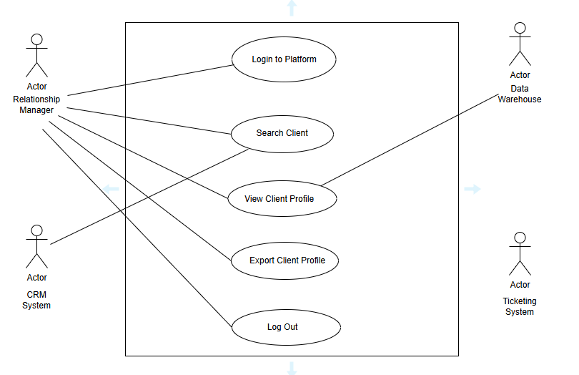

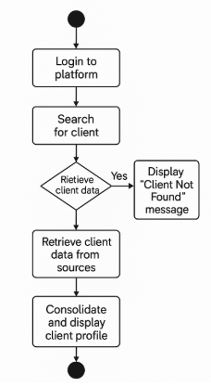

Document 7- Screens and pages

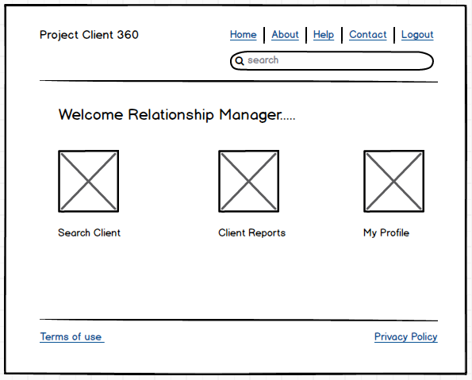

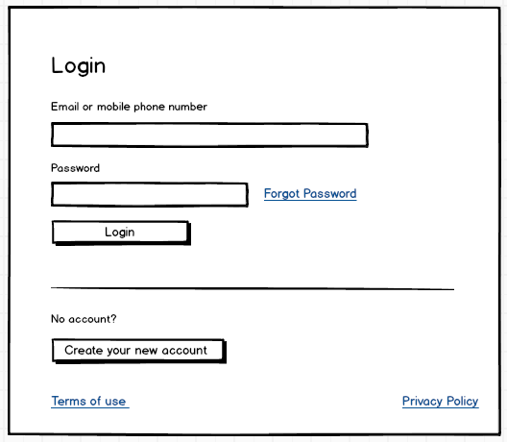

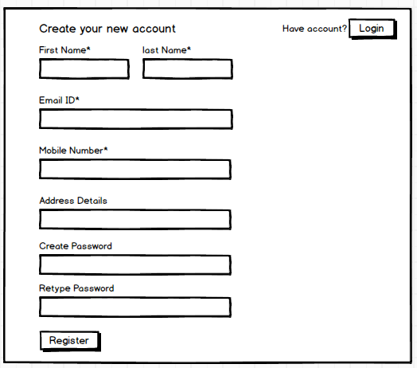

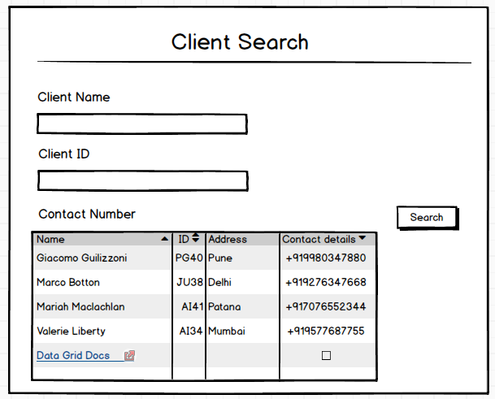

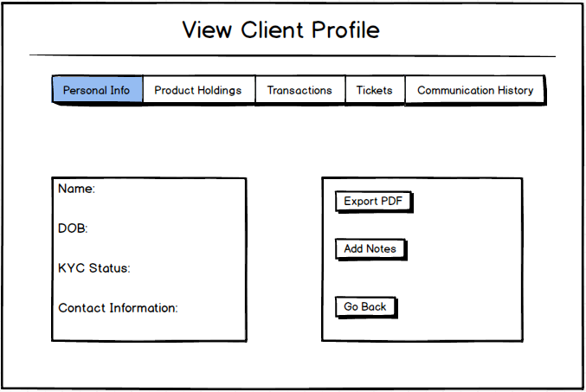

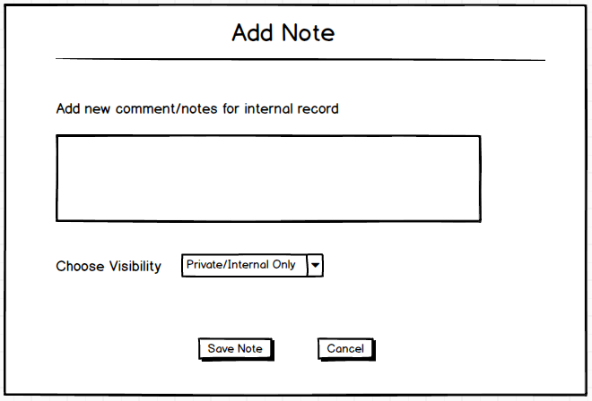

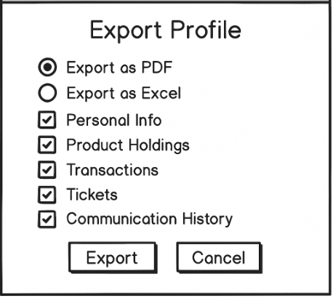

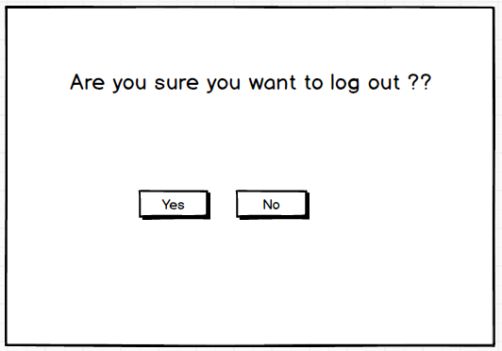

Document 8- Tools-Visio and Axure
Write a paragraph on your experience using Visio and Axure for the project.

For the Project Client 360, using Microsoft Visio and Axure RP significantly streamlined the process of creating visual artifacts and interactive prototypes. Visio proved to be an excellent tool for drawing use case diagrams, activity flows, and system architecture diagrams, thanks to its drag-and-drop interface, ready-made UML shapes, and strong formatting options. It allowed for quick communication of process logic to both technical and non-technical stakeholders. On the other hand, Axure RP was instrumental in developing high-fidelity wireframes and interactive mockups for the client interface. The ability to simulate real user interactions using Axure helped validate user journeys early in the design phase, enabling faster stakeholder feedback and refinements. Overall, both tools enhanced collaboration, clarity, and accuracy in defining and visualizing the business requirements and user experience for Project Client 360.

Document 9 – BA Experience

My experience as BA in following phases:
1. Requirement gathering:

During the requirement gathering phase of Project Client 360, I employed various structured techniques to ensure clarity and completeness. We used the MoSCoW prioritization technique to categorize and understand which requirements were critical, beneficial, optional, or out of scope. A key challenge during this phase was the limited availability of the client, which required me, as the Business Analyst, to proactively identify and engage alternate points of contact to avoid delays and keep the discovery process moving. To ensure the quality of the requirements, I applied the FURPS model (Functionality, Usability, Reliability, Performance, and Supportability) for validation. During the analysis, I also encountered duplicate and redundant requirements, which were systematically filtered out to maintain efficiency and consistency. Additionally, I used prototyping techniques to present visual representations of the proposed solution, which helped stakeholders articulate more specific needs and fostered a clearer shared understanding of the final deliverables.

2. Requirement Analysis:

In the requirement analysis phase of Project Client 360, I focused on translating gathered inputs into clear, structured documentation and visuals for the development team. As part of this effort, I created detailed UML diagrams to visually represent system functionalities, user interactions, and component relationships. Additionally, I developed activity diagrams to map out the end-to-end process flows, helping both technical and non-technical stakeholders understand how different modules interact. These visual models were shared with the team for review. During discussions, team members occasionally raised valid suggestions or proposed alternate logic, which I carefully considered and incorporated, ensuring collaborative consensus and accuracy. I also authored both the Business Requirements Specification (BRS) and Software Requirements Specification (SRS) documents, aligning them with stakeholder expectations and technical feasibility. This phase played a crucial role in bridging business understanding with system design.

3. Design:

During the design phase of Project Client 360, my role as a Business Analyst involved ensuring that the solution design aligned with business needs and was test-ready. Based on the finalized use case diagrams, I collaborated with the QA team to prepare comprehensive test cases, covering both positive and negative scenarios. I emphasized the importance of not missing a single test case, as even a minor oversight at this stage could lead to significant issues during development or production. I also worked closely with the client to review and validate the design and solution documents, ensuring clarity and alignment with expectations. In addition, I was involved in preparing test data that reflected real-world scenarios, enhancing the accuracy and relevance of the testing phase. To maintain traceability and compliance, I regularly updated the Requirements Traceability Matrix (RTM), ensuring that each requirement was accounted for and linked to corresponding test cases and design components.

4. Development:

In the development phase of Project Client 360, I played a key role in ensuring that the development team had complete clarity on requirements and design logic. I organized JAD (Joint Application Development) sessions to promote collaborative discussions between business and technical teams. Throughout the coding process, I was actively involved in clarifying queries from developers, helping them interpret requirements and logic accurately. Occasionally, challenges arose with team members who were either skeptical about certain concepts or hesitant to collaborate during JAD sessions. As a Business Analyst, I handled such situations diplomatically by initiating one-on-one conversations, explaining the impact of individual contributions on the overall project, and fostering a healthy, cooperative team environment. I ensured that UML and activity diagrams were readily available to assist developers in building units aligned with the design. Regular meetings with the technical team and client were essential yet sometimes difficult due to scheduling conflicts. In such cases, I made sure to record sessions, share them with absentees, and follow up individually to keep everyone aligned with project goals and progress.

5. Testing:

In the testing phase of Project Client 360, I was actively involved in preparing test cases based on the documented use cases, ensuring they aligned with business scenarios and captured both standard and edge-case behaviors. I performed high-level testing to validate that the system met the core business requirements before transitioning to formal QA or UAT phases. As part of my responsibilities, I requested and coordinated the necessary test data from the client to ensure realistic and meaningful test execution. I maintained and regularly updated the Requirements Traceability Matrix (RTM) to ensure that all test cases could be traced back to specific requirements. Once internal validation was completed, I worked closely with the client to prepare them for User Acceptance Testing (UAT) by guiding them through the process, clarifying expectations, and addressing any concerns. Upon successful execution of UAT, I facilitated the client sign-off, marking a critical milestone for project readiness and approval.

6. Deployment:

During the deployment phase of Project Client 360, I ensured all project deliverables were properly documented and shared with the client. I forwarded the finalized Requirements Traceability Matrix (RTM) as a key artifact to be included in the project closure document, ensuring traceability from requirements to implementation. I also took the lead in coordinating the preparation and distribution of end-user manuals, enabling smooth adoption of the system by business users. As part of the go-live preparation, I planned and organized comprehensive training sessions tailored to the end users' roles and system functionalities. I ensured active participation by all targeted users, following up with those who missed sessions and making necessary arrangements for one-on-one or repeat trainings. My involvement during this phase was crucial in facilitating a seamless transition from development to production and in empowering users to confidently use the new system.

