WATERFALL PROJECT DELIVERABILES PART 3

Document 6- Please prepare a use case diagram, activity diagram and a use case specification Document?
Answer-
Use Case Document –

A Use Case Diagram is a Visual Representation of the

interactions between users (Actors) and a system. It is a high-level Diagram. It

shows the external Interface work. It is used to describe the functionality of the

system in a horizontal way

Use Case Diagram has 4 elements –

1-Actors

2- System Boundary

3-Use Cases

4- The Lines that represents the relationships.

This diagram includes the key actors:
- Healthcare Provider
- System Administrator
- Finance Team
- First Source Tool (System)
And the core use cases:
- Register Account
- Make Payment (with extension: Enter Payment Details)
- View Transaction History
- Manage Provider Access
- Configure Payment Rules
- Review Payment Reports
- Reconcile Payments
- Validate Invoice
- Process Payment
- Generate Report

Activity Diagram-
Activity Diagram – It is the flow of the control and advanced version of flow
chart. It defines the workflow from one activity to another. It includes different
states and notations like actions, final, join, fork, merge swim lanes and control
flow. The elements of activity diagram are –

Start Node- It is also known as Initial Node where the workflow begins.

Final Node- It indicates that the workflow is completed

Activity-It is a unit of work done by the system, it has 1 input and 1 output

Control line -Showing the direction of the workflow from top to bottom and left to right

Decision Box-A diamond Symbol which indicates the choice. It has 1 input and multiple outputs

Continuation Nodes-We give continuity from one page to another page using continuation node.

Guard condition-A condition attached to workflow, when the guard condition is true, workflow may flow along the control flow .it is generally shown within the square brackets. YES OR NO

Branch and Merge- Between branch and Merge we can have number of paths for the control to pass from branch to merge. the condition between the path will be OR.

Fork and Joy-Between a fork and Joy we can have n number of paths. The condition between the paths will be AND. ONE TO MANY AND MANY TO ONE.

Use Case Specification Document –
Every use case document will have its own use case specification like below –
Use case specification document is a textual document of how the specifications interact with the system.

Primary Actors  Secondary Actors | Healthcare provider  • First Source Tool  • Finance Team  • System Administrator
Pre- conditions | Provider is registered
Post -conditions | Payment status updated in the system
Basic Flow | • Healthcare provider logs into the portal  • Navigates to the “Pending Payments” dashboard  • Selects an invoice to pay  • Enters payment details (method, amount, reference)  • Submits payment  • System sends payment request to First Source Tool  • Confirmation is received and displayed  • Dashboard is updated with payment status
Alternative Flow | - Partial Payment: Provider selects partial payment option, enters amount, and submits. System logs partial status and schedules remainder.  - Payment Scheduled: Provider chooses future date for payment; system queues transaction and sends reminder.
Exceptions | Customer Unavailable  Logistics Issues
Use Case Name | Making Payments to provider
Use Case Description | This use case describes how a healthcare provider initiates and completes a payment for approved invoices through the digital platform, which integrates with the First Source Provider Management Tool for validation, processing, and reporting.
Assumptions | • Provider has access to valid payment methods  • Invoice data is accurate and validated  • First Source Tool API is stable and responsive  • Finance team has access to reporting dashboard
Constraints | • Payment must match invoice amount unless partial payment is allowed  • Only verified providers can initiate payments
Inputs and Outputs | Inputs Provider Login Credentials  Selected Invoice ID
Payment Details
API responses from first source
Dependencies | - First Source Provider Management Tool  - Payment Gateway  - Notification Service (Email/SMS)  - Finance Reporting Module  - User Authentication System
Miscellanies Information | • Audit logs are maintained for compliance  • Payment history is accessible for 12 months  • System supports role-based access control

Document -7 Screens and Pages
Wire Frame – Wireframe is just like blue print of the project.
It can be drawn with pen or pencil like quick sketch

Wireframe shows the design team and stakeholders the

outlines of essential webpages, components, and features including:

- Screen layouts

- Navigation bars

- Components of UX and UI design

- Interactive elements.
Prototypes- The final Replica of the project is a prototype.
Generally, these are developed by developers.

prototyping is done before the development of the product to get clear

solutions to improve the product. It ensures that the product meets the

needs of the user. Prototypes are important during the design process

as they allow testing and revising a design before it becomes final.

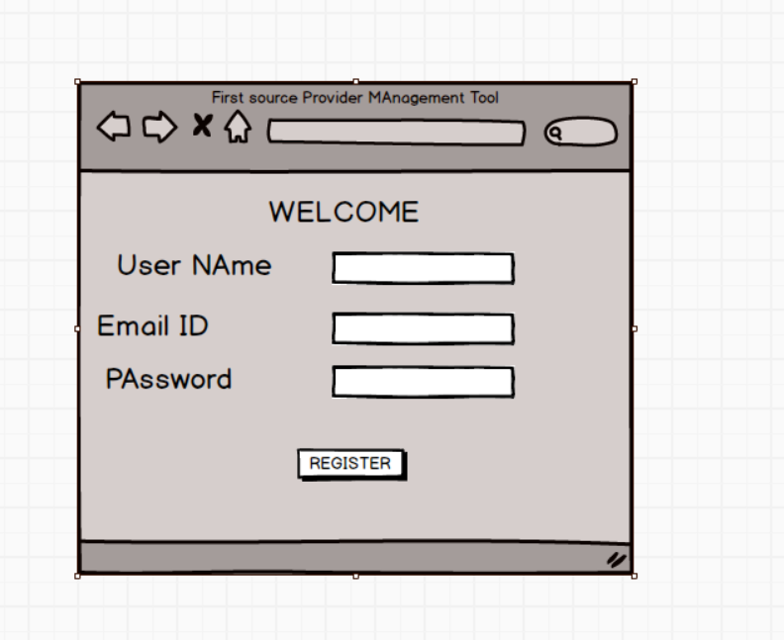

REGISTER PAGE
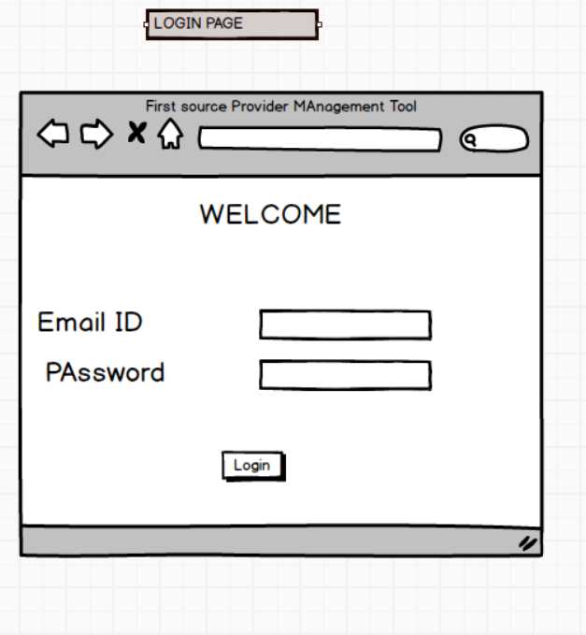

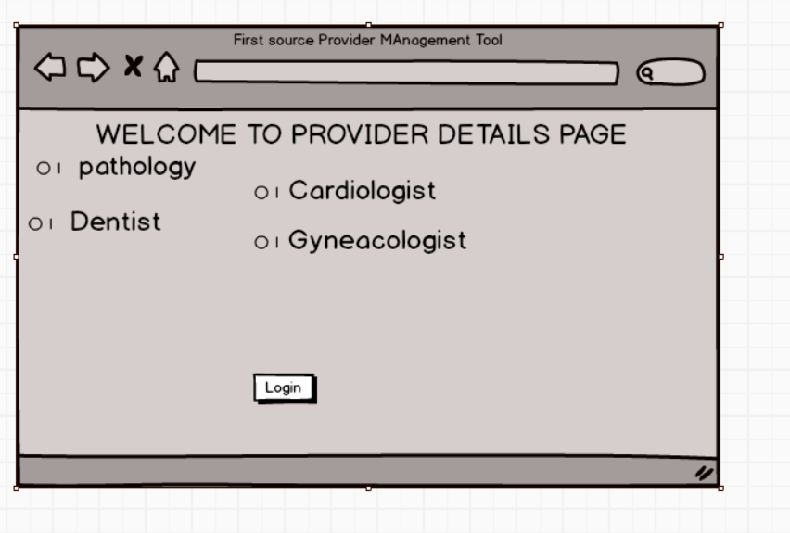

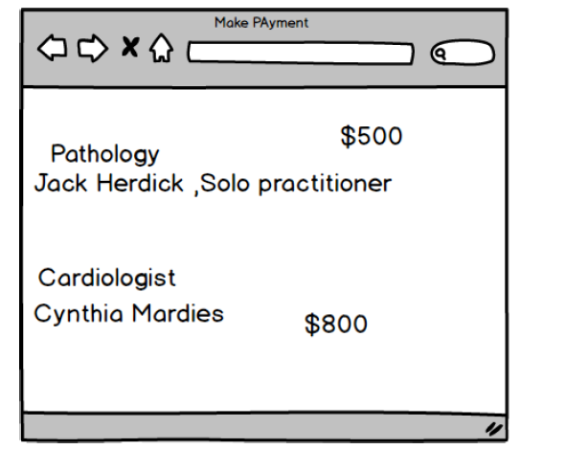
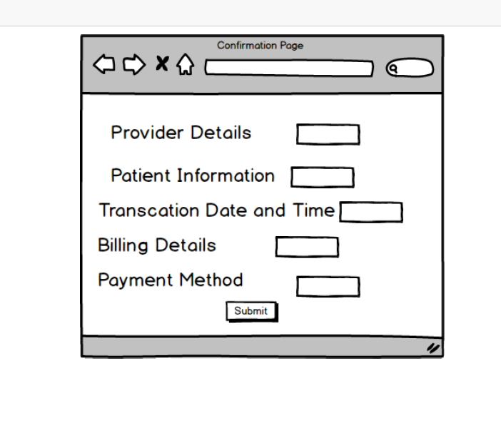
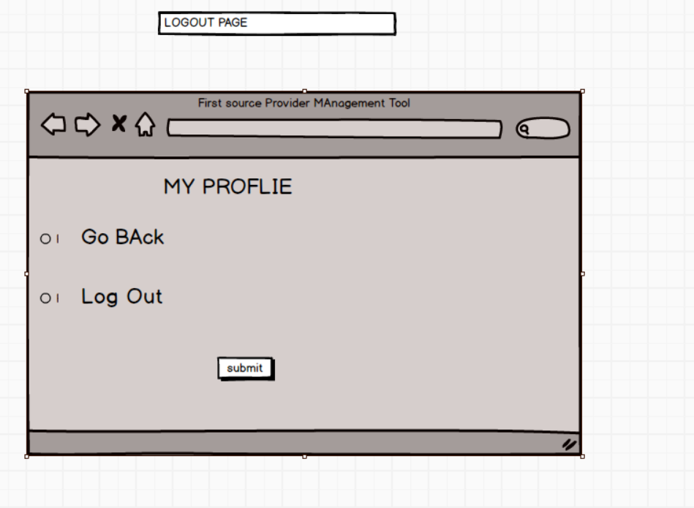

Document -8
Write a paragraph on your experience using Visio and Axure for the project.
As a Business Analyst, using Visio and Axure throughout the project significantly enhanced the clarity and precision of our deliverables. Visio proved invaluable for creating structured diagrams such as use case models, data flow diagrams, and process flows, which helped stakeholders visualize system interactions and dependencies with ease. The ability to prototype end-to-end workflows, from login to payment confirmation, helped validate requirements early and reduce ambiguity. Together, these tools supported both technical documentation and user experience alignment, making them essential assets in bridging the gap between business needs and development execution.
Document -9 BA Experience
Requirement Gathering -
- During the requirement gathering phase, I focused on bridging the gap
- between stakeholder expectations and technical feasibility.
- I conducted structured interviews, facilitated workshops, and used visual aids like process maps and use case diagrams to elicit clear, actionable requirements.
- To gather requirements, we used MOSCOW technique. I validate the requirements using FURPS technique.

Requirement Analysis -
- During the requirement analysis phase, I focused on translating raw stakeholder inputs into structured, validated, and prioritized business requirements.
- I applied techniques such as gap analysis, stakeholder mapping, and use case modelling to ensure that every functional and non-functional need was clearly defined and traceable.
- Leveraging tools like Visio and Axure, I created ER diagrams, DFDs, and wireframes to visualize system behaviour and user interactions. I collaborated closely with developers, QA teams, and product owners to resolve ambiguities, uncover hidden dependencies, and align technical feasibility with business goals.

Design-

- During the design phase, I played a pivotal role in translating business requirements into functional and visual specifications that guided development.
- I collaborated closely with UX designers and solution architects to ensure that wireframes, mock-ups, and system workflows aligned with both user needs and technical constraints.
- Using tools like Axure and Visio, I created interactive prototypes, ER diagrams, and sequence flows that clarified system behaviour and user interactions.
Development –
AS a BA we conduct Conducting JAD Sessions
During the development phase, I served as a critical liaison between the business and technical teams, ensuring that the implemented features aligned precisely with the documented requirements.
I participated in daily stand-ups, clarified and resolved blockers by providing timely business context.
My documentation—use case specs, data mappings, and wireframes—acted as a blueprint for developers and testers, reducing ambiguity and accelerating delivery.
Testing –
As a business analyst, the testing phase is a critical part of ensuring that the solution meets business requirements and delivers value. Here's how I typically engage during this phase:

Reviewing Test Plans and Cases
• Collaborate with QA teams to ensure test cases align with business requirements.
• Validate that all functional and non-functional requirements are covered.
• Confirm traceability between requirements and test scenarios using tools like RTM (Requirement Traceability Matrix).
Change Requests
- Evaluate change requests during testing and assess their impact on scope, timeline, and budget.
- Update documentation and communicate changes to relevant teams.
Sign-Off and Go-Live Readiness
- Ensure all critical business scenarios are tested and passed.
- Provide final sign-off from a business perspective.
- Support go-live planning and post-deployment validation.

Deployment –
- During the deployment phase, I ensured that the transition from development to production was smooth, coordinated, and aligned with business expectations.
- I collaborated with cross-functional teams to validate release readiness, reviewed deployment checklists, and supported final data migration and configuration activities.
- Whether deploying healthcare payment modules or food delivery workflows, I focused on minimizing disruption, maximizing user adoption, and ensuring that the deployed solution delivered measurable business value from day one.

