Assignment 1

BUSINESS REQUIREMENT DOCUMENT

Client name: Frozen delight
Project name: Inventory and delivery management
Document version: 1.0
Date : 25 july 2025
Prepared by : Divya( Business Analyst)

Document Revision:

Date | Version number | Document changes
23/06/25 | 0.1 | Initial draft
25/06/25 | 0.2 | Added business goals and objects
29/06/25 | 0.3 | Defined project scope, in and out of scope.
1/07/25 | 0.4 | Included process flow diagrams (As is & To be)
10/08/25 | 0.5 | Added assumptions and constraints
20/09/25 | 0.6 | Updated with finalized business rules
28/09/25 | 1.0 | Added document approval and review section
3/10/25 | 1.5 | Final version for sign off and client submission.

Approvals.

Role | Name | Title | Signature | Date
Project sponsor | John Smith | VP Retail Operations |  | 15/03/2024
Business owner | Emma | CEO |  | 15/03/2024
Business Analyst | Divya | BA
Project manager | Micheal | Project Manager |  | 15/03/2024
System architect | David | Lead Architect |  | 15/03/2024
Development lead | Sarah | Head of Development |  | 15/03/2024
User experience | Olivia | UX Lead |  | 15/03/2024
Quality lead | Matthew | QA Manager |  | 15/03/2024
Content lead | Lisa | Content Strategist |  | 15/03/2024

RACI
Task | Project manager | BA | Factory Mgr | Warehouse Sup. | Dev | Testing
Project initiation | A | R | C | I | I | I
Requirement Gathering | R | A, R | C | C | I | I
Inventory Module | I | I | A | A | C | I
Delivery Module | I | I | I | I | C | I
Development | I | I | I | I | A, R | I
Testing & QA | I | C | I | I | C | A,R
Deployment | A | I | I | I | R | C
Training Staff | A | C | S | S | I | I

Business Goals:

To implement a centralized digital system that can track product stock across all factories and warehouse in real time and help the company fulfill customer orders quickly and accurately.

Business Objectives
- Build a system to record real time inventory data from each factory and warehouse.
- Reduce order delivery delays by routing orders from the nearest warehouse.
- Provide managers with a dashboard to monitor stock levels , pending orders and dispatch schedules.
- Enable automatic low stock alerts to prevent stockouts.
- Improve customer satisfaction through timely order fulfilment.

Business rules
- Inventory must be updated every time stock is received or dispatched
- Only authorized users warehouse managers, factory staff, admins can update stock.
- Delivers must be assigned based on nearest warehouse with available stock.
- System must prevent double dispatchin of the same order.
- Low stock alerts will trigger automatic reorder request if configured.
- Orders can only be fulfilled if stock is available.

Background
Frozen delights produces and sells diary products through multiple production units and storage warehouse across india . currently they lack visibility into stock levels at different locations and face major delays in delivering products to customers due to inefficient dispatching planning. To solve this the company plans to develop a softwar platform that brings together inventory tracking and delivery logistics under one system.

Project Objectives
- Real time inventory tracking across all units.
- Central dashboard for stock visibility and order processing
- Route planning based on orer location and stock availability
- Integration with delivery partners or logistics software
- Alerts for low stock and order delays.

SMART OBJECTIVES

- Specific: automatise the inventory data and manage dispatch operations centrally
- Measurable: reduce delivery time by 30% and eliminate stock confusion within 3 months.
- Achievable : use cloud based infrastructure with warehouse connectivity via tablet or PC
- Relevant: aligns with company growth goals to scae nationwide deliveries efficiently.
- Time bound: complete project in 8 months with testing in 1 region in 3 months.

Project scope
- IN SCOPE
- Inventory tracking ( by product,location, quantity , date)
- Factory stock updates real time (daily production)
- Auto assign delivery agent based on location
- Track order and delivery status
- Role based login ( factory staff, warehouse manager, admin)
- Reporting :stock levels, delays, delivery times.
OUT SCOPE
- Customer facing app or website.
- Online payment process
- Integration with third party courier service.
- AI based delivery route optimization.

Assumption
- All factory /warehouse locations have internet enabled devices tablets/PC)
- Staff will be trained to input and monitor data in system.
- Delivery routes will be manually assigned unless future automation is added.
- Stock data entry will follow standard daily shift wise protocols.
- The company will maintain its own hosting / server for security reasons.
Constraints
- Time : system must be operational within 8 months.
- Technology: must support web and mobile users backend must allow API integration for future logistics automation.
- Budget: project must stay within allocated IT development budget.
- Connectivity: warehouse must have stable internet for real time sync.
- Security: system must comply with data protection for inventory logs and dispatch logs.
- Performance: must handle real time updates across 20 plus locations with up to 100 concurrent users.

Risk and mitigation
- Technical risk: poor network connectivity at some warehouse . likelihood high. Impact would be medium .
Mitigation: allow offline data entry and sync when online.

- Human error: wrong stock entries by warehouse staff likelihood huugh impact high.
Mitigation: use barcode scanning and validation for critical items.

- Operational risk:Delays in order assignment during peak times moderate likelihood and impact medium.
Mitigation:prioritize urgent orders and use color coded dashboards.

- Financial risk:unexpected increase in cost for logistics module likelihood moderate . impact medium.
Mitigation: Freeze phase 1 scope strictly to inventory and dispatch.

- Skill gap:warehouse staff may not be much aware of technically sound likelihood high impact medium.
Mitigation: provide simple UI and on site training.

- Requirement changes: scope changes due to evolving logistics models likelihood high impact medium.
Mitigation: create change control process with impact analysis.

- Integration risk: third party delivery API might nit be stable or compatible likelihood low and impact medium.
Mitigation: use modular APIs and failback manual entry options.

Process flow diagram

As is

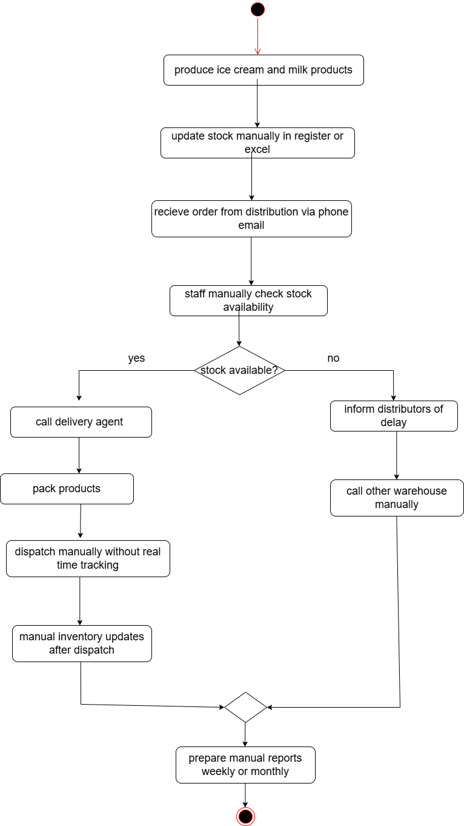
TO BE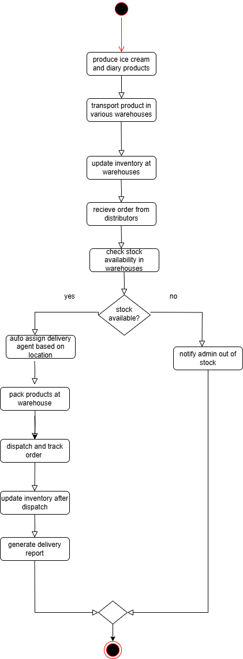

1.Introduction letter

To,
The Ashwin
Frozen delight,
Chennai , INDIA

Subject : Introduction from Business Analyst Project kick off

Hi Ashwin,

My name is Divya shree and i have been assigned as the business analyst for your upcoming aimed at developing a software solution to support your business goals, i will be working closely with you and your team to gather requirement, analyze business processes and ensure that the solution we deliver aligns with your expectations.

As a part of initial phase , i will be conducting requirement elicitation sessions, including stakeholder interviews, workshops and document analysis. My primary objective is to bridge the gap between business needs and technical implementation team by capturing all critical requirements clearly and accurately.

I look forward to a successful collaboration and am confident that together, we can deliver a robust and efficient solution. Please feel free to reach out to me for any clarification or support you may require throughout te project lifecycle.

Warm regards,
Divyashree. K
Business Analyst
divyakrsihnakumar39@gamil.com
9790701899
Brinker Team

BRD

Client Name: D&C support PVT
Project Name: Ticketing system
Document Version: 1.0
Date: 28 June 2025
Prepared by: Divya( Business Analyst)

Document revision

Date | Version | Document Changes
02/06/2025 | 0.1 | Initial draft created based on project understanding
04/06/2025 | 0.2 | Added problem statement and business objectives
07/06/2025 | 0.3 | Defined scope (in-scope and out-of-scope) and assumptions
09/06/2025 | 0.4 | Added process flow diagrams and use case identification
11/06/2025 | 0.5 | Finalized functional and non-functional requirements
13/06/2025 | 0.6 | Integrated ER diagram and data flow logic
16/06/2025 | 0.7 | Added stakeholder roles, RACI chart, and review section
21/06/2025 | 1.0 | Final version submitted for approval and sign-off

Approval

Role | Name | Title | Signature | Date
Project Sponsor | Rajesh Kumar | VP - IT Operations |  | 29/06/2025
Business Owner | Priya | Director - Customer Support |  | 29/06/2025
Business Analyst | Divya | Business Analyst |  | 29/06/2025
Project Manager | Arjun | IT Project Manager |  | 29/06/2025
Development Lead | Ananya | Head of Software Development |  | 29/06/2025
UX Lead | Sneha Reddy | User Experience Designer |  | 29/06/2025
QA Lead | Deepak Menon | QA Manager |  | 29/06/2025

RACI
Task | Project manager | Business analayst | Customer | Agent | Dev | Tester
Project Initiation | A | R | I | I | I | I
Requirement Gathering | R | A | C | C | I | I
System Design | C | R | I | C | A | I
Development | I | I | I | C | A, R | I
Testing & QA | I | C | I | I | C | A, R
Deployment | A | I | I | I | R | C
Training Support Staff | A | R | I | A | I | I

Business Goals:
To build a web based and mobile compatible ticketing system that simplifies customer complaint management by automating issue tracking , SLA monitoring , agent assignment and reporting all while improving transparency and reducing resolution times.

Business Objectives
- Develop a system where customers can raise tickets for issue like delivery, refunds or technical problems.
- Enable support agents to track , respond and resolve issues based on priority /SLA
- Provide admin users with dashboards to monitor workloads, generate reports and handle team performance.
- Send real time updates to user via email for every major ticket status change
- Support secure login,role based access and encrypted storage of ticket data.

Business Rules
- Tickets can be raised only by registered users.
- Each ticket must have a unique ID and a Statsu ( open, in progress, resolved, closed)
- SLA time limits are defined per ticket category.
- Only support agents and admins can change ticket status.
- Notification must be sent when a new ticket is created, a support agent replies, a ticket is resolved or closed.
- Customer feedback is optional but available after ticket closure.

Background:

D&C support pvt lad currently handles customers complaints via email and phone which results in lost or delayed issue resolutions, lack of prioritization and zero tracking.

To resolve this a centralized digital ticketing system is proposed that allows structured issue handling ,real time updates, SLA based priorities and performance insights.

Project Objectives
- To build and deploy a system that:
- Allows users to log issues with attachments
- Categorizes and priorities issues
- Enable agent to resolve and track tickets
- Provides admin reports and overnight
- send s timely updates via email
The goal is to reduce manual effort, improve response time and enhance user satisfaction.

SMART Objectives
- SPECIFIC : Automate the end to end customer complaint handling process.
- MEASURABLE: Reduce average ticket resolution time by 40% within 3 months.
- ACHIEVABLE: Use existing tech stack for compatibility.
- RELEVANT: Aligns with company mission to improve customer support quality.
- TIME BOUND: Go live within 6 to 8 months including training and UAT completion.

Project Scope In scope
- Customer login/ register
- Raise ticket with category and attachments
- View/ reply to ticket
- Agent dashboard view,reassign, agents, view reports.
- SLA monitoring
- Email notifications should be there whenever ther is update in ticket status.
- Reports: SLA breaches, agent performance, ticket trends

Out scope
- Integration with external CRM will be considered later
- AI based chat box.

Assumptions
- Stable internet all users are expected to have reliable internet access during system use.
- Trained user agents and admins will receive proper training before system launch.
- The client will provide hosting servers and access credentials as needed.
- System will follow predefined user roles customer, agents, admin without changes.
- Mobile app is excluded in this phase development is limited to a web based system.

Constraints:
- The project must be completed within 6 to 8 months including development, testing and getting final user approval
- The money available for this phase is strictly limited . no extra funds will be provided so everything must be completed within the ste amount.
- Only certain tools and programming languages can be used
- The system must be built in a way that protects all data safely it must follow international rules to make sure customer information stays secure.
- Controlled user access different types of users like customer, agent, admin will only be allowed to do certain task in the system. Each role will limited access based on what they need.
- Limited integration tools like email no third party services or apps can be added in this phase.

Risks
- Technical risk:SMS or email APIs may fail intermittent. likelihood moderate impact medium . mitigation would be use fallback email queue and retry logic.

- Skill risk:support agents may be slow adopt new system likelihood high impact high. mitigation conduct training workshop before go live.

- Business risk:changing complaint categories during development likelihood high . impact medium . mitigation : maintain flexibility in category design.

- Financial risk:exceeding budget due to unexpected features likelihood moderate impact medium. Mitigation scope freeze after phase 1 approval.

- Data migration risk: past complaints might not be imported correctly likelihood low . impact medium. Mitigation performance test migration and validation before final switch.

- Legal risk: violation of data likelihood low impact high. Mitigation data encryption and internal legal audit during development phase.

- Resources risk: limited developer / tester availability likelihood moderate impact high . mitigation plan sprint wise delivery and hire temporary resources if needed.

Process Flow Diagram

AS is

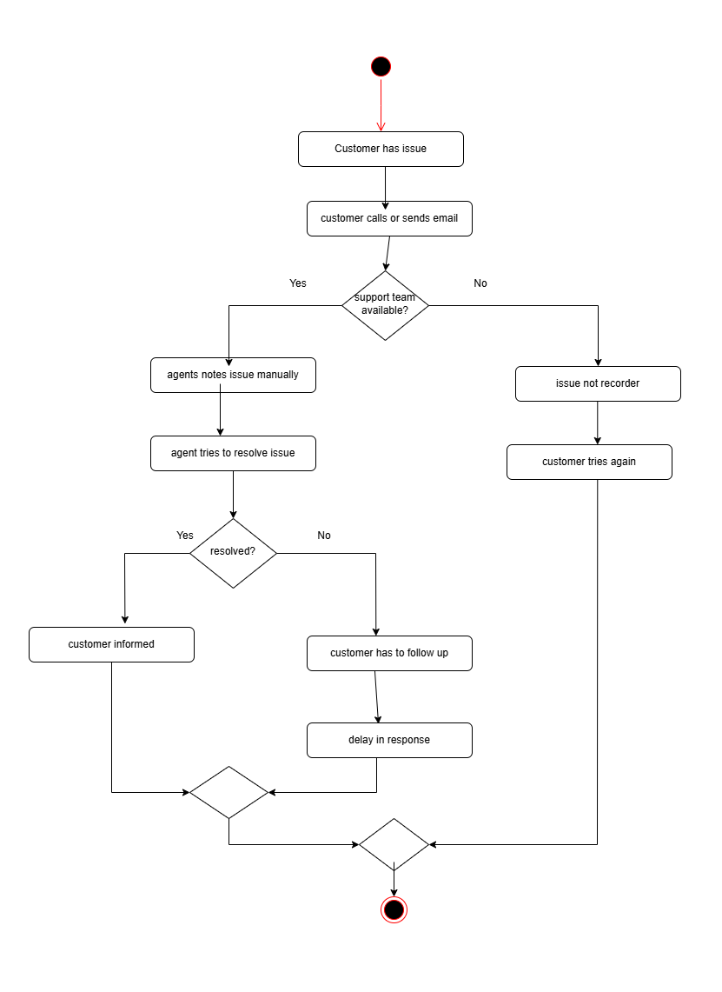

SRS document

Software requirements specification SRS
Client name : D& C support
Project name : ticketing system
Date: June 25 2025

Acceptance:
Signature
Client authorised representatives

Record of revisions.

Version | Date | Prepared / Revised By | Reviewed By | Approved By | Reason for Revision
1.0 | 25-Jun-2025 | Business Analyst | QA Lead | Project Manager | Initial draft of the SRS document
1.1 | 27-Jun-2025 | Developer | Technical Lead | Project Manager | Added UI requirements and module list
1.2 | 29-Jun-2025 | QA Tester | QA Lead | Client Manager | Updated acceptance criteria post UAT
1.3 | 01-Jul-2025 | Business Analyst | Scrum Master | Product Owner | Modified constraints based on API limits
1.4 | 04-Jul-2025 | System Architect | Tech Reviewer | CTO | Final edits after security review
2.0 | 05-Jul-2025 | Delivery Manager | QA Lead | Client | Final version approved for deployment

Table of contents
1.0 Introduction
1.1 Over view
1.2 Acronyms and definitions
1.3 Operational requirements
1.4 References
1.5 Design and implementation constraints
1.6 Assumed factors that could affect requirements
2.0 System overview
2.1 current system
2.2 proposed system
2.3 benifits of the proposed system
3.0 UI requirements
3.1 project constraints
4.0 other parameters
4.1 Acceptance

1.0 Introduction
1.1 overview
This software requirements specification SRS defines the functionality, design constraints and operations needs for ticketing system. The system will serve as a centralised platform for customer to raise issue and for support agents to track .manage and resolve those issues efficiently. The goal is to enhance customer service experience, ensure faster resolutions and provide transparent communication.

1.2 Acronyms and definitions
- SRS - software requirements specification the document describing all system requirements
- UI- user interface what user see and interacts.
- SLA - service lead agreement - the maximum time allowed to resolve a ticket
- API- application programming interface a method for connecting software system.
- CRM - customer relationship management a system that stores customer data and activity.
- UAT- user acceptance testing final client testing before approval.
- Ticket - a support request submitted by a user in the system

1.3 Operational requirements
Software requirements
- Operating system: windows 10 +
- Browser compatibility: chrome, firefox, edge.
- Back-end: node or java
- Front end : React or angular
- Data base: MySQL
Hardware requirements
- Client device: min 4gb ram , browser suppor
- Server: 8gb Ram, Quad core CPU, 100GB Storage
- Network: stable internet connection

1.4 References
- Project proposal document
- User requirements Document
- ISO 270001 Security Guidelines
- Best practice in IT Help desk platforms

1.5 Design and implementation constraints
- Technology constraint - the backend must be developed using node or java and frontend must be in React or Angular.
- Database constraint - Only MySQL and PostgreSQL are allowed for data storage no use of NoSQL or cloud Storage
- Integration constraint - the ticketing system must integrate with the clients existing CRM system using REST APIs only.
- Security constraint - the application must follow ISO 27001 standards and encrypt all ticket data during storage and transfer.
- Design constraint - the UI must be responsible to all web browser chrome,Edge and Firefox.
- Infrastructure constraint - hosting must be done on the clients private server no external cloud hosting is permitted.

1.6 Assumed factors that could affect the requirements
- SMTP Simple Mail Transfer Protocol or email service will be available for sending real time notifications
- A secure hosting environment ( cloud/ server ) will be provided for system deployment
- Role definition ( user, agent, admin) are already finalized and wont change during development
- SLA timings and ticket categories will be provided on time by stakeholders
- Required third party tool ( eg for dashboard or file uploads ) will be compatible and licensed

2.0 System Overview
2.1 current system
- Currently customer complaints are managed via email and phone calls.
- Automatic tracking
- Categorization of issues
- SLA monitoring
- Response time accountability
- Any kind of reporting or visibility

2.2 proposed system
The new ticketing system will be a web based platform that allows:
- Customers to raise ticket
- Support agents to reply and track statuses
- Admins to monitor workloads ,SLA breaches and System performance

2.3 Benefits of the proposed system
- Organized and timely issue resolution
- Clear ticket history for each user
- SLA based prioritization
- Admin Monitoring with dashboard reports
- Customer satisfaction and reduced escalations

3.0 UI Requirements
3.1 Project contents
- Customer interface
- Register / Login
- Create ticket ( choose category, attach files , write issue)
- Track ticket status ( open, in progress, resolved, closed)
- Respond to agent replies
- Close or reopen tickets
B.support agent interface
- View tickets assigned to them
- Reply to customer
- Filter tickets by status ( open, resolved)
- Change ticket status
- Add internal notes

C.Admin interface
- View and assign / reassign tickets
- Configure categories ( eg Billing , Technical)
- Manage agents and roles

D Notification system
- Emails and SMS alerts for new tickets, replies ,SLA breaches
- Ticket creation
- Ticket response
- Ticket closure
- SLA Breach

E. Dashboard & Reports
- Number of open, closed, overdue tickets
- Agent performance
- Daily ticket inflow
- Export Data (PDF/ Excel)

4.0 Other Parameters
Acceptance criteria
- Full system developed and deployed
- Approved wireframe and UI design
- All functional modules working as expected
- No major bugs found during user acceptance testing (UAT)
- Admin manual and user guide shared
- Training session provided to support staff
- Signed approval from client confirming the project is complete

3. Make ERD for support ticket system

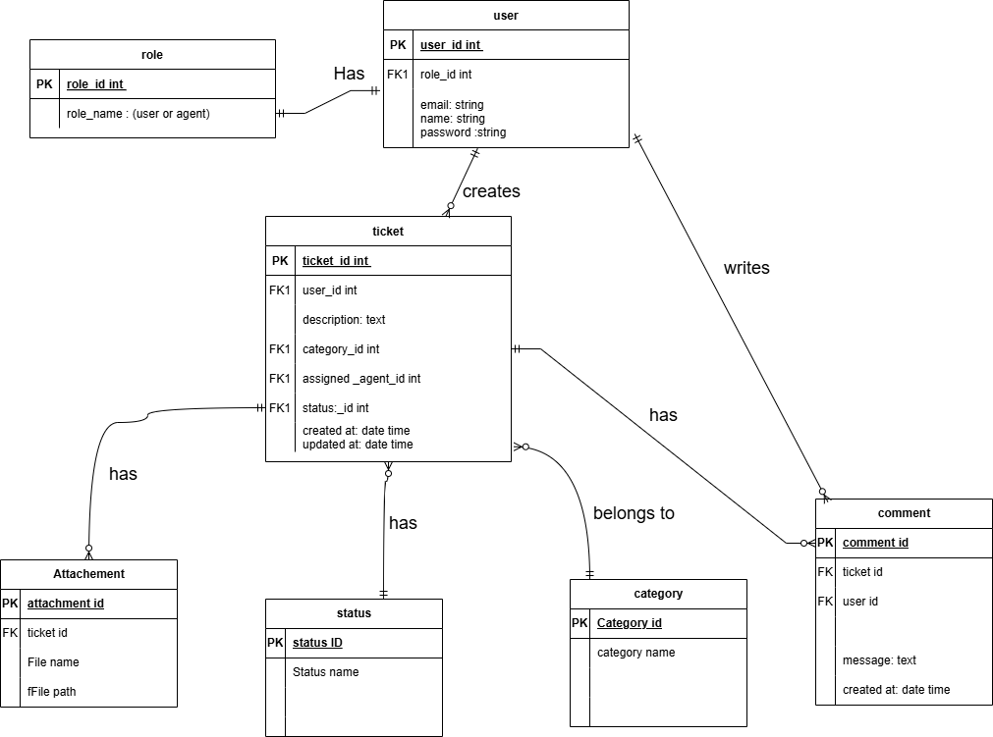

4. User stories
E commerce shopping
User Story No: 1 | Task: 2 |  | Priority: High
Value Statements:
As a new user, I want to register on the e-commerce platform so I can start shopping.

BV: 100 |  | CP: 5
Acceptance Criteria:
- Display registration screen.
- Enter fields: Name, Email, Password, Mobile No.
- Click “Register”.
- Show success message.
- Send confirmation email/SMS.

User Story No: 2 | Task: 2 |  | Priority: High
Value Statements:
As a registered user, I want to log in so I can access my account.

BV: 20 |  | CP: 2
Acceptance Criteria:
- Enter email and password.
- Validate credentials.
- Show error if invalid.
- Redirect to the home page on success.

User Story No: 3 | Task: 1 |  | Priority: Medium
Value Statements:
As a user, I want to search for products so I can find what I need quickly.

BV: 10 |  | CP: 1
Acceptance Criteria:
- Show search bar
- Enter product keyword.
- Display search results.
- Handle “no results found” message

User Story No: 4 | Task: 2 |  | Priority: High
Value Statements:
As a user, I want to apply filters so I can narrow down the product list.

BV: 20 |  | CP: 2
Acceptance Criteria:
- Filters for brand, price, rating.
- Apply filters.
- Show updated results.
- Option to clear filters.

User Story No: 5 | Task: 3 |  | Priority: Medium
Value Statements:
As a user, I want to save products to a wishlist so I can buy them later.

BV: 200 |  | CP: 8
Acceptance Criteria:
- “Add to wishlist” button on product page.
- View wishlist in profile.
- Move items from wishlist to cart.
- Remove items from wishlist

User Story No: 6 | Task: 2 |  | Priority: High
Value Statements:
As a user, I want to update my profile details so I can keep my account up-to-date.

BV: 100 |  | CP: 5
Acceptance Criteria:
- View profile screen.
- Edit Name, Email, Address, Password.
- Save Changes.
- Success message on update.

User Story No: 7 | Task: 2 |  | Priority: Medium
Value Statements:
As a user, I want to change my password so I can protect my account.

BV: 20 |  | CP: 2
Acceptance Criteria:
- Current password, new password fields.
- Password strength validation.
- Success message on change.
- Show error if current password is wrong.

User Story No: 8 | Task: 5 |  | Priority: Highest
Value Statements:
As a customer, I want to track my orders so I can know where they are.

BV: 500 |  | CP: 13
Acceptance Criteria:
- Go to “ My Orders”.
- Click on “Track Order”.
- Show live status (packed, shipped, delivered)
- Show estimated delivery date

User Story No: 9 | Task: 2 |  | Priority: High
Value Statements:
As a customer, I want to view my cart so I can review items before checkout.

BV: 100 |  | CP: 5
Acceptance Criteria:
- Click the cart icon.
- Show list of added items.
- Show subtotal and taxes.
- Proceed to the checkout button visible.

User Story No: 10 | Task: 3 |  | Priority: High
Value Statements:
As a customer, I want to apply coupon codes so I can get discounts.

BV: 200 |  | CP: 8
Acceptance Criteria:
- Enter coupon in textbox.
- Validate code.
- Apply discount.
- Show a new total amount.

User Story No: 11 | Task: 3 |  | Priority: Medium
Value Statements:
As a user, I want to save my card details securely so I can use them quickly during checkout.
BV: 100 |  | CP: 5
Acceptance Criteria:
- Enter card number, name, expiry, CVV.
- Use tokenization for security.
- Option to save card.
- Auto-fill at next checkout.
- PCI-DSS complaint message show.

User Story No: 12 | Task: 2 |  | Priority: Medium
Value Statements:
As a user, I want to set a default payment method so I don't need to choose it every time.

BV: 50 |  | CP: 3
Acceptance Criteria:
- View all saved payment methods.
- Select one as default.
- Highlight default in payment screen.
- Allow changing default any time.

User Story No: 13 | Task: 2 |  | Priority: Medium
Value Statements:
As a user, I want to set a default delivery address so I don’t have to enter it every time.

BV: 50 |  | CP: 3
Acceptance Criteria:
- Saved addresses displayed.
- Checkout to “Make Default”.
- Autofill in delivery step.
- Allow updating default.

User Story No: 14 | Task: 2 |  | Priority: Medium
Value Statements:
As a user, I want to save multiple addresses in my profile so I can choose where to deliver.

BV: 50 |  | CP: 3
Acceptance Criteria:
- Add/Edit/Delete address screen.
- Label: Home, Office, Other.
- Max 5 addresses stored.
- Select during checkout.

User Story No: 15 | Task: 3 |  | Priority: Medium
Value Statements:
As a customer, I want to cancel my order before shipping so I can avoid unwanted purchases.

BV: 50 |  | CP: 3
Acceptance Criteria:
- Cancel button available before dispatch.
- Ask for confirmation.
- Show refund initiation message.
- Email confirmation sent.

User Story No: 16 | Task: 1 |  | Priority: Low
Value Statements:
As a user, I want to logout securely so I can protect my account.

BV: 10 |  | CP: 1
Acceptance Criteria:
- Logout option in profile.
- Session ends.
- Redirect to the login page.

User Story No: 17 | Task: 3 |  | Priority: High
Value Statements:
As a user, I want to receive notifications so I can stay updated on offers and orders.

BV: 100 |  | CP: 5
Acceptance Criteria:
- Enable push/email/SMS notifications.
- Show success message.
- Allow managing preferences.

User Story No: 18 | Task: 2 |  | Priority: Medium
Value Statements:
As a user, I want to manage my saved addresses so I can select them during checkout.

BV: 20 |  | CP: 2
Acceptance Criteria:
- View address book.
- Add/edit/delete address.
- Set default delivery address.

User Story No: 19 | Task: 3 |  | Priority: high
Value Statements:
As a customer, I want to rate and review products after purchase so i can share my experience.

BV: 100 |  | CP: 5
Acceptance Criteria:
- Show “Write Review” button for delivery items.
- Rating (1 to 5 starts).
- Review text box (optional).
- Publish review after moderation.

User Story No: 20 | Task: 4 |  | Priority: High
Value Statements:
As a customer, I want to return items within a time limit so I can get a refund for unwanted items.

BV: 200 |  | CP: 8
Acceptance Criteria:
- Return option visible in order history.
- Reason for return required.
- Return policy validation.
- Confirmation message and pickup timeline.

User Story No: 21 | Task: 3 |  | Priority: High
Value Statements:
As a customer, I want to view refund status so I can know when I’II get my money back.
BV: 50 |  | CP: 3
Acceptance Criteria:
- View refund status in orders.
- Show refund type: Bank/Card/Wallet.
- Show expected refund date.
- Notify on refund success.

User Story No: 22 | Task: 4 |  | Priority: Medium
Value Statements:
As a user, I want to chat with customer support so I can resolve issues instantly.
BV: 100 |  | CP: 5
Acceptance Criteria:
- Chat window available in the help center.
- Support agent reply or chatbot enabled.
- Save chat history.
- Chat rating option.

User Story No: 23 | Task: 2 |  | Priority: Medium
Value Statements:
As a user, I want to save multiple addresses in my profile so I can choose where to deliver.
BV: 50 |  | CP: 3
Acceptance Criteria:
- Add/Edit/Delete address screen.
- Lable: Home, Office, Other.
- Max 5 addresses stored.
- Select during checkout.

User Story No:24 | Task: 3 |  | Priority: Medium
Value Statements:
As a user, I want to change my password so I can keep my account secure.
BV: 20 |  | CP: 2
Acceptance Criteria:
- Enter current password.
- Enter and confirm the new password.
- Show strength meter.
- Show success or error message.

User Story No: 25 | Task: 2 |  | Priority: Low
Value Statements:
As a user, I want to view my saved passwords in browser autofill so I don't forget them.
BV: 20 |  | CP: 2
Acceptance Criteria:
- Prompt to save password in browser.
- Allow “Remember Me” checkbox.
- Session stored securely.
- Timeout on inactivity.

User Story No: 26 | Task: 3 |  | Priority: High
Value Statements:
As a customer, I want to see all available payment options so I can choose what suits me.
BV: 100 |  | CP: 5
Acceptance Criteria:
- Payment methods: Card,UPI,Net Banking, Wallets, COD.
- Display with icons and logos
- Show success or failure status.
- Option to retry failed transaction.

User Story No: 27 | Task: 3 |  | Priority: Medium
Value Statements:
As a customer, I want to see a summary before placing the final order so I can confirm details.
BV: 50 |  | CP: 3
Acceptance Criteria:
- Display cart items, delivery address, delivery option, payment method.
- “Edit” button for each section.
- Final “place order” button.
- Confirmation prompt.

User Story No: 28 | Task: 2 |  | Priority: Medium
Value Statements:
As a customer, I want to save special instructions for my order so that the delivery person knows my request.
BV: 20 |  | CP: 2
Acceptance Criteria:
- Text box during checkout
- Optional fields.
- Display on seller dashboard and invoice.
- Limit characters.

User Story No: 29 | Task: 3 |  | Priority: High
Value Statements:
As a user, I want to see the estimated delivery time during checkout so I can plan accordingly.
BV: 50 |  | CP: 3
Acceptance Criteria:
- Auto-calculate delivery ETA based on pincode.
- Show standard and express delivery options.
- Update based on selected method.

User Story No: 30 | Task: 3 |  | Priority: High
Value Statements:
As a user, I want to view product details so i can decide whether to buy.
BV: 100 |  | CP: 5
Acceptance Criteria:
- Product name, image, price, description.
- Stock availability and rating.
- Show the “Add to Cart” button.

User Story No: 31 | Task: 4 |  | Priority: Highest
Value Statements:
As a customer, I want to add products to the cart so i can purchase them.
BV: 50 |  | CP: 3
Acceptance Criteria:
- Add to cart button.
- Product added confirmation.
- Updated cart icon.
- Items saved in session.

User Story No: 32 | Task: 5 |  | Priority: High
Value Statements:
As a customer, I want to change the quantity in the cart so I can update my order.
BV: 500 |  | CP: 13
Acceptance Criteria:
- Quantity input next to each product.
- Total updates automatically.
- Error shown for invalid input.

User Story No: 33 | Task: 3 |  | Priority:High
Value Statements:
As a customer, I want to Remove items from the cart so I can change my selection.
BV: 200 |  | CP: 8
Acceptance Criteria:
- Remove (X) button next to the product.
- Product disappear from cart.
- Total recalculates.
- Message: “Item removed”.

User Story No: 34 | Task: 2 |  | Priority: Medium
Value Statements:
As a customer, I want to reorder from past purchases so I can save time.
BV: 50 |  | CP: 3
Acceptance Criteria:
- “Reorder” button next to old orders.
- Add all items to the cart directly.
- Edit before checkout.
- Success message on reorder.

User Story No: 35 | Task:2 |  | Priority: Medium
Value Statements:
As a user, I want to receive delivery notifications so I can stay informed.
BV: 20 |  | CP: 2
Acceptance Criteria:
- SMS/email/push alerts for order shipped, out of delivery, delivered.
- Enable/disable preferences.
- Alert history in profile.

User Story No: 36 | Task: 4 |  | Priority: High
Value Statements:
As a seller, I want to see my Product performance reports so I can improve sales.
BV: 200 |  | CP: 8
Acceptance Criteria:
- Dashboard with sales summary
- Graphs for top-selling products.
- Return rate metrics.
- Export report option.

User Story No: 37 | Task: 4 |  | Priority: Medium
Value Statements:
As a user, I want to chat with customer support so I can resolve issues instantly.
BV: 100 |  | CP: 5
Acceptance Criteria:
- Chat window available in the help center.
- Support agent reply or chatbot enabled.
- Save chat history.
- Chat rating option.

User Story No: 38 | Task: 2 |  | Priority: Medium
Value Statements:
As a user, I want to submit a ticket for product issues so the team can investigate.
BV: 20 |  | CP: 2
Acceptance Criteria:
- Create a ticket form, with dropdown reasons.
- Attach image or proof.
- Ticket ID generated.
- Track ticket status.

User Story No: 39 | Task: 2 |  | Priority: Medium
Value Statements:
As a customer, I want to cancel an order if it has not yet shipped so I can stop the purchase.
BV: 50 |  | CP: 3
Acceptance Criteria:
- Cancel option before”shipped” status
- Confirmation dialog.
- Email confirmation sent.
- Show refund initiation if prepaid.

User Story No: 40 | Task: 2 |  | Priority: Low
Value Statements:
As a user, I want to read FAQs so I can find answers without contacting support.
BV: 20 |  | CP: 2
Acceptance Criteria:
- Display FAQs category-wise.
- Search option in FAQs.
- Expand/collapse answers.
- Link to help center

