- 4 Quarterly Audits are planned Q1 , Q2, Q3, Q4 for this Project What is your knowledge on how these Audits will happen for a BA ?
- Quality Audits during the Project Progresses: There will be Internal as well as External Audits conducted during the Project Progress as a Part of the Quality Assurance procedure that may belong to any standards that the IT Company may follows.
Here are sample 4 Quarterly Audits are planned for this Project:
Quarter 1 Audit
Stage | Quarter 1 Audit Report (Requirements Gathering Phase)
Completed | Approx 10 weeks (Week 1 to Week 10)
Check List | - BRD Template  - Elicitation results report  - Duplicate requirements report  - Grouping of Functionalities/ features – client signoff  - Email Communication – To CC, BCC

Quarter 2 Audit
Stage | Quarter 2 Audit Report ( Requirement Analysis Phase)
Completed | Approx 7 Weeks ( week 16 to week 23)
Check List | - UML Diagrams  - Business to Functional requirements mapping  - Client Signoff Documents  - RTM document version control  - Email Communication – To CC, BCC

Quarter 3 Audit
Stage | Quarter 3 Audit Report Design
Completed | Approx 7 Weeks
Check List | - Utilization of Tools  - Documented evidence on client communication  - Stakeholders MOM( Minutes of Meeting)  - Email Communication – To CC, BCC

Quarter4 Audit
Stage | Quarter 4 Audit Report (Development)
Completed | Approx 20 Weeks (Week 40 to week 60)
Check List | - JAD Session Report  - End user manual preparation document  - BA and Developer MOM  - Email Communication – To CC, BCC

Audit Objectives for BA: Each quarterly audit will assess the BA’s work to ensure:
- Requirements Gathering is complete, accurate, and traceable.
- Stakeholder Engagement has been properly documented.
- Documentation Quality (BRD, SRS, Use Cases, User Stories, etc.) meets organizational or project standards.
- Change Management is handled efficiently (Change Requests, Impact Analysis).
- Traceability Matrix is maintained between requirements and test cases.
- Collaboration with developers, testers, and stakeholders is effective.
- Risk Identification from a requirements perspective is tracked.

- Before the Project is going to Kick Start, The Committee asked Mr Karthik to submit BA Approach Strategy
Write BA Approach strategy (As a business analyst, what are the steps that you would need to follow to complete a project – What Elicitation Techniques to apply, how to do Stakeholder Analysis RACI/ILS, What Documents to Write, What process to follow to Sign off on the Documents, How to take Approvals from the Client, What Communication Channels to establish n implement, How to Handle Change Requests, How to update the progress of the project to the Stakeholders, How to take signoff on the UAT- Client Project Acceptance Form).
Your Team
Project Manager - Mr Vandanam Senior
Java Developer - Ms. Juhi
Java Developers - Mr Teyson, Ms Lucie, Mr Tucker, Mr Bravo
Network Admin - Mr Mike
DB Admin - Mr John.
Testers - Mr Jason and Ms Alekya
BA – You

Technical Team have assembled to discuss on the Project approach and have finalised to follow 3-tier architecture for this project?
- Below are some detailed Business Strategy Approaches:
- Elicitation Techniques to Apply: We have many elicitation techniques to apply used to gather requirements. Some of them are: Brainstorming, Document Analysis, Reverse Engineering, Focus Groups, Observation, etc.,
- To do Stakeholder Analysis RACI/ILS: Stakeholder Analysis can be done by using the RACI matrix involves identifying stakeholders and defining their roles and responsibilities within a project – Identify Stakeholders, Define Roles and Responsibilities, Create the RACI matrix, Assign RACI roles.
- Documents to Write: BRD, FRD, Use Case Documentation, Test Case Documents etc.,
- Process to follow to Sign off on the Documents: Sign off to be taken on SRS as this is the primary and important document, Sign off can be taken by using E-mail Confirmation from Client
- To Take Approvals from the Client: Establish a formal meeting with the clients to keep them informed and get continuous feedback
- Communication Channels to establish n implement: Regular Meetings – Weekly status meetings, Bi – weekly sprint reviews, monthly stakeholder updates
- To Handle Change Requests: Change Request Form, Do Impact Analysis, Approval Process, Documentation.
- To update the progress of the Project to the Stakeholders: Weekly Status Reports, Monthly Review Meetings
- To take signoff on the UAT – Client Project Acceptance Form: UAT Preparation, Conduct UAT, Fix Issues, Acceptance Form, Final Review Meeting, Obtain Signoff

- Explain and illustrate 3-tier architecture?
- This divides into 3 Logical Layers:
- Application Layer: Topmost layer of the Architecture – also known as “Presentation Layer”. It handles user interfaces(UI) components such as Screens, Pages Example: E- Commerce Website
- Business Logic Layer: Middle Layer of the Architecture – acts as an intermediary between the presentation layer and the data storage layer. This layer contains the core logic of application. Example: Printer, Payment Gateways
- Database Layer: Bottom most layer of the Architecture. Responsible for storing and retrieving data. Example: MySQL, Oracle Database
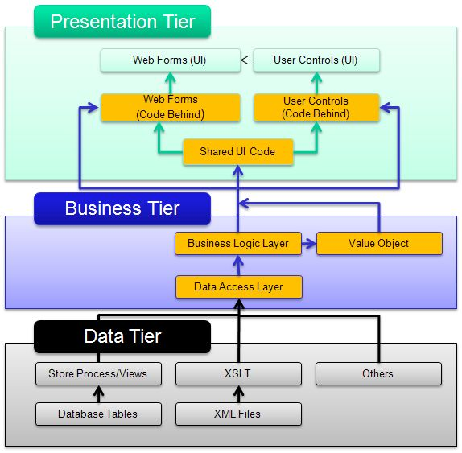

- Business Analyst should keep What points in his/her mind before he frames a Question to ask to the Stakeholder
( 5W 1H – SMART – RACI – 3 Tier Architecture – Use Cases, Use case Specs, Activity Diagrams, Models, Page designs)?
- Any Information which you gather should fit into any one of the below 6 sections described, otherwise it is just an information or a non-functional requirement:
- The 5W1H is a useful tool for gathering information and understanding a situation by answering questions about Who, What, When, Where, Why and How
- The SMART technique can help in creating questions: (Specific, Measurable, Attainable, Relevant & Time Bound)
- RACI Charts help define and clarify roles and responsibilities within a team by outlining who is responsible, accountable, consulted, and informed for each task
- UML(Unified Modeling Language) is a standardized way of diagramming and modeling software systems to aid in design, development and communication between team members
- There are 5 models mainly mentioned in BABOK V3 they are: Domain Model, Conceptual Model, Data Model, DFD, ER Diagram
- Screens / Pages are consequence of Matured Functional Requirement.
- Sign offs (Confirmations) should be taken on all Documents, Diagrams, SDLC Stages from responsible Stakeholders.

- As a Business Analyst, What Elicitation Techniques you are aware of? ( BDRFOWJIPQU)?
- Here are some Elicitation Techniques:
- Brainstorming: Brainstorming can be done either individually or in groups. The ideas collected during the brainstorming session are reviewed or analyzed. Brainstorming is an effective way to generate lots of ideas on a specific issue and then determine which idea is the best solution
- Document Analysis: Document analysis is done through reading a document and understanding the product, process and project
- Reverse Engineering: Reverse engineering, also called back engineering, is the processes of extracting knowledge or design information from anything man-made and re- producing it or re-producing anything based on the extracted information. The process often involves disassembling something and analyzing its components and workings in detail. Majorly used in migration projects.
- Focus Groups: A focus group is a means to elicit ideas and attitudes about a specific product, service or opportunity in an interactive group environment
- Observation: Observing, shadowing users or doing a part of their job, can provide information of existing processes, inputs and outputs.
- Workshops: A requirement workshop is a structured approach to capture requirements. A workshop may be used to scope, discover, define, prioritize and reach closure on requirements for the target system
- JAD(Joint Application Development): Application developed through JAD has higher customer satisfaction and less number of errors as user is directly involved in the development process
- Interviews: Interview of a user and stakeholders are important in creating software. An interview is a systematic approach where interviewee is going to ask relevant questions
- related to software and documenting the responses
- Prototyping: Prototyping is an attractive idea for complicated and large systems for which there is no manual process or existing system to help determining the requirements
- Questionnaires/Surveys: Questionnaire can be useful for obtaining limited system requirements details form the users/ stakeholders, who have minor input or are geographically remote
- User Stories/ Use Cases: Descriptions of how a user interacts with the system. Helps in identifying detailed functional requirements and alternate flows
- Which Elicitation Techniques can be used in this Project and Justify your selection of Elicitation Techniques?
- Prototyping
- Use case Specs
- Document Analysis
- Brainstorming
Fertilizers, seeds, pesticides details from the manufacturers and should be able to display them to the Farmers.
To gather the business requirements from the client, you went to SOONY and met Mr. Henry. When Mr. Henry was asked about the project and what are they expecting from the project, Mr. Henry stated that he is expecting to have a login for all its users (fertilizers, seeds, pesticides manufacturers and Farmers) , a product catalog of fertilizers, seeds, pesticides, a search option to search for products, payment process, and delivery tracking. After doing the stakeholder analysis, you have found out that Peter, Kevin, Ben are the key stakeholders and you have scheduled an appointment to meet them. After meeting with them and trying to gather the stakeholder requirements, Kevin said that, a Farmer should be able to browse through the products catalog once they visit the website and need to have a search option so that they can search for any product they need. Peter said that, if a farmer wants to buy any product or add them to buy-later list, they need to login first using their email id and password. If it is a new user, then they can create a new account by submitting their email ID and creating a secure password. Ben added saying that, Farmers needs to have an easy-to-use payment gateway which should include cash-on-delivery (COD), Credit/Debit card and UPI options so that the user’s experience should be better. Kevin mentioned that, a user gets an email confirmation regarding their order status. A delivery tracker to track the whereabouts of their order.
Identify Business Requirements (which includes Stakeholder Requirements)
- BR001 – Farmers should be able to search for available products in fertilizers, seeds, pesticides
- BR002 – Manufacturers should be able to upload and display their products in the application
- Based on the project context and stakeholder interactions described, the following elicitation techniques are most appropriate and justified for this agriculture e-commerce platform:

Prototyping:
- Visual representations (wireframes/mockups) of the UI will help non-technical stakeholders (farmers, manufacturers) easily understand and validate what the system will look like.
- Stakeholders like Kevin, Peter, and Ben emphasized user experience and specific UI behaviors (e.g., search options, login, payment gateway, delivery tracker), which are best explored through prototypes.
- Example Application in this Project: Design mockups for:
- Login/Register page
- Product Catalog/Search page
- Cart & Buy Later
- Payment page with multiple options
- Delivery tracking screen
- Present to stakeholders for feedback.

Use Case Specifications
- Each user action mentioned (e.g., login, search, browse catalog, make payment, track order) represents a distinct use case.
- Use Case Specs help define how each actor (Farmer, Manufacturer) interacts with the system in step-by-step flows.
- Helps development and QA teams to clearly understand functional scenarios.
- Example Application in this Project: Write detailed use case specs for:
- UC001: Farmer Login/Registration
- UC002: Product Search and Browse
- UC003: Add to Cart / Buy Later
- UC004: Upload Product (Manufacturer)
- UC005: Make Payment
- UC006: Track Order Status
Document Analysis
- To understand similar CSR projects, farming supply chains, and any existing internal documents (SOPs, brochures, or regulatory compliance for agricultural e-commerce).
- Helps create a baseline before meeting stakeholders and avoids asking questions that are already documented.
- Example Application in this Project: Review:
- Any existing app/portal references
- Existing product catalogs (from manufacturers)
- Government agriculture e-commerce initiatives
- Previous SOONY CSR documentation (if available)
Brainstorming
- Ideal to gather diverse perspectives in the initial phase, especially from internal team (Mr. Henry, Committee) and farmers.
- Useful to explore feature ideas, usability issues, or implementation challenges in a group setting.
- Example Application in this Project: Conduct sessions with:
- SOONY Committee: What they envision as success for the app?
- Farmers: What challenges they face with existing buying options?
- Developers/Designers: What innovative solutions can be implemented for remote usability?

- Make suitable Assumptions and identify at least 10 Business Requirements?
- Business Requirements are the specific needs or conditions that a business must meet to achieve its Objectives, below are some of the Business Requirements that are useful for this project:
- BR001: Users should be able to Search for fertilizers, seeds, and pesticides
- BR002: System should support offline mode for farmers with intermittent internet, syncing data once back online
- BR003: If the User is the new user then he should create the login Id and Password first
- BR004: Users should be able to add products to buy-later list or proceed to purchase
- BR005: Manufacturers should be able to upload and display their products in the application
- BR006: The system must be available in multiple regional languages for accessibility
- BR007: The system will support both Web and Mobile platforms
- BR008: Multiple payment options should be available (COD, Credit/Debit, UPI)
- BR009: Email confirmation should be sent upon order placement
- BR010: Delivery tracking system should be available to users
- BR011: The app should support basic analytics for product popularity
- BR012: A support/helpdesk feature is expected for farmers needing assistance
- BR013: Farmers should be able to view past order history and leave product reviews/ratings
- BR014: Admin users should be able to manage users, monitor transactions, and handle product approval or disputes
- BR015: The application should allow notifications/reminders for offers, order status, and new product listings

- List your assumptions?
- Some of the Assumption are following:
- Assumption 1: A user can login using Face book or Google account.
- Assumption 2: A user has Knowledge on Agriculture
- Assumption 3: Online Shopping Trend is increasing. The customers prefer Online Shopping
- Assumption 4:The Designers have Designs to display in the Application. The need for the application is ever growing
- Assumption 5: The customers have online accounts for secured payment processing
- Assumption 6:The customers can get the real time information about Prices, Products etc.,

- Give Priority 1 to 10 numbers ( 1 being low priority – 10 being high priority) to these Requirements after discussions with the stakeholders
Req ID | Req Name | Req Description | Priority
BR001 | Farmer Search for Products | Farmers should be able to search for available products in fertilizers, seeds, pesticides | 8
BR002 | Manufacturers upload their Products | Manufacturers should be able to upload and display their products in the application | 8
Once the requirements are finalized, as a business analyst, one of the major roles is to act as a
liaison between the client and the project team. To gather the requirements correctly from the client side and then to deliver those requirements to the project team in a way they understand.
To make the project team understand the requirements, you need to convert those requirements into UML diagrams and screen mock-ups?
- Here is some Requirements and their Priorities
Req Id | Req Name | Req Description | Priority
BR001 | Product Search | User should be able to Search for Products | 9
BR002 | Online/Offline | System should support offline mode for farmers with intermittent internet, syncing data once back online | 8
BR003 | Login | Users should be able to securely register and log in using their respective credentials | 10
BR004 | Cart | Farmers should be able to add products to cart or buy-later list | 7
BR005 | Manufacturers upload their Products | Manufacturers should be able to upload and display their products in the application | 8
BR006 | Multi-language Support | Support regional languages for better accessibility | 7
BR007 | System Support | The system will support both Web and Mobile platforms | 6
BR008 | Payment Integration | Support multiple payment methods for convenience  (COD, Credit/Debit, UPI) | 9
BR009 | Order Confirmation Notification | Send confirmation via Email/SMS upon order placement | 6
BR010 | Delivery Tracking System | User should be able to track their order's status | 8
BR011 | Support Analysis | The app should support basic analytics for product popularity | 7
BR012 | support/helpdesk feature | A support/helpdesk feature is expected for farmers needing assistance | 6
BR013 | Product Reviews & Ratings | Allow farmers to leave feedback and rate products | 5
BR014 | Admin Panel for Monitoring | Admin should manage users, orders, and approvals | 9
BR015 | notifications/reminders | The application should allow notifications/reminders for offers, order status, and new product listings | 5

- Draw use case diagram?
- A use case diagram is a visual representation of the Interactions between users (actors) and a system.
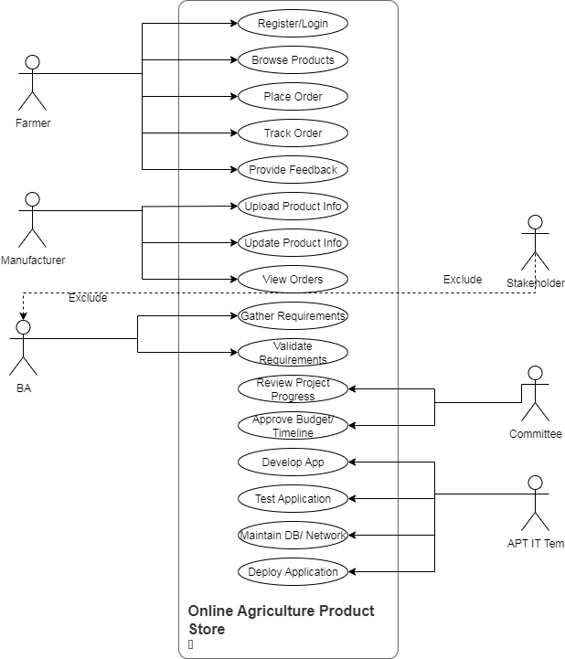

- Prepare use case specs for all use cases?
- A Use Case Specification Document which provides a detailed description of a use case, outlining how users (actors) will interact with the system to achieve a specific goal
UC001 – Login/Register
- Use Case ID: UC001
- Use Case Name: Login/Register
- Actors: Farmer, Manufacturer
- Description: Allows a user to log in or register using email and password
- Pre-Conditions: User is not logged in. Internet connection is active
- Post-Conditions: User is authenticated and redirected to dashboard
- Main Flow: User clicks login/register. User enters email and password (or creates new account). System validates credentials. User is redirected to their homepage
- Alternate Flow: Forgot Password flow. Email already registered
- Exceptions: Invalid login, server timeout, weak password
UC002 – Search/Browse Products:
- Use Case ID: UC002
- Use Case Name: Search/Browse Products
- Actors: Farmers
- Description: Farmer searches and browses available fertilizers, seeds, and pesticides
- Pre-Conditions: User is logged in
- Post-Conditions: Product list is displayed based on input/filter
- Main Flow: Farmer enters keyword or selects category. System filters results. Product list is shown
- Exceptions: No matching results, slow response
UC003 – Add to Cart / Buy Later:
- Use Case ID: UC003
- Use Case Name: Add to Cart / Buy Later
- Actors: Farmer
- Description: Farmer can add selected products to shopping cart or save them for later
- Pre-Conditions: Product is selected and user is logged in
- Post-Conditions: Item is added to cart or wish list
- Main Flow: Farmer clicks “Add to Cart” or “Buy Later”. System confirms addition
- Exceptions: Product out of stock, network issue
UC004 – Make Payment
- Use Case ID: UC004
- Use Case Name: Make Payment
- Actors: Farmer
- Description: Farmer pays using available options like COD, UPI, Credit/Debit Card
- Pre-Conditions: Items are in cart. Address and shipping info is filled
- Post-Conditions: Payment successful and order is placed
- Main Flow: Farmer proceeds to checkout. Selects payment method. Enters required info. Payment is processed. Confirmation shown
- Exceptions: Payment failure, invalid card, UPI limit exceeded
UC005 – Track Order
- Use Case ID: UC005
- Use Case Name: Track Order
- Actors: Farmer
- Description: Allows farmers to track current delivery status of an order
- Pre-Conditions: Order is placed
- Post-Conditions: Status is shown with location (if available)
- Main Flow: User goes to order history. Selects an order. System shows tracking info from logistics API.
- Exceptions: Tracking unavailable, logistics API error
UC006 – Receive Order Notifications
- Use Case ID: UC006
- Use Case Name: Receive Order Notifications
- Actors: Farmer
- Description: Sends order confirmation and status updates via email/SMS
- Pre-Conditions: User has placed an order
- Post-Conditions: Notification sent successfully
- Main Flow: Order is confirmed. System sends email/SMS confirmation. Updates sent on delivery stages
- Exceptions: Notification server failure, incorrect email/phone
UC007 – Upload Product
- Use Case ID: UC007
- Use Case Name: Upload Product
- Actors: Manufacturer
- Description: Manufacturer uploads product details for sale
- Pre-Conditions: Manufacturer is logged in
- Post-Conditions: Product submitted for review or listed directly
- Main Flow: Manufacturer fills product form. Uploads images and sets price, quantity. Submits form
- Exceptions: Invalid data, missing fields
UC008 – Manage Product Catalog
- Use Case ID: UC008
- Use Case Name: Manage Product Catalog
- Actors: Manufacturer
- Description: Manufacturer updates, deletes, or views product listings
- Pre-Conditions: At least one product exists
- Post-Conditions: Catalog reflects changes
- Main Flow: User goes to catalog section. Chooses product to edit/delete. Saves changes
- Exceptions: Product not found, permission denied
UC009 – Admin Panel Access
- Use Case ID: UC009
- Use Case Name: Admin Panel Access
- Actors: Admin
- Description: Admin logs into the panel to manage users, products, and complaints
- Pre-Conditions: Admin credentials required
- Post-Conditions: Admin dashboard displayed
- Main Flow: Admin logs in. Dashboard with tabs (Users, Products, Reports, Complaints) appears
- Exceptions: Invalid login, access denied
UC010 – Approve Product Listings
- Use Case ID: UC010
- Use Case Name: Approve Product Listings
- Actors: Admin
- Description: Admin reviews and approves products submitted by manufacturers
- Pre-Conditions: Product is submitted and pending
- Post-Conditions: Product is either approved or rejected
- Main Flow: Admin views pending products. Reviews info and images. Approves or rejects product
- Exceptions: Product doesn’t meet standards, image quality issue

- Activity diagrams?
- An Activity Diagram is a type of Diagram in the Unified Modeling Language(UML) that Visually represents the flow of Activities within a system

User Registration :
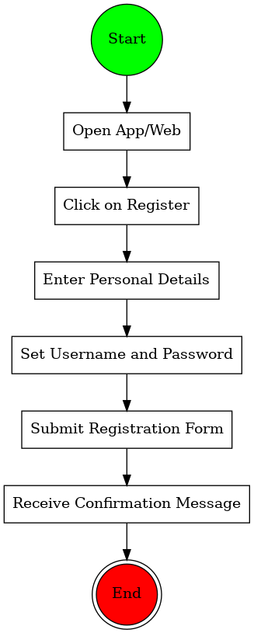

Search Products:
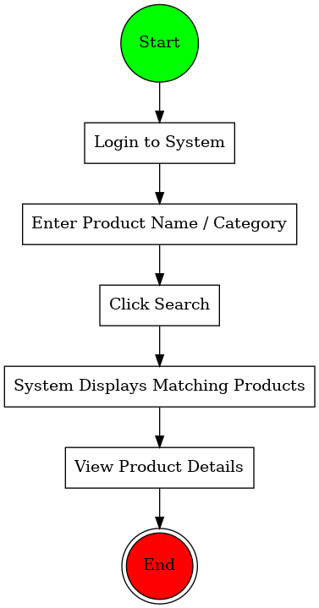

Add To Cart:
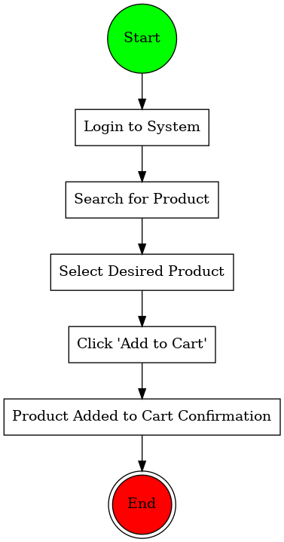
Make Payment:
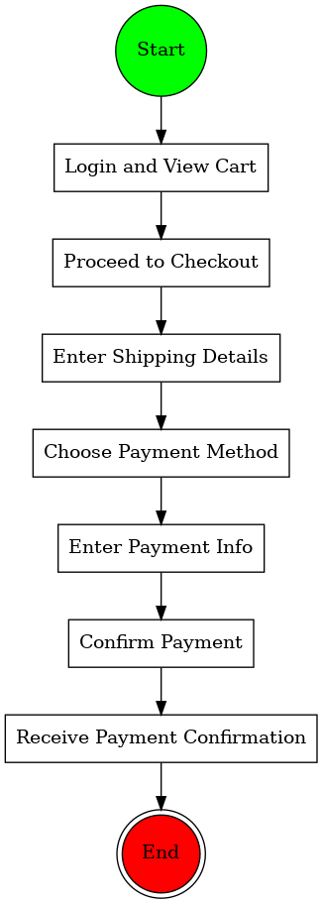

Delivery:
