Waterfall Project

Part 2/2 Evaluation

Document 6- Please prepare a use case diagram, activity diagram and a use case specification document

Answer :

USE CASE DIAGRAM
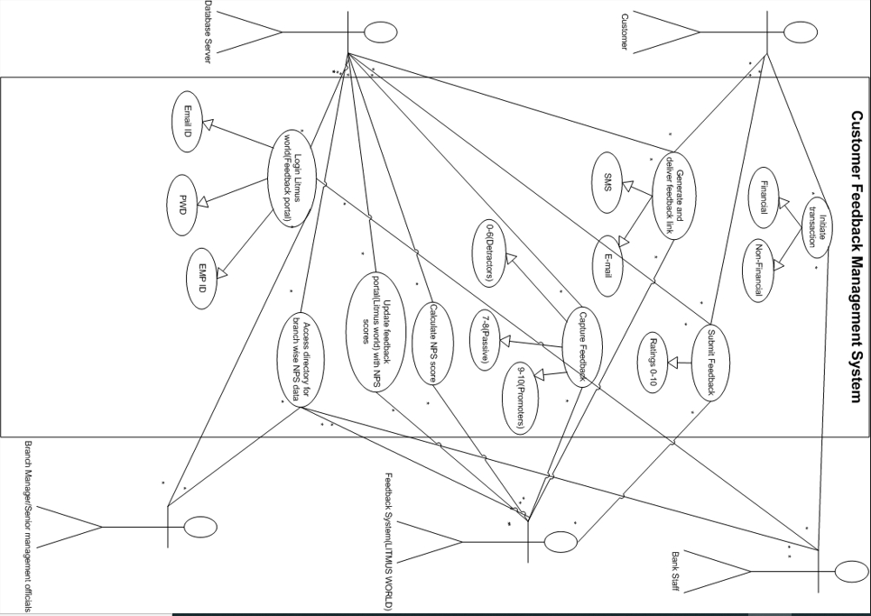

ACTIVITY DIAGRAMS
- User Feedback
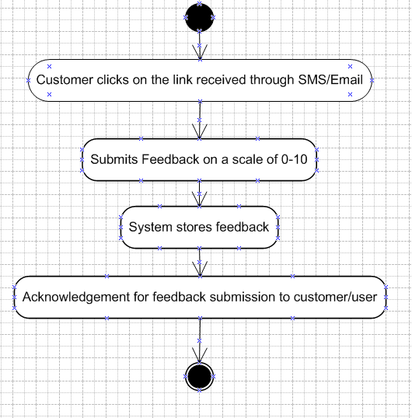

- Feedback Processing and NPS calculation
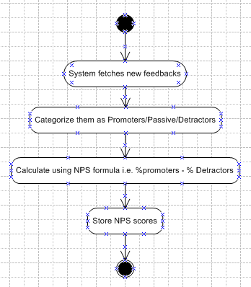

- Branch wise/user wise feedback and NPS aggregation
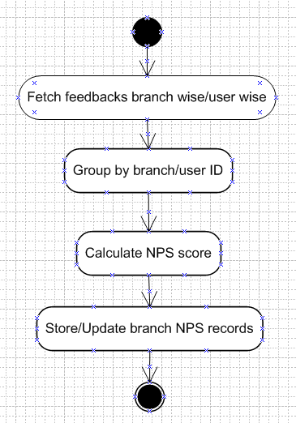

- Branch user/Branch Manager/Senior management officials login
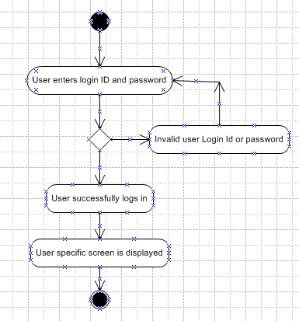

- Branch Manager/Senior Management official dashboard workflow
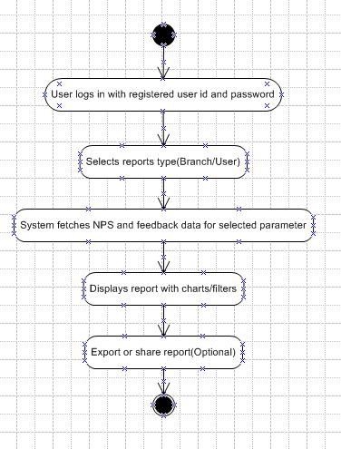

USE CASE SPECIFICATION DOCUMENT :
1)
- Use Case Name : Initiate Transaction

Use Case Description : Start a financial or non-financial operation.

Actors : User, System

Basic Flow : User selects and submits a transaction.

Alternate Flow : Show error for unsupported types.

Exceptional Flows : Fail on auth, funds, or system error.

Pre-Conditions : User must be logged in.

Post-Conditions : Transaction is logged or failed.

Assumptions : Services are available.

Constraints : Must follow session and security rules.

Dependencies : Banking and auth services.

Inputs : Transaction data.

Outputs : Transaction done.

Business Rules : Authentication is mandatory.

Miscellaneous Information : Logs kept for audit.

2)

Use Case Name : Submit Feedback

Use Case Description : Customer rates service from 0–10 through link in SMS/Email.
- Actors : Customer, Feedback System
- Basic Flow : Customer clicks link and submits score.
- Alternate Flow : Link expires or is already used.
- Exceptional Flows : Link invalid or system error.
- Pre-Conditions : Customer receives valid link.
- Post-Conditions : Feedback is recorded.
- Assumptions : Customer has access to device and link.
- Constraints : Link valid for a limited time.
- Dependencies : SMS/Email service, Feedback server
- Inputs : Score (0–10)
- Outputs : Acknowledgement
- Business Rules : Only one submission per link.
- Miscellaneous Information : May trigger NPS calculation.
3)
- Use Case Name : Generate Feedback Link
- Use Case Description : System generates a unique feedback link and sends it via SMS/Email.
- Actors : System, Customer, Notification Service
- Basic Flow : System generates link and delivers it to customer.
- Alternate Flow : Delivery fails, system retries or logs failure.
- Exceptional Flows : Invalid contact info or system outage.
- Pre-Conditions : Valid transaction or interaction completed.
- Post-Conditions : Feedback link delivered to customer.
- Assumptions : Customer contact details are up to date.
- Constraints : Link must be secure and time-limited.
- Dependencies : Notification system, Customer database
- Inputs : Customer ID, Customer’s registered contact information like mobile number/email id.
- Outputs : Feedback link sent via SMS/Email
- Business Rules : One feedback link per interaction.
- Miscellaneous Information : Link may be personalized or tokenized for security.
4)
- Use Case Name: Capture Feedback
- Use Case Description: Collect user feedback for improvement
- Actors: User, System
- Basic Flow: User submits feedback; system stores and confirms.
- Alternate Flow: Prompt user to correct invalid input.
- Exceptional Flows: Fail on system or database error.
- Pre-Conditions: User has access to feedback form.
- Post-Conditions: Feedback recorded and acknowledged.
- Assumptions: Users willing to provide feedback.
- Constraints: Must comply with privacy laws.
- Dependencies: Feedback management system availability.
- Inputs: Feedback text, rating.
- Outputs: Submission confirmation.
- Business Rules: Offensive content is rejected.
- Miscellaneous Information: Supports anonymous submissions.
5)
- Use Case Name: Calculate NPS Score
- Use Case Description: Compute Net Promoter Score from collected feedback.
- Actors: System, Admin
- Basic Flow: System processes feedback; calculates and stores NPS.
- Alternate Flow: Handle incomplete or invalid feedback data.
- Exceptional Flows: Fail on data processing or system errors.
- Pre-Conditions: Feedback data is available and accessible.
- Post-Conditions: NPS score is generated and saved.
- Assumptions: Feedback responses are representative.
- Constraints: Must use standard NPS calculation formula.
- Dependencies: Feedback database and analytics module.
- Inputs: Feedback ratings (0-10 scale).
- Outputs: NPS score report.
- Business Rules: Only valid feedback included in calculation.
- Miscellaneous Information: Reports generated periodically.

Document 7- Screens and pages
Answer:
1)
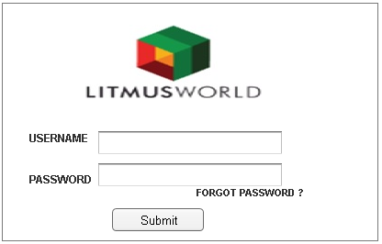
2)
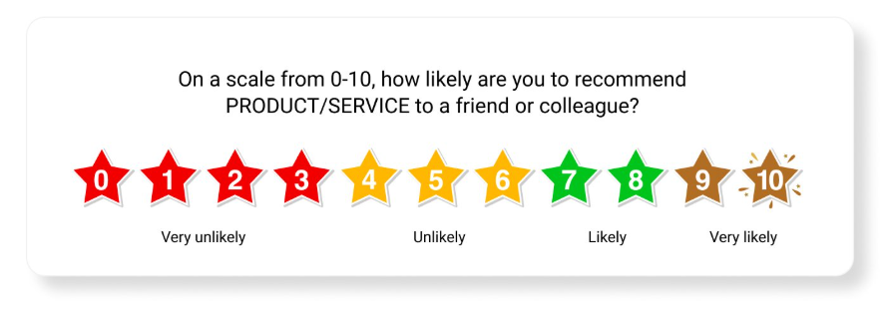
3)
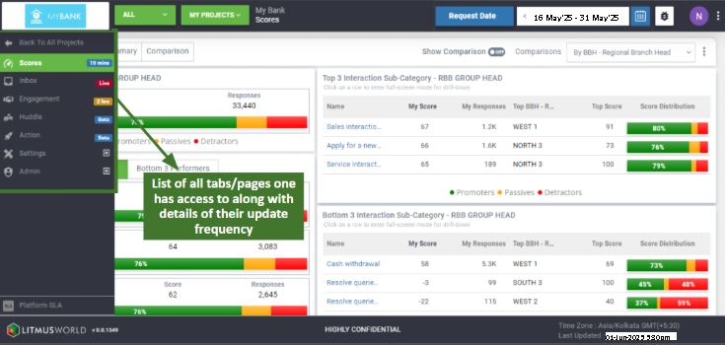
4)

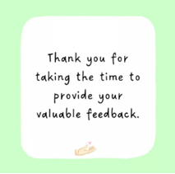

Document 8- Tools-Visio and Axure
Answer :

Experience with Microsoft Visio and Axure

In this project, I effectively utilized Microsoft Visio and Axure to streamline both the planning and prototyping stages of development. Microsoft Visio was essential in creating comprehensive technical diagrams, including process flows, system architectures, and organizational charts, which supported precise documentation and effective communication among stakeholders. Axure was employed to build dynamic, high-fidelity prototypes and wireframes, enabling detailed interaction design and user journey mapping. The ability of both tools to support collaboration and real-time updates significantly improved team alignment and accelerated the design iteration process, resulting in a robust and user-centric Litmus World platform.

Document 9- BA experience
My experience as BA in following phases:
1. Requirement gathering:
2. Requirement Analysis:
3. Design:
4. Development:
5. Testing:
6. Deployment:

Answer :
1. Requirement Gathering
• In this project, I applied my expertise as a Business Analyst to gather comprehensive requirements using the MOSCOW technique for the Litmus World portal.
• By conducting stakeholder interviews, workshops, and surveys, I thoroughly documented the needs and expectations of teachers, administrators, and IT staff.
• I validated the requirements using the FURPS technique.
• Through elicitation techniques such as use case analysis and process mapping, I ensured a complete understanding of both functional and non-functional requirements.
• My experience in requirement gathering enabled the creation of a detailed and accurate requirements document, which served as a strong foundation for the successful development and implementation of the Litmus World portal.
• Prototyping was used to further refine and specify requirements.
2. Requirement Analysis
• In this project, I applied my analytical skills as a Business Analyst to perform a detailed requirements analysis for the Litmus World portal.
• I began by organizing and classifying the gathered requirements to ensure clarity and eliminate ambiguities.
• Through detailed analysis, I identified and merged duplicate requirements, resulting in a streamlined and consistent set of needs.
• I shared diagrams with the team to gather feedback and incorporated their suggestions, making necessary adjustments.
• Regular validation sessions with stakeholders were conducted to verify the accuracy and completeness of the requirements.
• By creating and sharing prototypes, I promoted stakeholder engagement, helping refine the requirements to fully align with user expectations. This thorough approach ensured a solid base for the project’s success.
• Prepared BRS and SRS documents.
3. Design
• Created test cases based on use case diagrams.
• Communicated with the client regarding design and solution documents.
• Developed both negative and positive test cases.
• Ensured no test case was missed, as omissions could significantly impact later stages of development.
• Prepared necessary test data for the testing phase.
• Maintained and updated the RTM to ensure all requirements were met.
4. Development
• Organized and conducted JAD sessions.
• Resolved technical team queries during the coding phase.
• Managed conflicts during JAD sessions by addressing disagreements individually, explaining the impact of uncooperative behavior on the project, and fostering a healthy team environment.
• Referred to diagrams for accurate unit development.
• Held regular meetings with the technical team and client. When team members were unavailable, I ensured the session was recorded and followed up with individual discussions.
5. Testing
• Derived test cases from use cases.
• Conducted high-level testing.
• Requested test data from the client.
• Updated the RTM accordingly.
• Obtained client signoff.
• Prepared the client for UAT.
6. Deployment
• Shared the finalized RTM with the client as part of the project closure documentation.
• Coordinated the creation and distribution of end-user manuals.
• Planned and conducted training sessions.
• Ensured full attendance for all training meetings.

