Online Agriculture Products Store
Mr. Henry, after being successful as a businessman and has become one of the wealthiest persons in the city. Now, Mr. Henry wants to help others to fulfil their dreams. One day, Mr. Henry went to meet his childhood friends Peter, Kevin and Ben. They live in a remote village and do farming. Mr. Henry asked his friends if they are facing any difficulties in their day-to-day work.
Peter told Mr. Henry that he is facing difficulties in procuring fertilizers which are very important for farm. Kevin said that he is also facing the same problem in-case of buying seeds for farming certain crops. Ben raised his concern on lack of pesticides which could help in greatly reducing pests in crops. After listening to all his friends’ problems, Mr. Henry thought that this is a crucial problem faced not only by his friends but also by so many other farmers. So, Mr. Henry decided to make an online agriculture product store to facilitate remote area farmers to buy agriculture products. Through this Online Web / mobile Application, Farmers and Companies (Fertilizers, seeds and pesticides manufacturing Companies) can communicate directly with each other.
The main purpose to build this online store is to facilitate farmers to buy seeds, pesticides, and
Fertilizers from anywhere through internet connectivity. Since new users are involved, Application should be user friendly. This new application should be able to accept the product (fertilizers, seeds, pesticides) details from the manufacturers and should be able to display them to the Farmers. Farmers will browse through these products and select the products what they need and request to buy them and deliver them to farmer’s location. Mr. Henry has given this project through his Company SOONY. In SOONY Company, Mr Pandu is Financial Head and Mr Dooku is Project Coordinator. Mr. Henry, Mr Pandu, and Mr Dooku formed one Committee and gave this project to APT IT SOLUTIONS Company for Budget 2 Crores INR and 18 months Duration under CSR initiative. Peter, Kevin and Ben are helping the Committee and can be considered as Stakeholders share requirements for the Project. Mr Karthik is the Delivery Head in APT IT SOLUTIONS company and he reached out to Mr Henry through his connects and Bagged this project. APT IT SOLUTIONS Company have Talent pool Available for this Project. Mr Vandanam is project Manager, Ms. Juhi is Senior Java Developer, Mr Teyson, Ms Lucie, Mr Tucker, Mr Bravo are Java Developers. Network Admin is Mr Mike and DB Admin is John. Mr Jason and Ms Alekya are the Tester. And you joined this team as a BA.
Mr. Henry has company name SOONY Company, has following team.
- Mr Pandu - Financial Head
- Mr Dooku - Project Coordinator.
- Mr. Henry, Mr Pandu and Mr Dooku formed Committee
Mr. Henry outsourced this project to company name (APT IT SOLUTIONS) offshore team:-
-Mr Karthik - Delivery Head
-Mr Vandanam - project Manager
-Ms. Juhi - Senior Java Developer
-Mr Teyson – Developer 1
-Ms Lucie – Developer 2
-Mr Tucker – Developer 3
-Mr Bravo – Developer 4
-Mr Mike - Network Admin
- Mr John - Database Admin
-Mr Jason and Ms Alekya - Testers
-Mr Sujeet as a BA.
Question 1 – Functional Requirements - 15 Marks
Identify minimum 20 functional requirements.
Example:
Functional requirement: When an order is fulfilled, the local printer shall print a packing slip.
Non-Functional Requirement: Packing slips shall be printed on both sides of 4”x 6” white paper, the standard size for packing slips used by local printers.

Req ID | Req Name | Req Description | Priority
FR0001 | Farmer Registration | Farmers should be able to register with the application | 8
FR0002 | Farmer Search for Products | Farmers should be able to search for available products in fertilizers, seeds, pesticides | 8
NFR0101 | Page Loading Time | Each Page should load within 2 seconds time | 9
NFR0102 | WCAG 2.1. | The system must meet Web Content Accessibility Guidelines WCAG 2.1. | 9
Answer:
Req ID | Req Name | Req Description | Priority
FR001 | User registration and Login | Allow customer to create an account and login to the application to | 10
FR002 | Product Catalogue | Display all available products in a user friendly with detailed | 10
FR003 | Shopping cart | Allow customer to add products to a virtual shopping cart, review | 7
FR004 | Payment processing | Provide secure payment processing options to customers using | 7
FR005 | Order Management | Allow customers to view their order history and track the status of | 6
FR006 | Search | Implement a search bar to allow customers to find products based | 5
FR007 | Product reviews and Ratings | Allow customers to leave ratings for products they have purchased to help other customers make informed decisions | 4
FR008 | Wish list | Allow customers to save products they are interested into a | 8
FR009 | Shipping and Delivery | Provide customers with shipping options and estimated delivery | 5
FR0010 | Return and Refund Policy | Online the return and refund policy for customers to ensure a positive customer experience and minimize customer complaints | 5
FR0011 | Payment processing | Provide secure payment processing options to customers using | 8
FR0012 | Order Management | Allow customers to view their order history and track the status of | 5
FR0013 | Search | Implement a search bar to allow customers to find products based | 5
FR0014 | Product reviews and Ratings | Allow customers to leave ratings for products they have purchased to help other customers make informed decisions | 10
FR0015 | Wish list | Allow customers to save products they are interested into a | 10
FR0016 | Shipping and Delivery | Provide customers with shipping options and estimated delivery | 7
FR0017 | Return and Refund Policy | Online the return and refund policy for customers to ensure a positive customer experience and minimize customer complaints | 7
FR0018 | Wish list | Allow customers to save products they are interested into a | 6
FR0019 | Shipping and Delivery | Provide customers with shipping options and estimated delivery | 5
FR0020 | Return and Refund Policy | Online the return and refund policy for customers to ensure a positive customer experience and minimize customer complaints | 4
Question 2 - Minimum 5 page designs - 15 Marks
Make wireframe and prototypes
Answer:
Homepage
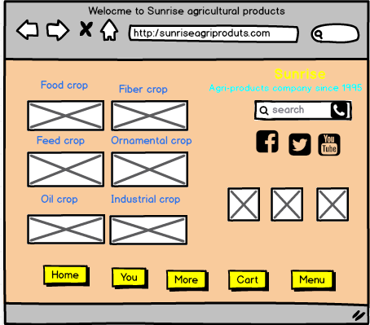
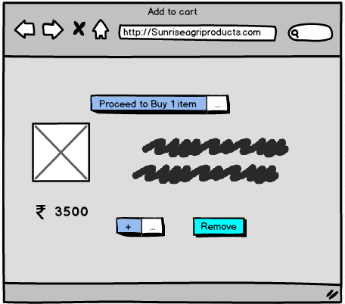
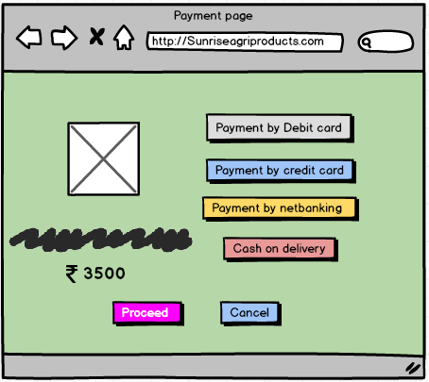
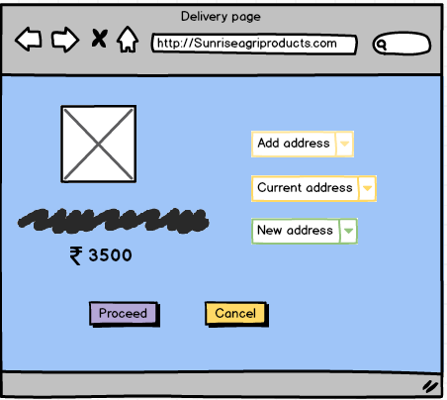
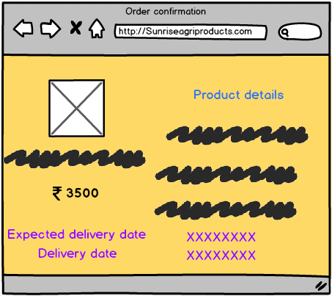

- Question 3 – Tools (Visio, Balsamiq) - 15 Marks
Make a note of the Tools, which you are using for above concepts.
Answer
Microsoft Visio
Microsoft Visio is a powerful diagramming tool used for creating structured diagrams, flowcharts, and system architectures. Here’s how Visio can help in this project:
- System Architecture Diagrams – Illustrates how various components like users, databases, and servers interact.
- Process Flowcharts – Maps out user journeys, order processing, and product management workflows.
- Entity Relationship Diagrams (ERD) – Designs the database structure by showing relations between tables such as farmers, manufacturers, orders, and products.
- Network Diagrams – Helps visualize the cloud-based infrastructure and connectivity requirements.
- Use Case Diagrams – Defines interactions between users and the system.
Balsamiq
Balsamiq is a user-friendly wireframing tool focused on UI/UX design. It helps in creating:
- Low-Fidelity Wireframes – Simple sketches of web and mobile application screens.
- Prototype Designs – Clickable elements to simulate the user experience.
- User Interface Layouts – Ensures intuitive navigation and usability.
- Interactive Mockups – Tests the design with users before development begins.
- Drag-and-Drop Components – Speeds up wireframe creation for dashboards, order pages, and product listings.
Comparison
- Visio: Ideal for technical diagrams, workflows, and backend structure.
- Balsamiq: Best for user interface design, mockups, and front-end visualization.
Question 4 – RTM - 6 Marks
A business analyst’s key responsibilities are to keep track of the requirements and make sure that no requirement is missed. Mr. Henry and peter have approached you regarding the current status of the project. How will you tackle this situation?
Answer:
- Gather Requirements: Compile functional and non-functional requirements from stakeholders (farmers, manufacturers, project sponsors).
- Define Requirement Categories: Classify them into sections like UI/UX, Payment, Ordering, Product Management, etc.
- Map Requirements to Deliverables: Ensure each requirement corresponds to specific modules in the application.
- Track Progress & Status: Indicate whether each requirement is completed, in progress, or pending.
- Traceability across Phases: Link requirements to design, development, testing, and deployment phases.
- Validate & Review: Regularly update stakeholders with progress and verify completeness.
- RTM Template Example
Req. ID | Requirement Description | Category | Priority | Assigned To | Status | Reference Docs
FR-001 | Farmers must be able to register and log in securely. | Functional | High | Dev Team | In Progress | BRD, Design Docs
FR-002 | Companies should list and manage agricultural products. | Functional | High | Dev Team | Completed | BRD, UI Mockups
FR-003 | Users must be able to search/filter products easily. | Functional | Medium | Dev Team | Pending | BRD, UX Specs
FR-004 | Secure payment gateway integration is required. | Functional | High | Dev Team | In Progress | Payment API Docs
NFR-001 | Application must load within 3 seconds. | Performance | High | Dev Team | Pending | Performance Test Reports

Question 5 – 10 Test Case Documents - 10 Marks
Answer:
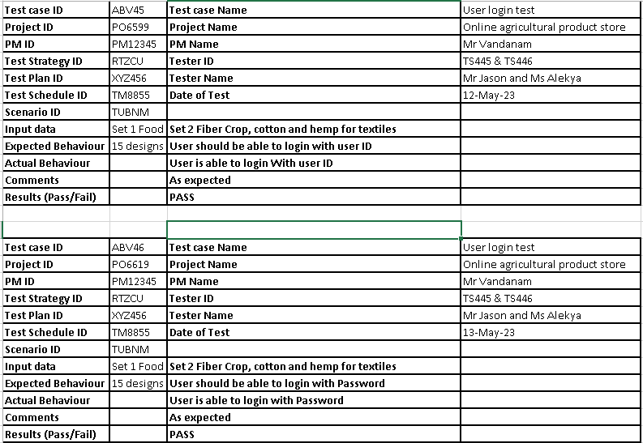
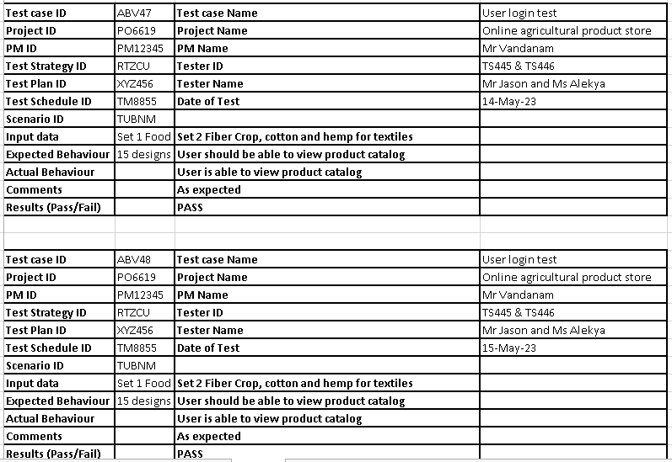

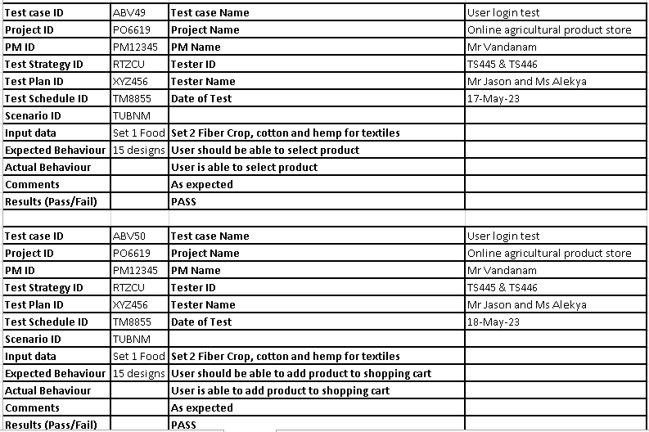
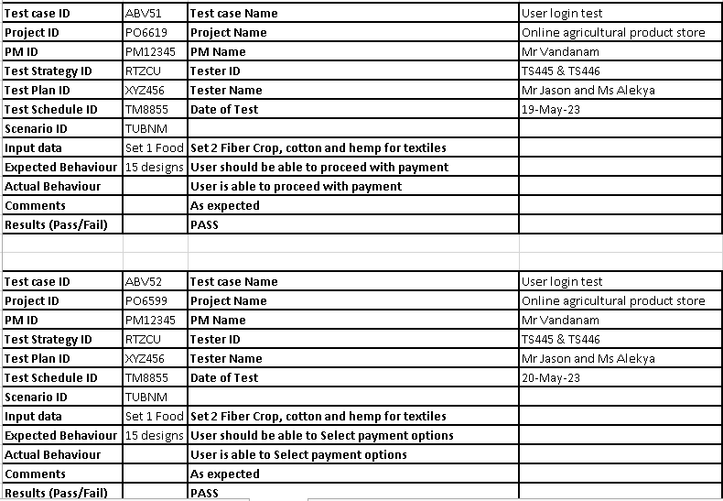

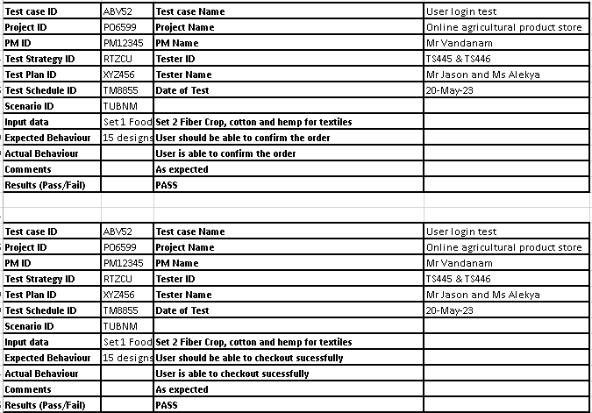
Question 6 – DB Design – 8 Marks
After the requirements are thoroughly explained to the entire project team by business analyst, the Database architects have decided to do the database design and also to represent the in-flow and out-flow of data. Draw database schema and ER diagram.
Answer: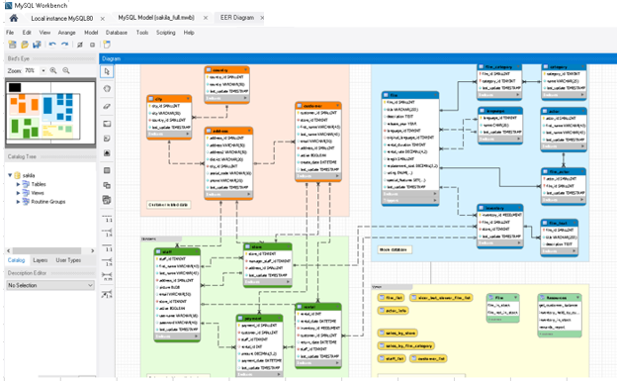
Question 7 – Data Flow Diagram - 3 Marks
what is a data flow diagram? Draw a data flow diagram to represent the in-flow and out-flow of data when a Farmer is placing an order for the product.
Answer:
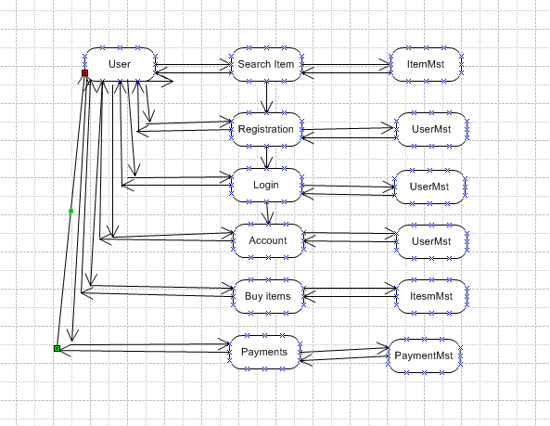
Question 8 – Change Request - 10 Marks
Due to change in the Government Taxation structure. we should change the Tax structure How do you handle change requests in a project?
Answer
1. Acknowledge and Log the Request
Start by formally recording the change request in the Change Request Register, with details like:
- Request origin (e.g., Mr. Henry, Regulatory Alert)
- Description: "Update product pricing and invoicing tax logic as per new government structure"
- Date received
- Priority level (High, due to regulatory compliance)
2. Conduct Impact Analysis
- Developers (Juhi & team) to understand code-level impact
- DB Admin (John) to check if tax-related schemas need alteration
- Testers (Jason, Alekya) for regression testing effort
- Network Admin (Mike) if APIs or integrations are affected
- Finance Head (Mr. Pandu) to validate correct interpretation of new tax laws
3. Update Requirement Documents
- New tax categories/logic
- Tax-exempt conditions (if any)
- UI changes (e.g., how tax details are shown in checkout or invoices)
4. Seek Approval from Stakeholders
- Committee (Mr. Henry, Mr. Pandu, Mr. Dooku)
- Possibly Peter or Ben if farmer impact needs validation
Once reviewed and approved, get sign-off on the updated scope.
5. Coordinate with PM & Dev Team
- Create a separate sprint for tax update
- Adjust existing timelines
- Reallocate tasks among developers
6. Implement & Test
- Validate calculations across product types
- Verify tax applied correctly in invoices, order summaries, reports
- Conduct UAT with stakeholders or committee members
7. Update Documentation & Communicate
- Ensure updated user manuals or help sections reflect tax changes
- Notify end users (e.g. farmers) about how prices may appear differently due to new tax rules
Question 9 – Change Request Vs an Enhancement - 5 Marks?
As the project is in process, Ben and Kevin have contacted you. The reason is to inform you that they want the Farmers to sell their crop yields through this application i.e. Farmers should be able to add their crop yields or products and display to general public and should be able to sell them. They also want to introduce Auction system for their Crop yields. As a BA, what will be your response?
Is this a change request or an enhancement???
Answer
The original project scope focused solely on facilitating purchase of agri-inputs (like seeds, fertilizers, and pesticides) from companies to farmers.
- What Ben and Kevin are now suggesting introduces a new set of user interactions, data flows, UI designs, roles (possibly traders or buyers), and transactional models.
- It touches multiple modules—product listing (from farmers), marketplace display, cart/inquiry management, payment systems, delivery logistics, and real-time auction mechanisms.
Because it expands functionality in a way that was not part of the original signed-off scope, it qualifies as a formal Change Request (CR) and must go through the CR process.
Question 10 – Estimations - 6 Marks
come up with estimations – How many Man-hours required.
Answer
Man-hours are the required effort of the resources to complete a project. There are 3 types of projects
Small: Up to 500 hours
Medium: Up to 1000 hours
Large: Up to 1500 hours
Analysis – As per the study, duration of the project is 20 months and current team size is around 12. This will come under medium project
As the trained resources are available, trainers are not required.
Question 11 – UAT – 6 Marks
Answer:
User Acceptance Testing (UAT) is the final phase in the software testing life cycle where the end users (farmers, stakeholders, and committee members) verify whether the developed system meets their business needs and functional requirements.
UAT Participants
Role | Name | Contribution
Business Sponsor | Mr. Henry | Final sign-off and expectations alignment
SOONY Committee | Mr. Pandu, Mr. Dooku | Review core business processes
Farmer Stakeholders | Peter, Kevin, Ben | Test real-world farming scenarios
BA | Mr. Sujeet | Facilitate and document UAT
Testers | Mr. Jason, Ms. Alekya | Execute test cases & log defects
Project Manager | Mr. Vandanam | Coordinate UAT schedule and resolution process
UAT Activities
- Prepare UAT Test Scenarios covering seed ordering, fertilizer lookup, pesticide comparison, delivery preferences, etc.
- Conduct live demos and field testing in villages
- Collect feedback on ease of use, language support, speed, and accuracy of search results
- Log and address any bugs or usability gaps
UAT Schedule
Phase | Duration | Activities
UAT Planning | Week 1 | Finalize scope, test data, and logistics
UAT Execution | Weeks 2–3 | Perform hands-on testing with actual users
Bug Resolution & Re-testing | Week 4 | Fix issues and validate resolutions
Sign-off | Week 5 | Collect approvals and finalize delivery
UAT Sign-off Criteria
- All critical and major defects are resolved
- Stakeholders confirm the platform’s usability in field conditions
- Functional requirements match the original Business Requirements Document (BRD)
- No blockers in user workflows

Question 12 – Project Closure Document - 6 Marks
Answer:
Project Name: Online Agriculture Products Store
Client: SOONY Company
CSR Initiative Budget: ₹2 Crores
Duration: 18 Months
Delivery Partner: APT IT SOLUTIONS Pvt Ltd
Prepared By: Mr. Sujeet (Business Analyst)
Date: 11-Jun-24
Project Objectives
- Build a scalable and intuitive web/mobile platform for farmers
- Enable direct communication between farmers and manufacturers
- Ensure seamless browsing, ordering, and delivery capabilities for agricultural products
- Promote digital inclusion in rural farming communities
Key Stakeholders
Mr. Henry | Project Sponsor, SOONY Company
Mr. Pandu | Financial Head, Committee Member
Mr. Dooku | Project Coordinator, Committee Member
Peter, Kevin, Ben | Farmer Representatives / Stakeholders
Mr. Karthik | Delivery Head, APT IT SOLUTIONS
Mr. Vandanam | Project Manager
Ms. Juhi | Senior Java Developer
Development Team | Mr. Teyson, Ms. Lucie, Mr. Tucker, Mr. Bravo
Mr. Mike | Network Administrator
Mr. John | Database Administrator
Mr. Jason & Ms. Alekya | Testers
Mr. Sujeet | Business Analyst
Deliverables Achieved
- Requirements gathering and documentation
- Secure login and product catalog for farmers and manufacturers
- Order management and delivery tracking features
- Quality assurance and system testing completed
- Final deployment and operational handoff
Acceptance & Sign-off
Client Acceptance:
The Committee (Mr. Henry, Mr. Pandu, Mr. Dooku) reviewed the system and validated all functional and non-functional requirements. The delivered solution met the CSR objectives and usability benchmarks.
Final Sign-off Authority:
- Mr. Henry
- Mr. Pandu
- Mr. Dooku
Documentation Archive
- Business Requirements Document (BRD)
- Functional Specifications Document (FSD)
- Technical Architecture Document
- Test Strategy & Test Reports
- User Training Manuals
All project documentation has been formally handed over to SOONY Company and archived for future audits and references.
Lessons Learned
- Early engagement with farmer stakeholders led to practical feature development
- Regional language support boosted app usability
- Strong collaboration across client and delivery teams ensured timely execution
Outstanding Items
- Post-deployment support & monitoring: [180 days]
-User Familiarization: Farmers in remote areas will need time to get comfortable with the application, often requiring language support and hands-on guidance.
-Training & Onboarding: Help centers, tutorials, and village workshops may be scheduled during this period to ease digital adoption.
- Training workshops in villages: [180 days]
-Awareness & Onboarding 1–2 Post-Deployment: Initial launch events in key villages, Introduction to app features, Distribution of printed user guides.
-Month 3–4 Post-Deployment: In-person training sessions by APT IT trainers, live demos in local languages, Use cases for ordering products.
-Month 5–6 Post-Deployment: Collect farmer feedback, Troubleshooting workshops, Offer refresher training & app updates
Final Remarks:
The Online Agriculture Products Store is now live and serving its intended communities. The effort and dedication from both SOONY and APT IT SOLUTIONS reflect a commendable example of technology empowering agriculture and social change.

