Capstone Project 1 – Part -3

Question 1 – Functional Requirements
Answer 1:

Requirement ID | Requirement Name | Requirement Description | Priority
FR0001 | Farmer Registration | Framer should be able to register with the application | 8
FR0002 | Farmer search for products | Farmer should be able to search for available product in fertilizers, seeds & pesticides | 8
FR0003 | Farmer login to the application | Farmers should be able to login in the application as users so that they can buy the products. | 6
FR0004 | Manufacturing Registration | Manufacturer should be able to register themselves and login to application | 7
FR0005 | Manufactures login to the application | Manufacturers of fertilizers seeds, pesticides should be able to login as 'merchant' to sell their products through the application. | 6
FR0006 | Unique login-id for each farmer | Farmers should have specific login-id that will be their email-id and a specific password. | 9
FR0007 | Manufacturer Upload product | Manufacturer should be able to upload the available product to the application. | 8
FR0008 | Sorting product in their catalogue | All the product are kept in their separate catalogue so that farmers can easily navigate to specific category e.g. fertilizers, seeds and pesticides. | 6
FR0009 | Product Filtering | The system should allow filtering products based on price, category (seeds/fertilizers/pesticides), rating, etc | 7
FR0010 | Buy Later / Wishlist: | Farmers should be able to save products to a "Buy Later" or Wishlist list after logging in the system. | 6
FR0011 | Farmer added product to cart | Farmer should be able to add selected product to the cart | 8
FR0012 | Farmer adding delivery address | Farmer should be able to add their delivery location for placing the order | 9
FR0013 | Delivery Address Change | Farmers should be able to add, edit, or delete delivery addresses in their profile. | 8
FR0014 | Farmer make a payment by UPI /Card | Farmers should be able to make a payment by UPI or credit or debit card | 8
FR0015 | Order confirmation | Farmers should be able to place orders for selected products after confirming quantity | 7
FR0016 | Farmer order on COD | Farmers should be able to place an order on COD (Cash On Delivery) | 8
FR0017 | Farmer track their order | Farmer should be able to track their order by using delivery tracker | 6
FR0018 | Purchase invoice | A purchase confirmation to be sent to farmers email-id which will have the invoice details, product details, date of purchase, purchase price and delivery tracker Id. | 8
FR0019 | Order History | Farmers should be able to view the history of their past order | 8
FR0020 | Product Review & Ratings | Farmers should be able to rate and review products after the order is delivered. | 7

Question 2–Minimum 5 pages designs
Answer 2:
- Login

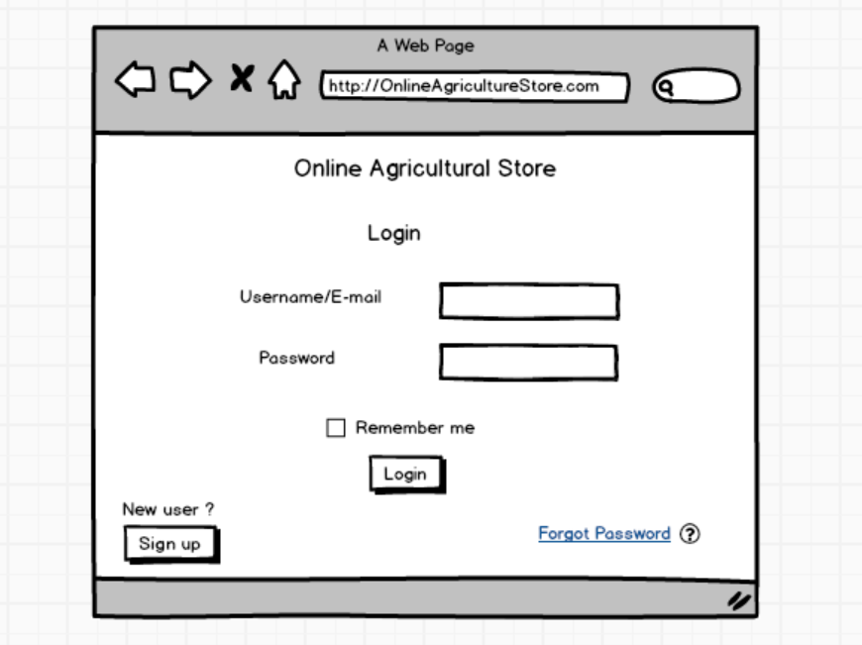

- Registration
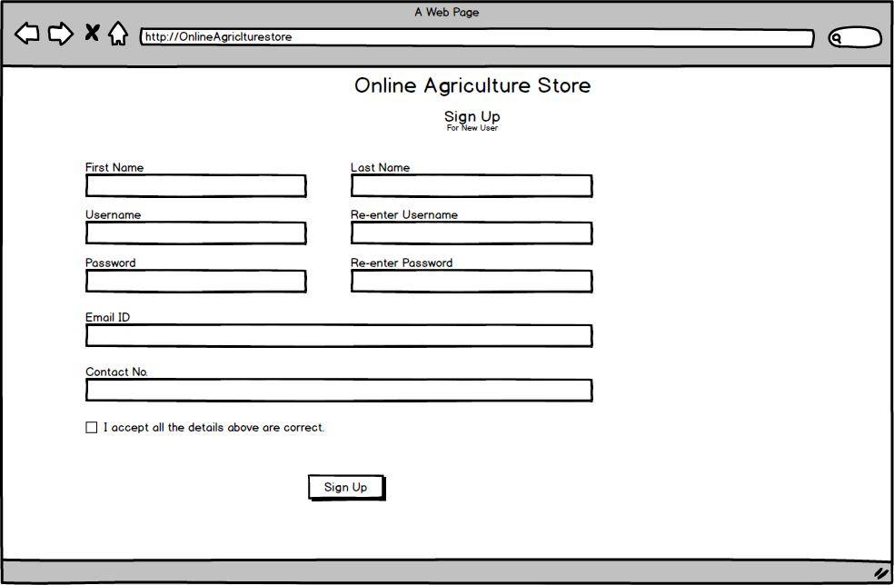

- View Product

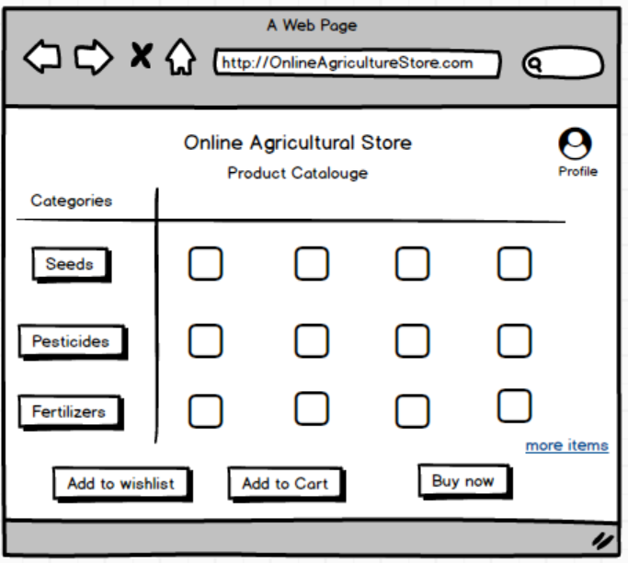

- Payment
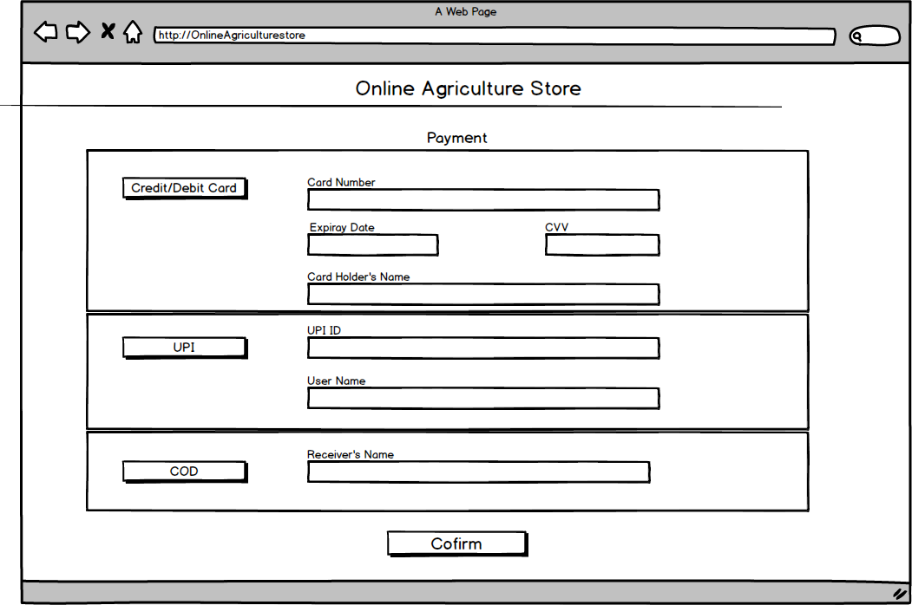

- Order confirmation
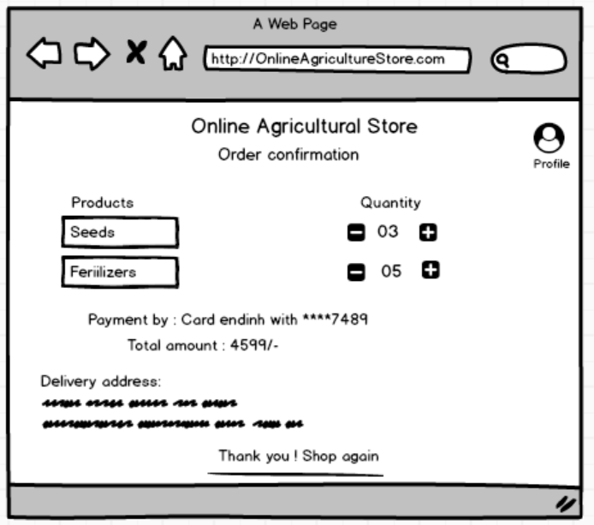

Question 3 – Tools (Visio, Balsamiq) –
Answer 3:
The tool which has been used for prototyping and for preparing use case and activity diagram are “Balsamiq” and “MS Visio” respectively.
The tool MS Visio is very user friendly and easy to use for diagramming and to explain activity flow. MS Visio is used to show the relation between user and their role or activity with the application. The proper activity of the application from it’s beginning to its end can explained by using MS Visio.
The tool Balsamiq is also very easy and fast application to show the actual presentation of the application. Balsamiq helps to create the imaginary out-put which can be seen after the completion of the application. Use various tools in Balsamiq a proper presentation of how the application is going to be look like can be made.

Question 4 – RTM
Answer 4:

Requirement ID | Requirement Name | Requirement Description | Design | D1 | T1 | D2 | T2 | D3 | T3 | D4 | T4 | UAT
FR0001 | Farmer Registration | Framer should be able to register with the application | Done | Y | Y | Y | Y | Y | Y | Y | Y | Done
FR0002 | Farmer search for products | Farmer should be able to search for available product in fertilizers, seeds & pesticides | Done | Y | Y | Y | Y | Y | Y | Y | Y | Done
FR0003 | Farmer added product to cart | Farmer should be able to add selected product to the cart | Done | Y | Y | Y | Y | Y | Y | Y | Y | Done
FR0004 | Farmer adding delivery address | Farmer should be able to add their delivery location for placing the order | Done | Y | Y | Y | Y | Y | Y | Y | Y | Done
FR0005 | Farmer make a payment by card/ UPI/COD | Farmers should be able to make a payment by credit or debit card or UPI or cash | Done | Y | Y | Y | Y | Y | Y | Y | Y | Done
FR0006 | Product Filtering | The system should allow filtering products based on price, category (seeds/fertilizers/pesticides), rating, etc | Done | Y | Y | Y | Y | Y | Y | Y | Y | Done
FR0007 | Order confirmation | Farmers should be able to place orders for selected products after confirming quantity | Done | Y | Y | Y | Y | Y | Y | Y | Y | Done
FR0008 | Farmer track their order | Farmer should be able to track their order by using delivery tracker | Done | Y | Y | Y | Y | Y | Y | Y | Y | Done
FR0009 | Manufacturing Registration | Manufacturer should be able to register themselves and login to application | Done | Y | Y | Y | Y | Y | Y | Y | Y | Done
FR0010 | Manufacturer Upload product | Manufacturer should be able to upload the available product to the application. | Done | Y | Y | Y | Y | Y | Y | Y | Y | Done
NFR0101 | Page loading time | Page loading time | Done | Y | Y | Y | Y | Y | Y | Y | Y | Done
NFR0102 | WCAG 2.1 | WCAG 2.1 | Done | Y | Y | Y | Y | Y | Y | Y | Y | Done
NFR0103 | Security Check | Security Check | Done | Y | Y | Y | Y | Y | Y | Y | Y | Done
NFR0104 | Connectivity | Connectivity | Done | Y | Y | Y | Y | Y | Y | Y | Y | Done
NFR0105 | Capacity | Capacity | Done | Y | Y | Y | Y | Y | Y | Y | Y | Done
NFR0106 | Compatibility | Compatibility | Done | Y | Y | Y | Y | Y | Y | Y | Y | Done
NFR0107 | Usability | Usability | Done | Y | Y | Y | Y | Y | Y | Y | Y | Done
NFR0108 | Maintainability | Maintainability | Done | Y | Y | Y | Y | Y | Y | Y | Y | Done
NFR0109 | Performance | Performance | Done | Y | Y | Y | Y | Y | Y | Y | Y | Done
NFR0110 | Scalability | Scalability | Done | Y | Y | Y | Y | Y | Y | Y | Y | Done

Question 5 – 10 Test Case Documents - Prepare 10 Test Case Documents
Answer 5:
Test Case 1-
Test Case Id | PQ100TS001 | Test Case Name | Login
Project Id | PQ100 | Project Name | Online Agriculture Product Store
PM Id |  | PM Name | Mr Vandanam
Test Strategy Id |  | Tester Id
Test Plan Id |  | Tester Name
Test Schedule Id |  | Date of Test

Scenario: User login to application
Example: Farmer or Manufacturer are logging in to the application by entering user-id and password.

Link to that page:

 | Set 1 | Set 2 | Set 3 | Set 4
Input Data | 1)Correct User-id  2)Correct Password | 1)Correct User-id  2)Wrong Password | 1)Wrong User-id  2) Correct Password | 1)Wrong user-id  2)Wrong Password
Expected Behaviour | Login successful | Login fail | Login fail | Login fail
Actual Behaviour | Login successful | Login  fail | Login  fail | Login  fail
Comment | User successfully login to application | User failed to login to application | User failed to login to application | User failed to login to application
Result | Pass | Pass | Pass | Pass

Test Case 2-
Test Case Id | PQ100TS001 | Test Case Name | Product Catalogue
Project Id | PQ100 | Project Name | Online Agriculture Product Store
PM Id |  | PM Name | Mr Vandanam
Test Strategy Id |  | Tester Id
Test Plan Id |  | Tester Name
Test Schedule Id |  | Date of Test

Scenario: User check the products catalogue in the application
Example: Farmer check the available product in the application from product catalogue section

Link to that page:

 | Set 1 | Set 2 | Set 3
Input Data | 1)Open catalogue  2)Open Seeds catalogue | 1)Open catalogue  2)Open Fertilizer catalogue | 1)Open catalogue  2)Open Pesticides catalogue
Expected Behaviour | Seeds products show on the screen | Fertilizer products show on the screen | Pesticides products show on the screen
Actual Behaviour | Seeds product appear on the screen | Fertilizer product appear on the screen | Pesticides product appear on the screen
Comment | Seeds catalogue shows product | Fertilizer catalogue shows product | Pesticides catalogue shows product
Result | Pass | Pass | Pass

Test Case 3-
Test Case Id | PQ100TS001 | Test Case Name | Add to Cart
Project Id | PQ100 | Project Name | Online Agriculture Product Store
PM Id |  | PM Name | Mr Vandanam
Test Strategy Id |  | Tester Id
Test Plan Id |  | Tester Name
Test Schedule Id |  | Date of Test

Scenario: User add a product to the cart from application
Example: Farmer select a product and add it to the cart to purchase the selected product

Link to that page:

 | Set 1 | Set 2
Input Data | 1) Select a product  2) Add it to the cart | 1)Select a product from catalogue  2) Add a product to cart  3) Move to
Expected Behaviour | Product added to cart | Product added to cart
Actual Behaviour | Product added to cart | Product added to cart
Comment | Cart move to payment | Cart move for payment
Result | Pass | Pass

Test Case 4-
Test Case Id | PQ100TS001 | Test Case Name | Payments
Project Id | PQ100 | Project Name | Online Agriculture Product Store
PM Id |  | PM Name | Mr Vandanam
Test Strategy Id |  | Tester Id
Test Plan Id |  | Tester Name
Test Schedule Id |  | Date of Test

Scenario: User select a product and make a payment
Example: Farmer select a product and make a payment to purchase the order.

Link to that page:

 | Set 1 | Set 2 | Set 3
Input Data | 1)Product Added to cart  2) Make a payment by Credit/Debit card | 1) Product Added to cart  2) Make a payment by UPI | 1) Product Added to cart  2) Select payment mode COD
Expected Behaviour | Payment successful and order placed | Payment successful and order placed | Order placed on cash on delivery mode
Actual Behaviour | Payment successful and order placed | Payment successful and order placed | Order placed on cash on delivery mode
Comment | Payment is successful | Payment is successful | Order placed
Result | Pass | Pass | Pass

Test Case 5-
Test Case Id | PQ100TS001 | Test Case Name | Product Invoice
Project Id | PQ100 | Project Name | Online Agriculture Product Store
PM Id |  | PM Name | Mr Vandanam
Test Strategy Id |  | Tester Id
Test Plan Id |  | Tester Name
Test Schedule Id |  | Date of Test

Scenario: User purchase a product and invoice is generated
Example: Farmer purchase a product from application and invoice forwarded to his email

Link to that page:

 | Set 1 | Set 2
Input Data | 1)Purchase product  2)Click to generate invoice | 1)Purchase product  2)Payment Failed
Expected Behaviour | Invoice generated | Invoice not generated
Actual Behaviour | Invoice generated | Invoice not generated
Comment | Invoice send to email | Invoice fail due to payment failed
Result | Pass | Pass

Test Case 6-
Test Case Id | PQ100TS001 | Test Case Name | Delivery Tracker
Project Id | PQ100 | Project Name | Online Agriculture Product Store
PM Id |  | PM Name | Mr Vandanam
Test Strategy Id |  | Tester Id
Test Plan Id |  | Tester Name
Test Schedule Id |  | Date of Test

Scenario: User received a delivery tracker code which used for tracking the order
Example: Farmer received a delivery tracker code which he entered in tracking website to check the current status of the order.
Link to that page:

 | Set 1 | Set 2 | Set 3
Input Data | 1)Enter delivery code to tracker website  2)Check order status | 1)Enter delivery code to tracker website  2)Check order status | 1)Enter wrong delivery code to tracker website  2) Check order status
Expected Behaviour | Order current status shown | Order yet to dispatch shown | No status shown
Actual Behaviour | Order current status shown | Order yet to dispatch shown | No status shown
Comment | User check current status of his order | Order is not yet dispatched | Order-id is wrong
Result | Pass | Pass | Pass

Test Case 7-
Test Case Id | PQ100TS001 | Test Case Name | Upload Product
Project Id | PQ100 | Project Name | Online Agriculture Product Store
PM Id |  | PM Name | Mr Vandanam
Test Strategy Id |  | Tester Id
Test Plan Id |  | Tester Name
Test Schedule Id |  | Date of Test

Scenario: User login to application and upload products
Example: Manufacturer login to application and upload available to product to sell through application.
Link to that page:

 | Set 1 | Set 2 | Set 3
Input Data | 1)Login  2)Open Catalogue  3)Upload Seeds product | 1)Login  2)Open Catalogue  3)Upload Pesticides product | 1)Login  2)Open Catalogue  3)Upload Fertilizer product
Expected Behaviour | Seeds product uploaded to seed catalogue | Pesticides product uploaded to pesticides catalogue | Fertilizer product uploaded to fertilizer catalogue
Actual Behaviour | Seeds product uploaded to seed catalogue | Pesticides product uploaded to pesticides catalogue | Fertilizer product uploaded to fertilizer catalogue
Comment | Seeds product with their detail information and price uploaded | Pesticides product with their detail information and price uploaded | Fertilizer product with their detail information and price uploaded
Result | Pass | Pass | Pass

Test Case 8-
Test Case Id | PQ100TS001 | Test Case Name | Credit/Debit card payment
Project Id | PQ100 | Project Name | Online Agriculture Product Store
PM Id |  | PM Name | Mr Vandanam
Test Strategy Id |  | Tester Id
Test Plan Id |  | Tester Name
Test Schedule Id |  | Date of Test

Scenario: User is making payment through credit or debit card
Example: Farmer is purchasing product through credit or debit card

Link to that page:

 | Set 1 | Set 2 | Set 3
Input Data | 1)Add product to cart  2)Enter card detail  3) Enter OTP | 1)Add product to cart  2)Enter card detail  3) Enter wrong OTP | 1)Add product to cart  2)Enter wrong card detail
Expected Behaviour | Payment is successful | Payment is failed | Order not proceed for payment
Actual Behaviour | Payment is successful | Payment is failed | Order not proceed for payment
Comment | Order placed successful | Order is unsuccessful | Wrong card detail entered
Result | Pass | Pass | Pass

Test Case 9-
Test Case Id | PQ100TS001 | Test Case Name | Payment by UPI
Project Id | PQ100 | Project Name | Online Agriculture Product Store
PM Id |  | PM Name | Mr Vandanam
Test Strategy Id |  | Tester Id
Test Plan Id |  | Tester Name
Test Schedule Id |  | Date of Test

Scenario: User is making payment through UPI
Example: Farmer is purchasing product through UPI.

Link to that page:

 | Set 1 | Set 2 | Set 3
Input Data | 1)Add product to cart  2)Enter UPI ID  3) Enter OTP | 1)Add product to cart  2)Enter UPI ID  3) Enter wrong OTP | 1)Add product to cart  2)Enter wrong UPI ID
Expected Behaviour | Payment is successful | Payment is failed | Order not proceed for payment
Actual Behaviour | Payment is successful | Payment is failed | Order not proceed for payment
Comment | Order placed successful | Order is unsuccessful | Wrong card detail entered
Result | Pass | Pass | Pass

Test Case 10-
Test Case Id | PQ100TS001 | Test Case Name | Pay by Cash on Delivery
Project Id | PQ100 | Project Name | Online Agriculture Product Store
PM Id |  | PM Name | Mr Vandanam
Test Strategy Id |  | Tester Id
Test Plan Id |  | Tester Name
Test Schedule Id |  | Date of Test

Scenario: User choose to pay by cash on the delivery of the product.
Example: Farmer choose payment mode as COD (Cash On Delivery)

Link to that page:

 | Set 1 | Set 2
Input Data | 1)Add product to cart  2) Pay by COD  3) Enter OTP | 1)Add product to cart  2) Pay by COD  3) Enter wrong OTP
Expected Behaviour | Order placed | Order Failed
Actual Behaviour | Order placed | Order Failed
Comment | Order placed on COD | Order not placed
Result | Pass | Pass

Question 7 – Data Flow Diagram - What is a data flow diagram? Draw a data flow diagram to represent the in-flow and out-flow of data when a Farmer is placing an order for the product.
Answer 7: A Data Flow Diagram (DFD) is a graphical representation of how data flows through a system. It shows the interaction between external entities, processes, data stores, and data flows. DFDs help in understanding how a system processes data in terms of input and output.

1) Login
2) Name
3) Address
4) Email ID
5) Contact No.
1) Catalogue
2) Seeds
3) Pesticides
4) Fertilizers
5) Quantity
6) Add to cart
Farmer
Products

1) Product Invoice
2) Order ID
3) Tracking ID
Order Placed
1) Payment Mode:
2) Credit/Debit Card:
3) UPI ID
4) Cash on Delivery
Payment

Question 8 – Change Request - Due to change in the Government Taxation structure . we should change the Tax structure How do you handle change requests in a project?
Answer 8: For handling change request we have to follow the below three steps:
(i) Impact Analysis.
(ii) Feasibility Study.
(iii) Effort Estimation.

- Impact Analysis:
Due to change in Government Taxation structure as the tax is rises by 4%. So the pricing of the goods are going to impact. The billing system is also going to impact. After doing the Impact analysis, we have calculated that how much the application is going to impact after this change in taxation structure.
We have 4 document which consist of old Government taxation structure, which have to been change as per new taxation structure.
We also have 2 programs consisting of old Government taxation structure, which also have to been change as per new taxation structure.

- Feasibility Study:
Due to change in taxation structure, there are 2 program which have to change as per new taxation rule.
For making the change in that 2 program, we will make a ‘request of change’ to the concern program manager of that 2 program and after they approve the request that technical team will make the change in program in the given particular time.

- Effort Estimation:
As we have change request from the client due to change in taxation structure, we have to change 4 documents and 2 programs. After discussing with the concern technical team, we asked them for the time which they required for to make change in program.
After calculating total time required to change 4 documents and 2 program, we make a request to the client to give 160 Manhours i.e. 20 working days additional time which require to make these changes.
In which, 40 manhours i.e. 5 days required for document changes and 120 manhours i.e. 15 working days required to program changes.

Question 9 – Change Request Vs an Enhancement
As the project is in process, Ben and Kevin have contacted you. The reason is to inform you that they want the Farmers to sell their crop yields through this application i.e. Farmers should be able to add their crop yields or products and display to general public and should be able to sell them. They also want to introduce Auction system for their Crop yields. As a BA, what will be your response? Is this a change request or an enhancement???
Answer 9: As per the discussion with Ben and Kevin, they want more changes in the application which are as follows:
- They want the Farmers to sell their crop yield through this application, so here the farmer can become seller as well.
- They also want to add general public so that they can purchase crop yield from the farmer through the application, so the general public become buyer here.
- They also want to arrange some auction system for the crop yield to decide the price of the crops.

Change request is certain small change which are most of time possible to do during the project.
Enhancement which is something more we can add in application to make the application functionable and to add more features in the application.
According to me, it is an enhancement not a change request.
At this time when the application is almost ready it is not possible to make these major changes which would almost change the whole application.
So, we will suggest them to not make this change request as enhancement because this is going to completely impact the whole budget and will need more extension on time. Also, As a BA I need to work with development team to consider any potential benefits, risks and cost associated with the enhancement.

Question 10 – Estimations - Come up with estimations – How many Manhours required
Asnwer10: Manhours are the required effort of the resources to complete the project. There are 3 types of projects:
- Small – Up to 500 hours
- Medium – Up to 1000 hours
- Large – Up to 1500 hours
Analysis:
The complete project is sanction on the budget of 2 Crores INR and 18 months of duration.
But due to change in request during the project, the budget and the given time is slightly affected. As for the change request, 1 month of extra time was required and the cost of 12 Lakh INR increased.
So, the final estimation of the project is as follows:
- Total budget: 2,12,00,000/- INR
- Total time required: 19 months i.e. 3040 Manhours.

Question 11 – UAT –Project has finally completed all the stages i.e., design, development, testing etc. Now, it is the role of a business analyst to contact the client for testing of the final product and have to successfully complete it. How are you going to handle this situation? And once it is done, what will be the process to close the project? Explain UAT Acceptance process.
Asnwer11:

Planning: In this step, Blue Prints are made to implement UAT testing for every feature that needs to test and minimum standards for accepting the test.
Designing: Here the Test cases are designed to hide all the possibilities of software packages in a real-world environment.
UAT Testers: A Testing team consists of a end users that meet the criteria for implementing testing. They should know the test cases to run and understand the functionalities.
Bug Fixing: Whatever Bugs are found in the UAT Testing, the development team should work on them and make it software error free.
Sign Off: After removing all the bugs, the testing team indicates acceptance of the completion of the bugs. In this phase, all the stakeholders come to conclusion that the software is ready to GO LIVE and sign it off.

Question 12 – Project Closure Document - Explain Project closure document.
Answer12:
Project Closer Document
- Project Name: Online Agriculture Store.
- Project ID: PQ100

The application ‘Online Agriculture Store’ has been completed under the supervision of the following team members,
Project Manager: Mr. Vandanam
Delivery Head: Mr. Karthik
Business Analyst: Ms. Saloni
Senior Java Developer: Ms. Juhi
Java Developers: Mr. Teyson, Ms. Lucie, Mr. Tucker, Mr. Bravo
Network Admin: Mr. Mike & Mr. John
Tester: Mr. Jason & Ms. Alekya
Helping Committee: Mr. Peter, Mr. Kevin, Mr. Ben

The entire project has been completed on the budget of 2,12,00,000/- INR in the duration of 19 months. The project has been tested by the respected client team and it is ready to launch in the market.

