DOCUMENT 6 : USE CASE DIAGRMA, ACTIVITY DIAGRAM AND USE CASE SPECIFICATION DOCUMENT
- USE CASE DIAGRAM :
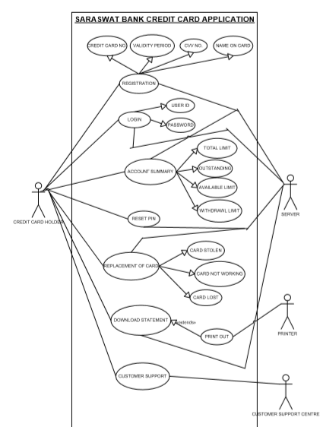

- ACTIVITY DIAGRAM :

- NEW USER REGISTRATION :
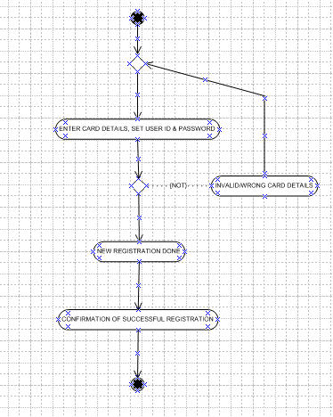

- LOGIN :

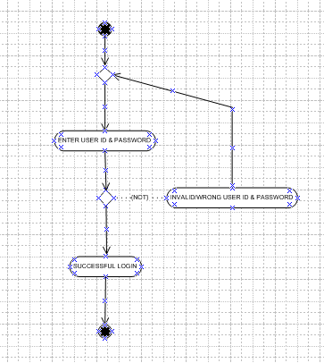

- REPLACEMENT OF CARD :

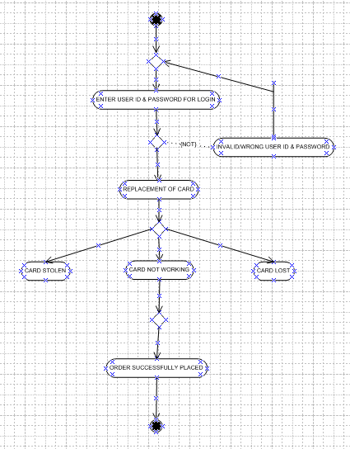

- CHANGE PASSWORD :
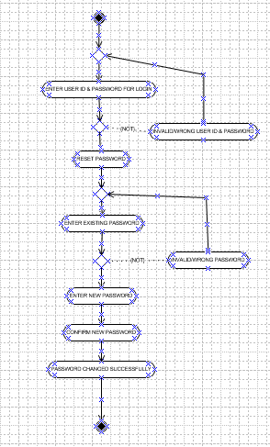

- PROVIDE RATING REVIEW :
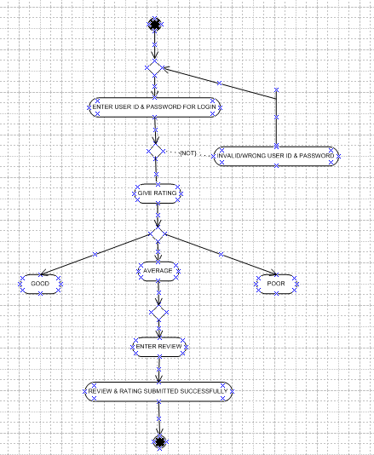

- USE CASE SPECIFICATION :

- USE CASE NAME : Registration
- Use Case Description :-
- This use case describes how the card holders will register themselves in application.
- Actors: Primary Actor – Credit Card holder, Secondary Actor – Active server.
- Basic Flow of Events :
- The Credit Card holder visit the application and select the option ‘New Registration’
Menu.
- Enter card details like Card No., Validity Date, Name on Card & CVV No.
- Set Registration Id.
- Set Password.
- Submit.
- Alternative Flow :
- Card details insertion is incorrect (short/wrong).
- Unable to provide confirmation due to ‘Network Unavailable’.
- Exceptional Flows :
- Do not have card physically while registration.
- Preconditions :
- The internet connectivity should be there
- Browser compatable.
- Post Conditions :
- Card holders successfully registered in application with confirmation on E-Mail & Mobile
No.
- Assumptions :
- Card holders must be KYC complied customer of Bank having basic knowledge of Mobile
Application and English.
- Constraints :
- User Id cannot be names.
- Dependencies :
- User should exists – Registration Process
- Input :
- Card No., Validity Date, Name on Card, CVV No.
- Output :
- Error Code or status flag.
- Business Rules :
- User Id – valid n unique card details
- Password – 1 Cap letter, 1 small letter, 1 Number, 1 Special Character
- Miscellaneous Information :
- Interactive design & browser compatable.
- USE CASE NAME : Login
- Use Case Description :-
- This use case describes how the card holders will login themselves in application.
- Actors: Primary Actor – Credit Card holder, Secondary Actor – Active server.
- Basic Flow of Events :
- The Credit Card holder visit the application and select the option ‘Login’ Menu.
- Enter User ID.
- Enter Password.
- Submit.
- Alternative Flow :
- User Id & Password details insertion is incorrect (short/wrong).
- Unable to provide confirmation due to ‘Network Unavailable’.
- Exceptional Flows :
- Forgot User ID
- Forgot Password
- Preconditions :
- The internet connectivity should be there
- Browser compatable.
- Post Conditions :
- Card holders successfully login the application and home screen appears.
- Assumptions :
- Card holders must be KYC complied customer of Bank having basic knowledge of Mobile
Application and English.
- Constraints :
- User Id cannot be names.
- Dependencies :
- User must have completed Registration Process
- Input :
- Valid User Id & Password
- Output :
- Error Code or status flag.
- Business Rules :
- User Id must be valid n unique
- Password – 1 Cap letter, 1 small letter, 1 Number, 1 Special Character
- Miscellaneous Information :
- Interactive design & browser compatable.

- USE CASE NAME : Reset Pin
- Use Case Description :-
- This use case describes how the card holders can set new pin of card in application.
- Actors: Primary Actor – Credit Card holder, Secondary Actor – Active server.
- Basic Flow of Events :
- The Credit Card holder visit the application and select the option ‘Reset Pin’ Menu.
- Enter New Pin
- Confirm New Pin.
- Submit.
- Alternative Flow :
- New Pin details insertion is incorrect (short/wrong).
- Unable to provide confirmation due to ‘Network Unavailable’.
- Exceptional Flows :
- Forgot Pin
- Preconditions :
- The internet connectivity should be there
- Browser compatable.
- Post Conditions :
- Card holder successfully reset the pin and get confirmation on Mobile via SMS.
- Assumptions :
- Card holders must be KYC complied customer of Bank having basic knowledge of Mobile
Application and English.
- Constraints :
- Pin Cannot be character, it is only number.
- Dependencies :
- User must have an active card.
- Input :
- Valid Pin Number.
- Output :
- Error Code or status flag.
- Business Rules :
- Pin must be 4 digit number.
- Last 3 Pin Numbers cannot be repeated.
- Miscellaneous Information :
- Interactive design & browser compatable.

- USE CASE NAME : Replacement of Card
- Use Case Description :-
- This use case describes how the card holders can replace existing or order new card in
application.
- Actors: Primary Actor – Credit Card holder, Secondary Actor – Active server.
- Basic Flow of Events :
- The Credit Card holder visit the application and select the option ‘Replace/Order Card’
Menu.
- Card holder should select any one of following reason, Card Lost / Card Not Working /
Card Stolen.
- Submit.
- Alternative Flow :
- Unable to provide confirmation due to ‘Network Unavailable’.
- Exceptional Flows :
- Delivery of card is not taken, so it gets returned to department.
- Preconditions :
- The internet connectivity should be there
- Browser compatable.
- Post Conditions :
- Card holder successfully placed order of new Credit Card and get confirmation on Mobile
via SMS.
- Assumptions :
- Card holders must be KYC complied customer of Bank having basic knowledge of Mobile
Application and English.
- Constraints :
- If delivery not taken, the Card may get returned to Issuing Department.
- Dependencies :
- User must be available to take delivery of Card by himself.
- Input :
- Valid reason for New Card.
- Output :
- Error Code or status flag.
- Business Rules :
- User must get delivery of Card by himself.
- User has option to take delivery at Residence Address or Branch Address.
- Miscellaneous Information :
- Interactive design & browser compatable.

- USE CASE NAME : View & Download Statement
- Use Case Description :-
- This use case describes how the card holders can view & download statement upto 1
year.
- Actors: Primary Actor – Credit Card holder, Secondary Actor – Active server.
- Basic Flow of Events :
- The Credit Card holder visit the application and select the option ‘View & Download
Statement’ Menu.
- Card holder should select month from last 1 year.
- List of months upto last 1 year gets appeared on screen.
- After selecting month, options ‘View’ & ‘Download’ appears.
- After selecting ‘View’ option the PDF file opens and Card holder can view statement.
- After selecting ‘Download’ option PDF file can be downloaded and customer can save it, send it and take print out of it.
- Alternative Flow :
- Every months statement to be mailed to Card holder on his mail id centrally.
- Unable to provide confirmation due to ‘Network Unavailable’.
- Exceptional Flows :
- Statement period prior to 1 year is not available.
- Preconditions :
- The internet connectivity should be there.
- Browser compatable.
- Post Conditions :
- Card holder successfully view & download the statement.
- Assumptions :
- Card holders must be KYC complied customer of Bank having basic knowledge of Mobile
Application and English.
- Constraints :
- If card is not used for minimum 1 month, the statement should not be generated.
- Dependencies :
- Card holder should use card for minimum 1 month to view & download the statement.
- Input :
- Valid period for view & download the statement.
- Output :
- Error Code or status flag.
- Business Rules :
- User must use the card for minimum 1 month.
- If user wants statement prior to 1 year, he can contact Customer Care.
- Miscellaneous Information :
- Interactive design & browser compatable.
DOCUMENT 7 – SCREENS & PAGES
- HOME PAGE :
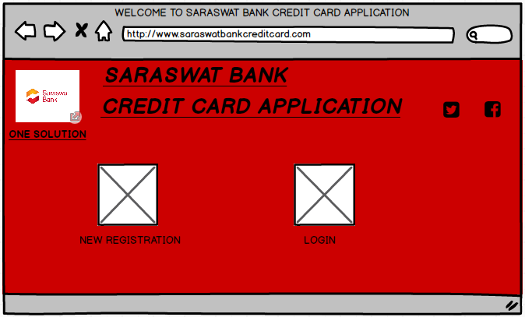

- NEW REGISTRATION :
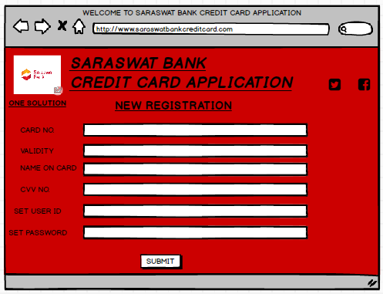

- LOGIN PAGE :
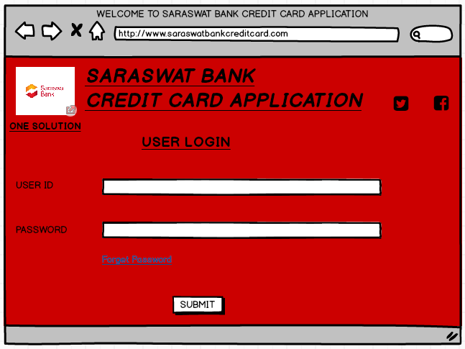

- MENU SCREEN :

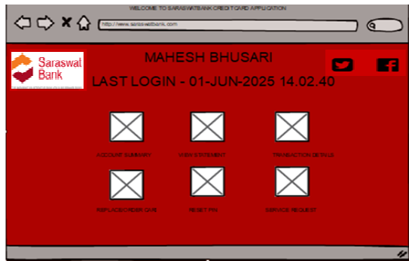

- ACCOUNT SUMMARY MENU SCREEN :

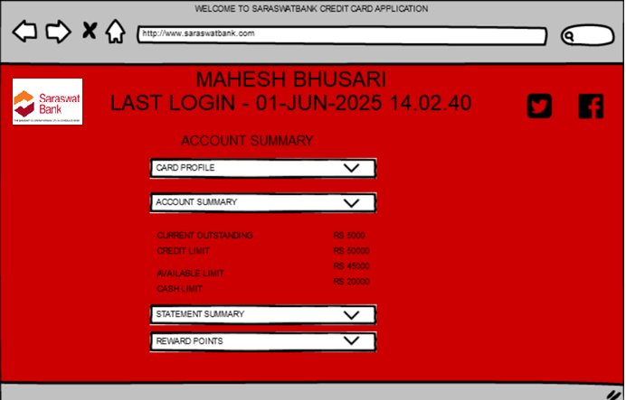

- REPLACE / ORDER CARD MENU SCREEN :

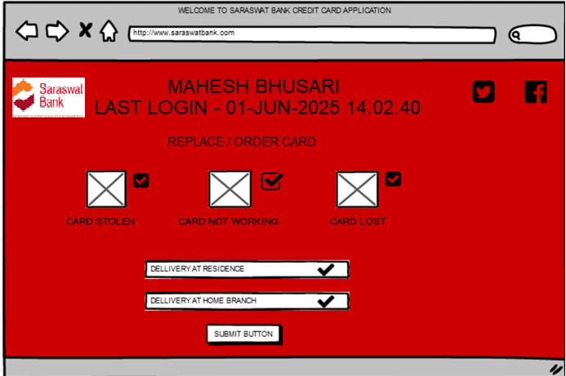

- VIEW & DOWNLOAD STATEMENT MENU SCREEN :

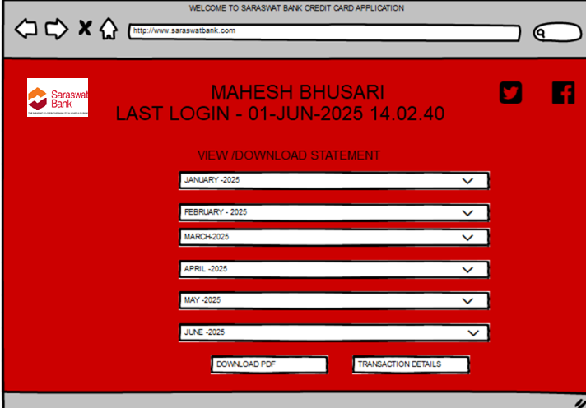

- RESET PIN MENU SCREEN :

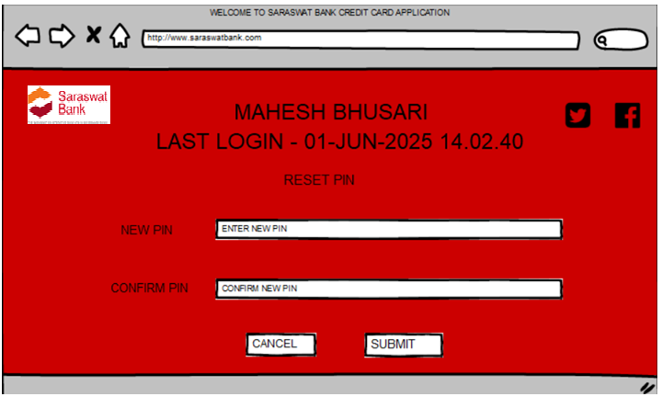

DOCUMENT 8 – TOOLS – VISIO, BALSAMIQ & AXURE
In this project I have used MS Visio tool for Use case diagram and Activity diagram and Balsamiq Tool for Prototyping.
- MS VISIO
Microsoft Visio is a diagramming and vector graphics application. MS Visio is used to create flowcharts, org charts, building plans, floor plans, data flow diagrams, process flow diagrams, UML diagrams, business process modelling, swim lane diagrams, 3D maps, and other visual representations of complex nature. MS Visio is part of the Microsoft Office software suite, although it is sold as a stand-alone program.
I have used MS Visio tool for drawing various diagrams like Use Case diagram, Activity Diagram and Data Flow diagram. It is easy to use and understand. The functions are very identical. With the help of MS Visio diagrams, it becomes very easy for a person to explain the flow and to understand the flow. If process flow is understood correctly, then it is easy for designer to design the software and for the developer to develop the codes. It reduces the time, energy and efforts. The chances of timely completion of project increases.
- BALSAMIQ
Balsamiq is a rapid wireframing tools used to create Mockup and prototypes of user interfaces. It allows you to rapidly create low-fidelity wireframes and mockups for Web, Mobile and Desktop Applications. You can use it to generate digital sketches of your idea or concept for your application or website, to facilitate discussion and understanding before any code is written. Balsamiq Wireframe is the easiest and fastest supported wireframing tool.
I have used Balsamiq tool for preparing prototypes of application. It is very easy to use and understand. It has got various options to express your mockup more effectively & efficiently. Mockups provide the idea about how a software / application may appear in front of user. It provides clear idea about how a software / application should be developed and what kind of changes needs to be done to make it more user friendly.
- AXURE
Axure is a tool that gives professionals the power to build realistic, functional prototypes, Mockups, flows & more. It helps to create prototypes with various combination of events triggers, conditions and actions to truly explore digital experience. With the help of Axure tool you can add various conditions and variables that takes your prototype to the next level. It helps to bridge the gap between design, development, customers and your business. It encourages designers, analysts, developers and users to push boundaries together.

DOCUMENT 9 – BA EXPERIENCE
My experience as BA in following phases:
- Requirement Gathering :
- As a BA my priority is to identify stakeholders and arrange meeting and gather the requirements from them. For gathering requirements I have used MOSCOW technique.
- It was not always possible for the stakeholders to present at meeting, so I have identified some people from technical team with whom I shall interact and get the information ASAP.
- After gathering requirements my next task is to validate those requirements, to check whether they are relevant or not. For validating these requirements I have used FURPS technique. FURPS represents Functionality, Usability, Reliability, Performance and Supportability.
- While gathering and validating requirements, it was observed that many requirements are duplicate or repeated, so we need to remove them and arrange them priority wise.
- We have prepared prototypes of some requirements and shown to client due to which they got idea about how they actually want the application.

- Requirement Analysis :
- After collecting the requirements I have drawn the UML diagram I.e. Use Case Diagram to mark the functionalities of User and Supporter. Use Case Diagram is best to identify, show and understand the actual functionalities of End User.
- To make understand the flow of process I have also drawn the Activity Diagram which shows each functionality in detail manner.
- To elaborate a Use Case I have prepared Use Case Specification Document.
- I have communicated Both Use Case Diagram and Activity Diagram with other team members to have clear idea about design and development of codes.
- Some team members suggests changes in it, which also plays very important role to make process flawless. And we have made those necessary changes in diagram to make it more user friendly.
- I have prepared various documents to segregate requirements like Business Requirements Document (BRD), Software Requirement Specification (SRS) and Supplementary Support Document (SSD) etc.

- Design :
- From Use Case diagram, I have prepared Test Case Document.
- Test Case Document is a document which is identified from each scenarios. From single Use Case 3-4 Test Cases can be identified.
- While communicating test cases with client, the design gets clearer.
- I have ensured that no single test case should escape, because it has huge impact on project.
- To make it more perfect, I have put all the requirements in Requirement Traceability Matrix (RTM) so that each and every requirement should be met and completed.

- Development :
- Development of application or codes was one the main task, so I have arranged Joint Application Development (JAD) session with stakeholders and development team members.
- JAD techniques is very helpful in development of application because it reduces time, energy and achieve more perfection in less time.
- Some team member’s find it difficult to interact with stakeholders while development, but as a BA having personal talk with them and ensuring accuracy while development I have successfully handled the situation.
- JAD session was one of the toughest part as because it is not possible for everyone to attend the session every time, so having discussion later with that missed person we have completed the development of codes.

- Testing :
- Test Case document for every single Use Case gets more perfect during testing stage. The details have helped us to make an application more perfect and user friendly.
- We have done high level testing of every single functionality. We have ensured the proper and perfect functionality of every single use case.
- After all test data is a key which signifies the amount of quality and quantity of work done as BA.
- After successful testing I have taken sign off from client.
- Finally I have arranged the User Acceptance Testing along with Project Manager, Client and Testing Team to get it approved from client and stakeholders.

- Deployment :
- After successful User Acceptance testing, I have forwarded the Project Closure Document along with Requirement Traceability Matrix (RTM) to the client for deployment of application.
- I have also coordinated with team members and client for completing and sharing end user manuals.
- I have also participated for planning and organizing training sessions for the Employees and End Users.
- I have also ensured that all the candidates who are needed to attend the training sessions and meetings regarding the usage of application must attend it and gets trained to resolve further queries of end users.

