Question 1 – write Agile Manifesto – 8 Marks

Four main Values :
- Individuals and interactions over processes and tools
- Working software over comprehensive documentation
- Customer collaboration over contract negotiation
- Responding to change over following a plan

Twelve Principles of Agile Software
- Satisfy the customer through early and continuous delivery of valuable software.
- Welcome changing requirements, even late in development. Agile processes harness change for the customer's competitive advantage.
- Deliver working software frequently, from a couple of weeks to a couple of months, with a preference to the shorter timescale.
- Business people and developers must work together daily throughout the project.
- Build projects around motivated individuals. Give them the environment and support they need and trust them to get the job done.
- The most efficient and effective method of conveying information to and within a development team is face-to-face conversation.
- Working software is the primary measure of progress.
- Agile processes promote sustainable development. The sponsors, developers, and users should be able to maintain a constant pace indefinitely.
- Continuous attention to technical excellence and good design enhances agility.
- Simplicity the art of maximizing the amount of work not done--is essential.
- The best architectures, requirements, and designs emerge from self -organizing teams.
- At regular intervals, the team reflects on how to become more effective, then tunes and adjusts its behaviour accordingly.

Question 2 – User Stories- Acceptance Criteria-BV-CP – 40 Marks

SPRINT-1
User Story No: 1 | Tasks: 2 | Priority: HIGHEST
AS A CUSTOMER
I WANT TO REGISTER IN SCRUM FOOD SO THAT I CAN PLACE MY ORDERS
BV: 500 | CP: 2
ACCEPTANCE CRITERIA
Registration with Name, Email, Phone, Address, Password. Click Register button
Display success notification.

User Story No: 2 | Tasks: 2 | Priority: HIGHEST
AS A CUSTOMER I WANT TO LOGIN
SO THAT I CAN ACCESS MY ACCOUNT
BV: 300 | CP: 1
ACCEPTANCE CRITERIA
Login screen with Email/Phone and Password. Click Login.
Redirect to homepage successfully .

User Story No: 3 | Tasks: 2 | Priority: HIGH
AS A CUSTOMER
I WANT TO SEARCH AND VIEW RESTAURANTS
SO THAT I CAN CHOOSE WHERE TO ORDER
BV: 400 | CP: 2
ACCEPTANCE CRITERIA
Display search bar for restaurants.
Display list of restaurants based on ,search/filter ( Areas ). Click to view restaurant details.

User Story No: 4 | Tasks: 2 | Priority: HIGH

AS A CUSTOMER
I WANT TO VIEW A RESTAURANT'S MENU SO THAT I CAN SELECT FOOD ITEMS
BV: 400 | CP: 2
ACCEPTANCE CRITERIA
Display menu items for selected restaurant. Show item details and prices.

User Story No: 5 | Tasks: 2 | Priority: HIGHEST
AS A CUSTOMER
I WANT TO ORDER FOOD
SO THAT I CAN GET IT DELIVERED
BV: 600 | CP: 3
ACCEPTANCE CRITERIA
Select items, add to cart, place order. Order confirmation message.

User Story No: 6 | Tasks: 2 | Priority: HIGHEST
AS A CUSTOMER
I WANT TO MAKE PAYMENT
SO THAT I CAN COMPLETE MY ORDER
BV: 500 | CP: 2
ACCEPTANCE CRITERIA
Display mode of payment (Card, UPI, COD). Payment confirmation and invoice.

User Story No: 7 | Tasks: 2 | Priority: HIGH
AS A CUSTOMER
I WANT TO TRACK MY ORDER
SO THAT I KNOW THE DELIVERY STATUS
BV: 300 | CP: 1
ACCEPTANCE CRITERIA
Display order tracking screen with estimated time of arrival .

User Story No: 8 | Tasks: 2 | Priority: MEDIUM

AS A CUSTOMER
I WANT TO CANCEL MY ORDER
SO THAT I CAN AVOID UNWANTED ORDERS
BV: 200 | CP: 1
ACCEPTANCE CRITERIA
Cancel order button before dispatch. Receive confirmation and refund info.

User Story No: 9 | Tasks: 2 | Priority: MEDIUM
AS A CUSTOMER
I WANT TO GIVE FEEDBACK & RATING SO THAT I CAN SHARE MY EXPERIENCE
BV: 200 | CP: 1
ACCEPTANCE CRITERIA
Feedback form after delivery. Submit rating and comments.

User Story No: 10 | Tasks: 2 | Priority: HIGH
AS A CUSTOMER
I WANT TO LOGOUT
SO THAT MY ACCOUNT IS SECURE
BV: 100 | CP: 1
ACCEPTANCE CRITERIA
Display logout button. Redirect to login screen.

DELIVERY BOY
User Story No: 11 | Tasks: 2 | Priority: HIGHEST

AS A DELIVERY BOY
I WANT TO REGISTER
SO THAT I CAN DELIVER ORDERS
BV: 500 | CP: 2
ACCEPTANCE CRITERIA
Registration form with required details. Success notification.

User Story No: 12 | Tasks: 2 | Priority: HIGHEST
AS A DELIVERY BOY I WANT TO LOGIN
SO THAT I CAN ACCESS MY ACCOUNT
BV: 300 | CP: 1
ACCEPTANCE CRITERIA
Display Login screen.
Redirect to delivery homepage.

User Story No: 13 | Tasks: 2 | Priority: HIGH
AS A DELIVERY BOY
I WANT TO VIEW ORDERS
SO THAT I CAN CHOOSE WHICH TO ACCEPT
BV: 400 | CP: 2
ACCEPTANCE CRITERIA
Order list with details. Select and accept orders.

User Story No: 14 | Tasks: 2 | Priority: HIGH
AS A DELIVERY BOY
I WANT TO ACCEPT ORDER
SO THAT CUSTOMERS KNOW ORDER READY DELIVERY STATUS
BV: 300 | CP: 1
ACCEPTANCE CRITERIA
Status order accepted .
Notify customer.

User Story No: 15 | Tasks: 2 | Priority: HIGH
AS A DELIVERY BOY
I WANT TO UPDATE ORDER STATUS
SO THAT CUSTOMERS KNOW DELIVERY STATUS
BV: 300 | CP: 1
ACCEPTANCE CRITERIA
Status update Estimated Time of Arrival (Picked up, Delivered, etc.).
Notify customer.

User Story No: 16 | Tasks: 2 | Priority: MEDIUM
AS A DELIVERY BOY
I WANT TO VIEW FEEDBACK
SO THAT I CAN IMPROVE SERVICE
BV: 200 | CP: 1
ACCEPTANCE CRITERIA
View Feedback section with customer ratings/comments.

User Story No: 17 | Tasks: 2 | Priority: MEDIUM
AS A DELIVERY BOY
I WANT TO RAISE ISSUES
SO THAT I CAN REPORT PROBLEMS
BV: 200 | CP: 1
ACCEPTANCE CRITERIA
Display Issue reporting form.
Receive confirmation.

User Story No: 18 | Tasks: 2 | Priority: HIGH
AS A DELIVERY BOY
I WANT TO VIEW REVENUE REPORT SO THAT I CAN TRACK MY EARNINGS
BV: 300 | CP: 1
ACCEPTANCE CRITERIA
Revenue report dashboard.

User Story No: 19 | Tasks: 2 | Priority: HIGH
AS A DELIVERY BOY I WANT TO LOGOUT
SO THAT MY ACCOUNT IS SECURE
BV: 100 | CP: 1
ACCEPTANCE CRITERIA
Logout button. Redirect to login.

RESTAURANT OWNER
User Story No: 20 | Tasks: 2 | Priority: HIGHEST
AS A RESTAURANT OWNER I WANT TO REGISTER
SO THAT I CAN RECEIVE ORDERS
BV: 500 | CP: 2
ACCEPTANCE CRITERIA
Display Registration with Email & Pswd Confirm success notification.

User Story No: 21 | Tasks: 2 | Priority: HIGHEST
AS A RESTAURANT OWNER I WANT TO VIEW ORDERS
SO THAT I CAN MANAGE DELIVERIES
BV: 400 | CP: 2
ACCEPTANCE CRITERIA
Order list in tabular form. Order details view.

User Story No: 22 | Tasks: 2 | Priority: HIGH
AS A RESTAURANT OWNER
I WANT TO VERIFY DELIVERY BOYS
SO THAT I CAN ENSURE SECURE DELIVERY
BV: 300 | CP: 1
ACCEPTANCE CRITERIA
Verification screen for delivery boys with OTP .
Status update.

User Story No: 23 | Tasks: 2 | Priority: HIGH
AS A RESTAURANT OWNER
I WANT TO VIEW REVENUE REPORT SO THAT I CAN TRACK EARNINGS
BV: 300 | CP: 1
ACCEPTANCE CRITERIA
Revenue report dashboard.

User Story No: 24 | Tasks: 2 | Priority: MEDIUM
AS A RESTAURANT OWNER I WANT TO RAISE ISSUES
SO THAT I CAN REPORT PROBLEMS
BV: 200 | CP: 1
ACCEPTANCE CRITERIA
Issue reporting form. Confirmation notification.

User Story No: 25 | Tasks: 2 | Priority: HIGH
AS A RESTAURANT OWNER I WANT TO LOGOUT
SO THAT MY ACCOUNT IS SECURE
BV: 100 | CP: 1
ACCEPTANCE CRITERIA
Logout button. Redirect to login.

REGIONAL ADMIN
User Story No: 26 | Tasks: 2 | Priority: HIGHEST
AS A REGIONAL ADMIN I WANT TO LOGIN
SO THAT I CAN MANAGE MY REGION
BV: 300 | CP: 1
ACCEPTANCE CRITERIA
Display Login screen with Email & PSWD . Redirect to admin Homepage.

User Story No: 27 | Tasks: 2 | Priority: HIGH
AS A REGIONAL ADMIN
I WANT TO TRACK ORDERS AND STATUS SO THAT I CAN MONITOR OPERATIONS
BV: 400 | CP: 2
ACCEPTANCE CRITERIA
Order tracking dashboard.
Status updates visible.

User Story No: 28 | Tasks: 2 | Priority: HIGH
AS A REGIONAL ADMIN
I WANT TO MANAGE DELIVERY BOYS AND RESTAURANTS SO THAT I CAN CONTROL REGIONAL OPERATIONS
BV: 400 | CP: 2
ACCEPTANCE CRITERIA
Management screens for delivery boys and restaurants. Add/edit/delete options.

User Story No: 29 | Tasks: 2 | Priority: HIGH
AS A REGIONAL ADMIN
I WANT TO VIEW REGIONAL REVENUE
SO THAT I CAN REPORT PERFORMANCE
BV: 300 | CP: 1
ACCEPTANCE CRITERIA
Revenue report dashboard.

User Story No: 30 | Tasks: 2 | Priority: MEDIUM
AS A REGIONAL ADMIN
I WANT TO MANAGE REFUNDS
SO THAT I CAN HANDLE CUSTOMER ISSUES
BV: 200 | CP: 1
ACCEPTANCE CRITERIA
Refund management screen.
Update status.

User Story No: 31 | Tasks: 2 | Priority: HIGH
AS A REGIONAL ADMIN I WANT TO LOGOUT
SO THAT MY ACCOUNT IS SECURE
BV: 100 | CP: 1
ACCEPTANCE CRITERIA
Logout button. Redirect to login.

ADMIN
User Story No: 32 | Tasks: 2 | Priority: HIGHEST
AS AN ADMIN
I WANT TO LOGIN
SO THAT I CAN MANAGE THE PLATFORM
BV: 300 | CP: 1
ACCEPTANCE CRITERIA
Display Login screen with Email& Pswd. Redirect to admin Homepage.

User Story No: 33 | Tasks: 2 | Priority: HIGH

AS AN ADMIN
I WANT TO MANAGE REGIONAL ADMINS
SO THAT I CAN CONTROL REGIONAL OPERATIONS
BV: 400 | CP: 2
ACCEPTANCE CRITERIA
Management screen for regional admins. Add/edit/delete options.

User Story No: 34 | Tasks: 2 | Priority: HIGH
AS AN ADMIN
I WANT TO APPROVE OR REJECT REQUESTS SO THAT I CAN CONTROL ONBOARDING
BV: 400 | CP: 2
ACCEPTANCE CRITERIA
Approval/rejection screen for restaurants, delivery boys, and regional admins.
Status update notification.

User Story No: 35 | Tasks: 2 | Priority: HIGH
AS AN ADMIN
I WANT TO RESOLVE ISSUES
SO THAT I CAN MAINTAIN QUALITY OF SERVICE
BV: 300 | CP: 1
ACCEPTANCE CRITERIA
Issue resolution dashboard. Update issue status.

User Story No: 36 | Tasks: 2 | Priority: HIGH
AS AN ADMIN
I WANT TO LOGOUT
SO THAT MY ACCOUNT IS SECURE
BV: 100 | CP: 1
ACCEPTANCE CRITERIA
Logout button.
Redirect to login.

BUSINESS OWNER
User Story No: 37 | Tasks: 2 | Priority: HIGHEST
AS A BUSINESS OWNER I WANT TO LOGIN
SO THAT I CAN VIEW REPORTS AND MANAGE PAYMENTS
BV: 300 | CP: 1
ACCEPTANCE CRITERIA
Display login screen with Email id & Pswd. Redirect to owner dashboard.

User Story No: 38 | Tasks: 2 | Priority: HIGH
AS A BUSINESS OWNER
I WANT TO VIEW REPORTS
SO THAT I CAN TRACK BUSINESS PERFORMANCE
BV: 400 | CP: 2
ACCEPTANCE CRITERIA
Reports dashboard with key metrics.

User Story No: 39 | Tasks: 2 | Priority: HIGH
AS A BUSINESS OWNER
I WANT TO UPDATE PAYMENTS FOR RESTAURANTS AND DELIVERY BOYS
SO THAT I CAN MANAGE FINANCES
BV: 400 | CP: 2
ACCEPTANCE CRITERIA
Payment management screen. Update payment status.

User Story No: 40 | Tasks: 2 | Priority: HIGH
AS A BUSINESS OWNER I WANT TO LOGOUT
SO THAT MY ACCOUNT IS SECURE
BV: 100 | CP: 1

Question 3– What is epic? Write 2 epics – 5 Marks
ACCEPTANCE CRITERIA
Logout button. Redirect to login.

Epic are considered as Big User Stories . We can divide the epics into Themes and then into User Stories.
  - Make payment: BV :1500, CP: 6
    - Debit/ Credit card
    - UPI
    - COD

User Story No: 1 | Tasks: 2 | Priority: HIGH
AS A CUSTOMER
I WANT TO MAKE CARD PAYMENT
SO THAT I CAN COMPLETE PLACING ORDER
BV: 500 | CP: 2
ACCEPTANCE CRITERIA
Display mode of payment (Debit/Credit card) Payment confirmation and invoice.

User Story No: 2 | Tasks: 2 | Priority: HIGH
AS A CUSTOMER
I WANT TO MAKE UPI PAYMENT
SO THAT I CAN COMPLETE PLACING ORDER
BV: 500 | CP: 2
ACCEPTANCE CRITERIA
Display mode of payment (UPI ) Payment confirmation and invoice.

User Story No: 3 | Tasks: 2 | Priority: HIGH
AS A CUSTOMER
I WANT TO MAKE COD PAYMENT
SO THAT I CAN COMPLETE PLACING ORDER

BV: 500 | CP:2
ACCEPTANCE CRITERIA
Display mode of payment (COD) Payment confirmation and invoice.

  - Customer Review or Feedback ( BV – 600, cp- 3)
    - Text review
    - Star Rating
    - Google form

User Story No: 1 | Tasks: 2 | Priority: HIGH
AS A CUSTOMER
I WANT TO GIVE FEEDBACK FOR SERVICE SO THAT I CAN SHARE MY EXPERIENCE
BV:200 | CP: 1
ACCEPTANCE CRITERIA
Feedback after delivery (Text review ). Submit rating and comments.

User Story No: 2 | Tasks: 2 | Priority: HIGH
AS A CUSTOMER
I WANT TO GIVE FEEDBACK FOR SERVICE SO THAT I CAN SHARE MY EXPERIENCE
BV:200 | CP: 1
ACCEPTANCE CRITERIA
Feedback after delivery (Star rating). Submit rating and comments.

User Story No: 3 | Tasks: 2 | Priority: HIGH

AS A CUSTOMER
I WANT TO GIVE FEEDBACK OF SERVICE SO THAT I CAN SHARE MY EXPERIENCE
BV:200 | CP: 1
ACCEPTANCE CRITERIA
Feedback after delivery (Google form). Submit rating and comments.

Question 4 –What is the difference between BV and CP – 2 Marks

Business Value | Complexity Point
1) Benefit or impact to users/business | Effort, resources, or technical difficulty
2) Helps prioritize features with highest  value | Helps estimate and manage delivery  challenges

Question 5 –Explain about Sprint– 5 Marks
What is Sprint ?
Who conduct Sprint ?
What are the important points to be covered in sprint meeting ?

Sprint: This is the period that team decides to deliver their objective. Normally a sprint period will be for 2 weeks but may extend to 4 weeks
A Sprint is conducted by the entire Scrum Team, which includes the Scrum Master, Product Owner, and Development Team. The Scrum Master facilitates the process, the Product Owner sets priorities and clarifies requirements, and the Development Team executes the work during the sprint period

Meetings:
Sprint Planning Meeting -This happens at the beginning of each sprint and team decides on what they will be delivering in the sprint.
Daily Scrum Meeting - This happens each day where team will just answer 3 questions:
- What did u do today?

- what will u do tomorrow?
- Are there any impediments that is slowing or stopping u?
Sprint Review Meeting - This happens at the end of the sprint where team will demo the completed stories to product owner and get it cleared.
Sprint Retrospective Meeting - This happens at the end of the sprint where team will answer these 3 questions:
- What went well in the sprint?
- what did not go well?
- What are the required areas of improvements in next sprint?

Question 6 – Explain Product backlog and sprint back log– 5 Marks

Product Backlog

  - The Product Backlog is a prioritized list of all the work required for a product, including features, enhancements, bug fixes, and technical tasks.
  - It is owned by the Product Owner, who is responsible for prioritizing items based on business value, customer feedback, and strategic goals.

  - The backlog items are broad at first and become more detailed as they move up in priority and are prepared for upcoming sprints.
  - The Product Backlog serves as the single source of requirements for any changes to be made to the product, ensuring alignment among all stakeholders.
  - It is continuously refined and updated throughout the project to reflect changing requirements and feedback.

Sprint Backlog

  - The Sprint Backlog is a subset of the Product Backlog, containing only the items selected for implementation in the current sprint (usually 2–4 weeks).
  - It includes the Sprint Goal, the selected Product Backlog items, and a detailed plan for delivering them within the sprint.
  - The Sprint Backlog is created and owned by the development team during
Sprint Planning, and it is updated daily to reflect progress and changes.

  - It provides a real-time, highly visible picture of the work the team plans to accomplish during the sprint, supporting daily inspection and adaptation.
  - The Sprint Backlog remains fixed during the sprint, except for minor adjustments made by the team to achieve the Sprint Goal.

Question 7 – What is impediments log? write 2 impediments – 5 Marks

An impediment log is a centralized record used in Scrum or Agile projects to document, track, and prioritize obstacles—called impediments—that block or slow down the team's progress.
The Scrum Master is responsible for maintaining the impediment log, but all team members contribute by identifying issues during meetings such as the Daily Standup.

Example:

- Server Downtime:
Description: Testing is delayed because the QA environment server is down.

- Lack of Clear Requirements:
The team cannot proceed because user stories or acceptance criteria are ambiguous or incomplete

Question 8 – Explain Velocity of the Team – 1 Marks

The combination of the development team working hour from the given complexity point is known as velocity. It is calculated by Scrum Master.
Scrum Master decide how many hours to be spent by development team in Sprint.

Question 9 – Draw Sprint Burn Charts n Product Burn Down Charts– 3 Marks

Sprint Burn Chart

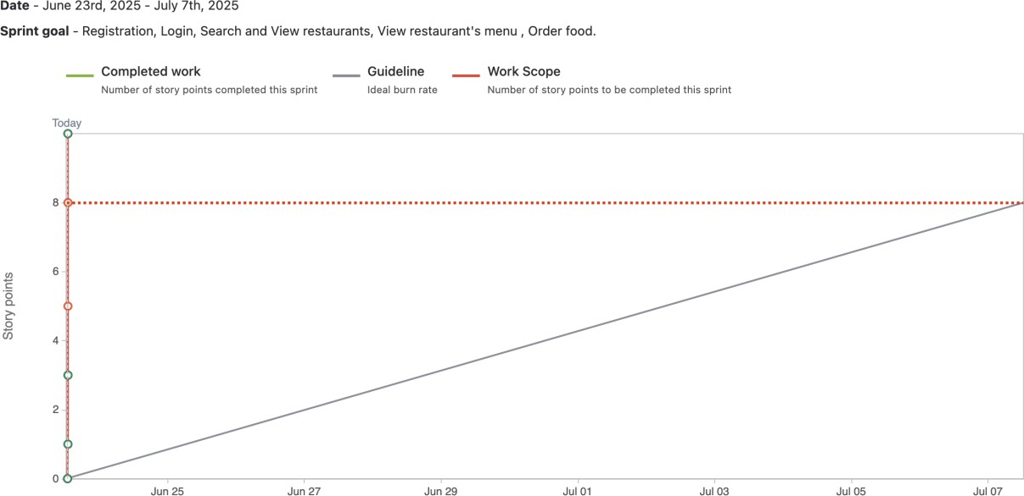
Product Burn Down Charts:
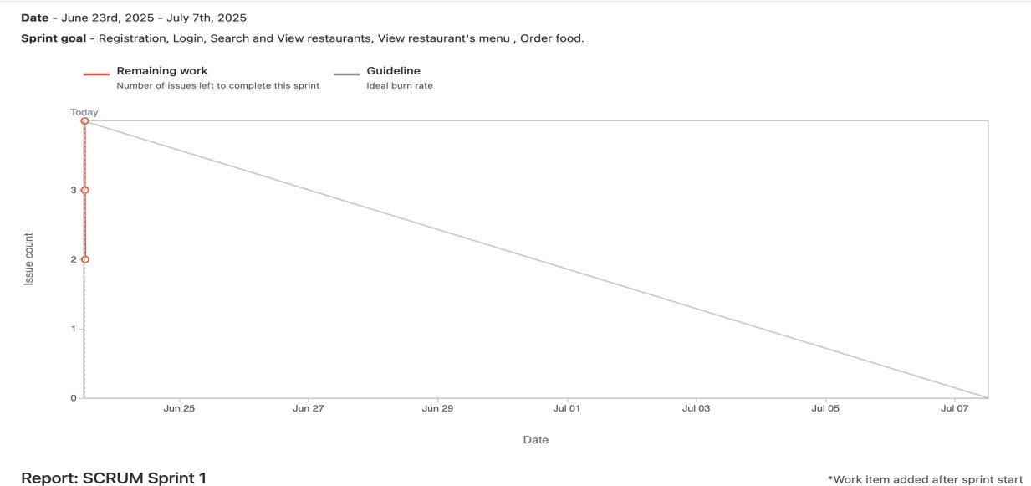

Question 10 – Explain about Product Grooming – 2 Marks

Product grooming is where whole team Refine the requirement (break down into small units) within the product backlog also called as Product Refinement.

Question 11 – Explain the roles of Scrum Master and Product Owner – 3 Marks

SCRUM MASTER
- Ensure Scrum Team follow Process
- Facilitate Scrum ceremonies
  - Sprint planning
  - Daily Standup
  - Sprint Retrospective
  - Sprint Review
- Removing Impediment from scrum Team Process
- Responsible for Scrum Team

PRODUCT OWNER
- Gather Requirement from Stakeholder & Balance Competing Priorities.
- Provide clear Vision For the Product.
- Responsible For managing User stories with well define Acceptance criteria.
- Make Sure Maximise Business value by Team deliveries
- Always available to Clarify requirement, accept /reject work.

Question 12 – Explain all Meetings Conducted in Scrum Project – 8 Marks

Product grooming Meeting:
Participants are the whole Scrum Team (PO, SM, Developers,BA)
Team Refine the requirement (break down into small units) within the product backlog and it is also called as Product Refinement.

Sprint Planning Meeting:
This happens at the beginning of each sprint and team decides on what they will be delivering in the sprint. Participants are the whole Scrum Team (PO, SM, Developers,BA).

Daily Scrum Meeting:
Developers, SM participate along with BA happens everyday This happens each day where team will just answer 3 questions:
- What did u do today?
- what will u do tomorrow?
- Are there any impediments that is slowing or stopping u?

Sprint Review Meeting:
This happens at the end of the sprint where team will demo the completed stories to product owner and get it cleared. Developers, Product owner, Scrum master, Client, 3 rd party reviewers will participate.

Sprint Retrospective Meeting:
This happens at the end of the sprint . Participants are the whole Scrum Team (PO, SM, Developers,BA) where team will answer these 3 questions:
- What went well in the sprint?
- what did not go well?
- What are the required areas of improvements in next sprint?

Backlog Refinement:
This happens weekly once to review, clarify, and prioritize product backlog items for future sprints. PO, SM, Developers,BA are participants

Question 13 – Explain Sprint Size and Scrum Size– 2 Marks

Sprint Size:
The number of user stories in a sprint can vary based on team size, story complexity, and sprint duration, but a common guideline is 5 to 15 user stories per sprint for most Scrum teams. Duration of a sprint (2–4 weeks)

Scrum Size: Average Number of people in a Scrum team (7-8 members). This project we have 10 members.

Question 14 – Explain DOR and DOD – 2 Marks

DOR is a checklist or set of criteria that a user story must meet before the team considers it "ready" for development.

DOD is backlog item to be considered complete. It acts as a quality checklist, ensuring that all necessary work—such as coding, testing, and documentation— has been done before the item is released or presented at the Sprint Review.

Question 15 – Explain Prioritization Techniques and MVP – 3 Marks

Prioritization Techniques are methods used in Agile and Scrum to determine the order in which features, tasks, or user stories should be developed to maximize value and meet business goals. Common techniques include:
- MoSCoW Method: Categorizes tasks as Must-have (IMP) , Should-have(IMP but not critical) , Could-have (Nice to have) , or Won’t-have (either or) , helping teams focus on what is critical for delivery.

- MVP stands for Minimum Viable Product. It is the simplest version of a product that includes only the essential "Must Have" features needed to deliver value to users and gather feedback for future development.

Question 16 – Difference between Business Analyst n Product Owner – 3 Marks
- Focus:

  - PO focuses on the product vision and prioritizing features to maximize value for users.
  - BA focuses on gathering detailed requirements and ensuring business needs are clearly understood and documented.
- Decision-Making:
  - PO makes final decisions about product features and backlog priorities.
  - BA provides analysis and recommendations but usually does not make final product decisions.
- Stakeholder Interaction:
  - PO primarily interacts with customers and end-users to align the product with market needs.
  - BA works closely with a broader range of stakeholders to elicit and clarify requirements.

Question 17 – Prepare a sample Resume of 3yrs exp Product Owner – 3 Marks

Priya Sharma
Bangalore, India | +91-9876543210 | priya.sharma@email.com | linkedin.com/in/priyasharma

Professional Summary
Certified Scrum Product Owner with 5+ years of experience driving product vision, managing backlogs, and delivering customer-centric solutions in Agile environments.

Skilled in stakeholder collaboration, prioritization, and sprint planning to maximize product value and user satisfaction.

Key Skills
- Agile & Scrum Framework
- Product Backlog Management
- User Story Creation & Prioritization
- Stakeholder Engagement
- Sprint Planning & Review
- Roadmap Development
- Data-Driven Decision Making
- Communication & Leadership

Professional Experience
Product Owner
ABC Technologies, Bangalore | Jun 2021 – Present

- Manage product backlog for SaaS platform serving 10,000+ users.
- Prioritize features using MoSCoW and WSJF techniques to maximize business value.
- Lead sprint planning, reviews, and retrospectives with cross-functional teams.
- Collaborate with stakeholders to refine requirements and adjust roadmap.
- Delivered features increasing user satisfaction by 30%.

Business Analyst
XYZ Solutions, Bangalore | Jan 2019 – May 2021

- Gathered and analyzed requirements, created user stories and acceptance criteria.
- Supported backlog refinement and sprint activities alongside Product Owner.
- Facilitated communication between business and technical teams.

Education
Bachelor of Engineering (Computer Science) Visvesvaraya Technological University, 2018

Certifications
- Certified Scrum Product Owner (CSPO)
- PMI Agile Certified Practitioner (PMI-ACP)

Projects
- Subscription Module Launch: Increased monthly recurring revenue by 20%.
- Mobile App Redesign: Improved app store rating by 40%.

