CAPSTONE PROJECT 1 PART 3
Online Agriculture Products Store
Q 1 Functional Requirement and Non Functional Requirement .
Functional requirement define the actual behavior , function or operation of the system . They describe what the system should do , Necessary Task action or activities to achieve objective.
Req ID | Req Name | Req Description
FR001 | Farmer Login | Farmer Should able to login
FR002 | Farmer Registration | Farmer id should be registered
FR003 | Farmer Search Product | Farmer Search for the product
FR004 | Farmer add product | User Add product in the cart
FR005 | Farmer process payment | User should process for payment
FR006 | SMS for Payment | User Must receive SMS for Payment
FR007 | Order placed | User placed the order
FR008 | Delivery Status | User Should check the delivery status
FR009 | Delivery confirmation | User Receive the item
FR010 | Sms and Email Confirmation | User receive sms and mail confirmation for product delivery

The Non Functional requirement mainly describes quality and attributes of the system , Focusing on how the system should perform
Req ID | Req Name | Req Description
NFR001 | Usability | The Application must have initiative user friendly
NFR002 | Performance | The Application must load page in 3 Second
NFR003 | Security | The Application must ensure secure authentication
NFR004 | Compact ability | The Application should be Compatible with major browser
NFR005 | Response Time | The Application should response the user
NFR006 | Web Content | The system must meet web content
NFR007 | Visibility | The system screen must be clear user friendly
NFR008 | Accessibility | The Application should be easily access by user
NFR009 | Result | The Application perform result with in second
NFR010 | Timesaver | The Application mustr be time saver and fast

Q.2 Make Wireframe and Prototypes
I have created screens and pages using Balsamiq and Axure
Wireframes :- Wireframes is basic skeletal outline of design it is working on layout and functionality , Wireframes is a blue print of any future without any color . it can be designed on paper with pen and pencil . this is generally developed in every project and designed by BA very quickly
Mock ups :- Mockups are more detail visual representation of any design with color typography and other visual representation to give realistic impression of any product . We are making screens and pages are called mockups Mockup is an improved version of the wireframes . it shows how the future system will look like Mockup can not be design on paper we use tools like Balsimq for creating Mockup .It will take more time than wireframes but less time than prototypes It is also designed by BA and almost developed in all projects
Prototype :- Prototype is interactive representation of a design which allows the user to interact with interface and experience its functionality Prototype is designed by the developer and BA to understand the system . Prototype takes more time to develop . Prototype may not be required for all the projects It is developed by the development team and business analyst
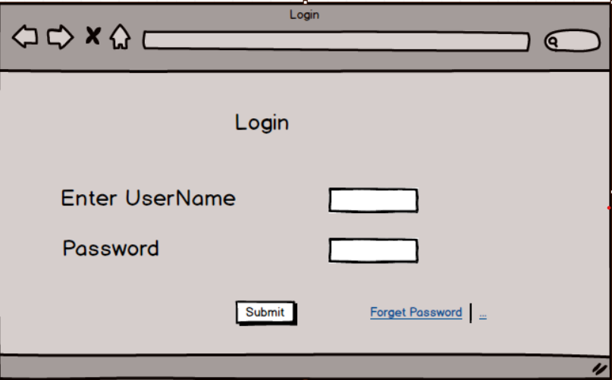
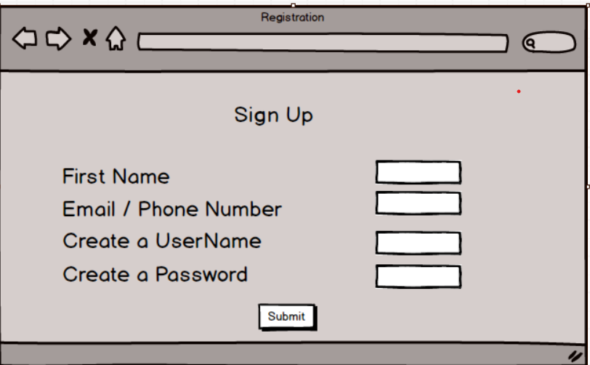

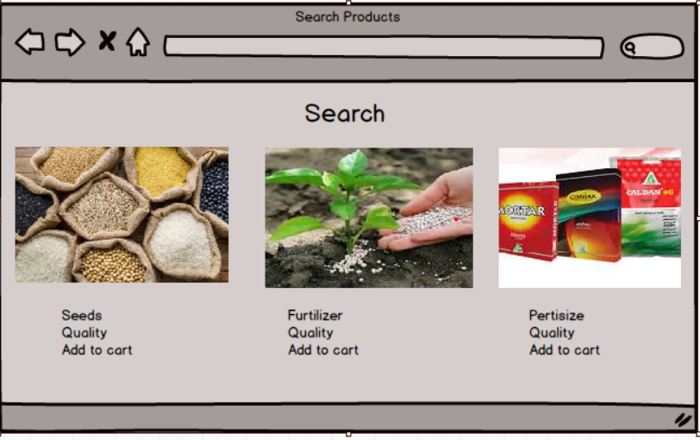
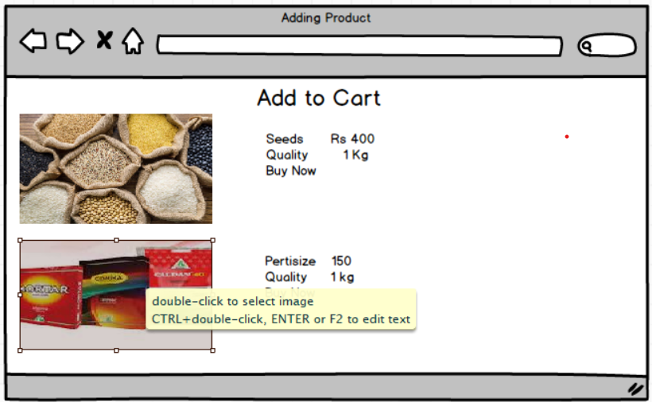

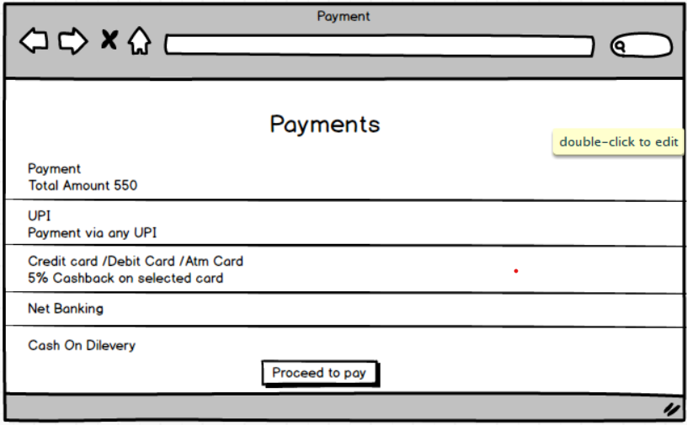

Now Prototypes

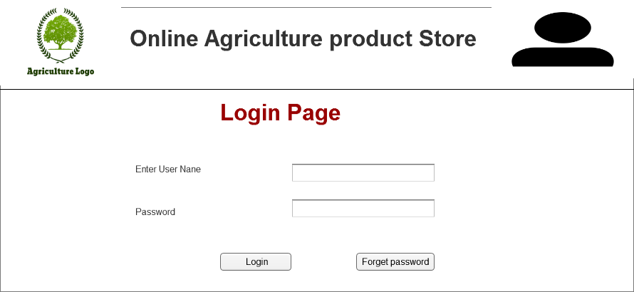

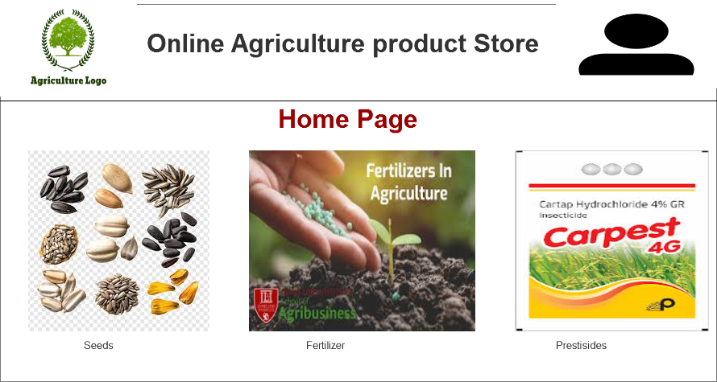

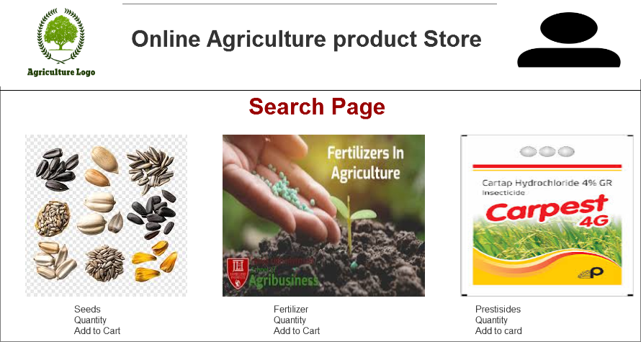

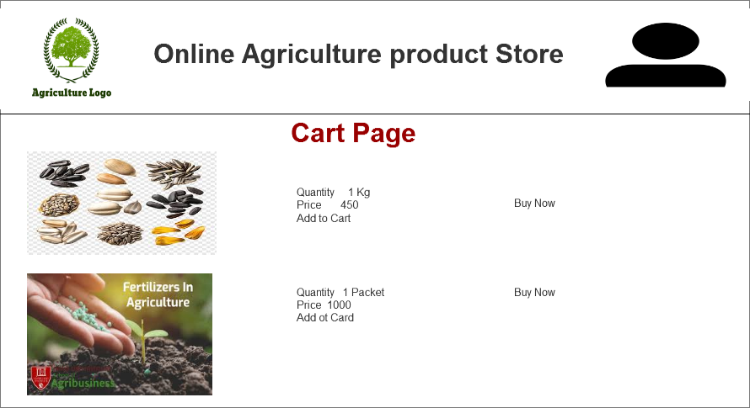
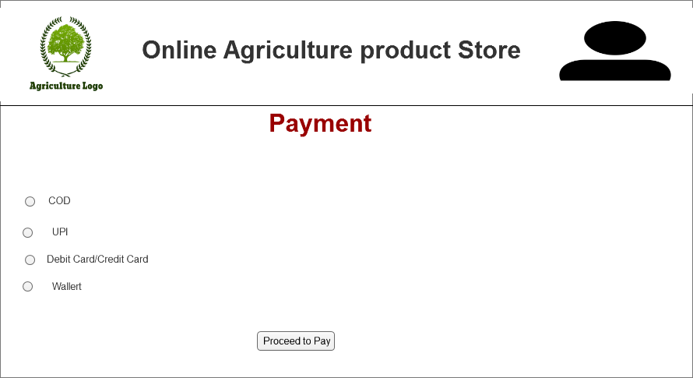

Q. 3 Make a note of the Tools , Which we are using
As a Business Analyst we are using
Ms Visio :- Ms Visio is a Diagrammatical and Vector Graphical Application and used to create flow charts activity diagrams and other visual representation of complex information .
Balsamiq :- This is a Wire framing tools used for creating Mockups and Prototype for user interfaces
Assure :- Assure is used for creating high fidelity graphical interface Wireframes and prototypes for Web and Mobile Application
We use Above tools for creating
Wireframes :- Wireframes is basic skeletal outline of design it is working on layout and functionality , Wireframes is a blue print of any future without any color . it can be designed on paper with pen and pencil . this is generally developed in every project and designed by BA very quickly
Mock ups :- Mockups are more detail visual representation of any design with color typography and other visual representation to give realistic impression of any product . We are making screens and pages are called mockups Mockup is an improved version of the wireframes . it shows how the future system will look like Mockup can not be design on paper we use tools like Balsimq for creating Mockup .It will take more time than wireframes but less time than prototypes It is also designed by BA and almost developed in all projects
Prototype :- Prototype is interactive representation of a design which allows the user to interact with interface and experience its functionality Prototype is designed by the developer and BA to understand the system . Prototype takes more time to develop . Prototype may not be required for all the projects It is developed by the development team and business analyst .
Q.4 :- Prepare RTM
RTM means Requirement Traceable Matrix used to track the requirement in our project life Cycle . We have to check the status of requirement weather it is complete or incomplete or in progress we have to ensure that all requirement are covered any requirement should not missed . When we are in any project we are preparing this RTM in this RTM Requirement Id , Requirement Name , Requirement Description , Design , Coding , Testing , UAT , System Testing .we have to follow this checklist so their should not be any chance to missed any requirement . For Tracking purpose we are creating RTM

Req Id | Req Name | Req Description | Design | Code | Testing | Component Testing | System Testing | SAT | UAT
FR001 | User Login | User Should login the Screen | Complete | Complete | Complete | Complete | Complete | Complete | Incomplete
Fr002 | User Registration | User Should Register themselves | Complete | Complete | Complete | Complete | Incomplete | Incomplete | Incomplete
Fr003 | User product Search | User Should be able to search | Complete | Complete | Complete | Complete | Incomplete | Incomplete | Incomplete
FR004 | Add Product | User should add product to cart | Complete | Complete | Complete | Complete | Incomplete | Incomplete | Complete
FR005 | Buy Product | User Should be able to buy product | Complete | Complete | Complete | Complete | Incomplete | Incomplete | Incomplete

Q.5 10 Test Case Documents

Test Case Document is a document with specific format and use to complete the work it contain Some parameters such as Test case id , Name , Project id , Target Id , Scenario , Autual behavior , expected behavior etc
Test Case ID | TC001 | Test Case Name | User Registration
Project ID | P001 | Project Name | Onlime Agriculture Product Store
PM ID | PM001 | PM Name | Mr. Vandanam
Test Strategy ID | TS001 | Test Id | T001
Test Plan ID | TS001 | Tester Name | Mr. Jason and Mr Alekya
Test Schedule iID | Ts001 | Date of Test | 05.06.25
Scenario | User Registration
Input Data | Enter Name and Mobile no
Expected Behaviour | Complete details should provided
Actual Behavior | Complete details should provided
Comments
Result ( Pass/Fail) | Pass
Test Case ID | TC002 | Test Case Name | User Login
Project ID | P001 | Project Name | Onlime Agriculture Product Store
PM ID | PM001 | PM Name | Mr. Vandanam
Test Strategy ID | TS001 | Test Id | T001
Test Plan ID | TS001 | Tester Name | Mr. Jason and Mr Alekya
Test Schedule iID | Ts001 | Date of Test | 05.06.25
Scenario | User Login
Input Data | Enter Login Id and Password
Expected Behaviour | Password Encryed during login
Actual Behavior | Password Encryeted during HTTPs
Comments | None
Result ( Pass/Fail) | Pass
Test Case ID | TC003 | Test Case Name | Farmer Search for the product
Project ID | P001 | Project Name | Onlime Agriculture Product Store
PM ID | PM001 | PM Name | Mr. Vandanam
Test Strategy ID | TS001 | Test Id | T001
Test Plan ID | TS001 | Tester Name | Mr. Jason and Mr Alekya
Test Schedule iID | Ts001 | Date of Test | 05.06.25
Scenario | Search Product
Input Data | Seeds Fertilizer , Frestisides
Expected Behaviour | Different products
Actual Behavior
Comments | None
Result ( Pass/Fail) | Pass

Test Case ID | TC004 | Test Case Name | Add to Cart
Project ID | P001 | Project Name | Onlime Agriculture Product Store
PM ID | PM001 | PM Name | Mr. Vandanam
Test Strategy ID | TS001 | Test Id | T001
Test Plan ID | TS001 | Tester Name | Mr. Jason and Mr Alekya
Test Schedule iID | Ts001 | Date of Test | 05.06.25
Scenario | Adding in Cart
Input Data | Selecting product and adding in cart
Expected Behaviour | Adding different item
Actual Behavior
Comments | None
Result ( Pass/Fail) | Pass
Test Case ID | TC005 | Test Case Name | Payment proceed
Project ID | P001 | Project Name | Onlime Agriculture Product Store
PM ID | PM001 | PM Name | Mr. Vandanam
Test Strategy ID | TS001 | Test Id | T001
Test Plan ID | TS001 | Tester Name | Mr. Jason and Mr Alekya
Test Schedule iID | Ts001 | Date of Test | 05.06.25
Scenario | Payment
Input Data | UPI , DC/CC Cod
Expected Behaviour
Actual Behavior
Comments | None
Result ( Pass/Fail) | Pass
Test Case ID | TC006 | Test Case Name | Order Confirmation
Project ID | P001 | Project Name | Onlime Agriculture Product Store
PM ID | PM001 | PM Name | Mr. Vandanam
Test Strategy ID | TS001 | Test Id | T001
Test Plan ID | TS001 | Tester Name | Mr. Jason and Mr Alekya
Test Schedule iID | Ts001 | Date of Test | 05.06.25
Scenario | Order Confirmation
Input Data | Order booked
Expected Behaviour
Actual Behavior
Comments | None
Result ( Pass/Fail) | Pass

Test Case ID | TC007 | Test Case Name | Order Cancelation
Project ID | P001 | Project Name | Onlime Agriculture Product Store
PM ID | PM001 | PM Name | Mr. Vandanam
Test Strategy ID | TS001 | Test Id | T001
Test Plan ID | TS001 | Tester Name | Mr. Jason and Mr Alekya
Test Schedule iID | Ts001 | Date of Test | 05.06.25
Scenario | Order Cancel
Input Data | Enter Name and Mobile no
Expected Behaviour | Quality
Actual Behavior
Comments
Result ( Pass/Fail) | Pass
Test Case ID | TC008 | Test Case Name | Tracking Order
Project ID | P001 | Project Name | Onlime Agriculture Product Store
PM ID | PM001 | PM Name | Mr. Vandanam
Test Strategy ID | TS001 | Test Id | T001
Test Plan ID | TS001 | Tester Name | Mr. Jason and Mr Alekya
Test Schedule iID | Ts001 | Date of Test | 05.06.25
Scenario | Ready for delivery
Input Data | Track online status of goods
Expected Behaviour | Delivered on date
Actual Behavior | Tracking material
Comments | None
Result ( Pass/Fail) | Pass
Test Case ID | TC009 | Test Case Name | Delivery Confirmation
Project ID | P001 | Project Name | Onlime Agriculture Product Store
PM ID | PM001 | PM Name | Mr. Vandanam
Test Strategy ID | TS001 | Test Id | T001
Test Plan ID | TS001 | Tester Name | Mr. Jason and Mr Alekya
Test Schedule iID | Ts001 | Date of Test | 05.06.25
Scenario | Sms and Email confirmation
Input Data | Track the goods
Expected Behaviour | Different products
Actual Behavior | Deliverd on time
Comments | None
Result ( Pass/Fail) | Pass

Test Case ID | TC010 | Test Case Name | Feedback
Project ID | P0001 | Project Name | Onlime Agriculture Product Store
PM ID | PM001 | PM Name | Mr. Vandanam
Test Strategy ID | TS001 | Test Id | T001
Test Plan ID | TS001 | Tester Name | Mr. Jason and Mr Alekya
Test Schedule iID | Ts001 | Date of Test | 05.06.25
Q . 6 Scenario | Feedback and Rating
Input Data | Status of product
Expected Behaviour | Different products
Actual Behavior | As per requirement
Comments | None
Result ( Pass/Fail) | Pass

Q.6 DB Design
DB Design = ER Diagram + DB Schema
ER Diagram :- In this we just shows Entity relationship , Attributes in rectangle oval and diamond shapes
In DB Schema we just create table column primary key foreign key and show the relationship
Primary key :- Show uniqueness it should not be duplicate
Foreign Key :- It is primary key in another table

Q 7 Data Flow Diagram
Data Flow diagram explain the complete process step by step in graphical manner that how system perform when we give any command For example when farmer place an order
Graphical representation of data how it is flowing Shown through data flow diagram
- The farmer select the product and place order .
- System Process the same
- Order details are saved in order database
- Notification are sent to Farmer and Manufacturer team

Q 8 How a BA Handle Change Request ?
- Understand the Scope of Change Request Document the Change Request
- We have to do Impact Analysis Project Scope , Schedule , Budget ,Recourses and Risks
- Prioritize Change request based on urgency , Important , Most Important , Impact on project
- Seek Approval from the project Sponsors for Change Request
- Communicate the change request and its potential impacts to all relevant Stakeholders and project Team
As per project there is changes in Taxation structure so this is a important request which will effect budget of our project . So as a BA There should be document for changes in taxation ,also effect budget , prioritization take place because these changes are important so we seek approval from Project Sponser and communicate the same to stake holders and Project Team
Q.9 Change Request Vs an Enhancement ?
The major difference between Change request and an Enhancement is if we change any application so that is called change request but if we update some feature in existing application or we upgrade then new version of application introduce than it is called Enhance and the process is called enhancement .
As per Case study this is called Enhancement as in online Agriculture project they want to add their crop yield or product to general public and they want to introduce the same in Auction System . So in this process only enhancement is sufficient. After An Enhancement they can also introduce new Application for Auction and bidding.
Q.10 Estimation
How many Man Hours required for a project
Man Hours are the required efforts of the resource to complete a project . There are three type of projects
- Small Upto 500 Hours
- Medium Upto 1000 Hours
- Large Upto 1500 Hours
AS per our project the given duration is 18 Months and team size is around 15
Trainer are available so they are not required separately
Structure is available new or enhancement not required

Q . 11 UAT Process
User Acceptance Testing process contains steps are Planning , Design , UAT Testing , Bug Fixing , Sign off .
Planning :- Under this step Blue Prints are made to implement UAT Testing for every feature that needs to be test and minimum standards for accepting the test .
Designing :- Here the test case are design to hide all the possibilities of software packages to a real world environment .
UAT Testing :- when we plan for UAT testing there are two testing one is client environment and other is company environment . Client testing is tested in presence of client . First we decide for UAT Testing and set the environment .
Bug Fixing :- The Bugs found in UAT Testing the development team should work on it and make it and make software error free .
Sign Off :- All removing all the bugs the testing team indicates acceptance the completion of the bugs in this stage all take holders come with a conclusion that software is ready to live and Sign off .

Q 12 Project Closure Document
A project closure document is also called project closure report . It is a formal document that summarize the key outcomes and final details of completed project .
Points includes in project closure documents are
- Project Overview
- Achievements
- Lesson Learned
- Quality Assurance
- Recourse Utilization
- Risk Management
- Challenges

